ENFORCEABLE UNDERTAKING

Between  
  
The Commonwealth of Australia   
  
(as represented by the Office of the Fair Work Ombudsman)  
  
and

Downes Rice Hulls Pty Ltd

ACN 072876629

ABN 62072876629

# *Fair Work Act 2009* Section 715 Enforceable Undertaking

## Parties

1. This enforceable undertaking **(Undertaking)** is given to the Fair Work Ombudsman **(the FWO)** by Downes Rice Hulls Pty Ltd **(the Employer)** for the purposes of section 715 of the *Fair Work Act 2009* (FW Act).

## Background

1. Downes Rice Hulls Pty Ltd of Jane Street Deniliquin, NSW 2710, is an Australian owned private company that was incorporated in 1996. It has two Directors, Jennifer Downes and Keith Downes. Jennifer Downes was appointed as Director and Secretary in 1996 and is the sole shareholder. Keith Downes was appointed as a Director of the company in October 2015.
2. The Employer has previously collected and transported rice hulls from three depots in Leeton, Deniliquin and Coleambally in New South Wales. The Employer employed approximately 17 drivers, 6 shed hands and 4 administrative staff. The Employer has advised that operations at Coleambally have now ceased.
3. The Employer stated at a meeting held on 13 September 2016 they did not pay in accordance with any Modern Award.
4. As the Employer is involved in the collection and transportation of a waste product (rice hulls), it was agreed that the terms and conditions for the drivers are governed by the *Waste Management Award 2010* **(the Modern Award)**.
5. Following a Request for Assistance from a former employee in relation to the underpayment of wages, the FWO calculated the amount owing to the former employee as $50,856.70 for the period of employment from 26 May 2011 to 23 July 2014. A summary of the amount owing is outlined in Attachment A.
6. Following the Request for Assistance, the FWO initiated an audit in May 2016. The audit of the records provided by the Employer found contraventions of Commonwealth workplace laws occurred between 31 December 2015 and 30 March 2016 (the Audit Period) affecting 15 full time and casual drivers.
7. Calculations completed by FWO for the Audit Period showed the total amount owing to the 15 drivers (in Attachments B and C) is $43,138.07.
8. A summary of the amounts owing to the full time drivers employed during the Audit Period is outlined in Attachment B. The total amount owing is $22,291.50.
9. A summary of the amounts owing to the casual drivers employed during the Audit Period is outlined in Attachment C. The total amount owing is $20,846.57
10. The Employer has accepted the findings of the audit and agreed to back pay the underpayments to the employees over a 12 month period.
11. The FWO has determined, and the Employer admits, that the Employer contravened in the following ways:
12. The FWO has determined that the Employer contravened with respect to the **employee named in Attachment A:**

Section 45 of the *Fair Work Act 2009* states a person must not contravene a term of a modern award.

The following contraventions of the Modern Award have occurred:

* 1. Clause 19.1 – Minimum Wages (including industry allowance)
  2. Clause 28.3(a) – Failure to pay correct Afternoon Shift loading
  3. Clause 28.3 (b) – Failure to pay correct Night Shift loading
  4. Clause 30.1– Failure to pay correct overtime rates – first two hours Monday to Friday (150%) and after the first two hours (200%)
  5. Clause 31.1 – Failure to pay correct overtime rates – Saturday – first two hours (150%) and after two hours (200%)
  6. Clause 31.4 – Failure to pay correct rates on a Sunday (200%)
  7. Clause 32.2– Failure to pay correct public holiday rates – Good Friday and Christmas Day and on other public holidays
  8. Clause 33.2 – Annual Leave Loading

Section 44 of the *Fair Work Act 2009* states an employer must not contravene a provision of the National Employment Standards.

The following contravention of the National Employment Standards has occurred:

* + 1. Section 116 – Failure to pay the employees correct base rate of pay when absent from work on a public holiday

1. During the Audit Period the FWO has determined that the employer contravened with respect to the **full time drivers named in Attachment B**:

Section 45 of the *Fair Work Act 2009* states a person must not contravene a term of a modern award.

The following contraventions of the Modern Award have occurred:

1. Clause 19.1 – Minimum Wages (including industry allowance)
2. Clause 28.3(a) – Failure to pay correct Afternoon Shift loading
3. Clause 28.3 (b) – Failure to pay correct Night Shift loading
4. Clause 30.1– Failure to pay correct overtime rates – first two hours Monday to Friday (150%) and after the first two hours (200%)
5. Clause 31.1 – Failure to pay correct overtime rates – Saturday – first two hours (150%) and after two hours (200%)
6. Clause 31.4 – Failure to pay correct rates on a Sunday (200%)
7. Clause 32.2– Failure to pay correct public holiday rates – Good Friday and Christmas Day and on other public holidays
8. Clause 33.2 – Annual Leave Loading

Section 44 of the *Fair Work Act 2009* states an employer must not contravene a provision of the National Employment Standards.

The following contraventions of the National Employment Standards have occurred:

1. Section 116 – Failure to pay the employees correct base rate of pay when absent from work on a public holiday
2. Section 99 – Failure to pay employees the correct base rate of pay whilst on personal leave
3. Section 90 (1) – Failure to pay employees the correct base rate of pay whilst on Annual Leave
4. During the Audit Period the FWO has determined that the employer contravened with respect to the **casual drivers named in Attachment C**:

Section 45 of the *Fair Work Act 2009* states a person must not contravene a term of a modern award.

The following contraventions of the Modern Award have occurred:

1. Clause 19.1 – Minimum Wages (including industry allowance)
2. Clause 14.4 – Failure to pay correct Casual Loading
3. Clause 28.3(a) – Failure to pay correct Afternoon Shift loading
4. Clause 28.3 (b) – Failure to pay correct Night Shift loading
5. Clause 14.5 & 30.1– Failure to pay correct overtime rates – first two hours Monday to Friday (150%) and after the first two hours (200%)
6. Clause 14.5 & 31.1 – Failure to pay correct overtime rates – Saturday – first two hours (150%) and after two hours (200%)
7. Clause 31.4 – Failure to pay correct rates on a Sunday (200%)
8. Clause 32.2– Failure to pay correct public holiday rates – Good Friday and Christmas Day and on other public holidays
9. The FWO has determined that the employer contravened with respect to its **record keeping** obligations.

Section 535 (1) of the *Fair Work Act 2009* – an employer must make and keep records of the kind prescribed by the regulations. The following contraventions of the regulations have occurred:

1. Regulation 3.33 (2) Failure to record all of the hours worked for casual employees
2. Regulation 3.33 (3) Failure to keep a record of all entitlements to penalty rates or loadings for assessed employees
3. Regulation 3.34 (b) Failure to correctly record when assessed employees started and finished working overtime

## Commencement of Enforceable Undertaking

This Enforceable Undertaking comes into effect when:

* 1. the Enforceable Undertaking is executed by the Employer, and
  2. the FWO accepts the Enforceable Undertaking when executed.

## Enforceable Undertaking

Upon the commencement of this Undertaking and for the purposes of section 715 of the FW Act, the Employer undertakes to:

**Rectify Underpayments**

1. Rectify the contraventions as identified in Paragraph 12 by paying the Employees the amounts as listed in Attachments A, B and C, in accordance with the agreed payment schedule in Schedule A, and provide evidence to the FWO that the payments were made within seven (7) days of each payment becoming due;
2. If any of the Employees cannot be located by the end of the payment plan, make application to the Commonwealth of Australia (through the FWO) in accordance with section 559 of the FW Act to pay money into the Commonwealth Revenue Fund. The Employer will complete the required documents supplied by the FWO.

**FWO My Account Registration**

1. Within 14 days of the execution of this undertaking:
   1. register with the FWO My account portal at [www.fairwork.gov.au/register](http://www.fairwork.gov.au/register) and fully complete the ‘My Account’ profile, including information about the business and coverage, through this portal;
   2. using the FWO Pay Calculator, calculate relevant minimum pay rates (and penalty rates where necessary) and save these calculations to your ‘My Account’
   3. provide to the FWO the ‘My Account’ Customer Registration Number (CRN);
2. Within 21 days of the execution of the Undertaking, at a mutually agreed time and location, demonstrate to an officer of the FWO of the use of ‘My Account’, including saving information within ‘My Account’ from the website and relevant FWO online tools. You must also demonstrate how your use of this saved information will contribute toward your compliance with workplace obligations including payment to employees of the correct minimum pay rates and public holiday penalty rates.
3. Within 28 days of the execution of the undertaking, subscribe to the following and provide evidence to the FWO of the subscriptions:
   1. ‘General information’ email alerts from the FWO relating to the modern award, available at <http://www.fairwork.gov.au/website-information/staying-up-to-date/subscribe-to-email-updates>
   2. FWO’s Employer newsletter for the relevant State and industry, available at <http://www.fairwork.gov.au/about-us/news-and-media-releases/newsletter>, selecting at least the following options:
      1. pay updates;
      2. award updates;
      3. holiday updates;
      4. working hours and breaks; and
      5. annual leave/sick leave.

**Future workplace relations compliance**

The Employer will undertake to:

1. investigate and use all reasonable endeavours to resolve any additional complaint, grievance or report of non-compliance with Commonwealth Workplace Laws or Fair Work Instruments, that is reported to the Employer by current or former employees either;
2. outside the employment period looked at by FWO, or
3. during the period looked at by FWO, but where there were missing or incomplete records;
4. up until 30 June 2018, provide written notification to the FWO within 25 business days of each complaint, grievance or report of non-compliance with Commonwealth Workplace Laws or Fair Work Instruments being received, including identification of the complaint, grievance or report made, the investigation undertaken, and the steps taken to rectify the conduct if required. The FWO reserves its rights to separately investigate any such complaint, grievance or report;
5. ensure that the Employer complies at all times and in all respects with the *Fair Work Act 2009*, the *Fair Work Regulations 2009* (Cth) and the Modern Award in relation its employees engaged as drivers involved in the cartage of waste material; and
6. provide the FWO, within 60 days of the date of execution of this Undertaking, details of systems and processes already in place or to be implemented to comply with paragraph (h) above. Without limitation, such systems and processes relating to:
   1. Ensuring employees receive the correct minimum rates of pay and entitlements, such as penalty rates and overtime rates;
   2. Ensuring employees receive the correct allowances;
   3. Ensuring employees receive the correct rates of pay for annual leave;
   4. Keeping accurate and complete records to ensure employees receive their correct wages and entitlements.

**Workplace relations training**

1. Within 28 days of execution of this undertaking ensure that all persons responsible for management, payroll and human resources complete all education courses designed for employers available on the FWO on line learning centre via <http://www.fairwork.gov.au/how-we-will-help/online-training> and provide evidence of completion to the FWO.

**Apology**

1. Send a letter of apology (**Apology Letter**) to the Employees listed in Attachments A, B and C in the form of Attachment D to this undertaking and provide copies to the FWO within 14 days of the execution of this undertaking.

**Audit Activity**

1. engage an external accounting professional, audit specialist or employment specialist to conduct future audits of the Employer’s compliance with the FW Act, FW Regulations and fair work instruments including but not limited to the Modern Award on the following terms:
   * 1. the audits will be required to cover each of the full pay periods that fall in the period from 30 April to 30 June in the years 2017 and 2018;
     2. the audits are to be completed by 31 July each year;
     3. the audits are to apply to all drivers involved in the cartage of waste material and employed at any time during the audit period;
     4. the audits will assess the Employer’s compliance with wages and work-related entitlements; and
     5. by 14 August each year, the Employer will provide to the FWO a copy of the audit report which must include:

* a statement of the qualifications of the person conducting the audit and the methodology used in the audit
* the audit findings
* written particulars of any contraventions identified in the audit, including the steps taken by the Employer to rectify any contravention(s), and evidence of the rectification to be supplied to the FWO. All contraventions must be rectified by 31 July in the year of the audit

**Matters notified to the FWO**

1. Where the FWO receives a request for assistance regarding non-compliance with the Modern Award, the Employer and its officers undertake to fully co-operate with the FWO to ensure compliance. This includes:

* providing all requested employment records and other documentation to the FWO relevant to the request for assistance;
* participating fully in any subsequent requests for information relevant to the request for assistance, including participation in any formal records of interview; and
* co-operating with the FWO’s processes employed to resolve the request for assistance.

**Workplace Notice**

1. Within 28 days of the execution of this Undertaking, cause to be displayed within all of the workplace/s controlled by the Employer a notice in the form of Attachment E to this Undertaking (**Workplace Notice**) and provide photographic evidence of its display:
   1. Ensure that the Workplace Notice is printed in at least A3 size and is clearly displayed:
      1. In a location to which all employees who work for the Employer have access;
      2. In a manner which is reasonably capable of drawing attention of all employees to the Workplace Notice (for example, by placement on a staff noticeboard; and
      3. For a period of 14 continuous days

**Record Keeping**

1. Within 30 days provide to the FWO a copy of time and wage records and payslips for one casual driver for the first full pay period following the execution of this undertaking. Such records are to comply with Commonwealth workplace laws.

**Broader Community workplace relations education**

1. Within 90 days of the date of execution of this Undertaking make a donation of **$5,000** to GetSet (ABN 49 578 807 761) of 11-13 Belah Street, LEETON, NSW 2705, with the objective of assisting their program that offers work readiness training, skill development and co-ordinated mentored work experience placements to youth at local schools in, and provide evidence of that donation to FWO within 7 days of the donation being made.

**No Inconsistent Statements**

1. The Employer:
   1. must not; and
   2. must ensure that each of its officers, employees or agents, do not make any statement, orally or in writing or otherwise imply anything that is inconsistent with admissions or acknowledgements contained in this agreement.

## Acknowledgements

The Employer acknowledges that:

* 1. the FWO may make this Undertaking (including any attachments) available for public inspection, including by posting it to its [website](http://www.fairwork.gov.au/) at www.fairwork.gov.au (subject to the FWO taking any necessary steps to redact the names of individuals not party to the Undertaking);
  2. the FWO may release a copy of this Undertaking pursuant to any relevant request under the *Freedom of Information Act 1982* (Cth);
  3. the FWO may issue a media release in relation to this Undertaking and from time to time, publicly refer to the Undertaking and its terms;
  4. the admissions made in the Undertaking may be relied upon by the FWO in respect of any future decision about enforcement action to be taken in relation to any future non-compliance with Commonwealth workplace relations obligations by the Employer;
  5. consistent with the Note to section 715(4) of the FW Act, this Undertaking in no way derogates from the rights and remedies available to any other person arising from the conduct set out in this Undertaking;
  6. if the FWO considers that the Employer has contravened any of the terms of this Undertaking the FWO may apply to any of the Courts set out in section 715(6) of the FW Act, for orders under section 715(7) of the FW Act; and
  7. consistent with section 715(3) of the FW Act, the Employer may withdraw from or vary this Undertaking at any time, but only with FWO consent.

## Executed as an undertaking

Executed by Downes Rice Hulls Pty Ltd in accordance with section 127(1) of the *Corporations Act 2001*:

|  |  |  |
| --- | --- | --- |
|  |  |  |
| (Signature of director) |  | (Signature of director/company secretary) |
|  |  |  |

(Name of director) (Name of director/company secretary)

|  |  |  |
| --- | --- | --- |
|  |  |  |

(Date) (Date)

in the presence of: in the presence of:

|  |  |  |
| --- | --- | --- |
|  |  |  |
| (Signature of witness) |  | (Signature of witness) |
|  |  |  |

(Name of witness) (Name of witness)

|  |  |  |
| --- | --- | --- |
| Accepted by the FAIR WORK OMBUDSMAN pursuant to section 715(2) of the *Fair Work Act 2009* on: | | |
| Steven Ronson  Executive Director  Dispute Resolution and Compliance  Delegate for the FAIR WORK OMBUDSMAN |  | (Date) |
| in the presence of: |  |  |
| (Signature of witness) |  | (Name of Witness) |

**Attachment A – Summary of contraventions and amounts owing to XXXXXXXXXX**

Attachment A

**Attachment B – Summary of contraventions and amounts owing to full time drivers**

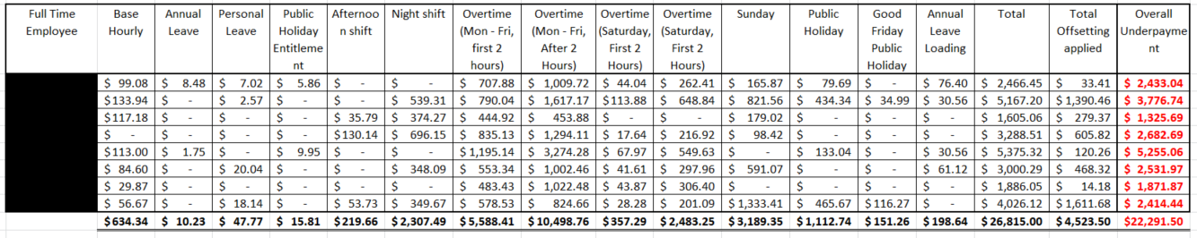

**Attachment C – Summary of contraventions and amounts owing to casual drivers**

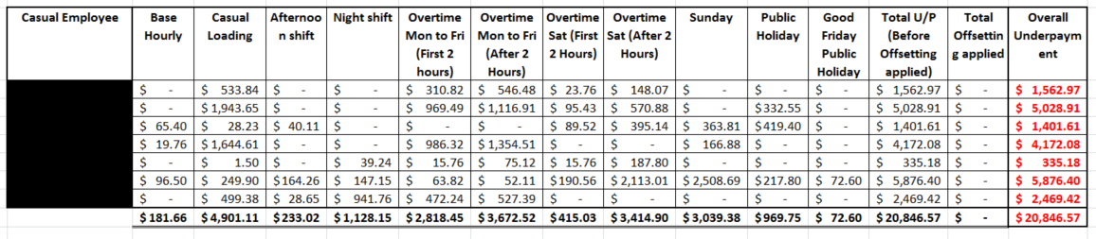

**Schedule A – Repayment Schedule**

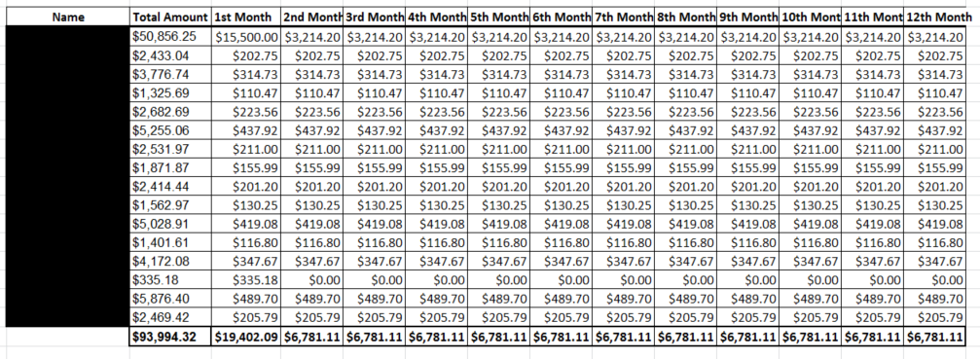

**Attachment D – Form of Apology Letter to affected employees**

**<Date>**

**<Employee Name>**

**<Employee Address>**

Dear **<Employee Name>**

I am writing to apologise on behalf of Downes Rice Hulls Pty Ltd for non-compliance with Commonwealth Workplace relations laws.

A recent investigation conducted by the Office of the Fair Work Ombudsman (**FWO**) determined that we had contravened the *Fair Work Act 2009* and the *Waste Management Award 2010*by failing to provide the correct rate of pay to employees.

Regrettably, the investigation determined that you were affected by our failure to pay the correct rate of pay.

You will receive progressive payments on [insert date] and will be provided with payment advice regarding the payment.

Downes Rice Hulls Pty Ltd have formally admitted to the FWO that we did not comply with our obligations under Commonwealth workplace relations laws and have entered into an Enforceable Undertaking with the FWO, a copy of which is available from the FWO website at [www.fairwork.gov.au](http://www.fairwork.gov.au/).

As part of the Enforceable Undertaking we have committed to a number of measures to ensure future compliance with Commonwealth workplace relations laws.

Downes Rice Hulls Pty Ltd expresses its sincere regret and apologises to you for failing to comply with our lawful obligations.

Should you have any questions, please contact Jennifer Downes.

Yours sincerely

**Director**

**Attachment E - FORM OF WORKPLACE NOTICE**

We refer to the investigation conducted by the Office of the Fair Work Ombudsman (**FWO**) where it was found that Downes Rice Hulls Pty Ltd contravened the *Fair Work Act 2009* and the *Waste Management Award 2010*by:

1. Failing to pay correct Minimum Wages (including industry allowance)
2. Failing to pay correct Afternoon Shift loading
3. Failing to pay correct Night Shift loading
4. Failing to pay correct overtime rates – first two hours Monday to Friday (150%) and after the first two hours (200%)
5. Failing to pay correct overtime rates – Saturday – first two hours (150%) and after two hours (200%)
6. Failing to pay correct rates on a Sunday (200%)
7. Failing to pay correct public holiday rates – Good Friday and Christmas Day and on other public holidays
8. Failing to pay correct Annual Leave Loading
9. Failing to pay the employees correct base rate of pay when employee is absent on a public holiday
10. Failing to pay employees the correct base rate of pay whilst on personal leave
11. Failing to pay employees the correct base rate of pay whilst on Annual Leave
12. Failing to pay correct Casual Loading

Downes Rice Hulls has formally admitted to FWO that these contraventions occurred and has entered into an Enforceable Undertaking with the FWO (available at www.fairwork.gov.au) committing to a number of measures to remedy the contraventions, including by rectifying the underpayments or paying compensation to the employee affected by the contraventions.

Downes Rice Hulls expresses its sincere regret and apologises for the conduct which resulted in the contraventions. Furthermore, Downes Rice Hulls gives a commitment that such conduct will not occur again and that it will comply with all requirements of the Commonwealth workplace relations laws in the future.

If you worked for Downes Rice Hulls and have queries or questions relating to your employment, please contact Jennifer Downes.

Alternatively, anyone can contact the FWO via the website at www.fairwork.gov.au or the Infoline on 13 13 94.