Inquiry into the wages and conditions of people working under the 417 Working Holiday Visa Program

October 2016

© Commonwealth of Australia, 2016

## Executive summary

Reflecting Australia’s position as operating within the global economy, approximately 7% of our nation’s total working population[1] is comprised of temporary visa holders with work rights[2].

Since 1 July 2014, a total 410,503 people have been granted the right to work in Australia courtesy of the subclass 417 working holiday visa (417 visa). This number can be compared with the number of 457 visa holder grants for the same period which totalled 96,530[3].

In the 2015-2016 financial year, the Fair Work Ombudsman (FWO) received 1,820 requests for assistance from visa holders (13% of the total requests received) and was responsible for recovering $3,087,133 for this group. In total, 44% of visa holders who lodged a request for assistance with the FWO were on a 417 visa (this figure has remained consistent over the two previous financial years).

In the same period, 76% of litigations filed by the FWO involved visa holder workers and more than one third of all of the FWO’s enforcement outcomes involved a visa holder. Significantly, half of these enforcement outcomes (that is, the issuing of compliance notices, the execution of enforceable undertakings and the filing of legal proceedings) involved 417 visa holders[4].

Over a decade ago, the 417 visa was expanded, with an option introduced for young people wanting to extend their stay in Australia for a second year to undertake 88 days of ‘specified work’ in regional Australia[5] during the first year of their visa (the 88 day specified work requirement).

While the public policy intention of the 417 visa remained, and remains, one of cultural exchange, the ‘second year’ option was introduced in part to address identified labour shortages in regional areas of Australia and, more specifically, the horticulture industry[6].

Due to the escalating number of requests for assistance received by the FWO from temporary visa holders[7], in August 2014, the FWO announced the commencement of a national Inquiry focusing on the wages and conditions of workers in Australia on the 417 visa.

The FWO regards 417 visa workers as especially vulnerable due to the difficulties in understanding and exercising their entitlements because of age and language barriers. In particular, their vulnerability is increased if they choose to undertake an 88 day placement, because of the remoteness of their working location and their dependence on employers to obtain eligibility for a second year visa. In 2013-2014, of the 183,428 417 visas granted, 45,950 visa holders elected to undertake 88 days of specified work in order to secure a second year visa. In 2015-2016, there was an 8.1% reduction in first year 417 visa grants (159,409) and a 12.3% reduction in the number of visa holders undertaking the 88 day specified work option.

In addition to examining the requests for assistance, throughout the course of this Inquiry, the FWO received information from visa holders, stakeholders and the public identifying a range of concerns suggesting exploitation of 417 visa holders, including instances of:

* underpayment and / or non-payment of wages
* visa holders offering (or being induced to offer) payment to employers and third parties for assistance to gain a second year work rights visa
* an increased dependency on the employer by the visa holder seeking employment during the 88 day specified work requirement of the 417 visa program in order to secure a second year visa and stay in Australia
* sexual harassment and workplace health and safety (WHS) issues
* employers recruiting workers with the offer of unpaid work to meet the second year visa eligibility requirements
* visa holders working for free in exchange for non-certified accommodation programs.

The Inquiry examined the impact of the conditions attached to the 417 visa, and specifically the 88 day specified work requirement. In recognising that working holiday makers are an ‘important source of labour’[8], the Inquiry looked at the nature and operation of the 88 day specified work requirement, and the impact that this requirement has upon the work experiences of 417 visa holders, the employment market and Australian workplace laws. The Inquiry considered whether the 88 day specified work requirement is a driver of non-compliance with the *Fair Work Act 2009* (FW Act). In so doing, the Inquiry sought to identify opportunities to address any non-compliance.

Following extensive consultation with a diverse range of stakeholders, survey responses from 4,056 working holiday visa holders and more than 25 dedicated investigations, the Inquiry found a series of tensions between:

* the public policy intention of the 417 visa program as a ‘cultural exchange’ and the use of the visa program as source of labour
* various restrictions under migration law associated with the ‘work rights’ and the labour imperatives in regional areas
* ‘unpaid work’ and employment relationships
* the power imbalance of the worker and cost pressures to business.

As a consequence, the Inquiry found the 417 visa program created an environment where:

* unreasonable and unlawful requirements are being imposed on visa holders by unscrupulous businesses
* exploitative workforce cultures / behaviours are occurring in isolated and remote workplaces
* employers are making unlawful deductions from visa holders’ wages, or are unlawfully requiring employees to spend part or all of their wages in an unreasonable manner.

In particular, the Inquiry found of 417 visa holders:

* they are generally recruited through word of mouth and social media, and are eager to remain employed during their stay in Australia
* are largely unaware of their workplace rights
* almost a third did not receive payment for some or all of the work they did
* more than a third described their regional work experiences as fair or poor
* a quarter described their accommodation conditions as poor
* 14% had to pay to secure regional work
* 6% had to pay an employer to ‘sign off’ on their regional work requirement
* more than a third claimed they were paid less than the minimum wage
* of those who were paid for their regional work, around 27% were paid in cash.

Visa holders from Asian countries (who are among the more recent groups granted access to the visa[9]) were more likely to have:

* low awareness of their workplace rights in Australia
* money deducted from their pay without a verbal or written agreement
* paid to complete the requirements to obtain a second year visa
* paid an agent to secure regional work to meet the eligibility requirements of the second year visa.

The majority of applications for the second year visa are lodged after work is performed in the agriculture, forestry and fishing industries and the highest number of ‘sign-offs’ for the second year visa occurred in Queensland.

From 1 December 2015, the Department of Immigration and Border Protection (DIBP) requires specified work undertaken to obtain a second year visa to be paid work. In May 2015 the then Assistant Minister for Immigration and Border Protection, Senator the Hon Michaelia Cash, announced that following the amendment to specified work arrangements to require paid work, the application for a second year visa would also require the provision of pay slips to DIBP to establish that the paid work had in fact been undertaken[10].

On 27 September 2016, the Treasurer, the Hon Scott Morrison MP, announced proposed changes to the taxation arrangements for the 417 program. From 1 January 2017, subject to the passage of legislation, the Government seeks to set the tax rate applying to working holiday makers at 19 per cent on earnings up to $37,000 and significantly, further proposes to require employers of 417 visa holders to undertake a ‘once off’ registration with the Australian Taxation Office (ATO).

Of further significance to the findings of this Inquiry, on 4 October 2016, the Minister for Employment Senator the Hon Michaelia Cash, announced the formation of a new Migrant Worker Taskforce which will be chaired by Professor Allan Fels AO and comprised of senior executive representatives from a number of Commonwealth departments and agencies. The Migrant Worker Taskforce will seek to identify further proposals for improvements in law, law enforcement, or other practical measures to more quickly identify and rectify any cases of migrant worker exploitation. Noting the Taskforce’s terms of reference include examination of the 417 visa program, the FWO will submit the recommendations contained in this Report to the consideration of the Taskforce.

The Inquiry found that in a significant number of cases the program is not being accessed primarily for its intended purpose, that of cultural exchange. Rather, the 417 visa is regarded by both visa holders and employers as a ‘ticket’ to work in Australia and the desire for a second year visa extension can drive vulnerable workers to agree to work for below minimum entitlements and in some circumstances, enter into potentially unsafe situations.

The Inquiry identified:

* instances of employers engaging in sophisticated labour supply chains involving sham contracting
* the enhanced vulnerability of a 417 visa holder
* the prevalence of unpaid work in exchange for the completion of the required DIBP form for the 88 day specified work requirement
* a lack of knowledge of workplace laws on the part of 417 visa holders
* an impact of recent regulatory changes and opportunities to improve the 417 visa program.

As the Commonwealth workplace regulator, the FWO is responsible for promoting harmonious, productive and cooperative workplace relations as well as ensuring compliance with the FW Act[11].

Based upon its findings, the Inquiry’s recommendations are directed toward three main areas designed to underpin the integrity of both the 417 visa program and the FW Act. The FWO proposes to submit the following recommendations to the consideration of the Government’s recently announced Migrant Worker Taskforce[12].

1. **Enhancing the framework**:

* collaboration between the FWO and DIBP in establishing a federal-state, inter-agency working group that examines current and future regulations to develop a holistic compliance and enforcement model that considers:
  + placing increased onus on employers with 417 visa holder employees to comply with state and federal legislation
  + strengthening sanction frameworks for employers who contravene relevant legislation
  + more diverse items of evidence to validate specified work to minimise the power imbalance between the visa holder and employer
  + reviewing and enhancing information sharing between FWO and other regulators to assist in the gathering of evidence against unscrupulous employers necessary to prove breaches of workplace and other laws.

1. **Enhancing information, education, compliance and support:**

* ensuring all existing laws and sanctions are being fully utilised to take action against unscrupulous employers in their recruitment and exploitation of vulnerable 417 visa holders, including immigration, tax, corporations and consumer protection laws
* collaboration between the FWO and the ATO to support the establishment of a publicly available Employer Register for employers of 417 visa holders
* exploring opportunities to work with a broader range of stakeholders to extend the channels through which information and support is delivered, including:
  + promoting the Employer Register to key stakeholders (including organisations that host websites dedicated to 417 visa holders such as DIBP, the Department of Employment, Tourism Australia, Austrade and consulates) in order to advise workers they should only work with registered and compliant employers
  + ensuring appropriate information sharing between FWO, the ATO and DIBP to enable records to be cross-referenced and verified
  + designing and implementing other education and compliance initiatives to address workplace exploitation, including reviewing the conditions required by 417 visa holders to obtain ABNs (noting that the purpose of the 417 visa is to enable a ‘cultural exchange’ with work rights attached to provide the visa holder an opportunity to supplement their travel expenses as compared to the purpose of an ABN, which is to operate a business),[13] as well as exploring technology that would support the simple recording of working hours.

1. **Supporting further research to build a culture of compliance:**

* continuing the FWO’s investment in partnering with academics and migration experts on researching and solving labour force issues associated with the need to balance cultural exchange, Australia’s international reputation, recognised regional labour supply needs and the vulnerable nature of the 417 visa holder cohort.

## Background

### The Working Holiday Maker Program

In 1975, the Australian government introduced the Working Holiday Maker (WHM) program with an intention to ‘foster closer ties and cultural exchange between Australia and partner countries, with particular emphasis on young adults’.[14]

More than 40 years later, the WHM program - comprising the Working Holiday (subclass 417) and the Work and Holiday (subclass 462) visas - involves 39 partner nations and regions[15]. 19 nations and regions are able to access 417 visa arrangements and 20 are able to access the 462 visa arrangements.[16]

The 417 visa currently enables people aged 18 to 31 years of age from 19 eligible nations and regions an opportunity to holiday and work in Australia for one year.[17] The exercise of such a right to work during the stay is entirely discretionary and self-directed. While the 417 visa is ‘uncapped’, the 462 visa arrangements have caps on the number of visas granted annually as well as additional eligibility requirements.  
  
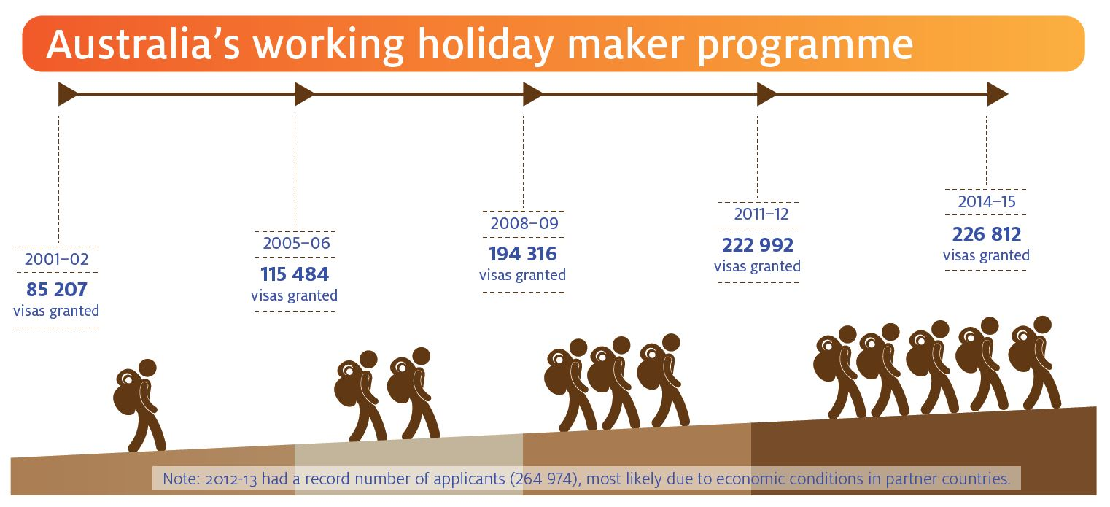[18]

The Inquiry notes that the current design of the program means 417 visa holders who choose to work throughout their stay are required to work for at least two different employers over the course of one year. That is, a 417 visa holder is prohibited from working for the one employer for longer than six months. This restriction reflects the dominant purpose of the program; the 417 visa facilitates short term employment in order to supplement the visa holder’s travel funds.

In November 2005, an option was introduced allowing 417 visa holders to extend their stay in Australia for a second year if they undertook three months (or more specifically, 88 days) of ‘specified work’ (see Appendix 2) in regional Australia[19] during the first year of their visa.

While the public policy intention of the 417 visa remained, and remains, one of cultural exchange, the ‘second year’ option was introduced in part to address identified labour shortages in regional areas and more specifically the horticulture industry[20]. That is, the 88 day period did not and does not need to be with one employer or entity but ‘specified work’ was, and is, restricted to the agriculture, mining and construction industries.

The ‘country of origin’ profile of the 417 visa holder has changed since the inception of the program. For instance, in 1975, the WHM program was only open to nationals of the United Kingdom, Ireland and Canada.

Expansion of partnerships with other countries in the WHM program has occurred over time and continues today (for example, the recent inclusion of citizens of China in the 462 visa as part of the China-Australia Free Trade Agreement). In recent years there has been a rapid increase in applications and visa grants for 417 visa holders from Asian countries. For instance, as at 31 December 2014, Taiwanese citizens were the highest users of the second year 417 visa, followed by the United Kingdom and then South Korea.

The Inquiry notes one possible cause for the enhanced interest from young Taiwanese and South Korean workers could be linked to the substantially lower minimum wage frameworks in both countries[21].

In the 2013-2014 financial year, DIBP granted 183 428 sub class 417 visas. Of this number,   
45 950 were ‘second year’ visas representing an 18.2% increase from the previous financial year.

In the 2015-2016 financial year, a total of 214 583 WHM visas were granted, a 5.4% reduction compared to the corresponding period in 2014-2015.

There was an 8.1% reduction in first year 417 visa grants to 159 409 and a 12.3% reduction in second year 417 visa grants to 36 264 in the 2015-2016 financial year. However, 462 visa grants increased 57.8 over this time to 18 910.[22]

At 30 June 2016, the total number of WHM in Australia was 137 376, a 4.5% reduction compared to 30 June 2015.[23]

As part of the 88 days of specified work, 417 visa holders are required to provide evidence to DIBP, including an Employment Verification Form (EVF) signed by an employer, confirming specified work has been undertaken. However, there is no legal or statutory requirement for an employer to sign the EVF and there are no penalties for employers who refuse to sign this form in a situation where a visa holder has in fact completed these work requirements.

Significantly, from 1 December 2015 there is an obligation for 417 visa holders to be paid for the performance of any specified work (sub-item s417.211-(5)(c) of Sch 2 of the *Migration Regulations 1994 (*Migration Regulations)*)*[24]. This regulatory change was announced by the then Assistant Minister for Immigration and Border Protection, Senator the Hon Michaela Cash, on 1 May 2015, where she explained that ‘*the current arrangements can provide a perverse incentive for visa holders to agree to less than acceptable conditions in order to secure another visa*’[25].

Consequently, 417 visa holders seeking to obtain a second year visa must now provide DIBP with evidence that the specified work undertaken was paid, including by providing pay slips disclosing that ‘the pay was in accord with the basic pay entitlements employees should receive when working in Australia*’[26]*. The new regulations do not place any additional onus on the employer and all evidentiary burdens still remain with the visa holder in order to obtain a second year visa.

The Inquiry notes that DIBP does not conduct any monitoring activities of employers of 417 visa holders, nor are there any legislative consequences under migration laws for any contraventions of workplace laws. All obligations and any resulting penalties/punishments fall to the 417 visa holder, therefore increasing the power imbalance and vulnerability in these relationships. This can be compared to employers of 457 visa holders who are monitored by DIBP and can face consequences for non-compliance, such as not being able to continue to access the pool of labour of 457 visa holders.

On 17 May 2016, the Prime Minister of Australia, the Hon Malcolm Turnbull MP, announced a review (the Government Review) into 417 and 462 visa use, specifically to address the issue of labour supply for the agriculture and tourism sectors with a focus on the short and long term needs of these business sectors[27]. In this announcement, the Prime Minister stated the ‘Government *had listened to issues raised by stakeholders about workforce challenges faced by industries such as agriculture and tourism’*[28]. On 27 September 2016, the Treasurer, the Hon Scott Morrison MP announced a proposal which subject to the passage of legislation seeks to set, from 1 January 2017, the tax rate applying to working holiday makers at 19 per cent on earnings up to $37,000. Of particular significance to this Inquiry, the Australian Government further proposes to require employers of 417 visa holders to undertake a ‘once off’ registration with the ATO, signalling employers who do not register will be required to withhold tax at the 32.5% rate[29].

Additionally, the application charge for 417 visa holders will reduce by $50 to $390, the age cap for eligible applicants will be increased from 31 to 35 years of age and 417 visa holders will be permitted to remain with one employer for up to 12 months, provided the second six month period is worked in a different location[30].

On 4 October 2016, Senator the Hon Michaelia Cash, announced the formation of a Migrant Workers Taskforce. Comprised of senior representatives from a number of Commonwealth departments and agencies, the Taskforce will be chaired by Professor Allan Fels AO and provide expert advice on measures that will deliver better protections for overseas workers.   
  
Of significance to this Inquiry, the Taskforce Terms of Reference detail how it will identify regulatory and compliance weaknesses that create conditions that allow exploitation of migrant workers; develop strategies and make improvements to stamp out exploitation; and consider ways agencies can better address and collaborate to address, avoid or rectify systemic and/or widespread exploitation of migrant workers.[31]

## Inquiry methodology

The FWO conducted the Inquiry relying upon powers contained in subsections 682(1)(b) and 1(c) of the FW Act. These provisions allow Fair Work Inspectors (FWIs) to conduct monitoring, inquiry and investigation activities.

During the course of and following the completion of the Inquiry there were a number of developments impacting the visa program. These included a Senate Inquiry into temporary work visas[32]; the new requirement for 417 visa holders to undertake ‘paid’ work in order to fulfil the 88 day specified work requirements[33]; the requirement to provide evidence with the second year visa application in the form of pay slips[34]; proposed changes announced on 27 September 2016 to the tax treatment of wages earned by 417 visa holders[35]; and a Government review of the WHM visa program[36].

It should also be noted that in August 2013, the FWO commenced a three year inquiry into employment arrangements along the ‘Harvest Trail’. The objectives of the Harvest Trail Inquiry included enhancing deterrence at the sub-sector and geographic level by tailoring a series of education and compliance activities in the seasonal fruit and vegetable harvests with an overarching aim of ensuring workers in fruit and vegetable picking jobs receive their correct minimum employment entitlements.

While distinct from this Inquiry, the Harvest Trail Inquiry is related insofar as the nature of the 88 day specified work requirement makes work picking fruit and vegetables on the Harvest Trail a common choice for 417 visa holders. Growers also rely heavily on this workforce to meet their seasonal requirements for labour. This labour is often sourced through labour hire arrangements, and a critical part of the Harvest Trail campaign has been to work with growers and their representatives to ensure they apply due diligence to the operators from which they are sourcing their workers. The Harvest Trail Inquiry is expected to report its findings in 2017[37].

The FWO commenced the 417 Inquiry by sourcing data from DIBP to assist in the identification of employers who were ‘signing off’ on specified work during the 2013-2014 financial year.

Following analysis of this data, the Inquiry engaged with employers who were high users of the program in regional areas and had a documented history of sourcing labour from 417 visa holders undertaking the 88 day specified work requirement[38].

The Inquiry also extensively engaged with key stakeholders across NT, QLD, NSW, TAS, SA and VIC such as unions and employer groups, community groups, local councils, government bodies, as well as businesses active in providing services to ‘backpackers’.

As part of the Inquiry’s community engagement strategy members of the FWO’s Overseas Workers Team and Media Team undertook a media roadshow through Cairns, Darwin, Alice Springs, Byron Bay, Lismore, Gympie and Maroochydore. These areas were identified by DIBP as high users of 417 visa holder labour[39].

The media roadshow aimed to raise awareness of the Inquiry among key stakeholders in specific regional areas which attract high numbers of 417 visa holder workers. Media coverage focused on the Inquiry’s role, purpose and how people could engage with and provide feedback to the Inquiry.

In Northern Australia, media engagement was undertaken through a number of channels including community radio and local newspapers across Cairns, Darwin and Alice Springs reaching a potential readership of 360 000.

Media coverage in Northern NSW and Southern Queensland reached more than 145 000 people through print coverage, more than 438 200 people through radio and television broadcasts and potentially millions online.

Meetings were held with the Canadian, South Korean, Irish, French and British consulates, as well as the Taipei Economic and Cultural Office. The FWO presented to the Consulate Working Holiday Working Group attended by 21 consular representatives from France, Canada, Italy, Germany, South Korea, Holland, the UK, the People’s Republic of China and the US.

**Case study:** **FWO collaboration**

The Inquiry engaged with the Taipei Economic and Cultural Office[40] who frequently contact the FWO requesting assistance for their citizens.

The Office has developed workshops to educate citizens on their rights while travelling and working within Australia. The Office has also developed materials to be distributed at Universities in Taiwan to provide information for young people planning to travel to Australia.

Bilingual FWIs have presented at a number of events organised by the Office and during the course of the Inquiry, the Director of the FWO’s Overseas Workers’ Team presented at the Australian Taiwanese Women’s Association in Sydney as a key note speaker.

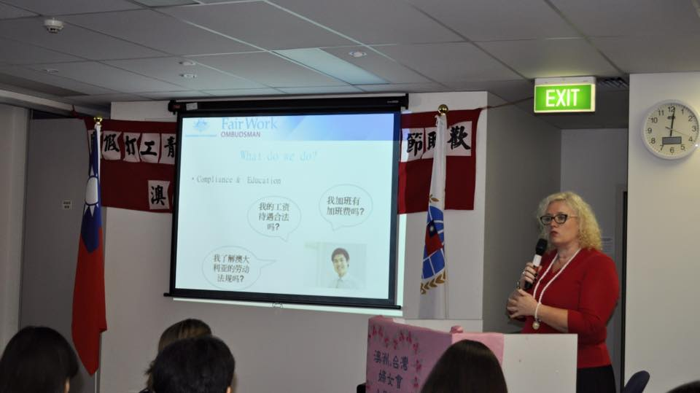  
  
FWO’s Director Overseas Workers Team presents to Australian Taiwanese Women’s Association

## The Inquiry’s survey

As part of its work, the Inquiry commissioned a mass survey of 43 219 sub class 417 visa holders who had been granted a second year visa in the 2013-2014 financial year.

The objective of the survey was to source feedback from a wide range of 417 visa holders to better understand their experiences of the program and identify key trends. Accordingly, the survey was offered in Korean, Italian and Chinese as well as English. The research was able to quantify certain measures around the 417 visa including a profile of where the visa holders worked, what work they carried out and their experiences of the work. In some instances, the information was able to assist the Inquiry in identifying areas or situations where non-compliance with the FW Act was occurring. Dimensions such as rating of the overall regional working experience, satisfaction with pay and satisfaction with accommodation were also determined through the research, thus providing the Inquiry with a greater understanding of the experiences of 417 visa holders in a broader context.

Of the 43 219 visa holders who were sent an email, the survey had a response rate of 9.4% (with 4,056 individual visa holder responses received).

Other than the 88 day work requirement to obtain a second year visa and the rule prohibiting a 417 visa holder from working for more than six months work with the same employer, 417 visa holders’ work requirements / obligations are not regulated. During any work done outside of the 88 day second year visa qualifying period, there is no requirement, for example, for visa holders to report on where they are employed and no monitoring or reporting obligations specific to the 417 visa are required by employers. Once the 417 visa is granted, immigration monitoring is limited.

Following changes to the Migration Regulations[41] since the commencement of the Inquiry, visa holders are now required to provide pay slips and evidence of paid work with the second year visa application, following the completion of the 88 day work requirement.

Three in 10 survey respondents (28%) did not receive payment for work undertaken, and yet, many of these felt that their situation was perfectly acceptable as food and accommodation was provided, though not necessarily in accordance with the laws that relate to deductions from wages.

The survey results identified that a significant proportion of the 417 visa holder cohort from across all cultural and language backgrounds was not aware of and did not hold a basic understanding of what conditions to expect when working in Australia. Participants, often vulnerable and in the main from non-English speaking backgrounds with significant cultural differences to the host country, are exposed to rogue employers looking to gain a competitive edge or commercial advantage through the reduction of a business’ most significant expenditure - labour costs.

The survey found that almost two in five (38%) of 417 visa holders were positive about their regional work experiences, describing them as excellent or very good. Just over a third (35%) described their experiences as fair or poor.

Overall, nearly half (46%) of survey respondents said they would be very likely or quite likely to undertake regional work even if it was not a requirement to obtain the second year visa. When asked how likely they were to recommend the first or second year 417 visa to friend or family, 86% said they would be very likely or quite likely to recommend the first year visa and 68% would recommend the second year visa.

While the survey respondents reported a satisfactory experience, the information also identified some very negative experiences for a number of this visa group. This shows there is a cohort of particularly vulnerable individuals within this group being exploited by deliberate and unscrupulous operators.

## Inquiry findings

#### The ‘backpacker industry’

The ‘backpacker industry’ is a significant component of labour provision in regional Australia and incorporates a range of participants including businesses, hostel owners, YHA Australia and private agencies assisting visa holders in finding work.

The Inquiry met with a range of stakeholders in this subsector who expressed generally positive views about the 417 visa program, especially the program’s facility of overseas workers experiencing regional Australia and interacting with rural communities. This view was held for instance by organisations such as ‘Australian Backpackers Work and Travel’ and ‘Travellers Contact Point,’ who assist 417 visa holders to source work. Other stakeholders such as the National Farmers Federation have identified the program as a key driver to the economic success of backpacker tourism[42]. According to one source, around 40 000 417 visa holders are employed on farms[43] and are vital to the maintenance of rural industry and the regional and rural economy.

The Inquiry confirmed that the architecture of the 417 visa program encourages visa holders to leave the cities and travel to rural and regional Australia, which in turn has benefits for the broader economy and tourism industry.

The Inquiry found high satisfaction ratings with the 417 visa program from employers such as Nolan Meats Pty Ltd, Dole Australia Pty Ltd and Paspaley Pearling Company Pty Ltd who considered the cohort of 417 visa holders to be a ready and reliable pool of workers in regional areas. Comments made to the Inquiry included, for example, that 417 visa holders were ‘less likely to resign without notice’[44].

The Australian Meat Industry Council (AMIC) shared its view that regional businesses found it difficult to engage local labour as locals did not like the work needing to be performed. This sentiment was expressed to the Inquiry by a number of employers who asserted that locally sourced labour was often either reluctant or unwilling to undertake the labour intensive and low skilled work involved in the horticulture and agriculture sectors. Accordingly, these employers and employer groups expressed strong support for the 417 visa program.

The Upper Hunter Shire Council (UHSC) informed the Inquiry overcrowding of residential premises was a significant community issue. The UHSC commenced activities through community engagement and media release initiatives, warning proprietors and occupants of the illegal use of premises for the purpose of a boarding house or backpackers accommodation.

The UHSC also informed the Inquiry that Fire and Rescue NSW, in conjunction with UHSC, conducted a community engagement project specific to the Meat Manufacturing and Processing Establishments (MMPE) educating migrant workers on the dangers of living in overcrowded conditions, following a spate of fires in share-house accommodation in Scone, NSW. The UHSC noted one migrant worker who was living in a share-house garage sustained injuries from a fire, resulting in the worker being airlifted for medical treatment.

When speaking with various consulates, it was noted some 417 visa holders regarded the visa as a pathway to Australian permanent residency, demonstrating that economic factors in the country of origin have impacted and influenced the numbers of workers applying for a 417 visa.

Common themes of concern with the 417 visa program arising from engagement with consulates disclosed 417 visa holders were:

* reluctant to report unsafe working conditions, sexual harassment or underpayment of minimum entitlements for fear that employers would deny that the 88 day specified work requirement had been undertaken
* most vulnerable to exploitation in Australia when they were:
  + not aware of their minimum lawful wage and conditions entitlements
  + without sufficient funds
  + undertaking the specified work toward the end of the first year
* more likely to seek assistance from consulates in situations where they have not obtained travel insurance or where employers or hostels hold passports without authority.

The Inquiry also engaged with a number of employee associations representing workers in this sub-sector.

#### 417 visa holders – target for exploitation?

The Inquiry engaged with a number of Unions, including the Australian Meat Industry Employees Union (AMIEU) which expressed its concern a significant number of 417 visa holders working in the meat industry were being exploited by unscrupulous labour hire intermediaries.

The AMIEU maintained businesses at the top of the labour supply chain were, and are, turning a ‘blind eye’ to phoenixing patterns exercised by labour hire entities involved in various sub-contracting arrangements. The AMIEU informed the Inquiry that from its experience, exploitation was more evident in the poultry processing industry as opposed to the ‘red meat’ industry.

Similarly, employers, particularly in the ‘red meat’ industry, raised concerns about the widespread use of third party labour hire contractors and processing plants paying the correct rates to the principal contractors however, these wage rates were being compromised as they moved down the labour supply chain.

In response to these concerns, the Inquiry targeted three MMPEs identified through DIBP data as registering within the top five entities signing off on specified work for 417 visa holders in SA, NSW, and Vic:

* G & K O'Connor Pty Ltd (G & K O’Connor) located in Pakenham, Victoria
* Thomas Food International Pty Ltd (Thomas Foods) located in Murray Bridge, South Australia
* Hunter Valley Quality Meats Pty Limited (Hunter Valley) located in Scone, New South Wales – now owned by JBS Primo.

The Inquiry obtained details of the contractors supplying 417 visa holders to the MMPEs and records were sourced for a sample period of February 2015 (the sample period). In addition, meetings were undertaken with the contractors to better understand their experiences in sourcing and supplying labour from the 417 visa holder cohort and the labour supply processes.

The MMPEs informed the Inquiry they relied on the 417 program to meet fluctuating staffing requirements and would like the program to provide a pathway to 457 visa sponsorship rather than restrict workers to six months with the one employer.

One MMPE commented that the nature of the 417 program means that after six months, a 417 worker moves to another MMPE and after completing their second year visa, returns to their country of origin and invests their wages earned rather than investing the money back into local Australian communities. The MMPE suggested that providing an automatic pathway to 457 visa sponsorship would significantly benefit local communities.

An MMPE told the Inquiry they relied heavily on labour hire companies to source labour as they had a greater ability to source foreign workers nationally and internationally as well as move workers between MMPEs seasonally or after the six month work limitation.

The Inquiry found of the 11 principal contractors identified across the three MMPEs, four subcontracted the supply of labour to other contractors in breach of their contractual obligations with the MMPEs. These principal contractors provided no direct employees and the Inquiry found on two occasions, two of the second tier contractors further subcontracted the supply of labour providing no direct employees to the tier above them[45].

**CASE STUDY: Supply chain issues**

**NRL International Pty Ltd engaged by Thomas Foods**

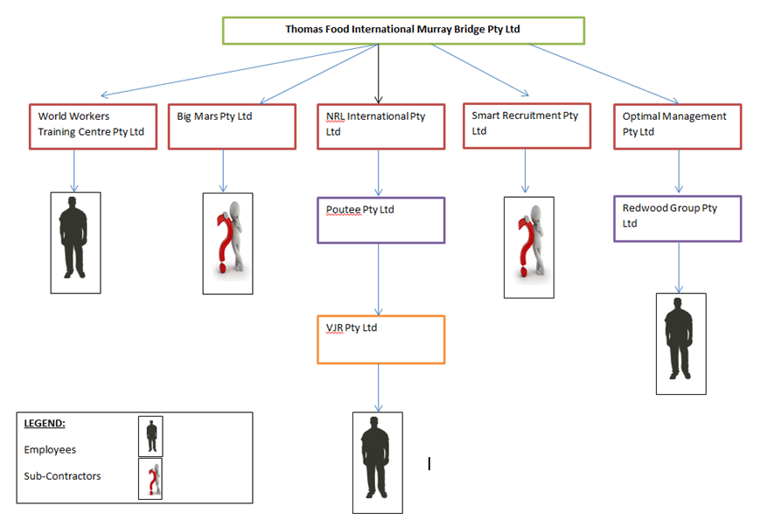

NRL International Pty Ltd (NRL International) was one of five entities contracted directly by Thomas Foods to provide labour. NRL International did not directly engage any employees to work at Thomas Foods and instead subcontracted to Poutee Pty Ltd (Poutee).

The Inquiry met with the director of NRL International who advised that she was unaware of where the 417 visa holders engaged to work originated from, how they were sourced, what checks were undertaken, how the workers had been paid, what amounts they were paid or if pay slips were provided. The director also informed the Inquiry that she did not undertake any audits to confirm how Poutee was engaging workers or whether they were paying workers in accordance with the applicable industrial instrument.

The Inquiry further identified that Poutee subcontracted to another entity VJR Pty Ltd which did not engage with the Inquiry by failing to respond to a Notice to Produce Records or Documents and other requests for information from the FWO.

When the Inquiry first met with Thomas Foods, it advised it was unaware of the NRL International supply chain.   
  
In a subsequent meeting, Thomas Foods advised it was taking a number of steps including auditing its labour hire providers to ensure compliance with workplace laws and to ensure these entities were not engaging in tiered sub-contracting.   
  
Thomas Foods told the Inquiry that it had introduced induction packs for workers translated into 15 different languages, and it now issues the Fair Work Information Statement to all workers regardless of whether they are directly employed or engaged by a labour hire company.   
  
Thomas Foods informed the Inquiry that it had increased its governance since the release of the FWO’s Baiada Inquiry Report. Revised systems and processes had also been implemented to ensure compliance with the FW Act.

In instances where 417 visa holders were engaged as employees, the Inquiry found four of these employers were paying 417 visa holders full-time rates, however, there was no evidence of the workers receiving associated full-time entitlements such as annual leave.

As evidenced by the Inquiry’s survey, 417 visa holders are often unaware of their minimum entitlements making them vulnerable to underpayment or non-payment of entitlements.

**Case study: the sub-contracting layers**

Optimal Management Pty Ltd (Optimal) and Redwood Pty Ltd (Redwood) both supplied labour to Thomas Foods.

Based on the records and documents provided to the Inquiry by Optimal, it was identified Optimal sub-contracted the supply of all its labour to Redwood.

The director of Optimal informed the Inquiry that he initially sourced and supplied skilled labour through the 457 visa program but when Thomas Foods asked him to supply 417 visa holders, he contracted Redwood as the direct employer of the labour. He advised he only takes a small percentage as commission to ensure Redwood pays employees correctly.   
  
The director of Redwood previously supplied labour through the entity Global HR Net Pty Ltd to Optimal at the Baiada Tamworth Plant. As part of the FWO’s Baiada Inquiry activity he received a letter of caution and two infringement notices in relation to his practice of engaging employees in sham contracting arrangements and record keeping breaches. The director told the Inquiry that as a result of these previous interactions with the FWO he now only engaged and paid workers as direct employees. At the time of the Inquiry Redwood engaged ninety 417 visa holders at the Thomas Foods site.

Redwood advised the 417 visa holders were engaged on a full-time basis and paid full-time rates but do not receive other entitlements such as annual leave and personal leave. Redwood further advised the Inquiry based on the rates provided by Optimal, it could not afford to pay the applicable casual rates.

The records provided to the Inquiry identified Optimal paid Redwood $26.98 per hour and a total of $19.40 per hour was then paid to the employees. Casual employees are entitled to at least $21.60 in accordance with the Modern Award. Both entities are still registered and the FWO issued a Letter of Caution to Redwood in relation to the non-compliance and informed the MMPE of the findings.

#### The issue of sham contracting

The Inquiry found of the 11 principal contractors identified in the labour supply chains of the MMPEs, four supplied no employees. Instead, all 417 visa holders working as boners, packers and slicers were engaged as independent contractors. It was the Inquiry’s view the workers had been misclassified as independent contractors when they were in fact employees.

Of significant concern, the Inquiry found that an individual who is a respondent in a current FWO litigation, against Raying Holding Pty Ltd (the Raying litigation), Mr Zu Neng Shi (Scott Shi) was linked to a number of entities contracted to perform work for the MMPEs. In the Raying litigation, the FWO has made allegations concerning Mr Shi’s involvement in sham contracting contraventions. He denied those allegations at a contested hearing and judgment is reserved.

A principal contractor, Big Mars Pty Ltd (Big Mars) was identified as engaging 417 visa holders as independent contractors and supplying their labour to Thomas Foods. The FWO identified Mr Shi as one of the authorised signatories on the bank account for Big Mars and the second signatory as Mr Quanfa Shi, director of the contractor Ezyrol Trading Pty Ltd (Ezyrol Trading) which supplied labour, classifying its workers as independent contractors, to the MMPE G & K O’Connor.

The Inquiry found the workers in this situation were not paid superannuation, tax was not deducted from wages and the workers were required to provide ABN. The workers were paid flat rates of pay between $22 and $28 per hour which was above the applicable minimum rates in the Modern Award, however, the workers did not receive overtime or penalty rate entitlements for working up to 50 hours each week.

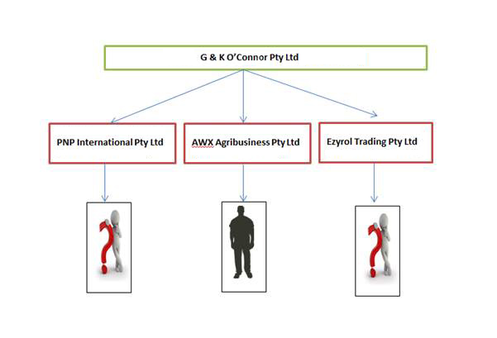

The Inquiry also met with 417 visa holders engaged by a contractor Rocube Pty Ltd (Rocube) performing work at the Thomas Foods site. The MMPE informed the Inquiry Rocube was an entity made up of two previous entities supplying labour at the site, Big Mars and Smart Recruitment Pty Ltd (Smart Recruitment). Both Smart Recruitment and Big Mars failed to engage with the FWO’s requests for information during the Inquiry.

During the course of the Inquiry, FWIs observed that as a result of FWO advice, monitoring and investigation activities, practices which may have amounted to sham contracting or misclassification at the three MMPEs appeared to cease, with 417 visa holders now being engaged as employees.

For instance, the Inquiry engaged with Hunter Valley Quality Meats Pty Ltd which was owned and operated under Primo Meats Pty Ltd (Primo Group). The Primo Group was sold to JBS Australia Pty Ltd (JBS Australia Pty Ltd) in March 2015. JBS Australia representatives met with the FWO in April 2015 and advised that it had ceased contracting for the supply of labour and ensured all 417 visa holders were now engaged through direct employment relationships only.

The FWO issued Letters of Caution to a range of entities in the various labour supply chains and investigations are ongoing with respect to allegations of serious non-compliance.

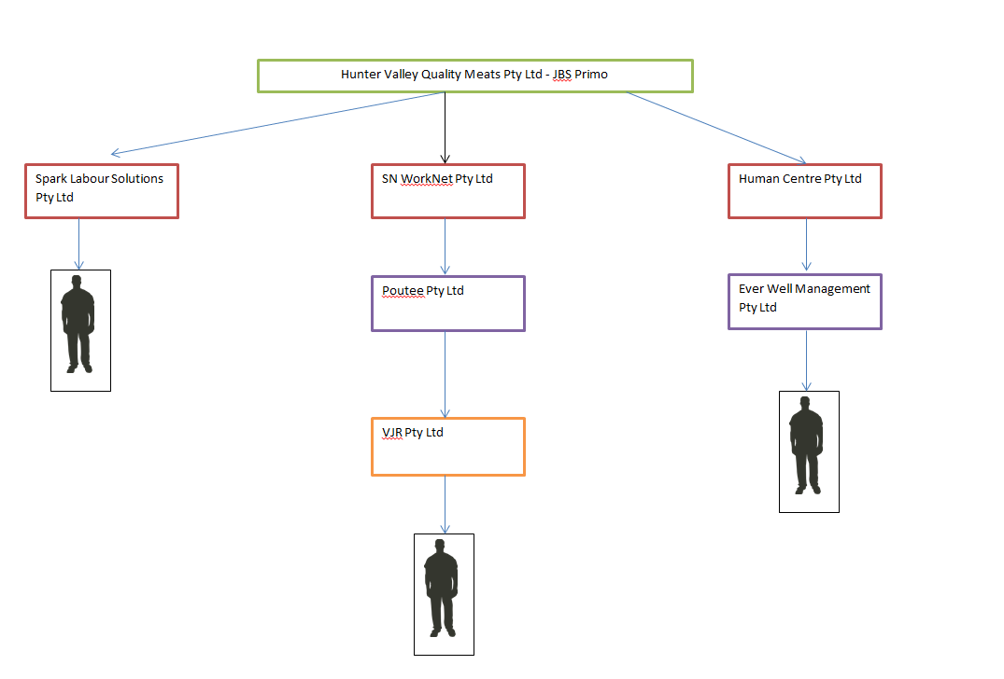

The Inquiry encountered difficulties in locating and contacting representatives of certain contractors in the supply chains. On repeated occasions FWIs attended registered business premises and principal places of business (as identified in Australian Securities and Investment Commission (ASIC) records) only to discover there was no business being conducted at those premises.

The FWO will be making referrals to ASIC in this respect given the potential breaches of Part 2B.5 of the *Corporations Act 2001.*

#### The issue of vulnerability

The Inquiry confirmed the FWO’s experience that visa holders engaged as employees in Australia are a vulnerable group due to cultural and language barriers, suspicion of government, little or no knowledge about their workplace rights and obligations and a lack of understanding about how to enforce these rights or where to find the assistance to do so[46].

The vulnerability of these visa holder workers is compounded when they are not aware of their rights, often coming to Australia from countries with differing legal standards and affording different standards of minimum workplace protections. The FWO’s experience shows that overseas workers, particularly those on 417 visas, are more vulnerable to exploitation. These workers typically find understanding and exercising their workplace rights difficult because of age and language barriers, the remoteness of their working location and their dependence on the employer to obtain eligibility for a visa or extension[47].   
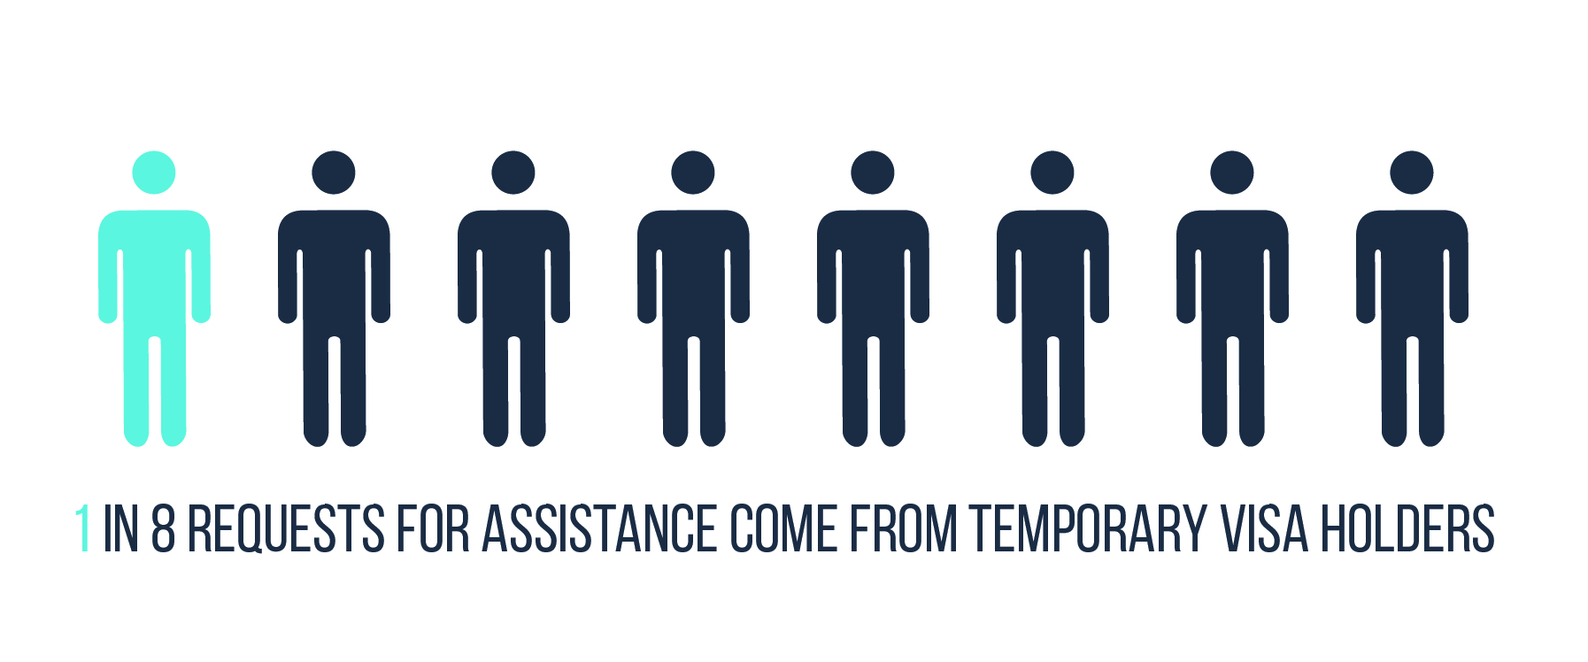

One in eight of the requests for assistance received by the FWO come from temporary visa holders and in the 2015-16 financial year, 45% of those requests originated from 417 visa holders. In addition to requests for assistance, the FWO has increasingly received information from visa holders, stakeholders and the public identifying concerns with exploitation of 417 visa holders.  
  
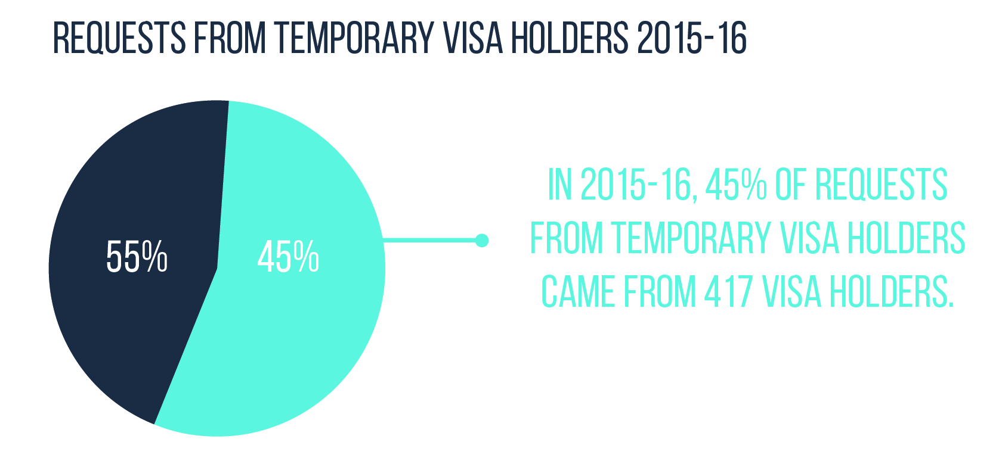  
Concerns identified by the FWO include:

* underpayment and/or non-payment of wages
* visa holders offering (or being induced to offer) payment to employers and third parties for assistance to gain a second year work rights visa
* an increased power imbalance between the employer and the visa holder seeking employment during the 88 day specified work requirement of the 417 visa program
* exploitation across jurisdictions outside of the remit of the FWO, including sexual harassment and WHS concerns
* employers recruiting workers with the offer of unpaid work to meet the second year visa eligibility requirements
* visa holders working in exchange for non-certified accommodation programs.

The high levels of vulnerability created by the 88 day specified work requirement of the 417 visa arguably has implications and consequences for visa holders beyond that of non-payment and underpayment of wages, for instance, WHS. In relation to WHS, the Australian Meat Industry Council (AMIC) informed the Inquiry it held concerns with the safety of workers both on and away from worksites.

The Inquiry notes a visa holder’s poor English language ability not only increases their vulnerability in the Australian labour market, but also their exposure to adverse health and safety situations, particularly those involved in labouring work requiring the use of heavy machinery.

With respect to the issue of a ‘power imbalance’, the Inquiry’s findings confirmed a temporary visa holder carries an additional burden of vulnerability in the workforce for the reasons detailed above.

In general, ‘vulnerability’ creates the settings for exploitation, specifically, the increased vulnerability of 417 visa holders provides opportunities for the power-holder to place unreasonable and unlawful demands on the visa holder. The Inquiry’s survey found 59% (2 596) of respondents stated they were unlikely to complain about their working conditions in case their work was not signed off by the employer and 66% (2 904) felt employers take advantage of 417 visa holders due to the requirement to undertake regional work. The Inquiry disclosed many instances of visa holders finding themselves in a situation where agreement to the conditions imposed by an employer is not optional. Moreover, when the 417 visa holder is required to complete 88 days of specified work, the power imbalance is at its greatest and creates opportunities for exploitation.

For instance, the Inquiry found visa holder workers at a strawberry farm in Caboolture, Queensland, were employed as ‘casual labour’ but nonetheless required to give ‘7 days’ notice’ to end their employment or the employer would not ‘sign off’ the Employment Verification form. This is significant as a worker engaged on a casual basis has a number of different employment conditions to workers engaged on a full- or part-time basis. One major difference between the employment rights and obligations of a casual employee is they are not required to provide notice when ending their employment[48]. Consequently, the notice displayed at this farm amounts to a misrepresentation of workplace laws to workers, who the Inquiry research identified, often have very limited or no knowledge of their workplace rights.

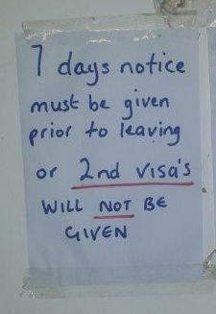

**Case study: the power imbalance**

In response to 12 requests for assistance, 11 of whom were 417 visa holders undertaking specified work to obtain their second year visa, the FWO commenced an investigation into a labour hire intermediary operating in the Northern Territory.

Engaged to perform pruning, weeding and fruit picking duties across four mango orchards in Darwin’s rural area, FWIs found that the workers were allegedly paid amounts which, when averaged across the hours worked, were equivalent to hourly rates ranging between $2.74 per hour to $4.79 per hour. Some were allegedly not paid at all.

The employer also allegedly failed to issue pay slips.

The total alleged underpayment identified for the 12 workers was $35 630.26. The employer failed to rectify the underpayment.

The FWO has commenced proceedings in the Federal Circuit Court in relation to its findings.[49]

The Inquiry found a number of other instances where employers of 417 visa holders exploited the visa holder’s vulnerability by advertising a job on a website such as Gumtree suggesting the job would secure a ‘second year visa’. The employer would then impose unlawful demands such as requesting money for the job or accommodation that did not exist, or indeed asserting the work would be considered ‘voluntary’ and thus withholding any remuneration.

**Case study: the second year visa promise**

The FWO commenced an investigation following identification of the following advertisement posted on Gumtree:

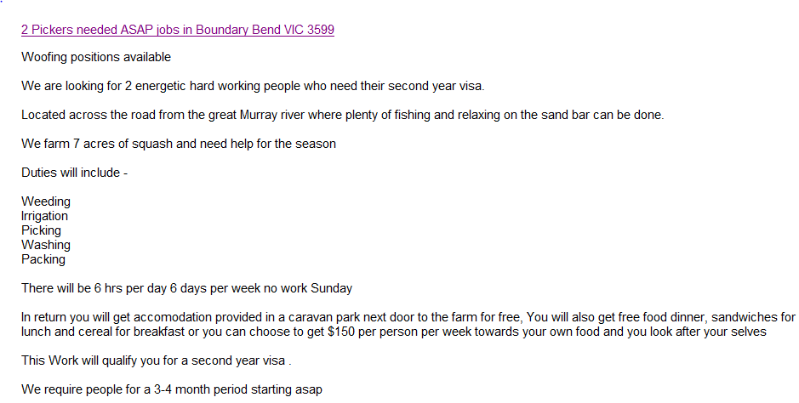

The investigation found workers were paid $10.00 per hour for work performed and were not provided with pay slips.   
  
Records provided by the employer identified an underpayment of $5 546.65 for nine workers who were not paid the correct minimum hourly rate of pay. In addition, pay slips had not been issued as required.

The investigation secured full rectification of the underpayment and a Letter of Caution was served on the employer. An Infringement Notice for an amount of $170 was also served and paid in relation to failure to provide pay slips.

As a vast and relatively sparsely populated country, work in Australia’s regional areas can equate to working in very remote locations with very limited or no contact due to limited phone and internet coverage. While this may be an enticement for adventure, the Inquiry concluded that such isolation also creates an additional level of vulnerability, especially for the lone backpacker.  
  
Safety concerns are raised where young, especially female, travellers with limited English, and who often travel alone, are encouraged through the 417 second year visa requirements to travel to remote areas to undertake specified work.

The unintended consequence of the increased vulnerability through isolated work in regional areas was witnessed and documented in an ABC publication *From sexual harassment to being underpaid – I’ve now seen how the work-for visa system is broken[50].*

*“I could not sleep that night, because the male farmer had threatened to pay me a ‘surprise’ visit”[51].*

#### The issue of unpaid work

The Inquiry identified a number of businesses, who prior to the introduction of the paid work requirement[52], were signing-off on the specified work requirement of the 417 visa program in exchange for ‘unpaid’ work.

The law requires where an employment relationship exists, the worker must be paid according to law and in accordance with the worker’s minimum entitlements. Unpaid work arrangements are only lawful where they meet the requirements of formal internships / vocational placements or are genuinely ‘volunteering’ positions[53].  
  
Commonwealth workplace laws, and industrial awards made under those laws, do not distinguish between the national system employees who are Australian citizens and national system employees who hold visas to perform work in Australia.

The threshold question therefore is whether a worker is, or is not, an employee.

There is no single factor that, in isolation, can determine whether a worker should be more appropriately classified as an employee or a volunteer, an intern or an independent contractor. Rather, to determine whether a workers is, overall, more likely than not to be an employee it is necessary to assess each specific engagement and consider the totality of the working relationship.

The courts will consider a number of characteristics of a working relationship collectively to determine, firstly, whether there is a contractual relationship between the parties, and secondly (if a contractual relationship does exist) to determine if that relationship is one of employment.

In then determining whether a contract of employment is in play (as opposed to an independent contracting relationship, for example), the law applies a ‘multi-factor test’. In applying this test, examination of various features of the arrangement is required, such as the degree and nature of control exercised over the worker, the mode of remuneration, responsibility for the provision and maintenance of tools or equipment, the extent of the obligation to work for the organisation, and any capacity for workers to delegate work to others[54].

The Australian Government’s announcement[55] to review the 417 visa program highlights a tension between the public policy intention of the visa program as a ‘cultural exchange’ and the use of the visa program as source of labour.

In response to the Inquiry’s survey questions regarding the ‘overall experience’ of undertaking regional work, 4 044 visa holder responses showed:

* 38% of visa holders (1 537) reported it was ‘positive’
* 35% of visa holders (1 416) reported it was ‘fair or poor’
* 28% of visa holders (1 132) reported they did not receive payment for some or all of the work they did.

A third of those who did not receive any payment for work, that is, 259 visa holders out of 700, (including around 50% of visa holders who had participated in alleged volunteer schemes) reported despite not receiving any monetary remuneration, they were satisfied with the arrangements they had entered into.

In exploring this question further, the Inquiry found 47% of visa holders surveyed responded if it had not been a requirement to undertake regional work in Australia they would ‘not likely’ have undertaken such work.

Similarly, while 86% of visa holder respondents stated they would be ‘very’ or ‘quite likely’ to recommend the first year of the 417 visa program experience, only 68% reported they would be ‘very’ or ‘quite likely’ to recommend the second year of the 417 visa program.

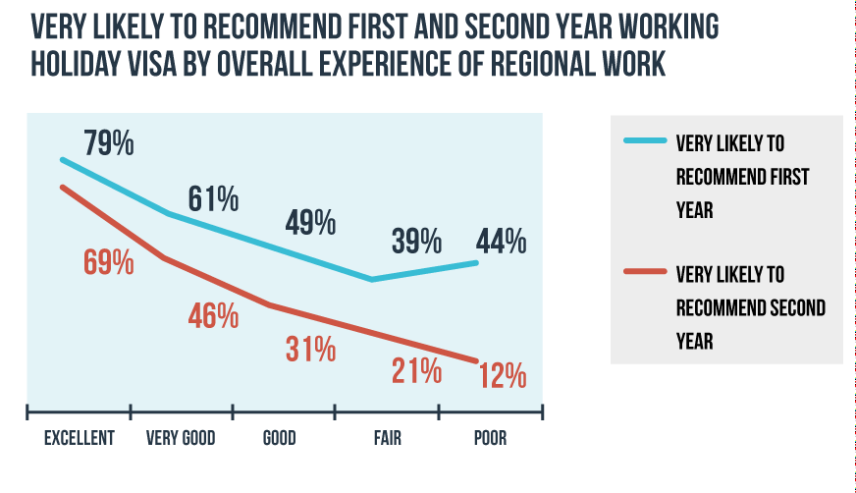

The Inquiry found numerous instances of 417 visa holders not receiving any remuneration for work performed as employees.

**Case study:** **unpaid work**

The Inquiry investigated a business based in northern NSW that grows and supplies cucumbers to Coles and Woolworths via an agent and sells produce directly to local stores.

In 2015, the business was identified as one of the top five businesses sourcing labour from the 417 visa program in New South Wales and signing off the ‘specified work’ requirement. In the financial year 2014-2015, the business signed off 171 forms facilitating a second year 417 visa.

The Inquiry first visited the business in April 2015 and found out of a total workforce of 15-20 people, they were all 417 visa holders on unpaid arrangements; providing food (no meat) and accommodation (10 caravans, two people per caravan), training and limited transport in exchange for signing the EVF for specified work. The FWO provided advice and assistance to the Director in regards to ensuring compliance with the FW Act.

Following the Government’s changes to regulations (see Background on page 8 and Impact of Migration Regulation Changes page 41) requiring payment for specified work, the Inquiry re-visited the business (in February 2016) and found 417 visa holders working at the business were receiving pay slips identifying payment of $17.29 per hour (the applicable minimum rate at the time). However, the business was withholding its employees’ total wages to cover food and accommodation. The FWO also found workers were receiving cash-in-hand payments for any work performed in addition to 40 hours per week.

Despite the director’s knowledge of the changes to the migration regulations and related obligations under the FW Act, on 25 December 2015, the business posted the following job listing on the Gumtree website:

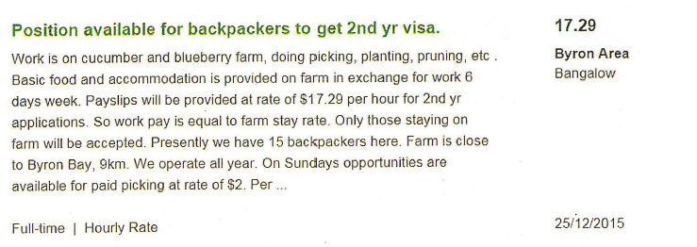

In the course of the Inquiry’s second visit, the director admitted to FWIs, that pay slips were only provided to 417 visa holders at the end of their 88 day term to comply with the regulatory requirements. The director further advised the pay slips were not accurate and advised the 417 visa holders, at the commencement of their employment, the food and accommodation was of equal cost therefore they would not (and did not) receive wages.

The director asserted without the benefit of unpaid labour, the business would not be able to grow and sell cucumbers profitably.

The FWO is continuing its investigation into these arrangements and any potential contraventions of the FW Act.

The Inquiry found 45% of 417 visa holder survey respondents who did not get paid undertook their specified work through a volunteer or exchange scheme.

The Inquiry identified a significant number of 417 visa holders were registered with one such volunteer exchange, Willing Workers On Organic Farms (WWOOF). The WWOOF’s Australian branch engaged with the Inquiry as part of the stakeholder consultation process. WWOOF Australia has six employees and operates from an eco-village, W Tree, six hours from Melbourne.

WWOOF has been operating in Australia since 1981. According to its website[56], there are around 65 000 WWOOFers worldwide in 70 countries with Australia having the largest number of WWOOFing hosts. Hosts pay $65 to join and an annual renewal fee. WWOOFers pay $70 for a 12 month membership. Hosts are not required to be certified but must be engaged in bio-dynamics or organic practices, although this is not monitored.

WWOOF has a complaints process which ultimately can lead to a host membership being cancelled. WWOOF Australia informed the Inquiry it takes complaints relating to sexual harassment and WHS extremely seriously but only usually receives one such complaint per year. The most common complaints to WWOOF Australia relate to food or accommodation standards and as a result, approximately 10 WWOOFing hosts per year are cancelled.

WWOOF Australia further informed the Inquiry 75% of hosts provide accommodation for only up to two people and they were not aware of farms running their entire business using WWOOF sourced labour. WWOOF Australia was of the view after six hours of work per day people should get paid as this departs from the intention of WWOOFing, being four hours of work per day in exchange for accommodation, coupled with a cultural experience in Australia. WWOOF Australia advised it had not observed a significant increase in WWOOFers since the introduction of the 88 specified work requirement day component of the 417 visa program.

WWOOF Australia did not appear to be aware of any significant breaches of the FW Act by any of its hosts.

**Case study: working for food and accommodation**

The Inquiry visited a company in northern NSW following reports of 417 visa holders not being paid for work performed. The company grows lettuce, herbs and Asian vegetables. According to its website, the business supplies major supermarkets in Australia.

The company had advertised online on Gumtree and HelpX websites seeking 417 visa holders to perform 88 days of unpaid labour in exchange for food and accommodation.

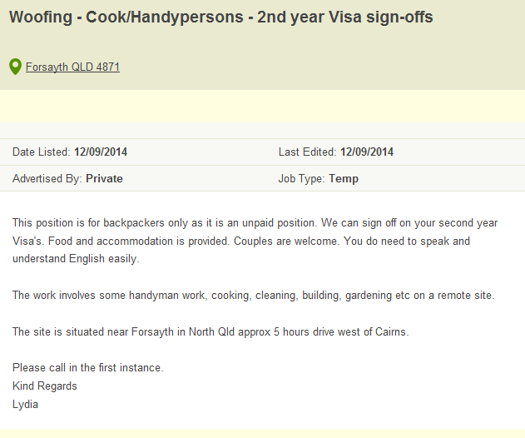

417 visa holders were required to work strict daily hours of 6.30 am to 2.00 pm Monday to Friday and 6.30 am to 12.00 pm Saturday before the employer would sign the visa holder’s EVF.

FWIs found 417 visa holder workers were provided with an induction package which stated:

**“This is NOT a holiday farm – this is a business and you are here to work for your second year visa. If you are not prepared to work to the best of your ability then we will replace you with someone who will respect us and fulfil the requirements set by the Australian Government”**

417 visa holder workers were paid when they worked past 2.00 pm Monday to Friday both while within the 88 day period and after completion of the 88 day period.

An audit of persons who had performed (paid or unpaid) work at the farm in the period from 1 July 2014 to 31 December 2014 identified:

* the farm had been actively engaging unpaid workers since 2009 and had assisted in excess of 600 unpaid workers to qualify for the second year visa
* local unemployed workers seeking paid employment were discouraged from applying for positions at the farm.

The FWO is continuing to conduct investigations into the arrangements at this company.

### The issue of ‘not knowing’

Amongst the many instances of non-payment and underpayment of wages found in the course of the Inquiry, of greatest concern is the disclosure of a cultural mindset amongst many employers wherein the engagement of 417 visa holders is considered a licence to determine the status, conditions and remuneration levels of workers (regardless of duties or hours) without reference to Australian workplace laws.

A number of employers informed the Inquiry as the majority of 417 visa holder workers perform low skilled work, they should not be entitled to Australian minimum pay rates.

A number of consulates informed the Inquiry that, from the experience of their citizens, Australian employers seemed to regard the 417 visa as largely unregulated (as opposed to the subclass 457 visa).

The Inquiry also found amongst many 417 visa holder employees a lack of knowledge or awareness of their workplace rights.

For instance, when asked about knowledge of workplace rights in Australia, the Inquiry’s survey found only 49% of visa holder respondents (1 981 of 4 044) felt they knew their workplace rights quite well or very well.

417 visa holders from an English speaking country (the UK, Ireland and Canada) were more likely to be aware of their rights than those from a non-English speaking country. Among those from Asian countries, it was visa holders from Hong Kong and Taiwan that were least likely to have felt they knew their rights when working in Australia.

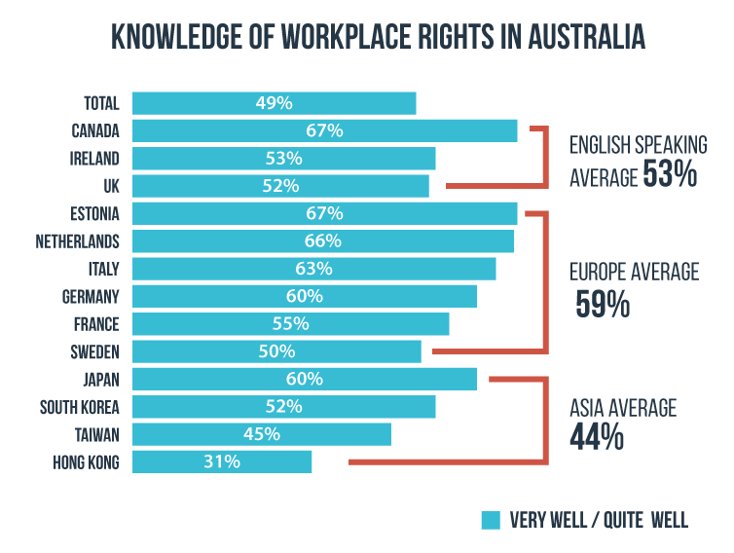

Significantly, 1 825 out of 4 044 (45%) subclass 417 visa holders responding to the Inquiry’s survey were unaware the 88 day specified work requirement legally required payment of wages if there was a contract of employment in place.

If these results are indicative of the cohort as a whole, this would indicate a significant number of 417 visa holders do not understand or know about their workplace rights and obligations while living in Australia. This in turn raises concerns about the high level of vulnerability within this cohort of workers. Further, such a significant lack of knowledge regarding workplace rights raises the question as to how many of those visa holders who participated ‘willingly’ in what they described as volunteer schemes would have done so had they known paid work was an option.

The Inquiry found poor knowledge of Australian workplace rights was associated with being more likely to have had a negative experience of the 417 visa program overall.

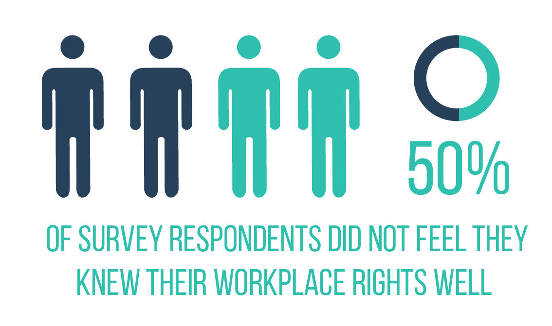

Those who did not feel they knew their rights well (in total 50% or 2 022) were more likely to:

* have described their experience of the regional work they performed as fair or poor - 43% (1 739) compared to 28% (1 133) of those who felt they knew their workplace rights very/quite well
* claimed they were paid less than the minimum wage - 35% (1 415) compared to 21% (849) of those who felt they knew their workplace rights very/quite well
* be dissatisfied with their pay - 25% (1 011) compared to 16% (647) of those who felt they knew their workplace rights very/quite well
* have been required to pay someone to have their regional work signed off - 16% (647) compared to 12% (485) of those who felt they knew their workplace rights very/quite well.

The Inquiry found contrary to the provisions of the FW Act, some workers were required to pay an agent for finding work or indeed pay an employer for ‘signing-off’ on the specified work.

Under subsection 325(1) of the FW Act ‘an employer must not directly or indirectly require an employee to spend any part of an amount payable to the employee in relation to the performance of work if the requirement is unreasonable in the circumstances’. The question of where an employer requiring an employee to spend money in this way may be an **unreasonable requirement** will be a matter of assessing the facts in each situation; however, factors that may suggest that the spending requirement is not reasonable may include where the money spent is solely for the employer’s benefit, the employee does not agree to the spending requirement, or the amount spent is excessive or designed to avoid the Migration Regulations.

The Inquiry’s survey found:

* 14% of visa holder respondents (564 of 4 044) reported they had to pay to secure regional work, with 63% (355 of 564) of those paying an agent;
* 58% of respondents (2 346 of 4 044) reported having to pay a hostel owner either directly or through a deposit for accommodation.

Of those dissatisfied with the wage payments they received, 21% (412 of 4 044) reported an agent or third party taking some of their pay, and 10% (114 of 1 139) stated simply their employer refused to pay them.

In addition, 6% (243 of 4 044) of visa holders stated they were required to pay to have their specified work signed off.  
  
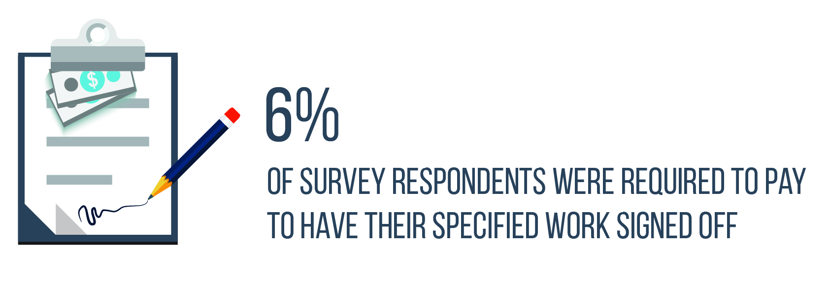

The Inquiry’s survey further identified of those visa holders (243 of 564) who reported they had felt required to pay a sum of money to the employer to have their specified work signed off, they were significantly more likely to:

* be dissatisfied with the payment they received - 47% (114 of 243) were dissatisfied or very dissatisfied with payment, compared to 18% of those who were not required to make a payment
* be paid less than the minimum wage - 60% (146 of 243), compared to 25% (61 of 243) of those who were not required to make a payment
* have rated their overall experience of regional work as poor - 42% (102 of 243) rated the overall experience as poor, compared to 13% (32 of 243) who were not required to make a payment
* 29% (70 of 243) who felt they were treated badly by their employer, compared to 8%   
  (19 of 243) of respondents who were not required to make a payment
* have been refused pay by their employer - 35% (85 of 243), compared to 8% (19 of 243) who were not required to make a payment
* 38% (92 of 243) had a proportion of wages taken by an agent, compared to 12%   
  (29 of 243) who were not required to make a payment
* felt dissatisfied with their accommodation - 58% (141 of 243) visa holders described the standard of accommodation as poor, compared to 22% (53 of 243) visa holders of those who were not required to make a payment
* be less likely to recommend the second year 417 visa - 46% (112 of 243) visa holders were not very likely or not at all likely to recommend the second year 417 visa, compared to 17% (41 of 243) visa holders of those who were not required to make a payment.

Those who felt required to pay a sum of money to have their ‘specified work’ signed off were significantly more likely to have found their job on a website aimed at travellers from their country of nationality (19% (46 of 243) versus 9% (22 of 243) of those not required to make a payment), or through a recruiter (14% (34 of 243) versus 8% (19 of 243) of those not required to make a payment).   
  
The survey findings identify there are especially vulnerable nationalities within this visa cohort who are being targeted to undertake work in contravention of their workplace rights, in particular those visa holders from Asian countries. While the survey did not identify this occurrence for the majority of respondents, the inquiry believes that where it is occurring it is organised and demonstrative of a structured business model used by an unscrupulous agent or employer seeking to exploit and make money from visa holders undertaking the 88 day specified work requirement.

Additionally, this group was significantly more likely to have been paid in cash (50% (122 of 243) versus 25% (61 of 243) of those not required to make a payment) and to have not received pay slips (32% (78 of 243) versus 16% (39 of 243) of those not required to make a payment).

Other key findings disclosed from the survey included regional work was mainly sourced through ‘word of mouth’ channels, with 52% (2 103 of 4 044) respondents finding work through friends, 23% (930 of 4 044) approaching employees directly and 38% (1537 of 4 044) finding work through websites.

The Inquiry researched and analysed a number of websites commonly used by 417 visa holders to source work. For instance, the Inquiry monitored websites such as Gumtree, Hojunara (a Korean community website) and backpacker.com.tw (aimed at Taiwanese visa holders) to further identify employers to be included in the Inquiry.

The Inquiry survey found 38% of respondents sourced work through a website.

The Inquiry engaged with representatives from EBay Australia and New Zealand Pty Ltd, the company that operates the Gumtree website and identified there are two million listings on Gumtree at any given time.   
  
Further, Gumtree representatives informed the Inquiry that the job advertisement section represented a small percentage of its business and the company had not invested in monitoring whether specific advertisements are compliant with the FW Act.

Gumtree representatives informed the Inquiry that advertising activity by FWO to promote minimum rates of pay in the Horticulture industry had shown strong engagement with website visitors.  
   
For the period the advertisements[57] were placed on Gumtree (20 April 2015 – 6 May 2015) there had been a total number of 1 898 clicks to receive more information about fair work laws.   
  
The representatives told the Inquiry Gumtree had a ‘report and take down’ policy and responded promptly when they received external information from government agencies. This has been clearly evidenced by Gumtree’s intervention preventing individuals advertising unpaid or volunteer positions on the website. The Gumtree representatives informed the Inquiry they would welcome the opportunity to work closely with the FWO in the future and could consider adding specific FWO links or information in their online blogs and their job policy documents. The representatives advised Gumtree is focussed on protecting its brand and ensuring the community is safe.

During the course of engagement with representatives from the Korean website Hojunara, the Inquiry was informed that approximately 5 000 advertisements are posted each day on the website which is extremely popular with Korean 417 visa holders.

The representatives advised the Inquiry it was difficult for them to monitor compliance with the FW Act as the pay rate is often not listed in the advertisement. They advised they received some reports of non-compliance with the required Australian minimum wage but many Korean visa holders were willing to accept below award wages as the minimum wage in Korea was $8 per hour.

The issue of ‘unlawful deductions’  
  
The Inquiry also disclosed a considerable number of employers were contravening subsection 324(1) of the FW Act by failing to have a written arrangement in place for deductions from employees’ wages[58].

Under section 324 of the FW Act, ‘unlawful deductions’ are prohibited. For a deduction to be permitted from an employee’s wages the deduction is required to be in writing, signed by the employee and principally for the employee’s benefit.

The Inquiry’s survey found 57% of respondents were provided with accommodation as part of at least some of the specified work they undertook. The accommodation was often perceived as substandard, with 25% (571 of 2 285) of visa holders describing the accommodation as poor, and 29% (663 of 2 285) describing it as fair.

Of those respondents who were provided with accommodation as part of their work, 31%   
(710 of 2 285) had deductions taken from their wages for accommodation. Just under one third, 30% (216 of 721) of this cohort had pay deducted without their prior agreement. Significantly, only 21% (151 of 721) reported having a written agreement for the accommodation deduction.

The survey results confirm FWO’s intelligence that some operators are setting out to profit through deliberate exploitation of workers in the 417 visa program.   
  
That is, some unscrupulous employers and agents are profiting through combining the placement of visa holders in work and associated accommodation, imposing unlawful deductions on pay and charging fees to place visa holders into employment. It appears that this vulnerable cohort of workers, especially those whose language and home cultures are different from Australia, are targeted through websites and forums directed at particular nationalities. The survey identified the experiences of 417 visa holders from Asian countries were less positive than those from other countries. This finding fits with other survey results regarding the level of knowledge held by different 417 visa holder nationalities and the finding that those less informed are more likely to be exploited.

**Case study: underpayments**

I Luv Pty Ltd (I Luv) operates a strawberry farm located in Cottonvale, Queensland, which supplies strawberries sold in Coles, Woolworths and other retailers.

The farm employs up to 200 workers during the picking season. I Luv had been subject to previous FWO investigations resulting in back payments to a number of workers, many of whom were 417 visa holders.

FWIs conducted an unannounced site visit to the farm on 22 April 2015 and discovered I Luv had allegedly not paid five employees the applicable public holiday rates (for work performed over the 2015 Easter long weekend) and one employee’s minimum hourly rates and casual loading as provided under the Award during the period 28 March 2015 – 10 April 2015.

An investigation found that six employees were allegedly underpaid and each of those employees was a 417 visa holder undertaking work to obtain their second year visa. The total alleged underpayment identified was $2 601 over the two week period.

Based on the FWO’s previous interactions with this employer, during which the FWO had advised I Luv of its obligations to pay penalty rates, legal proceedings were filed against the company and its operations manager and director.[59]

**Case study:** **incorrect penalty rates**

FWIs investigated Comprehensive Cleaning Pty Ltd (Comprehensive Cleaning), a labour-hire company supplying workers to an abattoir in Wooroloo, Western Australia, and determined 27 workers had been underpaid, the majority of which were 417 visa holders undertaking specified work to secure their second year visa.

The 417 visa holders were from a range of countries including China, South Korea, Taiwan and Italy. They were engaged on a casual basis to perform meat packing and storage duties at the abattoir. The employees were underpaid a total of $35 078 over a 13 month period.

The 417 visa holders were considered a casual workforce and paid a flat rate of pay for normal hours and additional for overtime but the rates paid were insufficient to cover casual entitlements, overtime and shift work entitlements under the Award. The Director of Comprehensive Cleaning maintained the workers were performing the same duties as ongoing employees and were therefore not entitled to casual rates of pay.

Comprehensive Cleaning cooperated with the FWO and agreed to back pay the employees in full. Comprehensive Cleaning entered into an enforceable undertaking with the FWO, in which it committed to changing its behaviour and ensuring future compliance with federal workplace laws.[60]

### Impact of migration regulation changes

As noted earlier in the report, since 1 December 2015 there is an obligation for 417 visa holders to be paid for the performance of any specified work (sub-item 417.211 (5)(c) of Schedule 2 of Migration Regulations).[61]

The Inquiry views these changes as positive and considers that they go some way to injecting greater accountability into the system. However, they give rise to potential new behaviours and consequences which are explored below.

It is the responsibility of the visa holder to provide DIBP with evidence the specified work undertaken was paid, including the requirement to provide pay slips disclosing *the pay was in accord with the basic pay entitlements employees should receive when working in Australia[62]*.

In welcoming this reform, the Inquiry sought to examine whether the regulatory changes had enhanced the status of a 417 visa holder working in Australia. In the case study below, the changes appear to have had the impact of reversing the use of the visa program to its original intention - that of being a cultural exchange experience.

**Case study: a cultural exchange** **experience**

Mattsue Pty Ltd trading as Mount-N-Ride Adventures (Mount-N-Ride) is a commercial business operating in Little Mulgrave, Cairns, Queensland in the tourism sector. The business offers scenic horse trail rides to locals and tourists.

For more than eight years, Mount-N-Ride has engaged 417 visa holders from Japan and Taiwan in an unpaid capacity and over that period signed approximately 500 DIBP-approved EVF forms facilitating the second year visa.

417 visa holders are required to work five days per week (including weekends) performing duties such as caring for horses, fixing fences, general farm work as well as lead rider and rainforest horse riding tours in exchange for basic food and accommodation.

In July 2015, Mount-N-Ride advertised on the Gumtree website for 417 visa holders seeking to complete their 88 day specified work requirement. The advertisement stated work would be unpaid in exchange for food and accommodation, and required a minimum stay of three months.

The business charges tourists between $100 - $275 per tour. According to the Director, the program is ‘great for the region and I wouldn’t survive without the program, I wouldn’t survive if it was paid work’.

Following the changes to the migration regulations, the FWO re-visited Mount-N-Ride in December 2015 to ascertain the impact of the changes and Mount-N-Ride’s compliance with the new requirements of paid work.

The Director informed FWIs he no longer offered 417 visa holders an opportunity to complete their specified work requirements for the second year 417 visa nor did he sign off on the required paperwork. As an alternative, he still offered an opportunity for 417 visa holders to undertake volunteer work for a three month period in exchange for food and accommodation, more akin to a cultural experience. The Director informed the Inquiry the business had not experienced a downturn in expressions of interest from 417 visa holders to undertake this experience following the changes to the Migration Regulations.

FWIs spoke with 417 visa holders at the site and found they identified as volunteers with one worker stating ‘I’m working here for the love of horses and farming, money is not a motivator’.   
  
Due to the intentions of the parties inspectors spoke to, it appears the arrangements are genuine volunteer arrangements rather than employment relationships.

The Inquiry notes new advertisements for Mount-N-Ride on Gumtree, placed after the Migration Regulations changes, sought tour guide volunteers to work for five days in exchange for all accommodation, meals, Wi-Fi and transport to the city but no longer offered ‘sign off’ of the specified work component for the second year visa.

While the new requirement that work is paid work in accordance with Australian workplace laws introduces a new level of protection to visa holders, the Inquiry notes that 417 visa holder is still dependent upon an employer agreeing to ‘sign off’ the EVF.

Secondly, the employer may not issue pay slips if it is of the view there is no contract of employment in place, but rather, the working arrangement is a contract for services or an ‘independent contractor’ engagement.

Accordingly, without the receipt of pay slips from an employer, the visa holder remains in a precarious position in trying to progress their application for a second year visa. The DIBP requirement is clear that pay slips, issued in accordance with the FW Act, must be provided as evidence along with the EVF which will allow the application to be assessed more quickly. It is therefore conceivable that 417 visa holders may be drawn into situations of exploitative wages and conditions based on the control the employer holds through the requirement of the provision of pay slips.   
  
DIBP states that contacting third parties to verify the claims of applicants for second 417 visas will now be a standard component of second 417 visa application assessments[63]. As an unregulated visa it is not clear how up to in excess of 45,000[64] second year visa applications per year will be verified in what was a previously unchecked process.

The FWO’s compliance and enforcement experience has identified record keeping requirements, including the provision of pay slips to employees, are often contravened by employers who are failing to meet their substantive obligations to employees, usually underpaying them and often deliberately. This can arise as a deliberate tactic to disguise underpayment of workers – where there are no records, or false records, there are real challenges in establishing the extent of any underpayment of wages. 32% of all matters filed in federal courts by the FWO in 2015-2016 involved allegations of employers deliberately providing false and/or misleading records to the regulator.

While the Inquiry notes the new evidentiary requirement of paid work may create an incentive for some employers of 417 visa holders to create false and misleading records, the Government’s proposal for those who use 417 visa labour to register with the ATO in order for the workers to access the lower tax rate may mitigate the risk of false records to a degree. Subject to appropriate information sharing between FWO, ATO and DIBP, tax records could be cross referenced to compare actual amounts paid with the pay slips. However, FWO has experienced on many occasions unscrupulous employers will often keep exploited workers ‘off the books’ entirely, paying sub-minimum rates of pay in cash and not remitting any tax information to the ATO.

Where an employer has established a business model underpinned by the supply and exploitation of 417 visa holders, they may find a work-around for the new requirements and secure a ‘sign off’ that doesn’t comply with the relevant award entitlements. The case study on page 30 is indicative of this behaviour.

For 417 visa holders, the lack of knowledge or understanding that an employer must legally provide pay slips further compounds the level of vulnerability in the face of this new regulatory requirement.

The requirement to undertake paid work, and provide evidence, in a specified industry in a regional area would appear to confirm the 417 visa operates as a de facto ‘low skilled work visa’, filling the needs of regional Australia’s demand for labour, rather than a cultural exchange visa.

Additionally, the expansion of work locations considered to be regional areas for the purpose of specified work, creating more opportunities for visa holders to complete the 88 day specified work requirement, would appear to further confirm this.

The Inquiry notes employee associations’ concerns that the expansion of the second year visa program has the potential to impact negatively on youth unemployment, including investment in training and skill development in these designated regional areas. For example, the entire state with the highest youth unemployment rate across Australia[65], South Australia, has recently been declared ‘regional’ for the 88 day specified work requirement, highlighting the inherent conflicting policy tensions within the 417 visa program.

The Inquiry has noted the regulatory changes are being felt acutely across a number of volunteer sectors that have previously relied upon the participation of 417 visa holders undertaking the 88 days specified work.[66] In particular this is being evidenced in the long established practice of WWOOFing.

DIBP does not view WWOOFing as a separate industry; it advised the Inquiry in order to fulfil the 88 day specified work requirement, WWOOFers would need to undertake a 7.5 – 8 hour day as per the horticulture industry standard.

In response, WWOOF Australia informed the Inquiry that DIBP was ‘forcing WWOOFers to be workers’ and an employment relationship was more likely to exist in relation to any work undertaken in excess of four hours per day.

WWOOF Australia was of the view that if WWOOFing is undertaken correctly then an employment relationship does not exist. As a result of the regulatory changes, 417 visa holders may still engage in the WWOOF program as volunteers but this work will no longer be eligible for the 88 day requirement.

**Case study:** **WWOOFers and unpaid labour**

Banyandah Alpaca Farm located in Gympie, Queensland operates a small scale commercial business selling alpaca wool and manure. It opens as a tourist farm two days per week.

The farm has been hosting WWOOFers for more than 16 years. 417 visa holders arrive at the farm through word of mouth recommendations and perform work feeding the animals in the morning and evenings with occasional days at rural shows in exchange for their specified work sign off. While identifying the benefits of cultural exchange and knowledge sharing the host also told the Inquiry it is unlikely she could continue to operate her business without the benefit of unpaid labour.

The host expressed her concern to the Inquiry although the 417 visa holders ‘enjoy the farm atmosphere and experience, the driving motivation is to gain the second year visa and other WWOOF hosts experience this’.

**Case study:** **volunteer organisations not able to ‘sign off’ EVF**

In April 2015 the Inquiry met with managers of a Hare Krishna Village Retreat, a not-for-profit organisation and one of the employers featuring as a ‘high’ provider of sign offs of the specified work requirement in northern NSW.

The retreat hosts between 25 – 30 volunteers at any one time providing 417 visa holders with exposure to a “natural lifestyle,” in return for unpaid work (maximum four – six hours per day) performed each day which is garden focussed and / or agricultural.

The retreat advised outside the daily work requirement, the 417 visa holders are able to engage in Yoga, relaxation and meditation and they have a vehicle available to them if they choose to go into the nearby town.

The retreat provides the 417 visa holders with food and accommodation. A group of workers informed the Inquiry it was an incredibly positive cultural experience and never ‘felt like work’ as opposed to other reports they had heard from 417 visa holders working on farms.

When the DIBP regulation changes came into effect, one of the hosts contacted the Inquiry expressing their concerns as they had booked in 417 visa holders months in advance who expected to receive sign off for their specified work and as a not-for-profit organisation, funds were not available to pay the 417 visa holders.

## Opportunities for the Fair Work Ombudsman

An analysis of the Inquiry’s survey findings evidenced opportunities for FWO to target those more vulnerable visa holders within the 417 group. In particular, those in the group from non-English speaking backgrounds, particularly from Asian countries, identified as most vulnerable in their responses regarding awareness and knowledge of workplace rights and targeting by employers and agents for unlawful deductions from wages and payments to obtain work. These findings also have identified opportunities for FWO to work with websites hosting / facilitating the targeting of 417 visa holders through dedicated job advertisements, with a view to providing information regarding workplace rights on related websites which the targeted cohort is likely to access and use.

Further analysis of the Inquiry’s survey findings in regards to levels of satisfaction based on the location where specified work was performed, has led to the identification of opportunities for the FWO and other agencies to better target monitoring and enforcement work, particularly in Victoria and South Australia.

For example, 417 visa holders undertaking the majority of their specified work in regional Victoria and South Australia were significantly more likely to describe their overall experience as fair or poor – 43% (279 of 647) for those working in Victoria, and 44% (156 of 356) for those working in South Australia, compared to 35% (1415 of 4044) across all states.

Reasons for these findings were:

* people carrying out the majority of their regional work in Victoria were significantly more likely to have been paid under the minimum wage - 42% (232 of 552) compared to 28% (937 of 3 344) across all states and consequently were significantly less likely to be satisfied with the payment they received for regional work. 178 of 647 respondents (28%) reported being dissatisfied or very dissatisfied, compared to 21% across all states. Overall, 417 visa holders in this region were significantly more likely to respond they had negative experiences undertaking regional work, 21% (136 of 647) compared to 16% (655 of 4 044) across all states.
* those carrying out the majority of their regional work in South Australia were significantly more likely to have had some pay taken by an agent or third party, 30% (26 of 87) compared to 14% (156 of 1 139) across all states and were significantly more likely to have had to make a payment to secure regional work, 24% (85 of 356) compared to 14% (85 of 356) across all states.
* across both regional Victoria and South Australia, those undertaking the majority of their specified work in these areas were significantly more likely to describe their standard of accommodation as fair or poor, 65% (242 of 374) in Victoria, and 64% (100 of 157) in South Australia compared to 54% (1243 of 2 285) across all states.

## Further reform - the view of the employer

Employers also identified changes they would like to see made to the 88 day specified work requirement, (including the expansion of specified work to include domestic occupations such as au pairs[67] and cooks in remote areas) and the 417 visa program becoming a pathway to a sponsored visa where the employer had invested time in the worker developing valued skills.

This view was supported through the Inquiry’s engagement with a range of stakeholders including the Australian Tourism Export Council (ATEC) and Adventure Queensland who both maintained the scope of specified work should be extended to include the hospitality and tourism industry as they had previously expressed in their 2012 report examining the importance of the 417 visa. Both associations have previously asserted that extending the availability of specified work to these industries would enhance its attractiveness and encourage engagement with a wider range of regional businesses[68].

**Case study:** **expanding ‘specified work’ requirements**

Operating in Goomeri, Queensland ABC is a business operating for more than 20 years dedicated to offering a program targeted at Europeans who are seeking outback or rural work and to experience farm life by placing visa holders with a host employer.

ABC targets young Europeans wanting to travel to Australia and experience farm life. Participants purchase a package from ABC which includes airport pick up, one week of training in farm work and job placement with a rural employer.

Host employers are required to pay workers Award rates (generally the Pastoral Award 2010).

Support is provided for 417 visa holders seeking their ‘specified work’ to be signed off, however, ABC asserts its focus is on the ‘cultural exchange’ component of the program rather than employment.

ABC informed the Inquiry the ‘88 day timeframe’ should be increased in order to improve the ‘cultural adventure’ as well as redefine ‘regional areas’ to include farms near major cities that may have the same labour demands as rural farms.

Similarly, the MMPEs subject of this Inquiry, advised that they would like the six-month employment restriction extended so they can obtain greater return on investment. Both Thomas Foods and G & K O’Connor submitted that the 417 visa program could be a pathway to the 457 visa program, and thus these employers could sponsor workers without the need for the workers to move to another employer / region after six months.

According to the MMPEs, the 417 visa holders are aware by working in the meat sector they will have regular hours of work and a rate of pay higher than those on offer in the hospitality and agricultural sectors.

Engagement with stakeholders in the backpacker industry also identified a number of concerns with the 417 visa program, most notably, any change to the program resulting in an automatic two year grant of the 417 visa would potentially result in many 417 visa holders not leaving the city and consequently, not contributing to the regional workforce and economy.

A range of ideas for improvements in the program were also put forward by the backpacker stakeholder group[69], including:

* increasing the cut off age to 35 years as older travellers have a higher spend which has the potential to encourage job creation. The Inquiry notes the Government now proposes to implement this change.
* extensions of the specified work component to domestic workers and the hospitality industry in remote areas and an extension of the maximum six months period during which a visa holder may only work for the one employer[70] The Inquiry notes as part of the Government’s proposed changes to working holiday maker tax arrangements, 417 visa holders will be permitted to stay with one employer for up to 12 months, provided the second six month period is worked in a different location.
* that consideration is given as to whether hostel owners who monitor and manage the work and hours performed by the visa holders be responsible for signing off the EVF rather than labour hire entities or growers who are unaware of the work actually performed by the individual.

### Summary of key findings

The Inquiry found:

* the 417 visa has introduced an uncapped labour source into the Australian market that fills a low-skill labour gap in the domestic workforce, particularly the specified work requirement of the 417 visa program which fills the labour shortage associated with food production in regional and rural areas
* a significant number of instances where the 417 visa program is not being used primarily for its intended purpose, that of cultural exchange, with the desire for a ‘second year stay’ driving vulnerable workers to agree to ‘below minimum’ entitlement arrangements and potentially unsafe working environments
* a significant number of visa holders report a satisfactory experience when undertaking the 88 day work requirement however, some workers, especially those from non-English speaking backgrounds, are being deliberately targeted (in some instances before travelling to Australia) through purpose designed websites and networks as part of a business model designed to exploit workers who are most vulnerable
* visa holders were primarily focused on their visa status and less aware of their workplace rights. For instance, in applying for a second year visa, 88% of visa holders surveyed were aware of the requirement to work for 88 days in a specified regional area, however, only three in ten (31%) were aware of the FWO and its role
* instances where the 417 visa program has been used by a number of entities to source an unpaid workforce in circumstances where this unpaid workforce is involved in productive work principally for the benefit of the business, thus facilitating an unfair commercial advantage to these employers, distorting the market place and placing pressure on the domestic employment market
* participation in the 417 visa program and acceptance of substandard workplace conditions is influenced by factors external to Australia such as the high youth unemployment rates across Europe, the lower (in comparison) minimum wages across partner countries and the relative domestic safety (in comparison) to other partner countries
* the lack of any specific regulation around those employing 417 visa workers combined with the need for the visa holders to produce evidence they have completed 88 days requisite paid work, places 417 visa holders seeking a second visa in a precarious situation with unscrupulous operators who can exploit the power imbalance and overcome the inclination of the workers to request assistance for fear of the operator refusing to evidence their work
* the 2015 policy changes have resulted in genuine volunteer arrangements, which offer cultural experiences to working holiday makers, no longer counting towards specified work (this has the consequence of limiting the experiences of working holiday makers and negatively impacting on genuine charitable and not for profit organisations – noting, the experiences of visa holders entering into arrangements that were identified as volunteer work in a setting not providing a commercial benefit were positive)
* while the ‘paid work’ regulatory reform should enhance transparency and protections for workers, it is open to circumvention by the unscrupulous employer through false record-keeping and unauthorised deductions (for example, when payment is made to the worker but then withdrawn for deductions such as food and rent which are a pre-requisite for the working holiday maker to obtain the employment)
* a 417 visa holder’s desire for a second year extension and the requirements to undertake specified work can have the unintended consequence of driving vulnerable workers to agree to work for below minimum entitlements and in some circumstances enter in to potentially unsafe situations.

### Opportunities

The FWO continues to undertake its work with migrant worker and visa holder communities in order to:

* build a culture of compliance with Australian workplace laws within migrant worker and visa holder communities
* refine, develop and target FWO services to better meet these communities’ needs
* raise awareness of the FWO, its role and services, and of employer and employee rights and obligations.

The Inquiry identified opportunities for the FWO to work collaboratively with other state, territory and federal agencies and external stakeholders, such as consulates, to educate 417 visa holders about their work rights before entering Australia.

Examples of opportunities are:

* exploring options with DIBP to strengthen legislated protections and reactive / proactive monitoring of 417 visa holders, including, building upon the work of Taskforce Cadena and engaging with the newly formed Migrant Worker Taskforce in addressing overseas worker exploitation[71]
* partnering with DIBP to educate potential visa holders about their workplace rights when they make a visa application (importantly, prior to the formal approval of a visa application by DIBP), for example, the requirement by the applicant to read the Fair Work Information Statement (in their own language) and confirm his or her understanding when submitting an application
* continuing to work with consulates to facilitate further education opportunities for overseas workers about their workplace rights in Australia and the role of the FWO
* examining the opportunities for co-delivery of education and compliance activities with the labour hire industry, including the Recruitment and Consulting Services Association [RCSA] under the terms of the Memorandum of Understanding entered into with the FWO, including exploring the merits of FWO’s role in an RCSA created and sponsored compliance certification scheme for blue collar on-hire[72]
* partnering with migrant worker and visa holder community groups and other non-government organisations providing services to migrant workers and visa holders to expand the influence and reach of education and assistance regarding workplace rights, including enhancing the use of media (print, radio, television and social media) to inform and engage with dedicated visa holder cohorts and community groups providing services to these groups and increased use of all forms of media to highlight to both employers the public, FWO and DIBP compliance and enforcement outcomes so as to ensure a strong general deterrence message
* enhancing education initiatives promoting specific migrant worker and visa holder cohorts through communication channels used by these cohorts, thus, reaching these visa holders who historically do not approach the regulator for assistance
* partnering with websites commonly used by 417 visa holders, such as Gumtree and Hojunara, to display links to the FWO website and to post information about workplace rights on a regular basis as well as facilitate a reporting process enabling the FWO to advise of advertisements that offer conditions which undercut minimum entitlements, so that they may be removed
* ongoing FWO contribution to inform academic research regarding the interplay between recognised regional labour supply needs and low skilled work and the precariousness and vulnerability of temporary visa holders in general[73].

### Recommendations

Based on the engagement of stakeholders, market research findings and the FWO’s compliance and enforcement experience, the Inquiry’s recommendations are directed toward three main areas designed to underpin the integrity of the 417 visa program and the FW Act. The FWO proposes to submit the following recommendations to the consideration of the Government’s recently announced Migrant Worker Taskforce[74]

1. **Enhancing the framework**:

* collaboration between the FWO and DIBP in establishing a federal-state, inter-agency working group that examines current and future regulations to develop a holistic compliance and enforcement model that considers:
  + placing onus on employers with 417 visa holder employees to comply with state and federal legislation
  + strengthening sanction frameworks for employers who contravene relevant legislation
  + more diverse items of evidence to validate specified work to minimise the power imbalance between the visa holder and employer
  + reviewing and enhancing information sharing between FWO and other regulators to assist in the gathering of evidence against unscrupulous employers necessary to prove breaches of workplace and other laws.

1. **Enhancing information, education, compliance and support:**

* ensuring all existing laws and sanctions are being fully utilised to take action against unscrupulous employers in their recruitment and exploitation of vulnerable 417 visa holders, including immigration, tax, corporations and consumer protection laws
* collaboration between the FWO and the ATO to support the establishment of a publicly available Employer Register wherein employers of 417 visa holders will be required to register.
* exploring opportunities to work with a broader range of stakeholders to extend the channels through which information and support is delivered, including:
  + promoting the Employer Register with key stakeholders (including organisations hosting websites dedicated to 417 visa holders such as DIBP, the Department of Employment, Tourism Australia, Austrade, and consulates) in order to advise workers they should only work with registered and compliant employers
  + ensuring appropriate information sharing between FWO, the ATO and DIBP to enable records to be cross-referenced and verified
  + designing and implementing other education and compliance initiatives to address workplace exploitation, including reviewing the conditions required by 417 visa holders to obtain ABNs (noting that the purpose of the 417 visa is to enable a ‘cultural exchange’ with work rights attached to provide the visa holder an opportunity to supplement their travel expenses as compared to the purpose of an ABN, which is to operate a business)[75] as well as exploring technology that would support the simple recording of working hours.

1. **Supporting further research to build a culture of compliance:**

* continuing the FWO’s investment in partnering with academics and migration experts on researching and solving the labour force issues associated with the need to balance cultural exchange, Australia’s international reputation, recognised regional labour supply needs and the vulnerable nature of the 417 visa holder cohort.

### Appendix 1 – Comparing FWO’s requests for assistance from 417 visa holders to all visa holders

Table 1 relates to requests for assistance completed on behalf of all visa holders, and of that figure, the total completed on behalf of 417 visa holders for the three financial years as specified.

Table set 2 relates to the number of each enforcement tool issued/executed on behalf of all visa holders, and 417 visa holders for the two financial years as specified.

Table 1. Requests for assistance completed

| Type of visa holders | 2015-2016 | 2014-2015 | 2013-2014 | **Total** |
| --- | --- | --- | --- | --- |
| All visa holders | 1 894 | 1 971 | 2 625 | **6 490** |
| 417 visa holders | 855 | 820 | 1 042 | **2 717** |
| 417 visa holders as a % of all visa holders | 45% | 42% | 40% | **42%** |

Table 2. Enforcement tools  
  
2a. Enforceable Undertakings

| Type of visa holders | 2015-2016 | 2014-2015 | **Total** |
| --- | --- | --- | --- |
| All visa holders | 15 | 20 | **35** |
| 417 visa holders | 8 | 10 | **18** |
| 417 visa holders as a % of all visa holders | 53% | 50% | **51%** |

2b. Compliance notices

| Type of visa holders | 2015-2016 | 2014-2015 | **Total** |
| --- | --- | --- | --- |
| All visa holders | 38 | 37 | **75** |
| 417 visa holders | 16 | 22 | **38** |
| 417 visa holders as a % of all visa holders | 42% | 59% | **51%** |

2c. Infringement notices

| Type of visa holders | 2015-2016 | 2014-2015 | **Total** |
| --- | --- | --- | --- |
| All visa holders | 161 | 124 | **285** |
| 417 visa holders | 45 | 29 | **74** |
| 417 visa holders as a % of all visa holders | 28% | 23% | **26%** |

2d. Assisted small claims

| Type of visa holders | 2015-2016 | 2014-2015 | **Total** |
| --- | --- | --- | --- |
| All visa holders | 168 | 99 | **267** |
| 417 visa holders | 31 | 35 | **66** |
| 417 visa holders as a % of all visa holders | 18% | 35% | **25%** |

2e. Litigations

| Type of visa holders | 2015-2016 | 2014-2015 | **Total** |
| --- | --- | --- | --- |
| All visa holders | 38 | 23 | **61** |
| 417 visa holders | 16 | 11 | **27** |
| 417 visa holders as a % of all visa holders | 42% | 48% | **44%** |

### Appendix 2 – 417 Visa Partner Countries

Table 1.

| Country / Region | Entry date into the 417 program | |
| --- | --- | --- |
| United Kingdom* | 1975 | |
| Ireland | 1975 | |
| Canada | 1975 | |
| Japan | 1980 | |
| South Korea* | 1995 | |
| Malta | 1996 | |
| Germany | 2000 | |
| Sweden | 2001 | |
| Norway | 2001 | |
| Denmark | | 2001 |
| Hong Kong (HKSAR of the PRC) | | 2001 |
| Finland | | 2002 |
| Cyprus | | 2002 |
| Italy* | | 2004 |
| France* | | 2004 |
| Taiwan* | | 2004 |
| Belgium | | 2004 |
| Estonia | | 2005 |
| Netherlands | | 2006 |

* indicates the top five countries whose citizens use access the 417 program

Table 2.

Number of second Working Holiday (subclass 417) visa applications granted in 2015-16 to 30 June 2016 by citizenship country - comparison to the previous four financial years[76]

| Citizenship Country | 2011-2012 30/06/12 | 2012-2013 30/06/13 | 2013-2014  30/06/14 | 2014-2015 30/06/15 | 2015-2016 30/06/16 | % Change from 2014-15 | 2015-2016 as a % of Total |
| --- | --- | --- | --- | --- | --- | --- | --- |
| United Kingdom | 6,012 | 7,349 | 8,430 | 8,473 | 8,078 | -4.7% | 22.3% |
| Taiwan | 4,245 | 7,162 | 11,295 | 8,975 | 7,354 | -18.1% | 20.3% |
| Korea, South | 5,194 | 5,606 | 5,783 | 4,928 | 4,304 | -12.7% | 11.9% |
| France | 1,698 | 2,249 | 2,776 | 3,129 | 2,997 | -4.2% | 8.3% |
| Italy | 941 | 1,775 | 3,150 | 3,387 | 2,854 | -15.7% | 7.9% |
| Japan | 1,524 | 1,709 | 2,040 | 2,148 | 2,222 | 3.4% | 6.1% |
| Hong Kong (SAR of the PRC) | 1,150 | 1,910 | 2,954 | 2,878 | 2,016 | -30.0% | 5.6% |
| Germany, Fed Republic | 1,408 | 1,497 | 1,612 | 1,766 | 1,770 | 0.2% | 4.9% |
| Ireland, Republic of | 6,335 | 7,300 | 5,233 | 2,572 | 1,644 | -36.1% | 4.5% |
| Canada | 633 | 589 | 649 | 762 | 806 | 5.8% | 2.2% |
| Estonia | 507 | 626 | 785 | 693 | 578 | -16.6% | 1.6% |
| Netherlands | 282 | 301 | 381 | 480 | 507 | 5.6% | 1.4% |
| Sweden | 248 | 371 | 406 | 541 | 454 | -16.1% | 1.3% |
| Belgium | 125 | 155 | 162 | 234 | 278 | 18.8% | 0.8% |
| Finland | 75 | 132 | 154 | 180 | 222 | 23.3% | 0.6% |
| Denmark | 77 | 91 | 87 | 115 | 120 | 4.3% | 0.3% |
| Malta | 13 | 13 | 14 | 15 | 26 | 73.3% | 0.1% |
| Norway | 32 | 24 | 26 | 38 | 24 | -36.8% | 0.1% |
| Cyprus | <5 | <5 | 13 | 25 | 10 | -60.0% | 0.0% |
| Not Specified |  | <5 |  |  |  |  |  |
| Total | 30,501 | 38,862 | 45,950 | 41,339 | 36,264 | -12.3% | 100.0% |
|  |  |  |  |  |  |  |  |

### Appendix 3 – Definitions of Specified Work

Approved industries for specified work include:

* plant and animal cultivation
* fishing and pearling
* tree farming and felling
* mining
* construction.

Specified work is any type of work described in the list below:

* plant and animal cultivation
  + the harvesting and/or packing of fruit and vegetable crops
  + pruning and trimming vines and trees

Note: This must be the applicant’s primary employment task and directly associated with the cultivation and commercial sale of plant produce, such as fruit and nut crops (commercial horticultural activities). General garden maintenance is not eligible

* + general maintenance crop work
  + cultivating or propagating plants, fungi or their products or parts
  + immediate processing of plant products
  + maintaining animals for the purpose of selling them or their bodily produce, including natural increase

Note: Maintaining animals for tourism or recreational purposes is not eligible.

* + immediate processing of animal products including shearing, butchery, packing and tanning  
    Note: Secondary processing of animal products, such as small goods processing and retail butchery is not eligible
  + manufacturing dairy produce from raw material.
* fishing and pearling
  + conducting operations relating directly to taking or catching fish and other aquatic species
  + conducting operations relating directly to taking or culturing pearls or pearl shell.
* tree farming and felling
  + planting or tending trees in a plantation or forest that are intended to be felled
  + felling trees in a plantation or forest
  + transporting trees or parts of trees that were felled in a plantation or forest to the place where they are first to be milled or processed or from which they are to be transported to the place where they are to be milled or processed.
* mining
  + coal mining
  + oil and gas extraction
  + metal ore mining
  + construction material mining
  + non-metallic mineral mining and quarrying
  + exploration
  + mining support services
* construction
* residential building construction
* non-residential building construction
* heavy and civil engineering construction
* land development and site preparation services
* building structure services
* building installation services
* building completion services
* other construction services.

Work undertaken in the areas of plant and animal cultivation, fishing and pearling, and tree farming and felling must be described in the list above to meet the specified work requirement.[77]

### Appendix 4 – Stakeholder Engagement Program

| **Stakeholder Engagement Program** | **Meeting accepted** |
| --- | --- |
| **Government bodies** |  |
| Alice Springs Town Council | Yes |
| Taipei Economic and Cultural Office in Sydney | Yes |
| Canadian Consulate | Yes |
| Consulate General of the Republic of Korea | Yes |
| British Consulate-General Sydney | Yes |
| French Consulate General | Yes |
| Chamber of Commerce NT | Yes |
| Workforce Growth NT (NT State Government) | Yes |
| Cairns Police Liaison Officers | Yes |
| Gympie Chamber of Commerce | Yes |
| Gympie Regional Council | Yes |
| Bryon Shire Council | Yes |
| Lismore Chamber of Commerce | No |
| Tweed Shire Council | Yes |
| DIBP - Department of Immigration and Border Protection | Yes - ongoing collaboration |
| DIBP Darwin | Yes |
| Anti-Discrimination Commissioner Queensland | Yes |
|  |  |
| **Program Users** |  |
| RAI Roses Pty Ltd | Yes |
| Hunter Valley Quality Meats Pty Limited (JBS Australia Pty Ltd) | Yes |
| G & K O’Connor Pty Ltd | Yes |
| Mattsue Pty Ltd trading as Mount-N-Ride Adventures | Yes |
| Dole Australia Pty Ltd | Yes |
| Colin A Hatcher Family Trust trading as Woodburn Farm | Yes |
| The Trustee For Viking Unit Trust | Yes |
| Blaine Pty Ltd trading as Alice Springs Prime Cut Meat Supplies | Yes |
| Ross River Resort Pty Ltd | Yes |
| The trustee for S & R Juffermans & Sons Family Trust trading as Pool and Spa Doctor | Yes |
| Paspaley Pearling Company | Yes |
| Woofing Host : #NT169 based in Howard Springs | Yes |
| Thomas Foods International Murray Bridge Pty Ltd | Yes |
| Banyandah Alpacas | Yes |
| Waterfall Feedlot Pty Ltd | Yes |
| Mary Valley Meats | Yes |
| Farmstay Hidden Valley | Yes |
| Iskcon Hare Krishna Farm | Yes |
| Brooloo Park | No - feedback provided by email |
| Nolan Meats Pty Ltd | Yes |
|  |  |
| **Employer groups** |  |
| AIG - Australian Industry Group | stakeholder letter sent – no response received |
| MINTRAC - National Meat Industry Training Advisory Council Limited | stakeholder letter sent – no response received |
| ACCI - Australian Chamber of Commerce and Industry | stakeholder letter sent – no response received |
| AMMA - Australian Mines and Metal Association | stakeholder letter sent – no response received |
| Master Builders Association - Darwin | Yes |
| Master Builders Association - Head office | Yes |
| AMIC | Yes |
| AHA | Yes |
|  |  |
| **Community Groups** |  |
| BlazeAid Inc | Yes |
| WWOOF (Willing Workers On Organic Farms) | Yes |
| Outback Helpers Scheme | Yes |
| Project y u Do - Australia | Yes |
|  |  |
| **Unions** |  |
| **Head office** |  |
| CFMEU - Construction, Forestry, Mining, Energy Union | Yes |
| ACTU - Australian Council of Trade Unions | Yes |
| NUW - National Union of Workers | stakeholder letter sent – no response received |
| AMIEU - Australasian Meat Industry Employees Union | Yes |
| AWU | stakeholder letter sent – no response received |
| Unions NT | Yes |
| UV - United VOICE | Yes |
| AMWU | Yes |
| TWU | Yes |
|  |  |
| **Local office** |  |
| CFMEU - Construction, Forestry, Mining, Energy Union - Darwin office | Yes |
| **Other Stakeholders** |  |
| Travellers Contact Point (job assistance agency) | Yes |
| Australian Backpackers Work and Travel | Yes |
| Dreamtime Travellers Rest Cairns | Yes |
| Melaleuca on Mitchell (Hostel) | Yes |
| Chilli’s (Hostel) | Yes |
| Ronnie’s Bush House | Yes |
| Visit OZ (farm work training business) | Yes |
| WWCNT - Working Women's Centre NT | Yes |
| A Better You | Yes |
| 2nd Year Visa Jobs (now known as Working Hostels Australia) | Yes |
| Gumtree | Yes |
| Gympie Community Place | Yes |
| Northern Rivers Legal Centre | Yes |
| Agforce QLD | No |
| Adventure Queensland | Yes |
| YHA Ltd. | Yes |
| Vision Legal | Yes |
| Hojunara | Yes |
| ATEC (Australia Tourism Export Council) | Yes |

### Appendix 5 - FWO’s Harvest Trail Inquiry

The Harvest Trail gives people the opportunity to combine seasonal harvest work with travel around Australia.[78]

In response to a number of requests for assistance from workers involved in the Harvest Trail alleging they were not receiving their correct minimum employment entitlements, the FWO commenced an Inquiry in August 2013 with the primary objective of enhancing deterrence at the sub-sector and geographic level by tailoring a series of education and compliance activities with employers and employees engaged in fruit and vegetable picking.

The Harvest Trail Inquiry was specifically interested in determining the drivers of non-compliance in the horticulture industry; a sector that hires a large contingent of overseas workers each year, including those visiting Australia on 417 visas.

The Inquiry has noted that many 417 visa holders working in the horticultural sector perform work subject to what is termed piece work arrangements, an issue which will be addressed in the FWO’s Harvest Trail Inquiry Report and is the subject of a matter filed by the FWO in the Federal Court – Queensland Registry on 13 September 2016. The labour sourced by the horticulture sector comprise a significant number of 417 visa holders seeking to complete 88 days in regional Australia to qualify for a second year working holiday visa.

Amongst a range of education and compliance activities, the Harvest Trail Inquiry has seen 24 key interventions across all states and the Northern Territory involving 700 employers. To date, a number of enforcement outcomes have resulted where non-compliance with workplace laws has been determined, these include:

* four filed litigations
* six enforceable undertakings executed
* three compliance notices issued
* 76 infringement notices issued
* 75 letters of caution issued.

### About the Fair Work Ombudsman

The FWO is an independent statutory agency, created by the *Fair Work Act 2009* (FW Act) on 1 July 2009.

The FWO supports compliant, productive and inclusive Australian workplaces.

The FWO ensures compliance with Australia’s workplace laws by:

* offering people a single point of contact to receive accurate and timely advice and information about Australia’s workplace relations system
* educating people working in Australia about their workplace rights and obligations
* monitoring compliance with, inquiring into and, investigating any act or practice that may be contrary to workplace laws, awards and agreements
* litigating to enforce workplace laws and to deter people from not complying with their workplace responsibilities.

For further information and media enquiries please contact FWO media

([media@fwo.gov.au](mailto:media@fwo.gov.au)).

Our Strategic Intent as well as our Compliance and Enforcement Policy can be located at <http://www.fairwork.gov.au/about-us/policies-and-guides/internal-policies-and-plans#strategic>.

If you would like further information about the FWO’s compliance and enforcement activities please contact Steve Ronson, Executive Director – Dispute Resolution and Compliance ([steven.ronson@fwo.gov.au](mailto:steven.ronson@fwo.gov.au)).

1. As at April 2016 this was 11,915,700 <http://www.abs.gov.au/ausstats/abs@.nsf/mf/6202.0>
2. This figure is indeed contested – while the Productivity Commission reported in its review of the Australian workplace relations framework – <http://www.pc.gov.au/inquiries/completed/workplace-relations/report> – a 6.5% figure dated 30 Jun 2014, there are other indications the percentage is higher. The Senate Inquiry into Temporary Visa Holders (Education and Employment References Committee) finalised its report in March 2016 (A National Disgrace: The Exploitation of Temporary Work Visa Holders) and found there were approximately 1.4 million temporary visas held in Australia at 31 March 2015 with work rights attached to them (this included 648,993 New Zealand citizens). This makes up 11.7% of the working population (or 12% excluding New Zealand citizens holding subclass 444 visas)
3. 457 data based on DIBP public website ‘*Work in Australia – Statistics’*

   <http://www.border.gov.au/ReportsandPublications/Documents/statistics/457-quarterly-report-30-06-2016.pdf>  
     
   <http://www.border.gov.au/ReportsandPublications/Documents/statistics/working-holiday-report-jun14.pdf#search=working%20holiday%20maker%20visa%20programme%20report>
4. This data is expanded in Appendix 1
5. Regional Australia is classified as anywhere with the exception of the ACT, Sydney, Newcastle, the Central Coast and Wollongong, the greater Brisbane area and the Gold Coast, the Melbourne metropolitan area and Perth and surrounding areas.
6. Commonwealth Parliament (2005) Migration Regulation Amendments 2005 (No. 9) regulatory impact statement: changes to the migration regulations: proposals to expand the working holiday makers program (Supplementary material).
7. In the 2011-2012 financial year, 5% of dispute forms lodged with FWO related to visa holders. In the 2015-2016 financial year, that figure had increased to 13%. In the 2011-2012 financial year, 23% of visa holders who lodged dispute forms with FWO were 417 visa holders. By the 2015-2016 financial year, that figure had nearly doubled to 44%.
8. <https://www.liberal.org.au/latest-news/2016/05/17/working-holiday-maker-visa-review>
9. Appendix 1 shows the date that countries were granted access to the 417 program (Table 1) and a comparison of second Working Holiday (subclass 417) visa applications granted in 2014-15 by citizenship country compared across the previous four financial years
10. Department of Immigration and Border Protection’s Senate Estimates hearing, 26 May 2015, p103.

    [***Senator Cash:***](http://parlinfo.aph.gov.au/parlInfo/search/display/display.w3p;query=Id%3A%22handbook%2Fallmps%2FI0M%22;querytype=;rec=0)*In relation to some of the integrity measures, Senator Carr, we also announced that, going forward, in terms of being able to apply for the second year on your working holiday visa, the department as an integrity measure will only now accept payslips. Four Corners suggested that documentation such as an employer reference was accepted by the department. Ensuring that the only document that will now be accepted by the department is a payslip is also a step in terms of the additional integrity measures we are putting in place.*

   
11. See section 682(1) of the *Fair Work Act 2009*
12. <https://ministers.employment.gov.au/cash/coalition-delivers-election-commitment-protect-migrant-workers>
13. The Inquiry notes the current ability of 417 visa holders to apply for an ABN and to ‘act’ as independent contractors reduces their protections, increases opportunities for exploitation as well as leading to a reduction of government revenue
14. See page 3 of DIBP, *Working Holiday Maker visa programme report*, 31 December 2014, <https://www.border.gov.au/ReportsandPublications/Documents/statistics/working-holiday-report-dec14.pdf>
15. As above n9
16. ibid
17. Department of Immigration and Border Protection (DIBP), <https://www.border.gov.au/Trav/Visa-1/417->, Viewed 8 October 2015 – a list of eligible countries is contained in Appendix 1.
18. Working Holiday Visa Review Summary, <http://www.agriculture.gov.au/SiteCollectionDocuments/ag-food/working-holiday/working-holiday-visa-review-summary.pdf>, viewed 15 September 2016
19. Regional Australia is classified as anywhere with the exception of the ACT, Sydney, Newcastle, the Central Coast and Wollongong, the greater Brisbane area and the Gold Coast, the Melbourne metro area and Perth and surrounding areas.
20. Commonwealth Parliament (2005) Migration Regulation Amendments 2005 (No. 9) regulatory impact statement: changes to the migration regulations: proposals to expand the working holiday makers program (Supplementary material).
21. As of 1 July 2015 the minimum wage was $5.06 AUD in Taiwan and $6.69 AUD in South Korea, compared to $17.29 in Australia.
22. The increased uptake of the 462 visa is partly attributable to the arrangement with the People’s Republic of China - commenced 21 September 2015 with 5000 visas being granted. There was also strong growth in visas granted to nationals of Argentina, Chile, Spain, Indonesia, Portugal, Uruguay and Poland in this year - <http://www.border.gov.au/ReportsandPublications/Documents/statistics/working-holiday-report-jun16.pdf#search=working%20holiday%20maker%20programme%20report>
23. [Ibid](https://www.border.gov.au/ReportsandPublications/Documents/statistics/working-holiday-report-dec15.pdf#search=417)
24. <https://www.legislation.gov.au/Details/F2016C00413/Html/Volume_4#_Toc449959412>
25. Political Alert – Strengthening integrity in Working Holiday visa programme, 1 May 2015
26. <http://www.border.gov.au/WorkinginAustralia/Pages/employer-obligations-and-payslip-evidence.aspx>
27. <https://www.liberal.org.au/latest-news/2016/05/17/working-holiday-maker-visa-review>
28. <http://www.aph.gov.au/Parliamentary_Business/Committees/Senate/Education_and_Employment/temporary_work_visa>
29. The Treasurer’s media statement further stated working holiday makers will be made aware of registered employers via the publication of the ABN Lookup and additional funding will be provided to the ATO and the FWO to establish and maintain the proposed register.
30. <http://sjm.ministers.treasury.gov.au/transcript/139-2016/>
31. <https://ministers.employment.gov.au/cash/coalition-delivers-election-commitment-protect-migrant-workers>
32. <http://www.aph.gov.au/Parliamentary_Business/Committees/Senate/Education_and_Employment/temporary_work_visa>
33. Migration Regulations 1994, subclause 417.211(5) of Schedule 2
34. <http://www.border.gov.au/WorkinginAustralia/Pages/employer-obligations-and-payslip-evidence.aspx>
35. <http://sjm.ministers.treasury.gov.au/media-release/104-2016/>
36. <https://www.liberal.org.au/latest-news/2016/05/17/working-holiday-maker-visa-review>
37. Appendix 5 provides a summary of Harvest Trail activities and enforcement outcomes as at August 2016, noting the Harvest Trail Inquiry has focused on the issue of piecework arrangements provided for by the Horticulture Award – refer Fair Work Ombudsman v Tao Hu & Ors [QUD – 708/2016] wherein the FWO seeks orders as to when pieceworkers agreements apply and the liability of various accessories.
38. The Inquiry did not engage with employers involved in the FWO’s Harvest Trail Inquiry.
39. <https://www.fairwork.gov.au/about-us/news-and-media-releases/2015-media-releases/april-2015/20150413>
40. The Taipei Economic and Cultural Office represents the Taiwan Government, Republic of China in Australia.
41. *Migration Legislation Amendment (2015 Measures No. 3) Regulation 2015*, Schedule 5
42. <http://www.theaustralian.com.au/business/farmer-tourism-outrage-forces-rethink-on-220m-backpacker-tax/news-story/85c29b3cf686efd8e32f885f590a7ed4>
43. <http://www.abc.net.au/news/2016-02-02/petition-on-backpacker-tax-changes/7132220>
44. FWO meeting with Thomas Foods International Pty Ltd, Lagoon Road, Murray Bridge SA
45. These findings are reflective of the findings from the Baiada Chicken Processing Inquiry (pages 10 and 17-18) <https://www.fairwork.gov.au/about-us/access-accountability-and-reporting/inquiry-reports#baiada>
46. Evidence to the Senate Education and Employment References Committee, Parliament of Australia, *Inquiry into the impact of Australia's temporary work visa programs on the Australian labour market and on the temporary work visa holders,* Melbourne, 24 September 2015, Page 70 (Natalie James, Fair Work Ombudsman)
47. Fair Work Ombudsman, *Annual Report 2013-2014*.
48. The exception to this is where notice is required by a registered agreement, award or employment contract <https://www.fairwork.gov.au/employee-entitlements/types-of-employees/casual-part-time-and-full-time/casual-employees>
49. <https://www.fairwork.gov.au/about-us/news-and-media-releases/2016-media-releases/september-2016/20160923-mango-shop-litigation>
50. ABC, *From sexual harassment to being underpaid – I’ve now seen how the work-for visa system is broken,* [*http://www.abc.net.au/news/2015-07-31/uibu-i've-seen-how-the-work-for-visa-system-is-broken/6661910*](http://www.abc.net.au/news/2015-07-31/uibu-i've-seen-how-the-work-for-visa-system-is-broken/6661910)Friday 31 July 2015.
51. Ibid
52. As above n10
53. <https://www.fairwork.gov.au/how-we-will-help/templates-and-guides/fact-sheets/unpaid-work/unpaid-work>
54. A. Stewart, ‘Stewart’s Guide to Employment Law’ 3rd edition (2011) Federation Press, Sydney – pages 47 - 48
55. Working holiday maker visa review was jointly announced on 15 August 2016 by the Deputy Prime Minister and Minister for Agriculture and Water Resources, the Hon Barnaby Joyce MP and the Assistant Minister to the Deputy Prime Minister, the Hon Luke Hartsuyker MP.
56. <http://www.wwoof.com.au/>
57. The FWO advertisement on Gumtree was a banner which could be viewed when searching for jobs in the Horticulture industry. The banner provided the federal minimum wage and minimum rate of pay under the Horticulture Award, being $17.29 per hour.
58. The Inquiry was able to determine this through the survey, anecdotal material and investigations.
59. <https://www.fairwork.gov.au/about-us/news-and-media-releases/2016-media-releases/june-2016/20160609-i-luv-litigation>
60. <https://www.fairwork.gov.au/about-us/news-and-media-releases/2016-media-releases/may-2016/20160531-comprehensive-cleaning-eu-mr>
61. <https://www.legislation.gov.au/Details/F2016C00413/Html/Volume_4#_Toc449959412>
62. <http://www.border.gov.au/WorkinginAustralia/Pages/employer-obligations-and-payslip-evidence.aspx>   
    The Inquiry notes that DIBP has recently provided the FWO with information relating to pay slips which DIBP has reviewed and considered warrants the attention of the workplace regulator. In considering this information and assessing whether any compliance activity is warranted, the FWO encourages the ongoing transfer of information from DIBP regarding pay slip irregularities or concerns in order to support the integrity of both the Migration Act and the FW Act.
63. <https://www.border.gov.au/Trav/Visa-1/417->
64. In the 2013-14 financial year DIBP granted 45,950 second year visas, however, there was a 12.3% reduction in second WHM visa grants in the first six months of 2015-16.
65. <http://library.bsl.org.au/jspui/bitstream/1/9004/1/BSL_Aust_youth_unemployment_hotspots_Mar2016.pdf>
66. The Productivity Commission recommended in its 13 April 2016 Report ‘Migrant Intake into Australia’ -http://www.pc.gov.au/inquiries/completed/migrant-intake/report- the Government should monitor the effects and assess the costs and benefits to changes to the eligibility of voluntary work as an input to the 88 days of employment and if the community-wide costs are found to outweigh the benefits, revisit these changes with a view to varying the conditions of the changes or rescinding them.
67. <https://www.fairwork.gov.au/about-us/news-and-media-releases/newsletter/april-2016/consider-nannies-and-au-pairs-is-my-babysitter-actually-an-employee>, accessed 16 September 2016
68. For example, see Australian Tourism Export Council, *The Importance of Working Holiday Visa (Subclass 417) Position Paper February 2012*
69. These were common themes from a range of stakeholders including unions, employers and employer groups. The ideas for improvement in the program were provided by the following backpacker stakeholders: Travellers Contact Point, Australian Backpackers Work and Travel, Visit Oz, 2nd Year Visa Jobs & YHA.
70. From 21 July 2015, permission to work longer than six months with an employer may be given where a visa holder has been employed as an au pair with a family and is seeking to continue that employment for a further period. From 21 November 2015, a visa holder may be eligible for an employment extension to work beyond six months with one employer if they work in certain industries in Northern Australia <https://www.border.gov.au/Trav/Work/Empl/WHM-six-months-one-employer>
71. Established on 1 July 2015, Taskforce Cadena is a Joint Agency Agreement between DIBP and FWO focusing on inter-agency coordination to address serious organised occurrences of illegal work, visa fraud and the exploitation of foreign workers. The FWO works closely with DIBP and the Australian Federal Police on intelligence gathering, disruption, and enforcement, targeting visa fraud, illegal work and the exploitation of foreign workers. The success of Taskforce Cadena in disrupting overseas workers exploitation demonstrate the positive outcomes that arise between greater inter-agency information exchange and collaboration.
72. <https://www.fairwork.gov.au/about-us/news-media-releases/2016-media-releases/august-2016/20160826-rcsa-mou-media-release>
73. FWO is currently participating in a three year project with Dr Joanna Howe of Adelaide University. The project titled ‘*Overcoming Labour Challenges and Precarious Work in Horticulture’* will contribute to improving workplace laws and compliance within the horticulture industry by developing the evidence viz structural reasons for non-compliance. This work complements the FWO’s Harvest Trail Inquiry and this Inquiry. The FWO will provide in-kind contribution encompassing information sharing, participation in interviews, feedback on draft research outputs from the project and participation in the joint-stakeholder workshop.
74. https://ministers.employment.gov.au/cash/coalition-delivers-election-commitment-protect-migrant-workers
75. The Inquiry notes the current ability of 417 visa holders to apply for an ABN and to ‘act’ as independent contractors reduces their protections, increases opportunities for exploitation as well as leading to a reduction of government revenue
76. <https://www.border.gov.au/ReportsandPublications/Documents/statistics/working-holiday-report-jun16.pdf#search=holiday%20maker%20programme>
77. DIBP, <https://www.border.gov.au/Trav/Visa-1/417->, Viewed 8 October 2015
78. <https://www.employment.gov.au/harvest-labour-services>