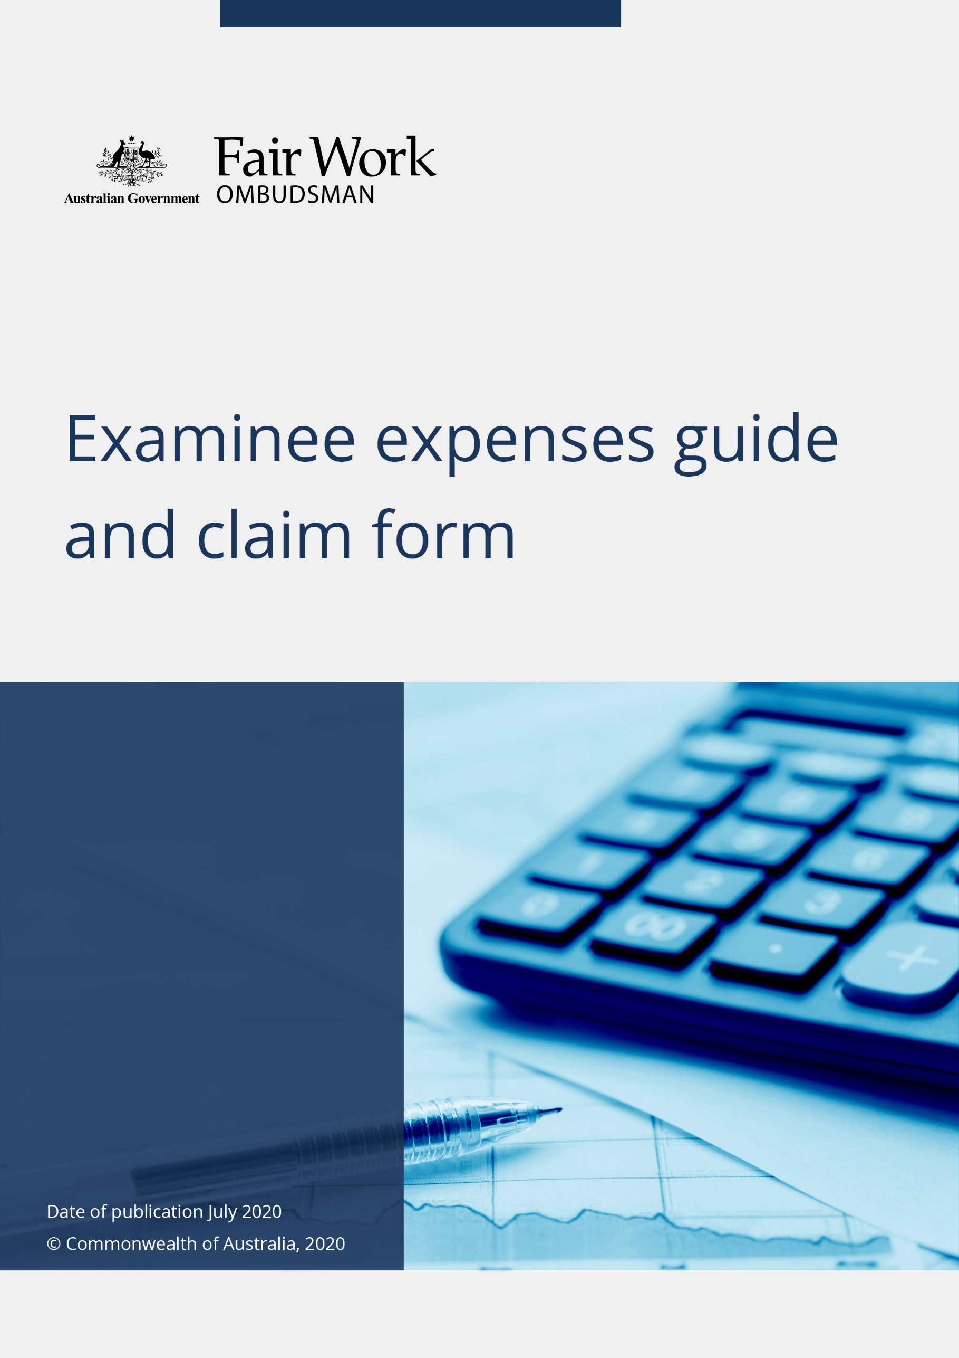

Examinee expenses guide and claim form

Version 3.0

July 2020

Introduction

This guide explains the expenses you may be entitled to recover from the Fair Work Ombudsman (FWO) under section 712C of the *Fair Work Act 2009* (the Act) if you are required to attend at a certain place to answer questions (an examination) as outlined by a FWO Notice issued under section 712AB of the Act.

You are entitled to be paid fees and allowances for reasonable expenses incurred in attending an examination as required by a FWO Notice, including your travel and some legal costs. Please see following a detailed breakdown of what expenses can be claimed and how. Attached to this guide is a Claim for Payment of Expenses form.

If you wish to claim reimbursement for expenses, you must:

* apply, in writing (using the attached forms), to the FWO for payment of the expenses within 3 months after the examination is completed, and
* provide the FWO with sufficient evidence (such as receipts) to establish that you incurred the expenses.

If you have any questions or for further information about claiming expenses, please contact your Fair Work Inspector or the FWO Notice Coordinator at: [fwonoticecoordinator@fwo.gov.au](mailto:fwonoticecoordinator@fwo.gov.au).

# **TRAVELLING ALLOWANCE**

You are entitled to a travelling allowance towards meeting the reasonable expenses you have incurred in travelling between your work or home (being a place in Australia) and the place where the examination took place.

The FWO can reimburse you for reasonable travel expenses incurred, up to a maximum amount of $2,000 for the travel options listed below. In exceptional circumstances, the FWO may be able to assist with pre-arranging your required travel to attend an examination.

## **Public transport/Taxi fares**

Public transport and taxi fares will be reimbursed upon a claim with a receipt.

## **Private motor vehicle**

If public transport is not available and you need to travel using your private motor vehicle - the amount is calculated at the rate of$0.85per kilometre travelled. When deciding whether public transport is, or is not, available you should consider whether you are able to conveniently travel to and from your home or work and the examination location in a reasonable time.

## **Air travel**

If it is reasonable for you to travel by air, please email the FWO Notice Coordinator at: [fwonoticecoordinator@fwo.gov.au](mailto:fwonoticecoordinator@fwo.gov.au). If it is reasonable then the FWO will arrange the air travel on your behalf. All air travel and airfares must be arranged by the FWO.

# **ACCOMMODATION ALLOWANCE**

You are entitled to an accommodation allowance if it is reasonable and necessary for you to be absent overnight from your home to attend the examination. The maximum amount of accommodation allowance claimable is calculated at the accommodation rate specified in the [Australian Taxation Office Determination](https://www.ato.gov.au/law/view/pdf/pbr/td2023-003.pdf) for the lowest salary range.

This means you can claim up to the following amounts per night for accommodation (for the 2023-2024 income year) upon a claim with a receipt:

|  |  |
| --- | --- |
| * Adelaide $158.00 * Brisbane $181.00 * Canberra $178.00 * Darwin $220.00 | * Hobart $176.00 * Melbourne $173.00 * Perth $180.00 * Sydney $198.00 |

In exceptional circumstances, the FWO may be able to assist with pre-arranging your required accommodation to attend an examination.

# **LEGAL ALLOWANCES**

A legal allowance is a payment towards meeting the reasonable legal costs and disbursements you may incur for a lawyer to represent you at the examination. This allowance is calculated using the costs for general federal law proceedings as set out in the [*Federal Circuit and Family Court of Australia (Division 2) (General Federal Law) Rules 2021* (Cth)](https://www.legislation.gov.au/Details/F2023C00085) (“**the FCFCOA Rules**”).

Rule [22.13](https://www.austlii.edu.au/cgi-bin/viewdoc/au/legis/cth/consol_reg/fcafcoa2flr2021675/s22.13.html) explains that where you are represented at a hearing by a solicitor, the amount you can claim for the solicitor’s appearance at the hearing is limited to 150% of the daily hearing fee for one solicitor, and a fee for the solicitor’s preparation for the hearing. You are not entitled to seek reimbursement for expenses incurred in relation to the preparation of a brief on hearing (if applicable).

This means you can claim up to the following amounts (incl GST) by way of legal costs for a solicitor to represent you at the examination, plus any reasonable disbursements, upon a claim with a receipt:

* a short (2 hours or less) examination $513.29
* a half day (2 to 4 hours) examination $1,883.63
* a full day examination $3,768.84

The amounts above are calculated based on the FCFCOA Rules [Schedule 2 Part 1](https://www.austlii.edu.au/cgi-bin/viewdoc/au/legis/cth/consol_reg/fcafcoa2flr2021675/sch2.html) Item 9 ‘Daily hearing fee’ as at the date of publication. Please check the FCFCOA Rules for any changes to these rates.

# **ATTENDANCE ALLOWANCE**

An attendance allowance is a payment for meeting any reasonable loss of income you may incur for being absent from your work to attend the examination. This allowance is calculated based on the amount you would have otherwise been entitled to receive for performing your normal duties, had you worked at the time of the examination.

When claiming the attendance allowance, you must provide evidence that confirms:

* your usual pay/income, and
* you did not receive your usual pay/income for the time when you were absent from work to attend the examination.

Examples of evidence include:

* a statutory declaration
* a letter from an employer
* tax returns
* pay slips.

## **Persons in paid employment**

If you are an employee in paid employment, complete **Part A** and **Part B** of the Claim for Payment of Expenses form ensuring that your employer sign the ‘Employer's Certificate’ in **Part B**. Generally, reimbursement for loss of income is made directly to your employer and must be included by your employer in your next group certificate for taxation purposes.

We recognise in some circumstances payment directly to your employer may not be appropriate, for example where your employer is the subject of the investigation. In these circumstances, the FWO can assist with alternative arrangements.

If alternative arrangements are made with the FWO and reimbursement is paid directly to you, we strongly advise you to seek independent financial advice in relation to your income tax and superannuation obligations as you will become personally responsible for meeting these legal obligations.

Please contact the FWO Notice Coordinator prior to completing any forms if you are seeking alternative arrangements for the attendance allowance at: [fwonoticecoordinator@fwo.gov.au](mailto:fwonoticecoordinator@fwo.gov.au).

## **Self-employed persons**

If you are self-employed, complete **Part A** and **Part C** of the Claim for Payment of Expenses form. You may claim for the loss of gross (i.e. before tax) income incurred for attending the examination. You must provide details of the method used to calculate your loss of income and provide evidence of the actual loss you have incurred.

Any reimbursement for loss of income will be made directly to you. We strongly advise you to seek independent financial advice if you are uncertain about how a reimbursement for loss of income will impact on your income tax obligations.

# **LODGEMENT OF YOUR CLAIM**

To lodge your claim, complete and return the Claim for Payment of Expenses form attached. Please send your completed claim form and supporting documents to the FWO Notice Coordinator at: [fwonoticecoordinator@fwo.gov.au](mailto:fwonoticecoordinator@fwo.gov.au)

**You will not be entitled to a reimbursement unless you apply, in writing (using the attached form) within 3 months after the examination is completed.**

# **WHEN CAN I EXPECT TO RECEIVE PAYMENT?**

All claim forms are processed by the FWO. Generally, payment can be expected within 14 days of approval.

# **FALSE OR MISLEADING STATEMENTS IN APPLICATIONS**

Note that under section 136.1 of the *Criminal Code Act 1995* (Cth) it is an offence to make a false or misleading statement in an application or claim for a benefit to a Commonwealth entity.

|  |  |  |  |  |  |  |  |  |  |  |  |
| --- | --- | --- | --- | --- | --- | --- | --- | --- | --- | --- | --- |
| **Claim for Payment of Expenses**  **FWO ref: _____________________ Date: ___/___/20__** | | | | | | | |  | | | |
|  | | | |
|  | | | |
| **EXAMINEE DETAILS** | | | | | | | | | | | |
| Full name | |  | | | | | | | | | |
| Address (include postcode) | |  | | | | | | | | | |
| Telephone and Email address | |  | | | | | | | | | |
| Occupation | |  | | | | | | | | | |
| Name and address of employer (if relevant) | |  | | | | | | | | | |
|  | |  | | | | | | | | | |
| **EXAMINATION DETAILS** | | | | | | | | | | | |
| ***Location***   * Adelaide * Brisbane * Canberra * Darwin * Hobart * Melbourne * Perth * Sydney * Other | Address: | | | | | | | | | | |
| Date(s) and time(s) examinee was absent from home/work because of examination | | Day 1 | ........ | from | ........ | am/pm | | to | ........ | am/pm |
| Day 2 | ........ | from | ........ | am/pm | | to | ........ | am/pm |
| Day 3 | ........ | from | ........ | am/pm | | to | ........ | am/pm |
| Day 4 | ........ | from | ........ | am/pm | | to | ........ | am/pm |
| Day 5 | ........ | from | ........ | am/pm | | to | ........ | am/pm |

|  |  |  |
| --- | --- | --- |
| **EXPENSES CLAIMED** | | |
| **1. TRAVELLING ALLOWANCE**  **Receipts (or certified copies) attached** | **AMOUNT CLAIMED**  Taxi fare  $..................................  Public Transport  $..................................  Private Motor Vehicle per km @ $0.74  $..................................  **Travelling allowance total**  $.................................... |  |
| **2. ACCOMMODATION ALLOWANCE**  **Receipts (or certified copies) attached** | **AMOUNT CLAIMED**  No. of night(s) accommodation  ..........................................  Accommodation provider  ............................................  Cost per night  $..................................  **Accommodation allowance total**  $.................................... |  |
| **3. LEGAL ALLOWANCE**  **Receipts (or certified copies) attached** | **AMOUNT CLAIMED**  Type:   * a short examination; or * a half day examination; or * a full day examination   **Legal allowance total**  $.................................... |  |

**4. ATTENDANCE ALLOWANCE – REASONABLE LOSS OF INCOME**

**Part A. All individuals**

**(Please read Section 4 of the Guide before completing this section)**

As a result of attending the examination, I would have received, from my employer **OR** I would have received as a self-employed person (delete as appropriate) **gross income** calculated as follows:-

No. of Days ______________________ At daily Rate = $___________

No. of Hours _____________________ At hourly Rate = $__________

SUB-TOTAL: $_______________

**Complete EITHER Part B or Part C below (please delete the Part which is not applicable to you)**

**Part B. Persons in paid employment:**

If approved, payment of the lost income as per Part A will be paid directly to your employer, unless alternative arrangements are made with the FWO.

Name of Employer__________________________________________________________

Employer's Address_________________________________________________________

Employer's Phone No. & email.________________________________________________

Employer's Certificate: **-** (*to be completed by your employer)*

I certify that _____________________________________(Employee's Name) has had withheld, wages or salary as per Part A.

________________________________ ______________________ ________________

Name & Position of Certifying Person Signature Date

Contact Telephone number/email:_________________________________________@______________________

**Part C. Self-employed persons**

I am self-employed under the business name of______________________________________

ABN______________________________

The rate for loss of income indicated in Part A above is calculated as follows:-

______________________________________________________________________

______________________________________________________________________

_________________________________________________________________________________________________________________________________________________________________________________________________________________________________________________________________________________________________________

(Please provide details of your annual income before tax or details of the other means used to

calculate the rate of loss of income. Proof, such as a copy of an income tax assessment, is required.)

**TOTAL CLAIMED AND CERTIFICATION**

**TOTAL:** $_______________

**BANK DETAILS**

Name:_________________________

BSB:__________________________

Account:_______________________

I certify that the above details are true and correct. Please be advised that is a criminal offence to make a false statement to a Commonwealth official (s.137.2 Criminal Code Act) and to make a false or misleading statement in an application or claim for a benefit to a Commonwealth entity (s.136.1 Criminal Code Act).

___________________________ ________________

(signature of claimant) (date)

**This section to be completed FWO**

Internal use only: PVW_____________ ____/____/20___

Checked by FWO Notice Coordinator______________________________Date______________

**Approving Officer**

Signature:__________________________

Name:_____________________________

Title:_______________________________

Date:_______________________________