WA – Gascoyne/Mid-West Regional Campaign 2015

Report - May 2016

A report prepared by the Fair Work Ombudsman under the *Fair Work Act 2009*

© Commonwealth of Australia, 2016

# Table of Contents

Table of Contents 2

Infographic Page 3

Summary 4

What We Did 4

Outcomes 5

Individual Errors 7

Association Membership and Business Size 7

Next Steps 8

Conclusion 8

About the Fair Work Ombudsman 9

# WA Gascoyne/Mid-West Regional CampaignInfographic Page

# Summary

In April 2015, the Fair Work Ombudsman (FWO) commenced an education and compliance campaign (the campaign) in the Gascoyne and Mid-West regions (the regions) of Western Australia (WA).

The regions were identified as suitable for a campaign based upon a number of factors including:

* An increase of 40% in Requests for Assistance (RfA’s) received by the FWO from the Gascoyne region between 2011 and 2014;
* A high violation rate in RfA’s received from the Gascoyne region;
* High numbers of RfA’s received from the Mid-West region between 2011 and 2014;
* A high violation rate in RfA’s received from the Mid-West region; and
* 90% of businesses in the regions are categorised as small businesses, providing an opportunity for the FWO to support these business who often don’t have dedicated staff to perform payroll functions.

During the campaign the FWO audited the time and wage records of 118 businesses. Of these businesses:

* 92 (78%) were compliant with record-keeping and pay slip requirements;
* 83 (70%) were paying their employees correctly;
* 66 (56%) were compliant with all requirements;
* $107,014 was recovered on behalf of 121 employees; and
* 1 formal caution was issued.

# What We Did

The FWO contacted stakeholders in the region to discuss the planning, promotion and delivery of the campaign. The campaign received additional promotion through local media outlets including ABC radio (in Broome, Kalgoorlie, Geraldton and Karratha), Indigenous community station Radio Goolarri, the Workplace Info website and the Northern Guardian in regional WA.

The promotion of the campaign ensured that information about both the campaign and the FWO was spread beyond those businesses contacted directly by the FWO during the campaign.

Fair Work Inspectors (FWI’s) audited businesses in towns in the regions including:

* **Gascoyne**: Carnarvon, Coral Bay, Exmouth and Denham; and
* **Mid-West**: Geraldton, Meekatharra, Paraburdoo, Kalbarri and Newman.

Although businesses were selected randomly, some industries such as Agriculture and Accommodation and Food Services were assigned a higher priority based on RfA’s received by the FWO from these industries in the regions.

FWI’s assessed time and wage records for compliance with the *Fair Work Act 2009* (the Act), the *Fair Work Regulations 2009* (the Regulations) and the applicable award/agreement. Where businesses had errors, FWI’s required them to rectify the issues and provide proof of having done so (including having back paid employees where applicable).

FWI’s also provided businesses with information and resources to help them comply with their obligations under Commonwealth workplace laws. In particular businesses were provided with the online resources freely available on [www.fairwork.gov.au](http://www.fairwork.gov.au/), including [Pay rates](https://www.fairwork.gov.au/pay), [Hiring employees](https://www.fairwork.gov.au/find-help-for/small-business/hiring-employees), [MyAccount](https://www.fairwork.gov.au/my-account/registerpage.aspx) and [Online training courses](https://www.fairwork.gov.au/how-we-will-help/online-training).

# Outcomes

Of the 118 businesses audited during the campaign:

* 66 (56%) were compliant with all requirements; and
* 52 (44%) had at least one error:
  + 26 (22%) related to pay rates;
  + 17 (14%) related to pay slips/records; and
  + 9 (8%) related to both pay rates and pay slips/records.

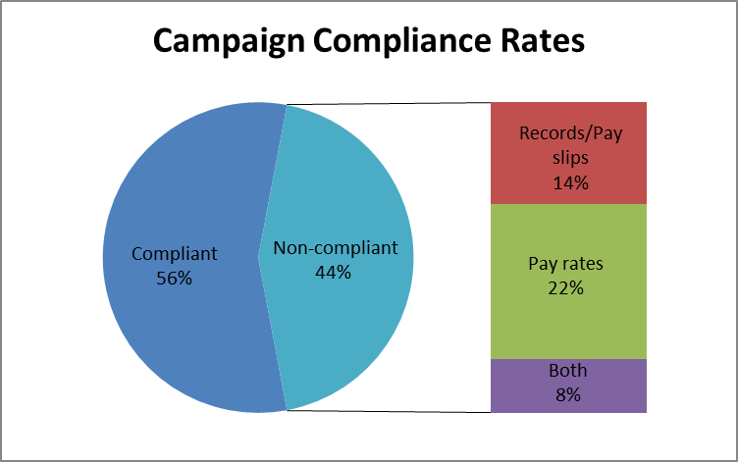

Figure 1 - Campaign compliance rates

This means that:

* 92 (78%) businesses were compliant with pay slip and record-keeping requirements;
* 83 (70%) businesses were paying their employees correctly;
* $107,014 was recovered on behalf of 121 employees; and
* 1 formal caution was issued. A formal caution is a written warning when the FWO had found non-compliance and wants to put a business on notice that future non-compliance could result in the FWO taking enforcement action against the business including seeking financial penalties through the courts.

Case Study - Failure to confirm correct pay rates

Fair Work Inspectors audited a supermarket as part of the WA Gascoyne/Mid-West Regional Campaign. When viewing employment records for the business, FWI’s identified the business was paying incorrect base rates of pay and weekend penalty rates to casual employees.

The business owner was surprised by the errors and advised they were paying under the same award as the previous owners. Upon investigation it was determined that the employer was paying under the WA state Shop & Warehouse Retail award, rather than the federal General Retail Modern Award. The owner was unaware that that there was a difference in the state and federal industrial relations system in WA, and that the business was covered by the *Fair Work Act 2009 (*theAct*)*. The FWI provided education to the owner about their obligations under the Act, and provided free tools and resources to help them comply.

FWI’s worked with the business to calculate correct rates of pay and the resulting underpayments. In total 11 employees were underpaid over $23,000. This case demonstrates the importance of checking employee entitlements when purchasing a business to ensure they are correct, as unchecked errors can result in large underpayments.

The employer actively engaged with FWI’s, readily rectified the issues and promptly back paid employees. The business owner was issued a formal caution.

## Individual Errors

52 businesses were identified with a total of 80 individual errors. The most common errors related to penalties, loadings and allowances (39%), followed by pay slip errors and underpayment of hourly rates (both 26%).

Figure 2 - Individual error types

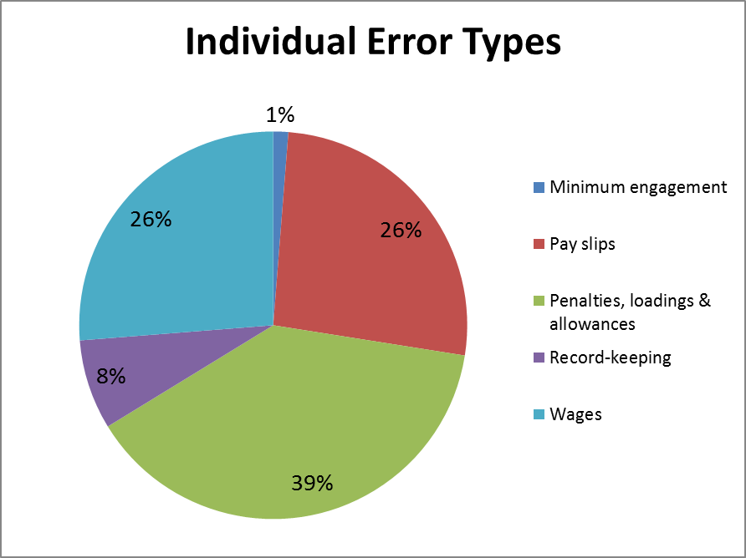

## Association Membership and Business Size

Businesses that were members of an industry or employer association had a higher compliance rate than businesses that were not members. Association member businesses had a compliance rate of 58% compared with a compliance rate of 54% for non-member businesses.

Larger businesses (those with 15 or more employees) also had a higher compliance rate than smaller businesses (those with less than 15 employees). The compliance rate for larger businesses was 58% compared with a compliance rate of 55% for smaller businesses.

Figure 3 – Compliance by association membership and size

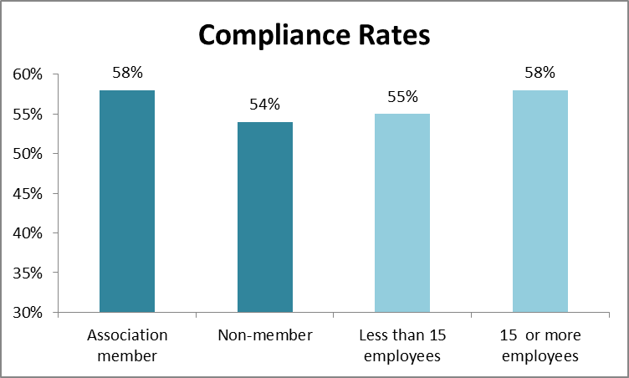

# Next Steps

To support businesses in the regions to comply with their workplace obligations, the FWO will:

* Continue to educate employers on their obligations and encourage them to contact the FWO and others for assistance and advice on workplace matters;
* Audit all businesses found to be non-compliant in this campaign in the FWO’s National Compliance Monitoring Campaign;
* Promote key themes identified in campaigns through communication and media activities and use the findings of this campaign to inform our future compliance activities; and
* Promote the tools and resources available on the FWO website [www.fairwork.gov.au](http://www.fairwork.gov.au/).

# Conclusion

The campaign revealed 56% of businesses in the regions were fully compliant with their workplace obligations. 70% of businesses were paying their employees correctly and 78% of businesses were meeting their record-keeping and pay slip obligations.

The FWO will use the results of this campaign to inform our future education and audit activities. This may involve the development of future national or regional campaigns that also include businesses from the regions. All businesses found to be non-compliant in this campaign will be re-audited as part of the FWO’s ongoing National Compliance Monitoring Campaign.

The FWO will continue to support a culture of compliance by empowering businesses and their employees to resolve any issues that arise at a workplace level. To assist businesses to do this, the FWO recently released a number of practical Guides to Resolving Workplace Issues on the FWO website [www.fairwork.gov.au](http://www.fairwork.gov.au/). Whilst the FWO will continue to monitor non-compliant businesses, supporting businesses and their employees to resolve issues at the workplace level gives the best chance of continued productive workplace relationships.

# About the Fair Work Ombudsman

The Fair Work Ombudsman is an independent agency created by the *Fair Work Act 2009* on 1 July 2009. Our main role is to promote harmonious, productive and cooperative workplace relations.

Each year the Fair Work Ombudsman (FWO) runs proactive campaigns to assist employers and employees understand their rights and obligations under Commonwealth workplace relations laws.

These campaigns can focus on particular industries, regions and/or labour market issues and are conducted on a national and state level.

This report covers the background, method and findings of the WA - Gascoyne/Mid-West Regional Campaign 2015-16. For further information and media enquiries please contact the media team at [media@fwo.gov.au](mailto:media@fwo.gov.au)

If you would like further information about the Fair Work Ombudsman’s campaigns please contact Lynda McAlary-Smith, Executive Director - Proactive Compliance and Education at [Lynda.McAlary-Smith@fwo.gov.au](mailto:Lynda.McAlary-Smith@fwo.gov.au)