Victorian retail bakeries campaign

Report – December 2014

A report by the Fair Work Ombudsman under the

Fair Work Act 2009. Date of Publication – December 2014

©Commonwealth of Australia, 2014

Summary 4

Campaign objectives 4

Why we conducted the campaign 4

Our industry partners 4

What we did 5

What we found 5

Other findings 6

Concluding remarks 7

About the Fair Work Ombudsman 7

Campaign snapshot

Total of

81

businesses were audited

We found

53%

were paying their employees correctly

Over

$146k

was recovered from 33 businesses on behalf of 211 employees

Victorian Retail bakeries campaign 2013

# Summary

In November 2013 the Fair Work Ombudsman (FWO) commenced the Victorian Retail bakeries campaign (the campaign).

The campaign aimed to promote awareness of and assess compliance with Australia’s workplace laws in the Victorian retail bakery industry.

We wrote to 81 retail bakeries across Victoria requesting records for assessment to ensure compliance with Australian workplace laws.

Fair Work Inspectors assessed the time and wage records and found that of the 81 businesses:

* 43 (53%) businesses were paying their employees correctly
* 51 (63%) businesses were compliant with record-keeping and pay slip requirements

We recovered $146 923 on behalf of 211 employees in relation to 33 businesses.

For further information on our findings, please refer to the body of this report.

# Campaign objectives

The aim of the campaign was to promote and assess compliance with the *Fair Work Act 2009* (the Act), the *Fair Work Regulations* 2009 (the Regulations) and the *General Retail Industry Award 2010* (the Award). In particular we aimed to:

* assess ordinary rates of pay
* assess penalty rates, loadings and overtime
* assess compliance with required pay slip and record-keeping practices
* provide employers with information to help make compliance easier, in particular, by introducing them to the tools and resources freely available at [our website](http://www.fairwork.gov.au/).

# Why we conducted the campaign

Internal FWO complaint data from 2012 indicated there was a higher than average rate of underpayments in the Victorian retail baking industry.

Of the 131 complaints we received in Victoria from the bakery product manufacturing sector:

* over 70% were from retail bakeries
* almost two thirds found that employees were underpaid

The campaign included assessments of pay slips and record keeping practices to ensure businesses understood their obligations. Accurate pay slips allow employees to understand and check their entitlements and detailed records help employers access and monitor important employee details..

# Our industry partners

We engaged with the following stakeholders to inform them of the campaign:

* Baking Industry Association
* Shop, Distributive and Allied Employees Association
* Bakers Delight (Franchisor)
* Brumbies (Franchisor)

We invited these stakeholders to provide feedback on the campaign and to assist us in promoting it amongst their networks.

# What we did

We wrote to 81 retail bakeries from across Victoria requesting time and wage records for assessment. These businesses included both franchises as well as independently owned and operated bakeries.

We assessed the businesses’ records to ensure compliance with the requirements of the Act, the Regulations and the Award.

Where we identified pay slip and record-keeping errors we required the employer to complete a written undertaking to issue compliant payslips in future.

Where we identified that employees were underpaid we required those employers to rectify the underpayments and provide us with proof of having paid the affected employees all entitlements owed.

# What we found

Of the 81 audits completed we found:

* 31 (38%) employers compliant with all their obligations
* 50 (62%) employers had at least one error, of which:
  + 12 (15%) had non-monetary errors
  + 20 (25%) had errors relating to underpayments
  + 18 (22%) concerned both underpayments and non-monetary errors

**Chart 1: Assessment results**

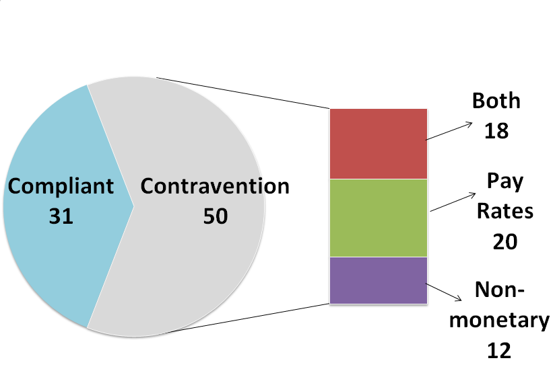

This means that of the 81 businesses:

* 43 (53%) were paying their employees correctly
* 51 (63%) were compliant with pay slip and record-keeping obligations

The 50 businesses found to have made errors had a collective total of 116 individual errors.

**Chart 2: Errors identified**

**Chart showing the individual contraventions identified by Fair Work Inspectors when they assessed employer records**

We recovered a total of $146 923 from 33 businesses, on behalf of 211 employees.

The amounts recovered from individual businesses ranged from $80 to over $24,000. The median recovery per individual business was $3141.

**Chart 3: Money recovered**

Chart showing the range of monetary recoveries from individual businesses

# Other findings

Fair Work Inspectors found that many of the employers with monetary errors were either:

* not paying weekend penalty rates and overtime; or
* not paying the correct shift penalties for early morning / evening work; or
* not keeping up to date with current rates of pay.

The errors were reflective of the lack of award knowledge amongst many of the businesses with monetary errors. Throughout the campaign Fair Work Inspectors were able to provide employers with information and advice about their workplace obligations and encourage them to visit [our website](http://www.fairwork.gov.au/).

**Case study: Paying the wrong rates**

We selected Emma’s* bakery for assessment.

When we reviewed her time and wage records, we found that she had overlooked the 1 July 2013 wage increase and had not paid her baking staff the shift penalty rate for shifts starting prior to 2am.

We also noted the pay slips she was issuing did not contain the date of payment or the pay period the pay slip related to.

We discussed our findings with Emma and explained the pay slip requirements. We also directed Emma to the [pay slips and record-keeping](http://www.fairwork.gov.au/Pay/pay-slips-and-record-keeping) section of our website for further information and templates.

When we discussed the underpayments identified, Emma explained that she was unaware of the applicable shift penalties and allowances under the Award. We showed her how to use [PayCheck Plus](http://paycheck.fwo.gov.au/PayCheckPlus.aspx) to calculate the rates and shift penalties for her employees.

As a result of our assessment, Emma paid a total of $9 257 to 11 employees who had been underpaid. She also committed to issuing correct pay slips in future.

*a pseudonym

# 

# Concluding remarks

The results of the campaign show that most employers we assessed had made errors relating to pay rates, pay slips or record-keeping.

Where back-payment of monetary entitlements was due, employers were asked to rectify underpayments, with the average recovery being $3141 per individual business. Inspectors assisted employers in understanding the value of ongoing efforts to remain aware of their obligations and avoid unexpected liabilities such as back-payment of wages.

The employers we engaged with during the campaign were open to our assistance and were quick to voluntarily rectify all errors identified.

Given our findings, we will continue to monitor complaints received from the industry, as well as assess the need for any subsequent education and compliance activity. The results from this campaign will serve to inform that assessment.

We encourage employers in the industry to visit [our website](http://www.fairwork.gov.au/) and utilise the free tools and resources to help make compliance easier for them into the future.

# About the Fair Work Ombudsman

The Fair Work Ombudsman is an independent agency created by the Fair Work Act 2009 on 1 July 2009.

Our vision is fair Australian workplaces, and our mission is to work with Australians to educate, promote fairness and ensure justice in the workplace.

Our education and compliance campaigns target specific industries to assist them achieve compliance with national workplace laws. Our focus is usually industries that need assistance with compliance and employ vulnerable workers.

We like to work with relevant industry associations and unions to deliver our campaigns. We rely upon their ‘real world’ knowledge and communication channels to design and deliver our education activities and products.

This report covers the background, method and findings of the Victorian Retail bakeries campaign 2013.

For further information and media enquiries please contact [media@fwo.gov.au](http://fwoforms.hosts.network/Lists/COWU/Attachments/844/media@fwo.gov.au).

If you would like further information about the Fair Work Ombudsman’s campaigns please contact Lynda McAlary-Smith, Executive Director - Proactive Compliance & Education (Lynda.McAlary-Smith@fwo.gov.au)

Commonwealth of Australia 2014

This work is copyright. You may download, display, print and reproduce this material in unaltered form only (retaining this notice) for your personal, non-commercial use or use within your organisation.

Apart from any use as permitted under the Copyright Act 1968, all other rights are reserved.

Requests and enquiries concerning reproduction and rights should be emailed to [communications@fwo.gov.au](mailto:communications@fwo.gov.au)

Copyright Act 1968 (ComLaw website)