VIC Loddon/Elmore and Campaspe Regional Campaign

Report - May 2016

A report prepared by the Fair Work Ombudsman under the *Fair Work Act 2009*

© Commonwealth of Australia, 2016

# Table of Contents

Table of Contents 2

Infographic Page 3

Summary 4

What We Did 4

Outcomes 5

Individual Errors 6

Association Membership and Business Size 7

Next Steps 7

Conclusion 8

About the Fair Work Ombudsman 8

# Campaign results infographicInfographic Page

# Summary

In February 2015, the Fair Work Ombudsman (FWO) commenced an education and compliance campaign (the campaign) in the Loddon/Elmore and Campaspe regions of Victoria. The regions were identified as suitable for a campaign based on analysis of FWO Request for Assistance (RfA) data and information from other sources.

Important factors behind selecting these regions for a campaign included:

* RfA’s received by the FWO increased between 2011 and 2014, with Loddon/Elmore recording a 60% increase and Campaspe a 48% increase;
* Both regions recorded high violation rates from RfA’s received during 2011 and 2014; and
* In both regions, 90% of businesses were identified as small businesses, providing the FWO an opportunity to support these businesses which often to do no have dedicated staff to perform workplace relations and payroll functions.

Of the 251 businesses audited:

* 173 (69%) businesses were paying their employees correctly;
* 149 (59%) businesses were compliant with record-keeping and pay slip requirements;
* 113 (45%) businesses were compliant with all requirements;
* $80,116 was recovered from 63 businesses on behalf of 183 employees; and
* 3 formal cautions and 3 Infringement Notices (on the spot fines) were issued.

# What We Did

The FWO contacted stakeholders in the region to discuss the planning, delivery and promotion of the campaign. The campaign received further coverage through local media outlets and many businesses advised they had heard about the campaign before the FWO had contacted them. Local media coverage also ensured that information about both the campaign and the FWO was spread beyond those businesses included in the campaign.

Fair Work Inspectors (FWI’s) audited major towns in the regions including;

* **Campaspe:** Kyabram, Rochester, Stanhope, Tongala and Rushworth; and
* **Loddon/Elmore:** Leitchville, Boort, Wedderburn, Elmore, Bridgewater, Pyramid Hill and Inglewood.

Businesses were selected randomly, though the Dairy Farming industry was assigned a higher priority based on RfA’s received by the FWO from this industry in the regions.

FWI’s visited businesses in a number of locations in the regions and assessed compliance with the *Fair Work Act 2009* (the Act), the *Fair Work Regulations 2009* (the Regulations) and the applicable award/agreement. Where businesses had errors, the FWO required them to rectify the issue and provide proof of having done so (including back-paying underpaid employees).

FWI’s also provided businesses with information and resources to help them comply with their obligations under Commonwealth workplace laws. In particular businesses were provided with the online resources freely available on [www.fairwork.gov.au](http://www.fairwork.gov.au/), including [pay rates](https://www.fairwork.gov.au/pay), [hiring employees](https://www.fairwork.gov.au/find-help-for/small-business/hiring-employees), [MyAccount](https://www.fairwork.gov.au/my-account/registerpage.aspx) and [online training courses](https://www.fairwork.gov.au/how-we-will-help/online-training).

# Outcomes

Of the 251 businesses audited:

* 113 (45%) businesses were compliant with all requirements; and
* 138 (55%) businesses had at least one error:
  + 60 (24%) had errors relating to pay slips or records;
  + 36 (14%) had errors relating to pay rates; and
  + 42 (17%) had errors relating to both pay rates and pay slips/records.

### Figure 1 - Compliance rates

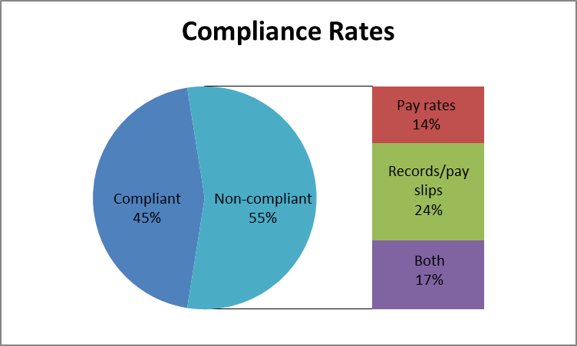

This means that:

* 173 (69%) businesses were paying their employees correctly;
* 149 (59%) businesses were compliant with record-keeping and pay slip requirements;
* $80,116 was recovered from 63 businesses on behalf of 183 employees. Amounts recovered from individual businesses ranged from less than $100 to over $9,000;
* 3 formal cautions were issued. Formal cautions are a written warning when the FWO has found non-compliance and wants to put a business on notice that future non-compliance could in the FWO taking enforcement action against the business including seeking financial penalties through the courts; and
* 3 Infringement Notices were issued. An Infringement Notice is an on the spot fine issued to a business for not complying with the record-keeping and/or pay slip obligations of the Act and Regulations.

## Individual Errors

The 138 non-compliant businesses had a total of 227 individual errors. The most common errors related to pay slips (40%), followed by underpayment of base wages (27%) and penalties, loadings and allowances (20%).

### Figure 2 - Individual error types

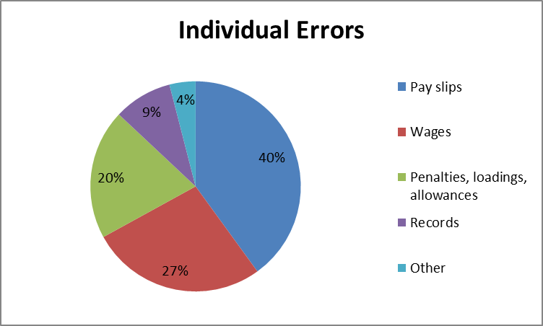

## Association Membership and Business Size

Businesses that were members of an industry or employer association had a higher compliance rate than businesses that were not members. Association member businesses had a compliance rate of 49%, compared to a compliance rate of 43% for non-member businesses.

Larger businesses (those with 15 or more employees) had a higher compliance rate than smaller businesses (those with less than 15 employees). The compliance rate for larger businesses was 84% compared with a compliance rate of 39% for smaller businesses.

Figure 3 – Compliance by association membership and size

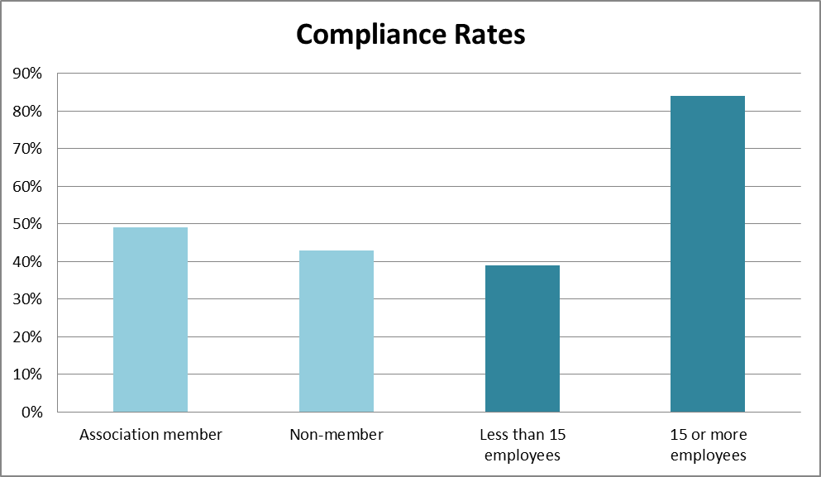

# Next Steps

The results of the campaign indicate that businesses in the region would benefit from further education and compliance activity. The FWO will:

* continue to educate employers on their obligations and encourage them to contact the FWO and others for assistance and advice on workplace relations matters;
* audit all businesses found to be non-compliant in this campaign in the National Compliance Monitoring Campaign;
* promote the tools and resources available on [www.fairwork.gov.au](http://www.fairwork.gov.au/); and
* promote key themes identified in campaigns through communication and media activities and use the findings of this campaign to inform future compliance activities.

# Conclusion

The campaign revealed 45% of businesses were fully compliant with their workplace obligations, 69% were paying their employees correctly and 59% were meeting their record-keeping and pay slip obligations.

The FWO will use the results of this campaign to inform our future education and audit activities. This may involve the development of future national or regional campaigns that include businesses from these regions. All businesses found to be non-compliant during this campaign will be re-audited as part of the FWO’s ongoing National Compliance Monitoring Campaign, to promote a culture of compliance, assess behavioural change and take compliance and enforcement action where necessary.

The FWO will continue to support a culture of compliance by empowering businesses and their employees to resolve any issues that arise at a workplace level. To assist businesses to do this, the FWO recently released a number of practical Guides to Resolving Workplace Issues on the FWO website [www.fairwork.gov.au](http://www.fairwork.gov.au/). Whilst the FWO will continue to monitor non-compliant businesses, supporting businesses and employees to resolve issues at the workplace level gives the best chance of continued productive workplace relationships.

# About the Fair Work Ombudsman

The Fair Work Ombudsman is an independent agency created by the *Fair Work Act 2009* on 1 July 2009. Our main role is to promote harmonious, productive and cooperative workplace relations.

Each year the Fair Work Ombudsman (FWO) runs proactive campaigns to assist employers and employees understand their rights and obligations under Commonwealth workplace relations laws.

These campaigns can focus on particular industries, regions and/or labour market issues and are conducted on a national and state level.

This report covers the background, method and findings of the VIC Loddon/Elmore and Campaspe Regional Campaign. For further information and media enquiries please contact the media team at [media@fwo.gov.au](mailto:media@fwo.gov.au)

If you would like further information about the Fair Work Ombudsman’s campaigns please contact Lynda McAlary-Smith, Executive Director - Proactive Compliance and Education at [Lynda.McAlary-Smith@fwo.gov.au](mailto:Lynda.McAlary-Smith@fwo.gov.au)