TAS Sorell-Dodges Ferry Regional Campaign

Report – June 2016

A report prepared by the Fair Work Ombudsman under the *Fair Work Act 2009*

© Commonwealth of Australia, 2016

# Table of Contents

Table of Contents 2

Infographic Page 3

Summary 4

What We Did 4

Outcomes 5

Individual Errors 6

Association Membership and Business Size 6

Next Steps 7

Conclusion 7

About the Fair Work Ombudsman 8

# Infographic Page

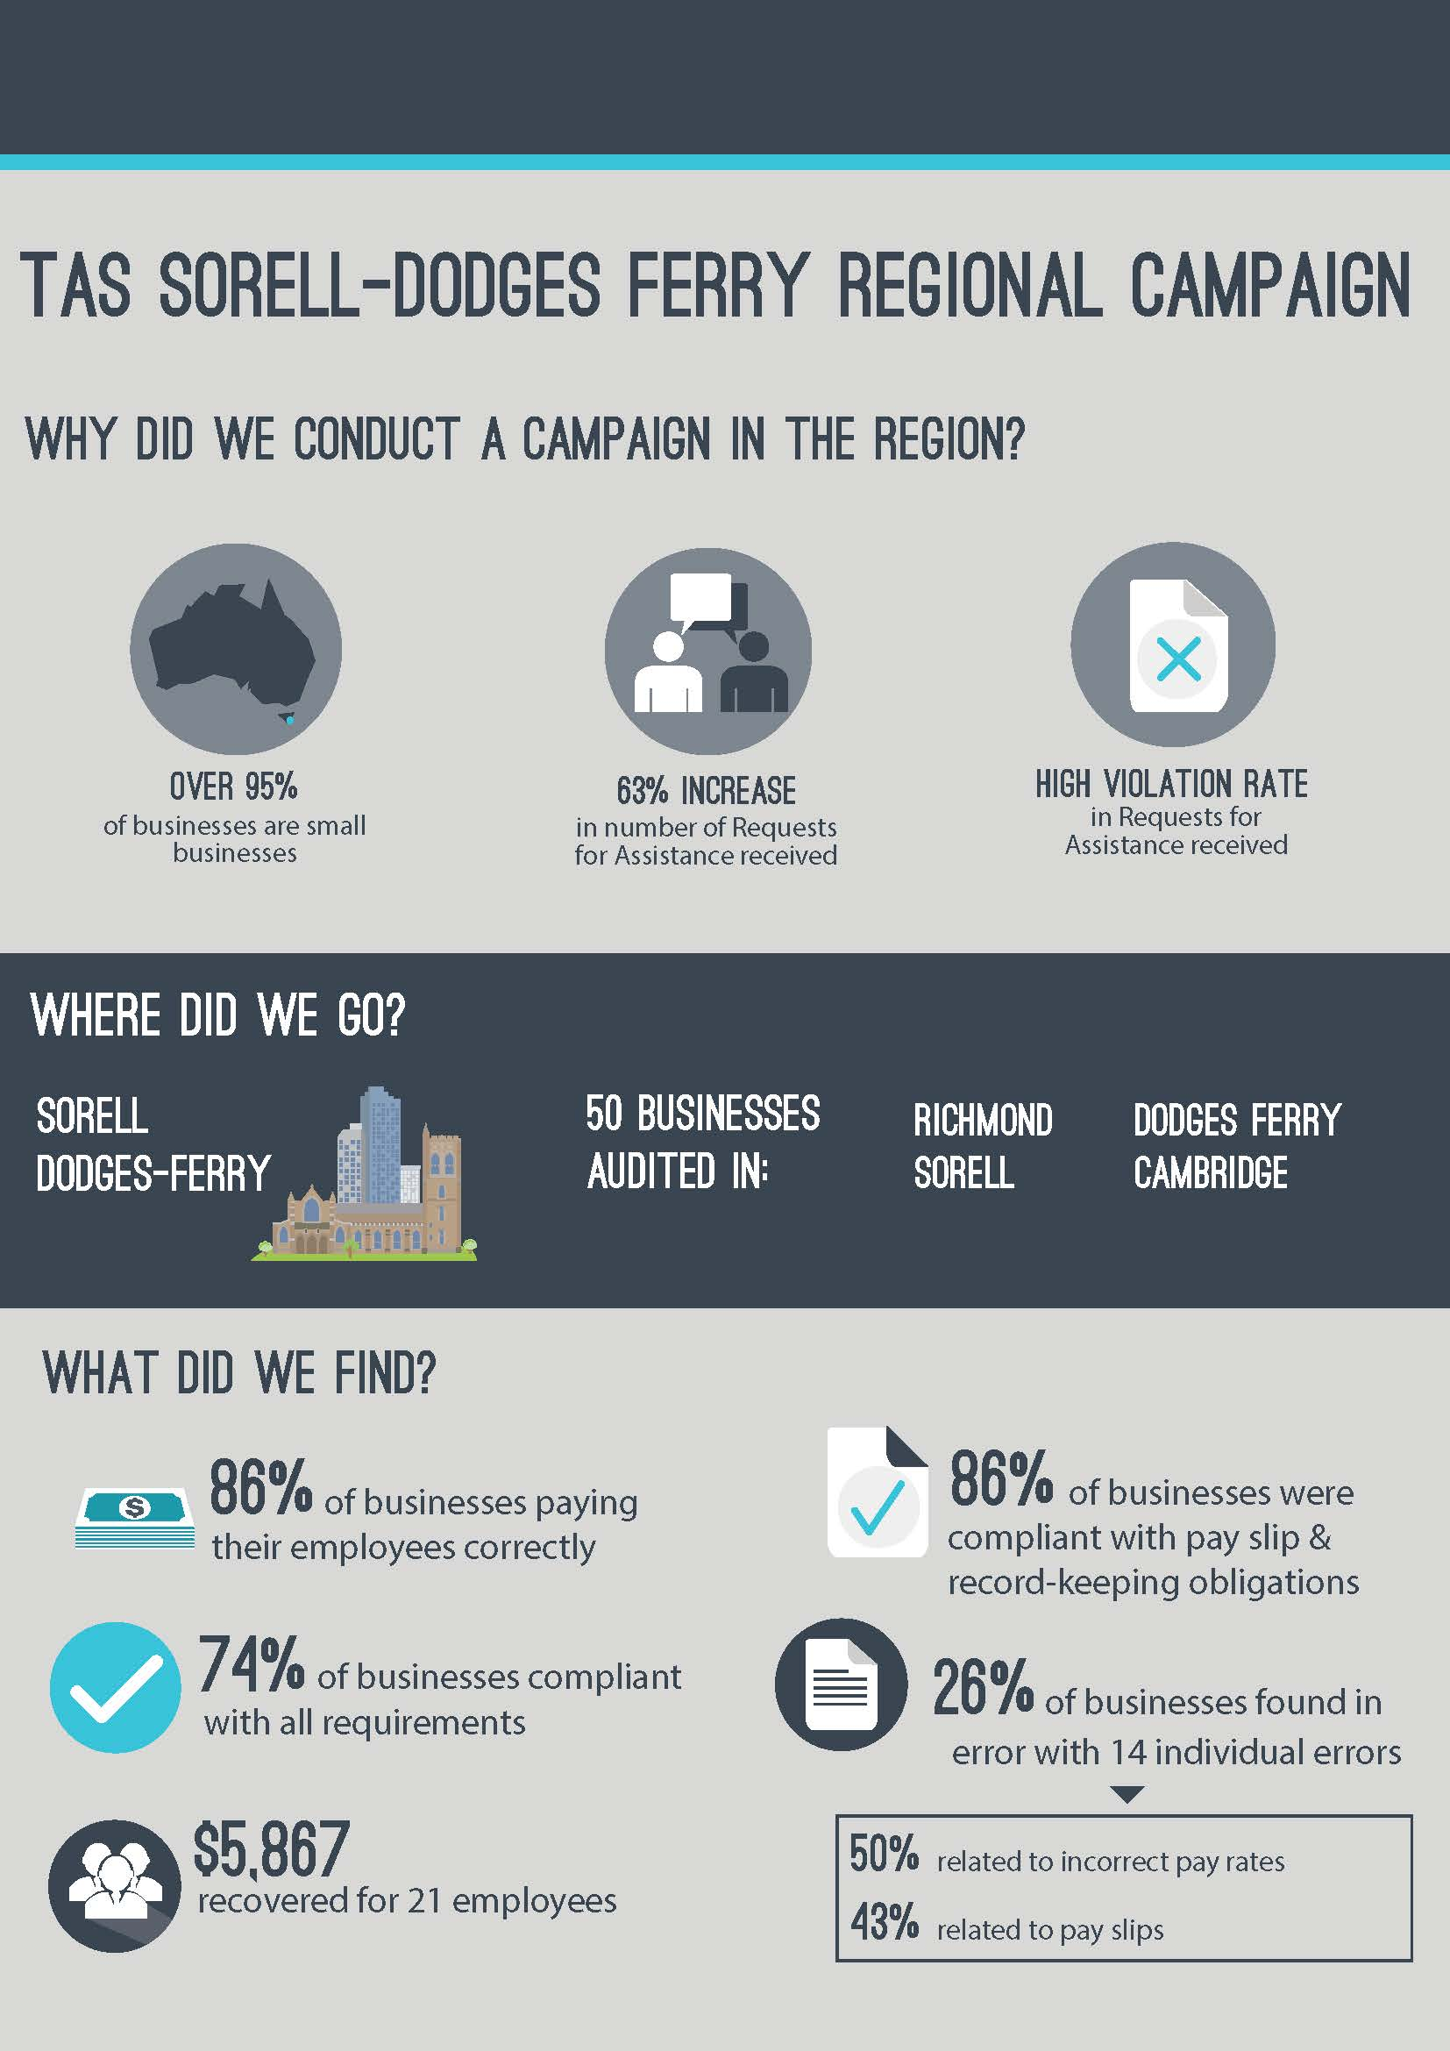

# Summary

In October 2015, the Fair Work Ombudsman (FWO) commenced an education and compliance campaign (the campaign) in the Sorell / Dodges Ferry region (the region) of Tasmania.

The region was identified as suitable for a campaign based upon a number of factors including:

* An increase of 63% in Requests for Assistance (RfA’s) received from the region by the FWO between 2011 and 2014;
* A high violation rate identified from RfA’s received; and
* Over 95% of businesses in the region are small businesses, providing an opportunity for the FWO to support business that often don’t have dedicated staff to perform payroll or Human Resources functions.

The specific objectives of the campaign were to:

* Promote a culture of compliance amongst employers in the region;
* Introduce employers to the suite of free educational tools and resources available at the FWO website [www.fairwork.gov.au](http://www.fairwork.gov.au/), such as My Account, the Online Learning Centre, downloadable templates and Best Practice Guides; and
* Review time and wages records to assess compliance with pay slip, record-keeping and pay rate requirements of the *Fair Work Act 2009* (the Act), the *Fair Work Regulations 2009* (the Regulations) and applicable awards/agreements.

Of the 50 businesses audited:

* 43 (86%) were paying their employees correctly;
* 43 (86%) were compliant with record-keeping and pay slip requirements;
* 37 (74%) were compliant with all requirements; and
* $5,867 was recovered on behalf of 21 employees.

# What We Did

The FWO contacted local stakeholders to discuss the planning, delivery and promotion of the campaign.

The campaign received coverage through local media outlets including Heart FM, Sea FM and The Mercury. Additionally, there was online coverage via Hospitality Magazine and Weekly Times Now. Local media coverage ensured that information about the campaign and the FWO was spread beyond those businesses included in the campaign.

As part of the campaign, Business East hosted an information session for approximately 20 employers. Fair Work Inspector’s (FWI’s) presented to local employers on their workplace relations obligations, and demonstrated the tools and resources the FWO has available to assist them.

FWI’s visited 50 businesses in towns throughout the region, including Sorell, Richmond, Cambridge and Dodges Ferry. Businesses were randomly selected from various industries operating in the region.

FWI’s spoke with employers about how the FWO can help them comply with their obligations. FWI’s provided advice and demonstrated key resources from [www.fairwork.gov.au](http://www.fairwork.gov.au/) designed to assist employers. Key resources promoted during the campaign included [pay rate](https://www.fairwork.gov.au/pay)s, [hiring employees](https://www.fairwork.gov.au/find-help-for/small-business/hiring-employees), [MyAccount](https://www.fairwork.gov.au/my-account/registerpage.aspx) and tailored [small business resources](https://www.fairwork.gov.au/find-help-for/small-business).

FWI’s assessed time and wage records of employers against the requirements of the Act, the Regulations and the applicable award/agreement.

# Outcomes

Of the 50 businesses audited:

* 37 (74%) businesses were compliant with all requirements; and
* 13 (26%) businesses had at least one error:
  + 6 (12%) had errors related to pay rates;
  + 6 (12%) had errors related to pay slips or record-keeping; and
  + 1 (2%) had both pay rate and records/pay slip errors.

### Figure 1 - Compliance rates

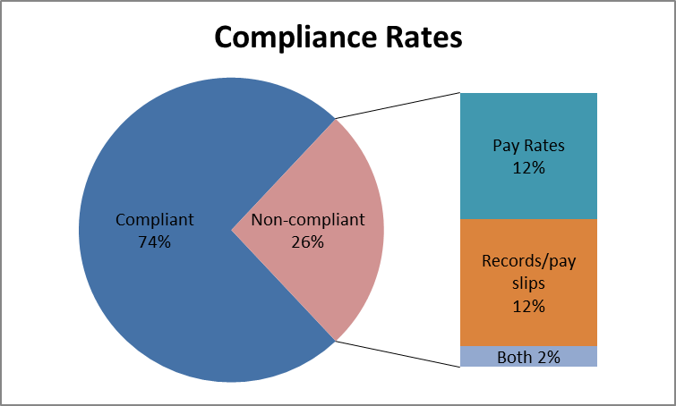

This means that:

* 43 (86%) businesses were paying their employees correctly;
* 43 (86%) businesses were compliant with record-keeping and pay slip requirements; and
* $5,867 was recovered on behalf of 21 employees.

## Individual Errors

The 13 businesses with errors had a total of 14 individual errors. Half of the errors were due to incorrect pay rates, 43% related to pay slips and 7% related to record-keeping.

### Figure 2 – Individual errors

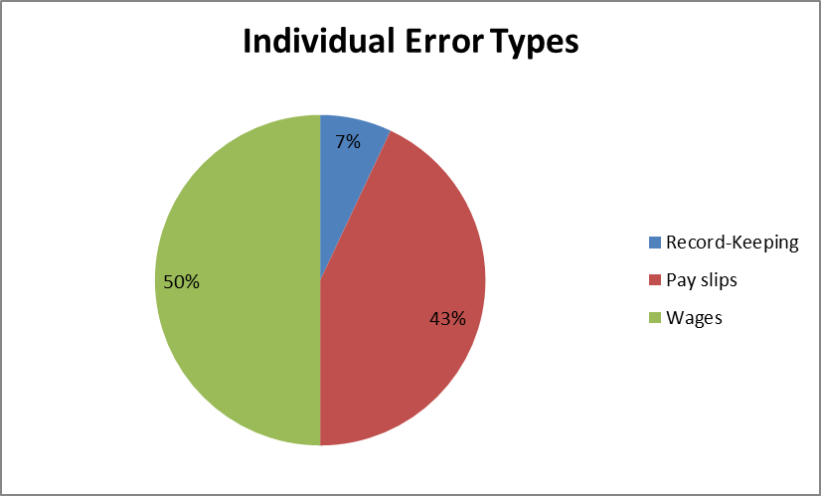

## Association Membership and Business Size

Businesses that were members of an industry or employer association had a higher compliance rate than businesses that were not members. Association member businesses had a compliance rate of 75% compared with a compliance rate of 73% for non-member businesses.

Larger businesses (those with 15 or more employees) had a higher compliance rate than smaller businesses (those with less than 15 employees). The compliance rate for larger businesses was 92% compared with a compliance rate of 68% for smaller businesses.

Figure 3 – Compliance by association membership and size

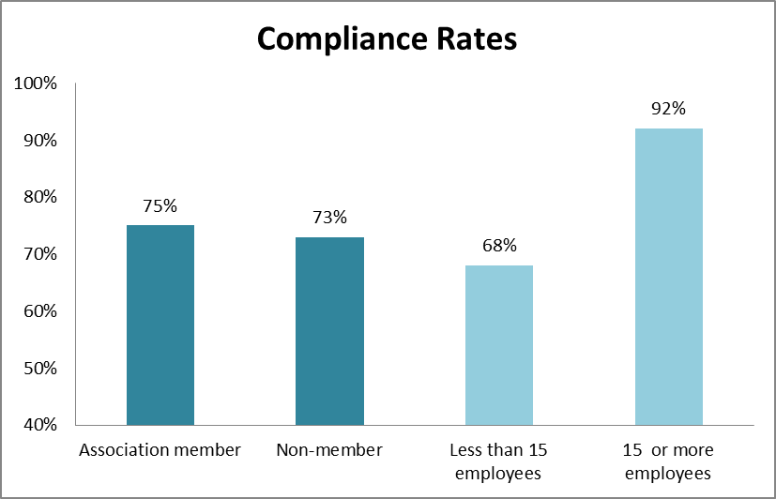

# Next Steps

To support businesses in the region to comply with their workplace obligations, the FWO will:

* continue to educate employers on their obligations and encourage them to contact the FWO and others for assistance and advice on workplace relations matters;
* audit all businesses found to be non-compliant in this campaign in the National Compliance Monitoring Campaign;
* promote the tools and resources available on [www.fairwork.gov.au](http://www.fairwork.gov.au/); and
* promote key themes identified in campaigns through communication and media activities and use the findings of this campaign to inform future compliance activities.

# Conclusion

The results of the campaign were encouraging and revealed 74% of businesses were fully compliant with their workplace obligations, 86% were paying their employees correctly and 86% were meeting their record-keeping and pay slip obligations. The campaign also showed that businesses who were not members of an employer or industry association were more likely to have errors.

The FWO will use the results of this campaign to inform our future education and audit activities. This may involve the development of future national or regional campaigns that include businesses from the region. All businesses found to be non-compliant in this campaign will be re-audited as part of the FWO’s ongoing National Compliance Monitoring Campaign.

The FWO will continue to support a culture of compliance by empowering businesses and their employees to resolve any issues that arise at a workplace level. To assist businesses to do this, the FWO recently released a number of practical Guides to Resolving Workplace Issues on [www.fairwork.gov.au](http://www.fairwork.gov.au/). Whilst the FWO will continue to monitor non-compliant businesses, supporting businesses and their employees to resolve issues at the workplace level gives the best chance of continued productive workplace relationships.

# About the Fair Work Ombudsman

The Fair Work Ombudsman is an independent agency created by the *Fair Work Act 2009* on 1 July 2009. Our main role is to promote harmonious, productive and cooperative workplace relations.

Each year the Fair Work Ombudsman (FWO) runs proactive campaigns to assist employers and employees understand their rights and obligations under Commonwealth workplace relations laws.

These campaigns can focus on particular industries, regions and/or labour market issues and are conducted on a national and state level.

This report covers the background, method and findings of the TAS Sorell/Dodges Ferry Regional Campaign. For further information and media enquiries please contact the media team at [media@fwo.gov.au](mailto:media@fwo.gov.au)

If you would like further information about the Fair Work Ombudsman’s campaigns please contact Lynda McAlary-Smith, Executive Director - Proactive Compliance and Education at [Lynda.McAlary-Smith@fwo.gov.au](mailto:Lynda.McAlary-Smith@fwo.gov.au)