Records and Resources Campaigns – Report

Report- June 2016

A report prepared by the Fair Work Ombudsman under the *Fair Work Act 2009*

© Commonwealth of Australia, 2016

# Contents

Contents 2

Summary 4

Purpose of the Campaigns 4

Overall Findings – Combined Campaigns 5

Individual Campaign Findings 6

Eastern States Campaign 6

SA/WA/NT Campaign 7

East Coast Campaign 8

Comparative Findings 9

Money Recovered 9

Other Findings 10

Next Steps 11

Conclusion 11

About the Fair Work Ombudsman 12

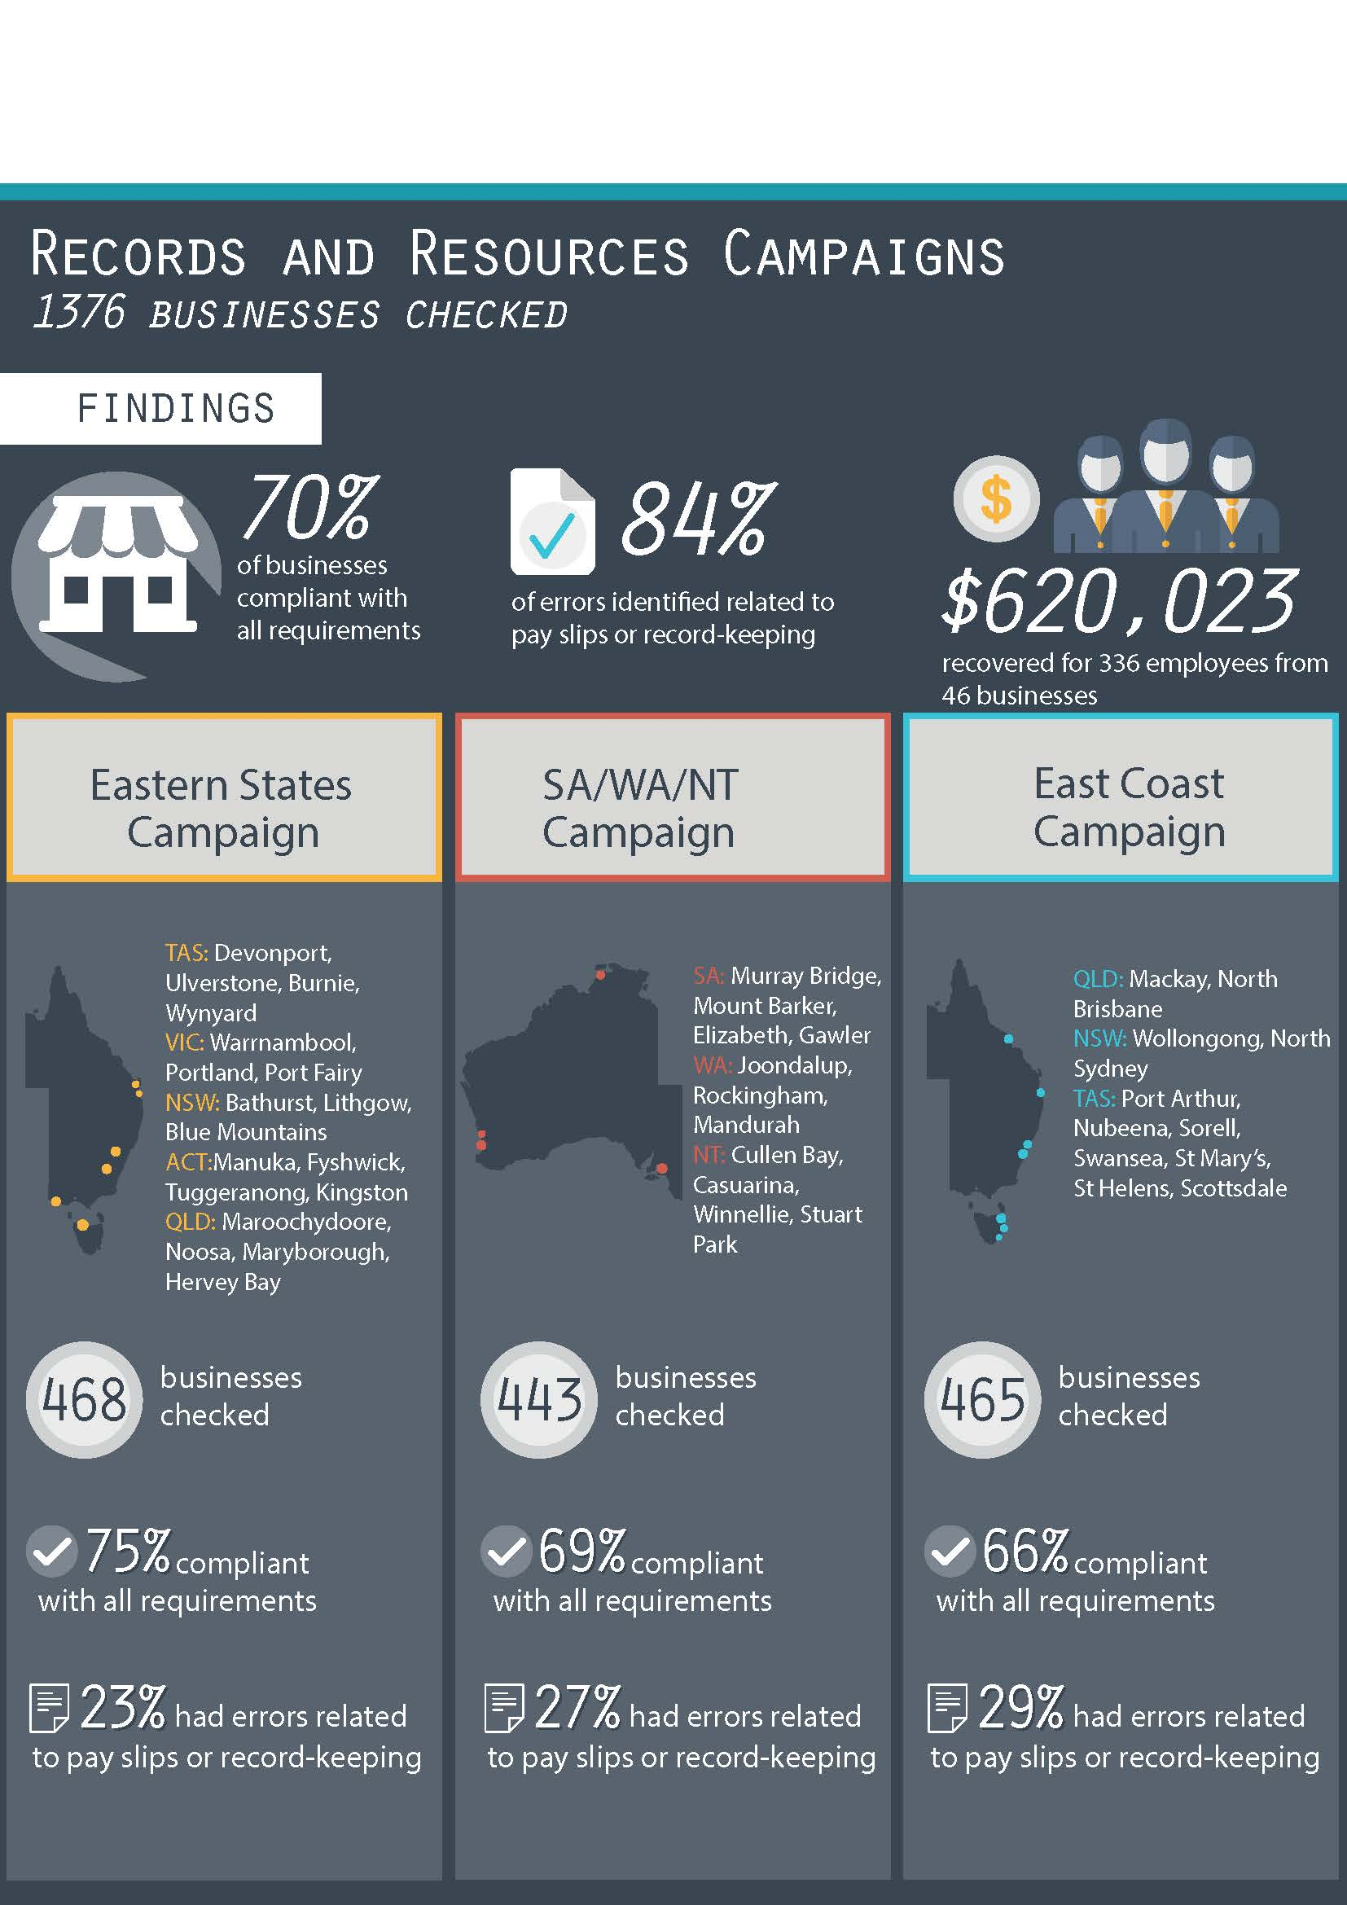

# Summary

During 2014 and 2015, the Fair Work Ombudsman (FWO) undertook three Records and Resources Campaigns (the campaigns) across Australia. The campaigns focused on providing education and assistance to businesses to comply with commonwealth workplace laws, and assessed levels of compliance with record-keeping obligations. The three distinct campaigns conducted were the:

* Eastern States Campaign;
* SA/WA/NT Campaign; and
* East Coast Campaign.

The campaigns focused on smaller businesses operating in areas where the FWO does not have a local office. Fair Work Inspectors (FWI’s) assessed compliance with record-keeping and pay slip obligations and provided information to businesses to make compliance easier. Businesses were provided with educational resources available from the FWO website [www.fairwork.gov.au](http://www.fairwork.gov.au/), including records and pay tools, the FWO Online Learning Centre and staff management resources such as the Hiring Employees Guide.

Overall, across the campaigns:

* 1,376 businesses were audited;
* 962 (70%) businesses were compliant with all requirements;
* 988 (72%) businesses were compliant with record-keeping and pay slip obligations;
* $620,023 was recovered from 46 employers on behalf of 336 employees; and
* 2 formal cautions were issued.

# Purpose of the Campaigns

The *Fair Work Act 2009* (the Act) and the *Fair Work Regulations 2009* (the Regulations) provide for a range of records that businesses are required to keep. If issues arise it is these records that can show that employees have received their correct entitlements. The FWO places great importance on correct record keeping so that FWI’s can assess entitlements should a dispute arise.

The FWO encourages employees and employers to discuss issues that may arise at the workplace level as this generally gives the best chance of a satisfactory outcome. The keeping of correct records also allows employees and employers to have those conversations and ensure that entitlements are being met in workplaces.

The campaigns were designed to:

* promote the role and services provided by the FWO to assist small businesses;
* assess compliance with record-keeping and pay slip obligations under the Actand the Regulations*;*
* identify underlying factors of non-compliance to inform the design of future resources to assist businesses; and
* address pay rate errors encountered by FWI’s in the course of assessing record-keeping and pay slip practices.

# Overall Findings – Combined Campaigns

Of the 1,376 businesses audited during the campaigns:

* 962 (70%) businesses were compliant with all requirements;
* 414 (30%) businesses had at least one error:
  + 363 (26%) had errors relating to records and pay slips;
  + 26 (2%) had errors relating to pay rates; and
  + 25 (2%) had both pay rate and records/pay slip errors.

### Figure 1: Overall compliance rates (combined campaigns)

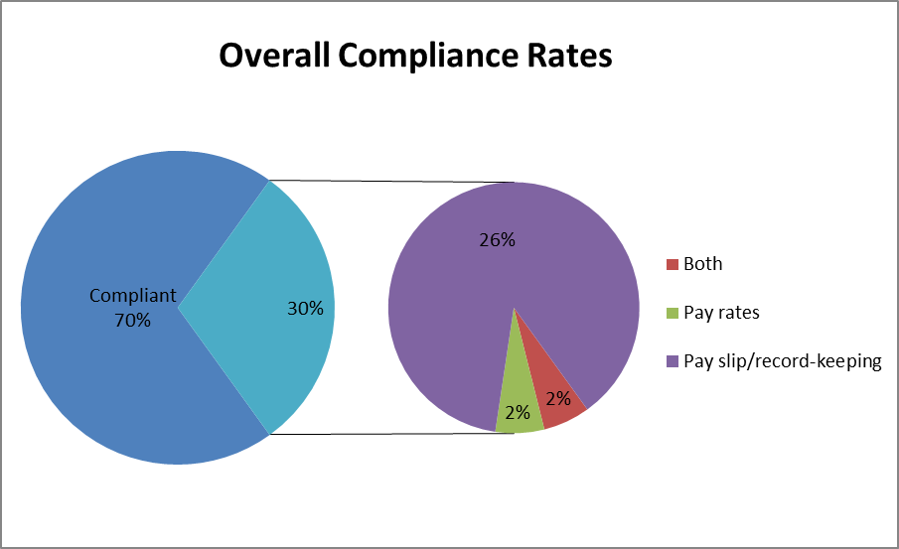

This means that:

* 484 individual errors were recorded from 414 businesses:
  + 69% of errors related to pay slips;
  + 15% of errors related to record-keeping; and
  + 9% of errors related to underpayment of hourly rates.
* $620,023 was recovered for 336 employees from 46 businesses; and
* 2 formal cautions were issued.

# Individual Campaign Findings

## Eastern States Campaign

The Eastern States Campaign commenced in May 2014. FWI’s conducted site visits with businesses in the following locations:

* Tasmania – Devonport, Ulverstone, Burnie and Wynyard;
* Victoria – Warrnambool, Portland and Port Fairy;
* New South Wales – Bathurst, Lithgow, Wentworth Falls, Katoomba and Blackheath;
* Australian Capital Territory – Manuka, Fyshwick, Tuggeranong and Kingston; and
* Queensland – Maroochydore, Noosa, Maryborough and Hervey Bay.

Of the 468 businesses audited:

* 349 (75%) were compliant with all requirements;
* 119 (25%) had at least one error:
  + 110 (23%) had errors relating to record-keeping and pay slips;
  + 4 (1%) had errors relating to pay rates; and
  + 5 (1%) had both pay rate and records/pay slip errors.

### Figure 2: Individual Errors – Eastern States Campaign

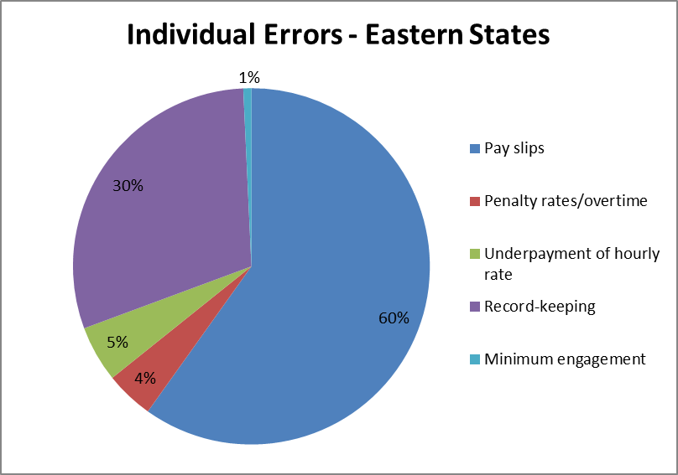

There were a total of 137 individual errors from 119 businesses. The most common were pay slips (60%) and record-keeping (30%). *Figure 2* provides a summary of all errors identified in Eastern States Campaign.

## SA/WA/NT Campaign

The SA/WA/NT Campaign commenced in July 2014. FWI’s conducted site visits with businesses in the following locations:

* South Australia – Murray Bridge, Mount Barker, Elizabeth and Gawler;
* Western Australia – Joondalup, Rockingham and Mandurah; and
* Northern Territory – Cullen Bay, Casuarina, Winnellie and Stuart Park.

Of the 443 businesses audited:

* 307 (69%) were compliant with all requirements; and
* 136 (31%) had at least one error:
  + 118 (27%) had errors relating to record-keeping and pay slips;
  + 8 (2%) had errors relating to pay rates; and
  + 10 (2%) had both pay rate and records/pay slip errors.

There were a total of 158 individual errors from 136 businesses. The most common errors related to pay slips (77%) and underpayment of hourly rate (12%). *Figure 3* provides a summary of all errors identified in SA/WA/NT Campaign.

### Figure 3: Individual Errors – SA/WA/NT Campaign

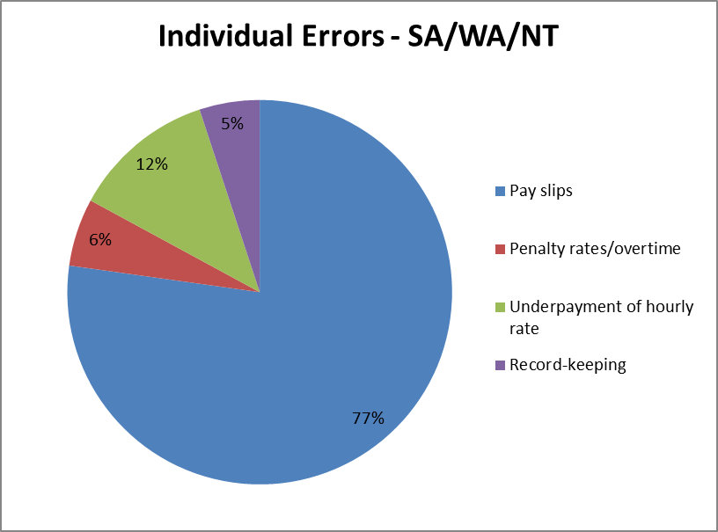

## East Coast Campaign

The East Coast Campaign commenced in September 2014. FWI’s conducted site visits with businesses in the following locations:

* Queensland – Mackay and North Brisbane;
* New South Wales – Wollongong and North Sydney; and
* Tasmania – Port Arthur, Nubeena, Sorell, Swansea, St Mary’s, St Helens and Scottsdale.

Of the 465 businesses audited:

* 306 (66%) businesses were compliant with all requirements; and
* 159 (34%) businesses had a least one error:
  + 135 (29%) had errors relating to record-keeping and pay slips
  + 14 (3%) had errors relating to pay rates; and
  + 10 (2%) had both pay rates and records/pay slip errors.

There were a total of 189 individual errors from 159 businesses. The most common errors were pay slips (68%), record-keeping (14%) and underpayment of hourly rates (11%). *Figure 4* provides a summary of all errors identified in East Coast Campaign.

### Figure 4: Individual Errors – East Coast Campaign

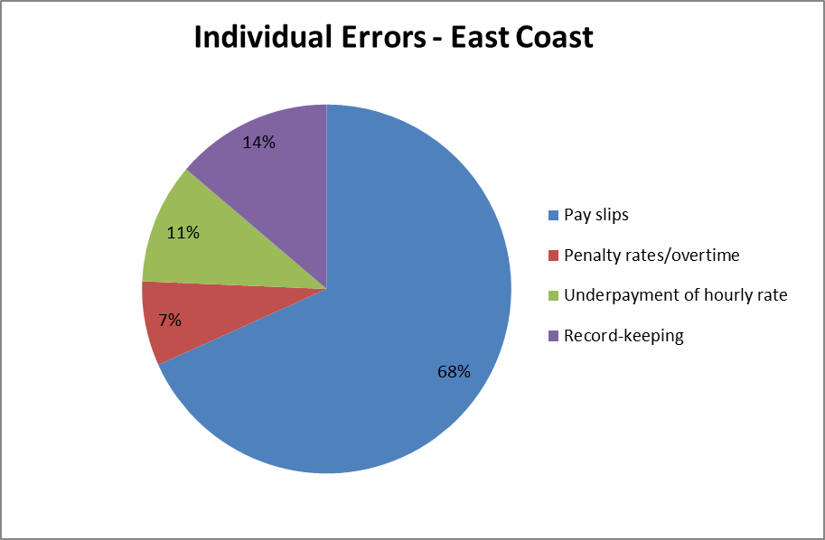

# Comparative Findings

As shown in *Figure 5*, compliance rates across the three campaigns were largely consistent, with the Eastern States Campaign having the highest compliance rate (75%) and the East Coast Campaign the lowest (66%). The average compliance rate amongst the campaigns was 70%.

The types of errors identified in each campaign was also similar, with errors relating to pay slips being the most common error identified in all three individual campaigns. The most common error on pay slips involved superannuation information not being recorded.  The Regulations provide that both the superannuation fund name and the superannuation contribution amount must be recorded on each employee pay slip.  The next most common pay slip error was employees not being provided with pay slips at all.  Other common errors related to pay slips not having a date of payment, missing the employee hourly rate or the pay period the pay slip related to not being recorded.

### Figure 5: Comparative Campaign Compliance

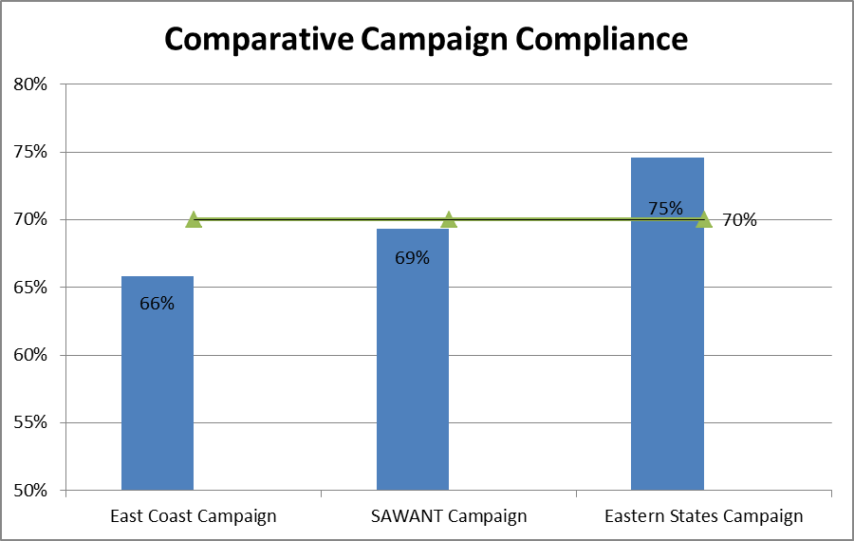

# Money Recovered

Whilst the focus of the campaigns was record keeping practices, FWI’s did provide advice and assistance to businesses about rates of pay. Where pay rate issues were identified, FWI’s worked with businesses to provide them with the correct rates, and required them to rectify any underpayments that were identified. Across the campaigns, $620,023 was recovered for 336 employees from 46 businesses, and two formal cautions were issued. This includes a recovery of $502,000 for 187 employees from one business, as outlined in the case study below.

### Figure 6: Case Study

Fair Work Inspectors attended the Darwin office of a business as part of the WA/SA/NT Campaign. When viewing employment records for the business, FWI’s noticed that the rates of pay seemed to be below the minimum rates. On further assessment FWI’s found the business was paying incorrect base rates of pay and penalty/shift rates to casual employees. The business was also incorrectly classifying employees under the applicable award.

The business was surprised by the errors as they employed dedicated HR staff to oversee payroll matters. Upon investigation it was determined the responsible payroll officer had misunderstood the applicable award and inadvertently applied incorrect pay rates. Further investigations revealed incorrect pay rates had been applied over several years, across several work sites mainly in Brisbane and Darwin.

FWI’s worked with the business in calculating the correct classifications and rates of pay, as well as calculating the resulting underpayments. In total 187 employees were underpaid over $502,000.

The business has repaid all affected employees, and with advice and assistance from FWI’s, introduced a payroll system capturing all time worked and automatically applying the correct rates of pay.

This case demonstrates the importance of regularly checking employee entitlements to ensure they are correct, as unchecked errors can result in large underpayments.

# Other Findings

To inform our future education and audit activities, the FWO spoke with businesses to determine the reasons for their non-compliance. Some reasons included:

* small businesses mistakenly believing that they were exempt from pay slip and record-keeping obligations due to their size. These businesses generally had not attempted to obtain the correct information regarding these obligations from the FWO or other available sources e.g. Industry associations or third party providers;
* some employers were not issuing pay slips because they mistakenly believed they did not have to issue them if their staff advised they did not wish to receive them;
* some employers expected their employees to keep their own records believing this would satisfy their record-keeping obligations;
* some employers were of the belief that as their employees worked the same hours every week there was no need to record hours worked; and
* payroll software was not sufficiently up to date and failed to include the required pay slip content (e.g. superannuation fund name and Australian Business Number).

# Next Steps

The results of the campaigns indicate that businesses benefit from education and compliance activity associated with pay slip and record-keeping obligations. The FWO will:

* continue to educate employers on their obligations and encourage them to contact the FWO and others for assistance and advice on workplace relations matters;
* continue to develop accessible and easy to use pay slip and record-keeping tools and resources;
* audit all businesses found to be non-compliant in this campaign in the National Compliance Monitoring Campaign 2016;
* promote key themes identified in campaigns through communication and media activities and use the findings of this campaign to inform future compliance activities; and
* promote the tools and resources available on the FWO website [www.fairwork.gov.au](http://www.fairwork.gov.au/).

# Conclusion

The campaign revealed 70% of businesses were fully compliant with their workplace obligations and 72% of businesses were meeting their record-keeping and pay slip obligations.

The FWO will use the results of this campaign to inform our future education and audit activities, which includes having pay slip and record-keeping components in audit activities. All businesses found to be non-compliant in this campaign will be re-audited as part of the FWO’s ongoing National Compliance Monitoring Campaign.

The FWO will continue to support a culture of compliance by empowering employers and employees to resolve any issues that arise at a workplace level. To assist businesses to do this, the FWO recently released a number of practical Guides to Resolving Workplace Issues on the FWO website [www.fairwork.gov.au](http://www.fairwork.gov.au/). Whilst the FWO will continue to monitor non-compliant businesses, supporting businesses and employees to resolve issues at the workplace level gives the best chance of continued productive workplace relationships.

# About the Fair Work Ombudsman

The Fair Work Ombudsman is an independent agency created by the *Fair Work Act 2009* on 1 July 2009. Our main role is to promote harmonious, productive and cooperative workplace relations.

Each year the Fair Work Ombudsman (FWO) runs proactive campaigns to assist employers and employees understand their rights and obligations under Commonwealth workplace relations laws.

These campaigns can focus on particular industries, regions and/or labour market issues and are conducted on a national and state level.

This report covers the background, method and findings of the Records and Resources Campaigns. For further information and media enquiries please contact the media team at [media@fwo.gov.au](mailto:media@fwo.gov.au)

If you would like further information about the Fair Work Ombudsman’s campaigns please contact Lynda McAlary-Smith, Executive Director - Proactive Compliance and Education at [Lynda.McAlary-Smith@fwo.gov.au](mailto:Lynda.McAlary-Smith@fwo.gov.au)