Central Queensland Regional Campaign

Report – July 2016

A report prepared by the Fair Work Ombudsman under the *Fair Work Act 2009*

© Commonwealth of Australia, 2016

# Table of Contents

Table of Contents 3

Infographic 4

Summary 5

What We Did 5

Outcomes 6

Individual Errors 7

Association Membership and Business Size 8

Next Steps 8

Conclusion 9

About the Fair Work Ombudsman 10

# Central Queensland Regional Campaign results infographicInfographic

# Summary

In February 2015, the Fair Work Ombudsman (FWO) commenced an education and compliance campaign (the campaign) in the Central Queensland Region (the region). The region was identified as suitable for a campaign based on analysis of FWO Request for Assistance (RfA) data and information from other sources.

Important factors behind selecting the region for this campaign included:

* The Rockhampton/Yeppoon area recorded a 22% increase in RfA’s between 2011 and 2014 and recorded a high violation rate of RfA’s received. The Gladstone-Biloela area recorded high violation rates of RfA’s received between 2011 and 2014; and
* The region has a high proportion of small businesses (over 90%) providing an opportunity to support businesses which often do not have dedicated staff to perform Human Resources and payroll functions.

The towns of Emerald and Blackwater were also included in this campaign given they are major regional centres (with an approximate population of 20,000) located in the Central Queensland area.

Of the 232 businesses audited:

* 163 (70%) businesses were compliant with record-keeping and pay slip requirements;
* 160 (69%) businesses were paying their employees correctly;
* 115 (49.6%) businesses were compliant with all requirements;
* $110,087 was recovered from 51 businesses on behalf of 316 employees; and
* 1 formal caution was issued.

# What We Did

The FWO contacted stakeholders in the region to discuss the planning, delivery and promotion of the campaign. The campaign received media coverage through regional web and print media publications including the Rockhampton Morning Bulletin, Gladstone Observer and the Blackwater Herald.

Local media coverage also ensured that information about both the campaign and the FWO was spread beyond those businesses included in the campaign and many businesses advised they had heard about the campaign before the FWO had contacted them.

Fair Work Inspectors (FWI's) audited businesses in Central Queensland including the major centres of Gladstone, Biloela, Emerald, Blackwater, Rockhampton and Yeppoon. Businesses were selected randomly, however industries with a higher number of RfA’s received from the region were assigned a higher priority. These industries included Accommodation, Hair and Beauty services and Earthmoving.

A sample of time and wage records was requested and FWI’s assessed compliance with the *Fair Work Act 2009* (the Act), the *Fair Work Regulations 2009* (the Regulations) and the applicable award/agreement. Where businesses had errors, FWI’s required them to rectify the issue and provide proof of having done so (including back-paying underpaid employees).

FWI’s also provided businesses with information and resources to help them comply with their obligations under Commonwealth workplace laws. In particular businesses were provided with the online resources freely available on the FWO website [www.fairwork.gov.au](http://www.fairwork.gov.au/) including [pay rates](https://www.fairwork.gov.au/pay), [hiring employees](https://www.fairwork.gov.au/find-help-for/small-business/hiring-employees), [MyAccount](https://www.fairwork.gov.au/my-account/registerpage.aspx) and [online training courses](https://www.fairwork.gov.au/how-we-will-help/online-training).

# Outcomes

Of the 232 businesses audited:

* 115 (49.6%) businesses were compliant with all requirements; and
* 117 (50.4%) businesses had at least one error:
  + 45 (19.4%) had errors relating to pay slips or record-keeping;
  + 48 (20.7%) had errors relating to pay rates; and
  + 24 (10.3%) had both pay rates and records/pay slip errors.

This means that:

* 163 (70%) businesses were compliant with record-keeping and pay slip requirements;
* 160 (69%) businesses were paying their employees correctly;
* $110,087 was recovered from 51 businesses on behalf of 316 employees; and
* 1 formal caution was issued. A formal caution is a written warning when the FWO has found non-compliance and wants to put a business on notice that future non-compliance could result in the FWO taking enforcement action against the business including seeking financial penalties through the courts.

### Figure 1: Campaign Compliance Rates

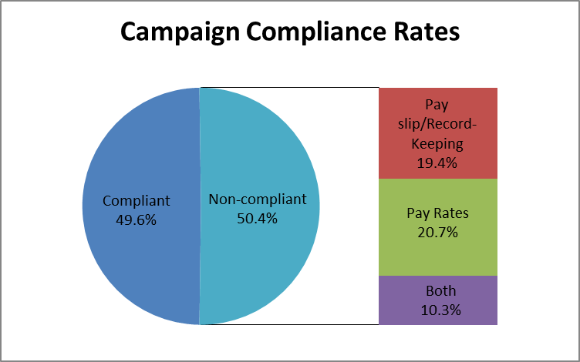

## Individual Errors

The 117 businesses with errors had a total of 173 individual errors. The most common errors related to penalty rates and overtime (35%), pay slips (30%) and underpayment of base rates (20%). *Figure 2* provides a summary of all errors identified

### Figure 2: Error Types Identified

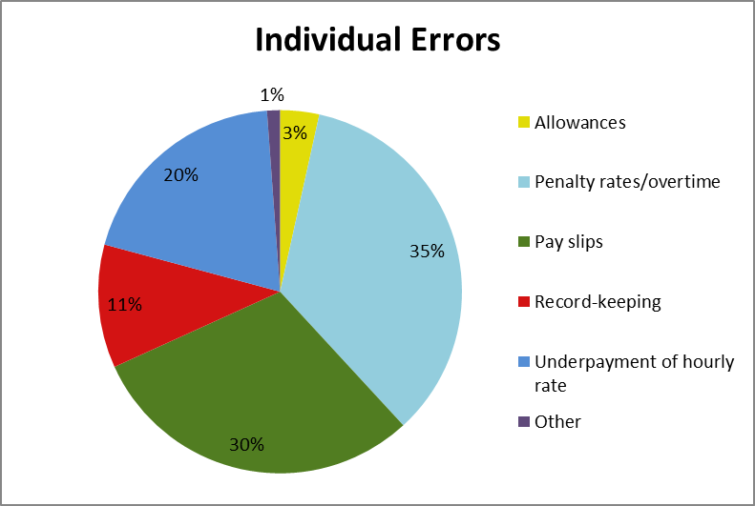

## Association Membership and Business Size

Businesses that were members of an industry or employer association had a higher compliance rate than businesses that were not members. Association member businesses had a compliance rate of 60% compared with a compliance rate of 50% for non-member businesses.

Larger businesses (those with 15 or more employees) also had a higher compliance rate than smaller businesses (those with less than 15 employees). The compliance rate for larger businesses was 65% compared with a compliance rate of 45% for smaller businesses.

### Figure 3 – Compliance by association membership and size

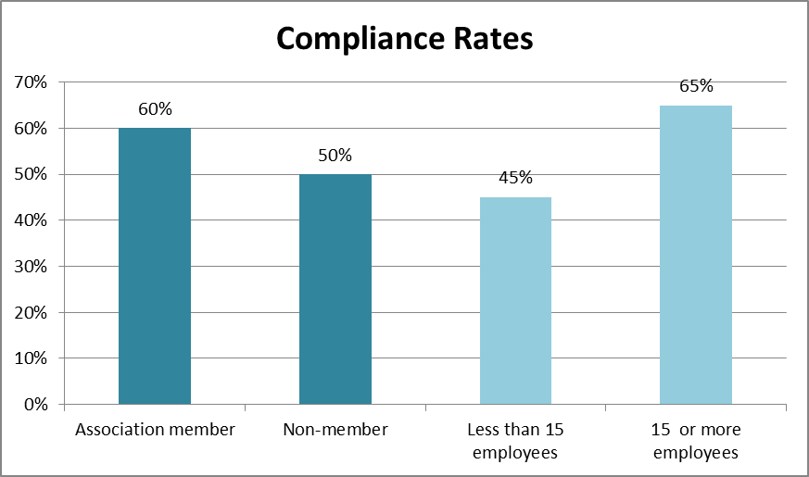

# Next Steps

To support businesses in the region to comply with their workplace obligations, the FWO will:

* continue to educate employers on their obligations and encourage them to contact the FWO and others for assistance and advice on workplace matters;
* audit all businesses found to be non-compliant in this campaign in the National Compliance Monitoring Campaign;
* promote key themes identified in campaigns through communication and media activities and use the findings of this campaign to inform future compliance activities; and
* promote the tools and resources available on the FWO website [www.fairwork.gov.au](http://www.fairwork.gov.au/).

# Conclusion

The campaign revealed 49.6% of businesses in the region were fully compliant with their workplace obligations. 69% of businesses were paying their employees correctly and 70 of businesses were compliant with their record-keeping and pay slip obligations.

The FWO will use the results of this campaign to inform our future education and audit activities. This may involve the development of future national or regional campaigns that also include businesses from the region. All businesses found to be non-compliant in this campaign will be re-audited as part of the FWO’s National Compliance Monitoring Campaign.

The FWO will continue to support a culture of compliance by empowering businesses and their employees to resolve any issues that arise at a workplace level. To assist businesses to do this, the FWO recently released a number of practical Guides to Resolving Workplace Issues on the FWO website [www.fairwork.gov.au](http://www.fairwork.gov.au/). Whilst the FWO will continue to monitor non-compliant businesses, supporting businesses and employees to resolve issues at the workplace level gives the best chance of continued productive workplace relationships.

# About the Fair Work Ombudsman

The Fair Work Ombudsman is an independent agency created by the *Fair Work Act 2009* on 1 July 2009. Our main role is to promote harmonious, productive and cooperative workplace relations.

Each year the Fair Work Ombudsman (FWO) runs proactive campaigns to assist employers and employees understand their rights and obligations under Commonwealth workplace relations laws.

These campaigns can focus on particular industries, regions and/or labour market issues and are conducted on a national and state level.

This report covers the background, method and findings of the Central Queensland Regional Campaign. For further information and media enquiries please contact the media team at [media@fwo.gov.au](mailto:media@fwo.gov.au)

If you would like further information about the Fair Work Ombudsman’s campaigns please contact Lynda McAlary-Smith, Executive Director - Proactive Compliance and Education at [Lynda.McAlary-Smith@fwo.gov.au](mailto:Lynda.McAlary-Smith@fwo.gov.au)