Northern ACT Regional Campaign

Report – May 2016

A report prepared by the Fair Work Ombudsman under the *Fair Work Act 2009*

© Commonwealth of Australia, 2016

# Table of Contents

Table of Contents 2

Infographic 3

Summary 4

What we did 4

Outcomes 5

Individual Errors 6

Employer Association Membership and Business Size 7

Conclusion 8

# Infographic

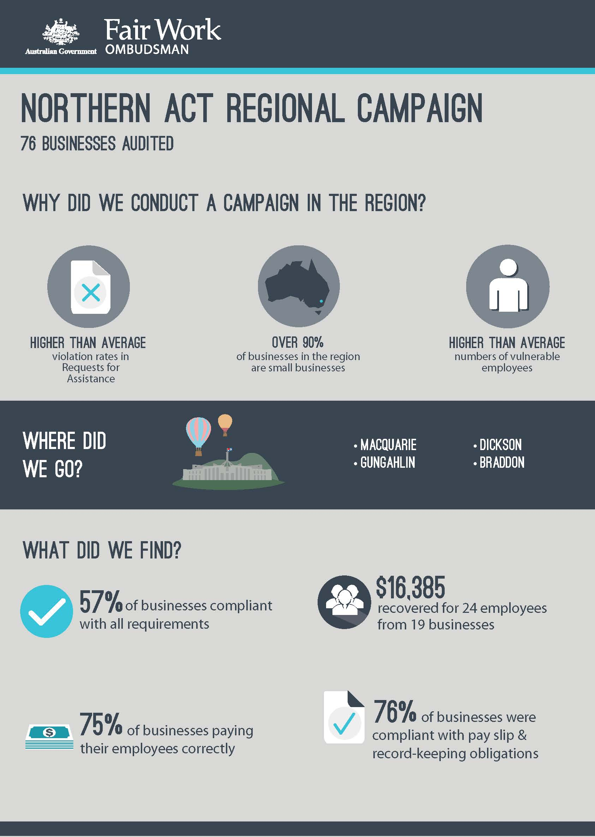

# Summary

In April 2015, the Fair Work Ombudsman (FWO) commenced the Northern ACT Regional Campaign (the campaign). The campaign was an education and compliance campaign conducted in the northern region (the region) of the Australian Capital Territory (ACT). The campaign was undertaken in response to a number of factors, including high violation rates in Requests for Assistance (RfA’s) received by the FWO. The region also has higher than average numbers of vulnerable employees, such as young workers and individuals from culturally and linguistically diverse (CALD) backgrounds.

The campaign was specifically conducted to:

* promote a culture of ongoing compliance by ensuring businesses are well informed about their employment obligations;
* assist businesses to comply with their workplace obligations by promoting the FWO educational tools and resources such as My Account, the Online Learning Centre, downloadable templates and Best Practice Guides; and
* conduct assessments of time and wages records against the relevant award/agreement to ensure compliance with Commonwealth workplace laws.

From the 76 businesses audited:

* 43 (57%) were compliant with all requirements;
* 57 (75%) were paying their employees correctly;
* 58 (76%) were compliant with record-keeping and pay slip requirements;
* $16 385 was recovered from 19 businesses on behalf of 24 employees; and
* 1 Enforceable Undertaking was executed and 1 formal caution was issued.

# What we did

The FWO contacted various stakeholders in the region to advise them of the campaign and to assist with the promotion of the campaign. These included:

* Canberra Business Chamber;
* North Canberra Community Council;
* Belconnen Community Council; and
* Gungahlin Community Council.

The campaign was also promoted in the media (both traditional and social media) to inform businesses in the region that the campaign was occurring, and to more widely publicise the resources that FWO makes available to assist businesses. Fair Work Inspectors (FWI’s) audited businesses in suburbs including Macquarie, Gungahlin, Dickson and Braddon. Businesses were selected randomly however the Retail, Hairdressing and Accommodation and Food Services industries were assigned a higher priority based on the RfA’s received from those industries in the region.

A sample of time and wage records was requested and FWI’s assessed compliance with the *Fair Work Act 2009* (the Act), the *Fair Work Regulations 2009* (the Regulations) and the applicable award/agreement. Where businesses had errors, the FWO required them to rectify the issue and provide proof of having done so (including back-paying underpaid employees).

FWI’s also provided businesses with information and resources to help them comply with their obligations under Commonwealth workplace laws. These resources included:

* [My Account](https://www.fairwork.gov.au/my-account/registerpage.aspx) (and how to register);
* FWO [online training](https://www.fairwork.gov.au/how-we-will-help/online-training) courses;
* Pay and Conditions Tool ([PACT](https://calculate.fairwork.gov.au/findyouraward)); and
* Downloadable best practice [templates](https://www.fairwork.gov.au/how-we-will-help/templates-and-guides) such as record-keeping and pay slips.

# Outcomes

Of the 76 businesses audited during the campaign:

* 43 (57%) were compliant with all requirements; and
* 33 (43%) had at least one error:
  + 15 (20%) related to pay rates;
  + 14 (18%) related to pay slips/records; and
  + 4 (5%) related to both pay rates and pay slips/records.

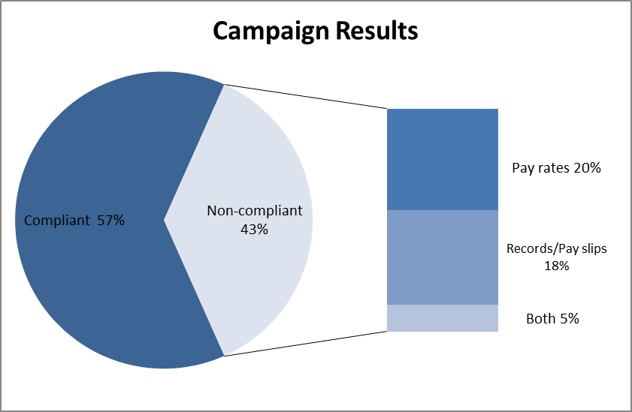Figure 1 – Campaign results

Therefore:

* 57 (75%) businesses were paying their employees correctly;
* 58 (76%) businesses were compliant with record-keeping and pay slip requirements;
* $16 385 was recovered from 19 businesses on behalf of 24 employees;
* 1 formal caution was issued. Formal cautions are a written warning when the FWO has found non-compliance and wants to put a business on notice that future non-compliance could result in the FWO seeking financial penalties; and
* 1 Enforceable Undertaking was executed (outlined in the case study below). An Enforceable Undertaking is a legally binding and publically available document where a business has acknowledged they’ve seriously breached the law, accepted responsibility and agreed to cooperate with the FWO to fix the error and ensure ongoing compliance.

## Individual Errors

The 33 businesses with errors had total of 50 individual errors. The errors most frequently identified were underpayment of base rates of pay (32%), pay slip errors (30%) and penalty rates (26%). Record-keeping and unpaid or incorrect overtime rates made up the remaining 12% of errors, as outlined in *Figure 2*.

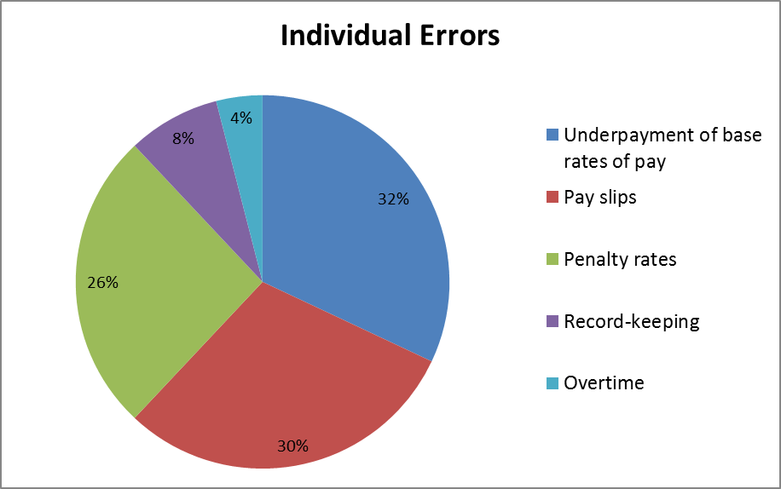Figure 2 - Individual errors

Case Study – Enforceable Undertaking

C & JT Pty Ltd operates Nando’s Canberra City, which was audited as part of the Campaign. Fair Work Inspectors found the business was not meeting its workplace relations obligations for 13 casual employees aged between 16 and 25 years of age. Most were paid a flat rate of $18 an hour for all hours worked, including weekends and public holidays.

Under the *Restaurant Industry Award*, they should have been paid at least $17.35 for a Level 1 adult for ordinary hours worked, up to $26.03 on weekends and $43.38 on public holidays. The underpayments occurred over a 12 month period and totalled $27,495.69.

As an alternative to litigation, the company entered into an Enforceable Undertaking with the FWO. The Enforceable Undertaking requires:

* back-payment of all outstanding wages and entitlements;
* an apology for the conduct to the affected employees;
* displaying a notice visible to all employees outlining the non-compliance;
* registration with the Fair Work Ombudsman’s online tool My Account;
* a commitment to future compliance with Commonwealth workplace laws; and
* the appointment of an external professional to audit the business’s compliance with workplace laws for the next three years.

## 

## Employer Association Membership and Business Size

Businesses that were members of an employer or industry association were more likely to be compliant than those who were not. 69% of businesses who were members of an association were compliant, compared with a compliance rate of 54% for businesses who were not members.

Of the 76 businesses audited, 13 were members of an employer or industry association. Of those, 4 (31%) had errors. All of those errors related to pay slips and record-keeping.

Of the 63 businesses that were not members of an association, 29 (46%) had errors. The most common error related to pay slips (9), followed by penalty rates (7) and underpayment of the hourly rate (4).

Larger businesses (those with 15 or more employees) had a higher compliance rate than smaller businesses (those with less than 15 employees). The compliance rate for larger businesses was 81% compared with a compliance rate of 50% for smaller businesses.

Of those smaller businesses, businesses with 1 - 4 employees were more likely to have made errors than businesses with 5 – 14 employees. Businesses with 1 – 4 employees had a compliance rate of 32%, compared to a compliance rate of 66% for businesses with 5 – 14 employees.

Figure 3 – Compliance by association membership and size

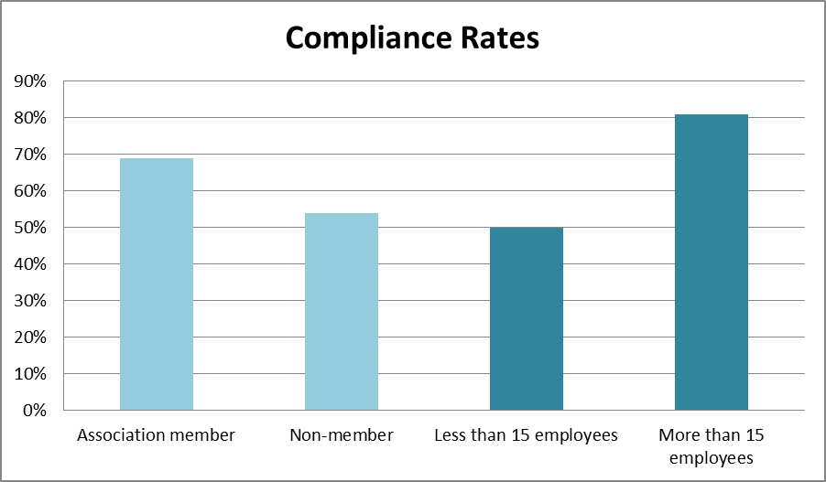

# Conclusion

The campaign revealed that most businesses were paying the correct rates of pay and keeping the required records and pay slips, though many had not consciously sought out the specific information to be certain they were compliant.

Businesses are now aware that the FWO can provide the tools and information they need to comply with their obligations; and that these freely available resources are both an efficient and reliable means of maintaining ongoing compliance.

The FWO will use the results of this campaign to inform our future education and audit activities. This may involve the development of future national or regional campaigns that also include businesses from the region.

Businesses with errors will be re-audited as part of the National Compliance Monitoring Campaign which is an initiative of the FWO aimed at ensuring that businesses previously identified as non-compliant, subsequently achieve ongoing compliance.

About the Fair Work Ombudsman

The Fair Work Ombudsman is an independent agency created by the *Fair Work Act 2009* on 1 July 2009. Our main role is to promote harmonious, productive and cooperative workplace relations.

Each year the Fair Work Ombudsman (FWO) runs proactive campaigns to assist employers and employees understand their rights and obligations under Commonwealth workplace relations laws.

These campaigns can focus on particular industries, regions and/or labour market issues and are conducted on a national and state level.

This report covers the background, method and findings of the Northern ACT Regional Campaign. For further information and media enquiries please contact the media team at [media@fwo.gov.au](mailto:media@fwo.gov.au)

If you would like further information about the Fair Work Ombudsman’s campaigns please contact Lynda McAlary-Smith, Executive Director - Proactive Compliance and Education at [Lynda.McAlary-Smith@fwo.gov.au](mailto:Lynda.McAlary-Smith@fwo.gov.au)