National Cleaning Services Compliance Campaign 2014/15

Report – March 2016

A report prepared by the Fair Work Ombudsman under the *Fair Work Act 2009*

Date of Publication – March 2016

© Commonwealth of Australia, 2016

# Table of Contents

Table of Contents 2

Summary 4

Industry activity 4

What we did 5

Industry stakeholders 5

Outcomes 5

Regional findings 8

Next steps 8

Conclusion 9

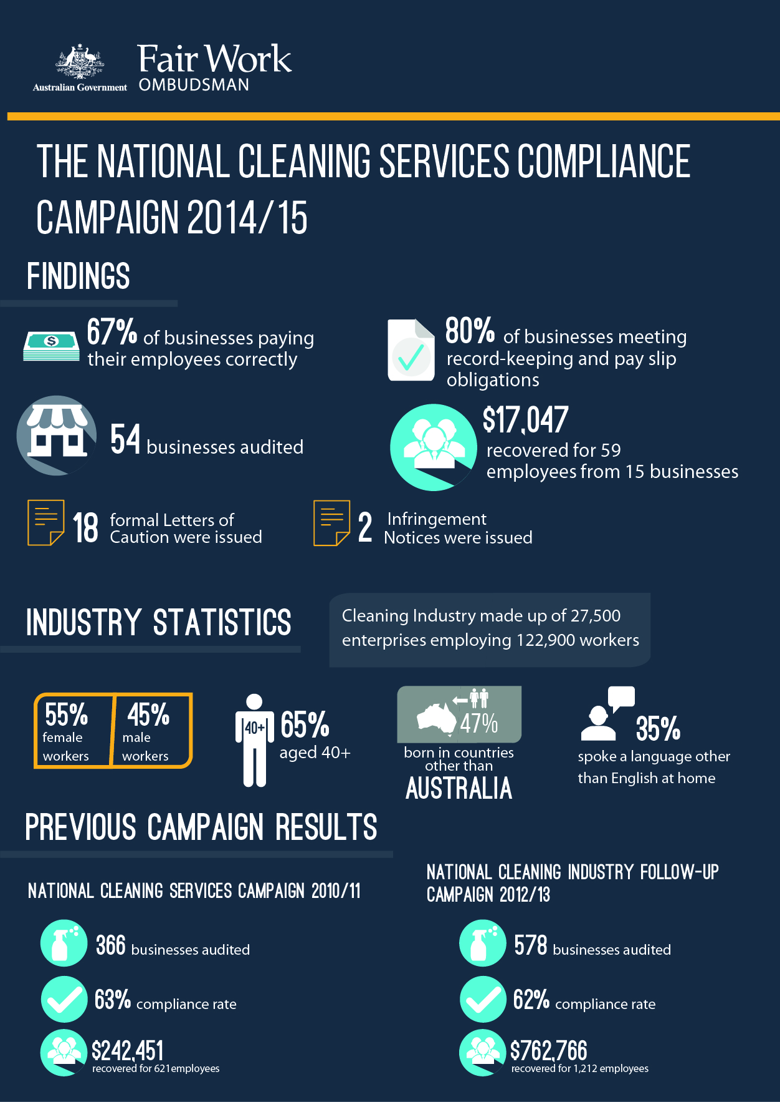

# Summary

The National Cleaning Services Compliance Campaign 2014/15 (the campaign) commenced in October 2014 in response to the history of non-compliance within the cleaning industry. The campaign assessed the compliance of 54 businesses identified as non-compliant during previous cleaning industry audit campaigns.

The campaign was specifically conducted to:

* initiate enforcement action to alter the behaviour of cleaning businesses who have remained non-compliant following their previous interaction with FWO; and
* provide education and assistance to these businesses to help them achieve and maintain ongoing compliance.

In total, from the 54 businesses audited:

* 36 (67%) businesses were paying their employees correctly;
* 43 (80%) businesses were compliant with record-keeping and pay slip requirements;
* $17,047 was recovered from 15 businesses on behalf of 59 employees;
* 18 (100%) businesses that were non-compliant in previous campaigns and found to be underpaying their employees in this campaign were subject to enforcement action; and
* 18 formal cautions and 2 infringement notices (on the spot fines) were issued.

# Industry activity

The FWO continues to have extensive interaction with the cleaning industry receiving more than 7,600 calls and over 500 requests for assistance during the 2014/15 financial year. From the requests for assistance during this period, a 40% non-compliance rate was identified.

The industry has also been subject to a number of previous audit campaigns, namely:

* Sham contracting Operational Intervention 2011 – which included audits of 65 cleaning businesses[1] focusing on industry contracting arrangements. This campaign found 21.5% of businesses were misclassifying employees - with the FWO filing one matter in court for sham-contracting (resulting in penalties of $47,250 against the company and $9,504 against the Director);
* National Cleaning Services Campaign 2010/11 – which found a 37% non-compliance rate from 366 businesses audited (recovering $242,451 for 621 employees); and
* National Cleaning Industry Follow-Up Campaign 2012/13 – which found a 38% overall non-compliance rate (recovering $762,766 for 1,212 employees, 8 formal cautions being issued and 3 businesses entering into an Enforceable Undertaking).

# What we did

The FWO contacted 54 businesses and requested a sample of time and wages records. The businesses audited as part of this campaign were selected based on:

* having contraventions identified through both the National Cleaning Services Campaign 2010-2011 and the National Cleaning Services Follow Up Campaign 2013-2014; or
* being compliant in the 2010 campaign but having contraventions in the 2013 campaign.

Fair Work Inspectors (FWI’s) assessed compliance with the *Fair Work Act 2009* (the Act), the *Fair Work Regulations 2009* (the Regulations) and the applicable award:

* where businesses were non-compliant in previous campaigns, and were found to be underpaying their employees in this campaign, enforcement action was taken; and
* where businesses were non-compliant for the first time in this campaign (due to a transfer of business), the FWO required them to rectify the issue and provide proof of having back-paid employees for all underpayments.

# Industry stakeholders

The FWO engaged significantly with industry stakeholders during the two previous campaigns and again notified them of this campaign. The stakeholders contacted were:

* Australian Cleaning Contractors Association;
* Building Services & Cleaning Association of Australia; and
* United Voice.

# Outcomes

Of the 54 businesses audited:

* 29 (54%) businesses were compliant with all requirements;
* 25 (46%) businesses had at least one error, of which:
  + 14 (26%) had errors relating to pay rates;
  + 7 (13%) had errors relating to pay slips or record-keeping; and
  + 4 (7%) had both monetary and pay-slip/record-keeping errors.

### Chart 1: Audit Results

25 (46%) had at least one error, of which:
14 (26%) had errors relating to pay rates;
7 (13%) had errors relating to payslips or record-keeping;
4 (7%) had both monetary and non-monetary errors.


This means that:

* 36 (67%) businesses were paying their employees correctly;
* 43 (80%) businesses were compliant with record-keeping and pay slip requirements; and
* 18 (100%) businesses that were non-compliant in previous campaigns and found to be underpaying their employees in this campaign were subject to enforcement action.

The 25 businesses with errors had a total of 44 individual errors across 4 contravention types as outlined in *Chart 2*.

### allowances and penalty rates (43%) payslips and record-keeping (30%) wages (20%) meal breaks and minimum engagement (7%) Chart 2 – Contravention Types

When assessing specific non-compliance, the most commonly identified contraventions were:

* allowances and penalty rates (43%);
* pay slips and record-keeping (30%); and
* wages (20%).

Of the 25 (46%) non-compliant businesses, 18 were found to be underpaying their employees. Enforcement action was taken in relation to all of these businesses.

The FWO views continuing non-compliance to be of a serious nature and strongly encourages businesses to take action to be consciously compliant with workplace laws. Consequently, 18 formal cautions and 2 Infringement Notices (on the spot fines) were issued.

In this campaign there were instances where there was a transfer of business in the period between the previous campaigns and this campaign. In these instances, where the business was found to be non-compliant, this was treated as their first transgression. These businesses were required to rectify any issues (including making back payments to underpaid employees) and were provided with assistance to help them comply with their obligations.

All businesses found to be non-compliant will be re-audited as part of the FWO’s ongoing National Compliance Monitoring Campaign.

## Regional findings

The regional findings contained in *Table 1* outline the campaign results for the states and territories.

### Table 1: Regional Findings

| State/Territory | Number of businesses audited | Outcome of Audit | |
| --- | --- | --- | --- |
| Compliant | Non-compliant |
| New South Wales | 16 | 9 | 7 |
| South Australia | 10 | 6 | 4 |
| Victoria | 10 | 5 | 5 |
| Western Australia | 8 | 5 | 3 |
| Queensland | 6 | 2 | 4 |
| Australian Capital Territory | 2 | 1 | 1 |
| Northern Territory | 1 | 0 | 1 |
| Tasmania | 1 | 1 | 0 |

# Next steps

The FWO will continue to monitor businesses found to be non-compliant through the ongoing National Compliance Monitoring Campaign. In addition the FWO will:

* continue to take compliance and enforcement action in relation to non-compliant businesses, including taking cases to court to enforce the law and seek financial penalties;
* promote key themes identified in compliance campaigns through communication and media activities and use the findings of this campaign to inform future compliance activities;
* continue to develop industry specific tools and resources, including providing industry specific articles through MyAccount;
* continue to educate employers on their obligations and encourage them to contact the FWO and others for assistance and advice on workplace relations matters;
* continue engagement with stakeholders to address key industry issues and in collaboration with these stakeholders, seek to develop resources and strategies aimed at improving compliance across the cleaning industry; and
* continue involvement in the Cleaning Accountability Framework (CAF), which is a group of key industry stakeholders across multiple parts of the procurement chain, collaborating to ensure compliance and best practice within the cleaning industry is achieved and maintained. The CAF aims to encourage all businesses involved in the cleaning industry to strive for best practice as well as strengthen procurement chains to ensure a level playing field between contractors and fair treatment of cleaning workers.

# Conclusion

The National Cleaning Services Compliance Campaign 2014/15 revealed that 54% of businesses were fully compliant with their workplace obligations. 67% of businesses were paying their employees correctly and 80% of businesses were meeting their record-keeping and pay slip obligations.

The levels of non-compliance in the cleaning industry may be impacted by the fragmented nature of the industry, specifically the high numbers of small business and the diverse range of operating hours. In addition, tight profit margins and low barriers to entry into the industry all contribute to high competition levels and may result in employee monetary entitlements not being met.

Given the results of this campaign, there is a demonstrated need for a multi-faceted approach to help reduce contravention rates and promote ongoing compliance. To achieve this, FWO will continue to work collaboratively with key stakeholders within the industry.

In addition, the FWO will continue to monitor the change in behaviour of businesses found to be non-compliant. All businesses found to be non-compliant in the campaign will be re-audited as part of the National Compliance Monitoring Campaign. Where further non-compliance is detected, the FWO will consider taking legal action to seek financial penalties.

The FWO will continue to support a culture of compliance by empowering employers and employees to resolve any issues that arise at a workplace level. To assist businesses to do this, the FWO recently released a number of practical Guides to Resolving Workplace Issues on the FWO website [www.fairwork.gov.au](http://www.fairwork.gov.au/). Whilst the FWO will continue to monitor non-compliant businesses, supporting businesses and employees to resolve issues at the workplace level gives the best chance of continued production workplace relationships.About the Fair Work Ombudsman

The Fair Work Ombudsman is an independent agency created by the *Fair Work Act 2009* on 1 July 2009. Our main role is to promote harmonious, productive and cooperative workplaces.

Each year the Fair Work Ombudsman (FWO) runs proactive campaigns to assist employers and employees understand their rights and obligations under Commonwealth workplace relations laws. These campaigns can focus on particular industries, regions and/or labour market issues and are conducted on a national and state level.

This report covers the background, method and findings of the National Cleaning Services Compliance Campaign 2014/15. For further information please contact the media team at [media@fwo.gov.au](mailto:media@fwo.gov.au)

If you would like further information about the Fair Work Ombudsman’s campaigns please contact Lynda McAlary-Smith, Executive Director – Proactive Compliance and Education at [Lynda.McAlary-Smith@fwo.gov.au](mailto:Lynda.McAlary-Smith@fwo.gov.au).

1. Data sourced from the [Report on the preliminary outcomes of the Fair Work Ombudsman’s Sham Contracting Operational Intervention 2011](https://www.fairwork.gov.au/about-us/news-and-media-releases/2011-media-releases/november-2011/20111111-sham-contracting-report).