National Children’s Services Campaign – 2013/14

Report – May 2015

A report by the Fair Work Ombudsman under the Fair Work Act 2009

Date of Publication – May 2015

© Commonwealth of Australia, 2015

# Contents

Contents 2

Campaign Snapshot 3

About the Campaign 2

Outcomes at a Glance 2

Industry Profile 3

Industry Stakeholders 3

Communication and Public Awareness 3

Time and wages audit 4

Regional Findings 5

Queensland 5

NSW/ACT 6

Victoria/Tasmania 7

South Australia, Western Australia and the Northern Territory 8

Conclusion 9

About the Fair Work Ombudsman 10

Appendix A 11

FWO Communication Activities 11

# Campaign Snapshot

Total of

420

Businesses audited as part of the National Children’s Services Campaign 2013/14

A total of

23%

Of businesses had errors only relating to pay rates

Total of

71%

Of businesses found to be compliant with all requirements

A total of

133

Errors were identified from 123 businesses

Over

438k

Recovered for 584 employees from 98 employers during the campaign

A total of

5%

Of businesses had errors only relating to record keeping and payslips

# About the Campaign

The Fair Work Ombudsman (FWO) undertook the National Children’s Services Campaign 2013/14 (the campaign) in response to a number of factors, including:

* the high number of requests for assistance received between 2010 and 2012, rising from 341 requests during 2010/11 (ranked 17th for complaints received) to 498 requests in 2012 (ranked 11th for complaints received);
* the high contravention rate - 61% of requests for assistance received in the 2010-11 calendar years identified errors and 56% identified errors in 2012;
* the vulnerability of the workforce – 30% of individuals who lodged a request for assistance in 2010/11 and 19% in 2012 were identified as young workers;
* the litigation history in the industry - three litigations against childcare centres were commenced in 2011/12; and
* almost 10,000 phone calls through the Fair Work Infoline (Infoline) between January 2012 and April 2013 (representing 1.2% of all phone calls made to the Infoline during that period).

The campaign focused on Long Day Care Centres and Outside School Hours Care (OSHC). It was delivered through two phases; communication and public awareness and a time and wages assessment; where compliance with the *Fair Work Act 2009 (The Act)*, the *Fair Work Regulations 2009 (The Regulations)* and the *Children’s Services Award 2010* (MA000120) (the Award) were assessed.

# Outcomes at a Glance

During the campaign 420 businesses were audited for compliance with wages and record keeping obligations.

The outcomes of the Campaign were:

* 297 (71%) businesses were compliant with all requirements;
* 123 (29%) businesses had at least one error;
* 133 errors in total were identified; and
* 1 Letter of Caution was issued.

The majority of contraventions identified were in relation to wages.

In total, $438,635 was recovered for 584 employees from 98 employers. The amounts recovered from individual businesses ranged from under $10 to over $60,000.

# Industry Profile

The Children’s Services industry in Australia has approximately 15,000 businesses and while it has experienced considerable growth over the past five years, it is expected to grow significantly through to 2016/17[1]. The expected increase in the workforce is attributed to more people accessing children’s services due to:

* changes to child care rebates/benefits;
* an increased participation of women in the workforce; and
* child care centres being able to register as kindergartens.

Child care businesses are obliged to maintain certain staff-to-child ratios and to ensure that suitably qualified staff are hired. This, in addition to the implementation of the National Quality Framework for Early Childhood Education and Care (progressively implemented up until 2015-16) may affect wage costs. 1

As this industry typically operates on tight margins and with labour costs among the highest, the industry has continued to be heavily reliant on award wages.

# 

# Industry Stakeholders

The FWO engaged with industry stakeholders to discuss the campaign and any industry specific issues. This also provided a chance to explore future opportunities to work collaboratively.

The stakeholders included;

* Australian Childcare Alliance (ACA);
* Early Learning Association Australia (ELAA);
* Australian Community Children’s Services (ACCS);
* Department of Education (Formerly part of the Department of Education, Employment and Workplace Relations (DEEWR);
* Early Childhood Australia (ECA); and
* United Voice.

In addition promotional support was received from the Community Services Employer Organisation, YMCA, the Australian Government and Independent Schools Queensland.

# Communication and Public Awareness

The communication and public awareness phase of the campaign aimed to promote the campaign and educate employers on their obligations prior to the audits.

The FWO contacted 8,963 businesses advising them of our campaign, directing them to the dedicated web page [www.fairwork.gov.au/childcare](http://www.fairwork.gov.au/childcare) and advised them about the industry specific webinar (conducted on 22 August 2013).

The campaign was also advertised through a number of digital platforms, the full description and result can be viewed in Appendix A.

# 

# Time and wages audit

As part of the campaign, time and wages records for 420 businesses were audited to assess compliance with the *Children’s Services Award 2010* (the award), the *Fair Work Act 2009* (the Act) and the *Fair Work Regulations* *2009* (the Regulations).

Of the 420 employers audited:

* 318 (76%) employers were paying their employees correctly;
* 395 (94%) employers were compliant with record-keeping and pay slip requirements;
* 297 (71%) employers were compliant with all requirements; and
* 123 (29%) employers had at least one error, of which;
  + 98 (23%) had errors relating to pay rates;
  + 21 (5%) had errors relating to payslips or record-keeping; and
  + 4 (1%) had both monetary and non-monetary errors.

Of the 123 businesses with errors, there were a total of 133 individual errors (as outlined in Figure 1). Underpayment of the minimum base hourly rate accounted for 76% of the errors and a further 13% due to payslips not including the correct information.

## Figure 1: Campaign Compliance Rates

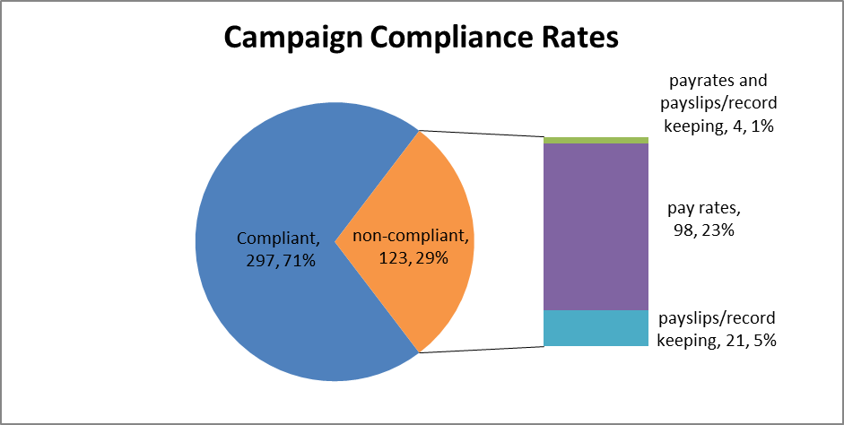

# Regional Findings

## Queensland

Of the 124 businesses assessed in **Queensland** (QLD):

* 110 (89%) of employers were compliant with all requirements;
* 14 (11%) employers had at least one error, of which:
  + 6 (5%) had errors relating to pay rates
  + 8 (6%) had errors relating to records and payslips

This means that of the 124 businesses assessed:

* 118 (95%) employers were paying their employees correctly
* 116 (94%) employers were compliant with record-keeping and pay slip requirements.

The 14 businesses found with errors, each had 1 individual error. Underpayment of the minimum base hourly rate accounted for 43% of the total errors, with a further 36% of errors relating to payslips not including the correct information.

In total, $9,536 was recovered from 6 businesses on behalf of 13 employees.

The high compliance rates in QLD was the result of employers having a sound understanding of their obligations and the fact that of the audits completed, few employees were working hours attracting penalty rates or loadings (these are often amongst the most common errors identified by FWO). In the few instances underpayments were identified, they were often due to incremental progressions not being updated in accordance with Clause 14.1 and 14.2 of the Award[2].

## NSW/ACT

Of the 103 businesses assessed in **New South Wales** (NSW):

* 61 (59%) of employers were compliant with all requirements;
* 42 (41%) had at least one error, of which;
  + 35 (34%) had errors relating to pay rates;
  + 3 (3%) had errors relating to payslips; and
  + 4 (4%) had errors relating to pay rates and payslips.

This means that of the 103 businesses assessed:

* 64 (62%) of employers were paying their employees correctly; and
* 96 (93%) of employers were compliant with record-keeping and pay slip requirements.

Of the 42 businesses found with errors, 52 individual errors were identified, with underpayment of the minimum base hourly rate accounting for 73% of errors.

In total, $170,117 was recovered from 38 businesses on behalf of 164 employees. One letter of caution was issued.

In NSW, a lower compliance rate was found when compared to some other states, with the most commonly identified errors being the underpayment of the base hourly rate or payslip errors (failure to include the ABN, the superannuation payment amount or superannuation fund name).

The main reason identified for the underpayment of hourly rates was due to confusion relating to the special phasing provisions (unique to NSW, Western Australia and Tasmania which ceased as at 30 June 2014), meaning employers were obliged to pay higher base rates of pay than in other states for certain classifications of employees.

Of the 10 businesses assessed in the **Australian Capital Territory** (ACT):

* 9 (90%) employers were compliant with all requirements
* 1 (10%) employer had an error relating to pay rates

This means that of the 10 businesses assessed:

* 9 (90%) of employers were paying their employees correctly; and
* 10 (100%) of employers were compliant with record-keeping and pay slip requirements.

In total, $76 was recovered for one employee from one business.

## Victoria/Tasmania

Of the 62 businesses assessed in **Victoria**:

* 48 (77%) employers were compliant with all requirements
* 14 (23%) employers had at least one error, of which:
  + 9 (15%) had errors relating to pay rates
  + 5 (8%) had errors relating to records and payslips

This means that of the 62 businesses assessed:

* 53 (85%) employers were paying their employees correctly
* 72 (92%) employers were compliant with record-keeping and pay slip requirements.

Of the 14 businesses identified with errors, each had 1 individual error, with underpayment of the base hourly rate accounting for 64% of all errors. In total, $46,575 was recovered from 9 businesses on behalf of 49 employees.

Of the 16 businesses assessed in **Tasmania**:

* 11 (69%) employers were compliant with all requirements
* 5 (31%) employers had at least one error, of which:
  + 4 (25%) had errors relating to pay rates
  + 1 (6%) had errors relating to records and payslips.

This means that of the 16 businesses assessed:

* 12 (75%) of employers were paying their employees correctly; and
* 15 (94%) were compliant with record-keeping and pay-slip requirements.

The 5 businesses found with errors, each had 1 individual error. Underpayment of the minimum base hourly rate accounted for 80% of all errors. In total, $11,667 was recovered from 3 businesses on behalf of 11 employees.

Overall, there was a high compliance rate in Victoria and Tasmania, with employers having a sound understanding of employee entitlements, particularly classification and incremental progressions for service or qualifications. In addition many child care centres were paying higher than the modern award rate in order to attract and keep quality staff (i.e. paying the qualified rate/higher grade before employee’s had achieved the appropriate qualifications or required years of service).

In contrast, where errors were identified, they were due to employers not updating pay rates on the anniversary of the completed training or service period, with the majority of these employers advising they were unaware of the award provisions.

## South Australia, Western Australia and the Northern Territory

Of the 20 businesses assessed in **South Australia** (SA):

* 18 (90%) of employers were compliant with all requirements:
* 2 (10%) had one error each, of which;
  + 1 (5%) related to pay rates; and
  + 1 (5%) related to payslips.

This means that of the 20 businesses assessed:

* 19 (95%) of employers were paying their employees correctly; and
* 19 (95%) of employers were compliant with record-keeping and pay slip requirements.

Of the 70 businesses assessed in **Western Australia** (WA):

* 30 (43%) employers were compliant with all requirements
* 40 (57%) employers had at least one error, of which:
  + 39 (56%) had errors relating to pay rates
  + 1 (1%) had errors relating to payslips

This means that of the 70 businesses assessed:

* 31 (44%) of employers were paying their employees correctly; and
* 69 (99%) of employers were compliant with record-keeping and pay slip requirements.

There were 40 businesses found to have errors, with each having 1 individual error. Underpayment of the minimum base hourly rate accounted for 97% of all errors. In total, $199,966 was recovered from 39 businesses on behalf of 341 employees. This includes a recovery of $169,959.47 from a chain of 26 child care centres that had underpaid 166 employees. Of the 15 businesses assessed in **Northern Territory** (NT):

* 10 (67%) employers were compliant with all requirements
* 5 (33%) employers had at least one error, of which:
  + 3 (20%) had errors relating to pay rates
  + 2 (13%) had errors relating to payslips

This means that of the 15 businesses assessed:

* 12 (80%) of employers were paying their employees correctly; and
* 13 (87%) of employers were complaint with record keeping and pay-slip requirements.

The 5 businesses found to have errors, each had 1 individual error. Underpayment of the minimum base hourly rate accounted for 60% of errors. In total, $698 was recovered from 2 businesses on behalf of 5 employees.

Monetary errors were often the result of confusion over the correct pay rates, most commonly relating to incorrect employee classification and incorrect or non-payment of allowances (i.e. district allowances – which were most common in WA and NT). In WA, the low compliance rate can also be attributed to the special phasing provisions unique to WA, NSW & Tasmania.

# Conclusion

The National Children’s Services Campaign 2013/14 disclosed an overall compliance rate of 71%. This is significantly higher than the complaint data collected prior to the campaign – which showed a 56% contravention rate from complaints received in 2010/11 and 61% in 2012. However there was a disparity in compliance rates across the different regions (which are detailed in **Figure 2**). There were four regions that recorded compliance rates above the overall compliance rate, specifically SA (90%), ACT (90%), Queensland (89%).

## Figure 2: Campaign Compliance Vs Contravention Rates

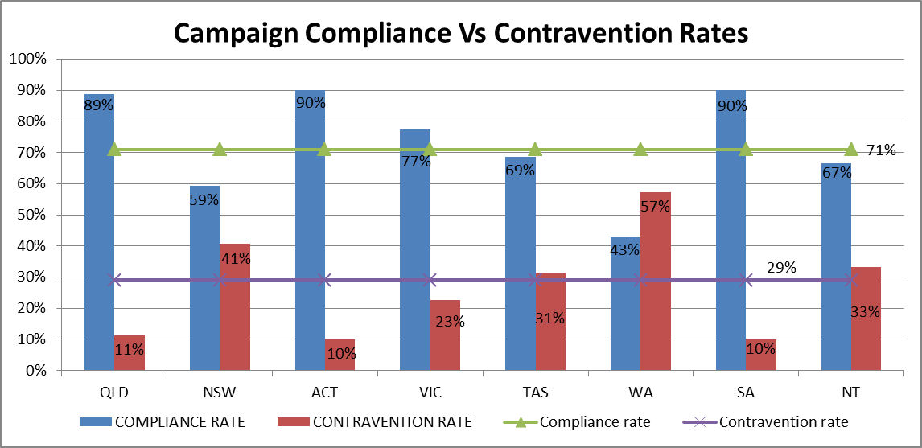

The results for NSW, Tasmania and WA can be in part attributed to the special phasing provisions unique to these states (which ceased as at 30 June 2014) which further complicated the award in respect of minimum wages entitlements. The Northern Territory (along with WA) is however subject to some district allowances which may also (in part) explain their lower than average compliance rates.

With the end of transitional provisions and the removal of the special phasing provisions in NSW, Tasmania and WA, it is anticipated there will be an overall increase in compliance rates across the industry in Australia.

# About the Fair Work Ombudsman

The Fair Work Ombudsman is an independent agency created by the Fair Work Act 2009 on 1 July 2009. Our main role is to promote harmonious, productive and cooperative workplace relations.

Each year the Fair Work Ombudsman (FWO) runs proactive campaigns to assist employers and employees understand their rights and obligations under Commonwealth workplace relations laws.

These campaigns can focus on particular industries, regions and/or labour market issues and are conducted on a national and state level.

This report covers the background, method and findings of the National Children’s Services Campaign 2013/14. For further information and media enquiries please contact the media team at [media@fwo.gov.au](mailto:media@fwo.gov.au)

If you would like further information about the Fair Work Ombudsman’s campaigns please contact Lynda McAlary-Smith, Executive Director - Proactive Compliance and Education at [Lynda.McAlary-Smith@fwo.gov.au](mailto:Lynda.McAlary-Smith@fwo.gov.au)

# Appendix A

## FWO Communication Activities

The webinar had a high attendance rate (230 attendees), received a further 165 views through YouTube and a further 2,656 views of the webinar’s Frequently Asked Questions (FAQ) page. We also advertised the campaign via a number of digital platforms (i.e. Facebook, Google and Twitter) achieving the following results:

* 9,296 views of the dedicated website ([www.fairwork.gov.au/childcare](http://www.fairwork.gov.au/childcare)) including 750 visitors on 6 August 2014 – (when businesses were notified of the campaign via email);
* 1,891 unique opens of the electronic email notification (42% of recipients - which is 10% higher than previous campaigns) and a further 569 (12%) following the link to our website.
* 139,401 views on google from search matches (including 3,084 views of our website through google AdWords);
* 8 Tweets and 13 retweets through twitter;
* Six Facebook posts throughout the campaign (16 October 2013 – 6 November 2013) reaching a total of 317,896 people, with 2,270 views of our YouTube channel; and
* 27,486 views of our dedicated employee’s page and 6,504 visits to our young workers page.

The campaign also received extensive coverage through traditional media channels including;

* Through 79 Radio stations including Triple J (National), 4KQ (Brisbane), Gold FM (Melbourne) and numerous broadcasts on regional ABC radio stations (which included live interviews with the Media Director on ABC Brisbane and 6PR Perth);
* through 39 regional newspaper publications (including Brisbane’s Courier Mail and the Hobart Mercury) and publication on a further 68 websites (including [www.news.com.au](http://www.news.com.au/) and [www.theaustralian.com.au](http://www.theaustralian.com.au/); and
* Strong TV coverage (including through the WIN network in Wollongong).

1. Ibis World Industry Report: Child Care Services in Australia – November 2011
2. Clause 14.1 “Minimum wages” of the Award details the minimum wages payable and clause 14.2 details the progression through the wage levels applicable in clause 14.1.