National Building and Construction Industry Campaign 2014/15

Report – July 2015

A report prepared by the Fair Work Ombudsman under the Fair Work Act 2009

© Commonwealth of Australia, 2015

Contents

Campaign Infographic 3

About the Campaign 4

Outcomes at a Glance 5

Industry Profile 6

Industry Stakeholders 6

Communication and Public Awareness 7

Wages Audit 7

National Findings 7

State Findings 9

Queensland 10

New South Wales 10

Australian Capital Territory 11

Victoria 11

Tasmania 12

South Australia 12

Western Australia 13

Northern Territory 13

Apprentices 14

Contractor Assessment 16

Next Steps 16

Conclusion 17

About the Fair Work Ombudsman 18

Appendix A 19

Appendix B 20

Appendix C 21

# Building and Construction report infographic

# About the Campaign

The National Building and Construction Industry Campaign 2014/15 (the Campaign) was developed in response to a number of factors in the building and construction industry (the industry), including;

* high contravention rates within the industry (through both complaints received and previous audit campaigns);
* large size of the industry and predicted high growth of this industry over the coming years; and
* the high volume of calls through the Fair Work Infoline

As part of this campaign, the Fair Work Ombudsman (FWO) audited the compliance of 700 businesses nationally with the *Building & Construction General On-Site 2010*, *Electrical, Electronic & Communications Contracting Award 2010, Plumbing & Fire Sprinklers Award 2010*, the *Fair Work Act 2009* (the Act) and the *Fair Work Regulations* *2009* (the Regulations). This included auditing 610 businesses for compliance with wages, penalty rates, allowances, overtime, pay slip and record-keeping obligations. Where a business was found to employ apprentices an assessment of their entitlements was also conducted. In addition, contracting arrangements were audited for a further 90 businesses.

The subdivisions focussed on were (see figure 1):

* **Residential building Construction -** House Construction & Other Residential Building Construction;
* **Building Structure Services** - Concreting Services, Bricklaying Services, Roofing Services and Structural Steel Erection Services;
* **Building Installation Services** - Plumbing Services, Electrical Services, Air-Conditioning and Heating Services, Fire and Security Alarm Installation Services and Other Building Installation Services;
* **Building Completion Services** - Plastering and Ceiling Services, Carpentry Services, Tiling and Carpeting Services, Painting and Decorating Services and Glazing Services; and
* **Other Construction Services-** Landscape Construction Services and other construction services

**Figure 1: Construction industry - business type**

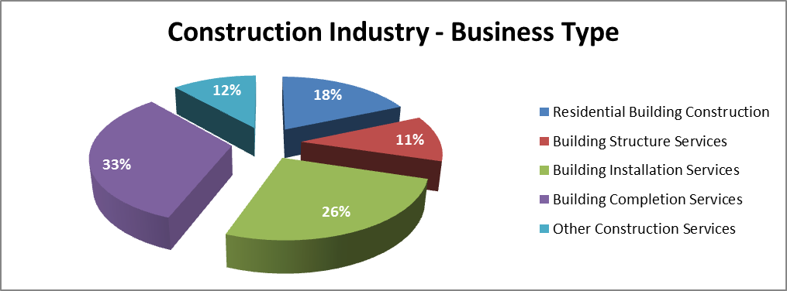

# Outcomes at a Glance

To maximise awareness of the campaign and encourage greater compliance within the industry the Campaign was undertaken in two stages:

* communication and public awareness; and
* an audit of pay and conditions.

Of 610[1] businesses audited for wage and record-keeping obligations, 360 (59%) were compliant and 250 (41%) of businesses had not met their workplace relations obligations. The main errors related to payslips not including required information and wage related entitlements.

Of these 610 businesses, 194 (32%) employed apprentices. Of these, 129 (66%) were compliant with apprentice obligations and 65 (34%) of the businesses had not met all of their workplace relations obligations.

The outcomes of the Campaign were:

* $259,155 in underpayments recovered from 96 businesses on behalf of 201 employees, including:
* $69,785 recovered for 194 apprentices (over one quarter of all monies recovered )
* 4 formal Letters of Caution issued.

# 

# Industry Profile

The industry sectors within scope of this campaign[2] comprised 278,429 businesses (as at June 2013), of which 75.4% were concentrated in Queensland, New South Wales, and Victoria.[3]

In February 2014, prior to the commencement of this campaign, the Construction Industry Division was the third largest employing industry in Australia, employing over 1 million workers (or nearly 9% of total workers in Australia).[4] The Department of Employment expects employment growth across the Industry Division to increase by 8.0% (approximately 83,500 workers) over the 5 years to February 2018 (compared with a 7.2% of general employment).

In addition to the high number of workers and expected increase, the Construction Industry Division was also the largest employer of young full time workers in Australia, employing over 154,000 (approximately 17%) of all full time workers aged 15-25 (in the year to February 2014).

During the 2013 calendar year, FWO completed 2,083 complaints in the construction industry. Of these, 1,027 were sustained against 971 individual employers resulting in a 49% contravention rate. These results are also consistent with the results of previous regional campaign activity in the industry (six campaigns since 2009) – in which FWO has audited over 500 businesses, with an overall contravention rate of 65%.

# Industry Stakeholders

The FWO engaged with industry stakeholders on the design, development and delivery of the campaign, and to gather insight into any industry specific issues. This provided the chance to explore future opportunities to work collaboratively to assist the industry.

The stakeholders included:

* Housing Industry Association (HIA)
* Master Builders Association
* Construction, Forestry, Mining and Energy Union (CFMEU)
* Australian Industry Group (AIG); and
* Australian Chamber of Commerce and Industry (ACCI).

A full list of stakeholders is available in **Appendix A**.

# Communication and Public Awareness

The communication and public awareness phase of the campaign aimed to promote the campaign and educate employers on their obligations prior to the audits. The campaign was advertised through the theme of *“Work Hard, Pay Fair”* between 30 October 2014 and 5 December 2014. During this time it reached 4.2 million people through a range of digital platforms including, Facebook, Twitter and email.

The FWO also advertised on websites such as Real Footy and Goal, which reached more than 2.2 million people over a four week period.

A full description of the results of FWO’s communication activities are detailed in **Appendix B**.

# Wages Audit

## National Findings

Of the 610 businesses audited;

* 460 (75%) employers were paying their employee’s correctly;
* 468 (77%) employers were compliant with their record-keeping and payslip obligations.
* 360 (59%) employers were compliant with all requirements; and
* 250 (41%) employer had at least one error; of which;
  + 108 (18%) had monetary errors;
  + 100 (16%) had pay-slip and/or record-keeping errors; and
  + 42 (7%) had both monetary and pay-slip/record-keeping errors.

Of the 250 businesses with errors, there were a total of 334 individual errors (see Figure 2). A total of $259,155 was recovered for 201 employees from 96 employers. The individual recoveries from businesses ranged from less than $50 to over $58,000, with a median recovery per business of $1,345.

The errors most commonly identified related to payslips, which accounted for more than one third of all individual errors with 36% (121), and underpayment of hourly rate with 31% (102).

Fair Work Inspectors found that generally trade qualified employees were receiving at least (and generally well above) their minimum monetary entitlements, with most contraventions relating to lower-skilled workers such as labourers who are more reliant on award conditions.

**Figure 2: Contravention Breakdown**

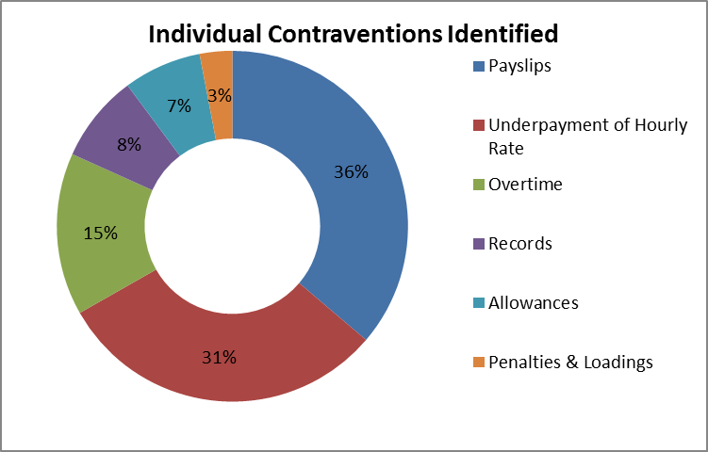

FWO identified that 30% (184) of businesses audited held membership with one or more employer associations within the industry (see figure 3). Of these businesses with membership, 64% (117) were compliant with all requirements (compared to a 57% compliance rate of non-employer association members) – suggesting a positive effect employer associations may have on compliance rates within this industry through ongoing engagement with their members.

**Figure 3**: **Employer Association Compliance Vs Non-Employer Association Compliance**

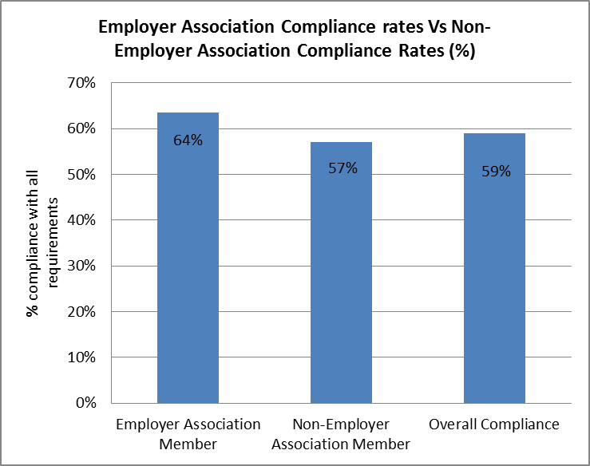

FWO also identified 84% (512) of the 610 businesses had 14 or fewer employees (including 302 businesses with less than 4 employees) and the remaining 16% (98) had 15 or more employees. Businesses with 14 or fewer employees had a 57% compliance rate (4 or less employees 54%, 5-14 employees 62%), while those with 15 or more employees had a 68% compliance rate (15-49 employees 65%, 50 or more employees 77%).

These results show that in this sample, smaller sized businesses tended to have a higher contravention rate (see figure 4)[5]. This highlights the importance of focusing educational tools and resources on small businesses, which often do not have dedicated in-house workplace relations expertise such as Payroll or Human Resources staff to manage their obligations.

FWO understands the unique challenges that small businesses face in meeting their workplace relations obligations, therefore have information and resources available on fairwork.gov.au/smallbusiness to help them get it right. Such as the free online courses, the Fair Work Handbook, employer checklists and other pay and conditions tools.

**Figure 4**: **Compliance rates by business size**

| **Compliance Rates by Business Size** | | | | |
| --- | --- | --- | --- | --- |
| Number of Employees engaged by a business | Number of businesses | Outcome of Audit | | Compliance rate (%) |
| Compliant | Contravention |
| 4 or less | 302 | 162 | 140 | 53.6% |
| 5 - 14 | 210 | 131 | 79 | 62.4% |
| 15 - 49 | 72 | 47 | 25 | 65.3% |
| 50 or more | 26 | 20 | 6 | 76.9% |
| **Total** | **610** | **360** | **250** | **59.0%** |

# State Findings

As detailed in Figure 5, the state compliance results were relatively consistent across Australia, with only Victoria (45%) significantly below the national compliance rate. While NSW, Qld and the ACT were all slightly above the national compliance rate, it was Tasmania that demonstrated a significantly high level of overall compliance.

**Figure 5: State compliance rates against national compliance rate**

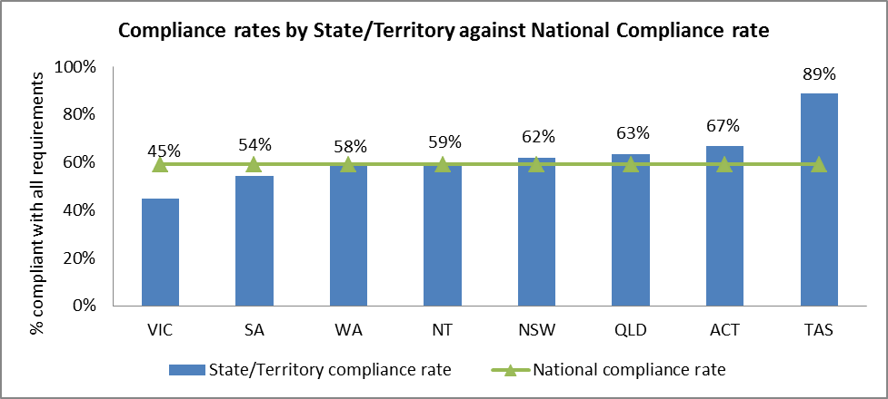

## Queensland

In Queensland (QLD) a total of 191 businesses were audited;

* 121 (63%) were compliant with all requirements; and
* 70 (37%) had at least one error; and of these;
  + 32 (17%) had monetary errors;
  + 28 (15%) had pay-slip and/or record-keeping errors; and
  + 10 (5%) had both monetary and pay-slip/record-keeping errors.

This means that;

* 149 (78%) were paying their employees correctly; and
* 153 (80%) were compliant with payslip and record-keeping obligations.

The 70 businesses with errors identified had a combined total of 88 individual errors, with the most commonly identified relating to: payslips 38% (33), underpayment of hourly rate 32% (28) allowances 11% (10), and overtime 10% (9).

In total $48,327 was recovered for 44 employees from 28 employers, with the median recovery per business being $1,345. One formal letter of caution was issued.

## New South Wales

In New South Wales (NSW) a total of 100 businesses were audited, finding;

* 62 (62%) were compliant with all requirements; and
* 38 (38%) had at least one error; of which;
  + 15 (15%) had monetary errors;
  + 20 (20%) had pay-slip and/or record-keeping errors; and
  + 3 (3%) had both monetary and pay-slip/record-keeping errors.

This means that of the 100 businesses audited;

* 82 (82%) were paying their employees correctly; and
* 77 (77%) were compliant with payslip and record-keeping obligations.

The 38 businesses with errors identified had a total of 45 individual errors, with the most commonly identified relating to: payslips 42% (19); and underpayment of hourly rate 33% (15).

In total, $49,433 was recovered from 11 businesses for 34 employees, with a median recovery per business of $5,260.

## Australian Capital Territory

In the Australian Capital Territory (ACT) a total of 21 businesses were audited, finding;

* 14 (67%) were compliant with all requirements; and
* 7 (33%) had at least one error; of which;
  + 2 (9%) had monetary errors;
  + 4 (19%) had pay-slip and/or record-keeping errors; and
  + 1 (5%) had both monetary and pay-slip/record-keeping errors.

This means that of the 21 businesses audited;

* 18 (86%) were paying their employees correctly; and
* 16 (76%) were compliant with payslip and record-keeping obligations.

The 7 businesses with errors identified had a total of 9 individual errors. Errors relating to records accounted for 3 of the contraventions (33%) with the remaining errors equally divided between allowances, underpayments, and payslips.

In total, $994 was recovered for 3 employees from 2 employers.

## Victoria

In Victoria a total of 109 businesses were audited, finding;

* 49 (45%) were compliant with all requirements; and
* 60 (55%) had at least one error; of which;
  + 23 (21%) had monetary errors;
  + 23 (21%) had pay-slip and/or record-keeping errors; and
  + 14 (13%) had both monetary and pay-slip/record-keeping errors.

This means that of the 109 businesses audited;

* 72 (66%) were paying their employees correctly; and
* 72 (66%) were compliant with payslip and record-keeping obligations.

The 60 businesses with errors identified had a total of 89 individual errors, with the most commonly identified relating to: payslips 35% (31); underpayment of hourly rate 27% (24); and overtime 17% (15).

In total, $53,976 was recovered for 54 employees from 29 employers, with a median recovery per business of $1,159.

## Tasmania

In Tasmania, a total of 18 businesses were audited, finding;

* 16 (89%) were compliant with all requirements; and
* 2 (11%) had at least one error; of which;
  + 1 (5.5%) had monetary errors; and
  + 1 (5.5%) had both monetary and pay-slip/record-keeping errors.

This means that of the 18 businesses audited;

* 16 (89%) were paying their employees correctly; and
* 17 (94%) were compliant with payslip and record-keeping obligations.

The 2 businesses with errors identified had 3 individual errors between, them relating to overtime, underpayment of wages, and pay slips.

## South Australia

In South Australia (SA) a total of 57 businesses were audited, finding;

* 31 (54%) were compliant with all requirements; and
* 26 (46%) had at least one error; of which;
  + 11 (19%) were for monetary errors;
  + 10 (18%) were due to pay-slip and/or record-keeping errors; and
  + 5 (9%) due to both monetary and pay-slip/record-keeping errors.

This means that of the 57 businesses audited;

* 41 (72%) were paying their employees correctly; and
* 42 (74%) were compliant with payslip and record-keeping obligations.

The 26 businesses with errors identified had a total of 34 individual errors, with the most commonly identified relating to: payslips 41% (14); and underpayment of hourly rate 38% (13).

In total, $26,837 was recovered from 9 businesses for 14 employees. The median recovery per business was $1,260.

## Western Australia

In Western Australia (WA) a total of 77 businesses were audited, finding;

* 45 (58%) were compliant with all requirements; and
* 32 (42%) identified with at least one error; of which;
  + 17 (22%) had monetary errors;
  + 11 (15%) had pay-slip and/or record-keeping errors; and
  + 4 (5%) had both monetary and pay-slip/record-keeping errors.

This means that from the 77 businesses we audited;

* 56 (73%) were paying their employees correctly; and
* 62 (81%) were compliant with payslip and record-keeping obligations.

The 32 businesses with errors identified had a total of 45 individual errors, with the most commonly identified relating to: underpayment of hourly rate 36% (16); payslips 31% (14); and overtime 24% (11).

In total, $76,802 was recovered for 48 employees from 16 employers. Western Australia had the lowest median recovery per business of $649 of all the states. However the highest recovery from an individual business in the campaign was also in Western Australia where a total of $58,453 was recovered for 22 employees. Two formal letters of caution were issued, including one to the business where the $58,453 underpayment was identified.

## Northern Territory

In the Northern Territory (NT) a total of 37 businesses were audited, finding;

* 22 (59%) were compliant with all requirements; and
* 15 (41%) had at least one error; of which;
  + 7 (19%) were for monetary errors;
  + 4 (11%) were due to pay-slip and/or record-keeping errors; and
  + 4 (11%) due to both monetary and pay-slip/record-keeping errors.

This means that of the 37 businesses audited;

* 26 (70%) were paying their employees correctly; and
* 29 (78%) were compliant with payslip and record-keeping obligations.

The 15 businesses with errors identified had a total of 21 individual errors, with the most commonly identified relating to: payslips 33% (7); and overtime 24% (5).

In total, $2,785 was recovered from 1 business for 4 employees. In addition a formal letter of caution was issued.

# Apprentices

The building and construction industry is one of the largest industry employers of apprentices in Australia. As at March 2014, prior to the commencement of this campaign, 44,900 apprentices and trainees were employed - including 6,700 who had commenced employment during that quarter.[6] The construction industry historically is also a high complaint sector for apprentices– in the 6 months immediately prior to the commencement of the campaign (January 2014 to June 2014) 38% (295) of the 770 complaints received from apprentices, were from the building and construction industry.

Apprentices are generally considered a vulnerable employee group, therefore as part of this campaign FWO audited the compliance of businesses engaging apprentices to ensure they were receiving their correct employment entitlements. Of the 610 businesses audited during the campaign, 194 (32%) businesses (who engaged approximately 340 apprentices) had apprentice records audited. Of these (as shown in figure 6):

* 122 (63%) were compliant with all requirements;
* 7 (3%) had errors not related to apprentices;
* 65 (34%) had errors relating to apprentices, and of these;
  + 52 (27%) related to pay rates
  + 13 (7%) related to record keeping and payslip requirements

In total, $69,785 was recovered for 194 apprentices with a median recovery of $1318 (recoveries from individual employers ranging from less than $50 to over $7,500).

From the total of 69 errors identified, 55 related to monetary errors (i.e. underpayment of hourly rate, overtime, and penalty rates etc.) and 14 were due to pay slip and record-keeping errors.

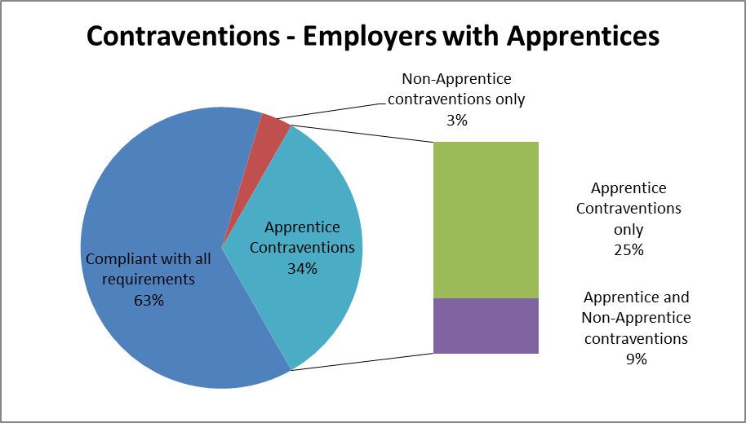

**Figure 6: Contraventions for employers with apprentices**

Interestingly, as per Figure 7, businesses in this sample who engaged apprentices had a 6% higher compliance rate compared to those businesses who did not engage apprentices. Fair Work Inspectors observed this may be as a result of active participation with their workplace relations obligations through the process of hiring an apprentice. This highlights the opportunity for FWO to continue to actively engage these employers through the ongoing development of accessible and practical tools and resources for and regarding apprentices.

**Figure 7: Apprentice Vs Non-Apprentice Compliance**

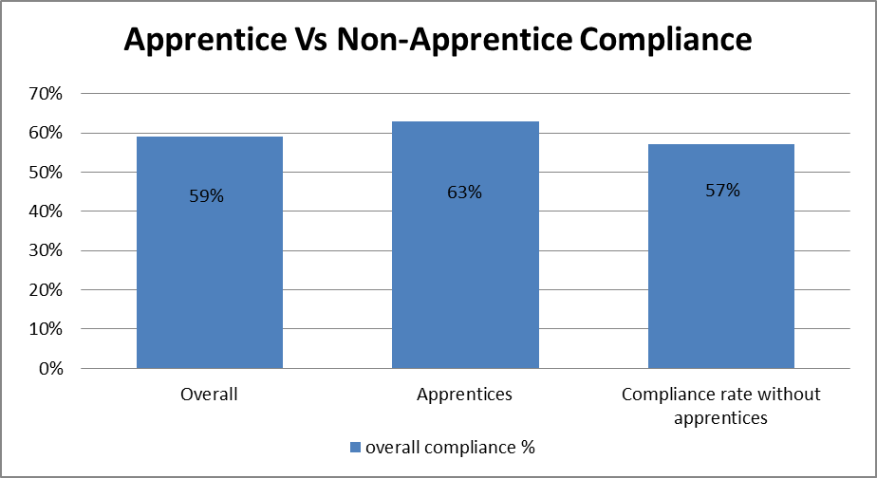

# Contractor Assessment

Given the historically high reliance on contracting arrangements and concerns of sham-contracting and misclassification within the industry, the contracting arrangements for 90 businesses within the sample of 700 employers were assessed.

Of the 90 contracting arrangements assessed, no prima-facie evidence of sham-contracting arrangements was found. Rather it was found that:

* Genuine invoices were being issued from one company to another (not from a company to an individual) and were usually based upon a quote to complete a job/task, with no reference to hours or days of work; and
* Where invoices were issued, they were for tasks outside the scope of the principal contractors skill-set (i.e. a builder invoices an electrical company to complete electrical work).

The assessment of paper based invoices is only one element of considering whether contracting arrangements are bona fide. The results of this initial assessment warrant further examination. Given the complexities associated with these arrangements, it is expected that this will be a substantial body of work and FWO will undertake this activity through a more in-depth investigative methodology & a broader sample size.

Sham-contracting remains an important issue for a number of agencies including FWO, FWBC, Department of Immigration and Citizenship (DIAC) the Australian Securities and Investment Commission (ASIC) and the Australian Tax Office (ATO). Employers, employees and contractors are encouraged to seek clarification and/or information on any contracting arrangements they may have concerns about by contacting the above-mentioned agencies.

# Next Steps

The FWO will work collaboratively with key stakeholders within the industry to educate and support businesses and help ensure ongoing compliance following the release of this report. Re-engagement activities will include;

* sharing the results of this campaign with employers through My Account, social media or email subscriptions;
* ongoing engagement through media and communication activities;
* the development of industry specific tools and resources;
* presentations and information sessions to and with key external stakeholder bodies

# Conclusion

The findings of this campaign show an overall compliance rate of 59%, and a slightly higher compliance rate for businesses with apprentices of 65%. This is an improvement on previous campaigns that were conducted since 2009 which identified an aggregated compliance rate of 35%.

In addition the results show that business size has a significant impact on compliance rates. This highlights the importance of continuing to support small businesses by providing them with easily accessible and tailored service offerings to help them better meet their workplace relations obligations.

While the results of the campaign are encouraging, the industry will remain a high priority given the high complaint rate, size and projected growth in the industry along with the high number of apprentices engaged within the industry. Therefore the FWO will continue to work collaboratively with stakeholders within the industry to help ensure ongoing compliance. In addition, to gauge the levels of change in behaviour by the employer in this industry, many of the businesses that were found to have contraventions will be reaudited as part of the National Compliance Monitoring program 2015-16.

# About the Fair Work Ombudsman

The Fair Work Ombudsman is an independent agency created by the Fair Work Act 2009 on 1 July 2009. Our main role is to promote harmonious, productive and cooperative workplace relations.

Each year the Fair Work Ombudsman (FWO) runs proactive campaigns to assist employers and employees understand their rights and obligations under Commonwealth workplace relations laws.

These campaigns can focus on particular industries, regions and/or labour market issues and are conducted on a national and state level.

This report covers the background, method and findings of the National Building and Construction Industry Campaign 2014/15. For further information please contact the media team at [media@fwo.gov.au](mailto:media@fwo.gov.au)

If you would like further information about the Fair Work Ombudsman’s campaigns please contact Lynda McAlary-Smith, Executive Director – Proactive Compliance and Education at [Lynda.McAlary-Smith@fwo.gov.au](mailto:Lynda.McAlary-Smith@fwo.gov.au)

# Appendix A

**Industry Stakeholders**

| **National Stakeholders** | **Regional Stakeholders** |
| --- | --- |
| Master Builders Association Australia (MBAA) | Northern Territory - Department of Employment; |
| Housing Industry Association (HIA) | Western Australia – Department of Training |
| Australian Tax Office (ATO); | Skills South Australia (SA) |
| Australian Chamber of Commerce and Industry (ACCI) | Queensland Department of Justice & Attorney General - Fair and Safe Work Queensland |
| Australian Industry Group (AIG) | NSW Industrial Relations |
| Communications, Electrical and Plumbing Union of Australia (CEPU) | Tasmanian Department of Justice |
| Fair Work Building & Construction (FWBC) | Victoria Registration and Qualifications Authority |
| Federal Department of Employment | SafeWork South Australia (SA) |
| Australian Manufacturing Workers Union (AMWU) |  |
| Construction, Forestry, Mining and Energy Union (CFMEU) |
| Electrical Trades Union (ETU) |
| Plumbing Trades Employee Union (PTEU) |
| Master Plumbers and Mechanical  Services Association of Australia (MPMSAA) |
| Master Electricians Australia (MEA) |
| Australian Institute of Building (AIB) |
| Australian Constructors Association |

# Appendix B

**FWO Communication Activities**

As part of the communication strategy, the campaign targeted males between the ages of 20 and 65 and FWO reached more than 4.2 million people to create greater awareness of the compliance campaign conducted on the Building and Construction Industry. The theme of the advertising was *“Work Hard, Pay Fair”* and through the following communication activities;

* Four week Facebook content plan
* Email sent to employers from FWO’s subscriber list
* Four week Twitter plan with a combination of Image, Website Card and standard promoted tweets going out every second day
* Digital display advertising on the Goal (A-League) and Real Footy (Fairfax news) websites running for four weeks.

FWO achieved the following results;

* 494,709 people reached through Facebook advertising (including 27,000 people who like our page (58% female, 42% male), accounting for 60% (16,538) of 27,473 click throughs across our communication activities. Facebook advertising also achieved high levels of engagement, with 479 comments, 1660 likes and 464 shares across our 4 promoted posts.
* 1.5 million impressions and 3,532 new followers through twitter advertising – with 88% of these engagements achieved on mobile devices;
* 2.2 million digital display advertising impressions across Fairfax (Real Footy website) and Perform (Goal Website) networks – providing high campaign exposure; and
* 3,427 employers notified of the campaign through our email updates;

The campaign was also covered through traditional media channels including TV (WIN Network), radio (including ABC & 3CR Melbourne), print and electronic media coverage (both local and national publications), advertising through a number of websites, including the Australian Chinese Community Forum, XKB.com.au and ABC Online along with advertising through key stakeholders including the Master Builders Association website.

# Appendix C

**FWO Communication Collateral**

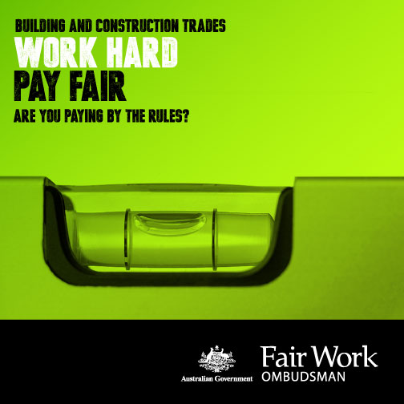 

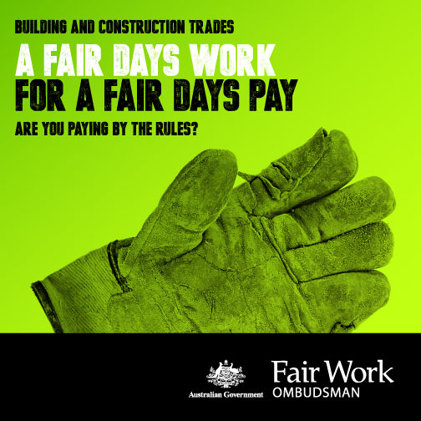 

1. This figure excludes the 90 businesses where contractual arrangements were audited
2. Specified in ‘About the Campaign’
3. Australian Bureau of Statistics (2014), Counts of Australian Businesses, including Entries and Exits, Jun 2009 to Jun 2013, data cube: cat. no. 81650, viewed 26 June 2014.
4. Department of Employment, Industry Outlook Construction, June 2014, ISSN 2201-3660
5. For this campaign, it was found that the relationship between employment numbers and contravention rate was significant (χ2 (3) = 9.203, p = .027).
6. Australian Bureau of Statistics (2014), Microdata: Education and Work, May 2014, data cube: Excel spreadsheet, cat no.6277.0.30.001.