National Hospitality Industry Campaign 2012-15

Takeaway Foods (Wave 3)

Report – March 2016

A report by the Fair Work Ombudsman under the *Fair Work Act 2009*

Date of Publication – March 2016

© Commonwealth of Australia, 2016

# Contents

Contents 2

About the Campaign 4

Outcomes at a Glance 4

Industry Profile 5

Communication and Public Awareness 5

Wages Audit 6

Regional Findings 8

New South Wales 8

Victoria 9

Queensland 9

Western Australia 10

South Australia 10

Tasmania 11

Northern Territory 11

Australian Capital Territory 12

Small Business 12

Next Steps 12

Conclusion 13

About the Fair Work Ombudsman 15

Appendix A 16

Appendix B 17

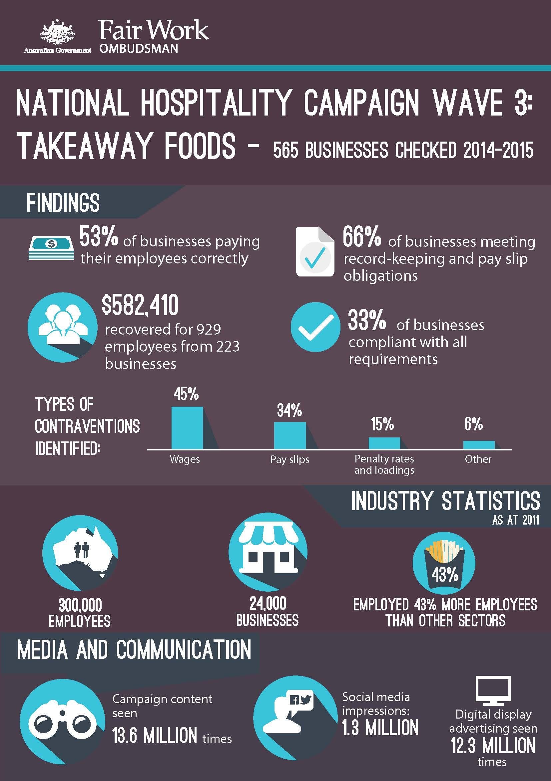

# About the Campaign

The National Hospitality Industry Campaign 2012-2015 was developed in 2012 in response to a number of factors in the hospitality industry, namely the:

* large size of the industry;
* high contravention levels (both through requests for assistance and previous audit campaigns);
* high levels of employee vulnerability (i.e. young workers, Culturally and Linguistically Diverse employees);
* high volume of calls through to the Fair Work Infoline; and
* the history of legal proceedings against businesses in the Hospitality industry for breaching workplace laws.

Given the size and diversity of the hospitality industry, the National Hospitality Industry Campaign 2012-2015 was split into three specific industry sub-categories, namely:

* Wave 1: Accommodation/Taverns & Bars;
* Wave 2: Restaurants, Café’s and Catering; and
* Wave 3: Takeaway Foods.

Further information on the first two campaigns is available at [www.fairwork.gov.au/hospitality](http://www.fairwork.gov.au/hospitality)

The results of **Wave 3** of the National Hospitality Industry Campaign - Takeaway Foods (the campaign) are detailed in this report.

# Outcomes at a Glance

The campaign was undertaken in two stages to maximise awareness and encourage greater compliance within the industry.

The two stages were:

* communication and public awareness; and
* an audit of pay and conditions.

During the campaign 565 businesses were audited for compliance with wage and record keeping obligations. Of these 185 (33%) were compliant and 380 (67%) businesses had not met all of their workplace relations obligations. The majority of errors related to underpayment of the hourly rate, pay slips not containing the correct information and incorrect/non-payment of weekend penalty rates.

The outcomes of the campaign were:

* $582,410 in underpayments recovered from 223 businesses on behalf of 929 employees; and
* 6 formal cautions and 1 Compliance Notice issued.

# Industry Profile – Take Away Food

According to the Australian Business Register (ABR) May 2011, the Takeaway Food Services Industry (the industry) was made up of over 24,000 businesses. More than 20,000 (83%) of these businesses were located in Queensland, New South Wales and Victoria. In 2012, Ibis World estimated the industry employed in excess of 300,000 people, and predicted employment within the industry would increase by 2.1% per annum over the next five years.[1] The industry employed almost 43% more people than the other Accommodation & Food Services industry sectors combined.[2]

The ABS (May 2011) also identified that the Accommodation and Food Services Industry (as a whole) was dominated by low skilled workers with 60.7% having no post school qualification, which in part, reflects the younger age profile across these sectors.

During the 2010-11 calendar years, 863 Requests for Assistance had been received from the industry. Half of these requests were received from vulnerable employees. Of these, 74% were young workers (aged 21 or under). 57% of requests completed that year were found to have monetary errors.

# Communication and Public Awareness

The communication and public awareness phase of the campaign aimed to educate businesses about their employment obligations and promote the campaign.

As part of the communication strategy for the wider National Hospitality Industry Campaign, the FWO engaged with industry stakeholders within the industry.

Stakeholders included:

* Australian Industry Group (AiG);
* Restaurant and Catering Australia (RCA);
* United Voice;
* Franchise Council of Australia (FCA);
* Shop Distributive and Allied Employees Association.

7,500 businesses were contacted and advised of the campaign. These businesses were directed to the dedicated web page [www.fairwork.gov.au/hospitality](http://www.fairwork.gov.au/hospitality) and invited to attend an industry specific webinar held on 28 November 2014.

As part of this work, the FWO promoted the campaign via a number of digital platforms and media channels specific to the fast food industry.

Details of the communication and promotional activities are detailed in **Appendix A**.

# Wages Audit

The wages audit component of the campaign included audits for 565 businesses, assessing compliance with the *Fast Food Industry Award 2010* (the award), the *Fair Work Act 2009* (the Act) and the *Fair Work Regulations 2009* (the Regulations).

Of the 565 audits completed:

* 185 (33%) businesses were compliant with all requirements;
* 380 (67%) businesses had at least one error, of which:
  + 187 (33%) had errors relating to pay rates;
  + 114 (20%) had errors relating to records and pay slips, and
  + 79 (14%) had both pay rate and pay slip/record-keeping errors.

### Figure 1: Campaign Compliance Rates

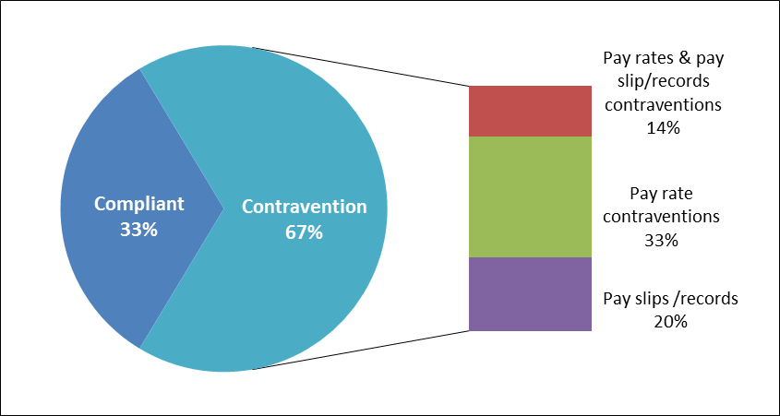

Overall:

* 299 (53%) businesses were paying their employees correctly;
* 372 (66%) businesses were compliant with record-keeping and pay slip requirements;
* 524 individual errors were recorded from 380 businesses;
* wages (45%) and pay slips (34%) made up the majority (79%) of errors;
* $582,410 was recovered from 223 businesses on behalf of 929 employees (with recovery amounts ranging from under $10 to over $35,000); and
* 1 Compliance Notice and 6 formal cautions were issued.

The 380 businesses identified as having errors had a total of 524 individual errors relating to wages, pay slips, penalty rates and loadings, and others including record-keeping, overtime, and allowances (see *Figure 2*).

The most commonly identified error related to wages (45%), specifically to underpayment of hourly rates, whereas penalty rates and loadings were a lower proportion (15%). Fair Work Inspectors (FWIs) found some businesses providing flat rates of pay for all hours worked, with many advising they had adopted this practice to simplify their payroll process. In nearly one third of cases, the hourly rate paid was not enough to cover hours attracting penalty rates and loadings, resulting in additional errors.

### Figure 2: Contravention Types

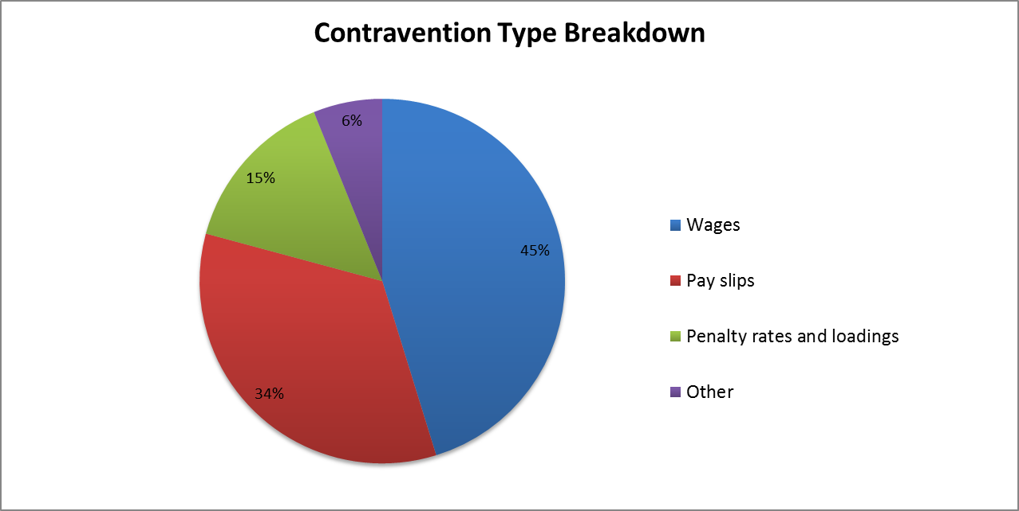

There were also some businesses using the incorrect award (most commonly the *Restaurant Industry Award 2010*) which was mostly an issue where the business provided both take-away food and dine-in services.

For pay slips the most common identified errors were in relation to missing or insufficient information such as the Australian Business Number (ABN), superannuation fund name or superannuation contribution amount, with businesses commonly advising they weren’t aware of the information required to be included.

# Regional Findings

## New South Wales

Of the 136 businesses audited in New South Wales (NSW):

* 63 (46%) businesses were compliant with all requirements;
* 73 (54%) businesses had at least one error, of which:
  + 33 (24%) had errors relating to pay rates;
  + 25 (18%) had errors relating to pay slips and records;
  + 15 (11%) had both pay rate and pay slip/record-keeping errors.

This means that of the 136 businesses audited:

* 88 (65%) businesses were paying their employees correctly; and
* 96 (71%) businesses were compliant with pay slip and record-keeping requirements.

There were a total of 93 individual errors from 73 businesses. Underpayment of the hourly rate accounted for 44% of errors and 35% related to pay slips not including the required information.

In total, $84,517 was recovered from 43 businesses on behalf of 120 employees in NSW.

## Victoria

Of the 155 businesses audited in Victoria (VIC):

* 32 (21%) businesses were compliant with all requirements;
* 123 (79%) businesses had at least one error, of which:
  + 58 (37%) had errors relating to pay rates;
  + 40 (26%) had errors relating to records and pay slips; and
  + 25 (16%) had both pay rate and pay slip/record-keeping errors.

This means that of the 155 businesses audited:

* 72 (46%) businesses were paying their employees correctly; and
* 90 (58%) businesses were compliant with pay slip and record-keeping requirements.

There we total of 179 individual errors from 123 businesses. Underpayment of the hourly rate accounted for 43% of these, 28% related to pay slips not including the correct information and 12% due to incorrect weekend penalties.

In total, $154,609 was recovered from 62 businesses on behalf of 269 employees in VIC.

## Queensland

Of the 123 businesses audited in Queensland (QLD):

* 45 (37%) businesses were compliant with all requirements; and
* 78 (63%) businesses had at least one error, of which:
  + 41 (33%) had errors relating to pay rates;
  + 21 (17%) had errors relating to pay slips and records; and
  + 16 (13%) had both pay rate and pay slip/record-keeping errors.

This means that of the 123 businesses audited:

* 66 (54%) businesses were paying their employees correctly; and
* 86 (70%) businesses were compliant with pay slip and record-keeping requirements.

There were 108 individual errors from the 78 businesses. Underpayment of hourly rate accounted for 42% of errors, 30% related to pay slips not including the required information and 21% related to incorrect weekend penalty rates.

In total, $132,433 was recovered from 53 businesses on behalf of 218 employees in QLD.

## Western Australia

Of the 42 businesses audited in Western Australia (WA):

* 12 (29%) businesses were compliant with all requirements; and
* 30 (71%) businesses had at least one error, of which:
  + 18 (43%) had errors relating to pay rates;
  + 9 (21%) had errors relating to pay slips and records; and
  + 3 (7%) had both pay rate and pay slip/record-keeping errors.

This means that of the 42 businesses audited:

* 21 (50%) businesses were paying their employees correctly; and
* 30 (71%) businesses were compliant with pay slip and record-keeping requirements.

There were a total of 33 individual errors from 30 businesses. Underpayment of the hourly rate account for 58% and 21% related to pay slips not including the correct information.

In total, we recovered $30,245 from 14 businesses on behalf of 54 employees in WA. Two formal cautions were issued. In addition further compliance action is being considered in relation to 3 businesses.

## South Australia

Of the 42 businesses audited in South Australia (SA):

* 10 (24%) businesses were compliant with all requirements; and
* 32 (76%) businesses had at least one error, of which:
  + 11 (26%) had errors relating to pay rates;
  + 9 (21%) had errors relating to pay slips and records; and
  + 12 (29%) had both pay rate and pay slip/record-keeping errors.

This means that of the 42 businesses audited:

* 19 (45%) businesses were paying their employees correctly; and
* 21 (50%) businesses were compliant with pay slip and record-keeping requirements.

There were a total of 50 individual errors from 32 businesses. Underpayment of the hourly rate related to 44% of errors and 34% due to pay slips not including the correct information.

In total, $99,527 was recovered from 21 businesses on behalf of 140 employees in SA. Two formal cautions and one Compliance Notice were issued.

## Tasmania

Of the 37 businesses audited in Tasmania (TAS):

* 15 (41%) businesses were compliant with all requirements; and
* 22 (59%) businesses had at least one error, of which:
  + 14 (38%) had errors relating to pay rates;
  + 5 (13%) had errors relating to pay slips and records; and
  + 3 (8%) had both pay rate and pay slip/record-keeping errors.

This means that of the 37 businesses audited:

* 20 (54%) businesses were paying their employees correctly; and
* 29 (78%) businesses were compliant with pay slip and record-keeping requirements.

There were a total of 31 individual errors from 22 businesses. Underpayment of the hourly rate accounted for 55% of errors and 19% related to pay slips not including the correct information.

In total, $26,305 was recovered from 17 businesses on behalf of 60 employees in TAS.

## Northern Territory

Of the 23 businesses audited in the Northern Territory (NT):

* 6 (26%) businesses were compliant with all requirements
* 17 (74%) businesses had at least one error, of which:
  + 8 (35%) had errors relating to pay rates;
  + 5 (22%) had errors relating to pay slips and records; and
  + 4 (17%) had both pay rate and pay slip/record-keeping errors.

This means that of the 23 businesses audited:

* 11 (48%) businesses were paying their employees correctly; and
* 14 (61%) businesses were compliant with pay slip and record-keeping requirements.

There were a total of 23 individual errors from 17 businesses., Underpayment of the hourly rate accounted for 43% of errors and 39% related to pay slips not including the correct information.

In total, $32,076 was recovered from 8 businesses on behalf of 41 employees in the NT.

## Australian Capital Territory

Of the 7 businesses audited in the Australian Capital Territory (ACT):

* 2 (29%) businesses were compliant with all requirements; and
* 5 (71%) businesses had at least one error, of which:
  + 4 (57%) had errors relating to pay rates; and
  + 1 (14%) had both pay rate and pay slip/record-keeping errors.

This means that of the 7 businesses audited:

* 2 (29%) businesses were paying their employees correctly; and
* 6 (86%) businesses were compliant with pay slip and record-keeping requirements.

There were a total of 7 individual errors from 5 businesses. Underpayment of the hourly rate accounted for 71% of errors and 14% related to pay slips not including the required information.

In total, $22,698 was recovered from 5 businesses on behalf of 27 employees in the ACT.

# Small Business

In the campaign, 92% (522) of businesses were identified as having 14 or less employees (including 53% with less than 4 employees). Businesses with 14 or less employees had a non-compliance rate of 68%, compared to 63% for business with 15 or more employees. These results highlight the importance of focusing educational tools and resources on small businesses, which often do not have dedicated in-house workplace relations expertise such as Payroll or Human Resources staff to assist with their obligations.

# Next Steps

Given the results of this campaign, the industry remains a priority requiring ongoing education and support to help ensure ongoing compliance. Re-engagement activities will include:

* sharing the results of the campaign with employers through MyAccount, social media and email subscriptions;
* ongoing engagement through media and communication activities;
* the development of industry specific tools and resources focusing on the industry, including the provision of industry specific articles through MyAccount;
* presentations and information sessions to and with key external stakeholder bodies; and
* all businesses found to be non-compliant in this campaign will be audited as part of the National Compliance Monitoring Campaign 2016.

# Conclusion

The campaign identified a 67% non-compliance rate from the 565 businesses audited. As shown in Figure 3, Vic (79%), SA (76%), NT (74%), WA & ACT (both 71%) recorded non-compliance rates above 70%, and above the national rate of 67%. The majority of errors in each state related to the underpayment of the hourly rate and pay slips not including the correct information.

The national non-compliance rate of 67% identified in the campaign is higher than the 45% non-compliance rate for formal Requests for Assistance (RfAs) completed by the FWO in the 2014-15 financial year. This suggests the specific targeting of businesses in the industry is an effective way of continuing to identify broader issues and promote ways of achieving ongoing compliance.

### A graphical breakdown of all the contravention rates per state, versus the national contravention rate. National contravention rate- 67%, Vic 79%, SA 76%, NT 74%, WA 71%, ACT 71%, QLD 63%, Tas 59%, NSW 54%Figure 3: Wave 3 Contravention Rates by State

The high levels of non-compliance may be impacted by the fragmented nature of the industry, specifically the high number of small business and the diverse range of operating hours, as well as the relatively low levels of employer association membership. To help reduce the non-compliance rate and promote ongoing compliance, the FWO will continue to work collaboratively with key stakeholders within the industry. In particular, we will work with the Restaurant & Catering Industry Association and the Australian Hotels Association, including where appropriate utilising the Memorandums of Understanding that are in place, to develop strategies and explore opportunities for co-design.

In addition, a defining characteristic of the industry is the young age profile of its workforce. The 2011 Census found almost 46% of the workforce was aged 15-19. This is more than double the 20% in Cafes and Restaurants, and more than ten times the 4% working in Accommodation.[3] Despite making up nearly half of the workforce, in the 2014-15 financial year, while the campaign was being undertaken, workers in the industry aged 15-19 only made up 19% of all Requests for Assistance received by the FWO. This suggests this particular age group may be unaware of their workplace rights or hesitant in coming to the FWO. The high non-compliance rate identified in the campaign highlights the vulnerability of the workforce and reinforces the importance of FWO continuing to proactively examine the industry.

The campaign demonstrates that the industry requires continued support to obtain ongoing compliance, as evidenced by the high non-compliance rates. Therefore the re-engagement activities associated with the campaign will focus on this industry in the first instance. In addition, to assess the change in behaviour by businesses in the industry, businesses that were found to have errors will be reaudited as part of the National Compliance Monitoring Campaign.

# About the Fair Work Ombudsman

The Fair Work Ombudsman is an independent agency created by the *Fair Work Act 2009* on 1 July 2009. Our main role is to promote harmonious, productive and cooperative workplaces.

Each year the Fair Work Ombudsman (FWO) runs proactive campaigns to assist employers and employees understand their rights and obligations under Commonwealth workplace relations laws. These campaigns can focus on particular industries, regions and/or labour market issues and are conducted on a national and state level.

This report covers the background, method and findings of the National Hospitality Industry Campaign (Wave 3) – Takeaway Foods. For further information please contact the media team at [media@fwo.gov.au](mailto:media@fwo.gov.au)

If you would like further information about the Fair Work Ombudsman’s campaigns please contact Lynda McAlary-Smith, Executive Director – Proactive Compliance and Education at [Lynda.McAlary-Smith@fwo.gov.au](mailto:Lynda.McAlary-Smith@fwo.gov.au)

# Appendix A

**FWO Communication Activities**

The communication and public awareness phase of the campaign aimed to educate employers about their employment obligations prior to the time and wages audit stage of the campaign. As part of this strategy, the FWO advertised and promoted the campaign via a number of media channels specific to the industry.

In January 2014, the FWO contacted over 7,500 businesses, advising them of the campaign and directing them to the free online resources available on the FWO website [www.fairwork.gov.au](http://www.fairwork.gov.au/) and industry specific webpage [www.fairwork.gov.au/hospitality](http://www.fairwork.gov.au/hospitality). The FWO advised businesses of the industry specific webinar uploaded to the FWO website on 28 November 2014 which was viewed over 180 times.

The campaign was also promoted via a number of digital platforms, achieving the following results:

* 1,255,611 impressions through Facebook ads and content, with 29,486 click throughs and 3.325 new page likes;
* 2100 visits to the FWO Facebook page between 1 December 2013 and 28 February 2014;
* Links to fairwork.gov.au/hospitality were seeded across top tier Australian publishers in order to drive more traffic to the FWO website. This resulted in 12,375,079 impressions and 13,947 clicks;
* The second most clicked digital display title was ‘Is your kid working in fast food? Make sure you know your rights!’ Indicating that the parents of young workers are interested in their children’s rights at work and are an ideal target to deliver information to this audience;
* 827 views of the dedicated website [www.fairwork.gov.au/hospitality](http://www.fairwork.gov.au/hospitality) between 1 October 2013 and 28 February 2014;
* 1,684 unique opens of the FWO electronic email notification (22% of recipients), with 396 click throughs to the 8 links provided; and
* 10 tweets between 21 October 2013 and 29 November 2013, which were retweeted 12 times and reached an audience of 51,300.

The campaign also received extensive coverage through traditional media channels, including publication in MyFuture eNewsletter (sent to 1,021 teachers and career practitioners) and was also picked up by traditional media channels including TV, Radio and print media along with receiving coverage through a number of websites.

# Appendix B

**FWO Communication Collateral**

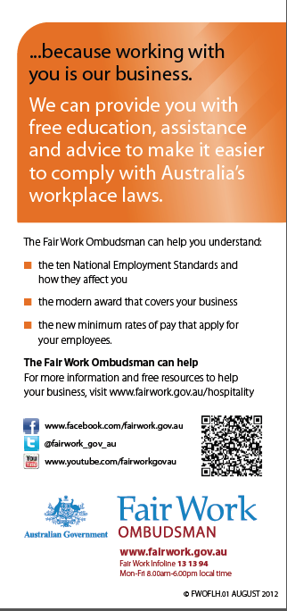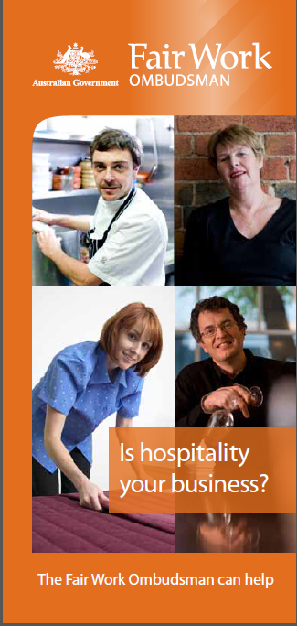

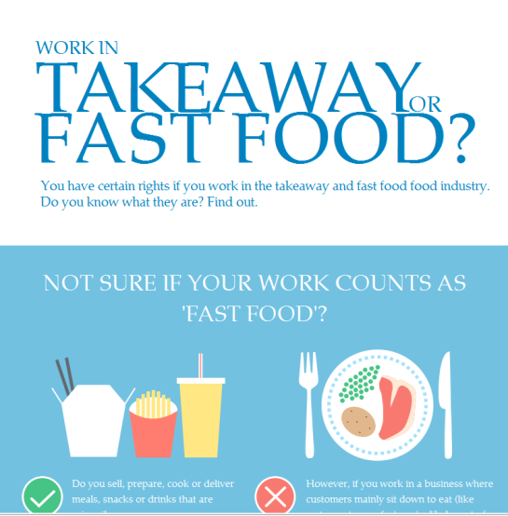

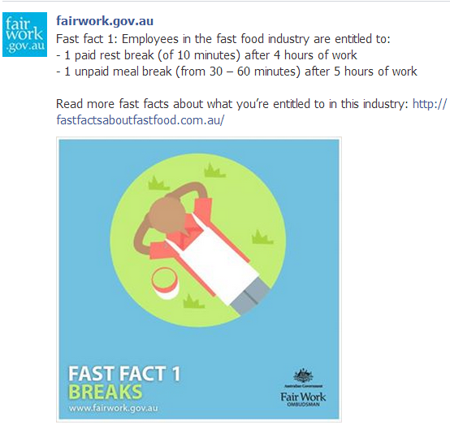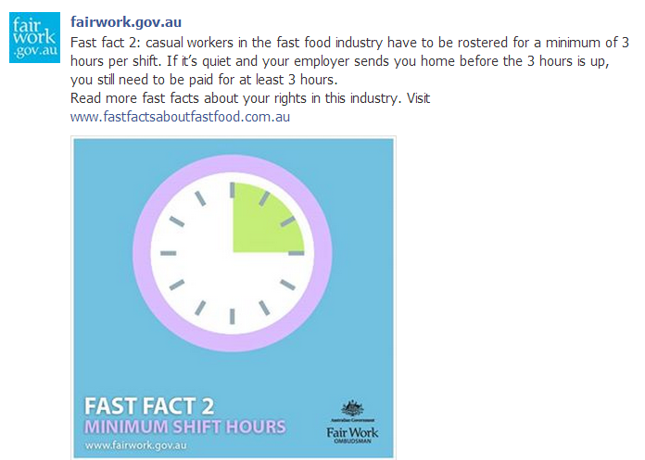

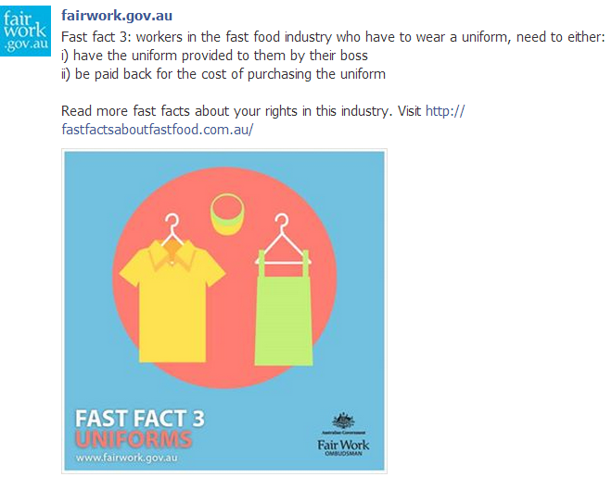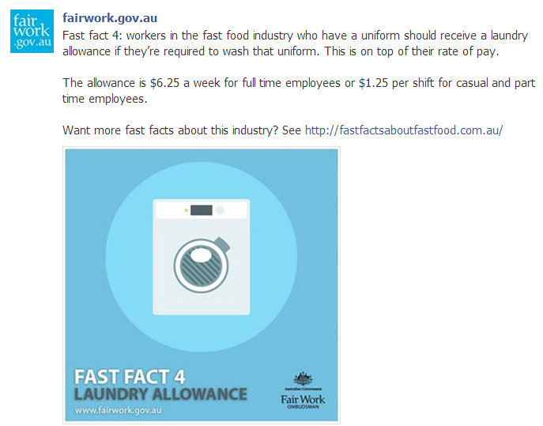

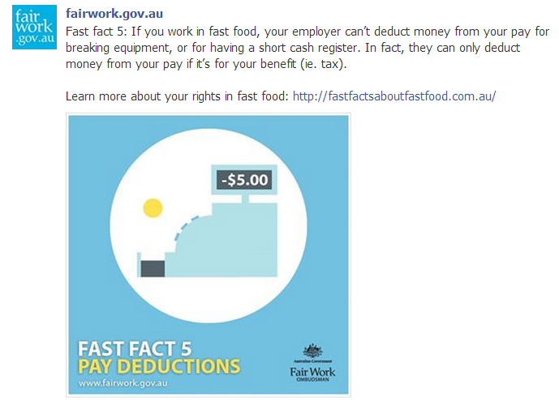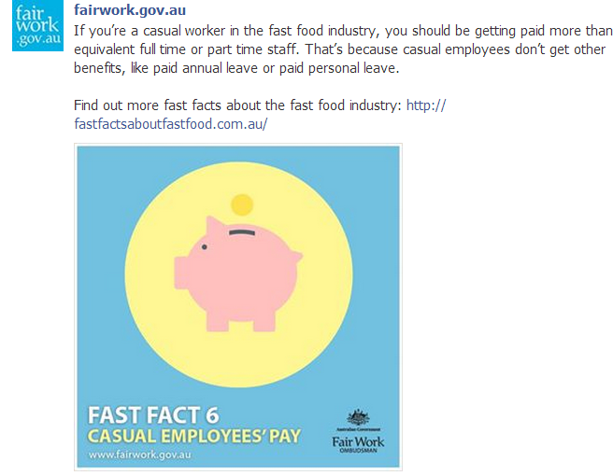

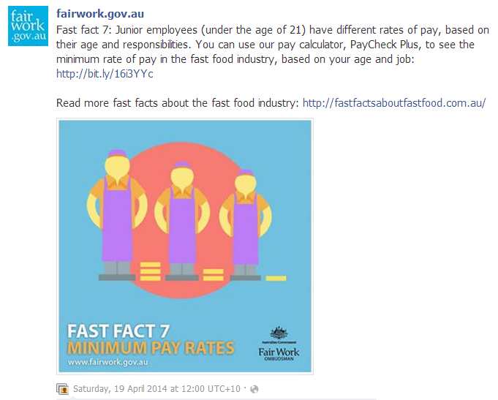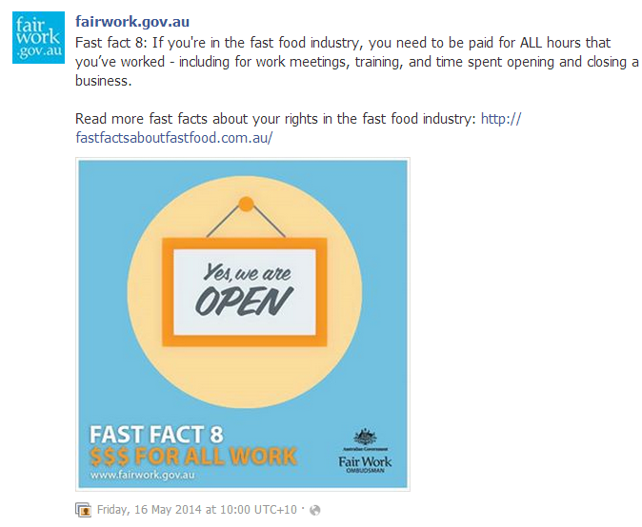

1. IBIS World Industry Report G5125a: Fast Food in Australia – January 2012
2. Various IBISWorld reports during 2011-12
3. *Department of Employment, Data Tools, Labour Market Information Portal,* [*http://lmip.gov.au/default.aspx?LMIP/IndustryInformation/DataTools*](http://lmip.gov.au/default.aspx?LMIP/IndustryInformation/DataTools) *2011 Census Data – Employment by industry and age group XLS* [*http://lmip.gov.au/PortalFile.axd?FieldID=1396081*](http://lmip.gov.au/PortalFile.axd?FieldID=1396081) *viewed 16 Oct* 2015.