TAS North West Hobart Regional Campaign

Report - March 2016

A report prepared by the Fair Work Ombudsman under the *Fair Work Act 2009*

© Commonwealth of Australia, 2016

# Table of Contents

Table of Contents 2

Infographic 3

Summary 4

What we did 4

Outcomes 5

Individual Errors 6

Further Information 7

Employer Association Membership 7

Conclusion 8

# Infographic

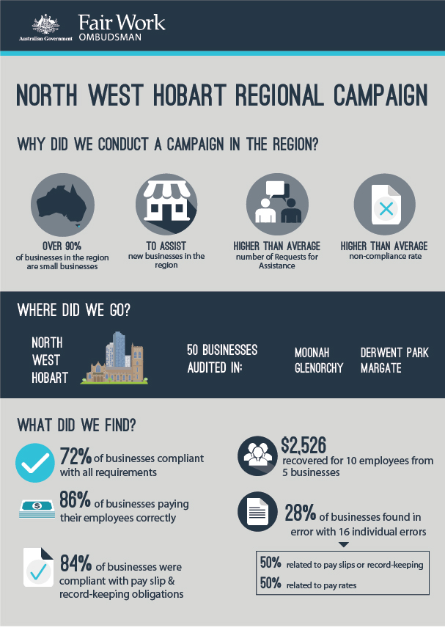

# Summary

In December 2014, the Fair Work Ombudsman (FWO) commenced the North West Hobart Regional Campaign (the campaign). The campaign was undertaken in response to a number of factors, including high numbers of Requests for Assistance (RfA’s) received by the FWO from the region, and a high violation rate of those RfA’s received. The campaign focused on new businesses (those that had registered to trade within 2 years of the commencement of the campaign).

The campaign was specifically conducted to:

* Promote a culture of ongoing compliance by ensuring new businesses were well informed about their employment obligations from an early stage;
* Assist new and small businesses to comply with their workplace obligations by promoting the FWO educational tools and resources such as My Account, the Online Learning Centre, downloadable templates and Best Practice Guides; and
* Conduct assessments of time and wages records to provide advice to businesses on correct record keeping practices and wage rates.

Fair Work Inspector’s (FWIs) visited 50 businesses to provide advice on the resources available from the FWO to assist in meeting their obligations. FWI’s also reviewed time and wage records of those businesses and found:

* 36 (72%) were compliant with all requirements;
* 43 (86%) were paying their employees correctly; and
* 42 (84%) were compliant with record-keeping and pay slip requirements.

A total of $2,526 was recovered from 5 businesses on behalf of 10 employees.

# What we did

In preparing for the campaign, the FWO contacted various stakeholders in the region to advise them of the campaign and to assist with the promotion of the campaign. These included:

* Moonah & Glenorchy Business Association;
* Glenorchy City Council;
* Tasmanian Chamber of Commerce and Industry;
* Tasmanian Small Business Council;
* Australian Hotels Association;
* United Voice;
* Shop, Distributive and Allied Employees Association;
* Tasmanian Hospitality Association;
* Restaurant & Caterers Association; and
* Hair & Beauty Tasmania.

The campaign was also promoted in the media to advise businesses in the region that the campaign was occurring, and to more widely publicise the resources the FWO has available for small and new businesses. The promotion included both traditional and social media.

FWI’s visited 50 businesses in the region, the majority having commenced trading within the last 2 years. Businesses were provided with advice and given demonstrations on the range of resources the FWO provides to assist them to meet their obligations with Commonwealth Workplace laws. The resources specifically discussed with businesses during the campaign included:

* My Account and how to register;
* A demonstration of the FWO online learning courses;
* Pay rates calculator;
* Downloadable best practice templates for record-keeping and pay slips; and
* Best Practice guides.

FWI’s also reviewed a sample of time and wages records to assess compliance with the *Fair Work Act 2009* (the Act), the *Fair Work Regulations 2009* (the Regulations) and the applicable award/agreement.

# Outcomes

Of the 50 businesses audited during the campaign:

* 36 (72%) were compliant with all requirements; and
* 14 (28%) had at least one error:
  + 7 (14%) related to pay slips/records;
  + 6 (12%) related to pay rates; and
  + 1 (2%) related to both pay rates and pay slips/records.

Therefore:

* 42 (84%) businesses were compliant with record-keeping and pay slip requirements; and
* 43 (86%) businesses were paying their employees correctly.

Figure 1 – Campaign results

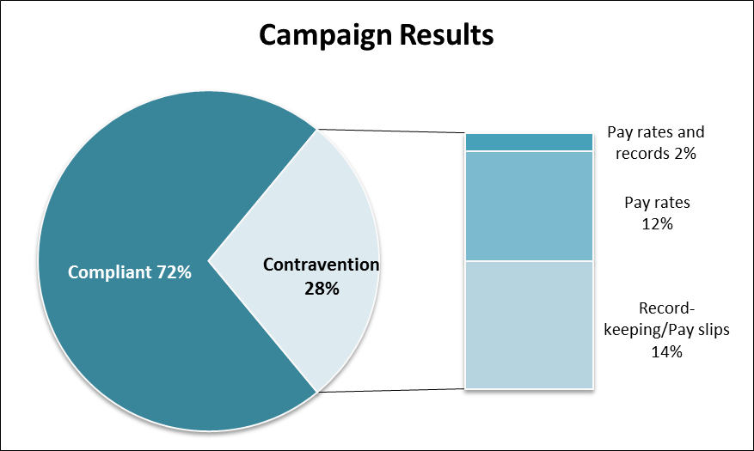

## Individual Errors

The 14 businesses with errors had a total of 16 individual errors. The error most frequently identified related to pay slips (37%), followed by underpaying the base rate of pay (25%) and overtime (19%).

### Figure 2 – Individual error types

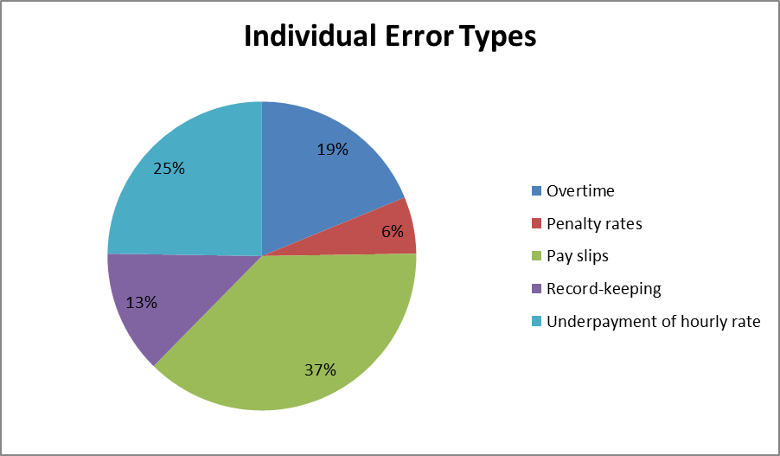

A total of $2,526 was recovered from 5 businesses on behalf of 10 employees.

## Further Information

The 50 businesses included in the campaign operated across a range of industries, including cafes and restaurants, automotive repairs, hairdressers, retail shops and road freight transport.

Almost half of the businesses audited (23) were located in Moonah, while 12 were located in Glenorchy. The remaining 15 businesses were located in suburbs including Derwent Park, Goodwood, Battery Point and Margate.

## Employer Association Membership

The campaign revealed that businesses who were members of an employer or industry association were more likely to be compliant than those who were not. 74% of businesses who were members of an association were compliant, compared with a compliance rate of 71% for businesses who were not a member.

Of the 50 businesses audited, 19 were members of an employer or industry association. Of those who were members of an association, 5 (26%) were found to be in contravention, with the majority having errors around pay slips (3), overtime (1) and record-keeping (1).

Of those who were not members of an association (31 businesses), 9 (29%) had errors with the most common error being underpayment of the hourly rate (3), pay slips (2) and overtime (2).

# Conclusion

The campaign revealed that most businesses were paying correct rates of pay and keeping the required records and pay slips, but few had consciously sought out the specific information required to be certain they were compliant.

As a result of the campaign, businesses are now aware that the FWO can provide the tools and information they need to comply with their obligations; and that these freely available resources are both an efficient and reliable means of maintaining ongoing compliance.

Businesses identified as having made errors during the campaign will be included in the National Compliance Monitoring Campaign 2016, which is an initiative of the FWO aimed at ensuring that businesses previously identified as non-compliant, subsequently achieve ongoing compliance.

About the Fair Work Ombudsman

The Fair Work Ombudsman is an independent agency created by the *Fair Work Act 2009* on 1 July 2009. Our main role is to promote harmonious, productive and cooperative workplace relations.

Each year the Fair Work Ombudsman (FWO) runs proactive campaigns to assist employers and employees understand their rights and obligations under Commonwealth workplace relations laws.

These campaigns can focus on particular industries, regions and/or labour market issues and are conducted on a national and state level.

This report covers the background, method and findings of the TAS North West Hobart Regional Campaign. For further information and media enquiries please contact the media team at [media@fwo.gov.au](mailto:media@fwo.gov.au)

If you would like further information about the Fair Work Ombudsman’s campaigns please contact Lynda McAlary-Smith, Executive Director - Proactive Compliance and Education at [Lynda.McAlary-Smith@fwo.gov.au](mailto:Lynda.McAlary-Smith@fwo.gov.au)