

FWO-ASIC joint audit campaign #2

A report on a joint education and compliance activity in Melbourne

May 2019

© Commonwealth of Australia, 2019

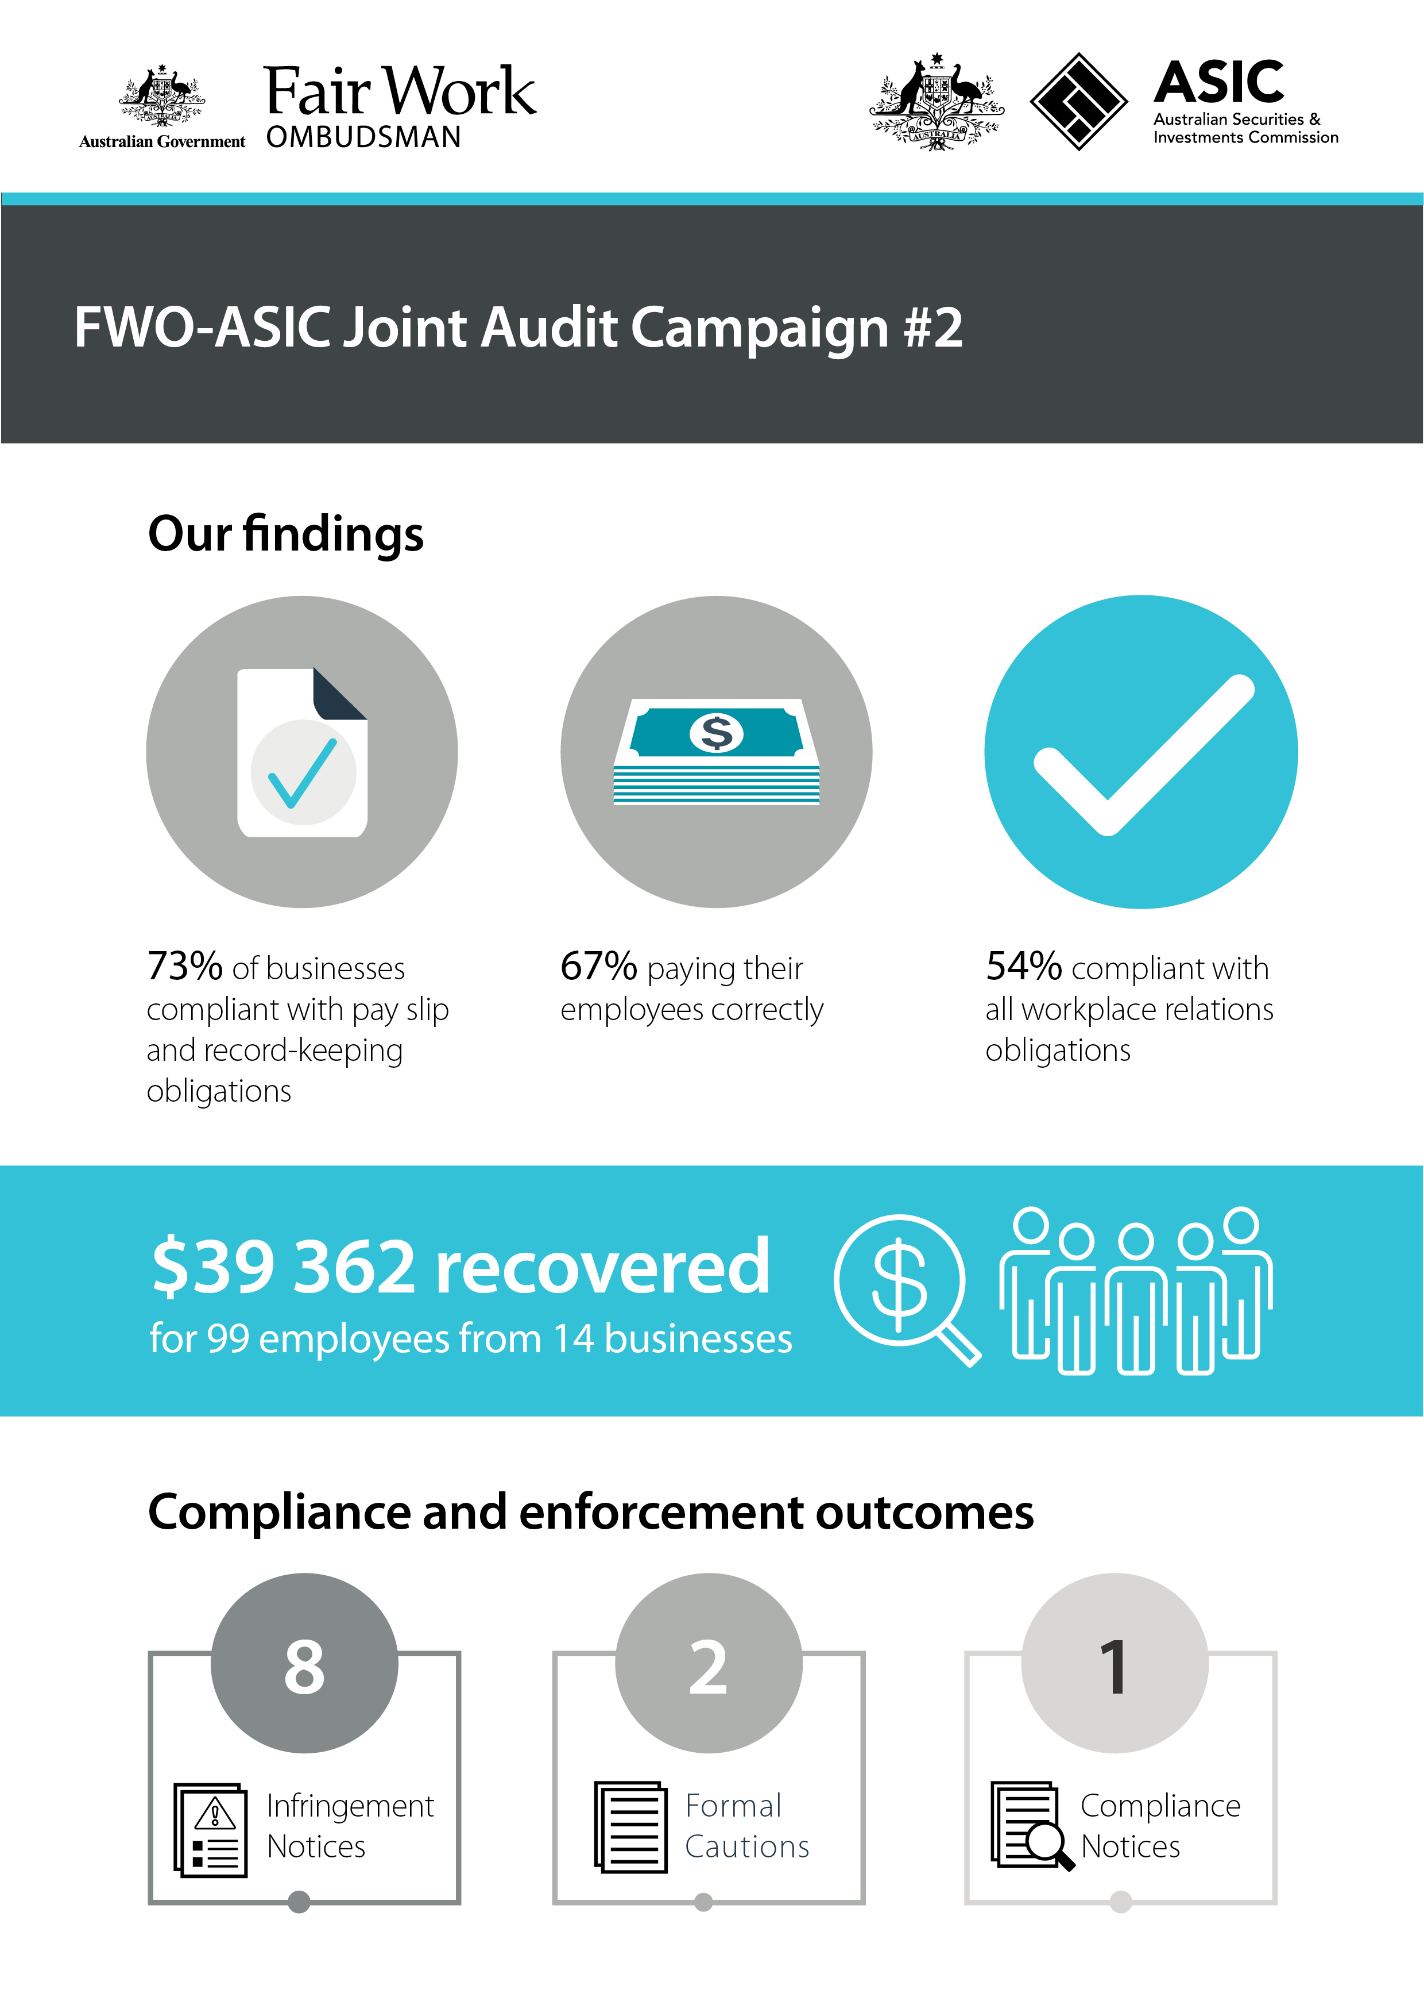

# Executive summary

This report discusses the second proactive compliance and education activity conducted by the Fair Work Ombudsman (FWO) and the Australian Securities and Investments Commission (ASIC).

Following an initial joint activity undertaken in Brisbane[1], Fair Work Inspectors and ASIC analysts visited 48 businesses operating in and around the Melbourne central business district (CBD).

The Campaign deliberately focused on first-time company directors with a view to providing early information and resources so they can understand and meet their obligations. Importantly, none of the businesses had been audited by the FWO previously.

The FWO found that 26 (54%) of these businesses were compliant with all aspects of their workplace relations obligations.

To ensure non-compliant businesses took action to comply, Fair Work Inspectors issued:

* eight Infringement Notices
* two Formal Cautions
* a Compliance Notice.

The FWO recovered $39 362 from 14 businesses for 99 employees.

This report outlines the background, objectives and methodology of the second FWO-ASIC joint education and audit campaign. It discusses the FWO’s findings and actions taken to rectify and deter non-compliance with workplace relations laws.

# Background

The FWO and ASIC commenced a joint education and audit campaign in Melbourne in 2017. The focus of the campaign was small to medium-sized companies that:

* had not previously been audited by FWO
* were operated by first-time directors
* were located in the Melbourne CBD and inner suburbs, including Avondale Heights, Balwyn, Carlton, Keilor, Mentone, North Melbourne, Oakleigh, Port Melbourne and Surrey Hills.

## Objectives

Both agencies sought to increase awareness of their respective roles and to educate businesses about tools and resources to make compliance easier.

ASIC’s specific objective was to educate first-time directors about their obligations as company office holders under the *Corporations Act 2001.*

The FWO sought to:

* assess compliance with the *Fair Work Act 2009* (the Act), *Fair Work Regulations 2009* (the Regulations) and with applicable awards or agreements
* take appropriate enforcement and compliance action to address and deter non-compliance.

## Methodology

The activity included businesses operating in the following sectors:

* Accommodation and Food Services
* Construction
* Rental, Hiring and Real Estate Services
* Administrative and Support Services.

Fair Work Inspectors obtained employee time and wages records from businesses and assessed compliance against relevant awards, including:

* Hospitality Industry (General) Award 2010
* Restaurant Industry Award 2010
* Fast Food Industry Award 2010
* Building and Construction General On-Site Award 2010
* Clerks - Private Sector Award 2010.

ASIC analysts spoke with the first-time company directors about their duties and responsibilities in accordance with the *Corporations Act 2001.* They gave a presentation at various sites and handed out information including the ‘Your Company and the Law’ booklet and information sheet. Directors were also shown the ASIC website, Small Business Hub, Moneysmart website, First Business App and how to subscribe to InFocus e-Newsletter.

The FWO issued a media release about the activity, which was reported by a number of online publications including SmartCompany, Inside Small Business, Public Accountant, Accountants Daily, and The Ragtrader.[2]

# Results

Of the 48 businesses audited by the FWO:

* 26 (54% of all businesses) were meeting all of their workplace relations obligations
* 22 (46%) were in breach of workplace laws, including:
  + nine in breach of their monetary obligations
  + six non-compliant with pay slip and/or record-keeping requirements
  + seven in breach of both their monetary and non-monetary obligations.

The most common breaches found were:

* underpayment of the minimum hourly rate (27% of all breaches)
* failure to provide pay slips in the prescribed form (24% of all breaches).

Fair Work Inspectors recovered $39 362 from 14 businesses for 99 employees.

# Compliance and enforcement outcomes

Fair Work Inspectors took proportionate compliance and enforcement action to ensure businesses remedied breaches and committed to ongoing compliance. They issued:

* eight Infringement Notices, amounting to $7020 in penalties for pay slip and record-keeping breaches
* two Formal Cautions
* one Compliance Notice requiring an employer back pay $5303 to 14 workers.

# Conclusion

The FWO found that nearly half (46%) of all business audited in this campaign were non-compliant with their workplace relations obligations. Fair Work Inspectors took action to ensure all breaches were rectified. The FWO has put these businesses on notice that it may re-audit them in future Campaigns.

The most common reason employers provided for non-compliance was their lack of awareness of the law. The FWO made it clear to non-compliant employers and/or company office holders that ignorance is no excuse and that individuals running a business will be held to account as accessories for any future non-compliance.

Section 550 of the FW Act extends remedies and penalties to a person, or accessory who is ‘involved’ in a breach – including, but not limited to, directors, companies within a supply chain and business advisers. In 92% of its matters filed in court last financial year, the FWO took action against an alleged accessory.

The FWO has numerous free tools and resources that assist employers to compy with workplace relations laws. By visiting [www.fairwork.gov.au](http://www.fairwork.gov.au/), employers can find the information they need to understand and manage their workplace relations obligations.

# About the FWO

The Fair Work Ombudsman is an independent agency created by the *Fair Work Act 2009* on 1 July 2009. The FWO’s role is to promote harmonious, productive and cooperative workplaces and ensure compliance.

The FWO regularly undertakes proactive campaigns to monitor compliance in particular industries, regions and/or with respect to key agency priorities.

For further information and media enquiries about this report please contact the media team at [media@fwo.gov.au](mailto:media@fwo.gov.au).

If you would like further information about the Fair Work Ombudsman’s campaigns please contact Steven Ronson, Executive Director - Proactive Compliance at [s](mailto:Steven.Ronson@fwo.gov.au)teven.ronson@fwo.gov.au

# About ASIC

ASIC is Australia’s corporate, markets and financial services regulator. ASIC contributes to Australia’s economic reputation and wellbeing by ensuring that Australia’s financial markets are fair and transparent, supported by confident and informed investors and consumers.

ASIC is an independent Commonwealth Government body, set up to administer the *Australian Securities and Investments Commission Act 2001* and *Corporations Act 2001.*

For further information and media enquiries please contact media.unit@asic.gov.au

1. The first joint campaign was in Brisbane in 2016. A copy of the report is on our website: https://www.fairwork.gov.au/ArticleDocuments/714/fwo-asic-joint-audit-campaign.pdf.aspx
2. FWO media release: https://www.fairwork.gov.au/about-us/news-and-media-releases/2017-media-releases/june-2017/20170620-fwo-asic-joint-campaign