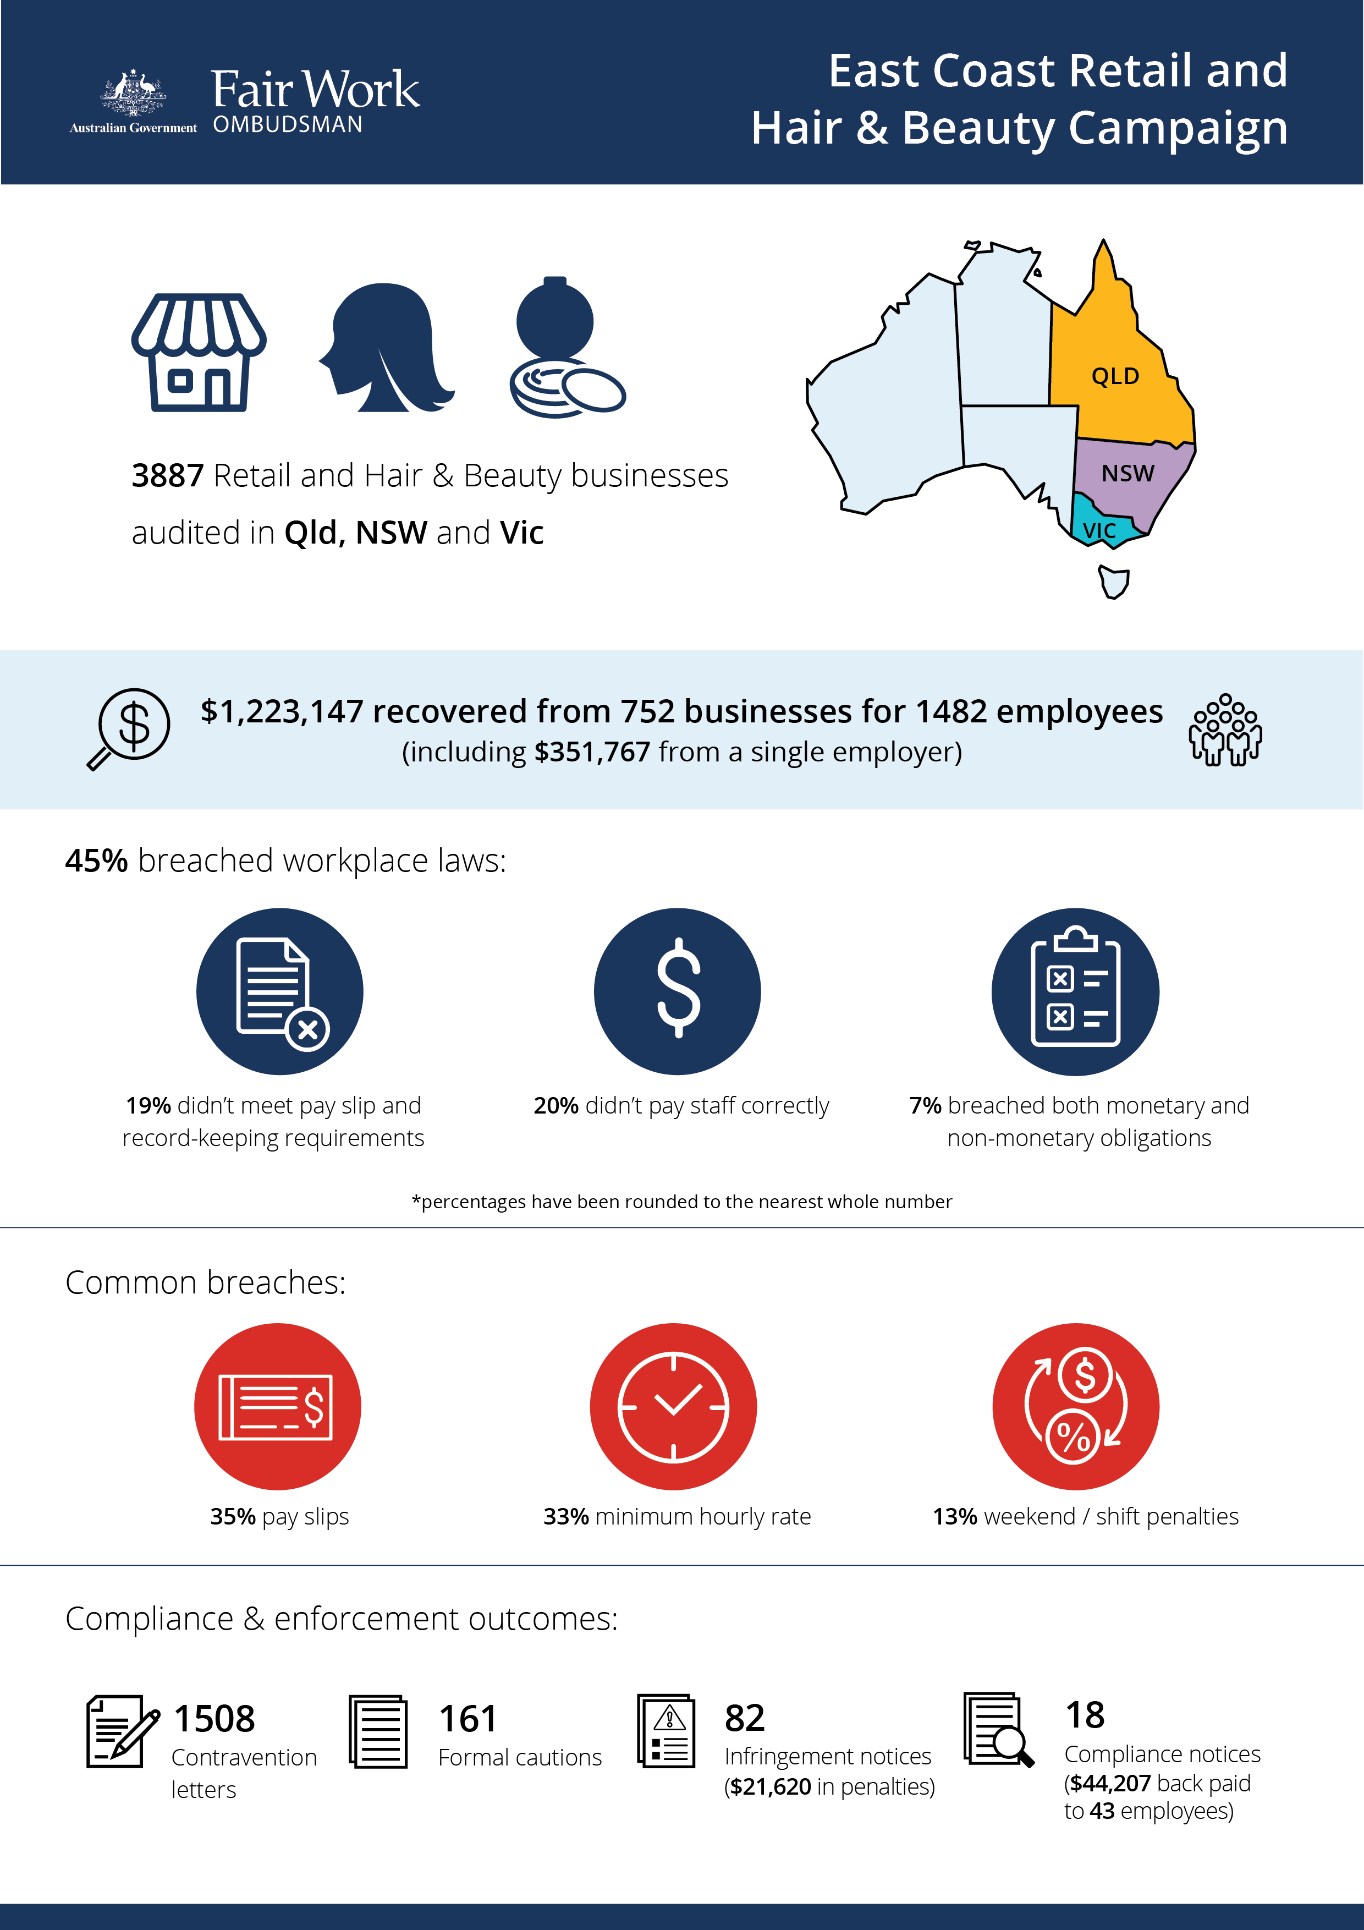

[infographic]

# East Coast Retail and Hair & Beauty Campaign

## What we did and why

The Fair Work Ombudsman (FWO) audited 3887 businesses in the retail and hair and beauty sectors on the East Coast (Queensland, NSW and Victoria). High proportions of vulnerable young workers, including apprentices and trainees are employed in these sectors, and our compliance work has consistently found high levels of non-compliance.

The audits were completed between February 2017 and December 2018. Fair Work Inspectors assessed records against the *Fair Work Act 2009* (the Act), the *Fair Work Regulations 2009* (the Regulations) and applicable modern awards (e.g. *General Retail Industry Award 2010* and *Hair and Beauty Industry Award 2010*) and enterprise agreements. Education resources were provided to employers to assist with compliance.

## Our findings

1758 (45%) of businesses audited had breached workplace laws.

* 779 (20%) were not paying staff correctly.
* 726 (19%) were non-compliant with pay slip and record-keeping requirements.
* 253 (7%) breached both their monetary and non-monetary obligations.[1]

The most common breaches related to:

* failure to provide pay slips as per requirements of the Act and Regulations (35%)
* underpayment of the minimum hourly rate (33%)
* non-payment of penalty rates (13%).

Reasons for non-compliance given by employers included:

* lack of awareness of obligations (63%)
* making a business decision that led to non-compliance, such as paying flat hourly rates in lieu of correct penalties (10%)
* missing the July annual wage increase (9%)
* misinterpreting award requirements (8%).

## Action taken and next steps

Employers were required to fix non-compliance and provide evidence of action taken, for example proof of payment of outstanding employee entitlements.

We recovered $1,223,147 from 752 businesses for 1482 employees. This included a recovery of $351,767 for 38 employees of a Sydney bakery.

Fair Work Inspectors issued:

* 1508 contravention letters
* 161 formal cautions
* 82 infringement notices ($21,620 in penalties for pay slip and record-keeping breaches)
* 18 compliance notices (recovering $44,207 in back pay for 43 employees).

Non-compliant employers were made aware of FWO’s free tools and resources. They were also advised that repeated breaches will see a stronger response, including significantly higher financial penalties.

Our compliance monitoring and enforcement activities remain focussed on high-risk industries across Australia.

The FWO expects employers to comply with all basic workplace relations obligations and utilise our free tools and resources, including:

* PACT - calculates employee entitlements, including award pay rates, leave entitlements and termination pay.[2]
* My account - interactive service where employers receive tailored information and updates.[3]
* Online Learning Centre - award-winning videos on key subjects like hiring employees, managing performance and record-keeping and pay slip obligations.[4]
* Templates and guides - tools and resources specifically designed to assist businesses with their payslips and record keeping obligations.[5]

The FWO considers employers who don’t take advantage of these free tools and resources to be negligent. A lack of awareness of obligations under the *Fair Work Act 2009* is not a valid reason for non-compliance in the workplace.

1. Percentages have been rounded to the nearest whole number
2. <https://calculate.fairwork.gov.au/>
3. <https://www.fairwork.gov.au/my-account/registerpage.aspx>
4. <https://www.fairwork.gov.au/how-we-will-help/online-training/online-learning-centre>
5. https://www.fairwork.gov.au/how-we-will-help/templates-and-guides