Compliance activities in regional education centres

A report on FWO’s compliance activities in Ballarat, Wollongong and Albury-Wodonga

June 2019

© Commonwealth of Australia, 2019

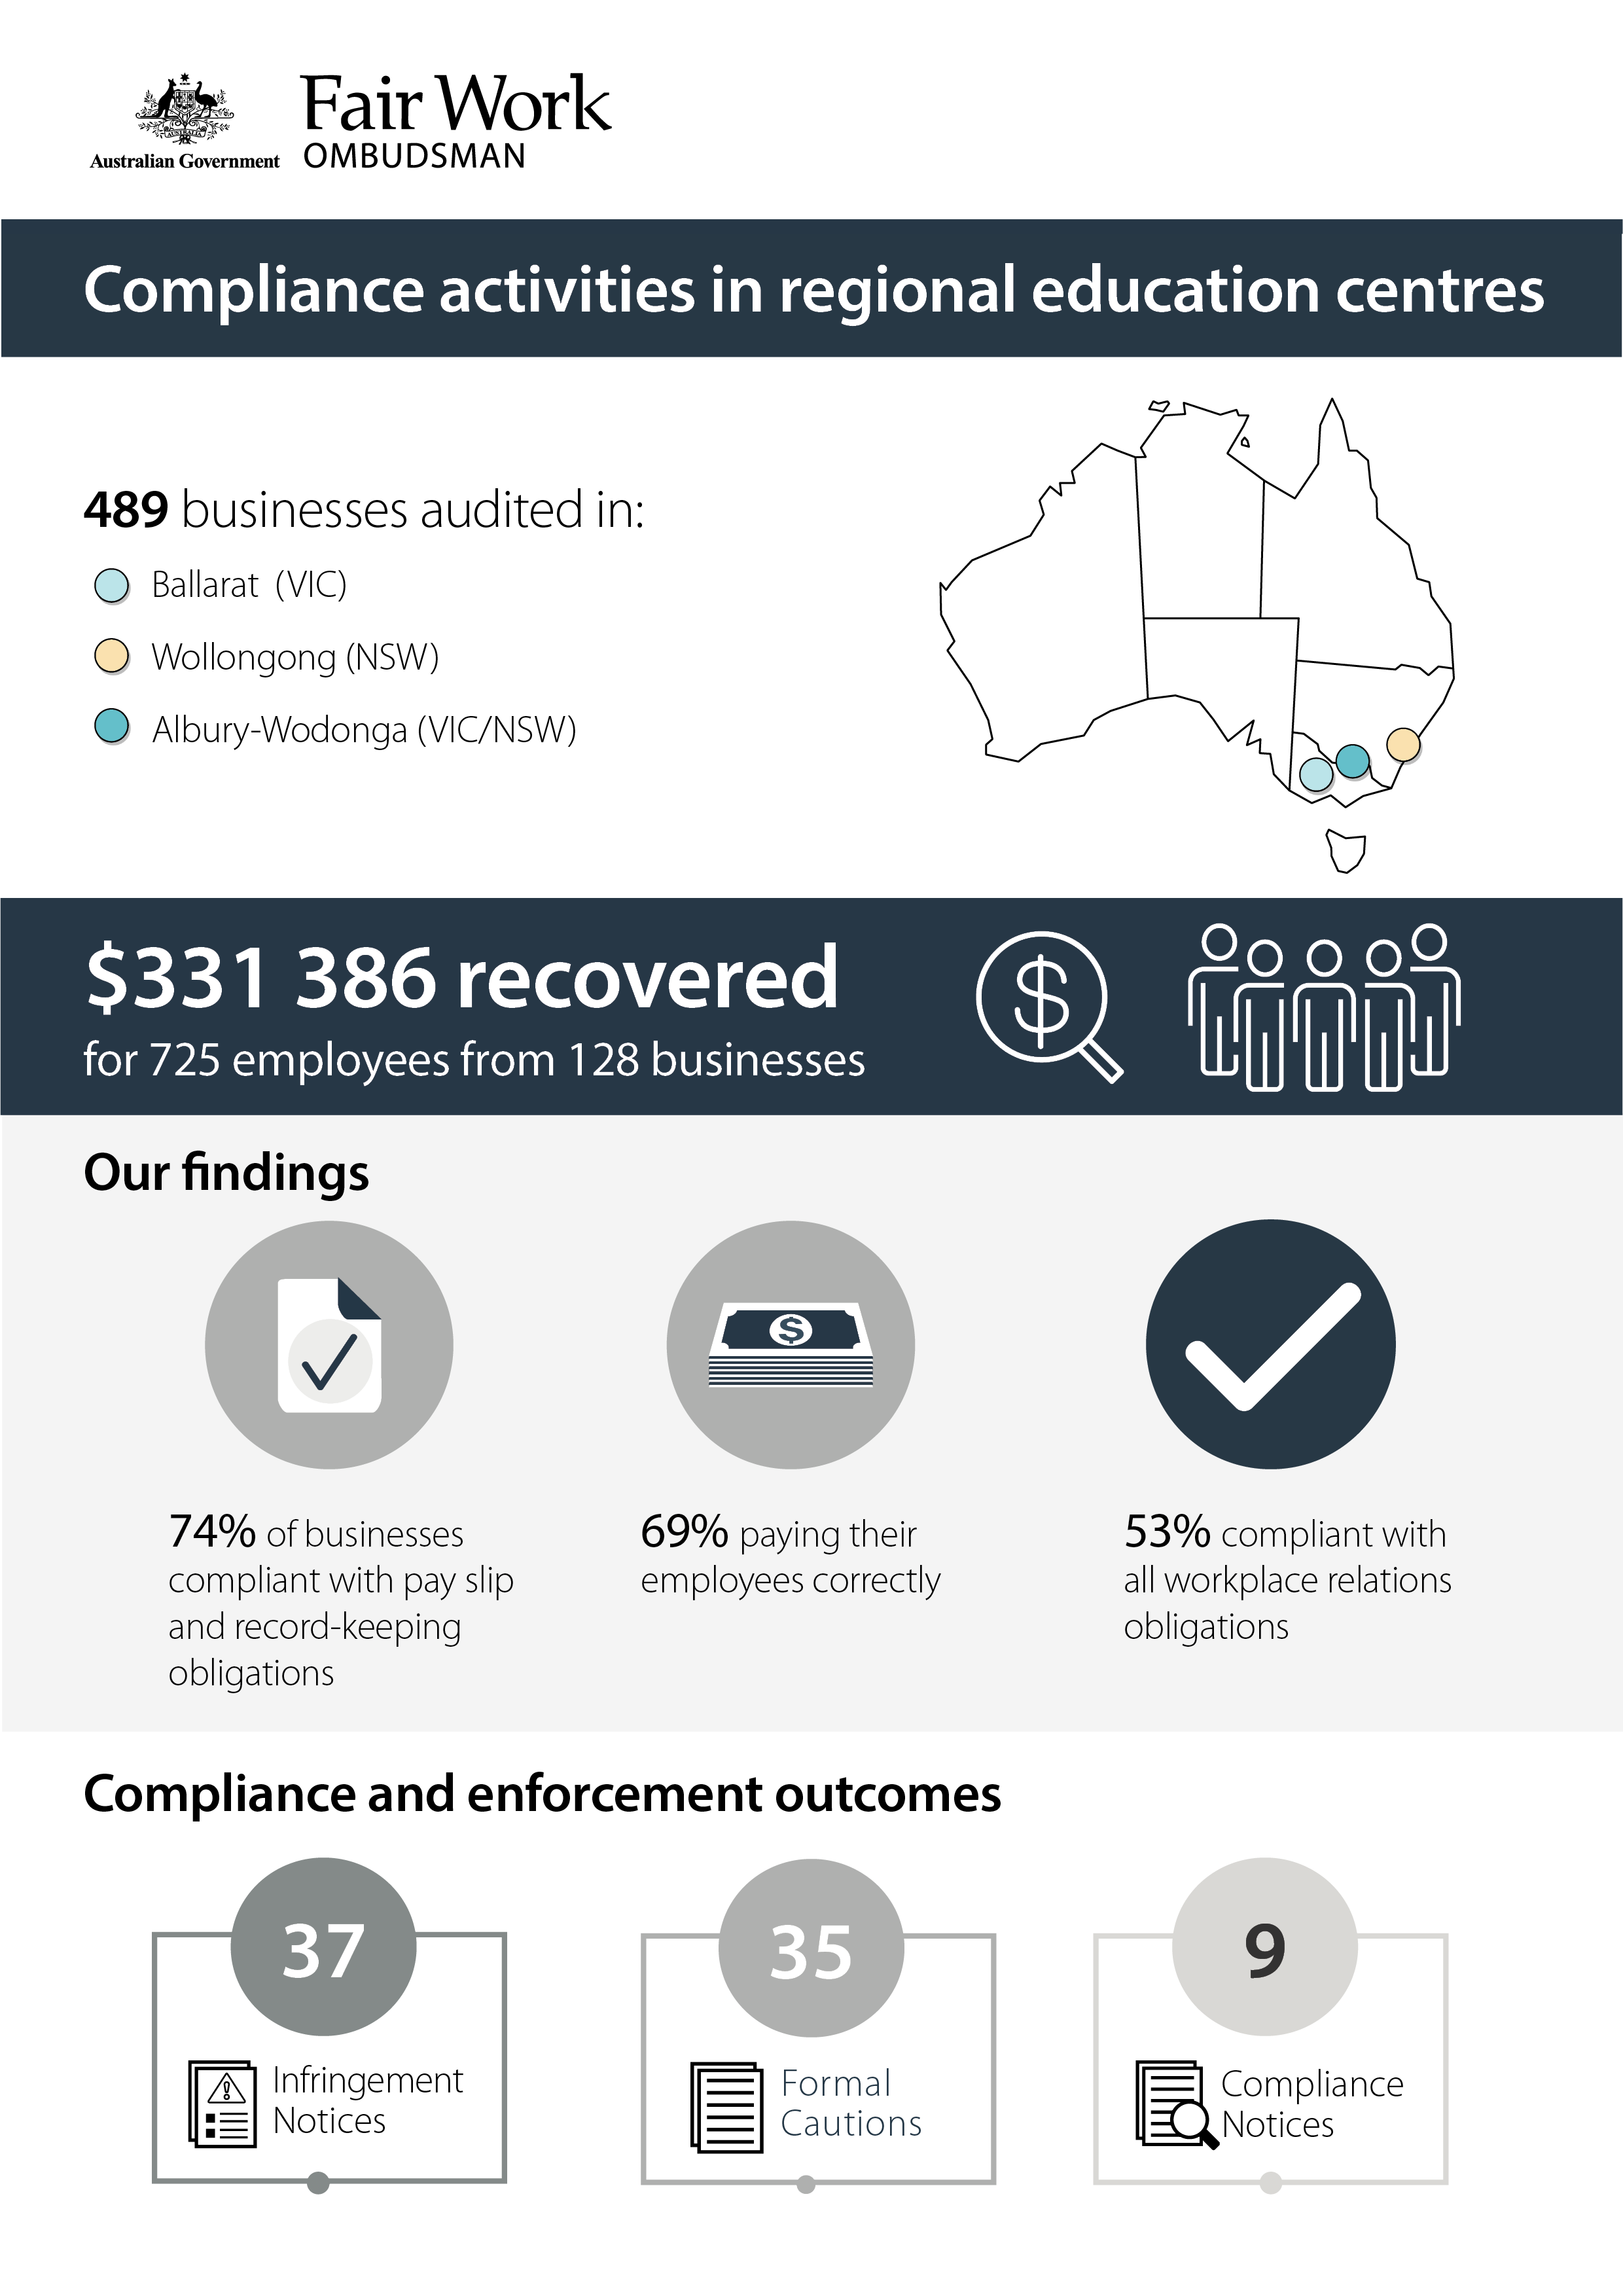

# Executive summary

This report discusses the FWO’s proactive compliance activities in:

* Ballarat (Vic)
* Wollongong (NSW)
* Albury-Wodonga (Vic/NSW).

Each of these locations are regional university centres or ‘education hubs’, hosting major tertiary education campuses and large student populations.

Young workers—including domestic and international students—rely on local jobs to support themselves. Young workers are particularly vulnerable to receiving below minimum wages and conditions.

The FWO targeted businesses in industries known to employ young workers in order to:

* detect and deter non-compliant behaviours
* ensure young workers and students are not exploited and that all employees receive their lawful minimum entitlements
* educate employers about their workplace relations obligations.

Fair Work Inspectors audited 489 businesses and found:

* 362 (74%) were compliant with pay slip and record-keeping requirements
* 338 (69%) were paying their employees correctly
* 259 (53%) were compliant with all aspects of their workplace relations obligations.

Inspectors determined that a lack of awareness was the key driver of non-compliance in the majority of non-compliant cases. Employers were educated about workplace relations laws and compliance and enforcement action was taken to ensure breaches were rectified. Fair Work Inspectors issued:

* 37 Infringement Notices, with $30 360 in penalties for pay slip and record-keeping breaches
* 35 Formal Cautions
* nine Compliance Notices, requiring employers to back pay $27 685 to 29 workers.

$331 386 was recovered for 725 employees working in 128 businesses. This included $181 557 recovered from 67 hospitality businesses for 573 workers.

# 

# Background

Ballarat, Wollongong, and the Albury/Wodonga region host some of Australia’s leading Universities. Several major tertiary education campuses are located in these areas including:

* Federation University of Australia and the Australian Catholic University (Ballarat)
* University of Wollongong and Illawarra Institute of TAFE (Wollongong)
* Charles Sturt and Latrobe Universities (Albury/Wodonga).

The FWO selected these locations based on a number of factors:

* the number of tertiary students
* public concern over the potential exploitation of student workers in these centres[1]
* intelligence, including anonymous reports from young workers, alleging underpayment and exploitation by local employers.

Industries with lower barriers to entry known to employ young workers—usually on a part-time or casual basis—were targeted, including:

* take-away food outlets
* cafés and restaurants
* accommodation providers, pubs and bars
* retail businesses.

A small number of business from other local industries such as Transport Postal and Warehousing, and Manufacturing were also audited.

## Objectives

The objectives of the activities were to:

* detect and to deter non-compliant behaviours, including through the use of compliance and enforcement tools
* recover outstanding entitlements for workers
* understand the reasons for non-compliance and provide tailored advice and assistance to help employers achieve long-term compliance with workplace relations laws.

## 

## Methodology

Fair Work Inspectors audited 489 businesses, including:

* 192 audits in Ballarat
* 97 in Wollongong
* 200 in the Albury-Wodonga region.

Inspectors made unannounced site visits to businesses in each of these locations. They asked to see employee time and wages records, interviewed workers and noted the number of staff on site. They used this information to assess the accuracy of records.

Inspectors assessed records against the *Fair Work Act 2009* (the Act), the *Fair Work Regulations 2009* (the Regulations) and the applicable award/agreement. The most common awards were:

* Hospitality Industry (General) Award 2010
* Restaurant Industry Award 2010
* Fast Food Industry Award 2010
* General Retail Industry Award 2010.

Employers were required to rectify any breaches and to provide evidence of corrective action, for example proof of payment of outstanding employee entitlements. Tailored advice was provided based on the reasons for non-compliance. The causes and extent of non-compliance also determined which compliance and enforcement tools were used.

Following the activity in Wollongong, the FWO returned to the region to present a workshop on industrial relations for local businesses. The event was a collaboration between the FWO, Industrial Relations NSW and the Illawarra Business Chamber. Representatives from the FWO discussed:

* the workplace rights and obligations of employers and employees
* the support the FWO makes available to employers to assist them with their workplace relations needs, including the free tools and resources at fairwork.gov.au.

The workshop also featured a presentation by Joe Murphy, Director of Workplace Relations from Australian Business Lawyers and Advisors, on the importance of:

* investing the time required to ensure compliance with workplace relations laws
* engaging with the FWO.

The workshop generated strong local interest and was attended by around 70 local employers.

# Results

Of the 489 businesses audited, Fair Work Inspectors found:

* 259 (53%) were compliant with all workplace relations laws
* 230 (47%) were in breach of their obligations.

Overall compliance rates for the regions were:

* 54% in Ballarat
* 38% in Wollongong
* 59% in Albury-Wodonga.[2]

Of the 230 non-compliant businesses:

* 103 (or 21% of all audited business) failed to pay their employees correctly, but complied with pay slip and record-keeping obligations (non-monetary obligations)
* 79 (16%) were in breach of non-monetary obligations, but complied with monetary requirements
* 48 (10%) were in breach of both their monetary and non-monetary obligations.

The most common breaches that Fair Work Inspectors identified were:

* underpayment of the minimum hourly rate (35% of all breaches)
* non-compliance with pay slip obligations as set out by the Act and Regulations (30%)
* penalty rate breaches (12%)
* the failure to comply with record-keeping requirements (10%)

$331 286 was recovered for 725 employees from 128 businesses.

Some of the identified reasons for non-compliance included:

* 63% of employers were unaware of all applicable workplace relations obligations
* 15% had misinterpreted award requirements
* 9% of employers made a business decision that led to non-compliance, such as paying flat hourly rates in lieu of weekend penalties
* 6% were non-compliant for ‘other’ reasons, for example, payroll software issues
* 4% missed the July annual wage increase
* 3% received incorrect advice from a third party, such as an accountant.

## Industry non-compliance

The Accommodation and Food Services (hospitality) and Retail sectors were the focus of these activities, with the majority of audits conducted with employers in these industries.

The compliance rates in industries where at least 20 audits were conducted were:

* 66% Manufacturing
* 57% Retail
* 56% Transport Postal and Warehousing
* 46% Accommodation and Food Services.

Over half (55%) of the total money recovered through these activities was from hospitality businesses - $181 557 from 67 employers for 573 employees.

# Compliance and enforcement outcomes

Fair Work Inspectors used compliance and enforcement tools to ensure employers took corrective action to rectify their non-compliance. They issued:

* 37 Infringement Notices, amounting to $30 360 in penalties for breaches of pay slip and/or record-keeping requirements
* 35 Formal Cautions, putting employers on notice about the consequences of continued non-compliance
* nine Compliance Notices, through which $27 685 was recovered for 29 workers.

# Conclusion

The FWO found 47% of employers audited in Ballarat, Wollongong and Albury/Wodonga failed to comply with their workplace relations obligations.

Employers in the hospitality sector were the least compliant overall, with 54% of businesses in breach of workplace laws. This is consistent with findings from across several FWO activities and highlights why the hospitality sector will remain a strategic priority for the agency.

Nearly two-thirds (63%) of non-compliant employers were unaware of workplace relations laws. A further 15% incorrectly interpreted the award covering their business. Inspectors educated employers and encouraged them to use the FWO’s free tools and resources, including:

* PACT - which calculates employee entitlements including award pay rates, leave entitlements and termination pay[3]
* My Account - which provides users with access to tailored information and updates.[4]

The FWO expects employers to use the education and advice provided during audits to be compliant with workplace relations laws.

Tools and resources to help young workers and employers of young people include:

* ‘An employer’s guide to employing young workers’[5]
* Myths and tips for young workers[6]
* Online learning centre - which includes videos on key subjects like managing performance, starting a new job, and having difficult conversations in the workplace. [7]

Non-compliant employers are revisited as part of the FWO’s National Compliance Monitoring Program. Employers who continue to breach workplace laws can expect the FWO to use its strongest compliance and enforcement tools. Where deliberate non-compliance affecting vulnerable employees is involved, the FWO may commence legal proceedings and seek penalties against the business and individuals.[8]

# About the Fair Work Ombudsman

The Fair Work Ombudsman is an independent agency created by the *Fair Work Act 2009* on 1 July 2009. The Fair Work Ombudsman’s role is to promote harmonious, productive and inclusive Australian workplaces as well as ensure compliance with Commonwealth workplace laws.

The Fair Work Ombudsman regularly conducts proactive campaigns targeting at-risk employers and employees as part of its monitoring function. As part of its role, the Fair Work Ombudsman encourages employers to implement sustainable self-monitoring compliance arrangements.

For media enquiries please contact the media team at [media@fwo.gov.au](mailto:media@fwo.gov.au)

If you would like further information about the Fair Work Ombudsman’s campaigns please contact Steven Ronson, Executive Director-Proactive Compliance at: [steven.ronson@fwo.gov.au](mailto:steven.ronson@fwo.gov.au)

1. See: https://www.thecourier.com.au/story/4227064/ballarat-on-the-radar-of-inquiry/& also https://www.smh.com.au/interactive/2016/great-student-swindle
2. Caution should be used when comparing results between regions due to limitations arising from sample profile and size.
3. https://calculate.fairwork.gov.au/
4. https://www.fairwork.gov.au/my-account/registerpage.aspx
5. https://www.fairwork.gov.au/how-we-will-help/templates-and-guides/best-practice-guides/an-employers-guide-to-employing-young-workers
6. https://www.fairwork.gov.au/find-help-for/young-workers-and-students/myths-and-tips-for-young-workers
7. https://www.fairwork.gov.au/how-we-will-help/online-training/online-learning-centre
8. Courts may impose penalties up to $12 600 per breach for an individual, and $63 000 per breach for companies. Where non-compliance is proven to be deliberate or systemic, penalties can amount to $126 000 per breach for individuals and $630 000 per for companies.