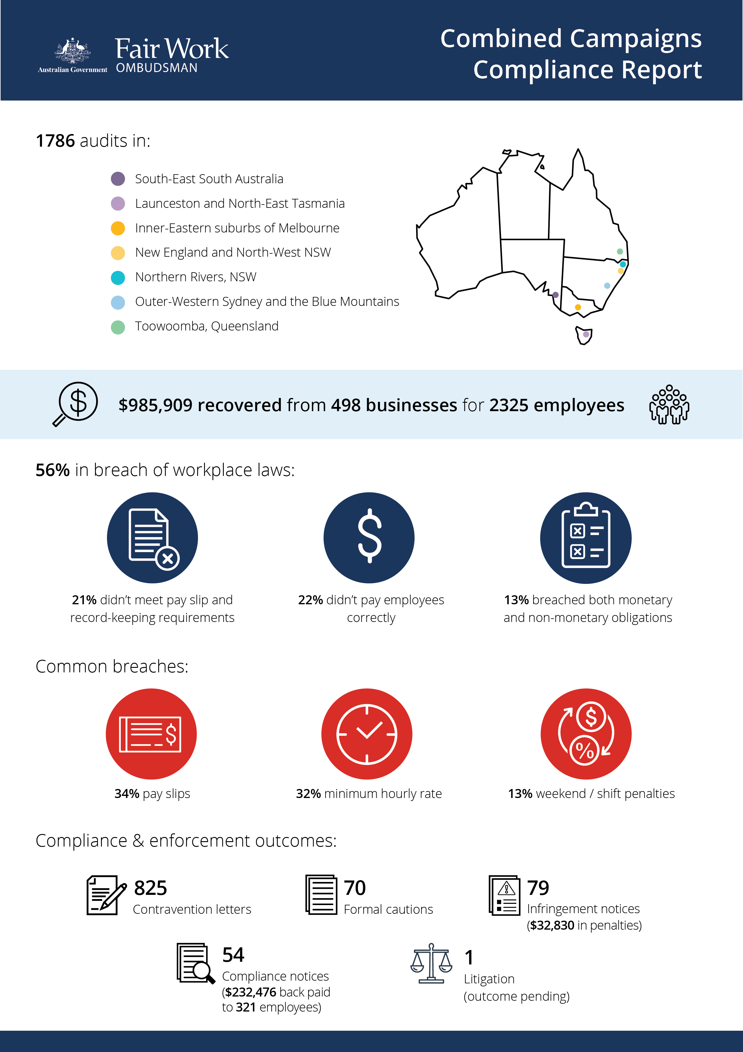

# Combined Campaigns Compliance Report

## What we did and why

Between July 2017 and November 2018, the Fair Work Ombudsman (FWO) conducted 1786 audits of businesses operating in a range industries and regions across Australia:

* Fleurieu-Kangaroo Island, Limestone Coast and Murray-Mallee regions of South-East South Australia (201)
* Launceston and North-East Tasmania (55)
* the Inner-Eastern suburbs of Melbourne (266)
* New England and North-West and the Northern Rivers regions of New South Wales (860)
* outer-Western Sydney and the Blue Mountains in NSW (375)
* the Toowoomba region of Queensland (29).

We selected areas based on internal and external data indicating potentially high levels of non-compliance, including:

* volume of disputes lodged with the FWO
* incidence of vulnerable workers, including those from culturally and linguistically diverse backgrounds (CALD), young / mature-age workers, temporary migrants, students / apprentices /trainees, and low-skilled workers
* concentration of hospitality businesses (the fast food, restaurant and cafés (FRAC) sub-sector a key priority for the FWO[1]).

Fair Work Inspectors reviewed employment and payroll records, interviewed employers, managers and workers and observed work practises. Pay slip and record-keeping practises were assessed against the requirements of the *Fair Work Act 2009* (the Act), the *Fair Work Regulations 2009* (the Regulations), and applicable awards or registered agreements.

## Our findings

1000 businesses (56%) were in breach of workplace laws:

* 401 (22%) failed to pay employees correctly
* 374 (21%) were non-compliant with pay slip and record-keeping requirements
* 225 (13%) had breached both their monetary and non-monetary obligations.

The most common breaches identified were:

* failure to provide pay slips as per the Act and Regulations (34%)
* underpayment of the minimum hourly rate (32%)
* non-payment of weekend/shift penalty rates (13%).

Some of the reasons for non-compliance given by employers included:

* 69% unaware of all their obligations
* 11% misinterpreted award requirements
* 6% missed the July annual wage increase.

Hospitality businesses had the highest non-compliance rate of all industry sectors at 64%. Non-compliance rates by industry (for sectors where we audited 30 or more businesses) are shown below.

### Table 1. Compliance results by industry

| **Industry** | **Total audits** | **Non-compliance rate** | **Monies recovered** |
| --- | --- | --- | --- |
| Accommodation and Food Services | 576 | 64% | $506,406  (for 1464 employees from 204 businesses) |
| Wholesale Trade | 69 | 62% | $27,047  (for 47 employees from 23 businesses) |
| Agriculture, Forestry and Fishing | 69 | 57% | $9152  (for 14 employees from 6 businesses) |
| Domestic construction | 100 | 56% | $38,895  (for 39 employees from 20 businesses) |
| Rental, Hiring & Real Estate Services | 33 | 53% | $15,077  (for 16 employees from 9 businesses) |
| Retail Trade | 437 | 52% | $154,680  (for 269 employees from 115 businesses) |
| Manufacturing | 173 | 49% | $45,811  (for 94 employees from 40 businesses) |
| Health and Social Assistance | 227 | 49% | $35,109  (for 156 employees from 29 businesses) |
| Other | 43 | 48% | $26,782  (for 22 employees from 7 businesses) |

Compliance results for each region are shown in the table below. Caution should be used when comparing results by area given differences in sample size and composition.

### Table 2: Compliance results by region

| **Location** | **Total audits** | **Non-compliance rate** | **Monies recovered** |
| --- | --- | --- | --- |
| Launceston and North-East Tasmania | 55 | 71% | $47,644  (for 93 employees from 28 businesses) |
| Melbourne Inner-East | 266 | 56% | $136,301  (for 203 employees from 72 businesses) |
| South-East South Australia | 201 | 43% | $28,563  (for 94 employees from 37 businesses) |
| Northern Rivers (NSW) | 601 | 54% | $401,645  (for 1042 employees from 177 businesses) |
| Outer Western Sydney and Blue Mountains (NSW) | 375 | 62% | $250,526  (for 420 employees from 118 businesses) |
| New England and North-West (NSW) | 259 | 56% | $46,627  (for 115 employees from 55 businesses) |
| Toowoomba (QLD) | 29 | 66% | $74,603  (for 358 employees from 11 businesses) |

## Action taken and next steps

Employers were required to fix non-compliance and provide evidence of action taken, for example proof of payment of outstanding employee entitlements.

We recovered a total of $985,909 from 498 businesses for 2325 employees.

Fair Work Inspectors issued:

* 825 contravention letters
* 70 formal cautions
* 79 infringement notices ($32,830 in penalties)
* 54 compliance notices ($232,476 back paid to 321 employees).

We commenced legal action against Available Dental Care Pty Ltd for failing to comply with a compliance notice.[2] It’s alleged that employees were underpaid ordinary hourly and Saturday penalty rates.

Non-compliant employers identified as part of this activity were made aware of FWO’s tools and resources. They were also advised that repeated breaches will see a stronger response, including significantly higher financial penalties.

Our compliance monitoring and enforcement activities remain focussed on high-risk industries across Australia.

The FWO expects employers to comply with all basic workplace relations obligations and utilise our free tools and resources, including:

* PACT - calculates employee entitlements, including award pay rates, leave entitlements and termination pay[3]
* My account - interactive service where employers receive tailored information and updates[4]
* Online Learning Centre - award-winning videos on key subjects like hiring employees, managing performance and record-keeping and pay slip obligations[5]
* Templates and guides - tools and resources specifically designed to assist businesses with their payslips and record keeping obligations.[6]

The FWO considers employers who don’t take advantage of these free tools and resources to be negligent. A lack of awareness of obligations under the *Fair Work Act 2009* is not a valid reason for non-compliance in the workplace.

1. <https://www.fairwork.gov.au/about-us/our-purpose/our-priorities>
2. <https://www.fairwork.gov.au/about-us/news-and-media-releases/2019-media-releases/november-2019/20191118-available-dental-care-litigation-media-release>
3. <https://calculate.fairwork.gov.au/>
4. <https://www.fairwork.gov.au/my-account/registerpage.aspx>
5. <https://www.fairwork.gov.au/how-we-will-help/online-training/online-learning-centre>
6. https://www.fairwork.gov.au/how-we-will-help/templates-and-guides