Victorian Compliance Campaign

Report – February 2016

A report by the Fair Work Ombudsman under the *Fair Work Act 2009*

Date of Publication – February 2016

© Commonwealth of Australia, 2016

# Contents

Contents 2

Campaign Snapshot 3

Summary 4

What we did 4

Outcomes 5

Other findings 7

Next Steps 7

Conclusion 7

About the Fair Work Ombudsman 8

# Campaign Snapshot

Total of

**220**

Businesses audited during the campaign

Over

**73%**

Of businesses were compliant with record-keeping and pay slip obligations

Total of

**60%**

Of businesses were paying their employees correctly

More than

**$72k**

Was recovered on behalf of 170 employees

Total of

**84**

Enforcement actions were taken

# 

# Summary

In August 2014 the Fair Work Ombudsman (FWO) commenced the Victorian Compliance Campaign (the campaign). The campaign was undertaken in response to high levels of non-compliance identified across a range of industries throughout Victoria during previous audit campaigns.

The campaign was specifically conducted to:

* initiate enforcement action to alter the behaviour of businesses who have remained non-compliant following their previous interaction with FWO; and
* provide education and assistance to other businesses to help them achieve and maintain ongoing compliance.

From the 220 businesses audited:

* 131 (60%) businesses were paying their employees correctly;
* 160 (73%) businesses were compliant with record-keeping and pay slip requirements;
* $72,904 was recovered from 65 businesses on behalf of 170 employees;
* 83 formal cautions and 1 infringement notice (on the spot fine) was issued; and
* 84 (100%) businesses that underpaid their employees in previous campaigns and found to be non-compliant in this campaign were subject to enforcement action.

# What we did

The FWO contacted 220 businesses across Victoria, including some that were non-compliant in previous campaigns. A sample of time and wage records was requested and Fair Work Inspectors (FWI’s) assessed compliance with the *Fair Work Act 2009* (the Act), the *Fair Work Regulations 2009* (the Regulations) and the applicable award:

* where businesses were underpaying their employees in previous campaigns, and were found to be non-compliant again in this campaign, enforcement action was taken; and
* where businesses were non-compliant for the first time in this campaign, the FWO required them to rectify the issue and provide proof of having back-paid employees for all underpayments.

# Outcomes

Of the 220 businesses audited:

* 103 (47%) were compliant with all requirements;
* 117 (53%) had at least one error, of which:
  + 57 (26%) related to pay rates;
  + 28 (13%) related to records or pay slips; and
  + 32 (14%) related to records/pay slips and pay rates.

Chart 1: Audit results

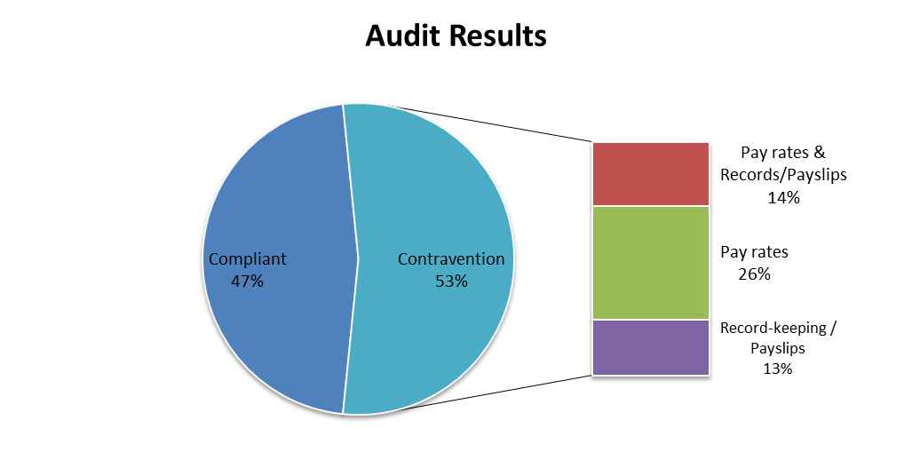

This means that:

* 160 (73%) businesses were compliant with record-keeping and pay slip requirements;
* 131 (60%) businesses were paying their employees correctly; and
* 100% of businesses underpaying employees in previous campaigns and found to be non-compliant in this campaign were subject to enforcement action.

The 117 businesses with errors had a total of 183 individual errors across 5 contravention types, as outlined in Chart 2.

Chart 2: Contravention Types

35% relating to wages
26% payslips
30% penalties
8% recordkeeping 
1% breaks

When assessing specific non-compliance, the most commonly identified contraventions were:

* wages - underpayment of hourly rate (35%); and
* failure to pay or underpayment of penalty rates, loadings and allowances (30%).

The FWO views continuing non-compliance to be of a serious nature and strongly encourages businesses to take action to ensure their employment systems adopt a state of conscious compliance with relevant workplace laws.

Of the 117 (53%) non-compliant businesses, 84 had previously been found to be underpaying their employees during previous audits. Enforcement action was taken in relation to all of these businesses.

83 businesses were issued formal cautions and 1 business was issued an infringement notice. Formal cautions are a written warning when the FWO has found non-compliance and wants to put a business on notice that future non-compliance could result in the FWO seeking financial penalties. If the FWO becomes aware of any further instances of non-compliance, the fact the business was issued with a formal caution will be a factor taken into account in deciding whether to commence civil proceedings against the business and may be used as evidence in any penalty determinations.

Formal cautions were issued to businesses operating in more than a dozen industry sectors. 23 formal cautions were issued to businesses in the hair and beauty industry, and 12 formal cautions were issued to businesses in the accommodation industry.

An infringement notice is a fine given to a business for non-compliance with record-keeping or pay slip requirements of the Act and Regulations.

Businesses that were found to be non-compliant for the first time were required to rectify any issues (including making back payments to underpaid employees) and were provided with assistance to help them comply with their obligations.

All businesses found to be non-compliant will be re-audited as part of the FWO’s ongoing National Compliance Monitoring Campaign.

# Other findings

To inform our future education and audit activities, the FWO spoke with businesses to determine the reason/s for their non-compliance. Some reasons included:

* small businesses mistakenly believing that they were exempt from pay slip and record-keeping obligations due to their size. These businesses generally had not attempted to obtain the correct information regarding these obligations from the FWO or other available sources eg. Industry associations or third party providers; and
* some businesses found to be underpaying their employees previously had rectified those issues, then failed to keep up to date with ongoing annual wage increases. These businesses had not used the FWO resources that were previously provided to them by FWI’s, including the FWO My account and email subscription services.

Next Steps

The FWO will continue to monitor businesses found to be non-compliant through the ongoing National Compliance Monitoring Campaign and continue to take enforcement action. In addition the FWO will:

* continue to educate employers on their obligations and encourage them to contact the FWO and others for assistance and advice on workplace relations matters;
* promote key themes identified in compliance campaigns through communication and media activities and use the findings of this campaign to inform future compliance activities; and
* promote the tools and resources available on the FWO website [www.fairwork.gov.au](http://www.fairwork.gov.au/).

Conclusion

The campaign revealed 47% of businesses were fully compliant with their workplace obligations. 60% of businesses were paying their employees correctly and 74% of businesses were meeting their record-keeping and pay slip obligations.

The campaign also revealed that 117 businesses were non-compliant in this campaign, including 84 businesses who were found to be underpaying their employees in previous campaigns.

The FWO will continue to monitor businesses found to be non-compliant. All businesses found to be non-compliant in the campaign will be re-audited as part of the National Compliance Monitoring Campaign. Where further non-compliance is detected, the FWO will consider seeking financial penalties.

The FWO will continue to support a culture of compliance by empowering employers and employees to resolve any issues that arise at a workplace level. To assist businesses to do this, the FWO recently released a number of practical Guides to Resolving Workplace Issues on the FWO website [www.fairwork.gov.au](http://www.fairwork.gov.au/). Whilst the FWO will continue to monitor non-compliant businesses, supporting businesses and employees to resolve issues at the workplace level gives the best chance of continued production workplace relationships.

About the Fair Work Ombudsman

The Fair Work Ombudsman is an independent agency created by the *Fair Work Act 2009* on 1 July 2009. Our main role is to promote harmonious, productive and cooperative workplace relations.

Each year the Fair Work Ombudsman runs proactive campaigns to assist employers and employees understand their rights and obligations under Commonwealth workplace relations laws.

These campaigns can focus on particular industries, regions and/or labour market issues and are conducted on a national and state level.

This report covers the background, method and findings of the Victorian Compliance Campaign. For further information and media enquiries please contact the media team at [media@fwo.gov.au](mailto:media@fwo.gov.au)

If you would like further information about the Fair Work Ombudsman’s campaigns please contact Lynda McAlary-Smith, Executive Director - Proactive Compliance and Education at [Lynda.McAlary-Smith@fwo.gov.au](mailto:Lynda.McAlary-Smith@fwo.gov.au).