

Performance highlights

The Fair Work Ombudsman (FWO) is a statutory office responsible for ensuring compliance with Australian workplace laws and educating employers and employees about their rights and responsibilities at work.

For 2013–14, we met all of our deliverables, key performance indicators, service standards and specific commitments to government.
Across our core functions of advice, assistance and enforcement we:
Advice
- Responded to more than 595,000 enquiries received through Fair Work Infoline services.
- Resolved 99% of call enquiries at first contact.
- Answered almost 90,000 Small Business Helpline calls in seven months.
- Received more than 11 million visits to fairwork.gov.au and more than two million fact sheet, best practice guide and template downloads.
- Introduced our transformed website offering increased accessibility and customisation including tailored industry information.
- Received more than 1.57 million visits to pay tools.
- Expanded and updated our suite of online self-service resources, including developing ‘starting a new job’ and ‘hiring an employee’ guides.
- Implemented strategies to educate areas, industries and workers most in need of our assistance, including young hospitality workers, overseas Harvest Trail workers and small business operators.
Assistance
- Finalised 25,650 complaints and recovered more than $23 million for 15,483 workers.
- Finalised 94% of complaints within 90 days.
- Finalised 4,567 targeted campaign audits recovering more than $4 million for 7,541 workers.
- Recovered more than $700,000 for 285 workers who were considering lodging a complaint through pilot ‘pre-complaint interventions.’
- Finalised 79% of complaints through assessment and dispute resolution processes.
- Entered into partnerships with seven businesses through proactive compliance deeds.
- Assessed sponsorship obligations of
- 1,029 employers of 457 visa holders as part of our expanded visa monitoring role, referring 243 possible breaches to the Department of Immigration and Border Protection.
Enforcement
- Commenced 37 civil penalty litigations to address serious, wilful and repeated non-compliance.
- Achieved court ordered penalties of more than $3 million in 39 cases decided.
- Issued 116 infringement notices to employers who breached record-keeping or pay slip obligations.
- Issued 65 compliance notices to recover unpaid wages.
- Entered into 15 enforceable undertakings to address non-compliance issues and put in place preventative measures to avoid future breaches.
- Initiated several test cases to clarify the operation of the Fair Work Act 2009.
- Litigated our first successful age discrimination case and secured a record $343,860 in penalties against a cleaning company for deliberately underpaying six workers.
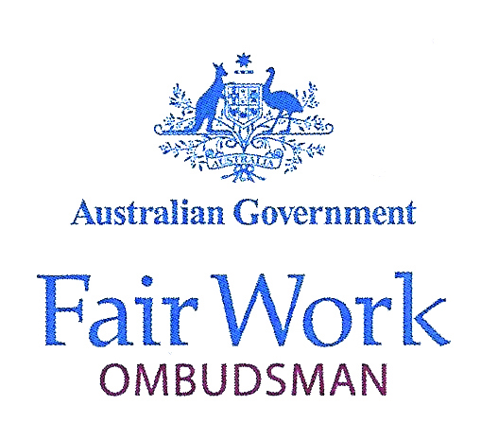
GPO Box 9887 Melbourne VIC 3001
414 LaTrobe Street Melbourne VIC 3000
P: (03) 9954 2611
F: (02) 6276 9849
E: natalie.james@fwo.gov.au
The Hon Eric Abetz MP
Minister for Employment
Parliament House
CANBERRA ACT 2600
Dear Minister
In accordance with section 686 of the Fair Work Act 2009 and Section 70 of the Public Service Act 1999, I am pleased to submit the annual report of the Fair Work Ombudsman for the financial year ending 30 June 2014.
This report has been prepared in accordance with Section 70 of the Public Service Act 1999 and the guidelines approved on behalf of the Parliament by the Joint Committee of Public Accounts and Audit.
Yours sincerely

Natalie James
FAIR WORK OMBUDSMAN
7 October 2014
Contents
PERFORMANCE HIGHLIGHTS 1
YEAR IN REVIEW 4
ABOUT THE FWO 7
Includes information on our role and program
structure, organisational structure and introduces
our Fair Work Ombudsman and her deputies.
Program structure 8
Fair Work Ombudsman 9
Organisational structure 9
PERFORMANCE REPORTING 11
Reports on our performance against our program
of work, including achievements against
deliverables and key performance indicators.
Deliverable 1: Advice 15
Deliverable 2: Assistance 25
Deliverable 3: Enforcement 37
MANAGEMENT AND ACCOUNTABILITY 43
Discusses our external scrutiny and governance arrangements as well as workforce,
financial and property management.
Corporate governance 43
Workforce management 51
Financial management 57
Property and environmental management 59
APPENDICES 60
Details aspects of our administration, such as
reporting on specific legislation, workforce
demographics and summary of resources.
Appendix 1: Reporting on specific legislation 60
Appendix 2: Workforce demographics 61
Appendix 3: Changes to disability reporting 65
Appendix 4: Summary of resources 66
FINANCIAL STATEMENTS 69
Contains the complete set of our audited and
unqualified financial statements and a report by
the Auditor-General.
REFERENCES 132
Provides a glossary, list of acronyms, a compliance index and an alphabetical index.
Glossary 132
Abbreviations and acronyms 133
List of requirements 134
Index 138
Contact 140



Year in review

In my first year as Fair Work Ombudsman the agency has continued to streamline and evolve its services to provide the community with accessible and reliable advice on Australian workplace laws.

I’m pleased with our progress and achievements in
2013–14. We delivered on our core responsibilities and
met key performance targets, while modernising our operations and services to deliver better outcomes for businesses and workers.

Small Business Helpline
We launched our Small Business Helpline in December 2013 (p17). To 30 June 2014, we provided close to 90,000 small business operators with prioritised and tailored advice on workplace relations issues.
Underpinning this service is our commitment to provide reliable advice that callers can confidently act on and implement in their workplace. The helpline, along with our new website, assists small businesses who are trying to do the right thing and minimises the risk that inadvertent mistakes result in workplace complaints in the future.
Transformed website
We transformed our website (fairwork.gov.au) in 2014 with a focus on delivering reliable information in a convenient, accessible way. The new features equip people with what they need to make decisions about their businesses and jobs, and provide advice on how they can resolve issues that arise in their workplace (p19).
With 11 million visits in 2013–14 – up 14% on last year – investing in self-help technologies remains a priority. Now that phasing to modern awards has ended and the award system is less complex, online tools are the most convenient way to deliver simplified information on pay rates.
End of transition to modern award rates of pay
Since 2010, wages in awards have been gradually phasing from multiple state-based rates to one national rate. People have had to identify ‘old’ and ‘new’ award classifications and perform calculations to determine what they should be paying and getting paid. These time-consuming processes are no longer necessary under the majority of awards from 1 July 2014.
A mobile friendly pay tool will be launched in 2015 to make accessing pay rates even easier.
Modern award review
Despite things getting simpler, the workplace relations framework can still be complex for those who are not experts. The most common enquiries to the agency continue to involve pay rates and conditions of employment.
After five years advising on the application of modern awards, we have a comprehensive understanding of where people can struggle to interpret and apply the framework. We are sharing this information with the Fair Work Commission via its review of modern awards (p25). Through our experience, we believe we can assist the Commission to inject greater clarity into the awards system and make the instruments more accessible.
Resolving disputes
We prefer to resolve the complaints we receive through dispute resolution processes such as mediation. This process can resolve issues quickly and cooperatively.
Two new dispute resolution approaches were successfully piloted during the year. We recovered over $700,000 for 285 employees through ‘pre-complaint interventions’. Our ‘three strikes’ pilot focused on intervening in tailored and proportionate ways to address repeated non-compliance. See p36 for more details on these pilots.
Enforcing the law
It’s important that we are proportionate in framing our response to cases of non-compliance. We reserve formal enforcement action for deliberate breaches of workplace laws, matters involving vulnerable workers or where a person hasn’t been willing to engage with us about legitimate problems.
Successful litigations send a clear message to the community that there are serious and visible consequences to deliberate non-compliance. This deters others from undercutting wages and conditions to gain an unfair competitive advantage.
Our record $343,860 in penalties secured against a cleaning company for deliberately underpaying six vulnerable workers grabbed headlines. The ruling and significant penalties handed down in our first age discrimination litigation also demonstrates that every employee – regardless of their age – has the right to work without fear of discrimination (p44).

Partnering with industry
Compliant workplaces are not achieved by merely responding to complaints. Through analysis of our data and other intelligence, and by working with influential partners, we are identifying and addressing the root causes of non-compliance in different industries and regions.
We’ll continue to work collaboratively with industry and individuals to identify and address non-compliance, with a focus on assisting those most vulnerable to exploitation.
The Productivity Commission’s good practice principles for regulators, outlined in their Regulator Audit Framework, and independent research into our work by the University of Melbourne is assisting us to assess and improve our performance as an effective regulator (p50). Our focus will remain on finding better ways of working to achieve results efficiently across all our activities.

Natalie James
Fair Work Ombudsman



About the FWO

We are responsible for ensuring compliance with Australian workplace laws and educating employers and employees about their rights and responsibilities at work.

Our jurisdiction is set out in the Fair Work Act 2009 and our services are free to all workers and employers in Australia.
We are accountable through Parliament, the courts and tribunals and the Commonwealth Ombudsman. We are also bound by the Australian Public Service Code of Conduct.

Responsibilities
- We are a single point of contact for reliable and timely information about Australia's workplace relations system.
- We educate people working in Australia about fair work practices, rights and obligations.
- We assess complaints or suspected breaches of workplace laws, awards and enterprise agreements.
- We enforce workplace laws, in some cases through the courts, to achieve appropriate remedies and to deter people from breaching the law.
- We build strong and effective relationships with industry, unions and other stakeholders.
Guiding principles
Aligned with the Productivity Commission’s best practice principles for regulators, our work is guided by the following principles:
- Clear and effective communication
- - We listen to the workplace concerns of workers and businesses.
- - We make compliance with workplace laws simpler by providing information that is easy to understand.
- - We provide effective and timely customer service.
- Consistency
- - We provide advice which can be relied and acted on.
- - We assist in creating a level playing field.
- - We apply consistent and transparent principles in deciding when and how to use our enforcement tools.
- Risk-based and proportionate- We reduce the time and cost of resolving workplace disputes by using dispute resolution processes such as mediation, to help people to find their own solutions.
- - We concentrate our enforcement tools on areas of serious non-compliance where we can have the greatest impact (e.g. vulnerable workers).
- - We take action in the courts to seek penalties against serious offenders.
- Accountable and transparent- We remain neutral and impartial in doing our work.- We provide the community with the right to review all our decisions.- We publish information on our compliance and enforcement activities. - We ensure our customers’ private details are kept confidential.
- Continuous improvement- We identify opportunities to improve our operations and services through feedback and research. - We consider the findings, ideas and views of all stakeholders and are open to working with others to devise solutions to issues and make the most of opportunities.

Program structure
We have a single outcome and three deliverables as prescribed in the Portfolio Budget Statements.

Outcome
Compliance with workplace relations legislation by employees and employers through advice, education and where necessary enforcement.

Objective
Educate employers, employees, organisations and contractors about the workplace relations system and ensure compliance with workplace laws.

Deliverables
The deliverables of the FWO are to:
- provide information, advice and education on the requirements and flexibilities of workplace laws to foster voluntary compliance
- investigate claims regarding alleged breaches of workplace laws and undertake targeted activities
- litigate, where necessary, to enforce compliance with workplace laws.

Fair Work Ombudsman
Our statutory-appointed Fair Work Ombudsman and Deputy Ombudsmen set the strategic direction of the agency and monitor the delivery of our commitments to government and the community.

Natalie James
Natalie James was appointed to the position of Fair Work Ombudsman by the Governor-General for a five-year term starting on 15 July 2013.
Prior to her appointment, Natalie was the Manager of the Victorian State Office of the then Department of Education, Employment and Workplace Relations.
Deputy Fair Work Ombudsmen
The FWO has two Deputy Fair Work Ombudsmen who provide high level strategic advice. They monitor expenditure, ensure compliance with relevant government directives and oversee recruitment and professional development of staff within their respective business group.

Michael Campbell
Michael Campbell is Deputy Fair Work Ombudsman, Operations. He leads the national inspectorate and advisory service groups in their mission to deliver consistent and high quality workplace relations advice, education, dispute resolution and compliance outcomes for the Australian community.
Prior to his appointment at the FWO, Michael was Chief of Field Operations at Fair Work Building and Construction and is a former Deputy Commissioner of the Australian Building and Construction Commission.

Mark Scully
Mark Scully is Deputy Fair Work Ombudsman, Corporate. He oversees human resources, finance, legal, IT, property and major project management. Mark has worked for the FWO and its predecessor organisations for seven years.
Prior to joining the federal public service, Mark worked for more than 20 years in the Victorian public service, mainly in the area of public transport.

Organisational structure
Our staff are located in 22 sites across Australia.

FIGURE 1: FWO ORGANISATIONAL STRUCTURE AS AT 30 JUNE 2014
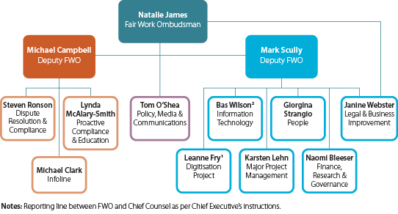
¹ Leanne Fry is expected to return to her substantive position of
Executive Director Information Technology in January 2015.
² Bas Wilson is also expected to return to his substantive position in the Department of Employment in January 2015.



Performance reporting

Our actions towards achieving the Australian Government’s planned outcome of compliance with workplace relations legislation by employees and employers through advice, education and, where necessary, enforcement are detailed in the following pages.

Activities and achievements are reported against program deliverables and key performance indicators.
Our program objective, deliverables and key performance indicators are published in the Portfolio Budget Statements that are released annually to accompany the Australian Government Budget. They are used to monitor and assess our performance. An overview of our performance is tabled below.

TABLE 1: PERFORMANCE AGAINST DELIVERABLES

Program 1: Education services and compliance activities
The objective of the FWO is to educate employers, employees, organisations and contractors about the workplace relations system and to ensure compliance with workplace laws.
DELIVERABLE |  | 2013–14 | PAGE
Deliverable 1: Advice  Provide information, advice and education on the requirements and flexibilities of workplace laws to foster voluntary compliance |  | Delivered products and initiatives to give workplace participants a  greater understanding of their workplace rights, obligations and options to help them make informed decisions. | 15-23
Deliverable 2: Assistance  Investigate claims regarding alleged breaches of workplace laws and undertake targeted activities |  | Worked with employers and employees to help resolve disputes, which included ensuring all parties were aware of their rights and obligations.  Targeted industries or areas where there has been a history of non-compliance, running education and audit campaigns.  Inquired into the reasons for non-compliance issues to better understand the barriers to compliance and identify opportunities to provide effective education and deterrents.  Investigated alleged contraventions and applied the appropriate resolution pathway. | 25-35
Deliverable 3: Enforcement  Litigate, where necessary, to enforce compliance with workplace laws |  | Used enforcement tools and took legal action in response to serious, wilful or repeated non-compliance and to deter further contraventions of Australian workplace laws. | 37-41
The FWO met or exceeded all key performance indicator (KPI) targets prescribed in the Portfolio Budget Statements for 2013–14.

TABLE 2: PERFORMANCE AGAINST KEY PERFORMANCE INDICATORS, 2011–2014
KEY PERFORMANCE INDICATOR | TARGET | ACTUAL RESULTS  2013–14 |  | ACTUAL RESULTS  2012–13 | ACTUAL RESULTS  2011–12 | PAGE
Number of targeted campaigns  - national | 4 | 4 |  | 4 | 4 | 33-34
- state (number of campaigns in each state and territory) | 2 | 2 |  | 2 | At least 2 in each state
Investigations into complaints about breaches of federal agreements or awards completed within 90 days (% of total complaints) | 80% | 94% |  | 84% | 68% | 25-41
Calls to the contact centre resolved at the first point of contact (% of total calls) | 80% | 99% |  | 99% | 98% | 15-21
Availability of contact centre services (% of availability during advertised hours) | 99% | 99% |  | 99% | 99% | 15-21
Availability of website (time available as a % of total time) | 99% | 99% |  | 99% | 99% | 15-21

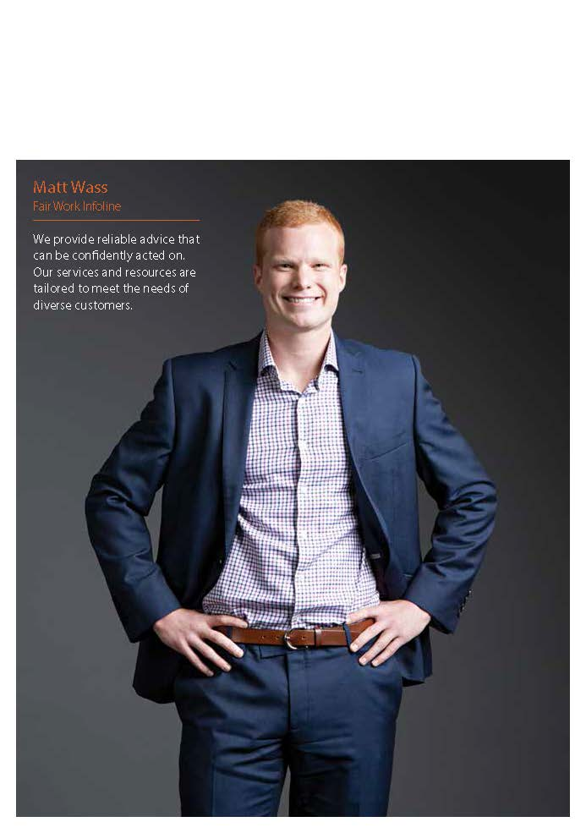

Advice

Deliverable 1:

Provide information, advice and education on the requirements and flexibilities of workplace laws to foster voluntary compliance.

The FWO delivers a range of education products and initiatives to support greater understanding of workplace rights and obligations. This enables employers and employees to make informed choices about their workplaces and jobs.
We believe providing information and advice early helps prevent disputes and plays a critical role in enabling workplace participants to resolve matters in their workplace. In doing this, employment relationships are maintained, and commitment to long-term compliance is enhanced, creating a productive workplace environment.

Customer service
Given the diversity of our customers and the scope of workplace issues handled by the FWO, we continued to invest in new information technologies and offered a range of service channels to meet changing customer needs.
In 2013–14, we encouraged people to visit fairwork.gov.au or call us instead of writing or emailing, as these channels allow us to offer a more efficient service. This saw a 55% decrease in written correspondence and a 6% increase in calls. Our online and phone channels were accessed more than 12.3 million times compared to around 10.9 million in 2012–13.

We also offer an online enquiry service to registered users of My account (see p19 for more information on this service). Demographic information provided by users, including their state and industry, improves our ability to answer enquires without the need to call.
Visits to fairwork.gov.au increased by around 14%. As awareness and use of our online tools and resources grows, we expect further reductions in the number of routine phone enquiries will free up resources and allow us to deal with more complex customer enquiries.

TABLE 3: PRIMARY ADVICE SERVICE CHANNELS
 | 2013–14 | 2012–13 | 2011–12
Calls for advice answered | 554,128 (4.6%)¹ | 522,782 (4.8%) | 683,992 (9.3%)
Advice by written correspondence | 41,443 (0.4%) | 93,123 (0.8%) | 88,389 (1.2%)
Visits to fairwork.gov.au | 11,780,824 (95%) | 10,327,287 (94.4%) | 6,595,855 (89.5%)
Total | 12,376,395 (100%) | 10,943,192 (100%) | 7,368,236 (100%)
¹Includes calls to the Small Business Helpline.

Call volumes, email and website traffic saw increased activity in June and July. This coincided with traditional peaks around the new financial year and annual minimum wage changes.

FIGURE 2: FAIR WORK INFOLINE ADVICE PROVIDED BY MONTH
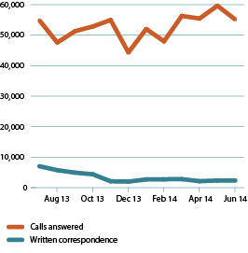

Small Business Helpline
In December 2013, we launched the Small Business Helpline to equip small businesses with the capacity to make informed choices about their workplace relations obligations and manage their workplace relationships. The helpline, which provides prioritised and tailored advice relevant to small business, can be accessed through the Fair Work Infoline number 13 13 94. This number is already well known and used in the community.
Over a seven-month period, from 6 December 2013 to 30 June 2014, the Small Business Helpline took 89,766 calls, which represented 30% of all calls answered by the FWO.
Since the launch of the helpline, we have monitored the average wait time for call queues to both the Small Business Helpline and the Fair Work Infoline. We’ve made adjustments to the queuing process to ensure good customer service for all callers. A post implementation review will be conducted in 2014–15 to determine if any further changes are needed.

TABLE 4: SMALL BUSINESS HELPLINE AND FAIR WORK INFOLINE, 6 DECEMBER 2013 - 30 JUNE 2014
 | SMALL BUSINESS HELPLINE | FAIR WORK INFOLINE
Calls answered | 89,766 | 208,364
Average call wait time | 2 minutes  13 seconds | 8 minutes  39 seconds

Nature of calls
Wages continued to be the number one reason workplace participants sought advice and information from the Fair Work Infoline and Small Business Helpline, and represented around one-third of all calls received in 2013–14. This was followed by enquiries about conditions of employment and termination of employment.
From an industry perspective, the highest numbers of calls received through the Fair Work Infoline related to people working in ‘other services’ including hair and beauty (12%), construction (11%), retail trade (9%), accommodation and food (8%) and health care and social assistance (7%).

TABLE 5: NATURE OF CALLS TO THE FAIR WORK INFOLINE AND SMALL BUSINESS HELPLINE BY PERCENTAGE
ENQUIRY TYPE | 2013–14  % | 2012–13  % | 2011–12 %
Wages | 28 | 35 | 38
Conditions of employment | 20 | 21 | 20
Termination of employment | 15 | 14 | 13
Leave | 11 | 10 | 9
Referrals to other agencies | 10 | 7 | 5
Entitlements | 6 | 5 | 5
Other | 2.3 | 0.7 | 1.6
Workplace complaint | 7 | 6.8 | 8
Independent contractors | 0.7 | 0.5 | 0.4
Total | 100 | 100 | 100
Note: The enquiry type ‘claims’ reported in our 2012–13 annual report has been merged with ‘workplace complaint’.

FIGURE 3: NATURE OF CALLS TO THE SMALL BUSINESS HELPLINE BY PERCENTAGE, 16 DECEMBER 2013 – 30 JUNE 2014
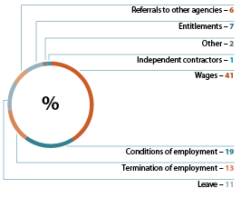
Online products and support
In 2013–14, we provided more education resources through fairwork.gov.au to equip people with the information they need to comply with workplace laws and resolve issues in the workplace.
As our primary education and communication channel, fairwork.gov.au was recently transformed to include tailored content structured around workplace relations topics, new online education modules and guides, as well as updated calculators to determine pay and conditions for different industries and types of employment.
In 2013–14, the number of visits to fairwork.gov.au increased by 14%, with an average of around 980,976 visits a month and 7,009,123 unique visitors for the financial year.

TABLE 6: VISITS TO FAIRWORK.GOV.AU
 | 2013–14 | 2012–13 | 2011–12
Visits to fairwork.gov.au | 11,780,824 | 10,327,287 | 6,595,855
Unique visitors to fairwork.gov.au | 7,009,123 | 5,949,628 | 3,683,873

Transformed fairwork.gov.au
On 16 June 2014, we relaunched our website to provide easier navigation and tailored content to our business and community users – and to support future innovations as we continue adding to our suite of online tools and services.
The new fairwork.gov.au is designed to provide accurate information quickly and conveniently. It was developed in response to user-needs research which consistently demonstrated that our customers preferred to search for information by subject matter rather than their status as an employer or an employee.
The site’s new functionality allows users to nominate the industry they work in and filters information as they search to reflect their particular workplace circumstances. Users can also create their own account, My account, which allows them to personalise their workplace information, save relevant data, such as pay rates, and access previous web searches at their convenience.
In its first 17 days of going live, the new website received 536,310 visits and saw 10,534 people register for My account. Of those who registered for My account during this period, 14% nominated themselves as an employer. People from the building and construction, retail and manufacturing sectors were the most common to register.

Online learning
In addition to providing people with basic information to address their workplace enquiries and support compliance, fairwork.gov.au delivered a range of online learning tools and resources. These are for people who want to broaden their workplace knowledge, update their skills and discover new and more productive ways of working.
In 2013–14, we expanded our online assistance to include:
- a new guide titled ‘Hiring your first employee’, which was downloaded 3,543 times since its launch on 25 March 2014
- six new templates to support our online learning courses
- six new fact sheets on unpaid work including four that are industry specific
- updated online pay tools, calculators and information to reflect recent legislative changes, including pay changes for apprentices, which started after 1 January 2014.
Two short education courses were also added to the website’s interactive Online Learning Centre including ‘Starting a new job’ for young workers and ‘Hiring employees’ for employers, managers and supervisors. This complements the ‘Hiring your first employee’ guide. The centre’s five learning modules attracted more than 51,516 page views and 13,718 courses were started in the financial year.
Organisations such as the Queensland Attorney-General's Department, the Australian Taxation Office and the Pharmacy Guild of Australian have redeployed a number of these courses into their own learning management systems. In 2013–14, 1,000 pharmacists completed the ‘Difficult conversations in the workplace’ course as part of their professional development program.

Online tools at a glance
In response to the different information needs and preferred learning styles of workplace participants, education products were delivered in several formats and through a number of channels, depending on the level of complexity involved.
At 30 June 2014, the full suite of online education products available through fairwork.gov.au included:
- our Online Learning Centre with courses to teach people skills and strategies to help them at work
- pay tools to help clients locate awards and calculate
- pay rates
- 13 best practice guides on areas such as work and family, and individual flexibility arrangements
- checklists to help employers and employees understand their rights and responsibilities and identify any knowledge gaps
- 65 template letters and documents designed to assist with keeping employment records and recording agreements between employees and employers
- 46 fact sheets explaining key provisions of the workplace relations legislation
- a subscription-based newsletter to help employers stay on top of their workplace relations obligations
- a subscription-based email update service to keep workplace participants up to date on employment issues and news
- translated workplace rights and entitlement information in 27 languages
- a series of Auslan videos accessible through our YouTube channel for customers with hearing disabilities.

TABLE 7: EDUCATION RESOURCES AND DOWNLOADS
 | 2013–14 | 2012–13 | 2011–12
Fact sheets available | 46 | 40 | 38
Fact sheets downloaded | 1,455,495 | 1,115,282 | 642,697
Best practice guides available | 13 | 13 | 12
Best practice guides downloaded | 126,065 | 93,882 | 68,699
Templates available | 65 | 59 | 51
Templates downloaded | 525,754 | 438,810 | 373,963
Pay tools visits¹ | 1,571,779 | 1,292,825 | 990,343
Online Learning Centre courses available | 5 | 2 | –
Online Learning Centre page visits | 51,516 | 2,151² | –
¹Excludes Award Finder.
²Service introduced.

Subscription services
Interest in receiving information and advice via email continued to grow with a 62% increase in newsletter subscribers and a 45% rise in email update subscribers throughout the year.
Our subscription newsletter was emailed to 9,945 employers to help them stay on top of their workplace relations obligations. Tailored email updates were sent to 32,499 workplace participants to keep them up to date with the latest employment issues and news. This included advising specific industries to check their wage rates using our pay tools following the annual wage review, along with other changes likely to impact their sector.
TABLE 8: EDUCATION SUBSCRIPTION SERVICES
 | 2013–14 | 2012–13 | 2011–12
Newsletters sent | 5 | 5 | 4
Newsletter subscribers | 9,945 | 6,128 | 2,301¹
Email updates sent | 6 | 9 | –
Email update subscribers | 32,499 | 22,487¹ | –
¹Service introduced.

PayCheck Plus
PayCheck Plus, an online tool that calculates modern award pay rates for employers and employees, was updated in 2013–14 in readiness for 1 July 2014 when transitional arrangements ended. Pre-modern award information is no longer required to calculate wages.
Work also commenced on a new pay tool that will allow easy access to accurate wage information through our website and mobile devices. The tool will be launched in 2015.
In 2013–14, the number of visitors to PayCheck Plus increased by around 27%. This included an average of 90,135 visits per month compared to the previous year which saw an average of 71,000 visits per month. The number of visits peaked in June 2014, coinciding with the launch of our new website – and spiked in July 2013 following the Fair Work Commission’s annual increase to the minimum wage, which takes effect on 1 July each year.
FIGURE 4: PAYCHECK PLUS USAGE BY MONTH 2013–14
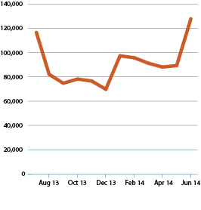

Service standards
A key measure of our performance is the timeliness and quality of our advice and assistance. In 2013–14, we again met and exceeded our Fair Work Infoline first call resolution and website service standards.
- The ‘first call resolution’ KPI was exceeded by 19%, with a one per cent increase on the previous year. This was based on enquiries being resolved within 48 hours without extra client contact required.
- We also met our 99% KPI for ‘availability’ to our contact centre services and website.
TABLE 9: PERFORMANCE AGAINST KEY PERFORMANCE INDICATORS
KPI | 2013–14 | 2012–13 | 2011–12
First call resolution  (KPI = 80%) | 99% | 99% | 98%
Availability of contact centre services  (KPI = 99%) | 99% | 99% | 99%
Availability of website (KPI= 99%) | 99% | 99% | 99%

Communication activities
Tailored media and communication strategies play an integral role in supporting our education and compliance activities and ensuring the community is aware of their workplace rights and obligations.
We use a range of channels, including fairwork.gov.au, social media, print media and radio, to reach different audiences with the information they need.

Media
In 2013–14, we maintained a strong public profile across all media platforms. We issued 227 media releases to promote our education and compliance activities and to raise community awareness of our free tools, resources and services.
We had over 2,000 interactions with suburban, regional, metropolitan and national media outlets and generated almost 12,800 articles throughout Australia. This included more than 6,000 online articles, 4,600 radio items, 1,300 print articles and 823 television items.
Media coverage included:
- a column on the benefits of family-friendly workplaces published to more than 150 websites
- the announcement of a national fast food campaign publicised via 30 newspaper articles, 300 radio bulletins, four television items and 50 websites
- a column on workplace culture and productivity published on more than 80 websites
- TV interviews encouraging employees and businesses to use our tools and resources to make informed decisions about their workplaces and jobs.
Social media
We also increased our use of social media channels to support the rollout of our national education and compliance activities and promote legislative changes and new initiatives. Activities generated included:
- 825 tweets, which reached over 7 million Twitter followers and engaged 1,800 new followers
- 339 posts, which reached over 7.6 million Facebook followers and engaged 15,000 new followers compared to 4,500 in 2012–13
- 99,000 views of our YouTube videos.
Social media activity rose in November 2013 and January 2014 with the launch of a fast food campaign to educate employers and employees working in the takeaway food services industry.
Activity also increased between May and June 2014 in response to a campaign aimed at creating awareness about the Fair Work Commission’s annual wage review. During this period, our tweets and Facebook posts on the topic reached almost 120,000 people on Twitter and over 1.2 million on Facebook.
Other digital communications included:
- development of a dedicated Facebook page to ensure foreign workers employed on the Harvest Trail are aware of their entitlements and have easy access to information and advice
- in-language workplace rights messages shared through social media channels in response to intelligence suggesting Korean employees were receiving as little as $8 an hour (less than half the minimum wage)
- a cross-promotional campaign using fairwork.gov.au and Australian Apprentices websites to communicate changes to apprentice pay rates which took effect from 1 January 2014.

Would you like workplace facts with that?
Just under half (45.7%) of employees working in the fast food industry are aged between 15–24 years and typically:
- don’t like reading long documents
- tend to have limited awareness of their basic workplace entitlements
- spend a lot of time using social media
- are motivated by money, breaks and leave
- have low formal education qualifications.
To attract their attention we repackaged the Fast Food Industry Award 2010 entitlements into eight bite-sized ‘fun facts about fast food’. Each fact was delivered as an interactive infographic on our Facebook page.
Facebook posts and tweets introduced followers to new facts each week covering information on topics such as breaks, pay and uniforms. A mini-site was also created to allow young workers access to the information via their desktop or mobile phone.
During the eight-week period, the campaign reached over 51,000 people on Twitter and 1.2 million on Facebook.
We also wrote to more than 7,000 fast food operators to highlight free resources on fairwork.gov.au to help them comply with workplace laws.
These activities form part of a wider three-year compliance campaign looking at wages and conditions in the hospitality industry and build on similar education activities undertaken in 2012 and 2013 with accommodation providers, pubs, cafés, restaurants and caterers.

Collaboration
We work with representatives from industry, unions, government and universities to share data and intelligence. Through our combined expertise and insights, we continue to explore the best way to maximise our reach and deliver relevant and timely services to workplace participants.
As part of our stakeholder engagement activities in 2013–14, we:
- hosted a joint small business roundtable discussion with the Fair Work Commission and Fair Work Building and Construction to identify the ongoing and emerging issues that small business face
- consulted widely with industry associations and organisations to develop and deliver four national and 10 state and territory education and compliance campaigns (see p36-37 for more information on campaigns)
- introduced a Community Engagement team focused on enhancing our connection with community organisations
- held workshops and presentations for those in the hair and beauty industry, and consulted with members of the hospitality and media and entertainment industries, to address the legality and legitimacy of unpaid work practices and internships
- worked closely with the Department of Immigration and Border Protection to monitor and investigate the working arrangements of 457 visa holders
- contributed data to, and attended a roundtable about, the Australian Human Rights Commission’s national review into the prevalence, nature and consequences of discrimination in relation to pregnancy at work and return to work after parental leave
- provided tailored advice to over 1,600 enquiries from employer organisations and unions through a dedicated telephone and email service called Practitioner Assist
- worked directly with 910 franchisors, employing more than 3,600 employees, to support compliant workplaces throughout their franchise network
- continued to work collaboratively with other government agencies including the Australian Taxation Office and the Australian Securities and Investments Commission on phoenixing activity, which involves the intentional transfer of assets from an indebted company to a new company to avoid paying creditors, tax and/or employee entitlements
- commissioned focus groups with small business operators to better understand and identify ways to respond to their needs
- provided the Fair Work Commission with information on the aspects of modern awards our clients find ambiguous.

Working towards a simpler system
Every four years, the Fair Work Commission reviews all modern awards. The latest review, which commenced on 1 January 2014, may result in the Commission creating new modern awards, or varying or revoking current modern awards.
As a regulator, the FWO is uniquely placed to help simplify and clarify how awards operate through our extensive contact with millions of employers and employees each year.
To assist the Commission achieve the Modern Awards Objective of ensuring a simple, easy to understand, stable modern award system for Australia that avoids the unnecessary overlap of modern awards, we provided material to clarify areas in awards that cause uncertainty and confusion among workplace participants.
In our experience, there are three main areas where employees and employers often encounter difficulty in applying awards, these are:
- interpreting coverage provisions, especially where more than one award may apply
- calculating rates of pay, especially overtime and penalty rates
- understanding the interaction with the National Employment Standards.
Our involvement is focused on providing information on where we observe complexity and ambiguity in the award system. We are not making submissions about the substance of entitlements.



Assistance
Deliverable 2:
Investigate claims regarding alleged breaches of workplace laws and undertake targeted activities.

In 2013–14, we continued to evolve our approach to workplace compliance. This involved placing a greater emphasis on dispute resolution processes to assist employers and employees resolve issues with less time, cost and intervention.
We are taking a more proactive and industry based approach to address non-compliance issues. This allows us to focus our efforts on those sectors and geographical locations where we can have the most impact on worker cohorts who are the most vulnerable to exploitation, including young people and overseas workers.

In 2013–14:
- we finalised 25,650 complaints, the majority within a month through our dispute resolution processes
- more than $23 million in back payments were recovered for workers through our assessment, dispute resolution, compliance and enforcement activities
- of the 24,103 complaints received, 45% related to the specific industry sectors of accommodation and food services (12%), construction (10%), retail trade (9%), administrative and support services (7%) and manufacturing (7%)
- over half (58%) of the complaints came from males. Of these, 41% were aged 31 to 50 years and 47% related to the construction (18%), accommodation and food services (10%), manufacturing (10%) and transport, postal and warehousing industries (9%)
- 42% of complaints were from females, of which 37% were aged 21–30 years. 51% worked in accommodation and food services (18%), retail (12%), health care and social assistance (11%) and ‘other services’ including hair and beauty (10%).

TABLE 10: COMPLAINTS RECEIVED AND FINALISED 2011–14
 | 2013–14 | 2012–13 | 2011–12
Complaints received | 24,103 | 24,678 | 26,366
Complaints finalised | 25,650 | 26,574 | 28,412
Note: The number of complaints resolved was higher than the number of complaints received as some complaints lodged in
2012–13 were resolved in 2013–14.

TABLE 11: PERCENT OF COMPLAINTS FINALISED BY STATE AND TERRITORY
 | 2013–14  % | 2012–13  % | 2011–12  %
Australian Capital Territory | 1 | 1 | 1
New South Wales | 29 | 29 | 30
Northern Territory | 1 | 1 | 1
Queensland | 24 | 24 | 24
South Australia | 7 | 7 | 8
Tasmania | 2 | 2 | 2
Victoria | 27 | 28 | 26
Western Australia | 9 | 8 | 8
Total | 100 | 100 | 100

Wages and conditions, including non-payment and underpayments of hourly rates, continued to make up the majority of complaints received, followed by annual leave entitlements and payment in lieu of notice.

FIGURE 5: TOP FIVE ALLEGATION TYPES FOR COMPLAINTS RECEIVED IN 2013–14
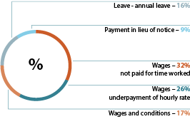

Dispute resolution
As part of our ongoing commitment to facilitating early resolution outcomes, around 79% of complaints finalised in 2013–14 were through our assessment and dispute resolution processes. This is up from 53% in 2012–13.
The number of complaints finalised through formal investigations decreased from 47% in 2012–13 to 21% in 2013–14.

FIGURE 6: COMPLAINT HANDLING PROCESS
Assessment establishes the background to a complaint. In most cases, complaints are progressed through to dispute resolution. Where allegations are serious, the issue is widespread, or the people affected are vulnerable we may investigate. Complaints outside our jurisdiction may be referred to another relevant agency.

Dispute resolution is typically conducted by phone with an accredited FWO mediator. Both parties are provided with an opportunity to discuss and develop solutions to workplace disputes.

If a dispute is unresolved we may assist a party through the small claims process. If the matter indicates serious non-compliance, it is referred to a Fair Work Inspector. There are a number of enforcement tools a Fair Work Inspector may use in resolving the matter. These include letters of caution, infringement and compliance notices, enforceable undertakings and proactive compliance deeds. See p43-47 for more information on our enforcement tools. See p41 for more information on proactive compliance deeds.

TABLE 12: HOW COMPLAINTS WERE FINALISED
 |  | 2013–14  % | 2012–13  %
COMPLAINT TREATMENTS | Average days taken to finalise matter | Complaints finalised
Assessment | 7 | 17 | 15
Dispute resolution | 16 | 62 | 38
Compliance and enforcement | 89 | 21 | 47

FIGURE 7: HOW COMPLAINTS WERE FINALISED IN 2013–14
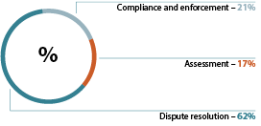

Dispute resolution initiatives
In 2013–14, we piloted two new approaches to dispute resolution:

Pre-complaint interventions
More than $700,000 was recovered for 285 employees through pre-complaint interventions. This was achieved by providing early assistance to employees who were considering lodging a formal complaint.
On calling the Fair Work Infoline, suitable clients were directed to specialist staff trained in dispute resolution. Clients were talked through the matters in dispute, provided information on workplace laws, education tools, self-resolution options and, in some cases, participatedin early mediation.
The program focused on those still employed in the workplace where a breach appeared to have occurred and small business employers seeking assistance with resolving issues in the workplace.
This approach equips people with what they need to make choices about their workplace and self-resolve issues. Administrative burden can be reduced and employment relationships are more likely to be maintained for parties whose disputes can be promptly resolved through this tailored assistance.

Three strikes program
Between 3 March and 30 June 2014, 90 complaints involving employers in Victoria, New South Wales and Queensland with a history of three or more complaints, lodged over a 12 month period, were referred for intervention. Matters involving serious non-compliance were not pursued through this pilot.
We recovered $114,705 for 28 workers through tailored and proportionate compliance responses, including issuing 25 letters of caution and four infringement notices.
During interventions, information was gathered on the reasons for an employer’s repeated non-compliance. Some of the contributing factors included:
- communication breakdowns
- poor workplace complaint handling processes
- financial difficulties and cash flow problems
- ignorance of obligations
- deliberate avoidance of legal obligations
- incorrect advice from third parties.
Follow-up activity will enable us to assess the long-term impact of our interventions on the employer’s compliance behaviour. These insights will be used to inform future education and compliance practices.

Early and effective solutions
Susie*, an employee working in the restaurant industry, sought the FWO’s assistance with an underpayment enquiry. She was considering lodging a complaint. Lacking the confidence to raise the issue with her employer, she requested we speak to them on her behalf.
To assist Susie, we provided her with self-help dispute resolution tips and tools. This included our ‘Dealing with difficult conversations’ online learning module, along with an example email to send to her employer.
Susie followed our advice and emailed her employer. Her wages were immediately increased and she was back paid. She said the assistance we provided to ‘help her help herself’ was instrumental in delivering a mutually positive result. Susie maintained a positive relationship with her employer by raising the issue in a respectful manner.
With accurate and independent advice at hand, and an authority Susie could cite as the source of that information, she felt empowered to deal with the issue quickly and effectively.
*The employee’s name has been changed to protect their privacy.

Small claims matters
We can assist employees through the small claims process where we find they may be owed money or where we have difficulty substantiating evidence. Small claims can be used to seek recovery of unpaid entitlements up to $20,000. The process is low cost and matters are dealt with less formally than other court applications.
Requests for assistance are dealt with on a case-by-case basis and can include help with small claims applications, through to representation by the FWO as ‘a friend of the court.’ In this capacity a FWO lawyer can assist the court on points of law or raise awareness about aspects of the case. They do not act for either party.
In 2013–14, we provided assistance to 200 people enquiring about the small claims process and assisted with 90 small claims applications heard before the courts.
A total of $268,202 was ordered in favour of applicants.

Compliance activities
Our four national subject-based compliance teams specialise in particular worker cohorts (youth, overseas) and allegation types (misclassification, general protections). Our regional compliance team, situated in 14 offices across Australia, focuses on local issues. Each are specialists in their area and are trained to observe industry patterns, locate specific issues and engage with the community to facilitate strategic compliance outcomes.
Young workers
Young people can be at high risk of exploitation in the workplace, particularly in regards to underpayment of wages and unpaid work arrangements.
In 2013–14, more than 6,200 complaints were received from young people aged 25 and under. In total, 6,727 were finalised. This represents 26% of all complaints completed in the year, including 471 received in prior years. More than $2.3 million in underpayments was recovered for 1,355 young employees.

TABLE 13: SMALL CLAIMS HEARD AND AMOUNTS AWARDED
 | 2013–14 |  | 2012–13 |  | 2011–12
STATE | SMALL CLAIMS HEARD | TOTAL AMOUNT AWARDED | SMALL CLAIMS HEARD | TOTAL AMOUNT AWARDED | SMALL CLAIMS HEARD | TOTAL AMOUNT AWARDED
Australian Capital Territory | 0 | 0 | 1 | $998 | 4 | $3,363
New South Wales | 6 | $20,792 | 24 | $129,711 | 21 | $90,563
Queensland | 1 | 0 | 11 | $20,829 | 12 | $25,393
South Australia | 1 | $3,605 | 0 | 0 | 0 | 0
Victoria | 82 | $243,805 | 10 | $6,173 | 46 | $109,966
Western Australia | 0 | 0 | 4 | $21,587 | 9 | $37,661
Total | 90 | $268,202 | 50 | $179,298 | 92 | $266,946

The highest proportion of complaints came from young workers in accommodation and food services (20%), with 21 to 25-year-olds making up 13% of these complaints. Construction received the second highest proportion of young worker complaints (16%).

TABLE 14: YOUNG WORKERS COMPLAINTS AND OUTCOMES
 | 2013–14 | 2012–13 | CHANGE%
Complaints received | 6,257 | 6,240 | 0.3
Complaints completed | 6,727 | 6,641 | 1
% of all FWO complaints completed | 26.2% | 25.7% | 2
Outside the FWO’s jurisdiction | 5.9% | 4.8% | 23
Matters proceeding to investigation | 1,248 | 2,859 | -56
Overseas workers
Overall, visa holder complaints accounted for more than 10% of all complaints completed in 2013–14. The most common complaints investigated involved subclass 417 working holiday (1,042) and subclass 457 temporary skilled work (404) visa holders.
We recovered more than $1.1 million for 659 overseas workers, initiated 12 litigations relating to visa holders and executed three enforceable undertakings.

417 working holiday visas
Our experience shows overseas workers, particularly those on working holiday visas, are more vulnerable to exploitation. These workers typically find understanding and exercising their entitlements difficult because of age and language barriers; the remoteness of their working location; and their dependence on employers to obtain eligibility for a visa.
To address these vulnerabilities, we will conduct an inquiry into the wages and conditions received by working holiday visa workers in 2014–15.

457 temporary skilled work visas
Since 1 July 2013, the FWO has had an expanded role in monitoring 457 visa holder sponsorship obligations, with all Fair Work Inspectors appointed as Migration Inspectors under the Migration Act 1958.
This role is limited to ensuring that nominated salaries are paid and the visa holder is performing the nominated position approved in their visa. Where employers are not meeting these obligations, the matter is referred to the Department of Immigration and Border Protection.
In 2013–14, a total of 1,029 entities employing 1,902 temporary skilled work visa holders were assessed. We referred 243 to the Department of Immigration and Border Protection due to concerns that wages or position obligations were not being met for 338 employees.

TABLE 15: OVERSEAS WORKER COMPLAINTS AND OUTCOMES
 | 2013–14 | 2012–13 | CHANGE %
Complaints received | 2,527 | 2,020 | 25
Complaints completed | 2,625 | 2,018 | 30
% of all FWO complaints completed | 10.2% | 7.8% | 31
Outside the FWO’s jurisdiction | 8.7% | 6.3% | 38
Matters proceeding to investigation | 841 | 1,108 | -24

Misclassification
The misclassification of employees as contractors is against the law. If deliberate, it is known as sham contracting.
Allegations of sham contracting are taken very seriously. The courts can impose heavy penalties on employers who try to disguise an employment relationship as a contracting arrangement to avoid paying tax, superannuation and other leave entitlements provided by modern awards.
In 2013–14, we received 447 complaints related to sham contracting and finalised 471, including 24 received in prior years.
The most common misclassification complaints investigated came from workers in administration and support services (20%) followed by rental, hiring and real estate (8%), public administration and safety (7%), construction (7%), and transport, postal and warehousing (6%).
We also commenced six litigations related to sham contracting. Three were decided, which represented around 8% of all litigation decisions made in the financial year.
In each case, significant penalties for sham contracting were imposed. A fruit and vegetable store was fined more than $166,000, a transport company received a record fine of more than $286,000 and a homewares business was fined in excess of $161,000.

TABLE 16: MISCLASSIFICATION COMPLAINTS AND OUTCOMES
 | 2013–14 | 2012–13 | CHANGE%
Complaints received | 447 | 307 | 46
Complaints completed | 471 | 362 | 30
% of all FWO complaints completed | 1.8% | 1.4% | 29
Outside the FWO’s jurisdiction | 33.5% | 18.3% | 83
Matters proceeding to investigation | 114 | 113 | 1

Discrimination
In 2013–14, we received 202 discrimination complaints. Of these, 33 were referred to our specialist general protections area for further investigation.
The most common discrimination complaints investigated were pregnancy (47%), disability (20%), and family and carer’s responsibilities (10%), which were comparable to 2012–13 figures – apart from the number of pregnancy complaints, which rose from 28% to 47%.
We are working with the Australian Human Rights Commission to identify ways we can support working parents. In 2013–14, we attended their national roundtable and contributed data to their national review into the prevalence, nature and consequences of discrimination in relation to pregnancy at work and return to work after parental leave.
In April 2014, an investigation conducted by the FWO resulted in our first successful age discrimination litigation (case study, p44).

TABLE 17: DISCRIMINATION COMPLAINTS AND OUTCOMES
 | 2013–14 | 2012–13 | CHANGE%
Complaints received | 202 | 235 | -14
Complaints completed | 211 | 327 | -35
% of all FWO complaints completed | 1% | 1% | 0
Outside the FWO’s jurisdiction | 29% | 14% | 107
Matters proceeding to investigation | 33 | 76 | -57

Service standards
The increased use of dispute resolution services contributed to a consistent rise in the number of wage and conditions complaints resolved within 90 days. In this timeframe, 94% of complaints were finalised in 2013–14 compared to 84% in 2012–13.

Inquiries
In 2013–14, we started a program of work seeking to identify the reasons for systemic non-compliance. Our methodology is to closely examine the structure of a particular industry or market to identify the structural and behavioural drivers that lead to widespread non-compliance. We have paid particular attention to the influence of entities at the top of supply chains.
A number of inquiries have commenced to understand how certain industries, sub-sectors and major brands with alleged compliance issues operate, and the key drivers behind their non-compliance, including by mapping their supply chain relationships and franchising arrangements.
In particular, we are seeking to understand how workplace responsibilities are structured along the Harvest Trail, in the procurement of security contractors by local government and in poultry processing. We are also examining sub-contracted trolley collection services, outsourced housekeeping arrangements, select retail franchises and bus operators. These inquiries will continue in 2014–15.
An inquiry into the wages and conditions of 417 working holiday visa workers will also start in 2014–15.
Inquiries typically run over a number of years and involve education and compliance activities. These may include site visits, interviews with employers, employees and contractors, and audits of workplace records.
Outcomes of this work will inform future interventions, monitoring arrangements and priorities.

Spotlight on fruit and vegetable farms
The Harvest Trail education and compliance project aims to ensure fruit and vegetable pickers, including migrant workers, receive their correct minimum employment entitlements.
Beyond this, we aim to acquire a better understanding of the sub-sector including any structural barriers to compliance. This knowledge will help us better direct our education and compliance activities in the future.
Picking and packing jobs on fruit and vegetable farms attract a large number of backpackers on subclass 417 working holiday visas. These workers are potentially vulnerable to exploitation because of barriers to understanding and exercising their entitlements.
Checking that employers are complying with their obligation to have written agreements in place for workers paid piece-rates (paid by the number of tasks completed) is a key focus of the project. In the absence of a piece-work agreement, workers must be paid hourly rates of pay according to the Horticulture Award 2010.
In August and September 2013, Fair Work inspectors visited strawberry growers in regional Queensland. More than 150 pickers and packers on 417 visas were found to have been underpaid about $133,000.
We also found employers have failed to make written agreements with workers, keep proper time-and-wages records and made unlawful deductions from wages. Three businesses were issued with infringement notices (on-the-spot fines) and 11 employers received letters of caution.
Strawberry growers in regional Victoria were also visited in March 2014. Investigations are ongoing.
The project will run over three years, with further farm visits in 2014–15. We will also return to the Queensland strawberry farms in August 2014 to check if compliance has improved.

Campaigns
We run national, state and regional campaigns to help employers and employees understand their rights and obligations in the workplace. Each campaign is tailored to certain industries, regions or workplace issues that need extra attention.
In 2013–14, our four national campaigns, integrating education and compliance audits, were in cleaning services, children’s services and hospitality.
We ran two hospitality campaigns. One occurred throughout the restaurants, cafes and catering sector, and the other focused on take away foods. Complaint data indicates that these sectors have a high non-compliance risk and are employers of vulnerable workers.
As with all our campaigns, we engaged with industry associations and unions to incorporate their specific knowledge and coordinate activities to maximise engagement and long-term compliance outcomes.
When contraventions of the law were identified, we worked with employers to achieve compliance.
In 2013–14, our campaign activity accounted for:
- 4,567 workplace audits
- $4,003,342 recovered on behalf of 7,541 employees
- engagement with 43 stakeholder groups
- execution of three enforceable undertakings.
Our national cleaning services campaign led to two enforceable undertakings (Fleet Cleaning Pty Ltd and Jorgensen’s Property Services Pty Ltd) to address significant underpayments ranging from $40 to $50,000.

TABLE 18: CAMPAIGN AUDITS FINALISED AND MONEY RECOVERED
 | 2013–14 | 2012–13 | 2011–12
Total audits completed | 4,567 | 5,675 | 6,547
National audits completed | 2,848 | 2,192 | 3,329
Regional audits completed | 1,719 | 3,483 | 3,218
Total monies recovered from audits | $4,003,342 | $3,948,401 | $6,158,875
Total employees monies recovered for | 7,541 | 5,209 | 6,574

TABLE 19: CAMPAIGN AUDITS FINALISED BY STATE AND TERRITORY
 | 2013–14 | 2012–13 | 2011–12
New South Wales and Australian Capital Territory | 1,342 | 1,618 | 1,846
Northern Territory | 151 | 108 | 110
Queensland | 1,020 | 1,879 | 1,969
South Australia | 476 | 742 | 676
Tasmania | 167 | 294 | 214
Victoria | 999 | 639 | 1,211
Western Australia | 412 | 395 | 521
Total | 4,567 | 5,675 | 6,547

TABLE 20: MONEY RECOVERED FOR EMPLOYEES THROUGH CAMPAIGNS BY STATE AND TERRITORY
 | 2013–14  $ | 2012–13  $ | 2011–12 $
New South Wales and Australian Capital Territory | 1,064,815 | 904,087 | 974,761
Northern Territory | 110,915 | 145,282 | 96,440
Queensland | 799,826 | 704,383 | 2,233,379
South Australia | 294,862 | 589,714 | 416,303
Tasmania | 167,904 | 128,621 | 202,994
Victoria | 1,080,449 | 733,268 | 1,281,277
Western Australia | 484,571 | 743,046 | 953,721
Total | 4,003,342 | 3,948,401 | 6,158,875

In 2013–14, the FWO began 10 regional education and compliance campaigns and programs:
- NSW Tamworth/Armidale Records and Pay Slips Campaign 2013
- QLD Townsville Records and Pay Slips Regional Campaign 2013
- SA/WA/NT Alice Springs Proactive Compliance and Education Campaign 2014
- SA/WA/NT Compliance Follow Up Program 2013-2014
- SA Kangaroo Island Education and Compliance Campaign
- SA/WA/NT Retail Campaign 2013-2014
- TAS Compliance Follow Up Campaign 2014
- VIC Retail Bakeries Campaign 2013
- VIC/TAS/NSW/QLD/ACT Records and Resources Campaign 2014
- WA Enterprise Agreement Audit Program 2013-2014
During these campaigns we trialled innovative ways of assisting targeted sectors, including:
- piloting the use of agreement-based self-help tools by employers in our ‘enterprise agreement’ campaign.
- In the case of one company that used the tools,
- we identified underpayments of over $35,000 for
- 450 employees. These workers were back paid without the need to use enforcement tools. The company also entered into a proactive compliance deed to prevent future breaches.
- providing small business operators with demonstrations of our tools and resources at their workplace as part of our ‘records and resources’ campaign. Employers were keen to receive ‘hands on’ assistance and information about their responsibilities and best practice advice.
In 2014–15, we will undertake a mix of industry and issues-based campaigns to ensure we are reaching those in greatest need – including vulnerable workers, specific geographic locations and high-risk industries.

Proactive compliance deeds
We are increasingly encouraging businesses to enter into partnerships with us through proactive compliance deeds. These are cooperative arrangements where businesses formally agree to take active steps to ensure compliance with workplace laws. They also allow employers to publicly demonstrate an intention to operate responsibly and ethically.
In 2013–14, we entered into seven proactive compliance deeds with major proprietary limited brands including Bread Top, Hays Specialist Recruitment, Australia Fast Foods (trading as Chicken Treat), McDonald’s Australia, United Trolley Collections, Compass Group (Australia) and La Porchetta Franchising.
Proactive compliance deeds are tailored to individual businesses and their circumstances. Common features include:
- implementing systems to ensure ongoing compliance
- self-auditing of wages and record-keeping
- committing to self-resolve any disputes that arise within a set number of days and reporting these matters to
- the FWO
- training managers and franchisees in workplace law.
Further details and copies of 2013–14 proactive compliance deeds are available at fairwork.gov.au.

TABLE 21: PROACTIVE COMPLIANCE DEEDS ENTERED INTO
2013–14 | 2012–13 | 2011–12
7 | 1 | 1

Pizza outlets to check pay packets
La Porchetta Franchising has agreed to self-audit the records of 24 stores over the next three years to ensure its workers are receiving their lawful wages and conditions.
This positive and constructive action is part of a proactive compliance deed with the FWO. The company was prompted to work with franchisees following breaches of workplace laws by two of its stores.
In June 2014, two La Porchetta restaurant operators were fined $334,818 following an investigation and litigation which found 111, mostly teenage employees, had been underpaid a total of $258,000 between 2009 and 2012.
Under the terms of the deed, La Porchetta has agreed to:
- provide new franchisees with employment induction training and employment packs covering key aspects of workplace laws
- provide franchisees with annual wage obligation updates
- appoint an employee liaison officer to deal specifically with any new disputes from workers about their entitlements.
We have agreed to refer any new disputes (excluding matters considered serious) to the company so they can liaise directly with franchisees to resolve issues within the workplace.
La Porchetta Franchising’s cooperative approach has allowed the company to publicly show corporate responsibility to its large number of employees – and is an example of how the FWO continues to look for ways to assist employers and employees put good workplace practices in place.

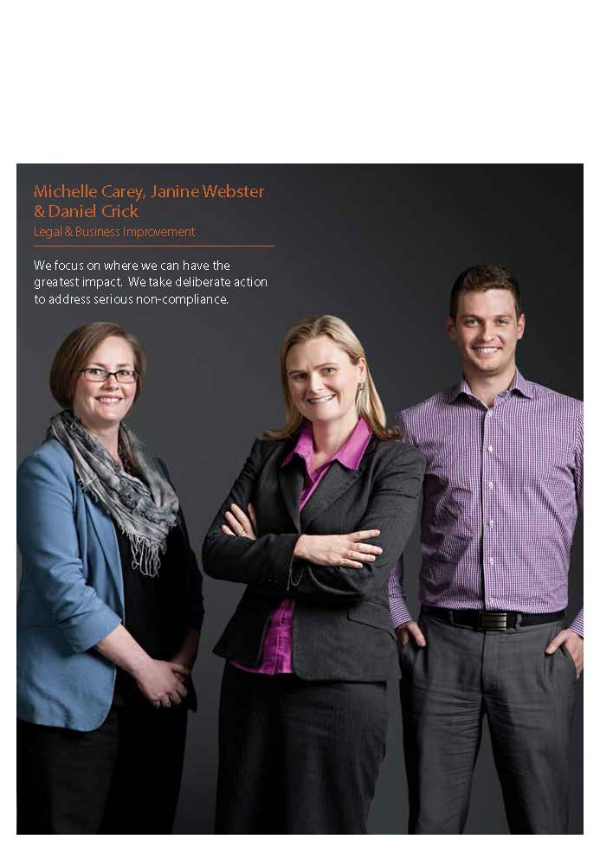

Enforcement
Deliverable 3: Litigate, where necessary, to enforce compliance
with workplace laws.

We are responsible for ensuring compliance with Australian workplace laws. We prefer to achieve compliance through dispute resolution processes.
If unsuccessful, our enforcement tools allow us to tailor our approach and determine the appropriate action given the type of breach, its seriousness and the size of the business involved.
This ensures a balanced and proportionate response based on individual circumstances. In the most serious cases, or where repeat contraventions occur, we will take formal action through the courts.
In deciding on the most appropriate action to take, we are guided by the following considerations:
- the nature, extent and seriousness of the breach
- the prior compliance history of the person or business
- whether it will achieve the best outcome for the parties involved and the wider community
- whether it will deter others from similar behaviours and more broadly promote compliance under the Fair Work Act.
In 2013–14, we issued 116 infringement notices and 65 compliance notices, executed 15 enforceable undertakings and initiated 37 civil penalty litigations.

Infringement notices
An infringement notice is an on-the-spot fine issued to employers who do not comply with their record-keeping or pay slip obligations under workplace laws.
In recent years, we have increased our use of infringement notices and in 2013–14 issued 116 notices to instill the importance of record-keeping which is integral to workplace compliance.
Before notices were issued, we took into consideration the employer’s previous compliance history and/or the impact their lack of record-keeping had on our ability to find, calculate or recover entitlements.

TABLE 22: INFRINGEMENT NOTICES ISSUED
2013–14 | 2012–13 | 2011–12
116 | 124 | 18

Compliance notices
Compliance notices are issued to correct breaches of workplace law where employers have failed to cooperate with the FWO. Once issued, the employer must either comply with the requirements or make a court application to review and challenge the notice. Before issuing compliance notices, we consider the nature of the breach and the employer's response to our requests to correct breaches.
In 2013–14, we issued 65 compliance notices to recover unpaid wages and launched 14 litigations against employers alleging they failed to comply with their notice. In each case extensive efforts were made to facilitate back-payments owed to employees before we commenced legal proceedings.
For the first time in 2014, the Federal Circuit Court in Brisbane imposed penalties for failure to comply with a compliance notice (Fair Work Ombudsman v Extrados Solutions Pty Ltd). The operators of the Brisbane based information technology business were fined a total of $21,420 and ordered to backpay a young Chinese national more than $10,000.

TABLE 23: COMPLIANCE NOTICES ISSUED
2013–14 | 2012–13 | 2011–12
65 | 74 | 51

Enforceable undertakings
An enforceable undertaking is a written commitment given by an employer and accepted by the FWO in exchange for no further action being taken in relation to compliance issues. As an alternative to court action, the employer agrees to address contraventions and take preventative action to avoid future breaches.
In 2013–14, 15 employers made written commitments to action and rectify non-compliance issues. This included revamping their workplace policies and procedures and apologising to affected employees. Over $3.1 million in underpayments were recovered.
Further details and copies of 2013–14 enforceable undertakings are available at fairwork.gov.au.

TABLE 24: ENFORCEABLE UNDERTAKINGS ENTERED INTO AND UNDERPAYMENTS RECOVERED
 | 2013–14 | 2012–13 | 2011–12
Enforceable undertakings entered into | 15 | 12 | 8
Underpayments recovered | $3,115,759 | $671,358 | $1,434,224

TABLE 25: TYPES OF BREACHES WHERE ENFORCEABLE UNDERTAKINGS WERE ACCEPTED
 | 2013–14 | 2012–13 | 2011–12
Adverse action | 1 | 2 | 0
Discrimination | 0 | 3 | 3
Failure to pay fairness test compensation and failure to make and keep pay records | 0 | 0 | 1
Sham contracting | 1 | 0 | 0
Wages and conditions | 13¹ | 7 | 4
Total | 15 | 12 | 8
¹ One enforceable undertaking involved 17 employees. 16 for wages and conditions breaches and 1 for adverse action.

Cleaning company commits to compliance
Fleet Cleaning Pty Ltd was first found to have underpaid 19 cleaners more than $18,000 when it was audited in 2011. A follow-up audit in 2013 revealed 53 former and current employees had also been underpaid more than $40,000.
To remedy the contraventions, help build a greater understanding of workplace responsibilities and motivate Fleet Cleaning to prevent future breaches, we entered into an enforceable undertaking with the company.
As part of the written agreement, Fleet Cleaning committed to:
- apologise to all staff and rectify the underpayments
- engage a full-time book-keeper to ensure its pay rates are compliant
- ensure managers of the company undertake formal, accredited training on workplace relations laws
- engage a specialist to audit its compliance with workplace laws each year for the next three years and provide a report on the outcome to the FWO.

Litigation
As well as enforcing compliance with Australian workplace laws, successful litigation plays an important role in deterring people from engaging in unlawful behaviours.
It also creates a level playing field for Australian businesses by removing the unfair advantage some employers may gain by underpaying employees.
Matters are taken to court when we need to address serious, deliberate, or repetitive contraventions and where it is considered to be in the public interest.
The decision to commence litigation is not taken lightly and is guided by our litigation policy (Guidance Note 1 – Litigation Policy), available at fairwork.gov.au. Key considerations include:
- the involvement of vulnerable workplace participants, such as overseas or young workers
- whether workplace participants suffered significant consequences as a result of the contravention
- whether there was a need for judicial clarification of workplace laws.
In 2013–14, we initiated 37 civil penalty litigations, 39 were decided in court, including two commenced in prior years. This resulted in court-ordered penalties totalling $3,046,380.
A record penalty of $343,860 was handed down against a Perth cleaning company and its managers for deliberately underpaying six cleaners, including five overseas workers. The employer had refused to cooperate and rectify non-compliance issues despite having his obligations explained to him on several occasions by the FWO.

TABLE 26: CIVIL PENALTY LITIGATIONS
 | 2013–14 | 2012–13 | 2011–12
Civil litigations | 37 | 50 | 51
Penalty decisions | 39 | 45 | 37
Penalties | $3,046,380 | $1,654,570 | $1,536 143
Underpayments recovered | $1,558,116 | $683,026 | $475,984

In addition to financial penalties, we sought other orders including backpay or compensation, injunctions and requirements to undertake training and implement other practices to address non-compliance issues.
The majority of litigations commenced (81%) related to wages, conditions and failure to comply with a compliance notice. A list of the types of breaches litigated is provided in Table 27.

TABLE 27: TYPES OF CIVIL PENALTY LITIGATIONS
 | 2013–14 | 2012–13 | 2011–12
Adverse action | 0 | 2 | 5
Discrimination | 0 | 3 | 0
General protections | 0 | 0 | 2
Sham contracting | 6 | 1 | 4
Wages and conditions | 16 | 40 | 40
Failure to comply with a compliance notice | 14 | 4 | 0
Failure to comply with an Order of the Fair Work Commission | 1 | 0 | 0
Total | 37 | 50 | 51
In 2013–14, we were also involved in nine debt recovery proceedings, one intervention, two applications to set aside compliance notices and four appeals.

Litigation initiatives
In 2013–14, we initiated several test cases to clarify the operation of the Fair Work Act including:
- Fair Work Ombudsman v Maritime Union of Australia and Ors where posters disseminated at the Fremantle Port Authority named five employees as ‘scabs’ because they did not participate in industrial activity. The court found the Maritime Union of Australia had taken adverse action against the named employees by prejudicing other workers. However, the court declined to find that the action was undertaken with the intent to coerce the employees into engaging in industrial activity.
- Fair Work Ombudsman v Pocomwell Limited and Ors where the FWO alleged that four Filipino workers on sub-class 456 visas had not been paid in accordance with the Hydrocarbons Industry (Upstream) Award 2010 when performing work on two rigs operated within Australia’s Economic Exclusion Zone. The Court dismissed the FWO’s application on the basis that the mobile rigs were not ‘fixed platforms’ and that the FWO had not established that the rigs were ‘majority Australian’ crewed ships at this time.
- Fair Work Ombudsman v Theravanish Investments Pty Ltd and Ors where the Federal Court in Brisbane ruled on the FWO’s first age discrimination case and imposed significant penalties on two restaurant operators and the holding company after a long-serving employee was told his employment would be terminated on his 65th birthday. Further information on discrimination matters is found on p34.
- FWO v Jetstar Airways Limited & Ors where the Federal Court in Sydney imposed penalties totalling $90,000 for unlawfully making six cadet pilots responsible for training costs and making deductions from their wages. The cadets were employed by a New Zealand-based Jetstar subsidiary while they underwent training. Their employment was subsequently transferred to an Australian entity, Jetstar Group. The FWO alleged the cabin crew were employed to work on Australian domestic flights and therefore subject to Australian workplace laws.
Further information on litigation cases decided in 2013–14 is available at fairwork.gov.au.

How old is too old?
In April 2014, the Federal Circuit Court in Brisbane ruled on the FWO’s first discrimination case on the grounds of age.
The matter was placed before the court after a
long-serving restaurant employee was told his employment would be terminated on his 65th birthday. The company confirmed in writing its policy not to employ staff that reach the retirement age of 65.
The restaurant operators were penalised a total of $29, 150 for contraventions of age discrimination and record-keeping laws. The company, Theravanish Investments Pty Ltd, which owns two restaurants on the Gold Coast, was fined $20,790. They were also instructed to pay $10,000 compensation to the former employee, while its joint directors and equal shareholders were each penalised a further $4,180.
The outcome of the case serves as a warning to employers that discrimination against employees on the grounds of age is unlawful and won’t be tolerated. It also encourages employees to speak up against any discrimination they may encounter in the workplace.
‘My effectiveness as a food and beverage attendant when I turn 65 is no less than my effectiveness at the age of 64’ – restaurant employee.

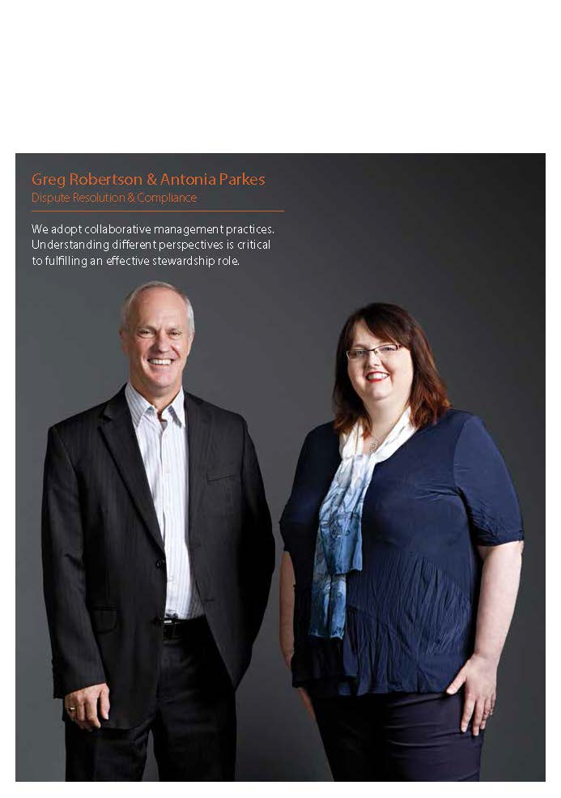

Management and accountability
We are accountable through Parliament and subject
to external scrutiny. Our governance framework provides the structure for effective planning, decision making
and reporting.

Corporate governance
Our corporate governance practices ensure we maintain high standards of accountability and well-defined performance management.

Corporate governance covers the rules, relationships, systems and process by which we apply the resources entrusted to us.
The Executive Committee sets the FWO’s strategic direction, makes decisions across all corporate and operational areas and ensures our responsibilities are discharged in a timely and lawful manner.
In order to achieve the highest standards of professional and ethical conduct, financial accountability and prudent management of risk, the committee evaluates, approves and monitors strategic, operational and financial plans.
The Executive Committee aims to put in place settings for a workplace that develops its staff, promotes open communication and high levels of collaboration.
The Executive Committee meets twice a month and the outcomes of its meetings are distributed to all staff via the intranet. Outcomes of previous meetings are also available through the intranet, along with the charters and minutes for each of the six management committees.
Membership of the management committees is reviewed regularly and selection of members is undertaken to ensure a representative cross-section of our business areas, classification levels, geographical locations and gender.

Audit Committee
The FWO Audit Committee is responsible for providing independent assurance to the Fair Work Ombudsman on our risk, control and compliance framework and external accountability responsibilities.
In 2013–14, the committee considered the following reviews:
- fraud control and implementation
- workforce planning
- Fair Work Infoline task restructure
- credit card and travel audit.
Further discussion of our security and risk management policies and procedures can be found on p48.

Executive Committee
The Executive Committee is our peak decision making body and is comprised of all FWO Senior Executive Service Officers.
EXECUTIVE COMMITTEE MEMBERS AS AT 30 JUNE 2014

Chair
Fair Work Ombudsman
Natalie James

Deputy Fair Work Ombudsman
Operations
Michael Campbell

Deputy Fair Work Ombudsman
Corporate
Mark Scully
Executive Directors

Dispute Resolution & Compliance
Steven Ronson

Infoline
Michael Clark

Proactive Compliance & Education
Lynda McAlary-Smith

Policy, Media & Communications
Tom O’Shea

Information Technology
Bas Wilson*

Digitisation
Leanne Fry*

Major Project Management
Karsten Lehn

People
Giorgina Strangio

Legal & Business Improvement
Janine Webster

Finance, Research & Governance
Naomi Bleeser
* Leanne Fry will return to her substantive position of Executive Director Information Technology in January 2015. Bas Wilson will return to his substantive position in the Department of Employment.

Contracts Committee
The Contracts Committee ensures that our procedures for procuring major supplies and services, and managing significant contracts are consistent with the Commonwealth Procurement Rules.
The Contracts Committee considered and endorsed 41 spending proposals valued at $25,000 or more during 2013–14.

Information Technology Committee
The Information Technology Committee provides strategic guidance and recommendations to ensure our IT systems support business strategy, ongoing performance and risk management. It also promotes awareness of the effectiveness of using information and communication technologies to improve our business performance.

IT Projects and Capital Expenditure Sub-Committee
The IT Projects and Capital Expenditure Sub-Committee provides high level strategic governance of major IT and capital expenditure projects.

Health and Safety Committee
The Health and Safety Committee advises the Executive Committee on health and safety matters. It reviews and provides advice on policy matters concerning the work health and safety of employees, including the implementation of preventative initiatives. It also reviews and reports on the implementation of relevant legislation.
Discussion of our work health and safety outcomes takes place on p57.

Diversity Council
The Diversity Council acts in an advisory capacity to the Executive Committee. The council monitors and reviews our progress against agreed diversity strategies, plans and targets and ensures diversity and inclusion is considered in strategic management initiatives.
Discussion of diversity initiatives appears on p57. Statistics on our culturally and linguistically diverse staff can be found on p67.

Corporate and operational planning
Our planning and reporting uses a risk-based approach, and harnesses intelligence to identify opportunities or threats to our administration.
Our strategic and operational plans set our direction and strategies as well as accountability and performance measures. Throughout the year, we monitored and reported on our performance against these plans through senior management committees. Performance is also scrutinised by a range of external stakeholders.

Security and risk management
Our Risk Management Framework provides a holistic view of our risks, threats and vulnerabilities across our administrative and operational areas. Our Audit Committee reviews the work program and risk information annually.
Introduced in 2010, the Protective Security Policy Framework provides controls for the Australian Government to protect its people, information and assets, at home and overseas. In 2013–14, we fully complied with 32 of the 33 mandatory reporting requirements. Our IT Service Provider notes non-compliance in one category: INFOSEC-4 – Operational security management.
A FWO-wide office security review has also been conducted to achieve cost effective security and safety for our staff, clients and systems.

Fraud prevention and internal investigation
To meet our obligations under the Commonwealth Fraud Control Guidelines 2011 and the Financial Management and Accountability Act 1997, we completed a cycle of fraud risk assessments which underpin our Fraud Control Plan.
The plan, which was revised in 2014, provides a formal framework for managing and monitoring identified fraud risks including our prevention, detection and response initiatives. The plan is available to staff on our intranet.
We take all reasonable measures to minimise the risk of fraud and to investigate and recover the proceeds of fraud against the FWO.

There were no known or suspected cases of fraud committed against the FWO in 2013.

Ethics and values
Information on ethics and values is available on our intranet and is also embedded in our development programs as part of our mandatory training.
Our ethics and values training provides employees with knowledge about the APS Values, Code of Conduct and Employment Principles and how to apply them practically in the workplace.
The Australian Public Service ICARE values (impartial, committed to service, accountable, respectful and ethical) are included in every employee’s performance agreement as a measure of expected and agreed behaviours.

TABLE 28: COMMONWEALTH OMBUDSMAN INVESTIGATIONS
 | 2013–14 | 2012–13 | 2011–12
Commonwealth Ombudsman investigations | 2 | 5 | 13
Number relating to the FWO | 2 | 5 | 12
Adverse findings | 0 | 0 | 0

External scrutiny

Reports by the Auditor-General, Parliamentary Committees or Commonwealth Ombudsman and agency capability reviews
The Commonwealth Ombudsman investigates complaints about our actions, and identifies and conducts its own motion investigations on matters of administration. In 2013–14, two formal reviews were conducted with no adverse findings made.
The Australian National Audit Office conducts financial audits of our financial statements. The 2013–14 Independent Auditor’s Report is available on p72 of this report.
There were no other reports by the Auditor-General, Parliamentary Committees or Commonwealth Ombudsman in relation to the operation of the FWO.

Judicial decisions or administrative reviews
There were no judicial decisions or administrative reviews or findings that affected our operation in 2013–14.

Community perceptions
Complaints, compliments, research, media and external scrutiny provide insights into how we are perceived and highlight areas for improvement.
Our Customer Service Charter sets out the standards of service and values to which we are committed. It states our role, the standard of service the public can expect and what steps may be taken if standards are not met. The charter outlines the procedure for contact, communication, feedback and lodging of complaints, and is available at fairwork.gov.au.
External scrutiny of our business, processes and strategies assists us to deliver real value for the public and identify opportunities to improve and balance the findings, ideas and views of all stakeholders.

Review of engagement with small business
The Productivity Commission conducts independent research projects and acts in an advisory role for the government on a range of issues. The findings from the recent review of Regulator Engagement with Small Business highlighted our effective small business engagement practices.

Study into enforcement of minimum employment standards
During a three year-study, the University of Melbourne examined The Transformation of Enforcement of Minimum Employment Standards in Australia and found us to be strategic, sophisticated, dynamic and actively engaged in continuous improvement.
The report makes 29 recommendations in the areas of reporting, vulnerable workers, enforcement and compliance, and litigation. Of these, we have directly agreed with 23, with a further four under consideration and two rejected.
We also conducted research to better understand community perceptions towards us and to gauge satisfaction with aspects of our service. In 2013–14, we undertook customer experience research with employees and employers involved in our dispute resolution and compliance processes.
We use these reports and research to review our policies and processes and focus on implementing changes that offer the most benefit to the community.

Reviews of FWO investigations
As part of our commitment to service we welcome our clients' feedback about their experience with us. Clients may request a review if they are dissatisfied with our processes, disagree with an outcome or if we did not meet their service expectations.
We saw a decrease of 1.9% in the number of requests for a review received during 2013–14 compared to 2012–13. These requests make up around 1% of the 25,650 complaints finalised for
the year.

TABLE 29: REVIEWS RECEIVED AND FINALISED
 | 2013–14 |  | 2012–13 |  | CHANGE
 | Received | Finalised | Received | Finalised | % received
Infoline, Dispute Resolution and Compliance work group reviews | 313 | 268 | 319 | 309 | -1.9%

Freedom of information
We received and finalised 68 freedom of information (FOI) access requests in 2013–14, with five outstanding requests at 30 June 2014. This was a 25% decrease on the number received in 2012–13.
During 2013–14, we responded to seven requests for documents made outside the Freedom of Information Act 1982 and seven general enquires about document access matters.
Members of the public wanting to access documents relating to their complaints are directed to our Document Access Policy, available from fairwork.gov.au. In 2013–14, we proactively facilitated access to documents outside the Freedom of Information Act 1982 to reduce the need for clients to make FOI requests.

Information Publication Scheme
We are required to publish information to the public as part of the Freedom of Information Act 1982 Information Publication Scheme (IPS). Each agency must display a plan on its website showing what information it publishes in accordance with IPS requirements. Our IPS Agency Plan can be found at fairwork.gov.au. The plan sets out what information is published under the IPS, how and to whom it is published, and how we otherwise comply with IPS requirements.

Decisions by the Australian Information Commissioner
The Office of the Australian Information Commissioner (OAIC) includes the Freedom of Information Commissioner and the Privacy Commissioner who review our compliance with information transparency, freedom of information (FOI) and privacy.
One application for an Information Commissioner review of a decision made by the FWO was filed with the OAIC in 2013–14 and three applications were finalised. One application was withdrawn and the Information Commissioner exercised the discretion in section 54W of the Freedom of Information Act 1982 not to conduct an investigation into another. On 24 September 2013 the Privacy Commissioner, exercising the power of the Information Commissioner, affirmed the decision to release documents relating to a FWO investigation.
There were no outstanding Information Commissioner review applications with the OAIC at 30 June 2014 and no complaints about our handling of FOI requests were made to the OAIC during the reporting period.

Privacy
In response to Privacy Act 1988 reforms which commenced on 12 March 2014, we revised our privacy policy and undertook training to prepare staff for the changes introduced by the reforms.
We participated in Privacy Awareness Week 2014 by educating staff on the importance of protecting personal information.
No privacy complaints about FWO were made to the OAIC in 2013–14.



Workforce management
.Our workforce is managed nationally and follows corporate and site leadership-driven strategies. This assists us to attract, engage and retain a workforce that is skilled, diverse and professional.

In 2013–14, we engaged in strategic workforce planning to assist us identify and manage our current and future resourcing requirements. Workforce planning ensures we have the right people, capabilities, leadership and culture in place to meet our obligations to the community and government.

Workforce
At 30 June 2014, we employed 779 ongoing, 41 non-ongoing and no casual employees under the Public Service Act 1999.
In 2013–14, our external recruitment processes resulted in a total of 6 ongoing engagements, 28 non-ongoing engagements and two internal promotions.
We remained committed to supporting flexible work practices, with all vacancies advertised as full-time or part-time. The percentage of part-time employees increased to 21.5%, up from 20% in 2012–13.
A series of tables on p64-67 shows the size, location and make-up of our workforce.

Engaging our workforce
Since the 2013 APS Employee Census, engagement levels have remained steady, except in relation to communication between senior leaders and employees, which increased by 15% in the 2014 census. Staff also responded positively to questions on our change management practices.
Effective consultation and genuine involvement from staff in decision making ensures new ideas work effectively in practice and delivers productive outcomes for the FWO.
Our Agency Consultative Forum facilitates open communication and consultation across the FWO. Representatives discussed and sought feedback on a range of initiatives, reviews and policies affecting staff in 2013–14.

Capability development
We promote and support the professional and personal development of our workforce to deliver the FWO’s strategic priorities.
In 2013–14, over $900,000 was spent on programs to develop the capability of our workforce. This equates to 1.7% of the FWO’s total salaries cost. Other costs associated with attending and delivering courses are not included in this figure.
We supported 44 employees to undertake formal accredited courses through our Study Assistance Scheme. In addition, 26 employees were accredited in Certificate IV in Government (Investigations).
Core technical skills training ensures we can provide accurate information, advice and education and competently deal with workplace matters.
In 2013–14, technical training included interpreting industrial instruments, induction covering the Fair Work Act 2009 and other related legislation, conducting investigation and investigative interviewing, and improving the ability to control calls.
2013–14 capability development highlights include:
- designing and delivering a comprehensive leadership program for all SES and EL2 senior leaders, focusing on both their individual and organisational leadership. The program develops our leaders to strive for high performance, meet our strategic objectives and increase our productivity and outputs
- introducing a Continuing Professional Development framework to ensure frontline employees have the opportunity to maintain and enhance their technical knowledge and professional development
- supporting the successful delivery of IT systems, including a new document management system (540 training participants) and new website (504 training participants)
- facilitating national accreditation of 26 staff in Certificate IV in Government (Investigations)
- delivering learning interventions to over 5,300 participants via more than 70 courses across 240 sessions nationally, both online and face-to-face. This equates to approximately 16,600 participant training hours. Programs included corporate induction and compliance, ethics, judgement and decision making, advanced client service skills, dispute resolution and project management.

TABLE 30: LEARNING INTERVENTIONS DELIVERED BY FWO FROM 2011–2014
 | SESSIONS COMPLETED
LEARNING | 2013–14 | 2012–13 | 2011–12
Accredited qualifications¹ | 2 | 4 | 15
Enabling skills² | 52 | 19 | 23
Technical induction | 10 | 9 | 6
Technical skills | 21 | 61 | 28
Workplace performance³ | 59 | 4 | 85
Systems | 98 | 58 | 16
 | PARTICIPANTS
LEARNING | 2013–14 | 2012–13 | 2011–12
Accredited qualifications¹ | 26 | 47 | 113
Enabling skills² | 792 | 143 | 261
Technical induction | 94 | 52 | 63
Technical skills | 622 | 1,001 | 294
Workplace performance³ | 1,808 | 56 | 868
Systems | 1,987 | 332 | 181
¹ Certificate IV in Government (Investigations).
² Learning interventions included training in project management, practical resilience, having difficult conversations, Aboriginal and Torres Strait Islander cultural awareness, and domestic violence awareness.
³ Learning interventions included training in corporate compliance, and judgment and decision making.

Workplace diversity
We value diversity and recognise the contribution employees from diverse backgrounds and experiences can make in delivering positive outcomes for the community.
Our commitment to creating a flexible, diverse and inclusive workforce continued in 2013–14, where we:
- were among the first eight Australian workplaces accredited by White Ribbon Australia, recognising our active steps to prevent and respond to violence against women
- developed a Domestic and Family Violence Support Policy and trained a network of domestic violence contact officers
- held a successful conference for 100 employees to increase their skills in providing quality service to clients from diverse backgrounds
- maintained a register of multilingual staff willing to assist our clients with language and interpreting services
- appointed a senior executive Indigenous champion and launched our Indigenous employee network
- developed the FWO 2014–16 Innovate Reconciliation Action Plan in association with Reconciliation Australia
- continued our participation in the Australian Public Service Commission (APSC) Indigenous Pathways Programs
- supported 238 employees to complete Indigenous cultural awareness training
- maintained gender equity at executive levels. As at 30 June 2014, 59% of executive level managers and 46% of senior executive service level managers were female
- briefed 50 female and 18 male barristers, spending $574,870.06 on females and $543,454.74 on males. In previous years, male barristers briefed by the FWO received close to double that of females briefed, indicating males were generally briefed on larger matters or matters requiring more court appearances
- participated in the APSC’s ‘Recruitability’ pilot to enhance opportunities for people with disabilities to enter the Australian Public Service
- reviewed our Diversity Council’s terms of reference to place more emphasis on the role of FWO employee networks in diversity and inclusion
- appointed a senior executive champion to sponsor our gay, lesbian, bisexual, transgender and intersex (GLBTI) employee network
- participated in the Pride in Diversity Australian Workplace Equality Index to promote inclusion of GLBTI employees at the FWO
- continued to improve the accessibility of online material
- were re-accredited by the Australian Breastfeeding Association as a breastfeeding friendly workplace.

Health and safety
In 2013–14, we continued to deliver work health and safety services to staff, including programs to support mental health and wellbeing.
Initiatives and outcomes during the year included:
- implementation of the FWO’s Health and Wellbeing Strategy to provide support and education services and encourage employees to focus on their own health and wellbeing
- mental health education including delivering 12 practical resilience workshops and work health and safety refresher training for staff
- a hazard and risk assessment, compliant with the Work Health and Safety Act 2011, to identify the most prevalent hazards and risks in our workplace
- an influenza vaccination program
- a rehabilitation management system audit to ensure compliance with Guidelines for Rehabilitation Authorities
- active prevention initiatives such as workstation assessments and providing rehabilitation case management services.
The initiatives received positive feedback from employees and raised awareness about general health and wellbeing.

Notifiable incidents
Under section 38 of the Work Health and Safety Act 2011, we are required to inform Comcare of any notifiable accidents or dangerous occurrences arising out of work undertaken by any of our workers.
There were no notifiable accidents and no dangerous occurrences reported to Comcare in 2013–14.

Investigations
Under section 39 of the Work Health and Safety Act 2011, the FWO is required to report any investigations conducted during the year into any of its undertakings.
No investigations were conducted in 2013–14.

Enterprise agreement
The FWO Enterprise Agreement 2011–14 remains the key source of terms and conditions of employment for
APS1–EL2 employees and has enabled us to remain a quality and attractive employer and service provider responsive to the needs of government and the Australian community.
The enterprise agreement was fully implemented during the year and employees were provided with information to help them understand their rights and obligations.
Negotiations have begun for a new enterprise agreement.

Remuneration
Our remuneration policy operates in accordance with government parameters that apply across the Australian Public Service.

TABLE 31: SALARY RANGES BY CLASSIFICATION, AT 30 JUNE 2014 AND 30 JUNE 2013
CLASSIFICATION SALARY RANGES
 | 2014 | 2013
APS 1 | $46,546 – $48,384 | $45,633 – $47,435
APS 2 | $52,792 – $57,815 | $51,757 – $56,681
APS 3 | $59,407 – $64,063 | $58,242 – $62,807
APS 4 | $66,144 – $71,779 | $64,847 – $70,371
APS 5 | $73,738 – $78,148 | $72,292 – $76,615
APS 6 | $79,862 – $91,867 | $78,296 – $90,065
EL 1 | $101,665 – $109,750 | $99,672 – $107,598
EL 2 | $117,221 – $170,000 | $114,923 – $162,000
SES Band 1 | $172,340 – $219,671 | $181,005 – $211,334
SES Band 2 | $230,139 – $250,676 | $230,139 – $243,310
Note: Excludes the Fair Work Ombudsman.

Performance bonuses
No performance bonuses were paid to staff in 2013–14.

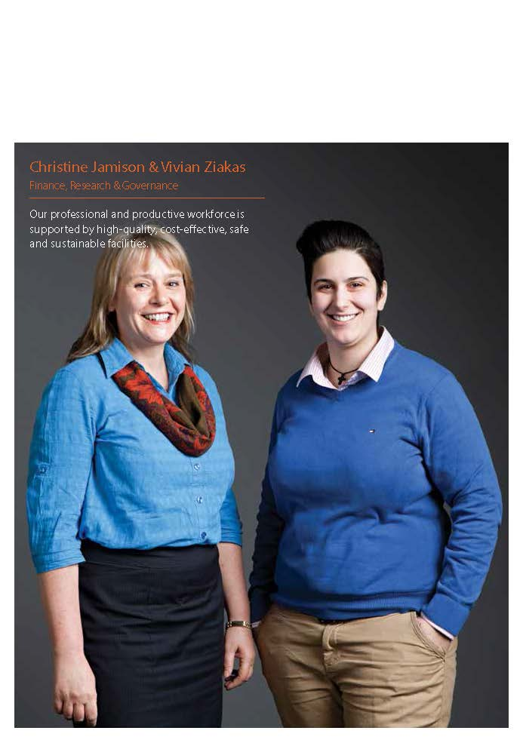

Financial management
We maintain a strong focus on budget management
and ensure our resources are allocated to optimise
our performance.
Our financial results for 2013-14 are outlined from p74. The loss for the year of $2.771 million was within the FWO’s approved budget funding.
We maintained sufficient cash through the year to fund our operations. There are adequate funds held in the Official Public Account as undrawn appropriations which will be used to pay employee entitlements and other liabilities as and when they fall due.

Purchaser-provider arrangements
Our procurement policies are consistent with the Financial Management and Accountability Act 1997 and the Commonwealth Procurement Rules. We apply the following criteria to all procurement activities:
- value for money
- encouraging competition
- efficient, effective and ethical use of resources
- accountability and transparency.
We obtain value for money by accessing existing Commonwealth panels or coordinated contract arrangements and partner with other larger Australian Government departments and agencies, where applicable, when procuring goods and services.
In 2013–14, we purchased information technology services and other administrative functions from the Department of Education and Department of Employment on a fee-for-service basis through a memorandum of understanding.

Consultants
We engage consultants where we require specialist expertise or independent research, reviews or assessments to assist in our decision making. Providers of consultancy services are selected through either open tender, pre-qualified tender, limited tender or an established panel arrangement.
The decision to engage a consultant is made in accordance with the Financial Management and Accountability Act 1997 and related regulations, including the Commonwealth Procurement Rules and relevant internal policies.
During 2013–14, we negotiated 15 new consultancy contracts involving total actual expenditure of $581,438 (including GST).

TABLE 32: CONSULTANCY CONTRACT SPENDING
 | 2013–14 | 2012–13 | 2011–12
Number of new consultancy contracts | 15 | 10 | 5
Value | $581,438 | $725,000 | $445,000
Information about the value of contracts and consultancies can be found on the AusTender website at tenders.gov.au.
There have been no requests for exemption or exemptions given by the Commissioner from publishing a contract on AusTender.
All our contracts provide for the Auditor-General to have access to the contractor’s premises.

Grants
The FWO administers the Community Based Employment Advisory Services Grants Program (CBEAS).

Advertising and market research
Details of payments made to market research and media advertising organisations by the FWO in 2013–14 are listed on p62.
Where the total amount paid to an organisation is less than $12,100, details have not been included consistent with the Commonwealth Electoral Act 1918.
No advertising campaigns were undertaken by the FWO in 2013–14.

TABLE 33: MARKET RESEARCH, DIRECT MAIL AND MEDIA ADVERTISING CONTRACTS OVER $12,100 IN 2013–14
ORGANISATION | SERVICE PROVIDED | TOTAL $ PAID IN 2013–14 (GST INCLUSIVE)
Universal McCann | Media advertising for communication campaigns | 105,626
Adcorp | Recruitment advertising | 22,000
Hays Personnel | Recruitment advertising | 49,995
Hudson Global Resources | Recruitment advertising | 15,000
Inspired Apps | Recruitment advertising | 40,500
McArthur | Recruitment advertising | 34,934
Employment Research Australia | Market research | 51,243
Inside Story Knowledge Management | Market research | 59,400
IPSOS Australia | Market research | 15,400
New Focus | Market research | 19,910
Sweeney Research | Market research | 50,312

Property and environmental management

We provide our employees with high-quality, cost-effective, safe and sustainable office accommodation and facilities to meet business needs.

Accommodation
The implementation of our national property strategy has successfully delivered office consolidation, improved occupational density ratios and significantly reduced property operating expenditure.
Between July 2009 and June 2014, the ongoing management of our property strategy achieved a 35% reduction in space occupied by the FWO.
We also successfully collaborated with other government agencies to identify opportunities for more targeted use of Commonwealth property, including assignment and subletting of surplus metropolitan lease holdings and co-location with other government agencies in smaller regional centres.
We are currently located in 22 sites across Australia, including all capital cities and territories.

Environmental performance
We are progressively implementing policies and work practices that minimise our waste, energy and water consumption, and greenhouse emissions through our Environmental Management Action Plan. We actively inform employees about their environmental responsibilities at work.
In 2013–14, our environmental initiatives included:
- reduction of our total vehicle fleet by 13
- use of Print on Demand, requiring staff to swipe their ID card to print
- use of 100% carbon neutral paper for internal printing and piloting of paperless processes
- reduction of our property size and fit outs to meet government standards
- donation of 34 computers and accessories to the Computer Technology for Schools Program
- participation in programs to recycle toner cartridges and mobile phones.

Appendices

Appendix 1: Reporting on specific legislation

TABLE 34: SPECIFIC LEGISLATIVE REPORTING REQUIREMENTS
LEGISLATION | PAGE
Section 311A Commonwealth Electoral Act 1918 | 58-59
Section 516A Environment Protection and Biodiversity Conservation Act 1999 | 59
Section 57 Financial Management and Accountability Act 1997 | 69-131
Section 8 Freedom of Information Act 1982 | 49
Schedule 2, Part 4 Work Health and Safety Act 2011 | 54-55

Appendix 2: Workforce demographics

TABLE 35: EMPLOYEES BY CLASSIFICATION, AT 30 JUNE 2011–14
CLASSIFICATION | 2013–14 | 2012–13 | 2011–12
APS1 | 1 | 1 | 1
APS2 | 6 | 7 | 11
APS3 | 115 | 115 | 133
APS4 | 161 | 158 | 166
APS5 | 239 | 222 | 222
APS6 | 154 | 158 | 144
EL1 | 95 | 92 | 96
EL2 | 36 | 42 | 40
SES Band 1 | 9 | 9 | 9
SES Band 2 | 3 | 5 | 5
Total | 819 | 809 | 827
Note: Excludes the Fair Work Ombudsman.

TABLE 36: EMPLOYEES BY CLASSIFICATION AND LOCATION, AT 30 JUNE 2014 AND 30 JUNE 2013
CLASSIFICATION ACT |  |  | NSW |  | VIC |  | QLD |  | SA |  | WA |  | NT |  | TAS |  | Total
 | 2014 | 2013 | 2014 | 2013 | 2014 | 2013 | 2014 | 2013 | 2014 | 2013 | 2014 | 2013 | 2014 | 2013 | 2014 | 2013 | 2014 | 2013
APS 1 | 0 | 0 | 0 | 0 | 0 | 0 | 0 | 0 | 1 | 1 | 0 | 0 | 0 | 0 | 0 | 0 | 1 | 1
APS 2 | 0 | 1 | 1 | 1 | 1 | 1 | 0 | 0 | 2 | 3 | 1 | 1 | 0 | 0 | 1 | 0 | 6 | 7
APS 3 | 3 | 3 | 40 | 47 | 34 | 32 | 18 | 22 | 4 | 3 | 16 | 8 | 0 | 0 | 0 | 0 | 115 | 115
APS 4 | 7 | 9 | 64 | 61 | 31 | 34 | 15 | 16 | 23 | 29 | 6 | 7 | 3 | 2 | 12 | 0 | 161 | 158
APS 5 | 12 | 12 | 68 | 64 | 84 | 72 | 39 | 38 | 18 | 17 | 10 | 10 | 0 | 0 | 8 | 9 | 239 | 222
APS 6 | 17 | 15 | 51 | 52 | 46 | 47 | 18 | 18 | 12 | 13 | 8 | 10 | 1 | 1 | 1 | 2 | 154 | 158
EL 1 | 14 | 16 | 26 | 25 | 35 | 32 | 7 | 5 | 8 | 8 | 4 | 4 | 0 | 0 | 1 | 2 | 95 | 92
EL 2 | 6 | 6 | 11 | 11 | 13 | 15 | 2 | 3 | 3 | 6 | 0 | 1 | 0 | 0 | 1 | 0 | 36 | 42
SES Band 1 | 2 | 2 | 4 | 4 | 2 | 2 | 0 | 0 | 1 | 1 | 0 | 0 | 0 | 0 | 0 | 0 | 9 | 9
SES Band 2 | 0 | 2 | 0 | 0 | 2 | 2 | 0 | 0 | 1 | 1 | 0 | 0 | 0 | 0 | 0 | 0 | 3 | 5
Total | 61 | 66 | 265 | 265 | 248 | 237 | 99 | 102 | 73 | 82 | 45 | 41 | 4 | 3 | 26 | 13 | 819 | 809
Note: Excludes the Fair Work Ombudsman.

TABLE 37: ONGOING FULL-TIME AND PART-TIME EMPLOYEES BY GENDER AND LOCATION, AT 30 JUNE 2014 AND 30 JUNE 2013
CLASSIFICATION ACT |  |  | NSW |  | VIC |  | QLD |  | SA |  | WA |  | NT |  | TAS |  | Total
 | 2014 | 2013 | 2014 | 2013 | 2014 | 2013 | 2014 | 2013 | 2014 | 2013 | 2014 | 2013 | 2014 | 2013 | 2014 | 2013 | 2014 | 2013
Female  full-time | 27 | 29 | 123 | 120 | 101 | 102 | 34 | 41 | 31 | 40 | 11 | 16 | 2 | 1 | 11 | 8 | 340 | 357
Female  part-time | 10 | 11 | 40 | 42 | 45 | 42 | 27 | 24 | 17 | 14 | 10 | 8 | 1 | 0 | 3 | 0 | 153 | 141
Total female | 37 | 40 | 163 | 162 | 146 | 144 | 61 | 65 | 48 | 54 | 21 | 24 | 3 | 1 | 14 | 8 | 493 | 498
Male full-time | 23 | 23 | 87 | 87 | 83 | 82 | 28 | 35 | 24 | 25 | 12 | 14 | 1 | 2 | 9 | 5 | 268 | 273
Male part-time | 0 | 3 | 11 | 8 | 2 | 4 | 2 | 2 | 0 | 2 | 2 | 1 | 0 | 0 | 0 | 0 | 17 | 20
Total male | 23 | 26 | 98 | 95 | 85 | 86 | 30 | 37 | 25 | 27 | 14 | 15 | 1 | 2 | 9 | 5 | 285 | 293
Total female and male | 60 | 66 | 261 | 257 | 231 | 230 | 91 | 102 | 73 | 81 | 35 | 39 | 4 | 3 | 23 | 13 | 778 | 791
Note: Excludes the Fair Work Ombudsman.

TABLE 38: NON-ONGOING FULL-TIME AND PART-TIME EMPLOYEES BY GENDER AND LOCATION, AT 30 JUNE 2014 AND 30 JUNE 2013
CLASSIFICATION ACT |  |  | NSW |  | VIC |  | QLD |  | SA |  | WA |  | NT |  | TAS |  | Total
 | 2014 | 2013 | 2014 | 2013 | 2014 | 2013 | 2014 | 2013 | 2014 | 2013 | 2014 | 2013 | 2014 | 2013 | 2014 | 2013 | 2014 | 2013
Female full-time | 1 | 0 | 2 | 5 | 11 | 3 | 5 | 0 | 0 | 1 | 3 | 1 | 0 | 0 | 1 | 0 | 23 | 10
Female part-time | 0 | 0 | 1 | 0 | 1 | 0 | 0 | 0 | 0 | 0 | 1 | 1 | 0 | 0 | 0 | 0 | 3 | 1
Total female | 1 | 0 | 3 | 5 | 12 | 3 | 5 | 0 | 0 | 1 | 4 | 2 | 0 | 0 | 1 | 0 | 26 | 11
Male full-time | 0 | 0 | 1 | 3 | 3 | 4 | 3 | 0 | 0 | 0 | 5 | 0 | 0 | 0 | 0 | 0 | 12 | 7
Male part-time | 0 | 0 | 0 | 0 | 2 | 0 | 0 | 0 | 0 | 0 | 1 | 0 | 0 | 0 | 0 | 0 | 3 | 0
Total male | 0 | 0 | 1 | 3 | 5 | 4 | 3 | 0 | 0 | 0 | 6 | 0 | 0 | 0 | 0 | 0 | 15 | 7
Total female and male | 1 | 0 | 4 | 8 | 17 | 7 | 8 | 0 | 0 | 1 | 10 | 2 | 0 | 0 | 1 | 0 | 41 | 18
Note: Excludes the Fair Work Ombudsman.

TABLE 39: ONGOING AND NON-ONGOING FULL-TIME AND PART-TIME EMPLOYEES BY GENDER, AT 30 JUNE 2014 AND 30 JUNE 2013
CLASSIFICATION ACT |  |  | NSW |  | VIC |  | QLD |  | SA |  | WA |  | NT |  | TAS |  | Total
 | 2014 | 2013 | 2014 | 2013 | 2014 | 2013 | 2014 | 2013 | 2014 | 2013 | 2014 | 2013 | 2014 | 2013 | 2014 | 2013 | 2014 | 2013
Female full-time | 28 | 29 | 125 | 125 | 112 | 105 | 39 | 41 | 31 | 41 | 14 | 17 | 2 | 1 | 12 | 8 | 363 | 367
Female part-time | 10 | 11 | 41 | 42 | 46 | 42 | 27 | 24 | 17 | 14 | 11 | 9 | 1 | 0 | 3 | 0 | 156 | 142
Total female | 38 | 40 | 166 | 167 | 158 | 147 | 66 | 65 | 48 | 55 | 25 | 26 | 3 | 1 | 15 | 8 | 519 | 509
Male full-time | 23 | 23 | 88 | 90 | 86 | 86 | 31 | 35 | 25 | 25 | 17 | 14 | 1 | 2 | 9 | 5 | 280 | 280
Male part-time | 0 | 3 | 11 | 8 | 4 | 4 | 2 | 2 | 0 | 2 | 3 | 1 | 0 | 0 | 0 | 0 | 20 | 20
Total male | 23 | 26 | 99 | 98 | 90 | 90 | 33 | 37 | 25 | 27 | 20 | 15 | 1 | 2 | 9 | 5 | 300 | 300
Total female and male | 61 | 66 | 265 | 265 | 249 | 237 | 99 | 102 | 73 | 82 | 45 | 41 | 4 | 3 | 24 | 13 | 819 | 809
Note: Excludes the Fair Work Ombudsman.

TABLE 40: SENIOR EXECUTIVE AND EXECUTIVE LEVEL EMPLOYEES BY CLASSIFICATION AND GENDER, AT 30 JUNE 2014 AND 30 JUNE 2013
CLASSIFICATION | FEMALE |  | MALE |  | TOTAL
 | 2014 | 2013 | 2014 | 2013 | 2014 | 2013
EL 1 | 63 | 61 | 32 | 31 | 95 | 92
EL 2 | 14 | 17 | 22 | 25 | 36 | 42
SES Band 1 | 5 | 5 | 4 | 4 | 9 | 9
SES Band 2 | 0 | 1 | 3 | 4 | 3 | 5
Total | 82 | 84 | 61 | 64 | 143 | 148
Note: Excludes the Fair Work Ombudsman.

TABLE 41: WORKPLACE DIVERSITY PROFILE, AT 30 JUNE 2014 AND 30 JUNE 2013
TOTAL STAFF |  | FEMALE |  | PEOPLE FROM CULTURALLY AND LINGUISTICALLY DIVERSE BACKGROUNDS |  | PEOPLE FROM ABORIGINAL AND TORRES STRAIT ISLANDER BACKGROUNDS |  | PEOPLE WITH DISABILITIES
2014 | 2013 | 2014 | 2013 | 2014 | 2013 | 2014 | 2013 | 2014 | 2013
819 | 809 | 519 | 509 | 176 | 210 | 8 | 8 | 26 | 23
Note: Excludes the Fair Work Ombudsman.

TABLE 42: EMPLOYEE WORKPLACE AGREEMENTS BY CLASSIFICATION, AT 30 JUNE 2014 AND 30 JUNE 2013
CLASSIFICATION | ENTERPRISE AGREEMENT |  | COMMON LAW CONTRACT |  | TOTAL
 | 2014 | 2013 | 2014 | 2013 | 2014 | 2013
APS 1 | 1 | 1 | 0 | 0 | 1 | 1
APS 2 | 6 | 7 | 0 | 0 | 6 | 7
APS 3 | 115 | 115 | 0 | 0 | 115 | 115
APS 4 | 161 | 158 | 0 | 0 | 161 | 158
APS 5 | 239 | 222 | 0 | 0 | 239 | 222
APS 6 | 154 | 158 | 0 | 0 | 154 | 158
EL 1 | 95 | 92 | 0 | 0 | 95 | 92
EL 2 | 36 | 42 | 0 | 0 | 36 | 42
SES Band 1 | 0 | 0 | 9 | 9 | 9 | 9
SES Band 2 | 0 | 0 | 3 | 5 | 3 | 5
Total | 807 | 795 | 12 | 14 | 819 | 809
Note: Excludes the Fair Work Ombudsman.

Appendix 3: Changes to disability reporting
Since 1994, Commonwealth departments and agencies have reported on their performance as policy adviser, purchaser, employer, regulator and provider under the Commonwealth Disability Strategy. In 2007–08, reporting on the employer role was transferred to the Australian Public Service Commission’s State of the Service Report and the APS Statistical Bulletin. These reports are available at www.apsc.gov.au. From 2010–11, departments and agencies have no longer been required to report on these functions.
The Commonwealth Disability Strategy has been overtaken by the National Disability Strategy 2010-2020, which sets out a ten-year national policy framework to improve the lives of people with disability, promote participation and create a more inclusive society. A high level two-yearly report will track progress against each of the six outcome areas of the strategy and present a picture of how people with disability are faring. The first of these reports will be available in late 2014, and can be found at www.dss.gov.au

Appendix 4: Summary of resources

TABLE 43: EXPENSES AND RESOURCES FOR OUTCOME 1
OUTCOME 1: COMPLIANCE WITH WORKPLACE RELATIONS LEGISLATION BY EMPLOYEES AND EMPLOYERS THROUGH ADVICE, EDUCATION AND, WHERE NECESSARY, ENFORCEMENT. | BUDGET 2013–14 $'000 | ACTUAL EXPENSES 2013–14 $'000 | VARIATION ’000
 | (a) | (b) | (a-b)
Program 1: Education Services and Compliance Activities
Departmental Expenses
Ordinary Annual Services (Appropriation Bill No.1) | 124,008 | 120,193 | 3,815
Revenue from independent sources (Section 31) | 1,400 | 4,717 | (3,317)
Total for Program 1 | 125,408 | 124,910 | 498
Total Expenses for Outcome 1 | 125,408 | 124,910 | 498
 | 2013–14
Average staffing level (number) |  | 726
Note: Budget information reflects budgets as set out in the Portfolio Budget Statements 2013–14.

TABLE 44: AGENCY RESOURCE STATEMENT 2013–14
 | ACTUAL AVAILABLE APPROPRIATIONS FOR 2013–14  $'000 | PAYMENTS MADE 2013–14  $'000 | BALANCE REMAINING  2013–14  $'000
 | (a) | (b) | (a-b)
Ordinary Annual Services
Departmental Outputs  Departmental outputs | 194,440 | 128,881 | 65,559
Total Ordinary Annual Services | 194,440 | 128,881 | 65,559
Other Services
Departmental Non-Operating  Equity injections | 23,491 | 6,237 | 17,254
Total Other Services | 23,491 | 6,237 | 17,254
Special Appropriation  Administered outputs | 177 | 177 | -
Total Special Appropriation | 177 | 177 | -
Total Available Annual
Appropriations | 218,108 | 135,295 | 82,813
Total Appropriations Excluding
Special Account | 218,108 | 135,295 | 82,813
Special Account  Opening balance  Non-appropriation receipts  Payments  Transfer to CRF | 958  61  -  - | -  -  71  948 | 958  61  (71)  (948)
Total Special Account | 1,019 | 1,019 | -
Funds Held by CRF  Opening balance  Non-appropriation receipts  Payments  Transfer from Special Account | 1,751  147  -  948 | -  -  177  - | 1,751  147  (177)  948
Total Funds Held by CRF | 2,846 | 177 | 2,669
Total Net Resourcing for
Fair Work Ombudsman | 221,973 | 136,491 | 85,482



Financial statements

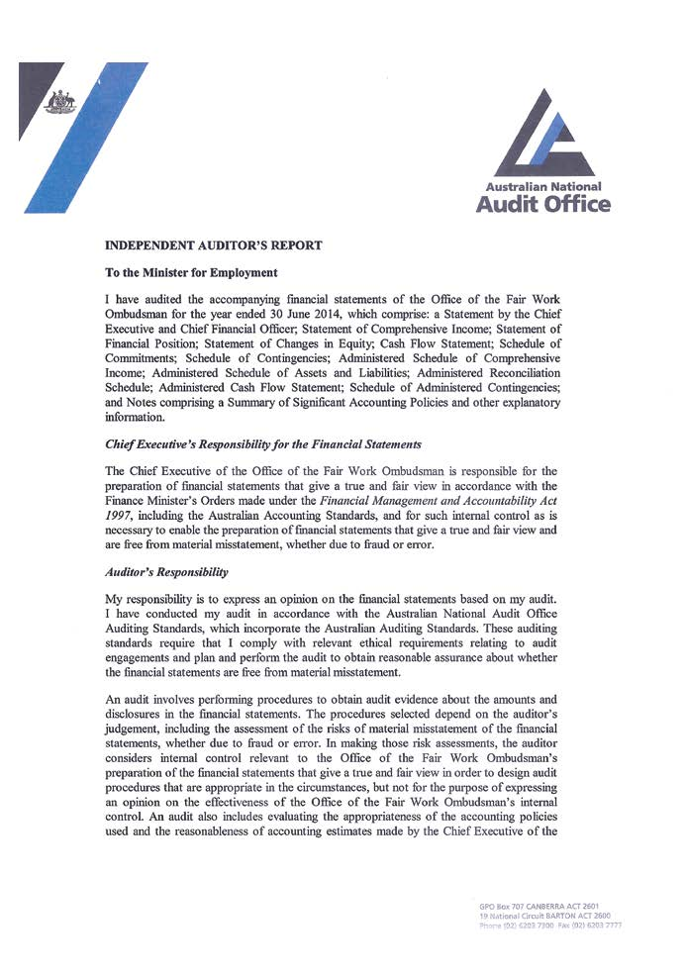
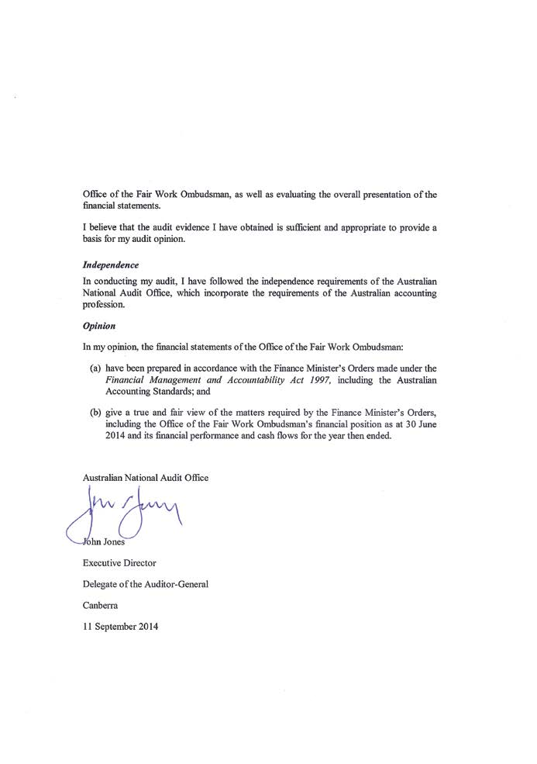
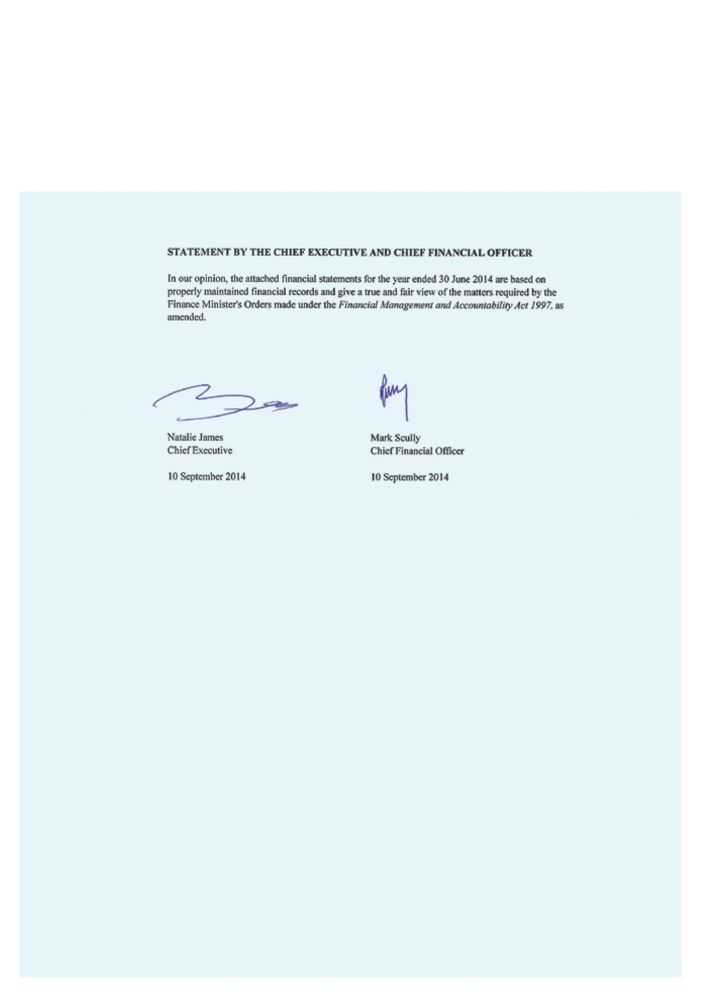
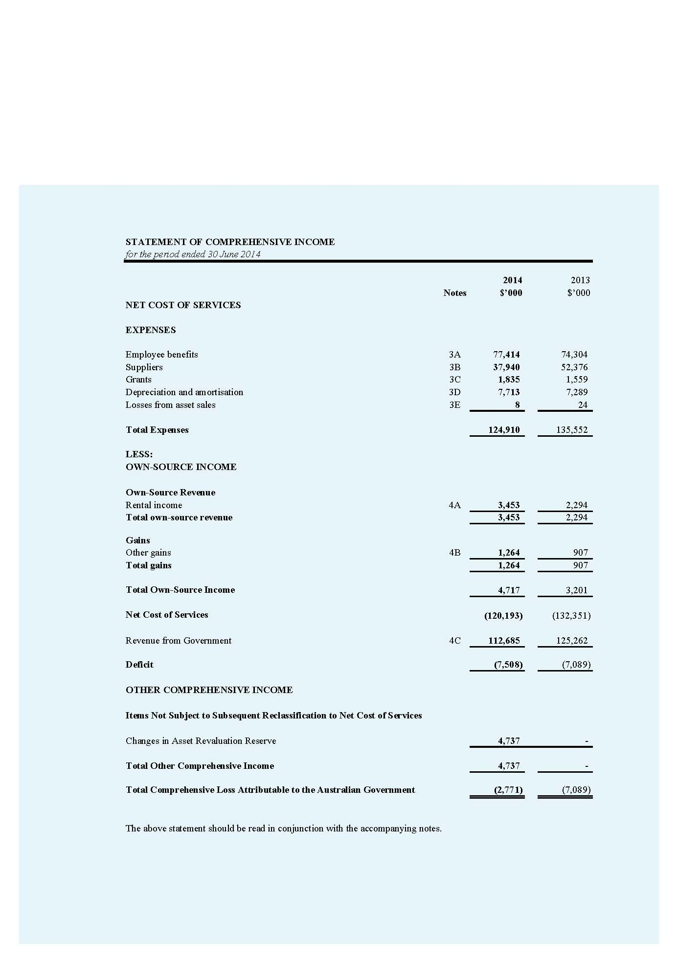
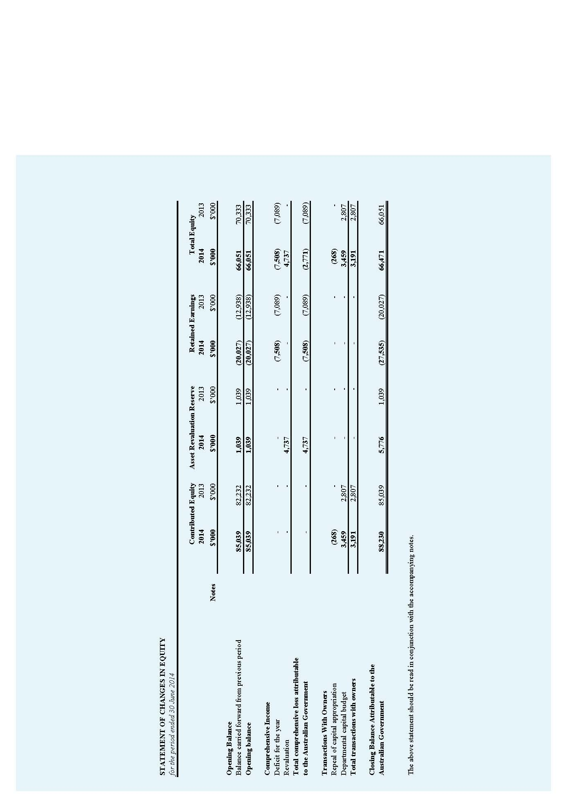
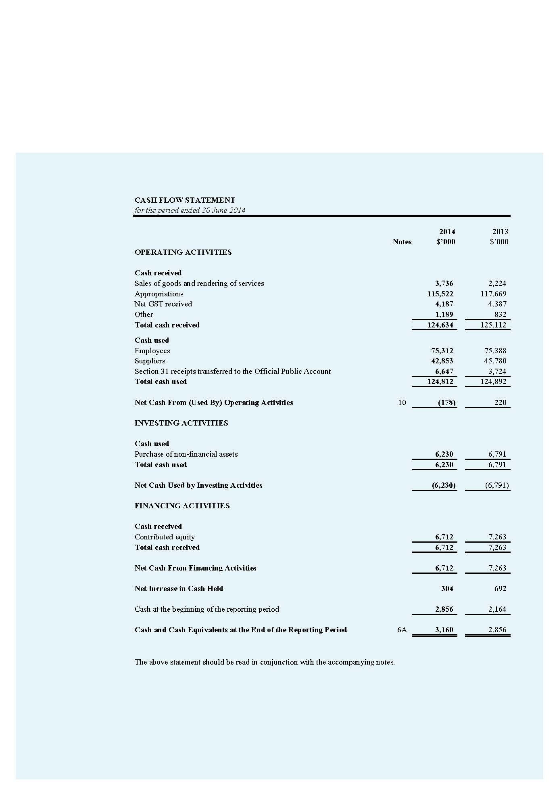
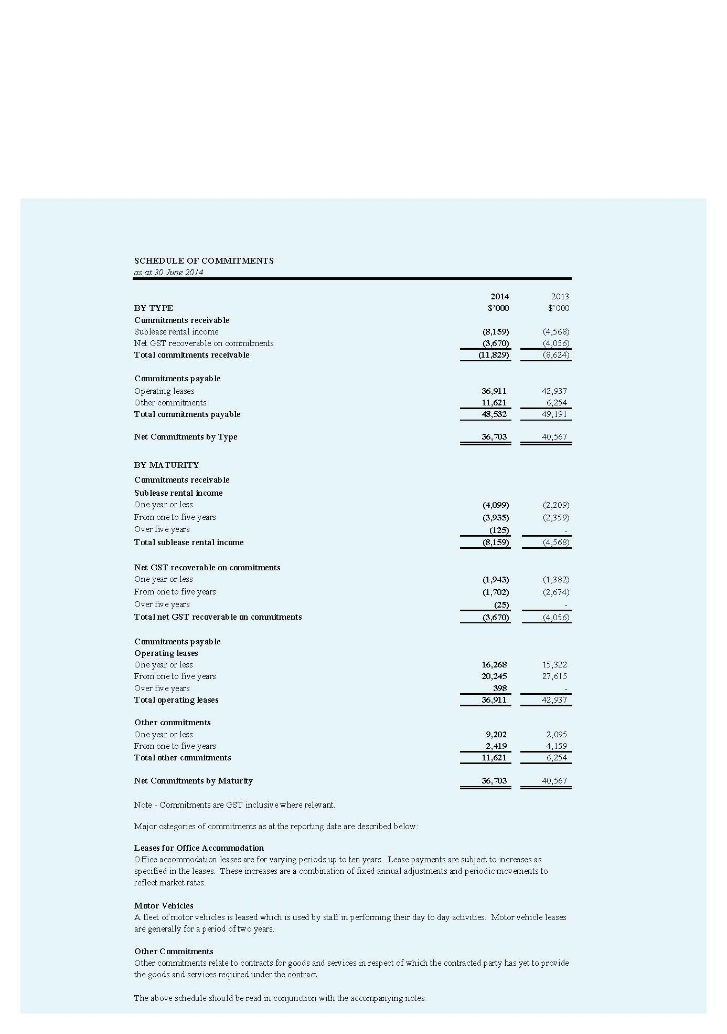
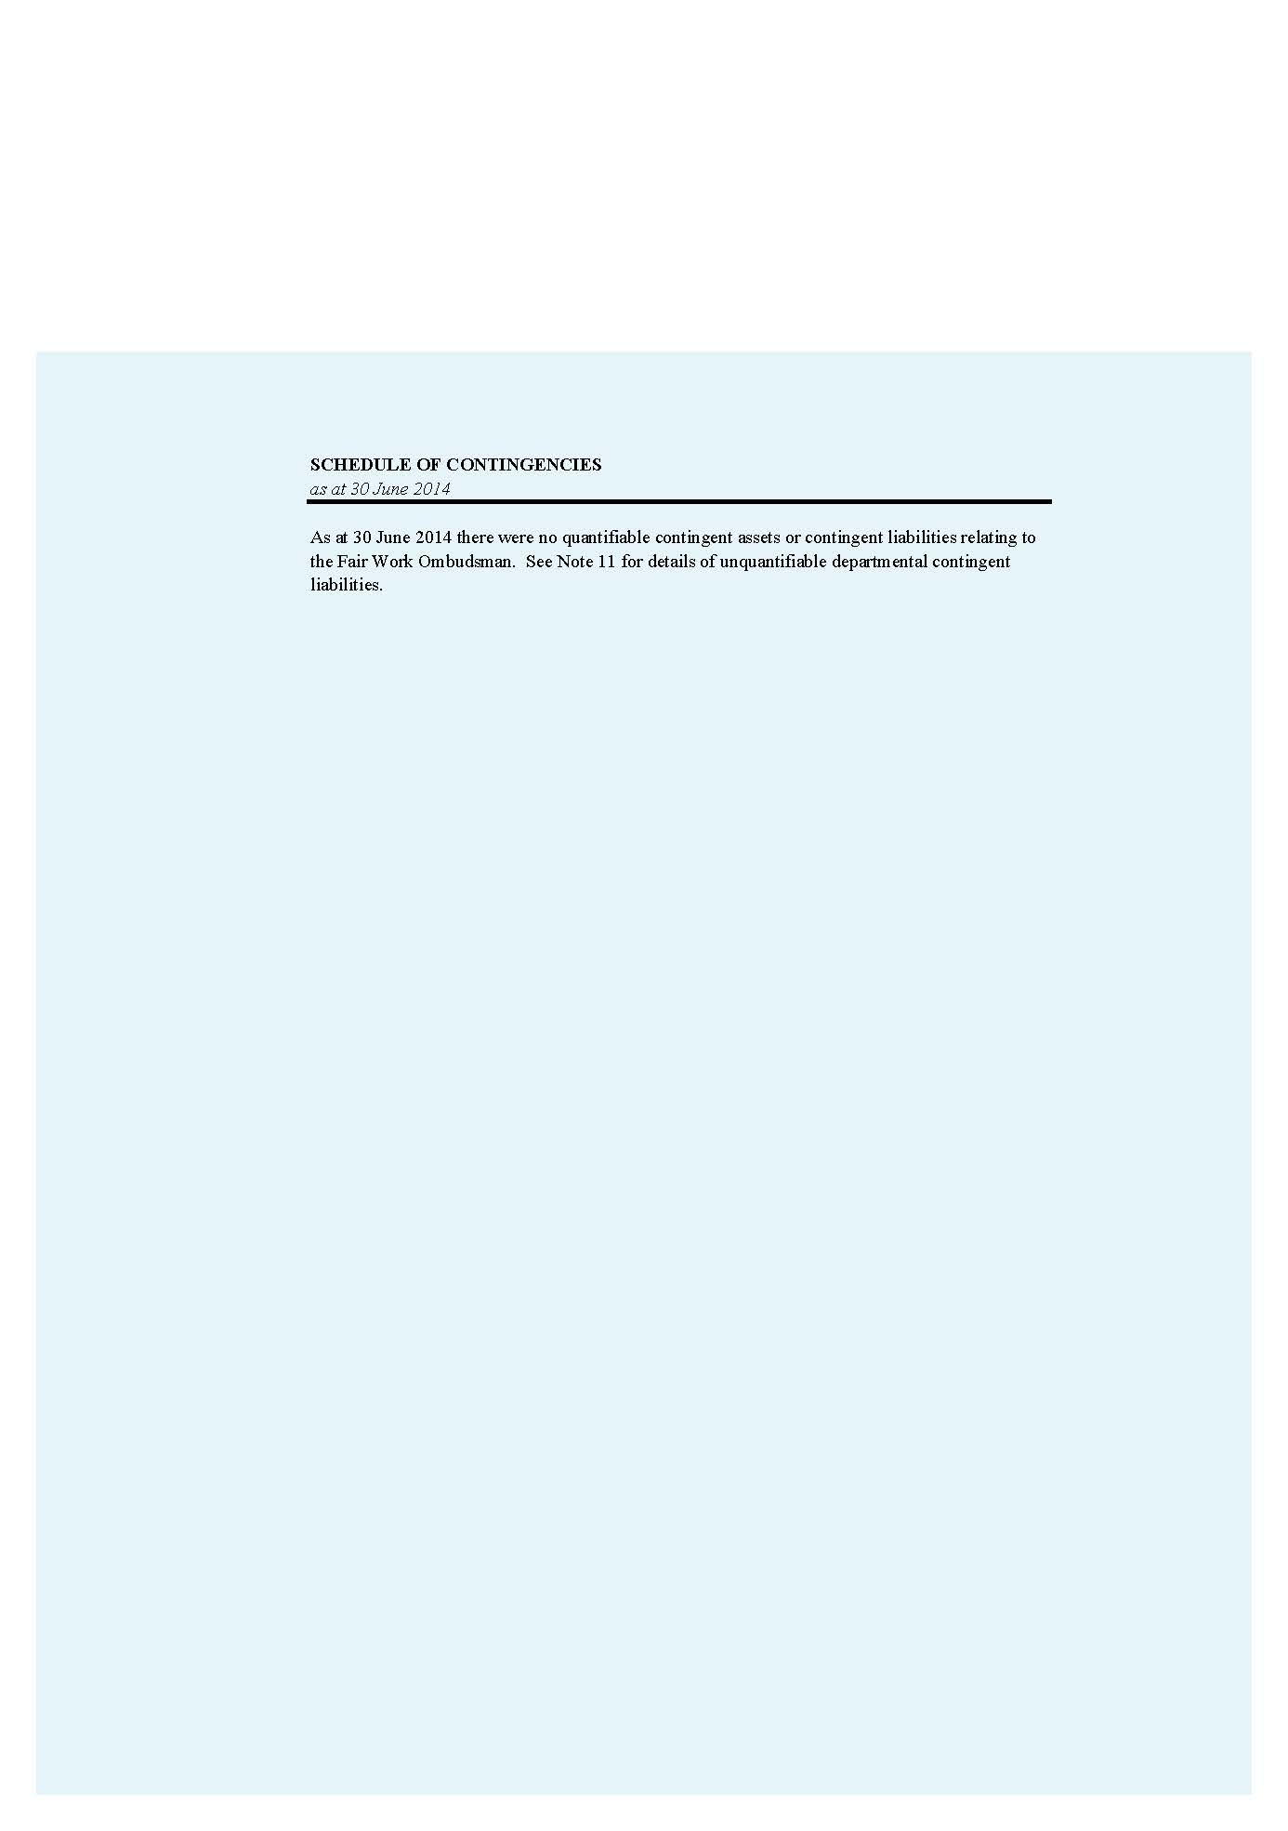
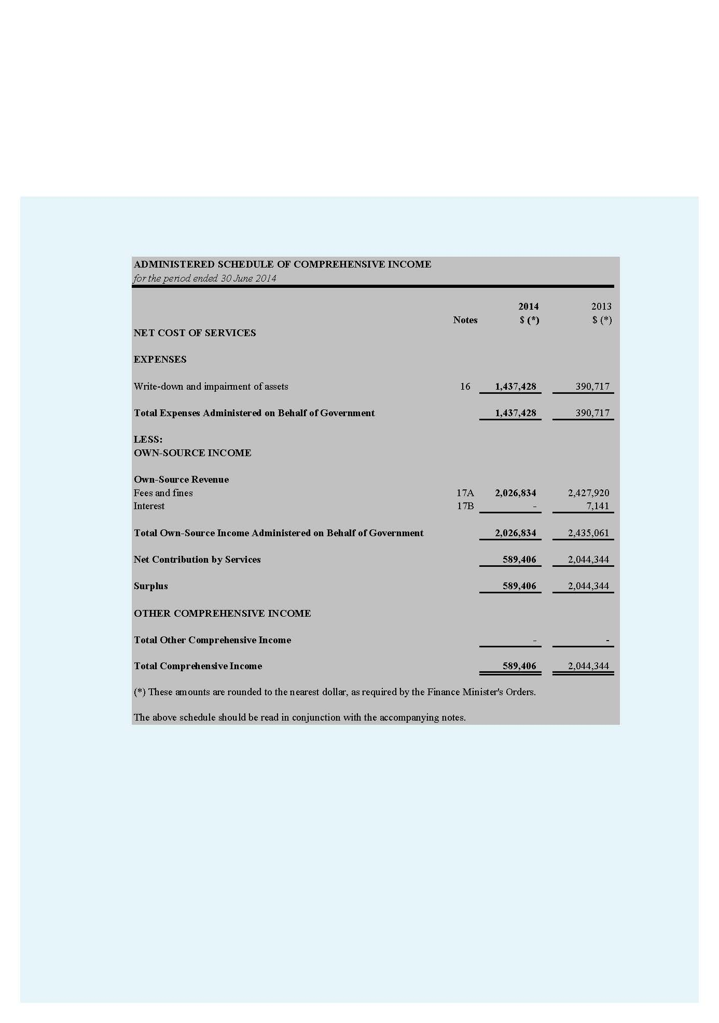
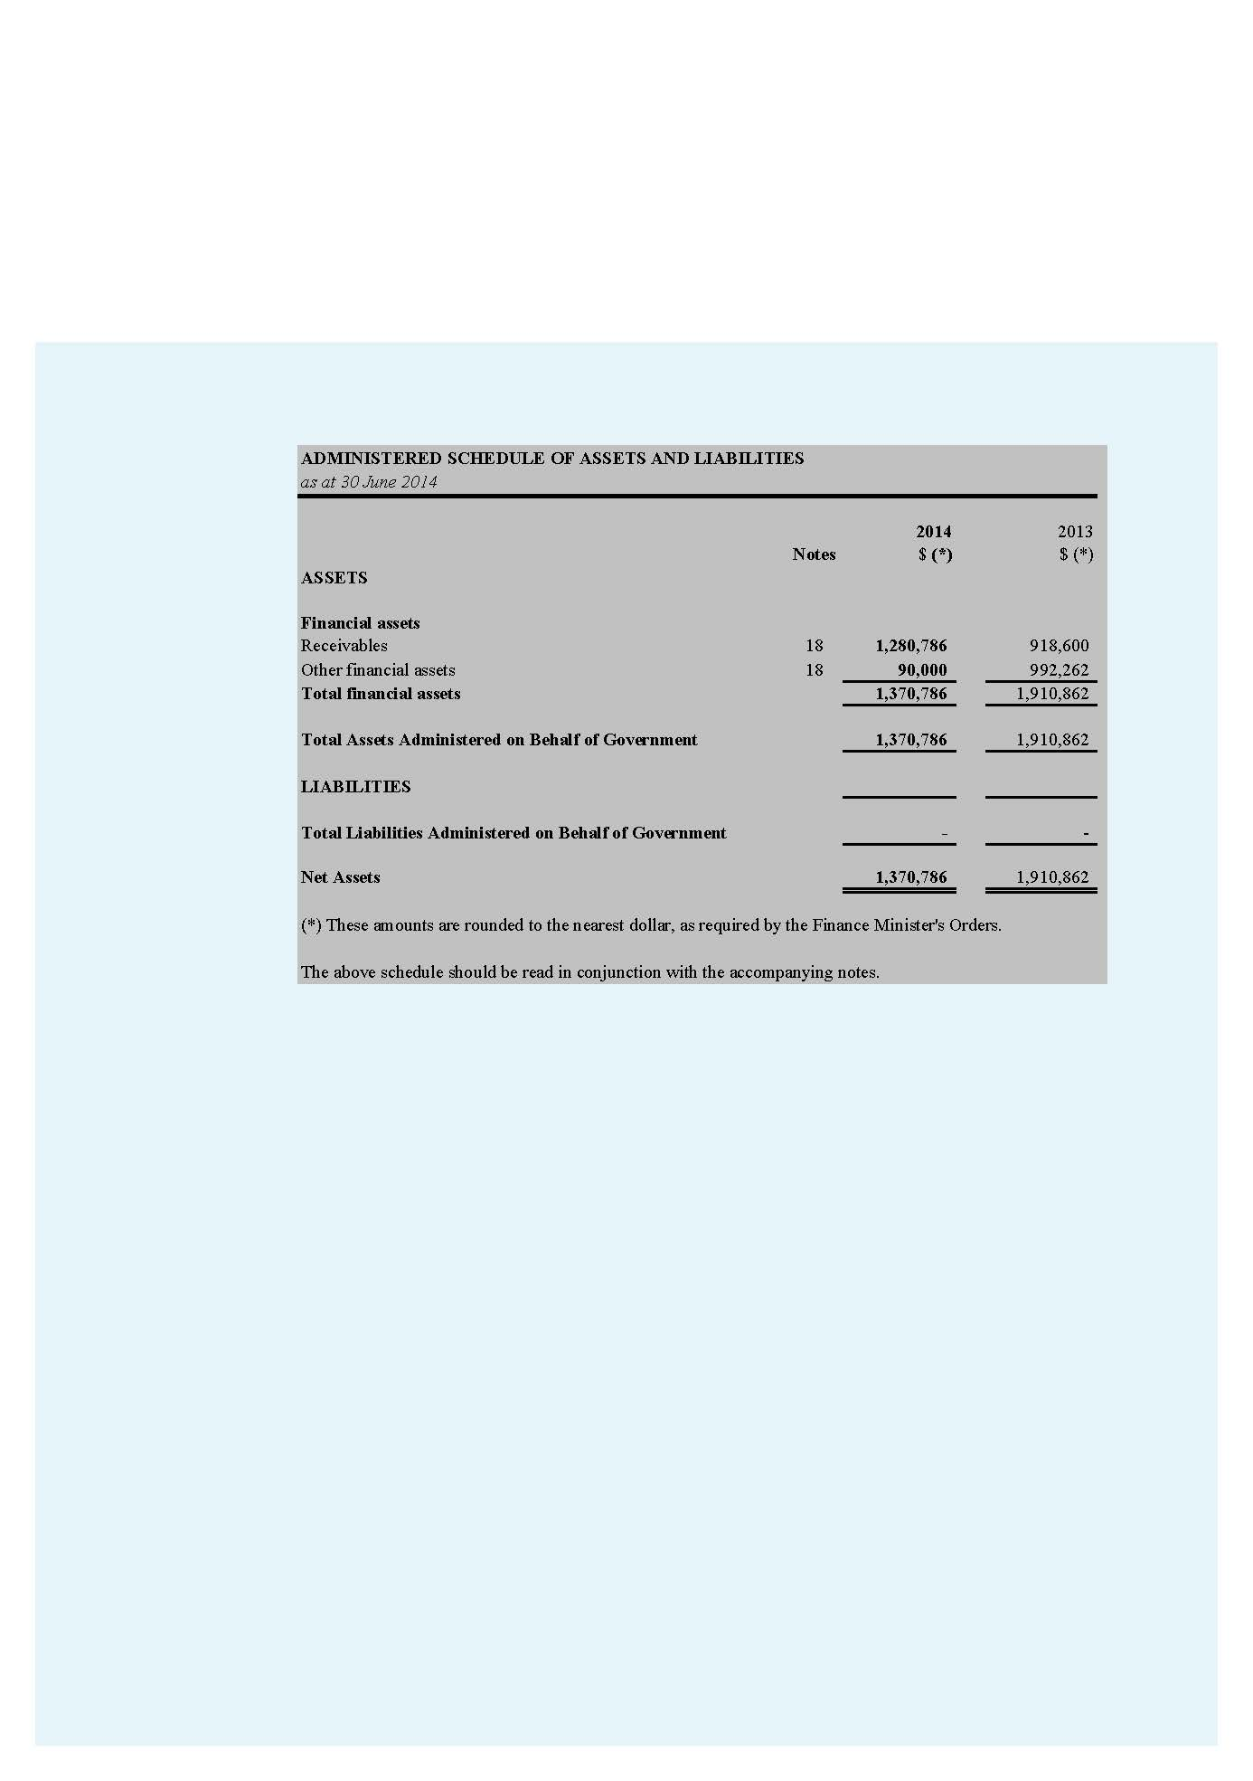
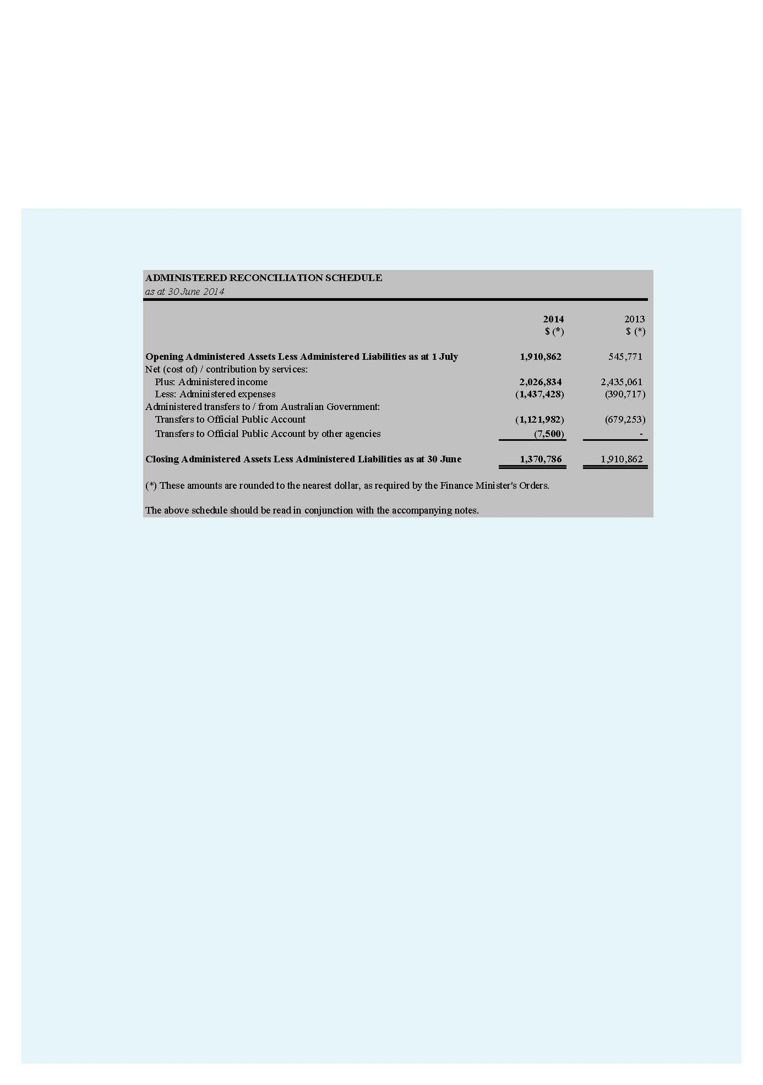
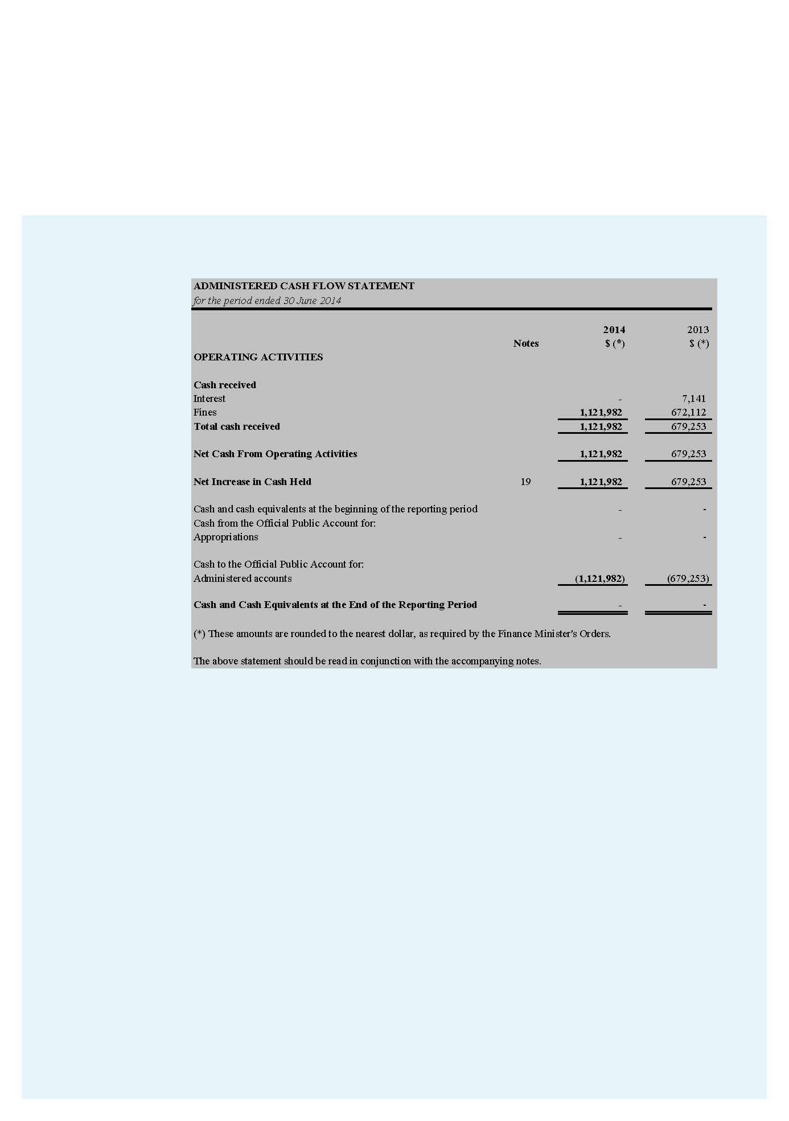
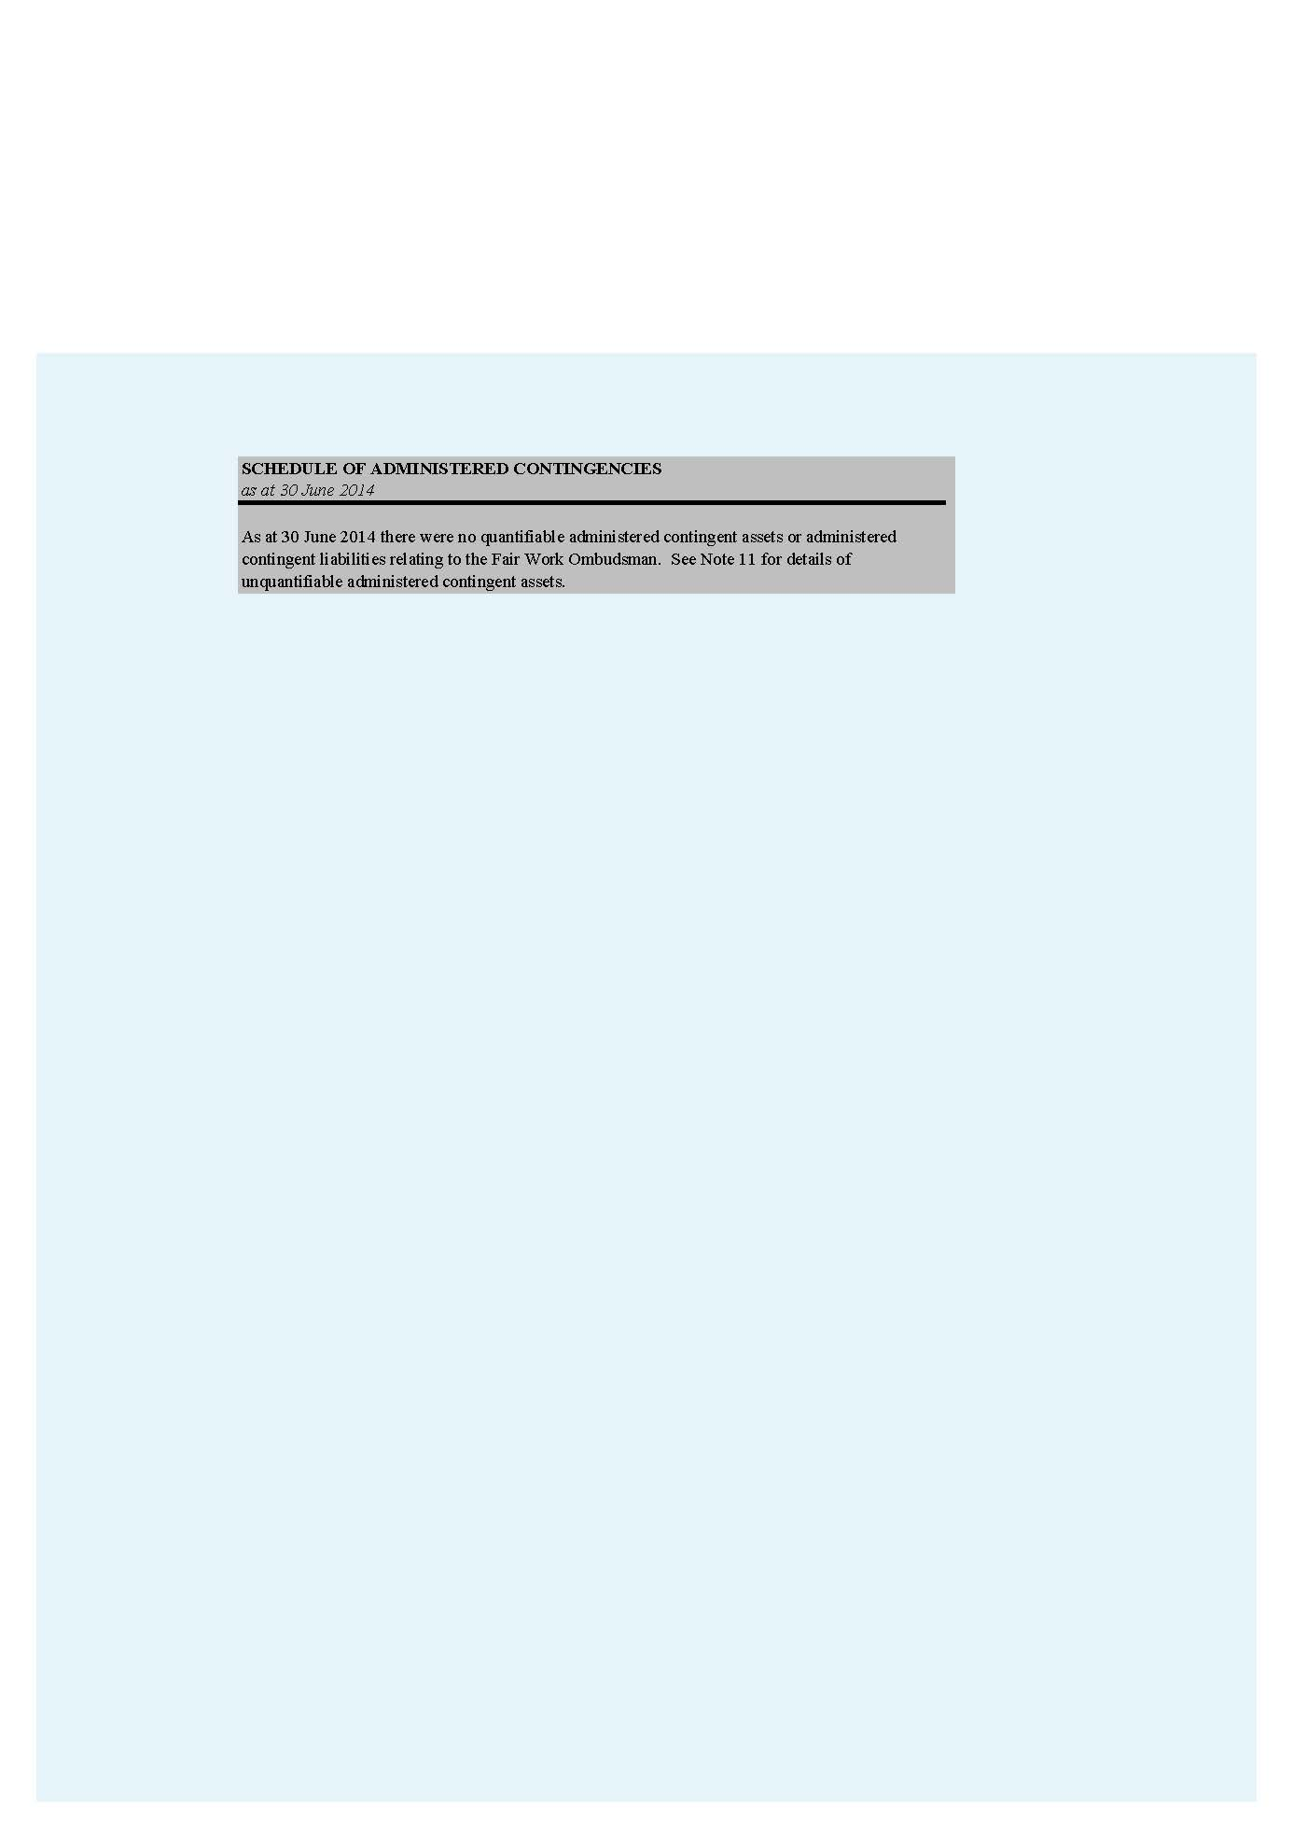
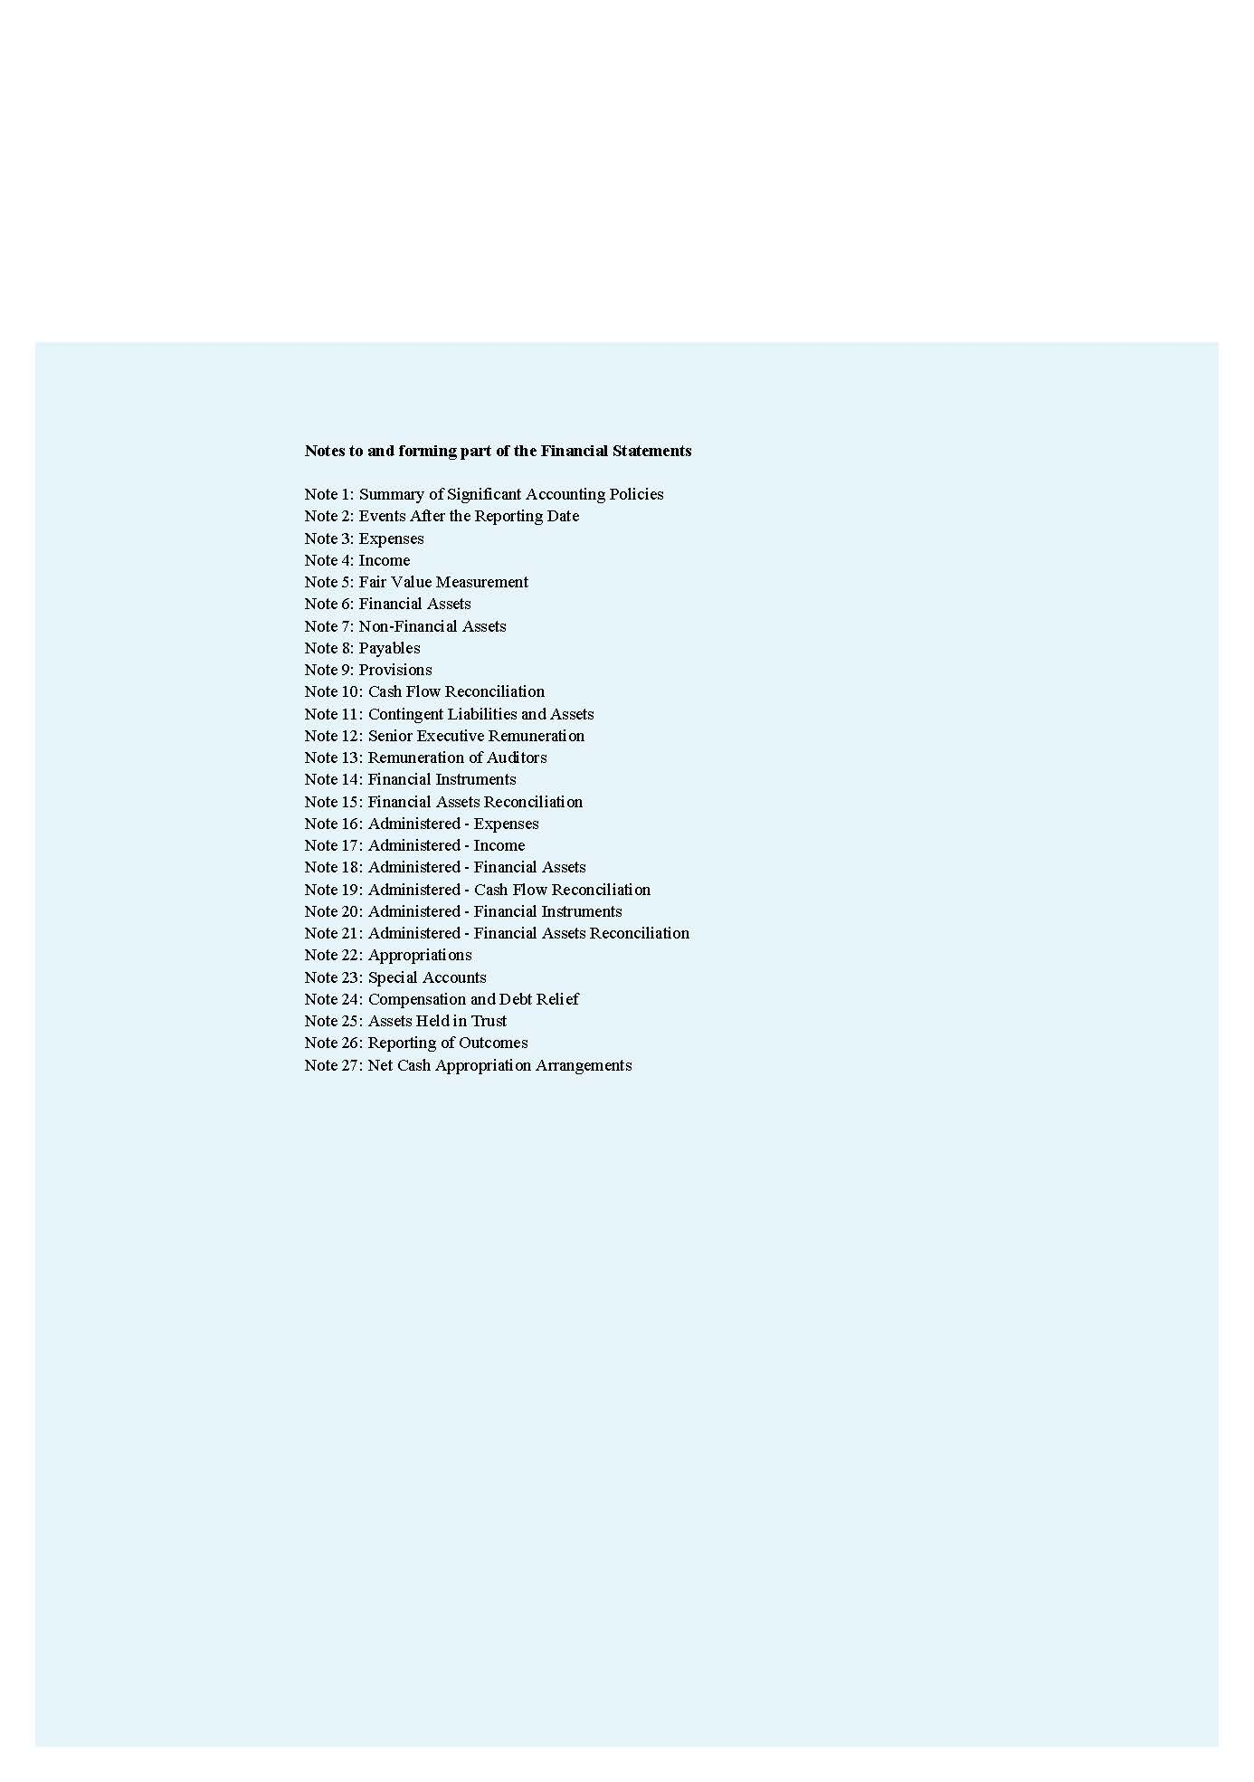
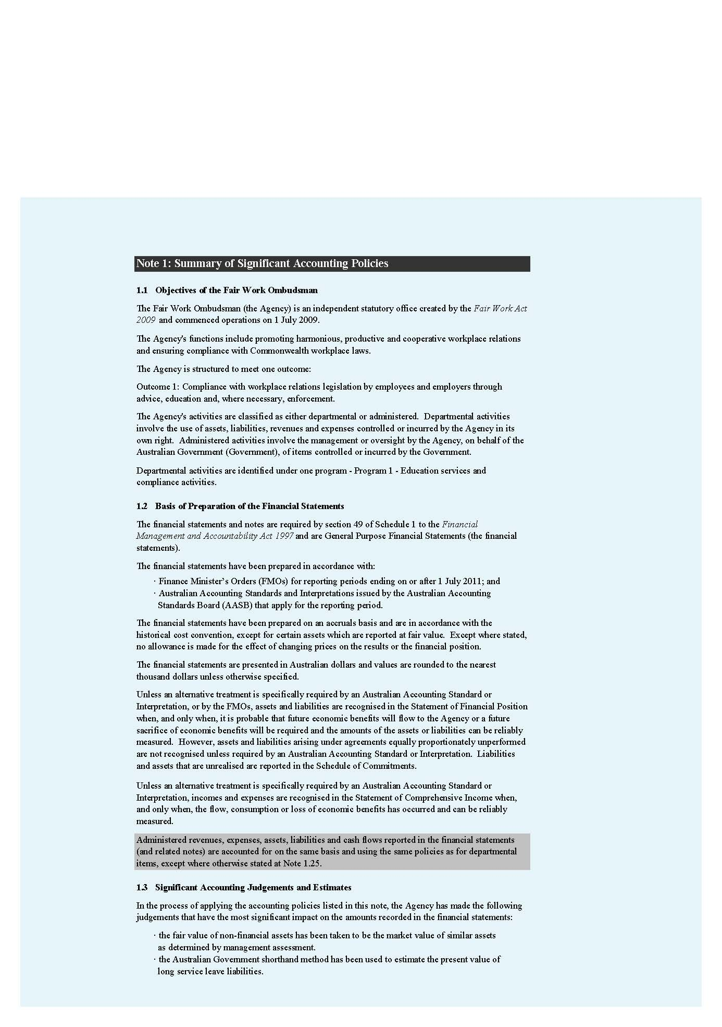
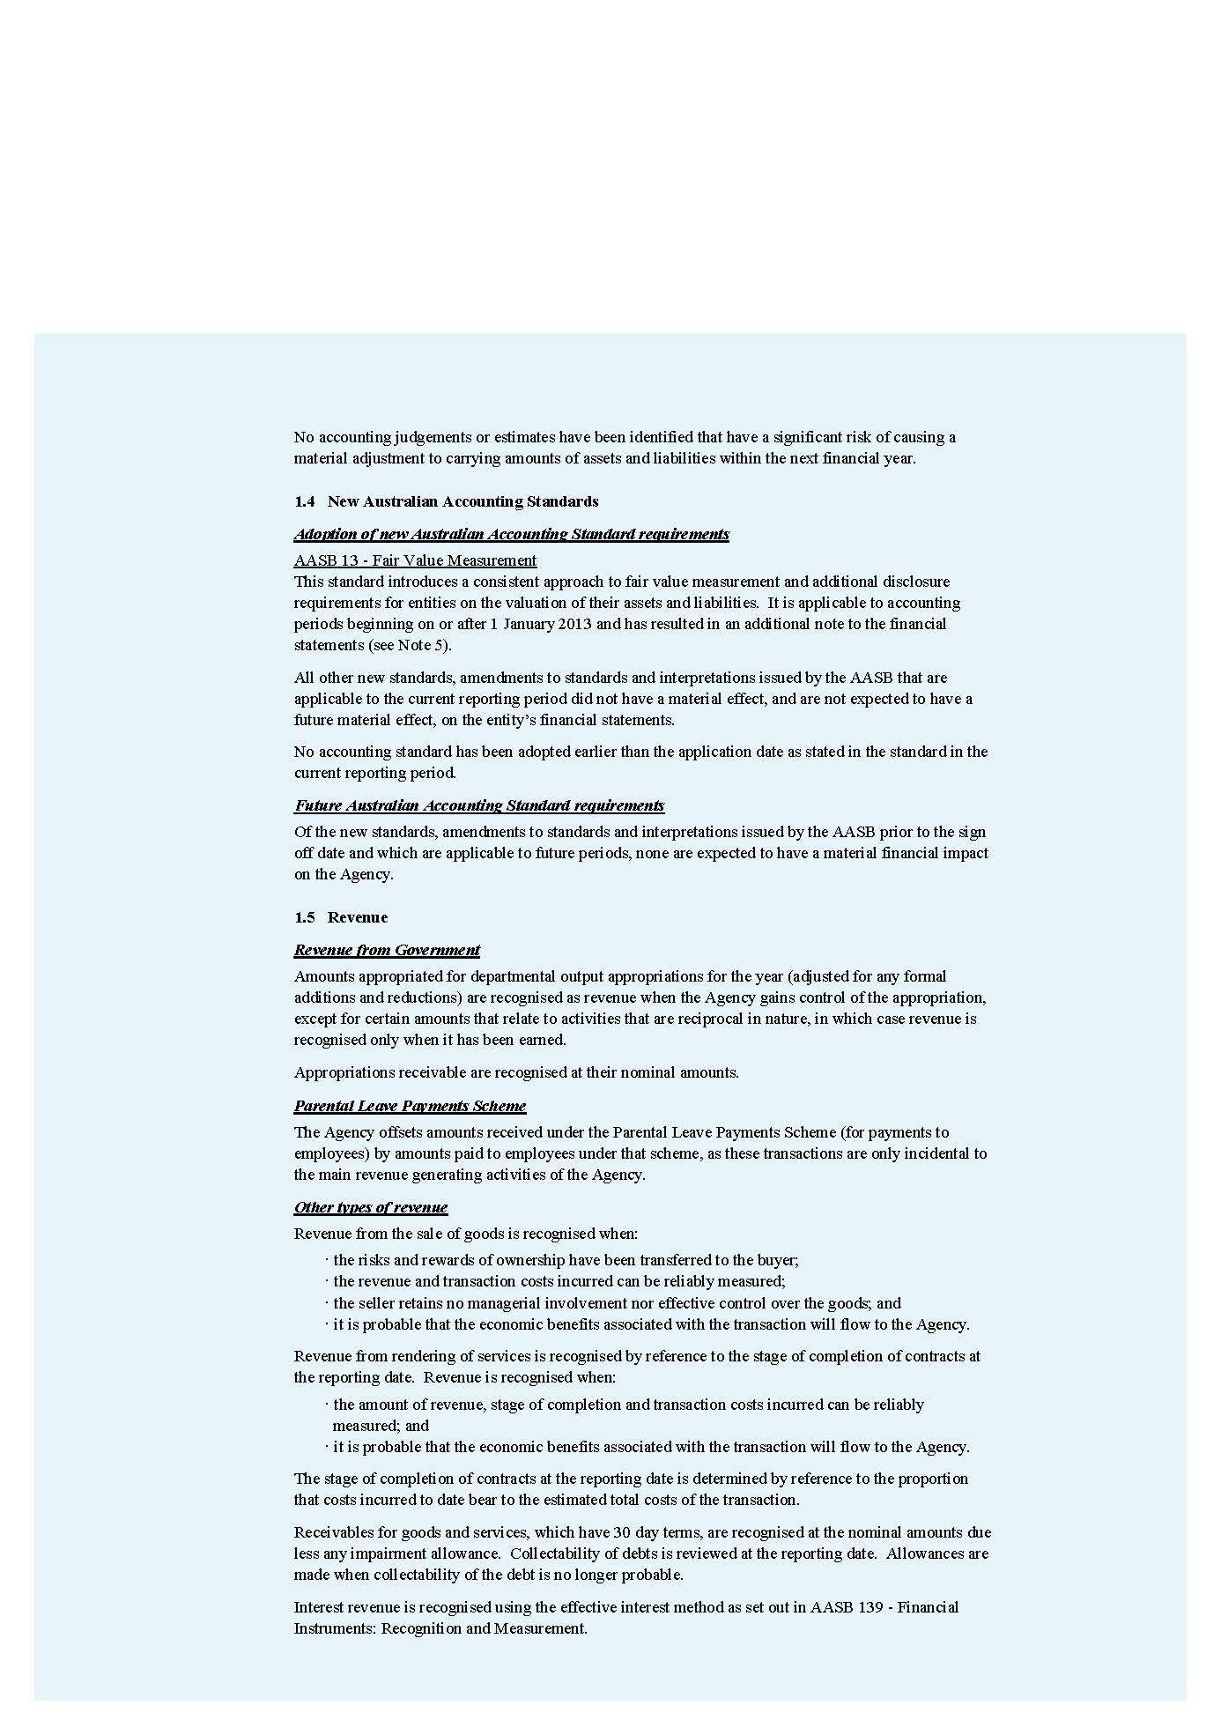
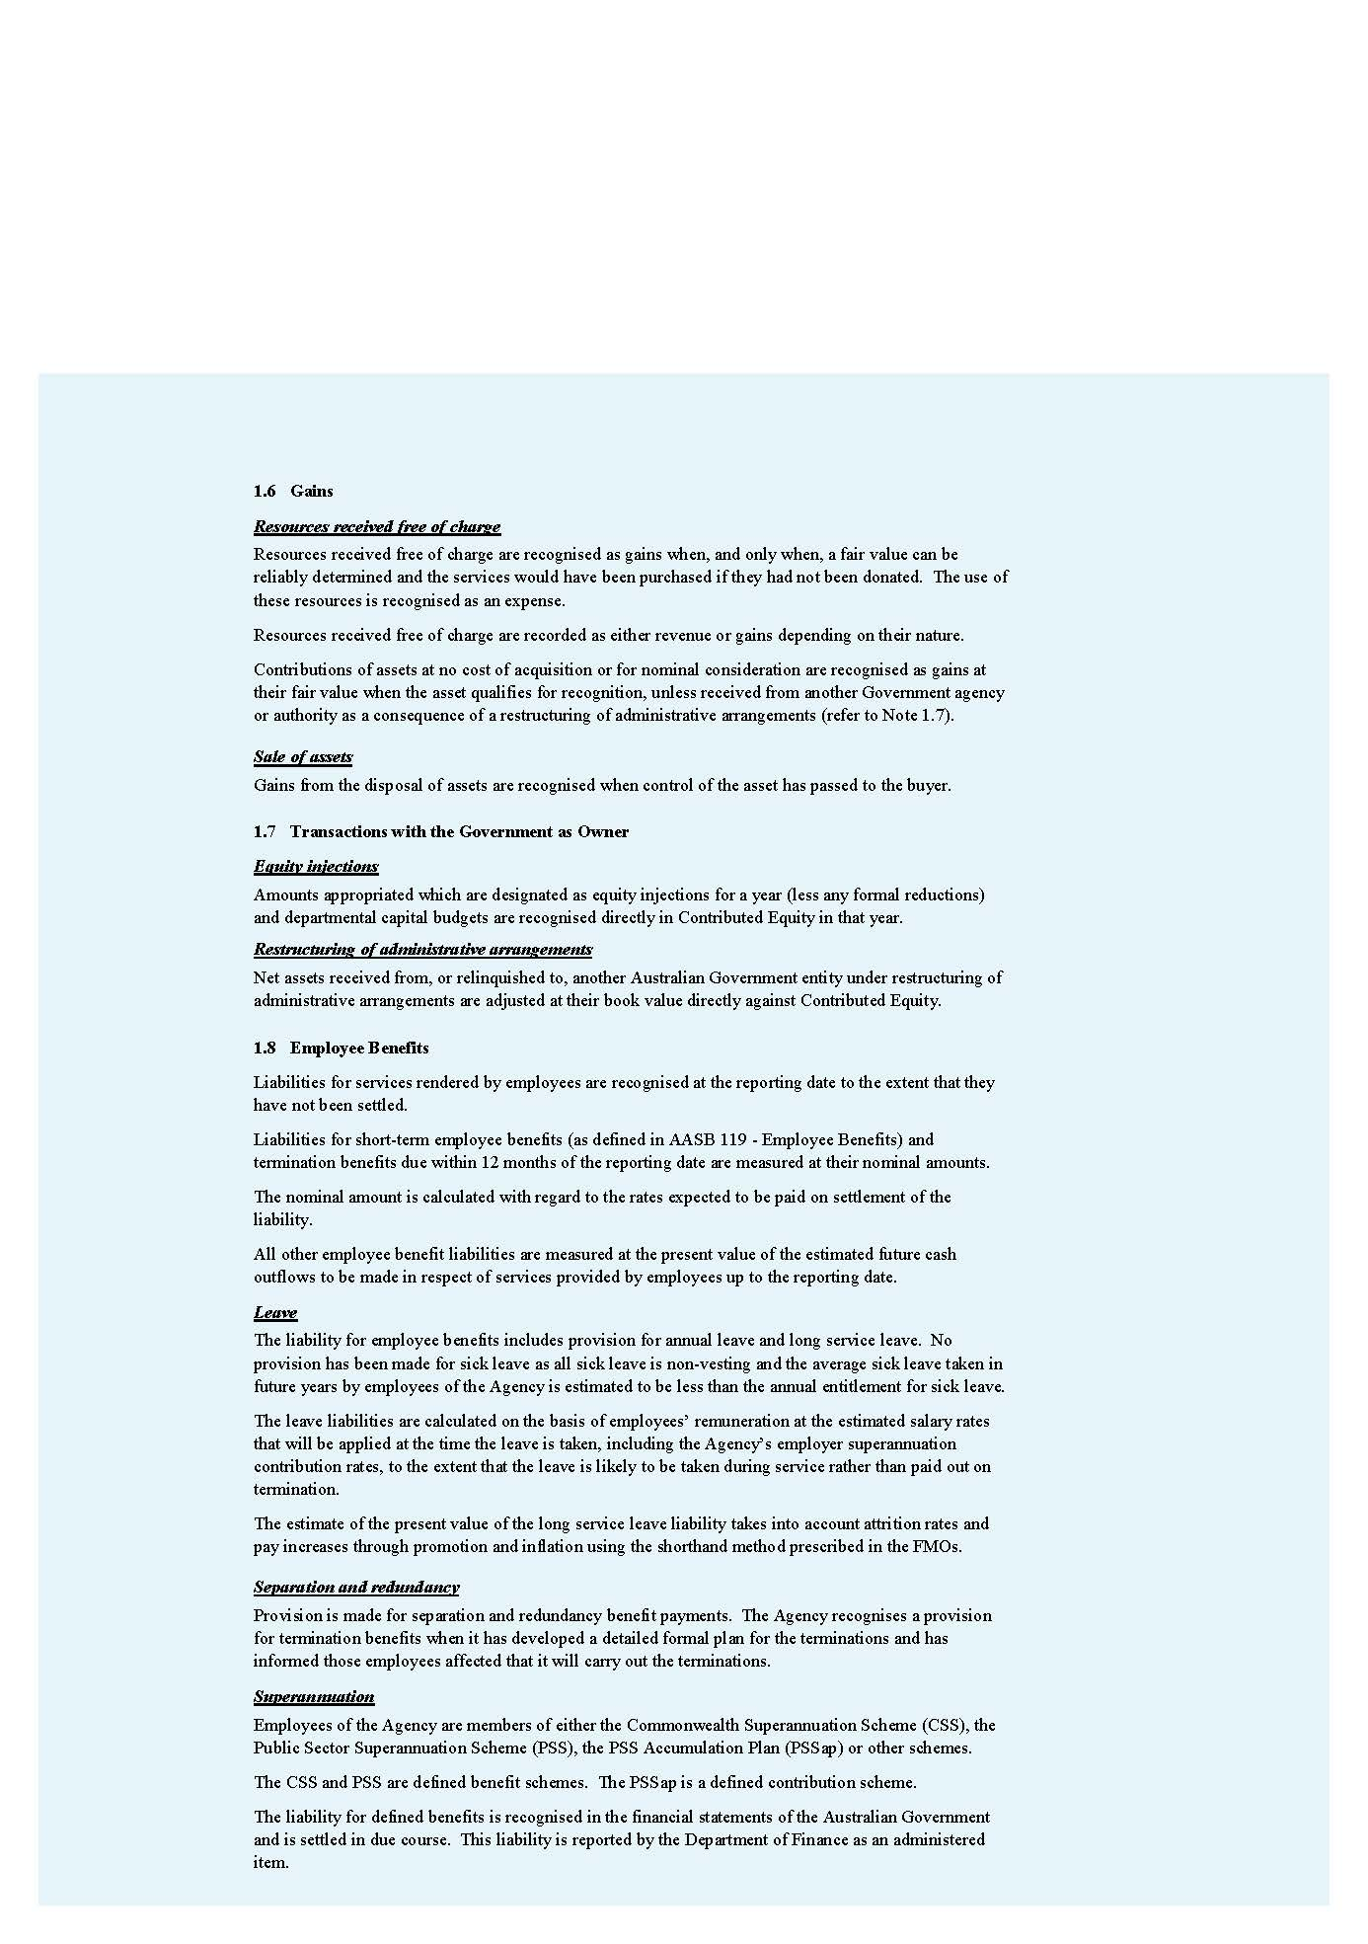
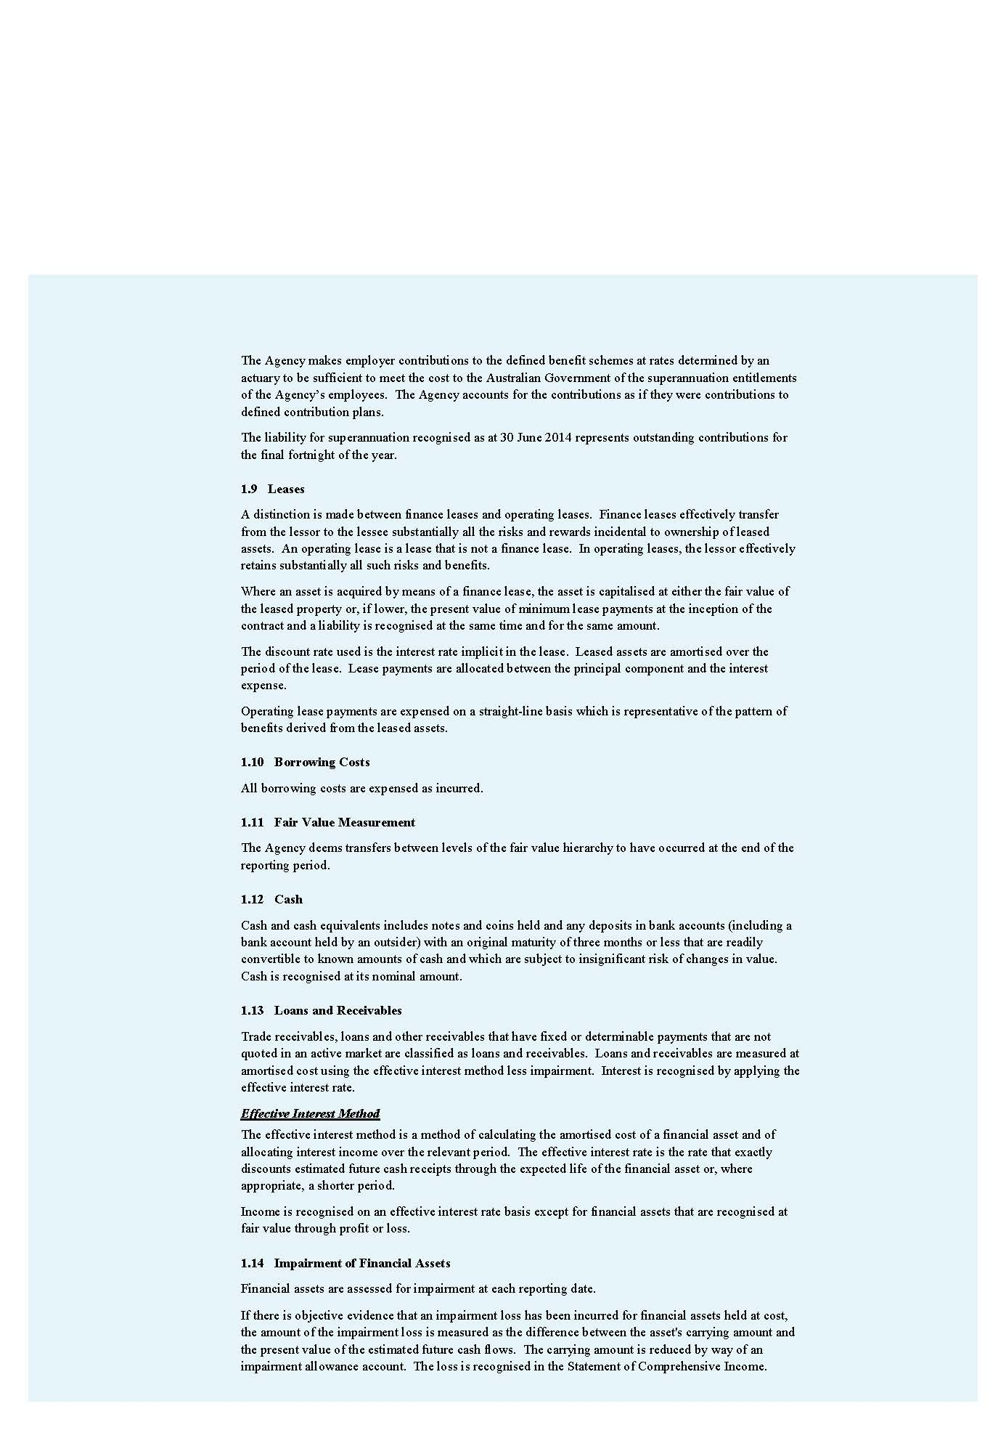
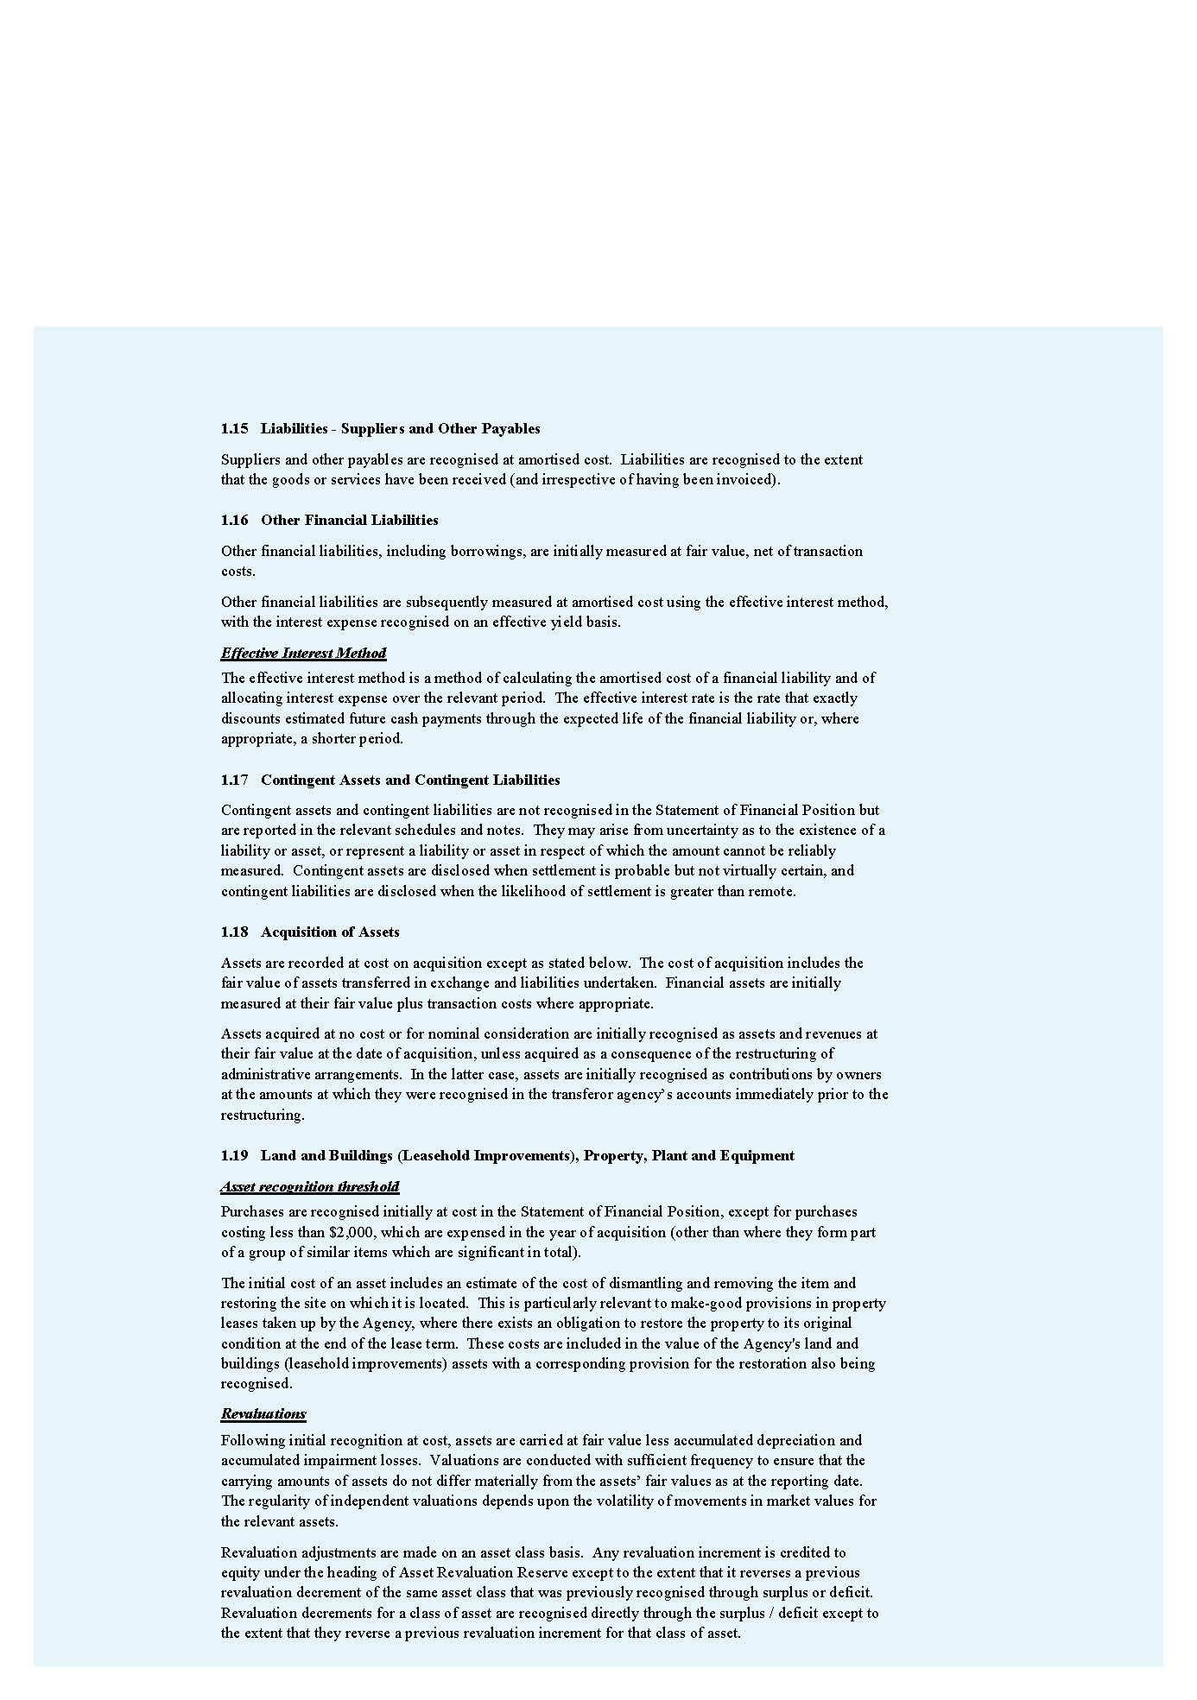
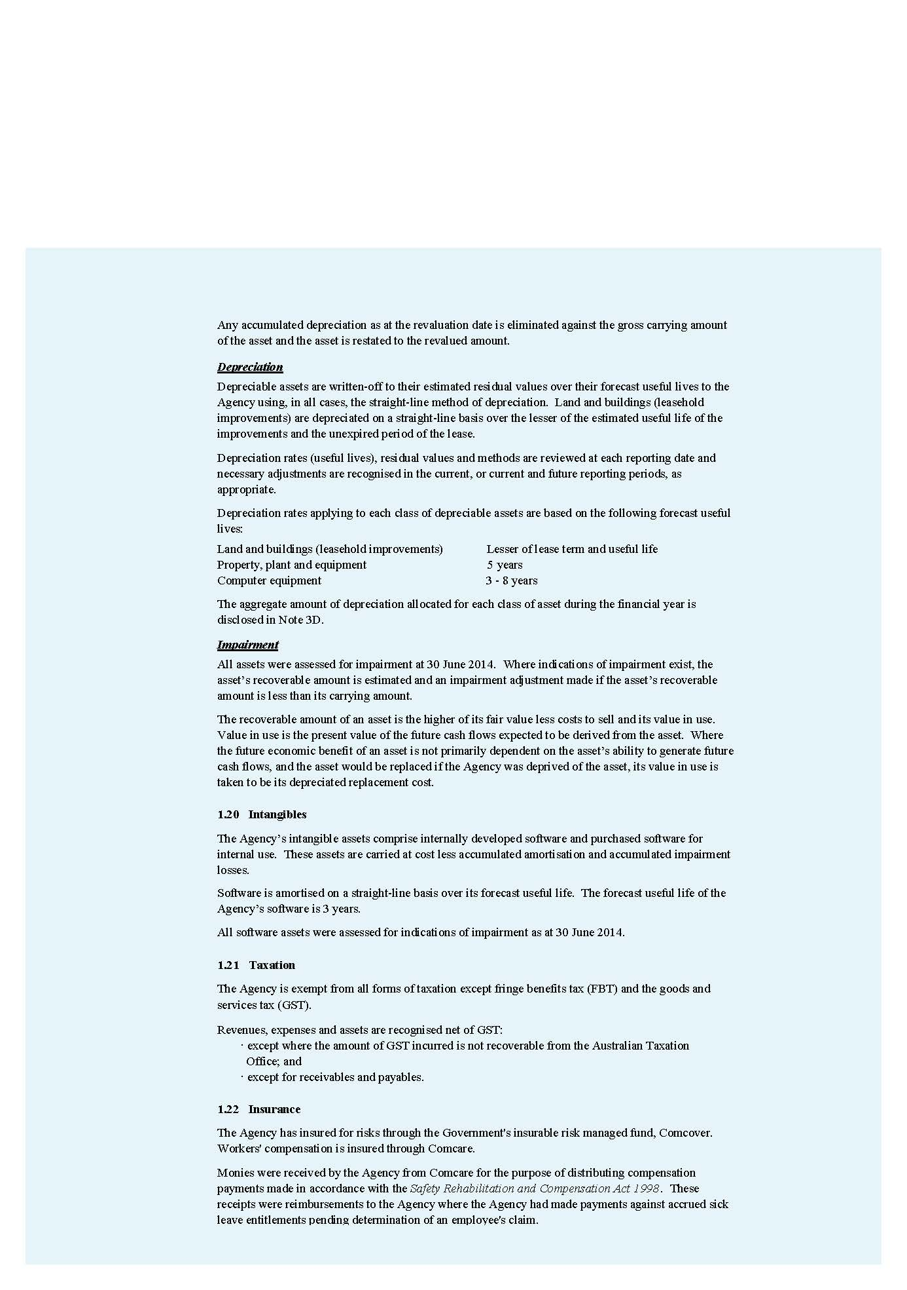
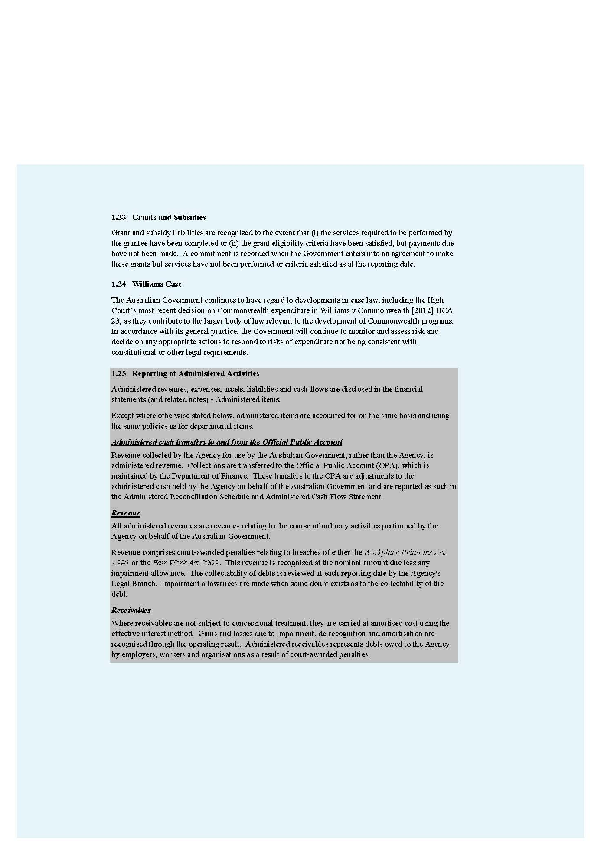
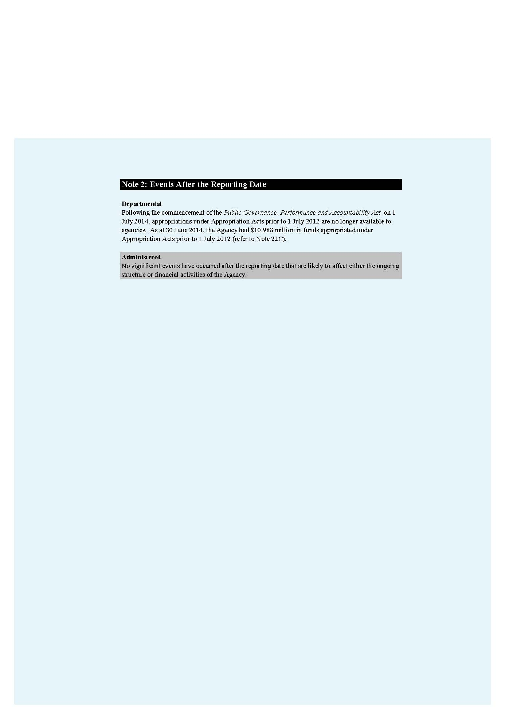
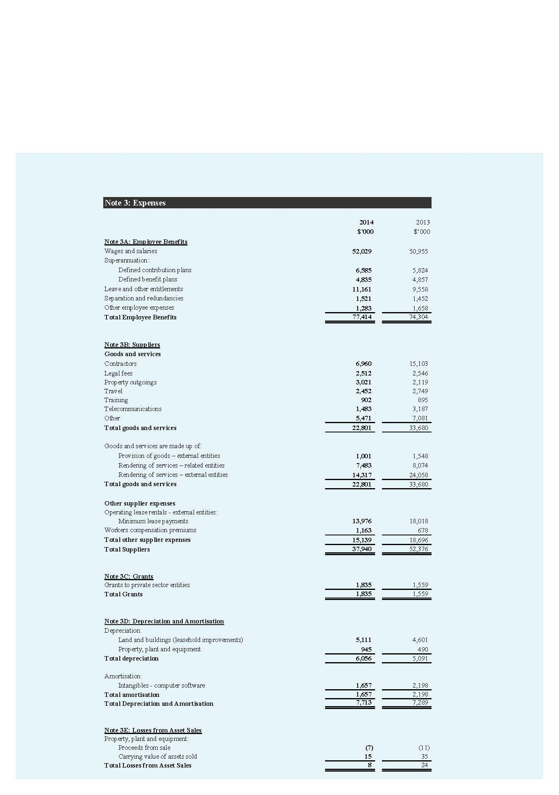
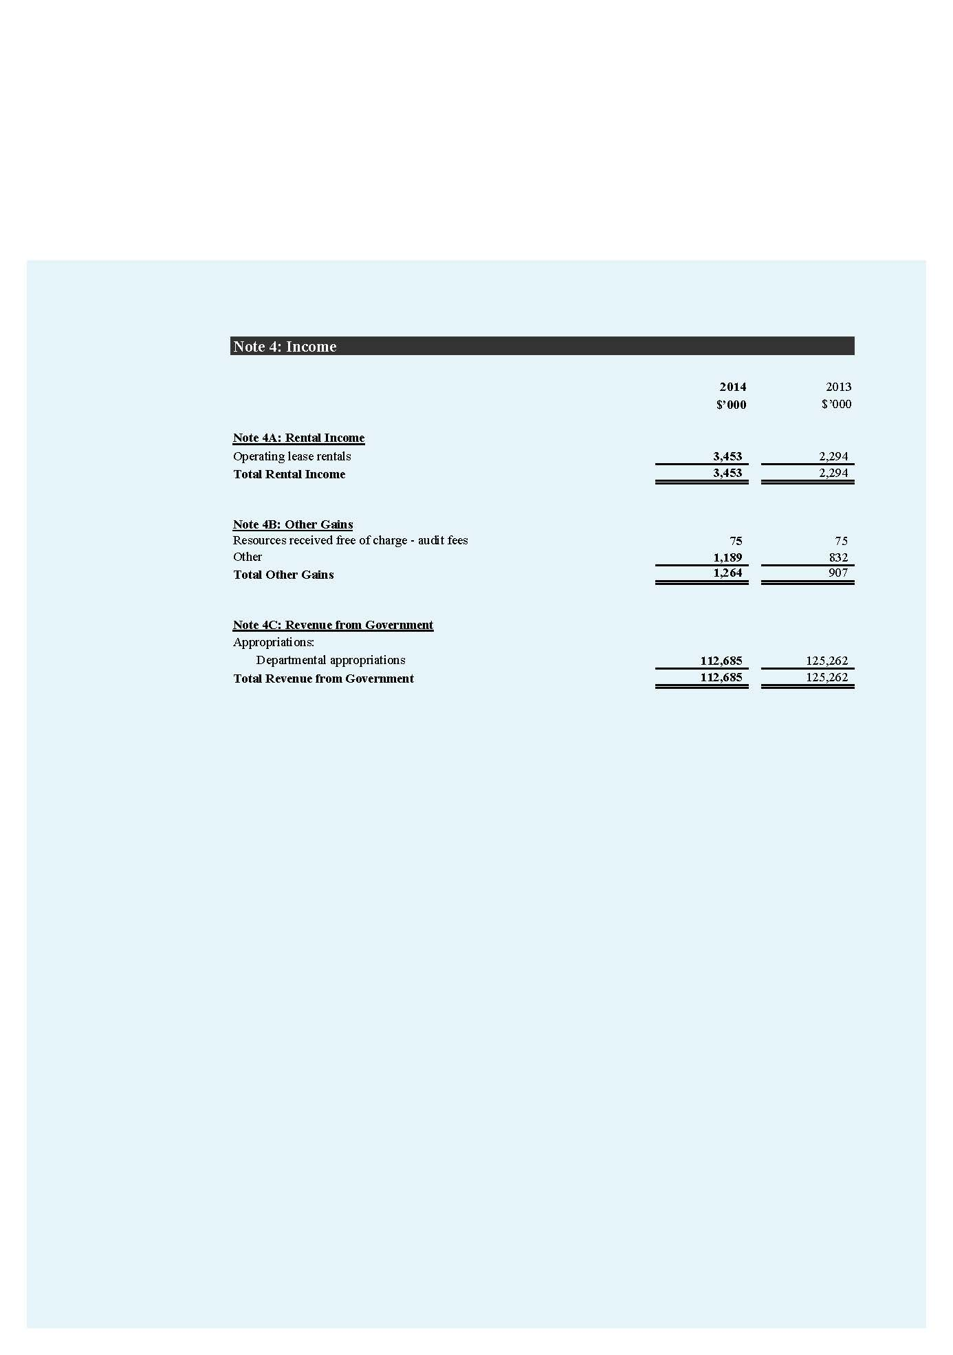
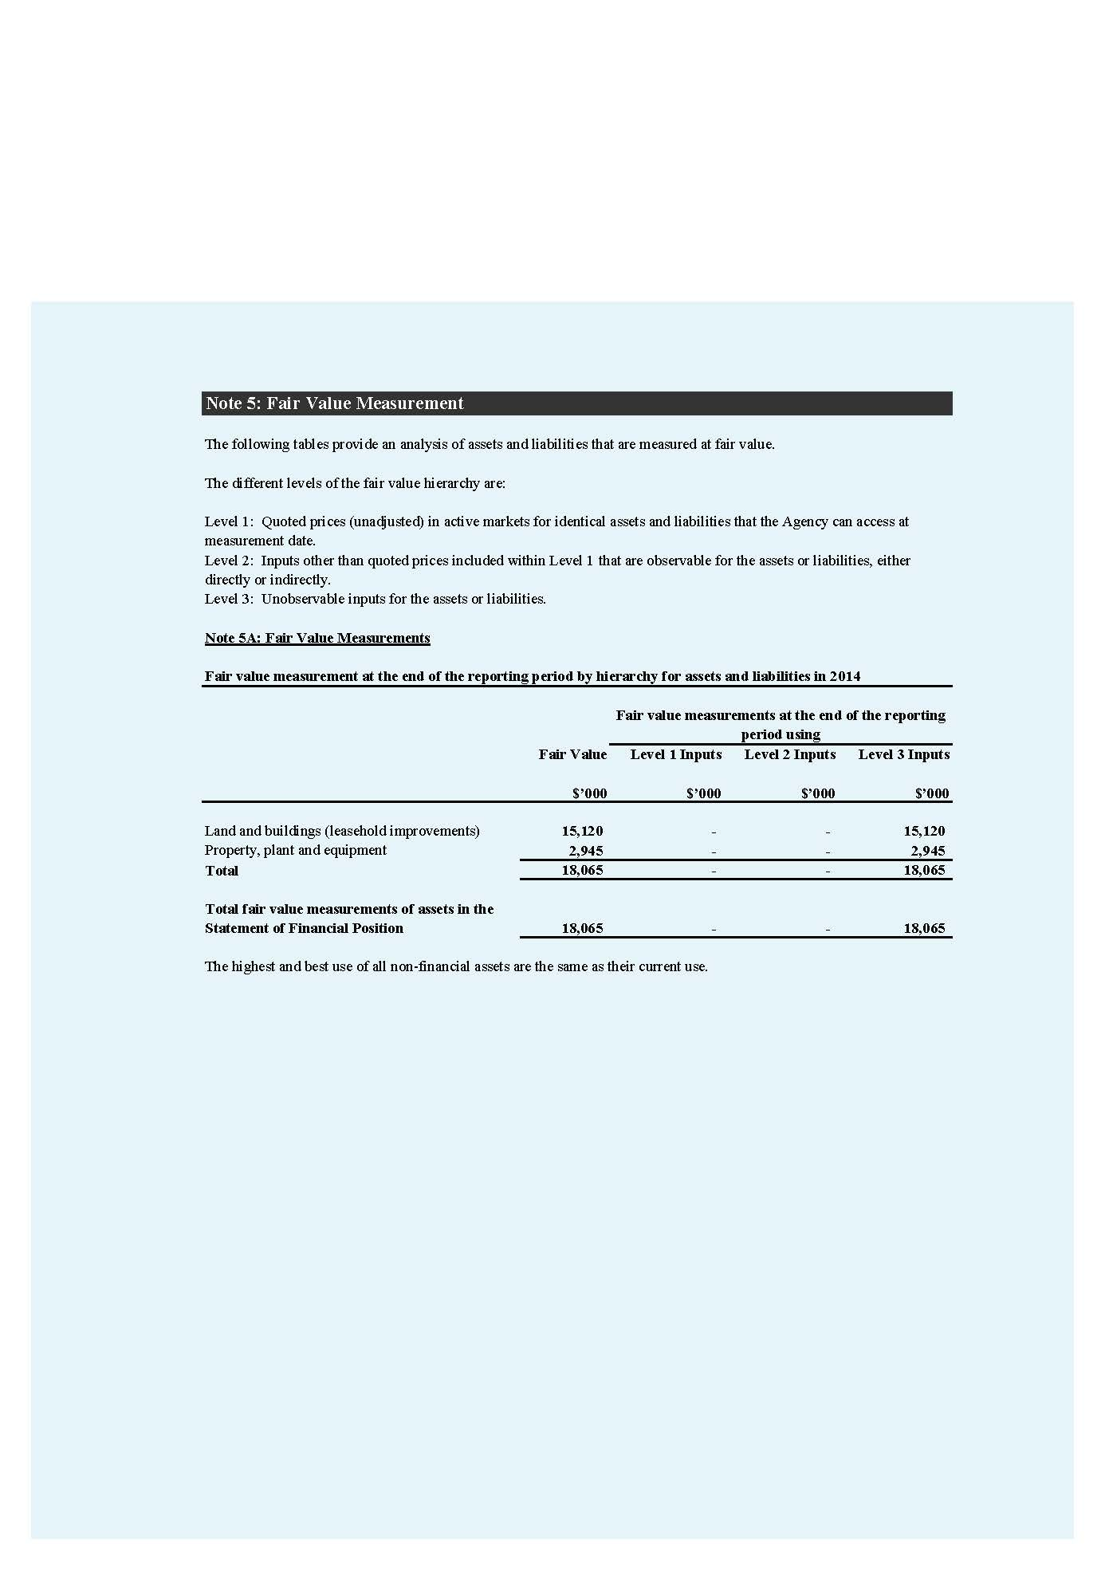
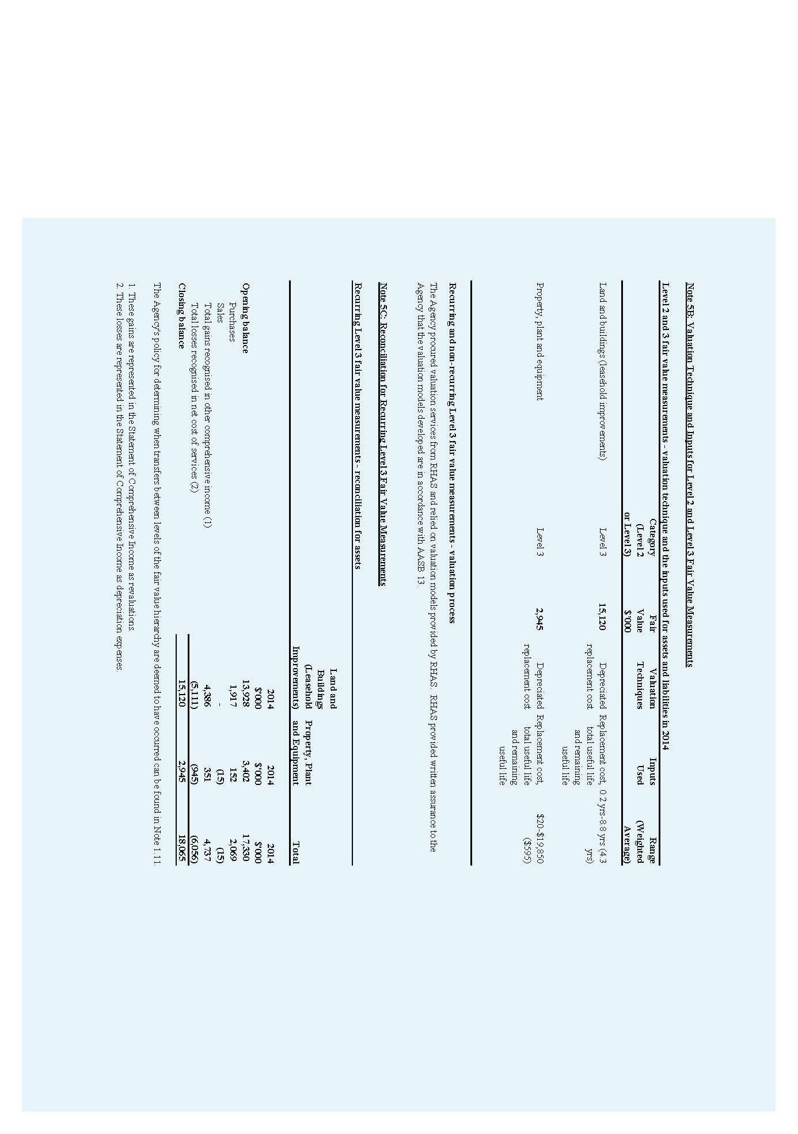
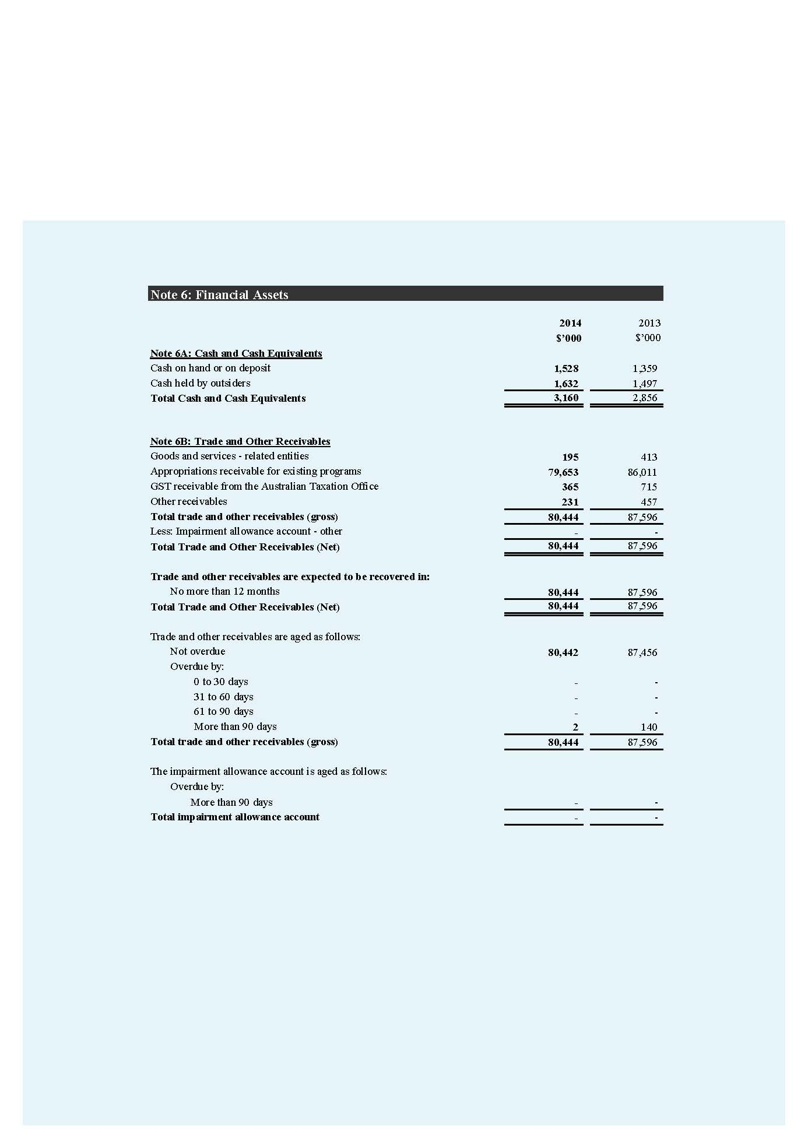
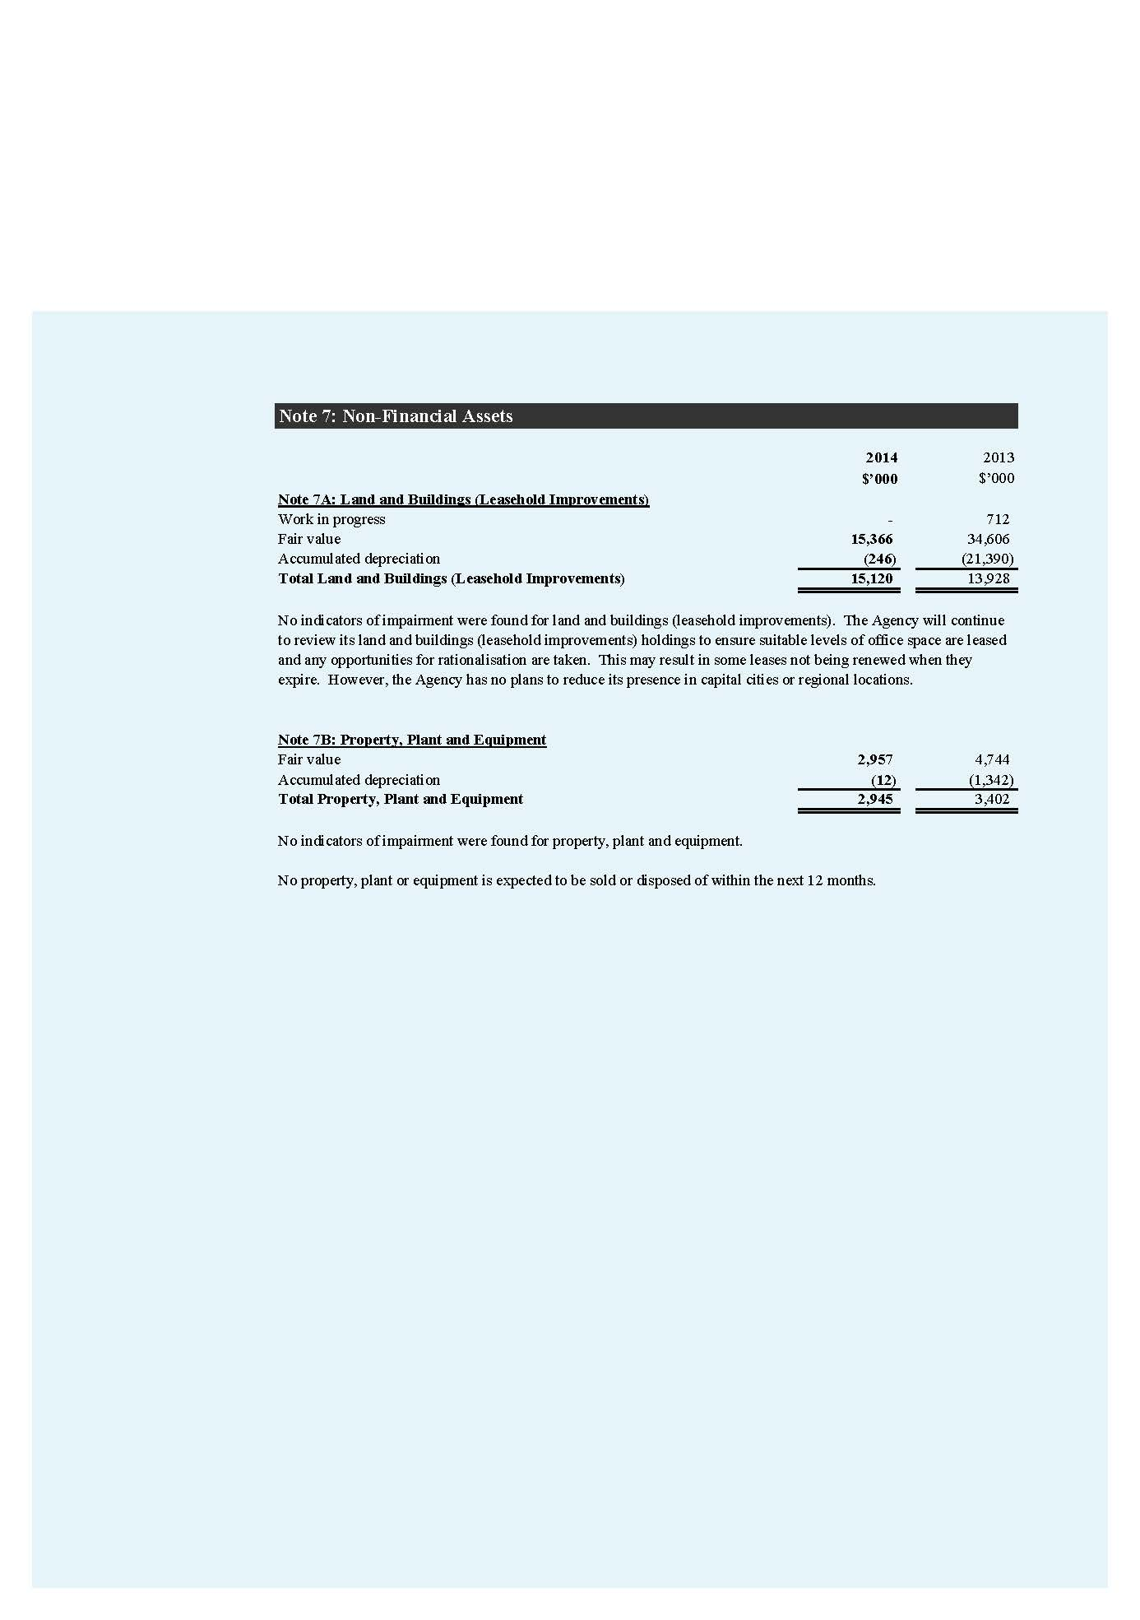
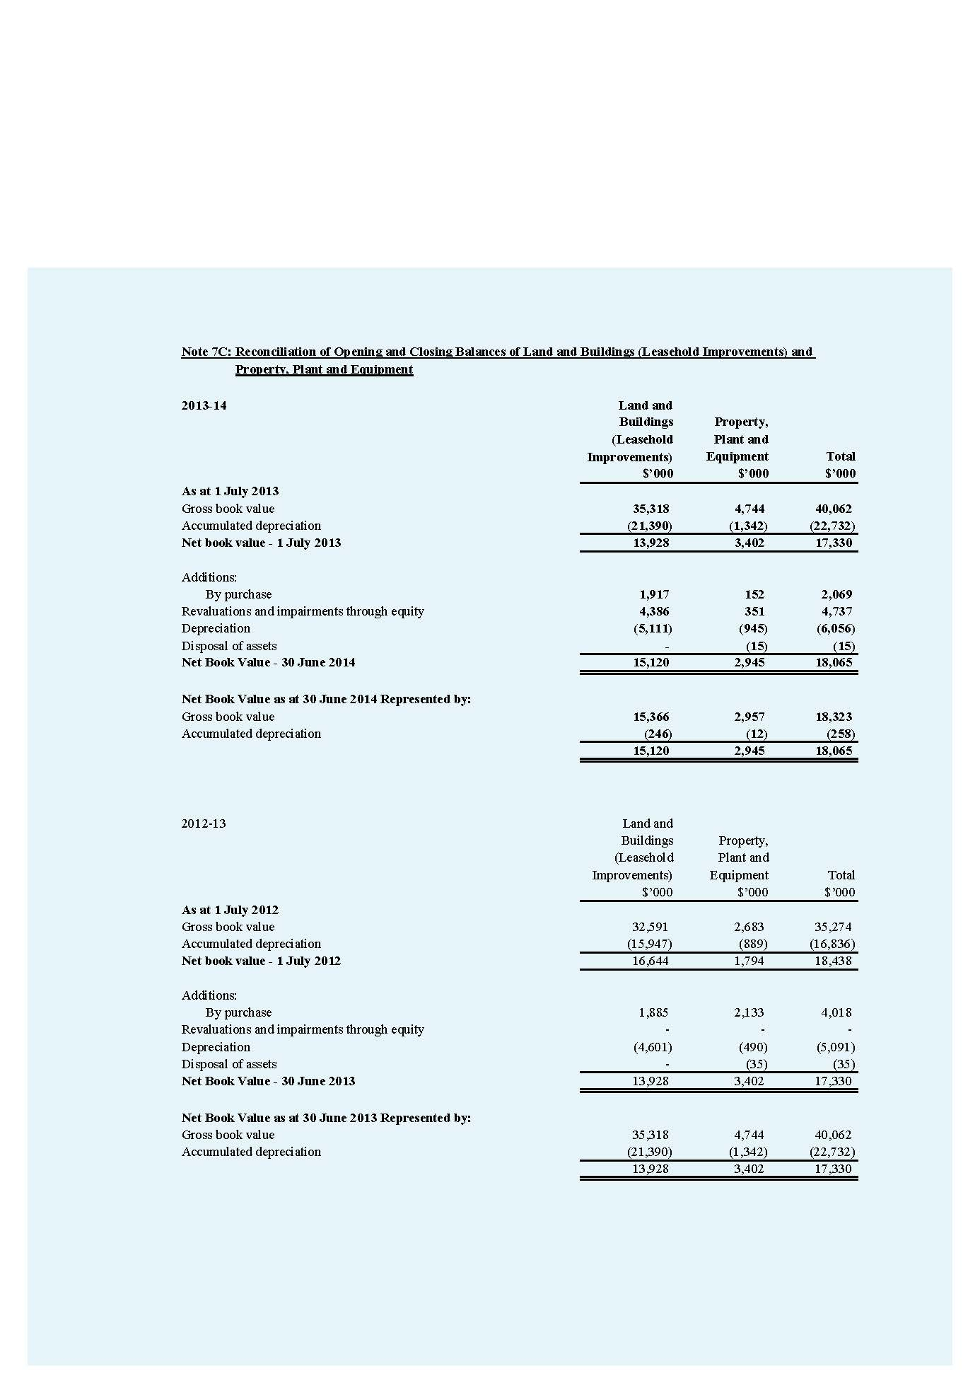
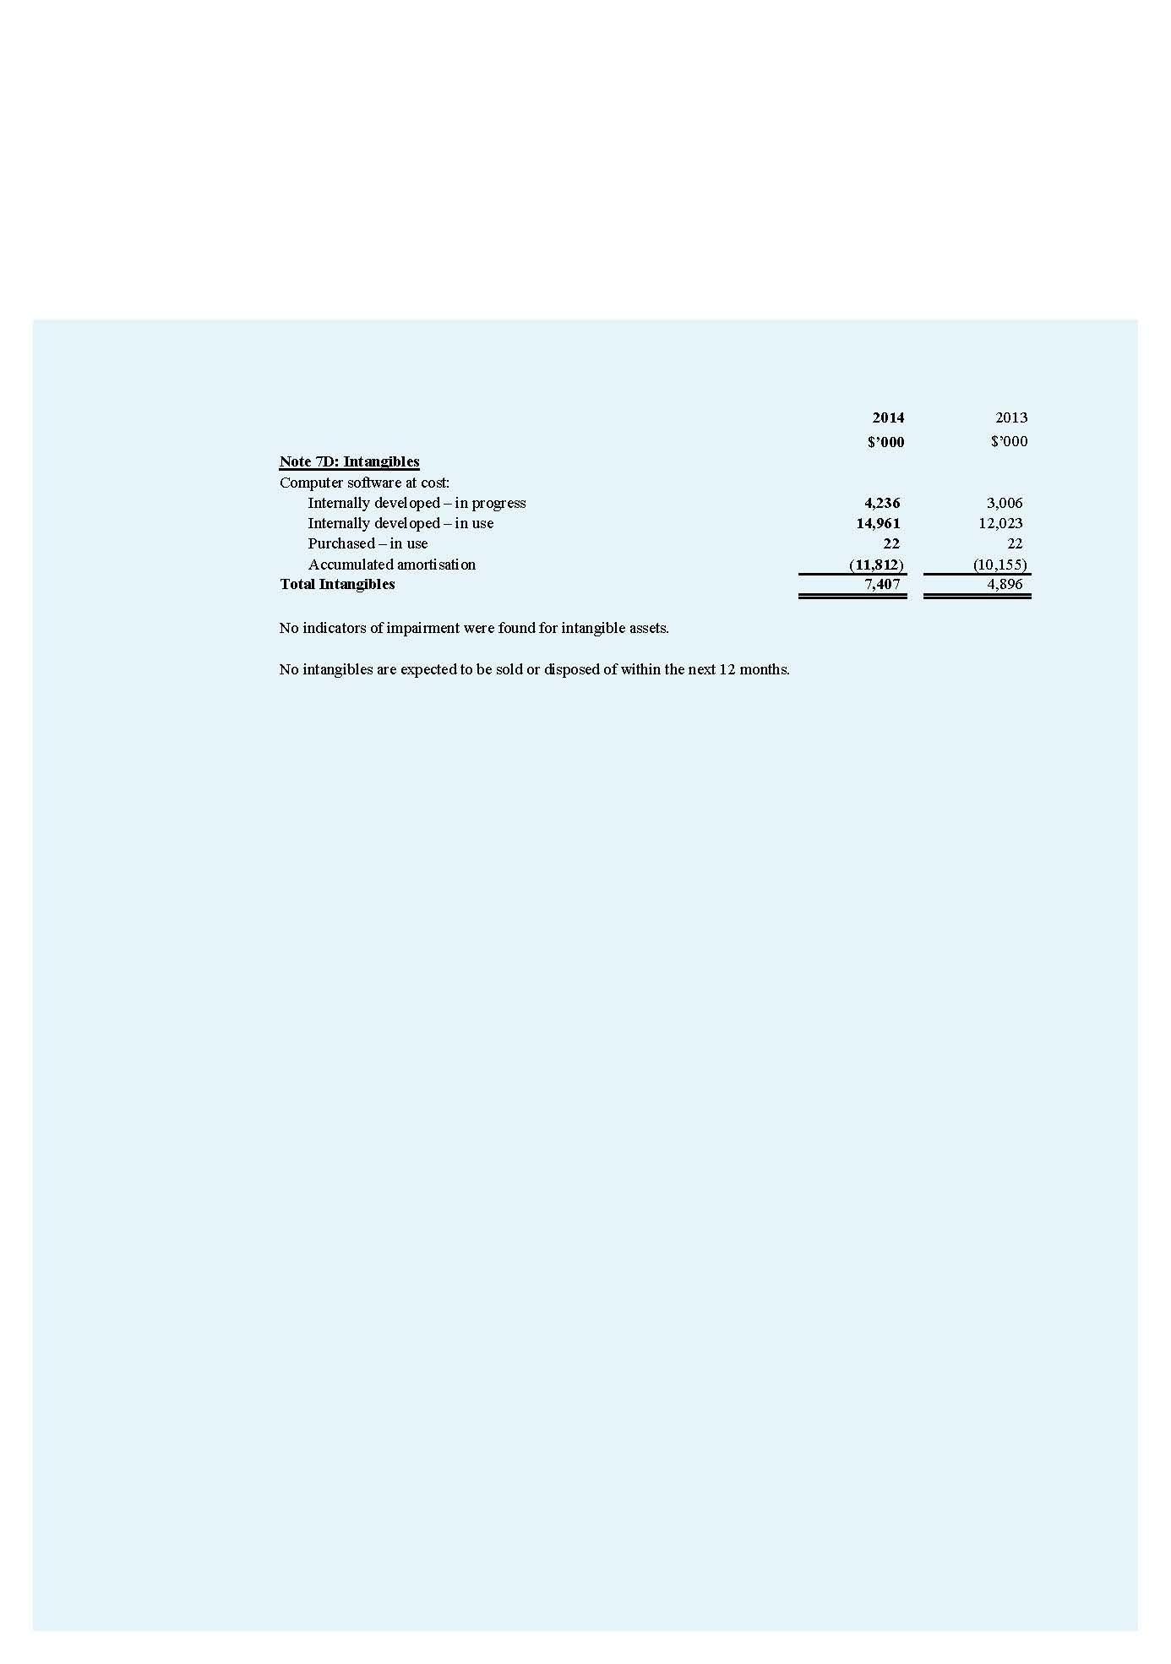
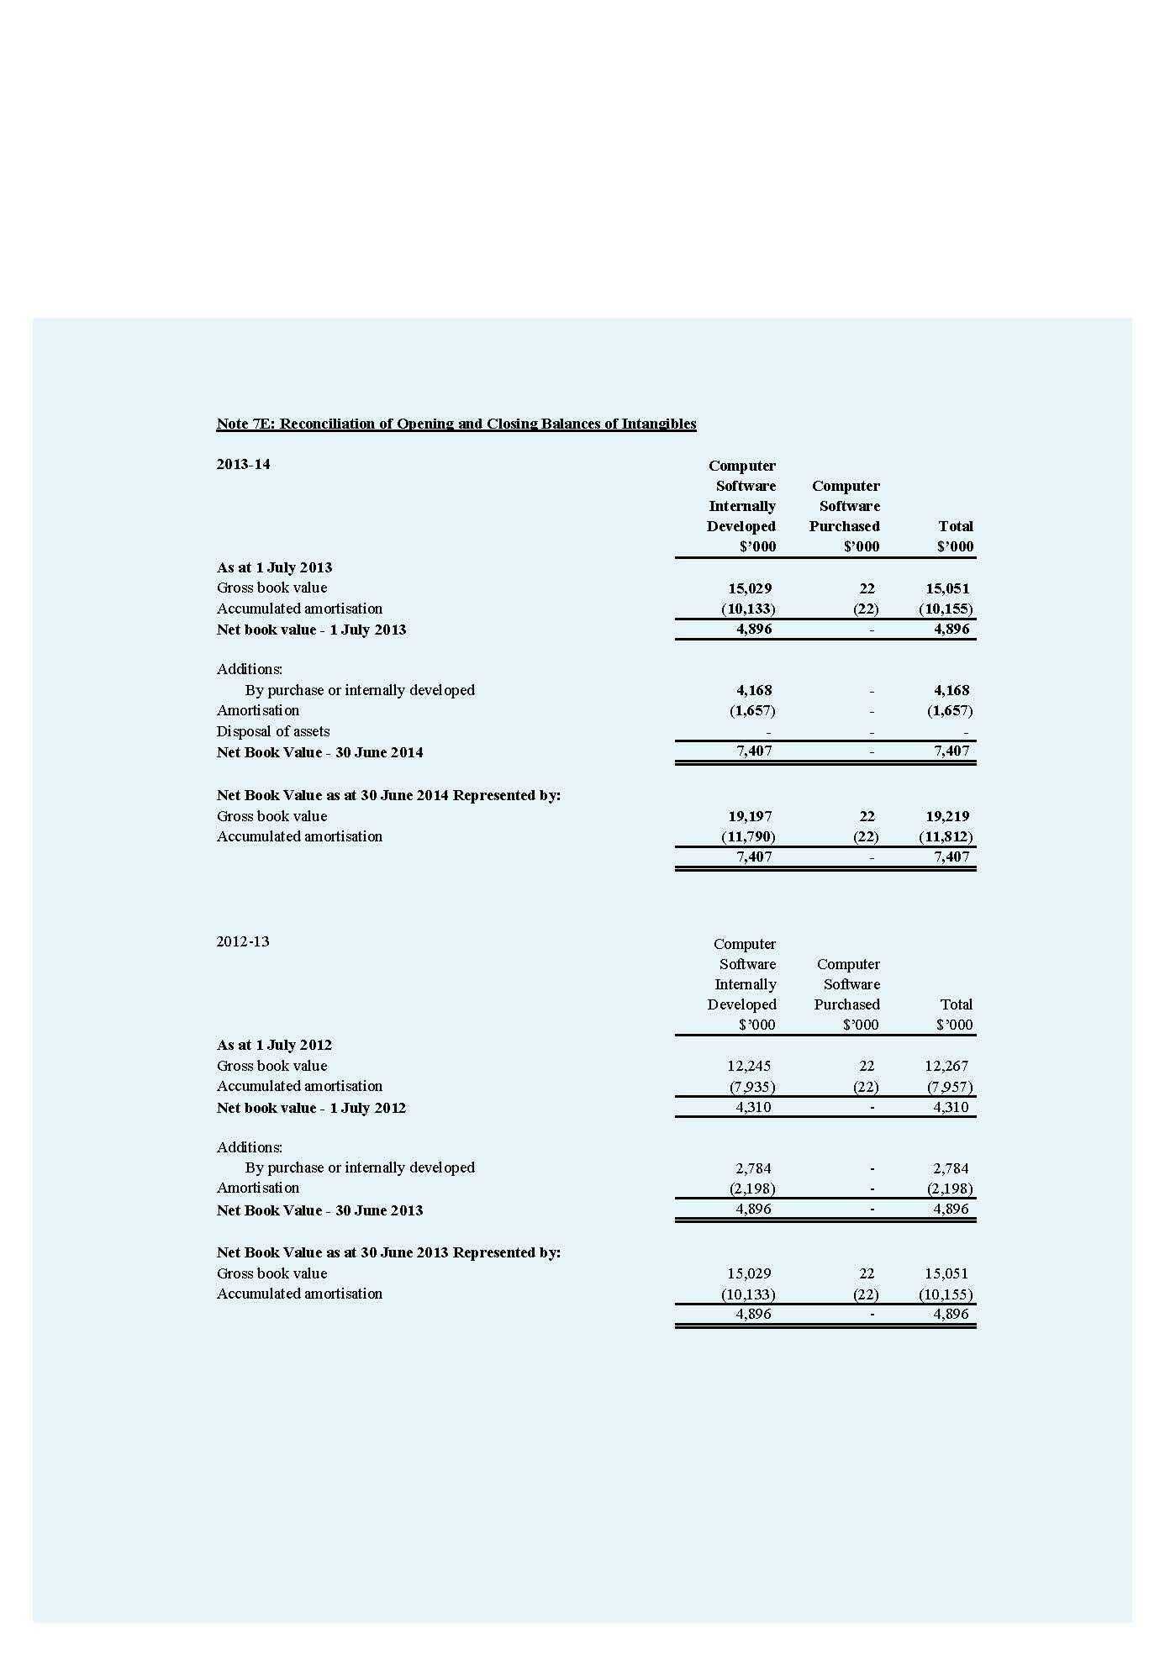
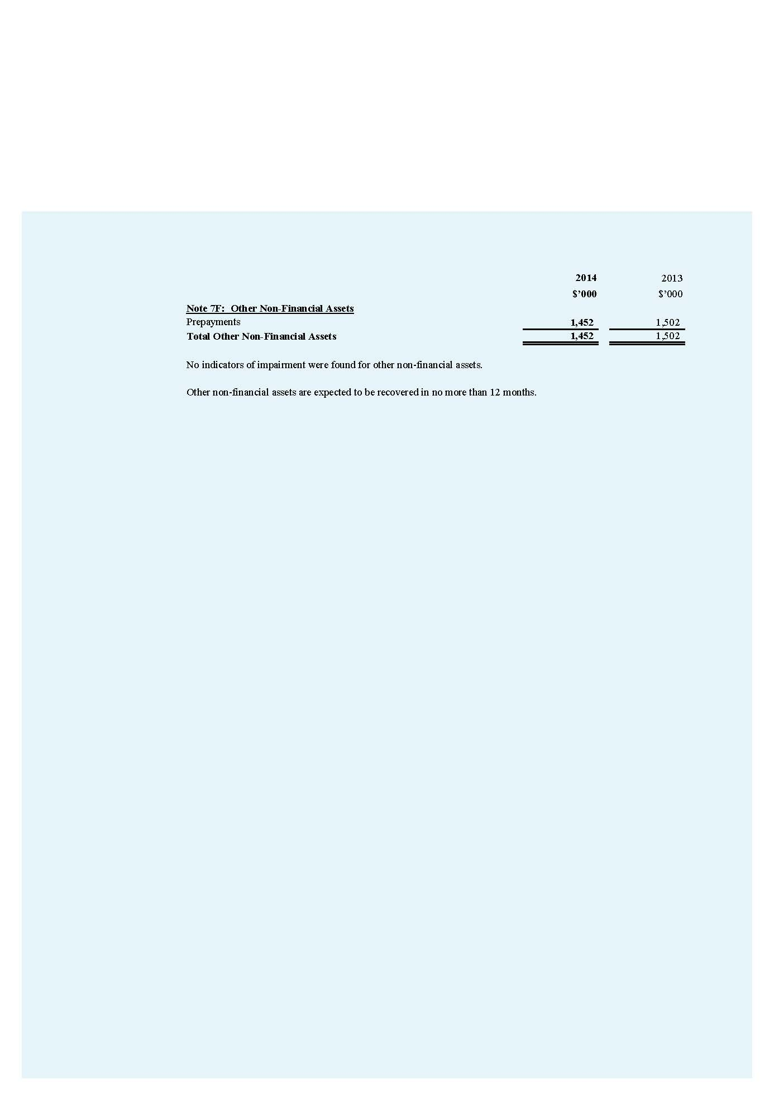
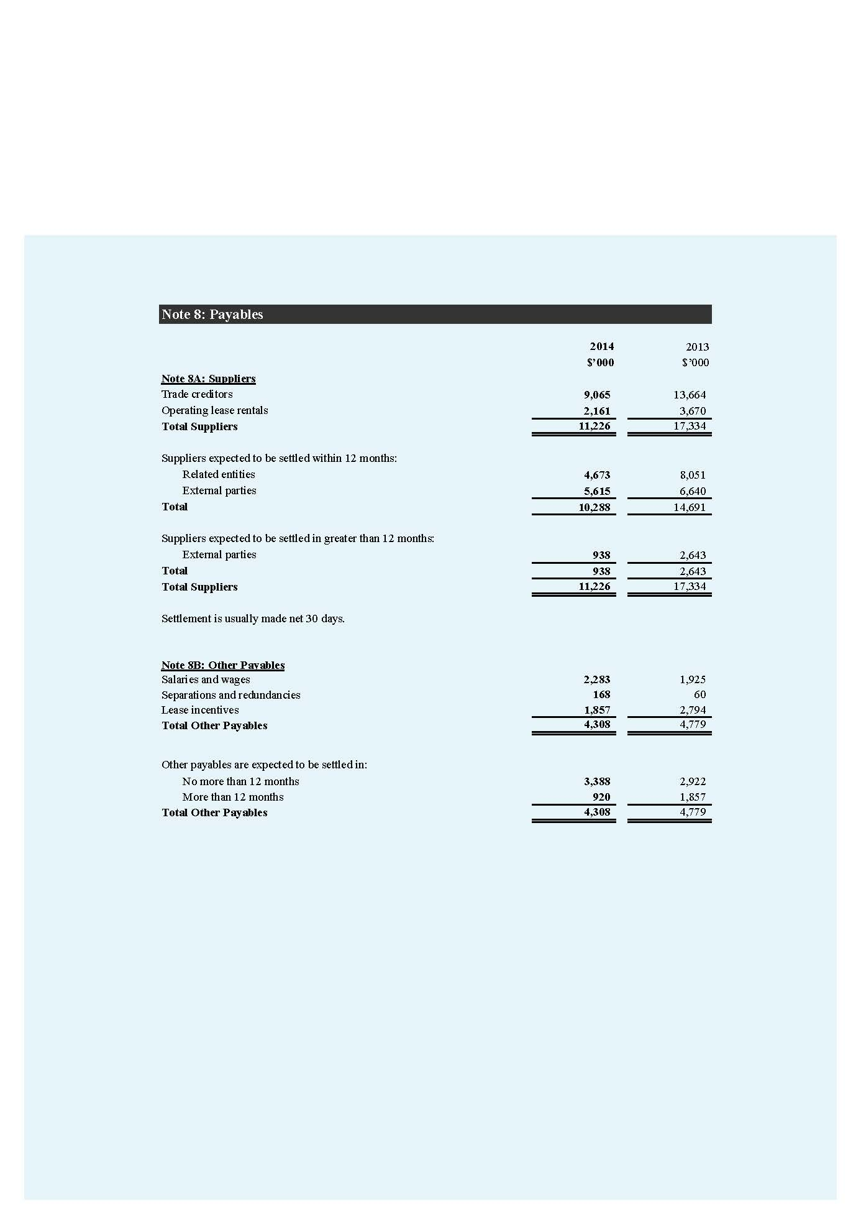
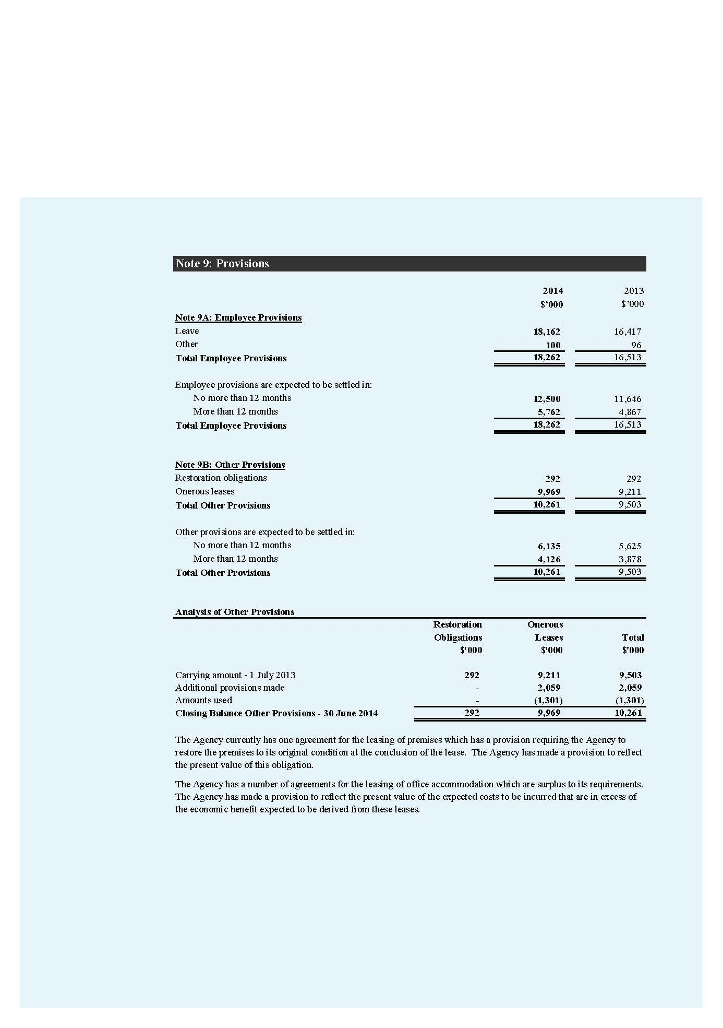
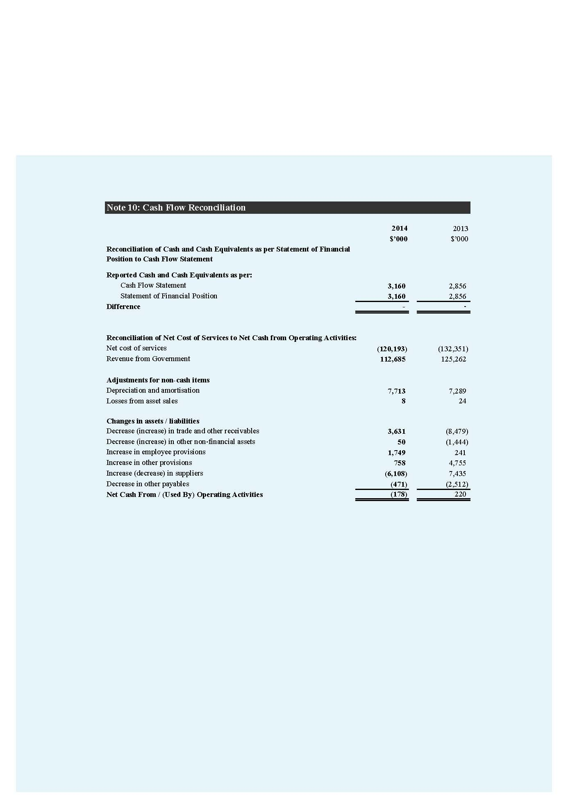
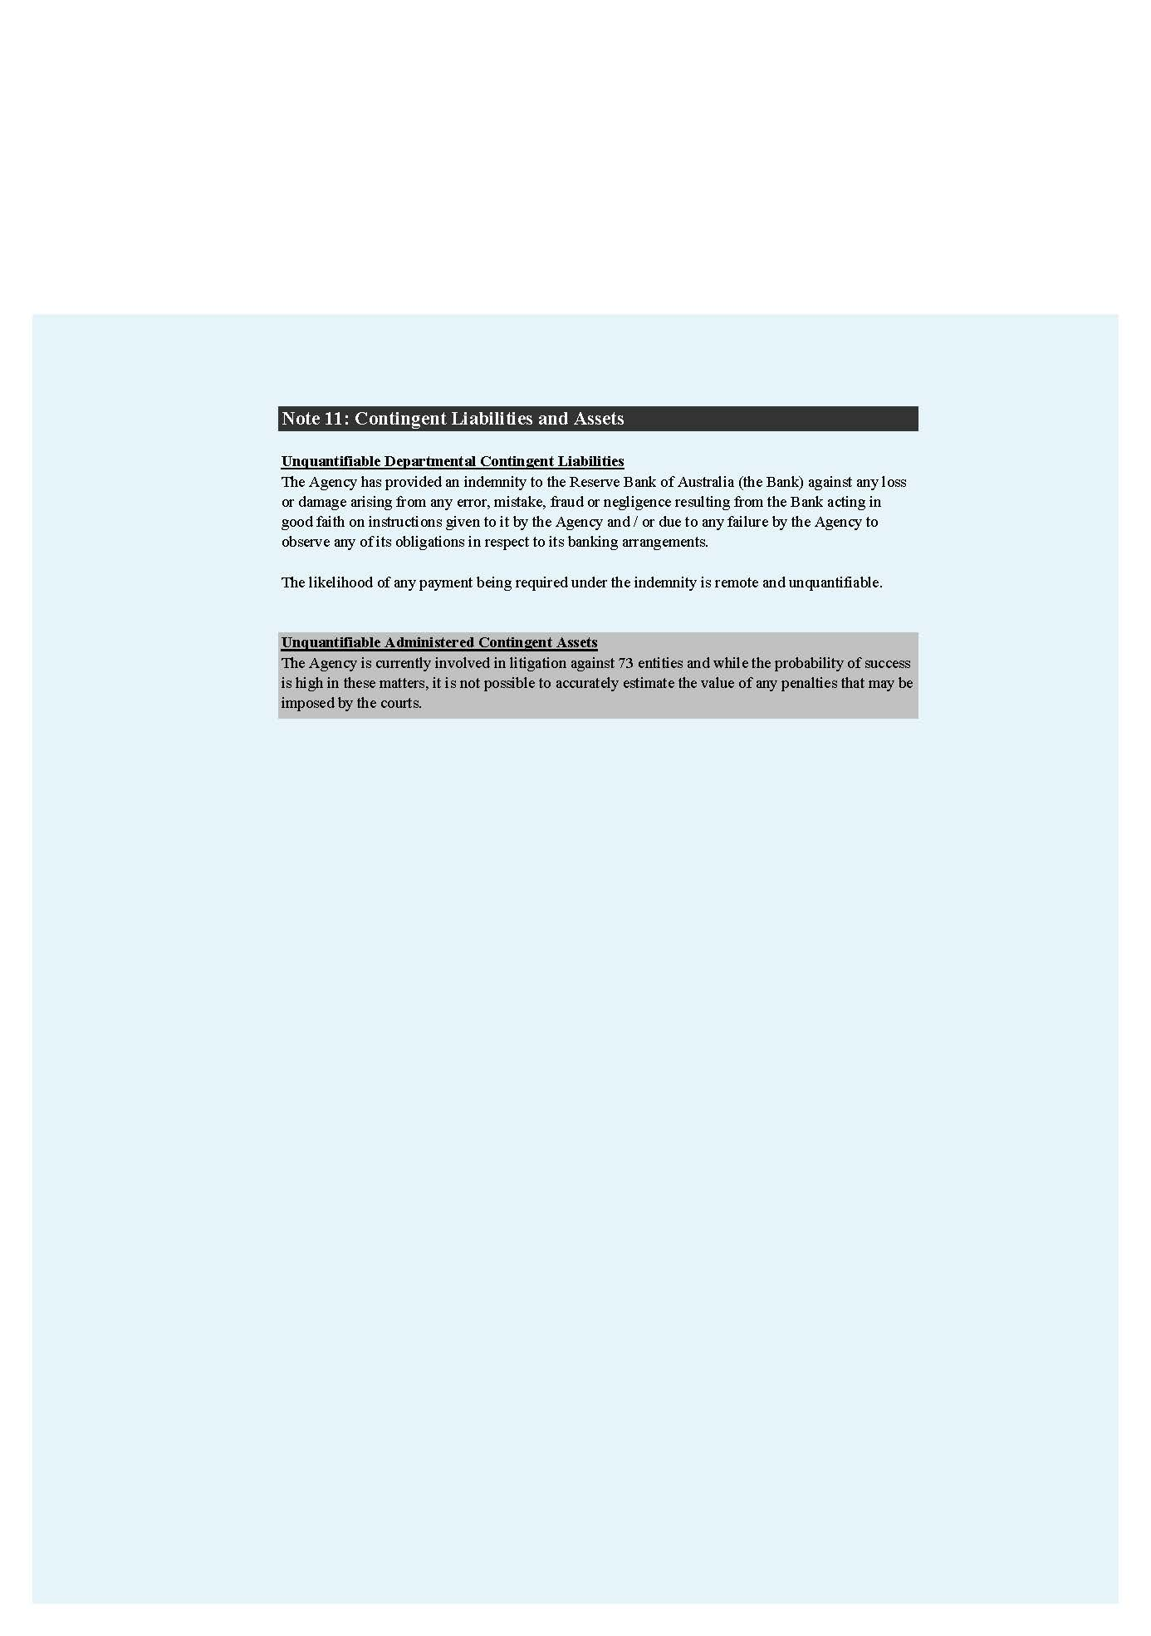
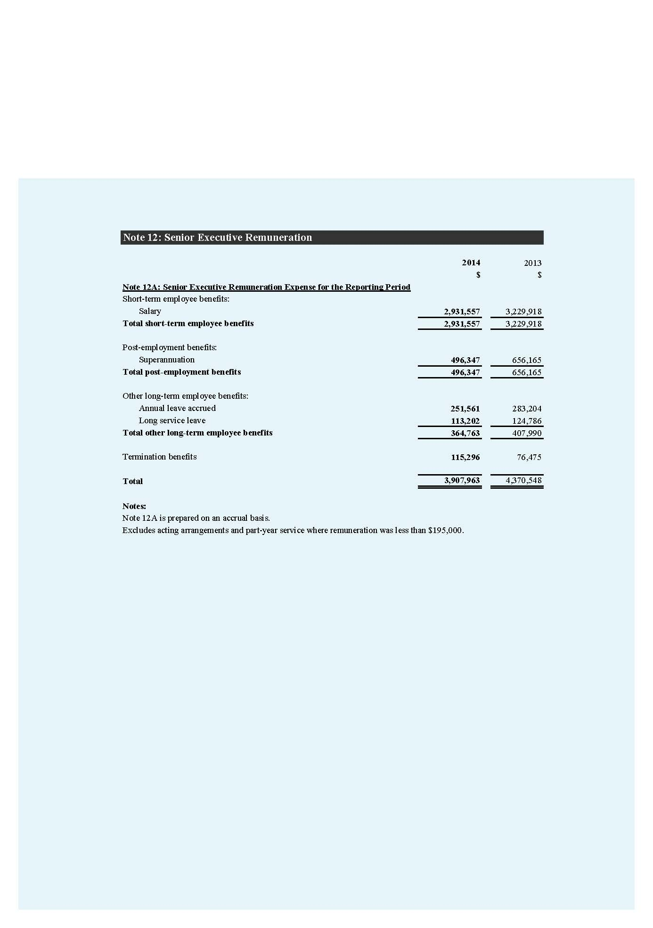
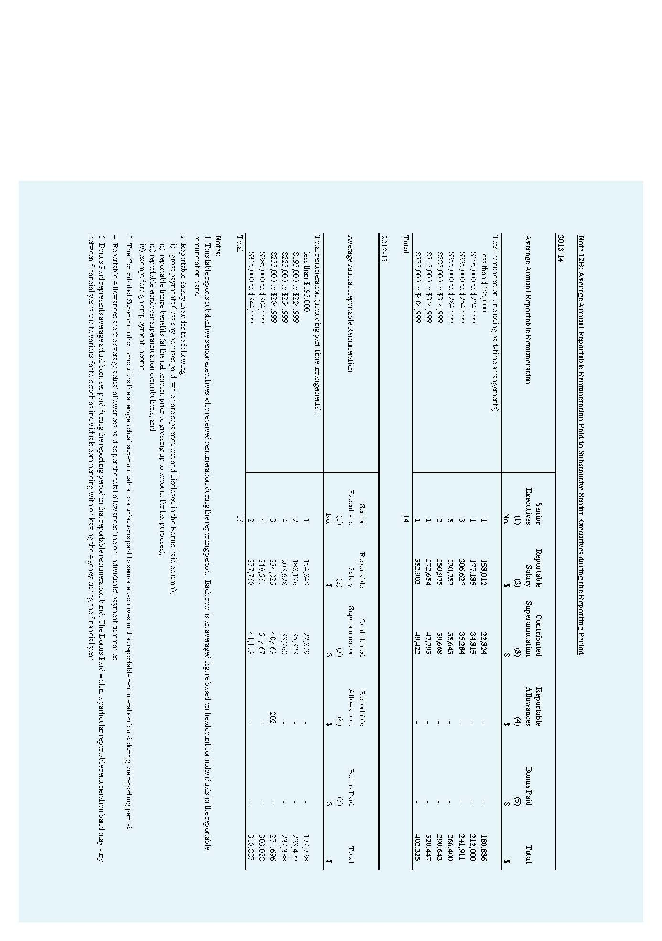
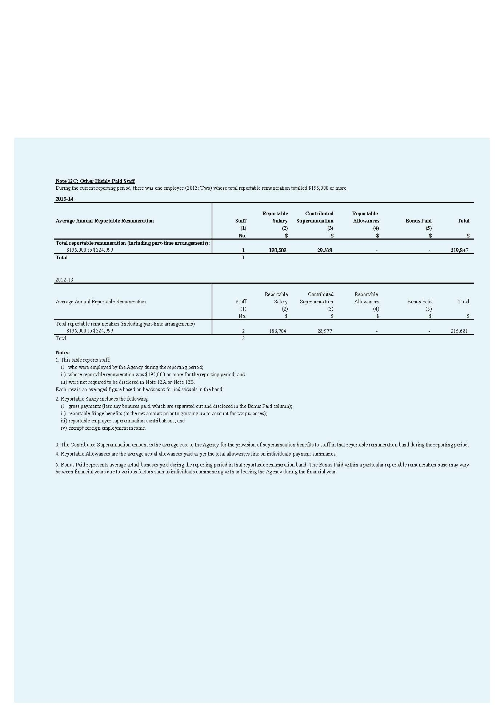
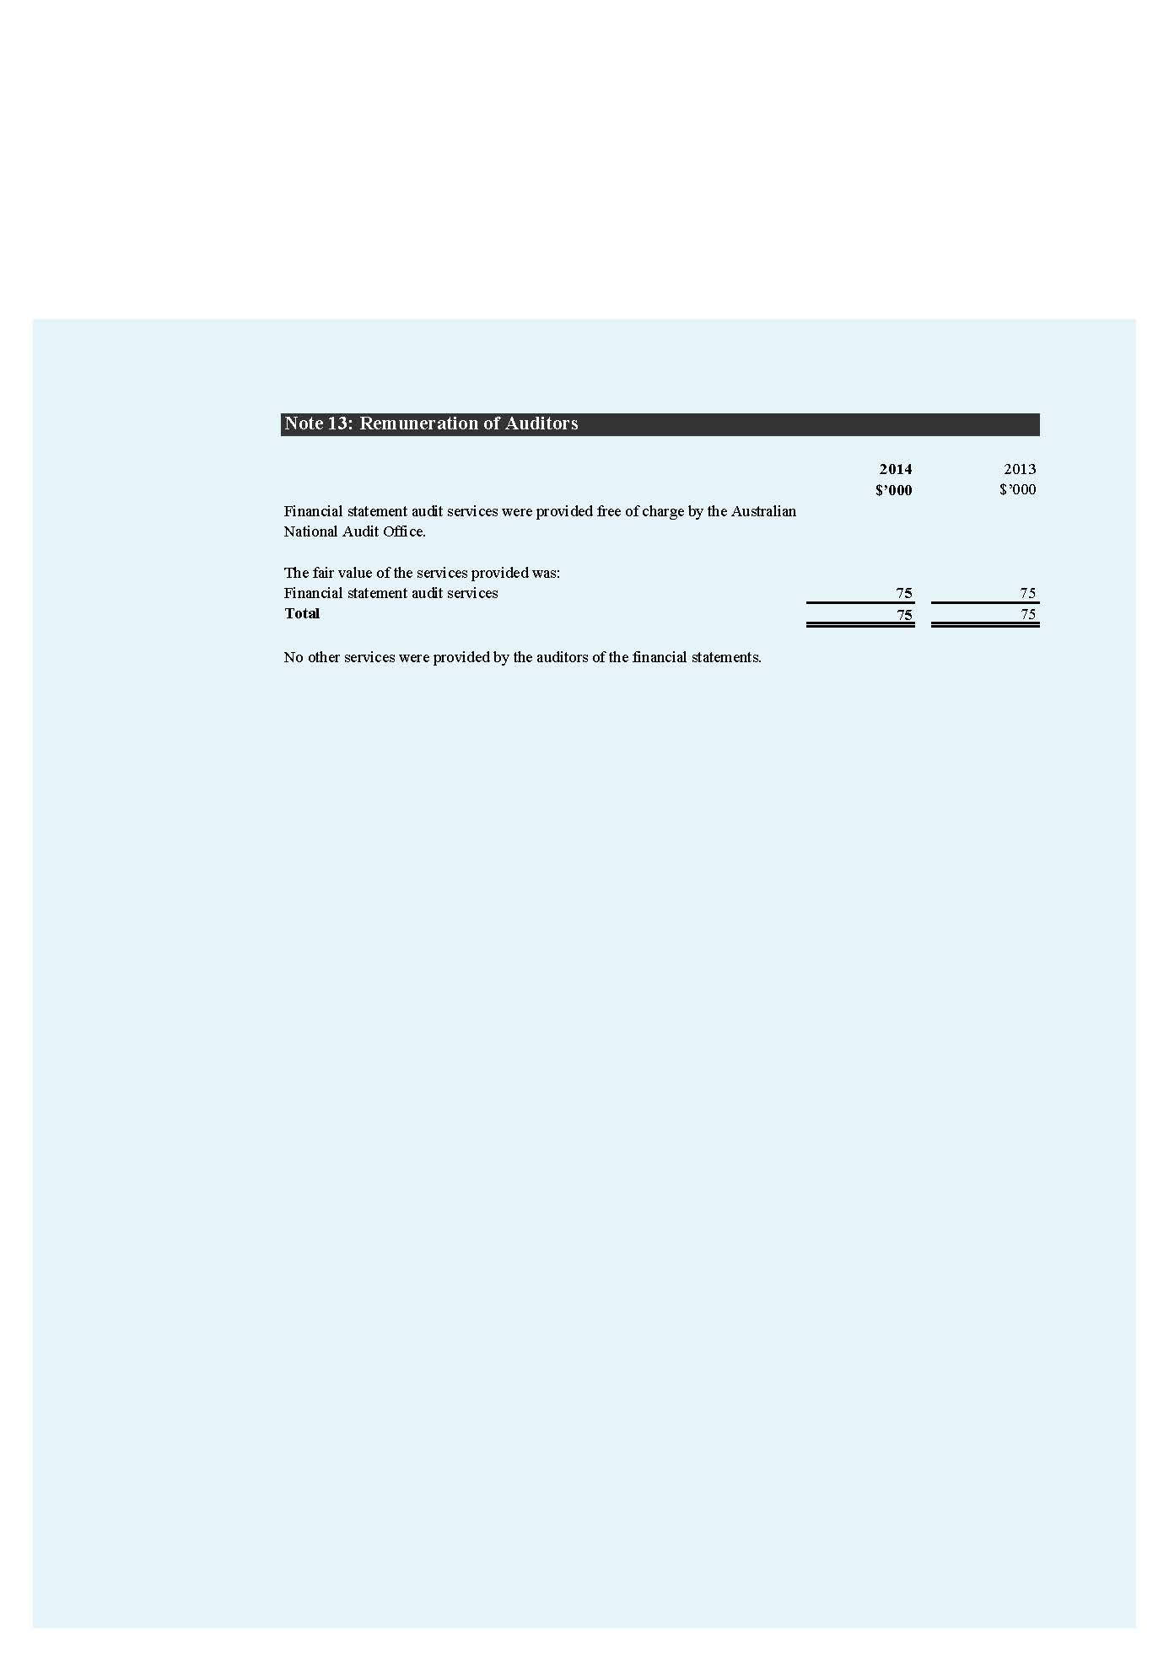
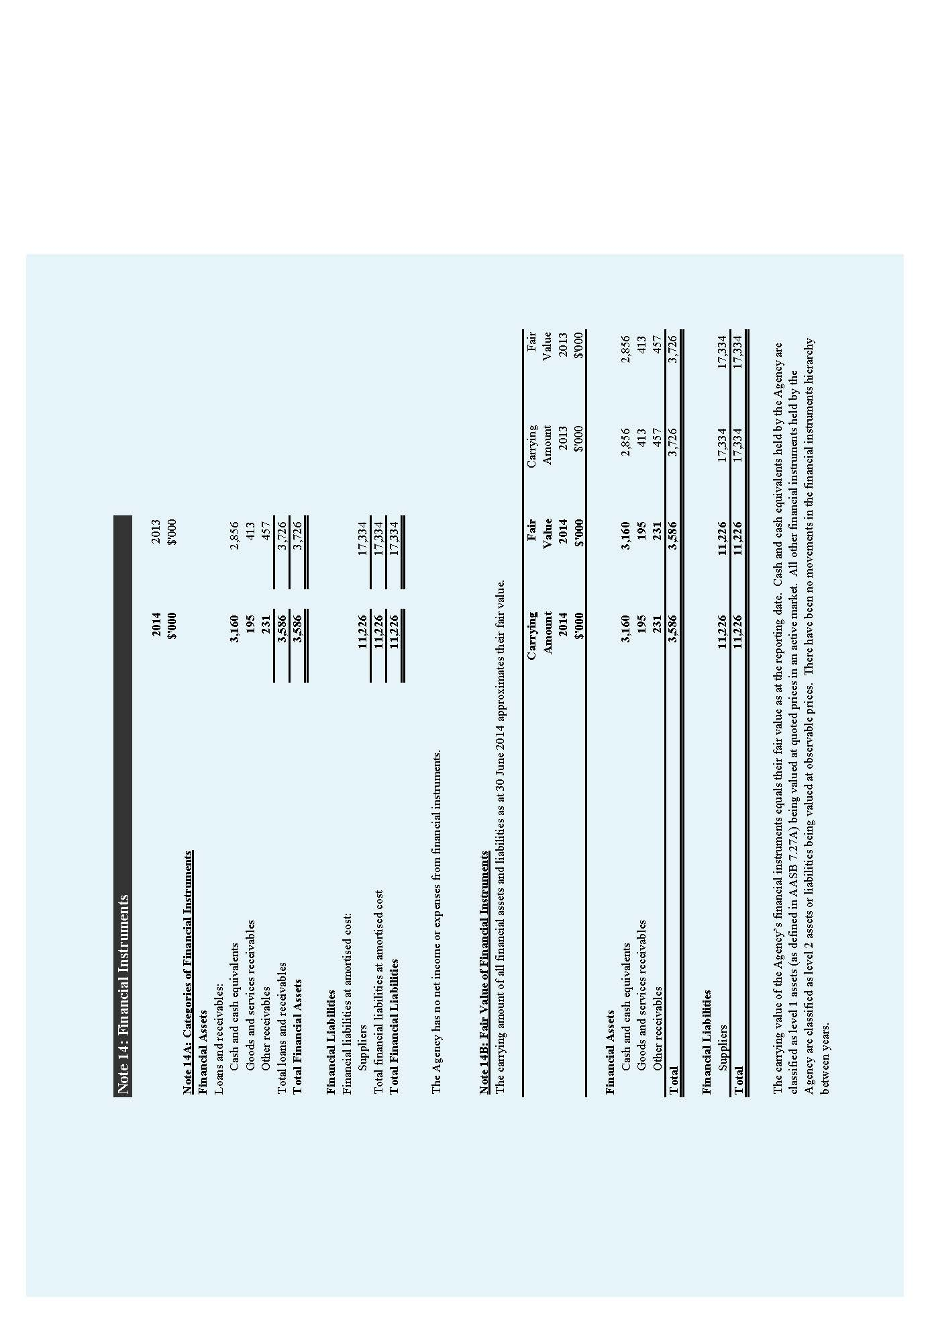
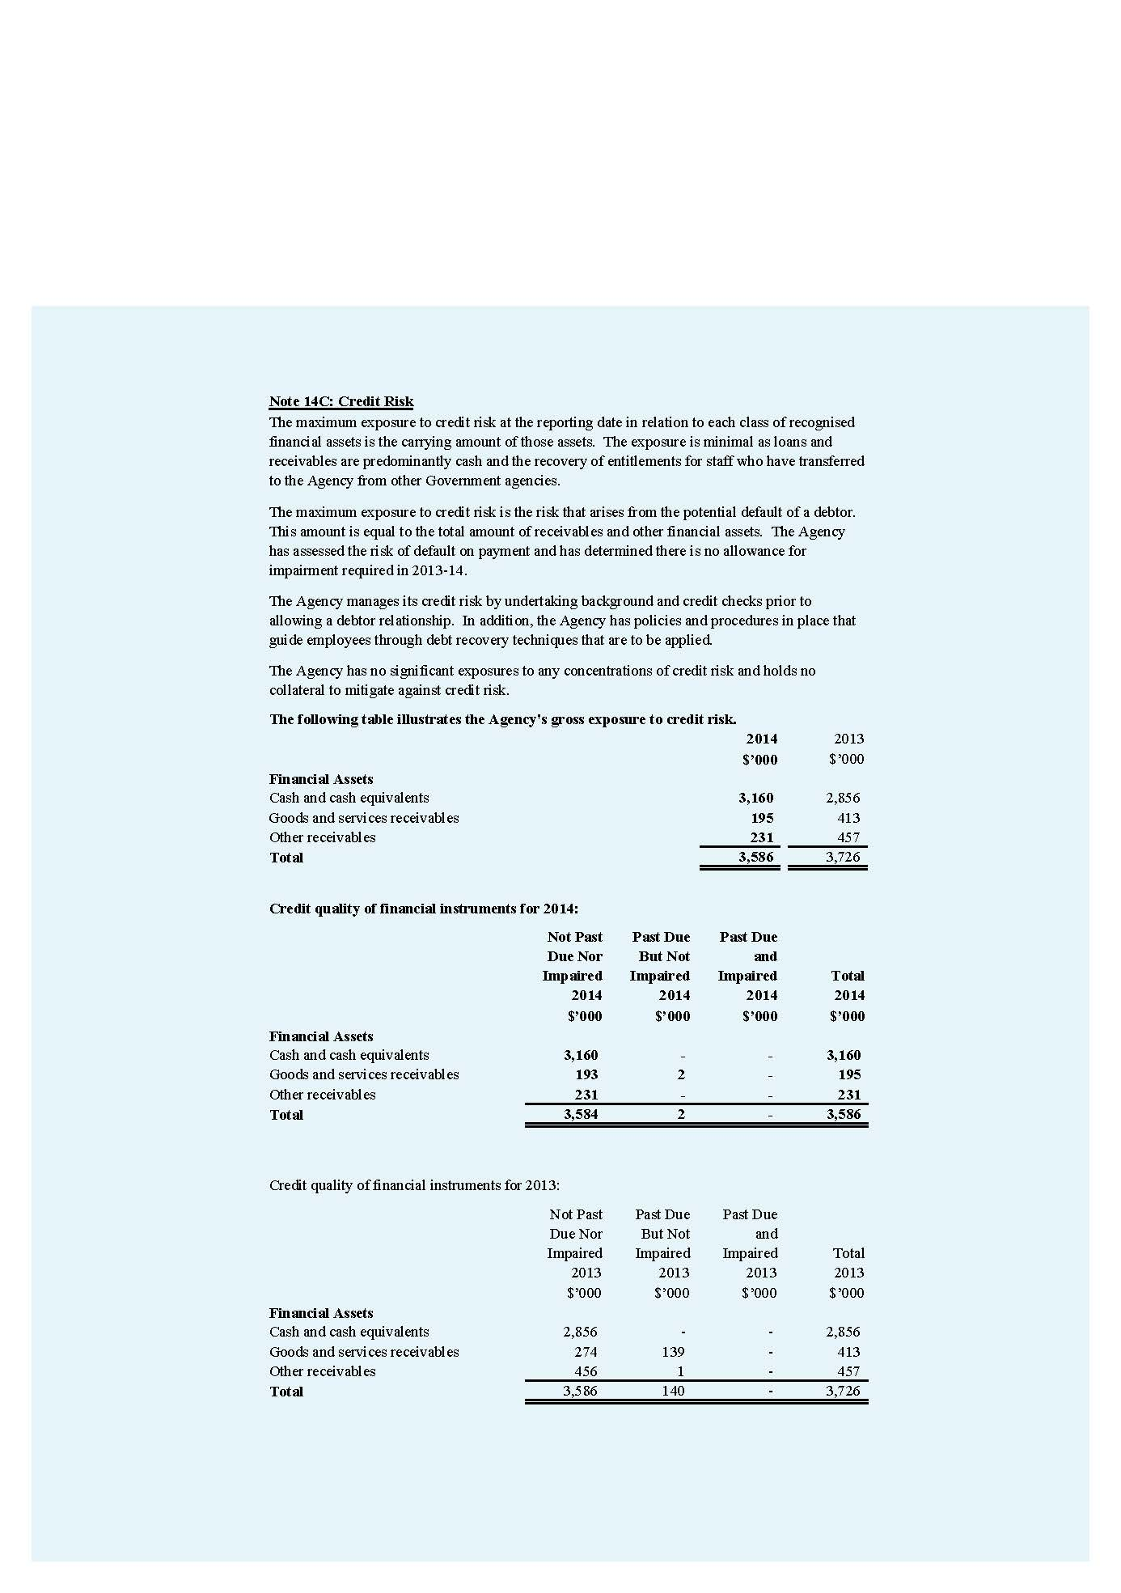
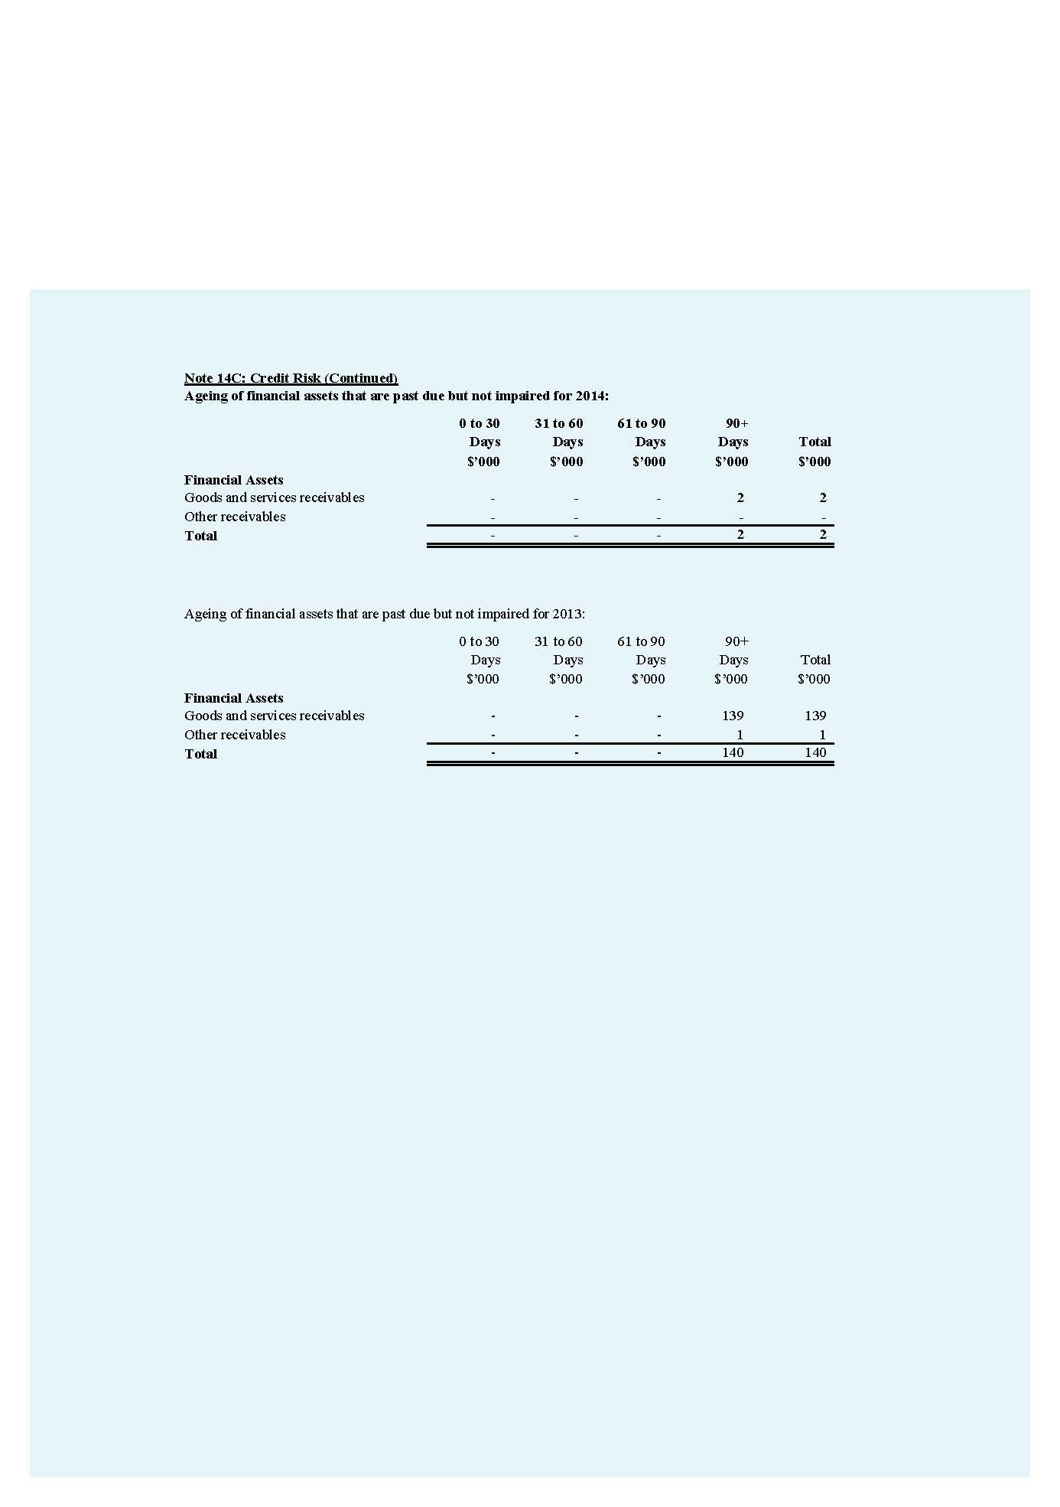
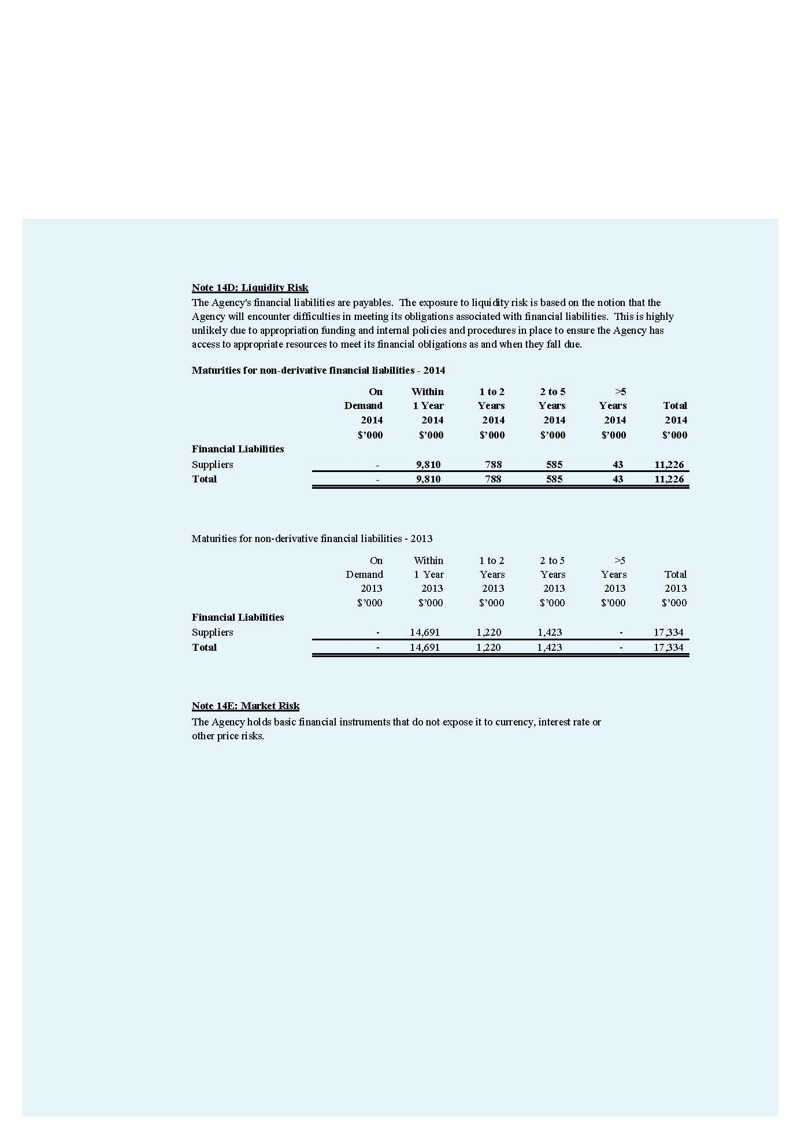
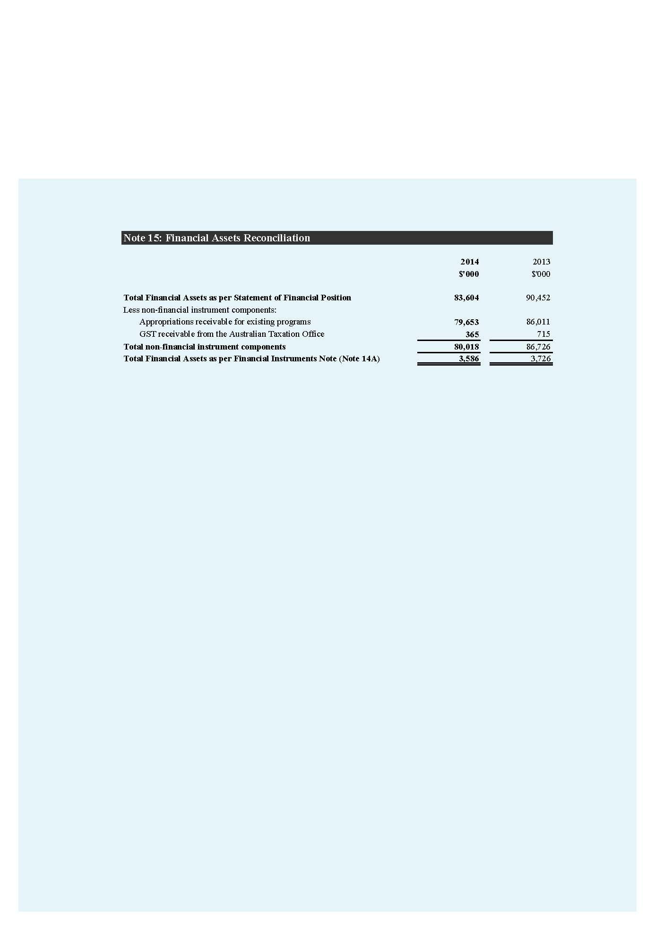
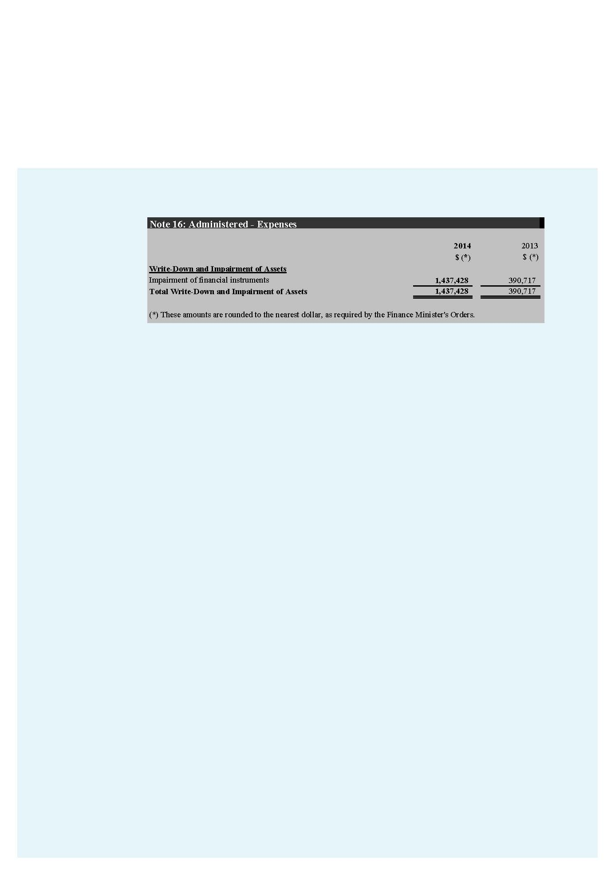
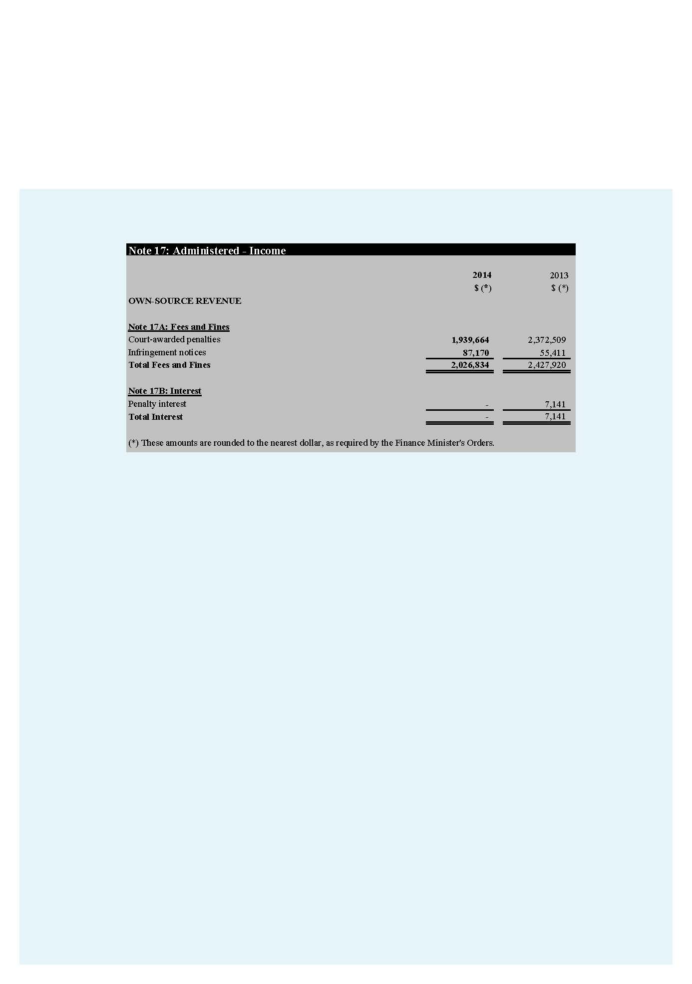
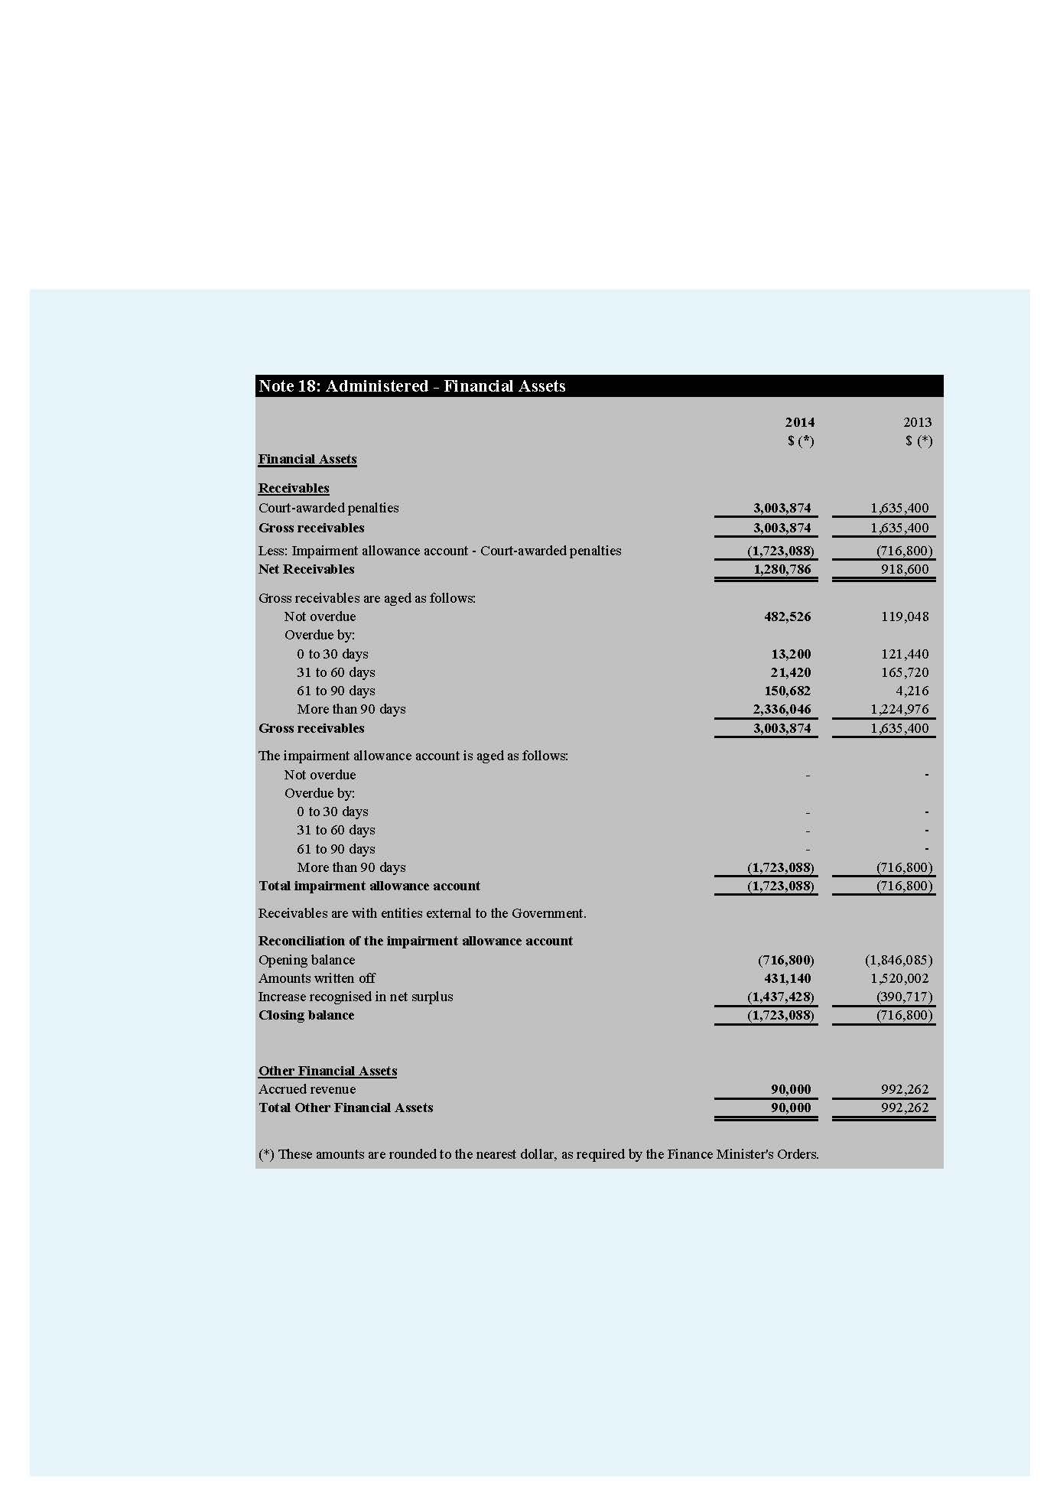
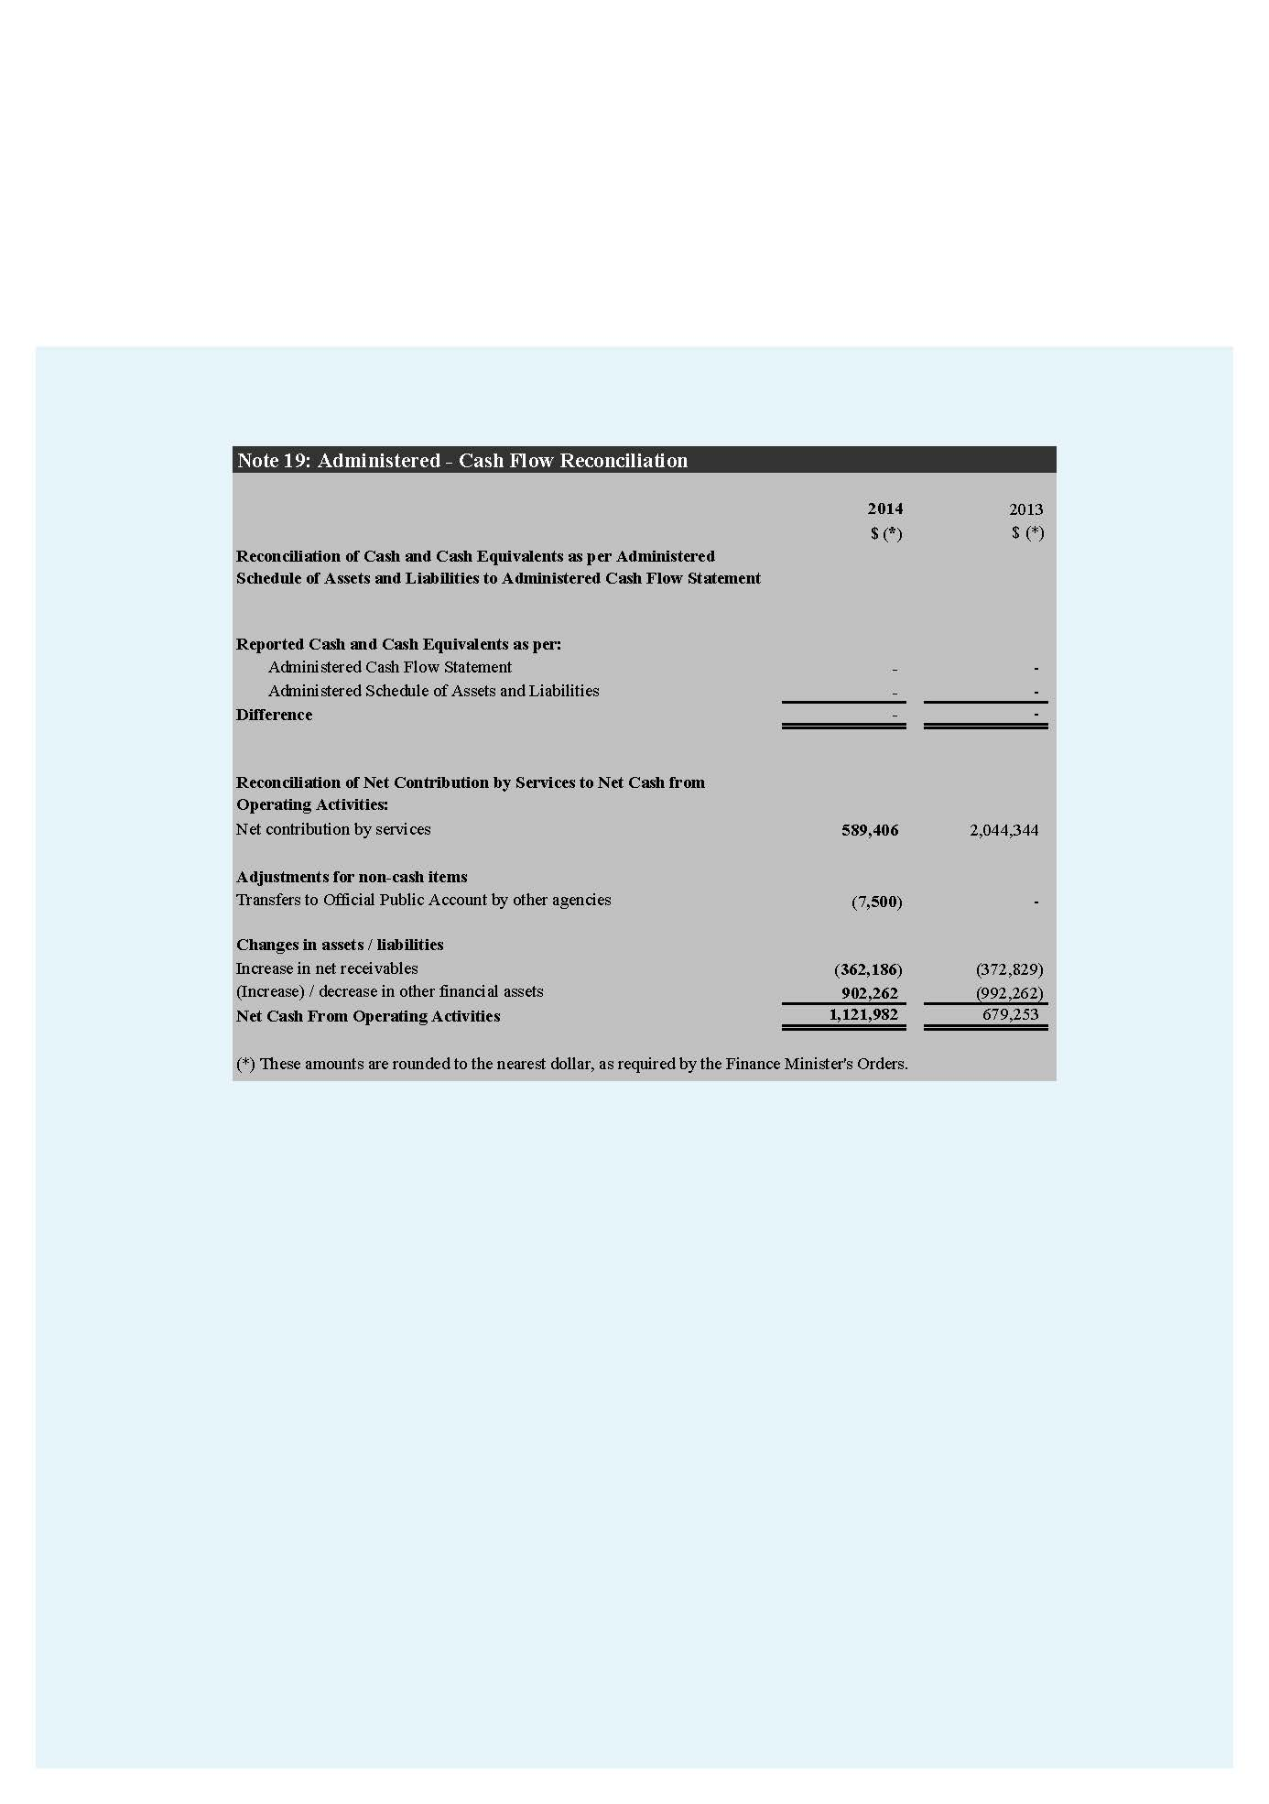
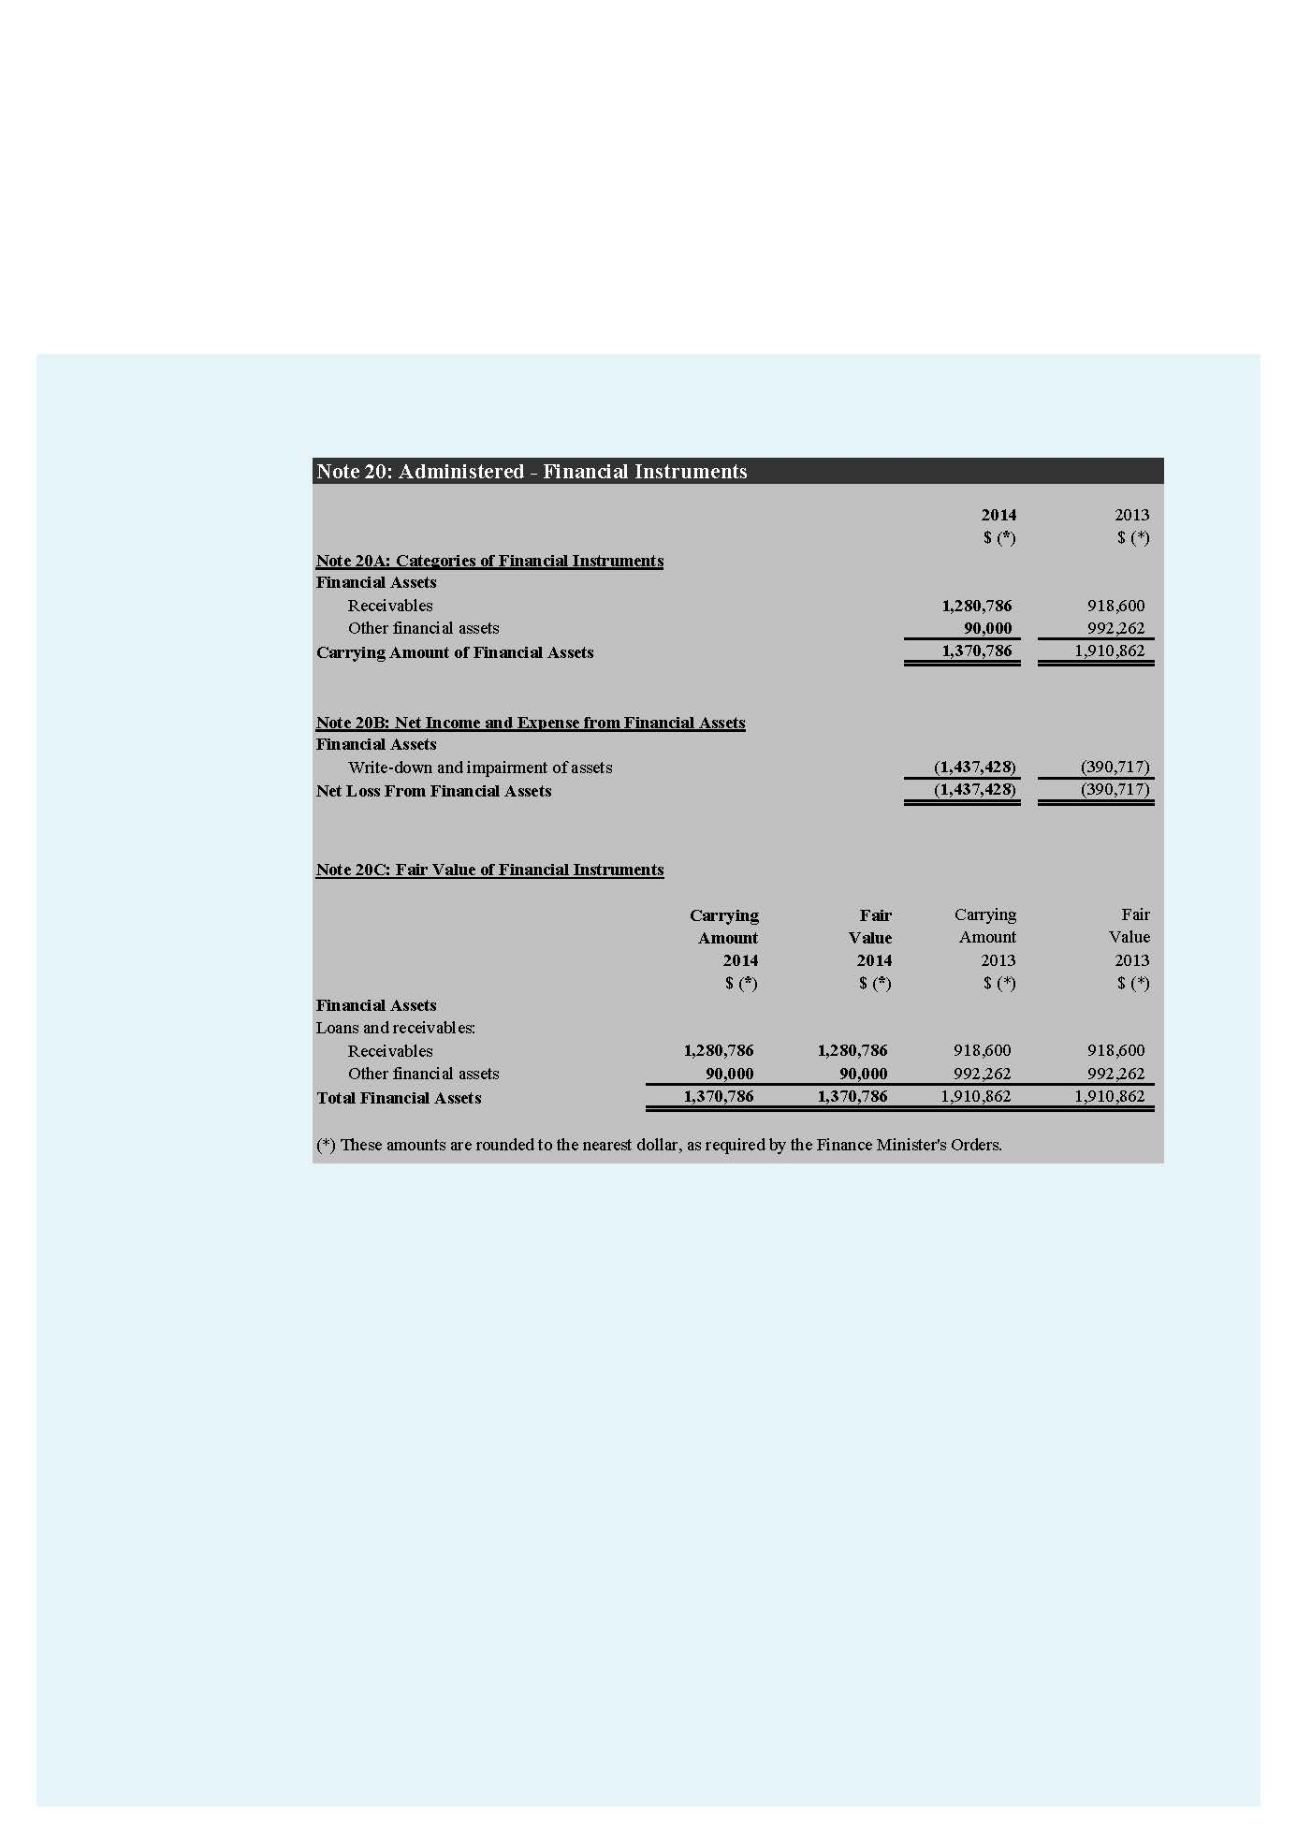
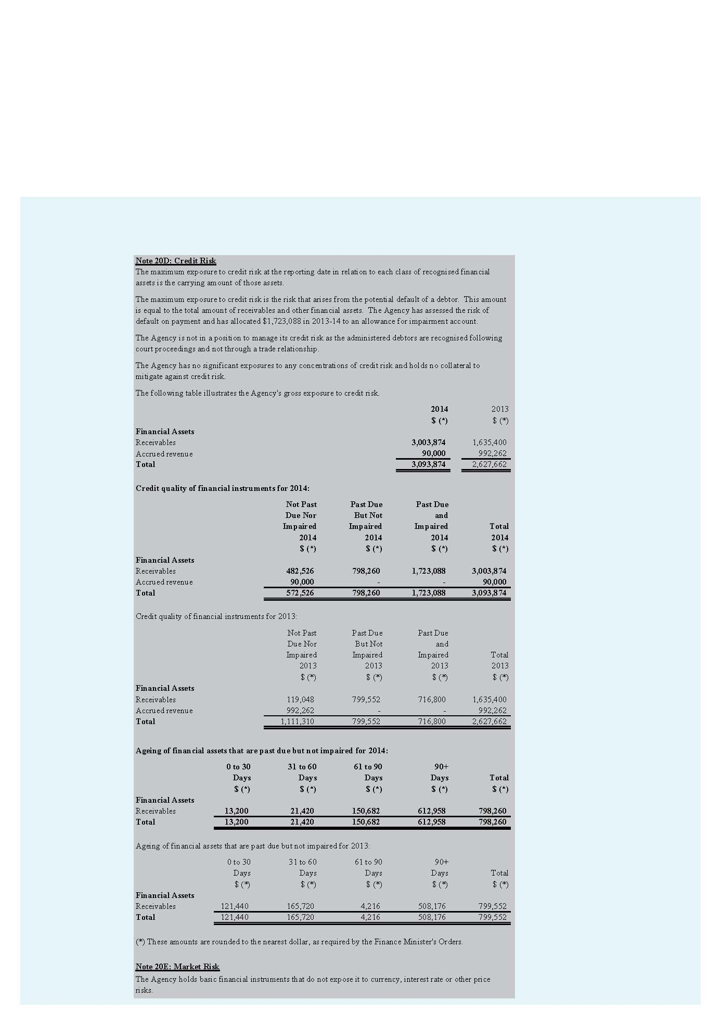
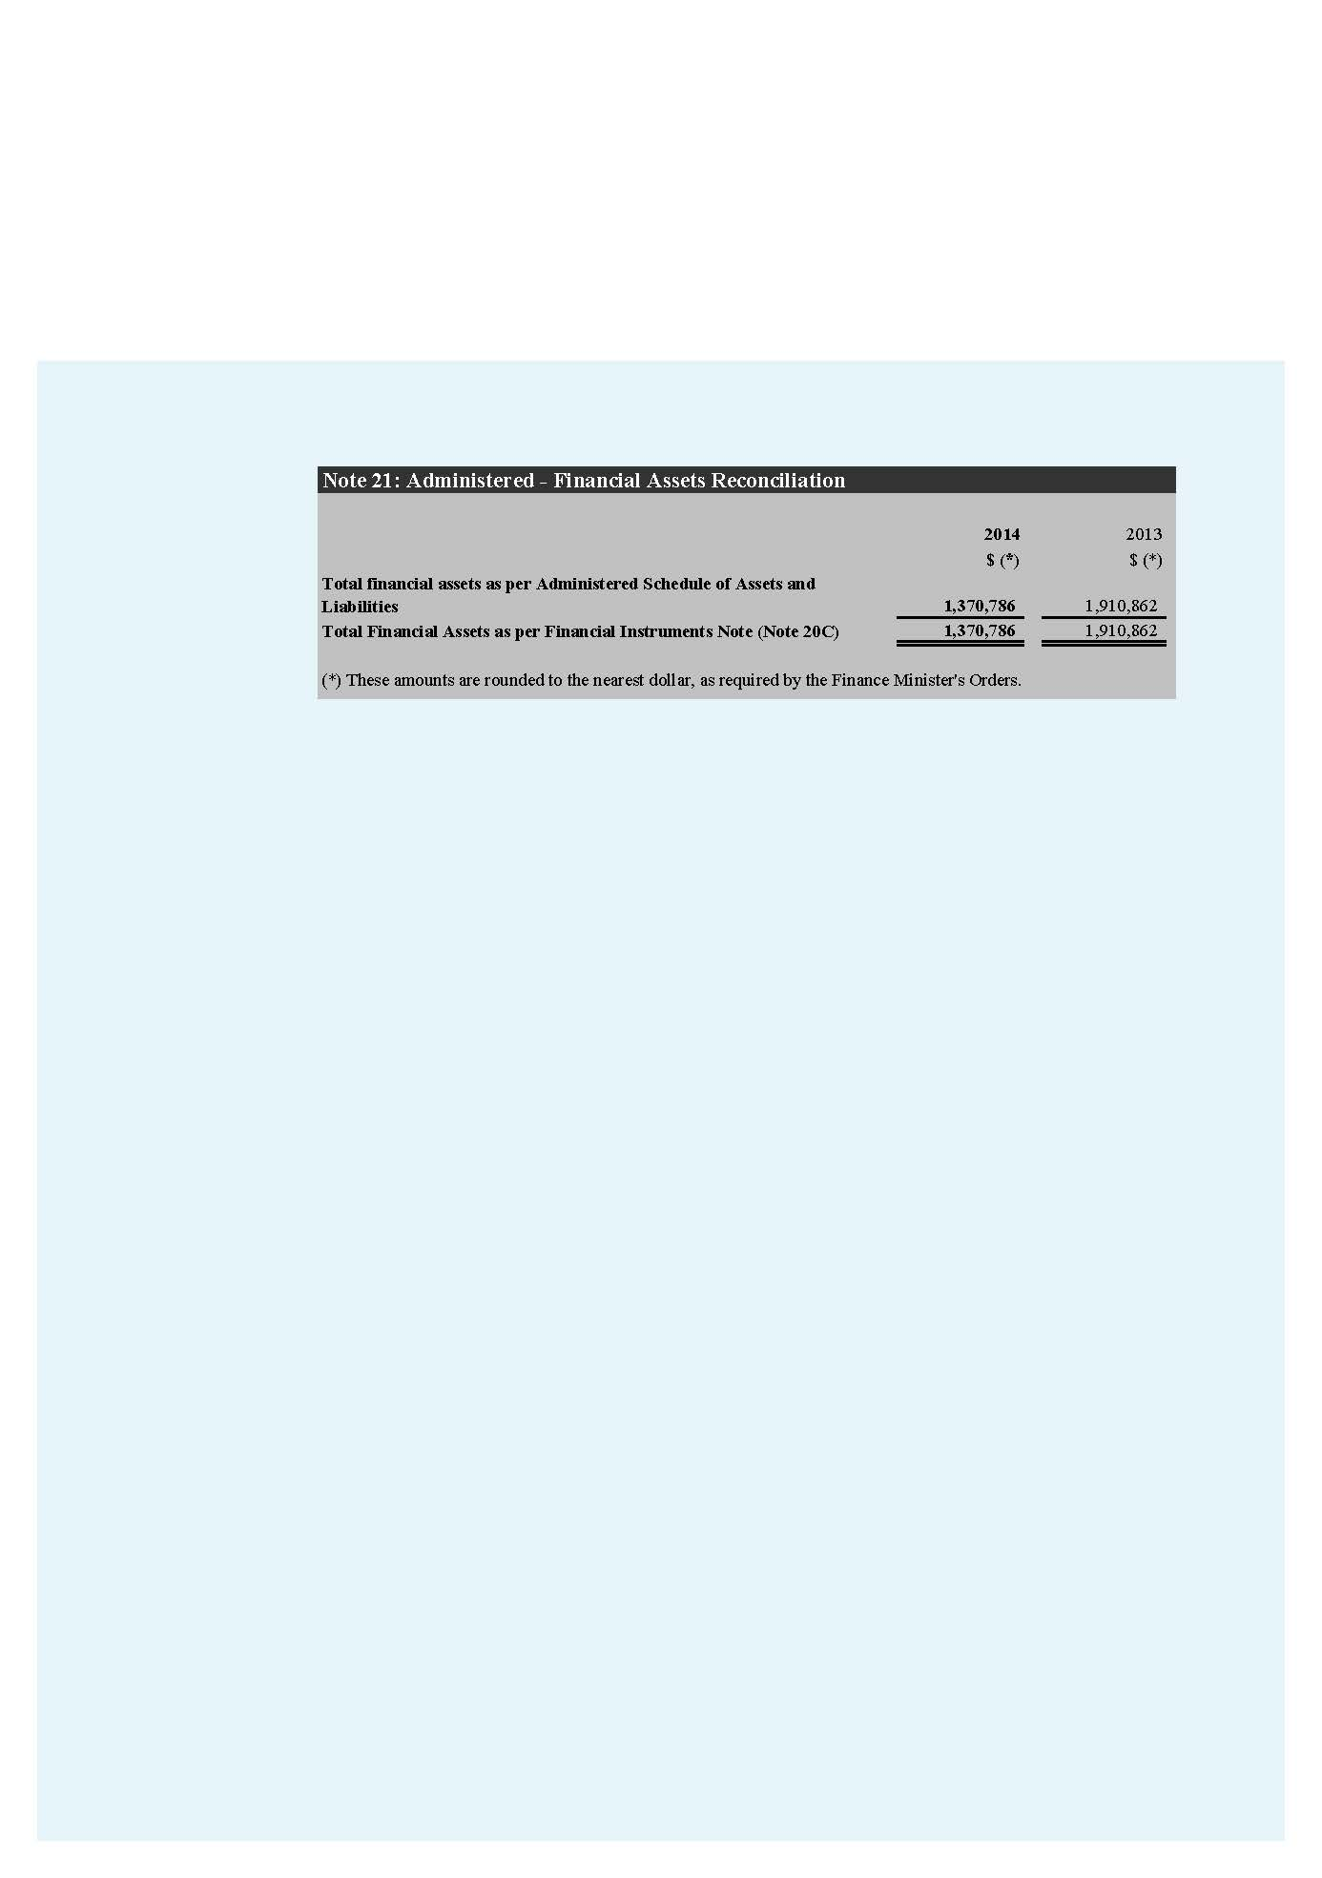
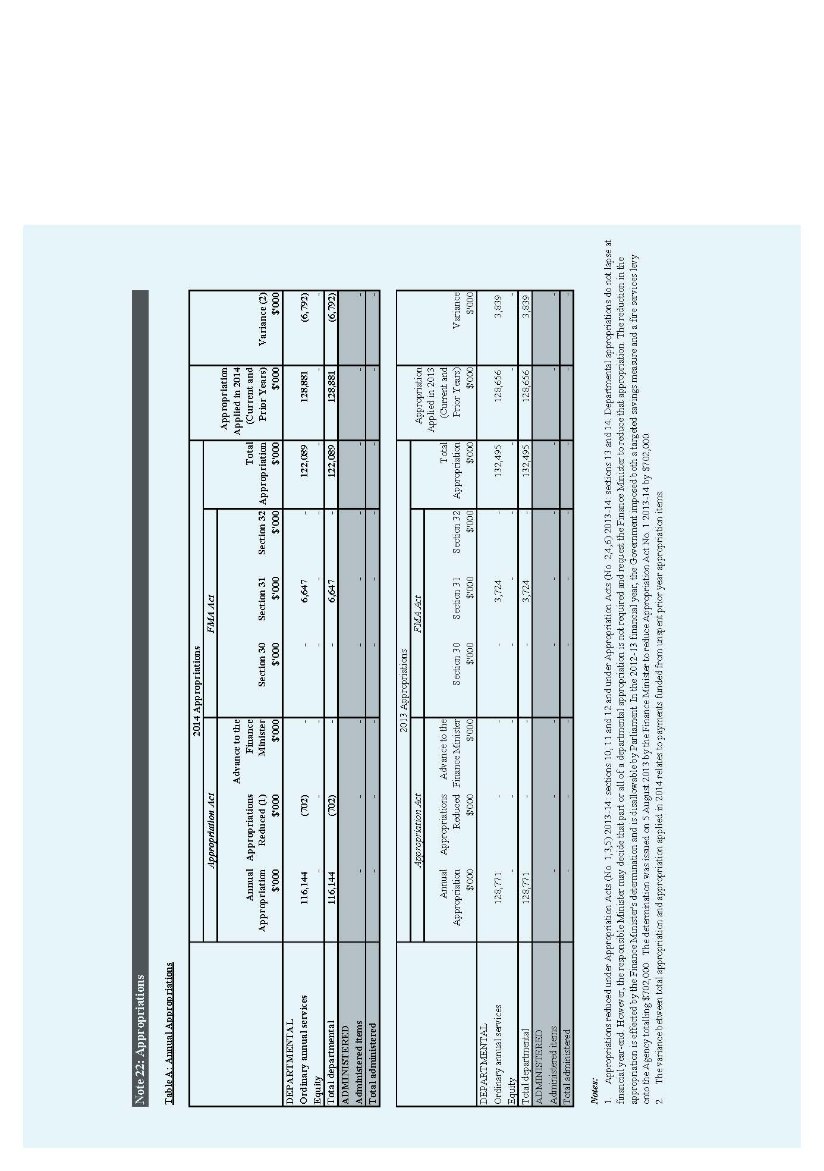
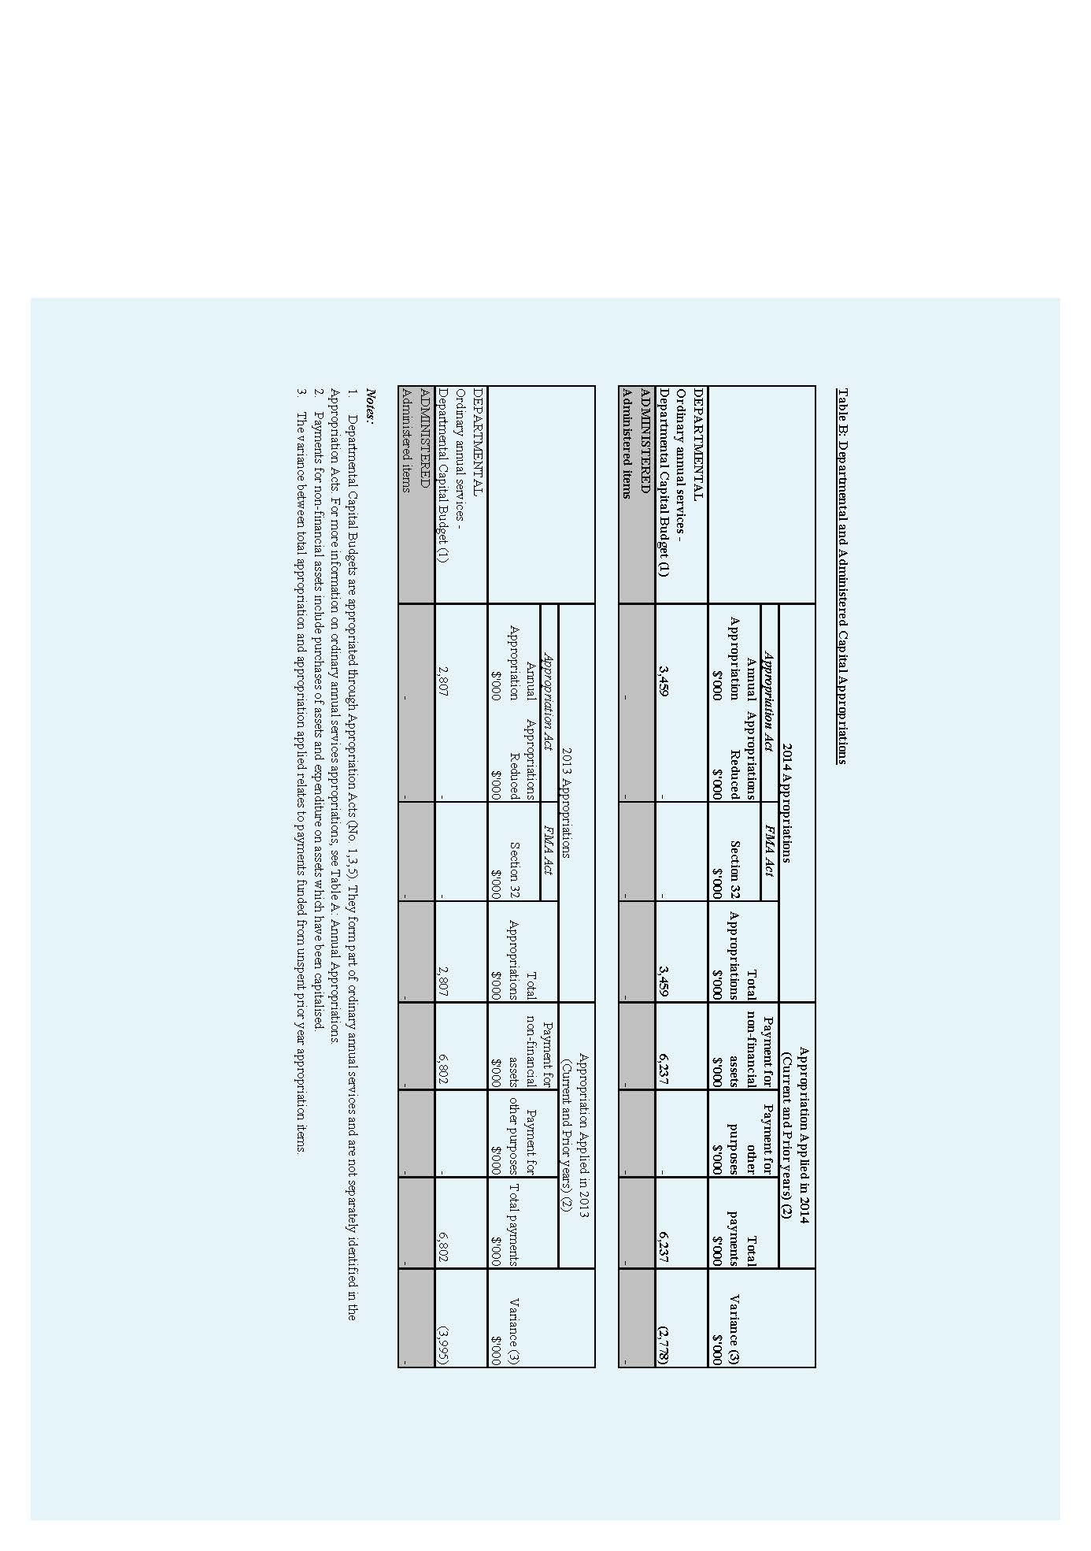
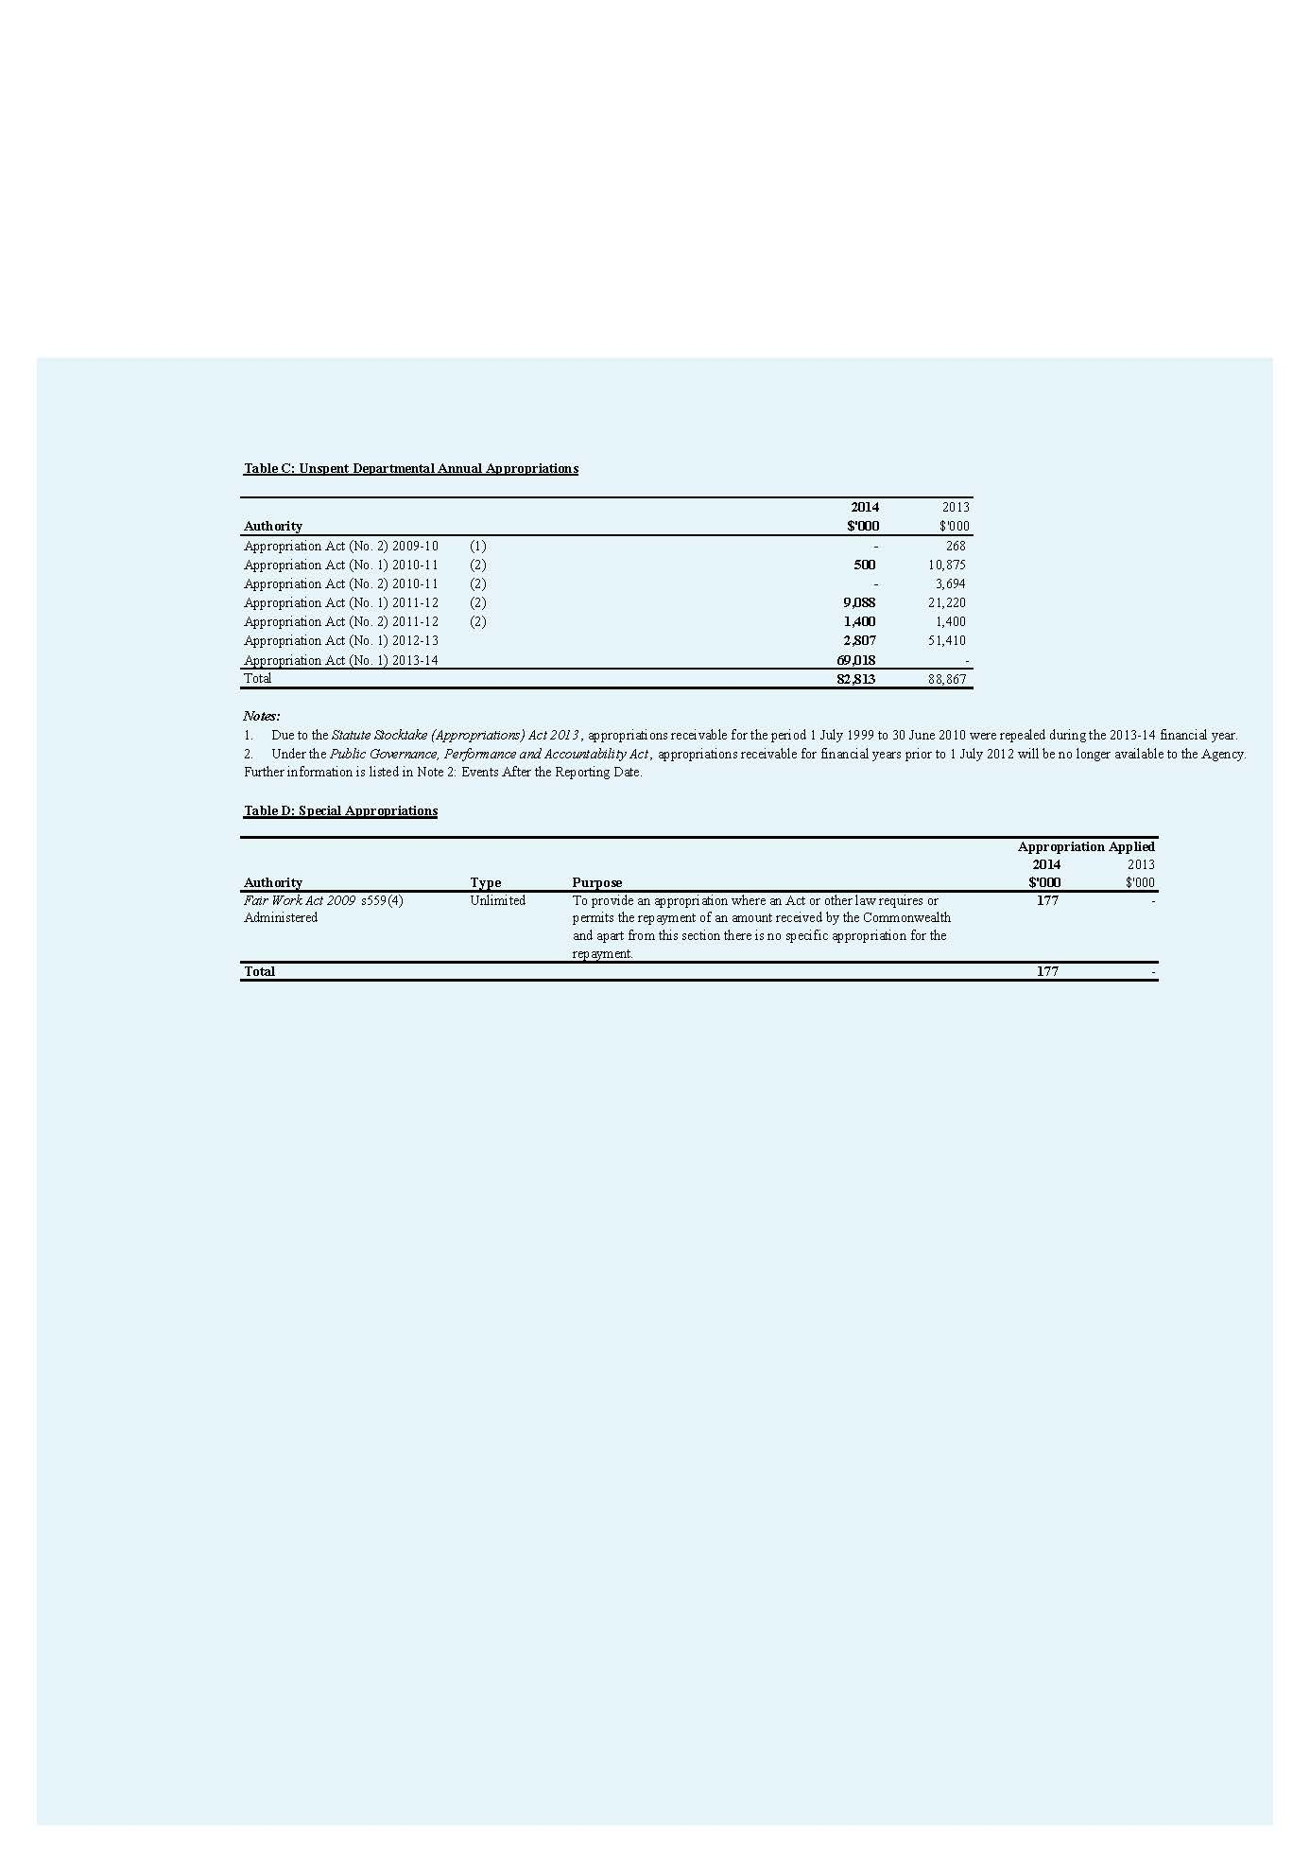
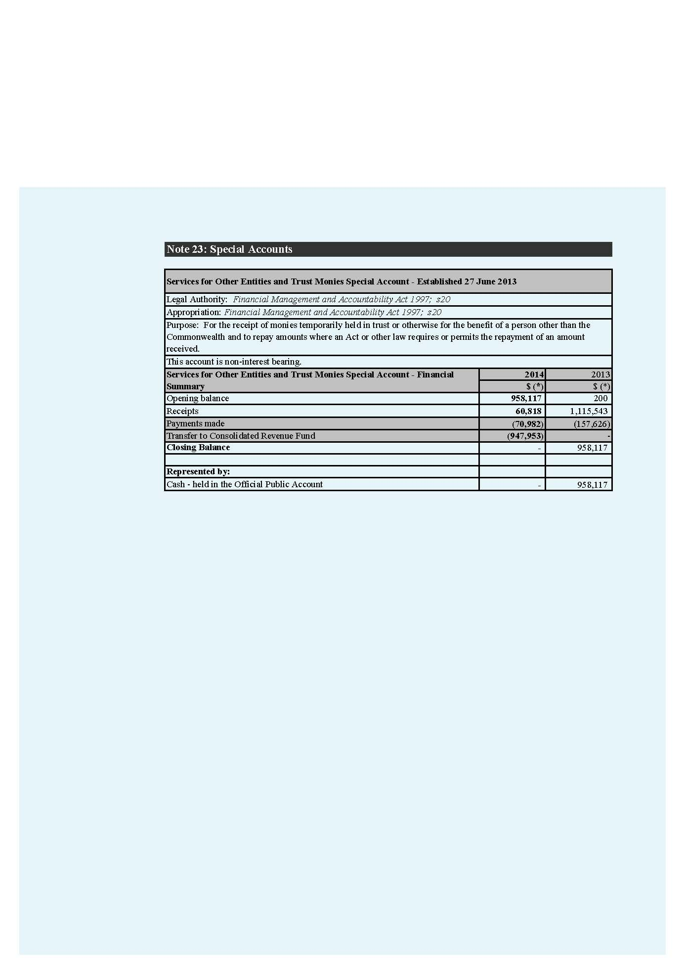
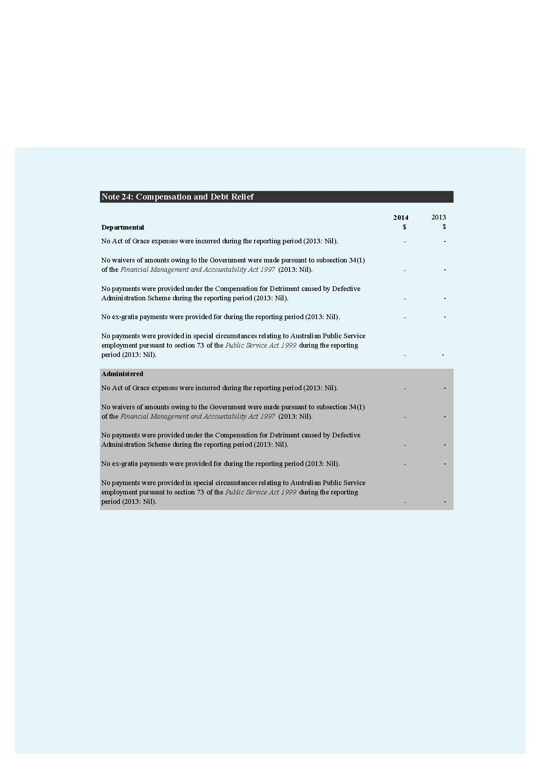
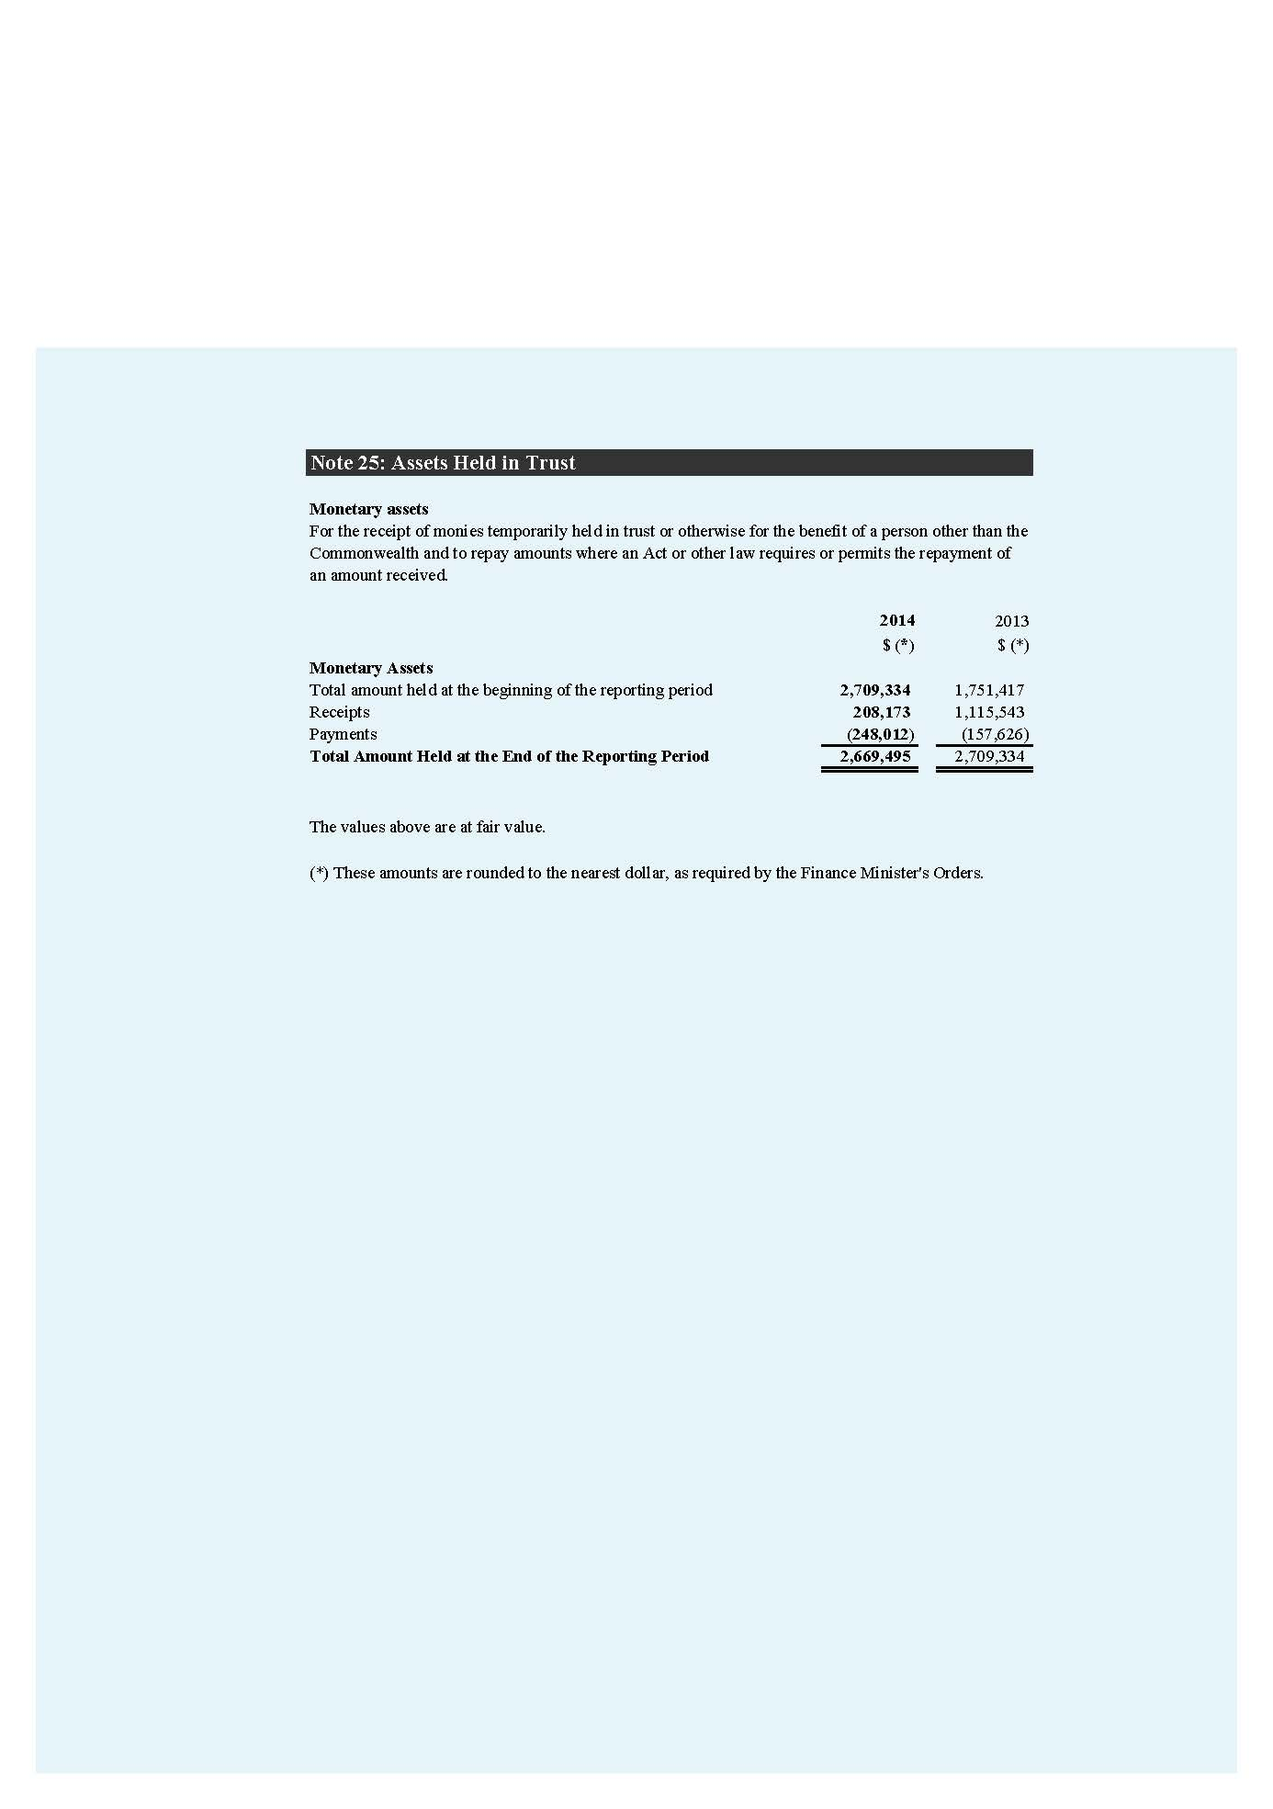
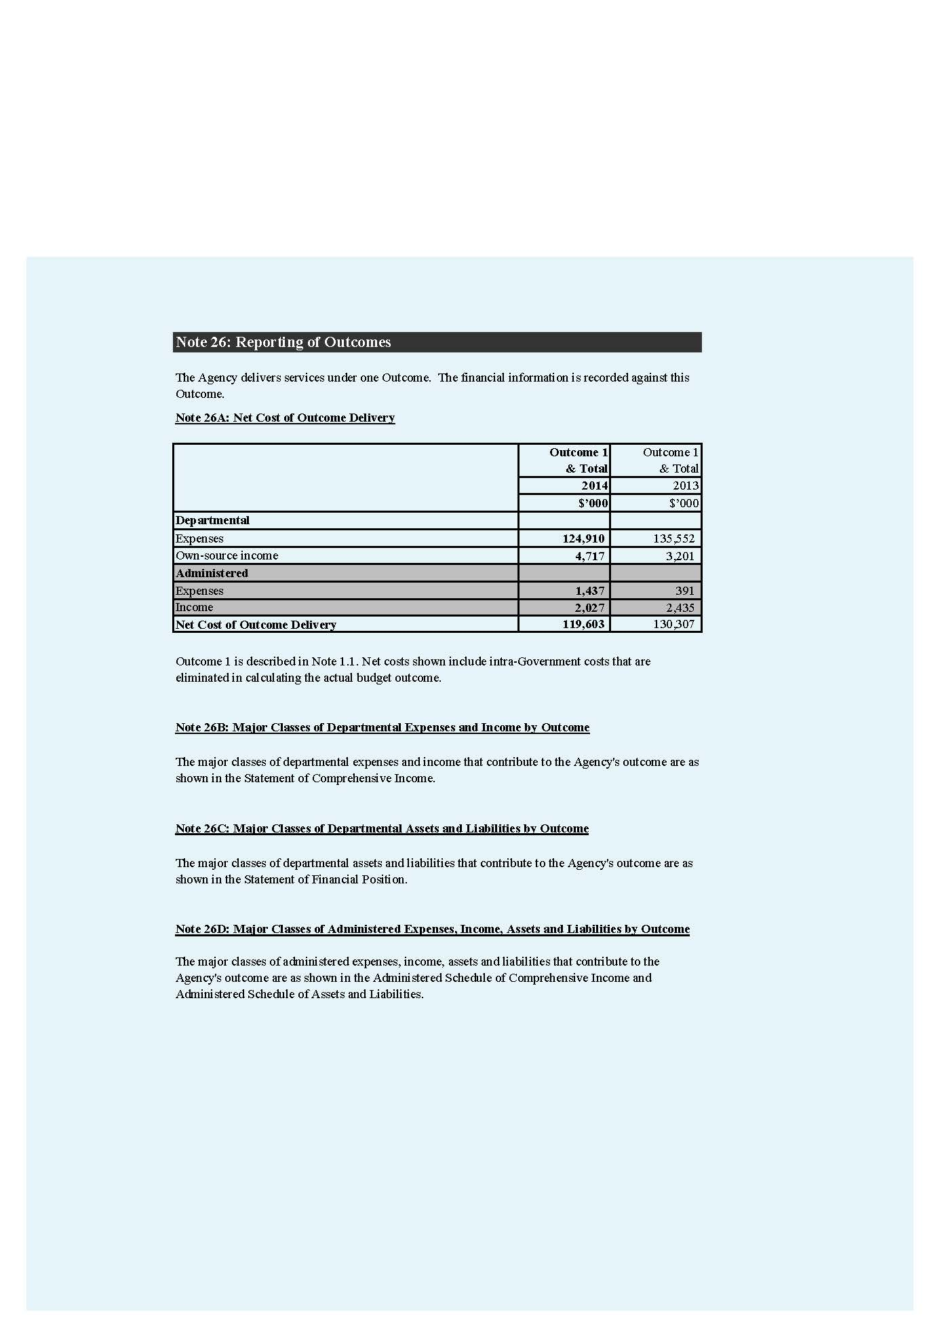
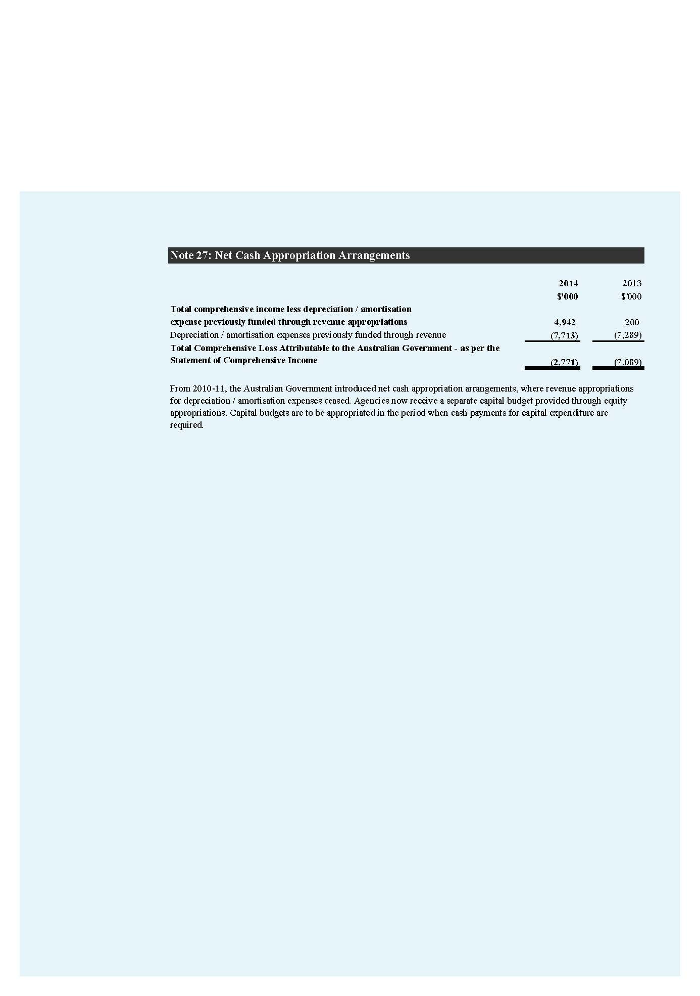
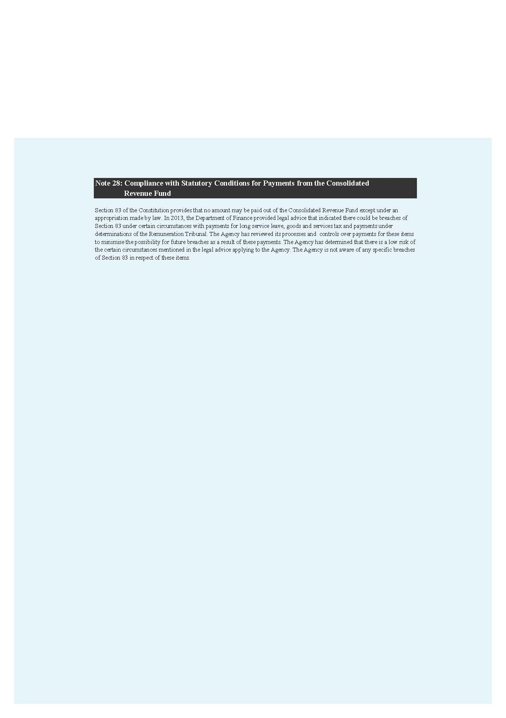

References

Glossary

Annual wage review
A review of minimum award wages and the national minimum wage order conducted by the Fair Work Commission each financial year.

Australian Public Service (APS) employee
A person engaged under section 22, or a person who is engaged as an APS employee under section 72, of the Public Service Act 1999.

Corporate governance
The process by which agencies are directed and controlled. It is generally understood to encompass authority, accountability, stewardship, leadership, direction and control.

Enforceable undertakings
A written commitment outlining how a person intends to rectify a contravention.

Enterprise agreement
An agreement made under the Fair Work Act 2009 (on or after 1 July 2009) between one or more employers and a group of employees in relation to terms and conditions of employment for those employees.

Fair Work Building and Construction
An independent statutory agency established by the Fair Work (Building Industry) Act 2012 responsible for regulating workplace relations laws in the building and construction industry.

Fair Work Commission
The national workplace relations tribunal created by the Fair Work Act 2009. It is an independent body with power to carry out a range of functions covering: the safety net of minimum wages and employment conditions; enterprise bargaining; industrial action; dispute resolution and termination of employment.

General protections
Protections provided by the Fair Work Act 2009, relating to workplace discrimination, sham contracting, and workplace rights.

Individual flexibility arrangement
An arrangement between an employer and an employee, that can vary the effect of some conditions of a modern award or enterprise agreement. The individual flexibility arrangement must pass the ‘Better Off Overall Test’, but does not need to be registered.

Industrial instruments
Sets out minimum conditions of employment for employees to whom they apply. Instrument types include modern awards, enterprise agreements, award-based transitional instruments, transitional minimum wage instruments and agreement-based transitional instruments.

Mediation
A dispute resolution process that focuses on assisting parties to reach a mutual agreement, and to resolve disagreements on their own terms.

Modern awards
An award made by the Australian Industrial Relations Commission as part of the award modernisation process that commenced operation on 1 January 2010. Modern awards supplement the National Employment Standards by setting out additional minimum terms and conditions that apply in a particular industry or occupation including monetary entitlements such as wages, penalty rates and allowances.

National Employment Standards (NES)
Ten minimum standards of employment that apply to national system employees from 1 January 2010. For a list of the NES visit www.fairwork.gov.au/nes.

Phoenixing
Involves a company intentionally accumulating debts to improve cash flow or wealth and then liquidating to avoid paying the debt. The business is then continued as another corporate entity, controlled by the same person or group and free of their previous debts and liabilities.

Proactive compliance deed
A written commitment outlining how a business will work cooperatively with the FWO to build compliance capacity.

Sham contracting
Where an employer tries to disguise an employment relationship as an independent contracting relationship. This may be done to avoid having to provide employees with their proper entitlements.

Transitional arrangements
A process of implementing certain monetary entitlements in modern awards in five 20% increments over a four-year period from the first full pay period on or after 1 July 2010 in accordance with the model transitional provisions in a modern award.

Workplace discrimination
Under the Fair Work Act 2009, it is unlawful for an employer to discriminate against an employee or prospective employee on the basis of race, colour, sex, sexual preference, age, physical or mental disability, marital status, family or carers responsibilities, pregnancy, religion, political opinion, national extraction or social origin.

Abbreviations and acronyms
APS Australian Public Service
APSC Australian Public Service Commission
AWA Australian Workplace Agreement
CBEAS Community Based Employment Advisory Services
EL1 Executive Level 1
EL2 Executive Level 2
Fair Work Act Fair Work Act 2009
FOI Freedom of Information
FOI Act Freedom of Information Act 1982
FWO Fair Work Ombudsman
GLBTI Gay, lesbian, bisexual, transgender and intersex
IFA Individual Flexibility Arrangement
IPS Information Publication Scheme
KPI Key Performance Indicator
NES National Employment Standards
OAIC Office of the Australian Information Commissioner
PBS Portfolio Budget Statements
SES Senior Executive Service

List of requirements
PART OF REPORT | DESCRIPTION | REQUIREMENT | PAGE
 | Letter of transmittal | Mandatory | 2
 | Table of contents | Mandatory | 2
 | Index | Mandatory | 138-139
 | Glossary | Mandatory | 132-133
 | Contact officer(s) | Mandatory | 140
 | Internet home page address and Internet address for report | Mandatory | 140
Review by Secretary
 | Review by departmental secretary | Mandatory | 4-5
 | Summary of significant issues and developments | Suggested | 4-5
 | Overview of department’s performance and financial results | Suggested | 4-5
 | Outlook for following year | Suggested | 4-5
 | Significant issues and developments – portfolio | Portfolio departments – suggested | N/A
Departmental Overview
 | Role and functions | Mandatory | 7-8
 | Organisational structure | Mandatory | 9
 | Outcome and program structure | Mandatory | 8
 | Where outcome and program structures differ from PB Statements/PAES or other portfolio statements accompanying any other additional appropriation bills  (other portfolio statements), details of variation and reasons for change | Mandatory | Nil to report
 | Portfolio structure | Portfolio departments – mandatory | N/A

Report on Performance
 | Review of performance during the year in relation to programs and contribution to outcomes | Mandatory | 11-41
 | Actual performance in relation to deliverables and KPIs set out in PB Statements/PAES or other portfolio statements | Mandatory | 12-13
 | Where performance targets differ from the PBS/PAES, details of both former and new targets, and reasons for the change | Mandatory | Nil to report
 | Narrative discussion and analysis of performance | Mandatory | 11-41
 | Trend information | Mandatory | 11-41
 | Significant changes in nature of principal functions/services | Suggested | Nil to report
 | Performance of purchaser/provider arrangements | If applicable, suggested | 58
 | Factors, events or trends influencing departmental performance | Suggested | 11-41
 | Contribution of risk management in achieving objectives | Suggested | 8
 | Performance against service charter customer service standards, complaints data, and the department’s response to complaints | If applicable, mandatory | 47-48
 | Discussion and analysis of the department’s financial performance | Mandatory | 57-59
 | Discussion of any significant changes in financial results from the prior year, from budget or anticipated to have a significant impact on future operations | Mandatory | Nil to report
 | Agency resource statement and summary resource tables by outcomes | Mandatory | 67
Management and Accountability
Corporate Governance
 | Agency heads are required to certify that their agency complies with the ‘Commonwealth Fraud Control Guidelines’. | Mandatory | 46
 | Statement of the main corporate governance practices  in place | Mandatory | 44-49
 | Names of the senior executive and their responsibilities | Suggested | 45
 | Senior management committees and their roles | Suggested | 44-45
 | Corporate and operational plans and associated  performance reporting and review | Suggested | 44-49
 | Internal audit arrangements including approach adopted to identifying areas of significant financial or operational risk  and arrangements to manage those risks | Suggested | 46-48
 | Policy and practices on the establishment and maintenance of appropriate ethical standards | Suggested | 47
 | How nature and amount of remuneration for SES officers is determined | Suggested | 55

External Scrutiny
 | Significant developments in external scrutiny | Mandatory | 47-48
 | Judicial decisions and decisions of administrative tribunals and by the Australian Information Commissioner | Mandatory | 47
 | Reports by the Auditor-General, Parliamentary Committees, the Commonwealth Ombudsman or an agency capability review | Mandatory | 47
Management of Human Resources
 | Assessment of effectiveness in managing and developing human resources to achieve departmental objectives | Mandatory | 51-55
 | Workforce planning, staff retention and turnover | Suggested | 51
 | Impact and features of enterprise or collective agreements, individual flexibility arrangements (IFAs), determinations, common law contracts and Australian Workplace Agreements (AWAs) | Suggested | 55
 | Training and development undertaken and its impact | Suggested | 52-53
 | Work health and safety performance | Suggested | 54-55
 | Productivity gains | Suggested | Nil to report
 | Statistics on staffing | Mandatory | 61-65
 | Enterprise or collective agreements, IFAs, determinations, common law contracts and AWAs | Mandatory | 65
 | Performance pay | Mandatory | 55
Assets management | Assessment of effectiveness of assets management | If applicable, mandatory
Purchasing | Assessment of purchasing against core policies and  principles | Mandatory | 58
Consultants | The annual report must include a summary statement detailing the number of new consultancy services contracts let during the year; the total actual expenditure on all new consultancy contracts let during the year (inclusive of GST); the number of ongoing consultancy contracts that were active in the reporting year; and the total actual expenditure in the reporting year on the ongoing consultancy contracts (inclusive of GST). The annual report must include a statement noting that information on contracts and consultancies is available through the AusTender website. | Mandatory | 58
Australian National Audit Office Access Clauses | Absence of provisions in contracts allowing access by the Auditor-General | Mandatory | Nil to report
Exempt contracts | Contracts exempted from publication in AusTender | Mandatory | Nil to report
Financial Statements | Financial Statements | Mandatory | 69-131

Other Mandatory Information
 | Work health and safety (Schedule 2, Part 4 of the Work Health and Safety Act 2011) | Mandatory | 54-55
 | Advertising and Market Research (Section 311A of the Commonwealth Electoral Act 1918) and statement on advertising campaigns | Mandatory | 59
 | Ecologically sustainable development and environmental performance (Section 516A of the Environment Protection and Biodiversity Conservation Act 1999) | Mandatory | 59
 | Compliance with the agency’s obligations under the Carer Recognition Act 2010 | If applicable, mandatory | Nil to report
 | Grant programs | Mandatory | 58
 | Disability reporting – explicit and transparent reference to agency level information available through other reporting mechanisms | Mandatory | 65
 | Information Publication Scheme statement | Mandatory | 49
 | Correction of material errors in previous annual report | If applicable, mandatory | Nil to report
 | Agency Resource Statements and Resources for Outcomes | Mandatory | 66-67
 | List of Requirements | Mandatory | 134-137

Index

A
administrative reviews or findings 47
advertising 58-59
Agency Consultative Forum 52
Agency Resource Statement 66-67
assistance and advice 15-35
see key performance indicators
Audit Committee 44, 46
audits 1, 32-33, 47
Australian National Audit Office 47
Australian Taxation Office 19, 23
average staffing level 66

B
best practice guides 19-20
breaches, types of 1, 8, 12-13, 25, 34, 38-40

C
campaigns 12-13, 23, 33-34, 58-59
civil penalty litigation
see litigation
common law contract 65
Commonwealth Ombudsman 7, 47
complaints and investigations
discrimination 1, 5, 31, 39-41, 132-133
key performance indicator 13, 21
compliance 8-9, 12, 15, 19, 21-23, 25, 27-29, 32-35, 37-40, 45-46, 48-49, 52, 54, 66, 133
compliance audits 33
contact centre 21
key performance indicators 13
contractors 17-18, 31-32
Contracts Committee 46
corporate governance 44, 132
culturally and linguistically diverse backgrounds 64
people from 40
staff 9, 41, 45, 54, 64
Customer Service Charter 47

D
Department of Education, Employment and Workplace Relations 9
disability
workplace discrimination 31, 133
discrimination
see workplace discrimination

E
ecologically sustainable development 59
education 8-9, 12, 15, 18-22, 32-34, 54, 66
employment conditions
see wages and conditions
enforceable undertakings 27, 30, 33, 38-39
enterprise agreement 34, 55, 65, 132
environmental performance 59
Executive Committee 44-45
expenses and resources 66
external scrutiny 47-48

F
Facebook 22
fact sheets 19-20
Fair Work Building and Construction 9, 23, 132
Fair Work Infoline B, 14, 16-17, 21
key performance indicators 13, 21
Fair Work Ombudsman B, 2-5, 8-9, 38, 41, 44-45, 67, 133, 140
financial recoveries from compliance activities
see campaigns
fines 32
see litigation
foreign language
information 19, 22, 29-30, 54
foreign workers 22
education 19
litigation 30, 40-41
fraud control 46
freedom of information 49

G
governance 44, 132

H
hair and beauty industry 17, 23, 26
health and wellbeing 54
hospitality industry 22-23, 33

I
independent contractors
see contractors
Infoline B, 14, 16-17, 21
Information Publication Scheme 49, 133
information technology 15, 38, 46, 58
internships 23
investigations 27, 30-32, 35, 46-49, 52

J
James, Natalie 3-5, 9, 45
judicial decisions 47
see litigation

K
key performance indicators 13, 21

L
legal actions 38, 40-41
litigation 30-32, 35, 46-49, 52

M
management and accountability 43
media advertising organisations 58-59
media coverage 21
mediation 27-28, 132
multilingual staff 54

N
national campaigns 33
see campaigns
non-compliance 1, 5, 8, 12, 25, 27-28, 32-33, 39-40, 46

O
online tools and resources 4, 16, 18-21
key performance indicators 13
PayCheck Plus 20-21
social media 22
overseas workers 29-30, 40
foreign workers 22

P
penalties 1, 5, 8, 31, 38, 40-41
see litigation
performance bonuses 55
performance indicators 13, 21
phoenixing 23, 132
Portfolio Budget Statements 8, 12-13, 66, 133
proactive compliance deeds 27, 34-35, 133
procurement 32, 58
program 8, 12, 19, 28, 32, 34, 46-47, 52, 54, 58-59, 66
purchasing 58

R
recruitment 9, 51, 54, 59
remuneration 55
see wages and conditions
report on performance 12-13
research 5, 18, 47-48, 58-59
resources B, 16, 18-22, 34, 58, 66-67

S
safety 31, 46, 54-55
sham contracting 31, 39-40, 132-133
small business B, 4, 16-18, 23, 34, 48
social media 22
staff, profile 9, 54-55, 64
see health and wellbeing
state and territory campaigns
see key performance indicators
see campaigns

T
templates 19-20
tenders and contracts
see procurement
Twitter 22

U
underpayments 27-29, 33-34, 39-40
see wages and conditions
unions 8, 23, 33, 41

V
voluntary compliance 8, 12, 15

W
wages and conditions 22, 32, 39
see enforceable undertakings
see litigation
website 4, 13, 16, 18-21, 49, 52
see online tools and resources
work health and safety 54
workplace agreements 65
workplace discrimination 1, 5, 23, 31, 41, 132-133

Y
young workers 19, 22, 29-30, 40
YouTube 19, 22

Contact

Mail
Annual Report Coordinator
Policy, Media and Communications
Fair Work Ombudsman
GPO BOX 9887
Melbourne Victoria 3000
Phone: 03 9954 2583
Email: communications@fwo.gov.au

Annual report
www.fairwork.gov.au/about-us/reports-and-submissions/annual-reports
Website: fairwork.gov.au

Acknowledgements
Annual report team:
Sarah Strudwicke and Carly Britt.
Thank you to all FWO contributors, especially those who appear in these pages.
Design: Bite Visual Communications Group.
Photography: Paolo Cappelli.
Copyright
With the exception of the Commonwealth Coat of Arms, the Fair Work Ombudsman logo and any other material specified below, all the material in this annual report is licensed by Fair Work Ombudsman for the Commonwealth of Australia under a Creative Commons Attribution 3.0 Australia License. To view a copy of the license visit
http://creativecommons.org/licenses/by/3.0/au.
You are free to copy, distribute, transmit, communicate and adapt the work as long as you attribute it to © Fair Work Ombudsman and comply with other license terms.
For terms for use of the Coat of Arms visit
http://www.itsanhonour.gov.au/coat-arms/index.cfm.

Find us
facebook.com/fairwork.gov.au
@fairwork.gov.au
FairworkGovAu

