National remote and regional locations campaign

January 2019

© Commonwealth of Australia, 2019

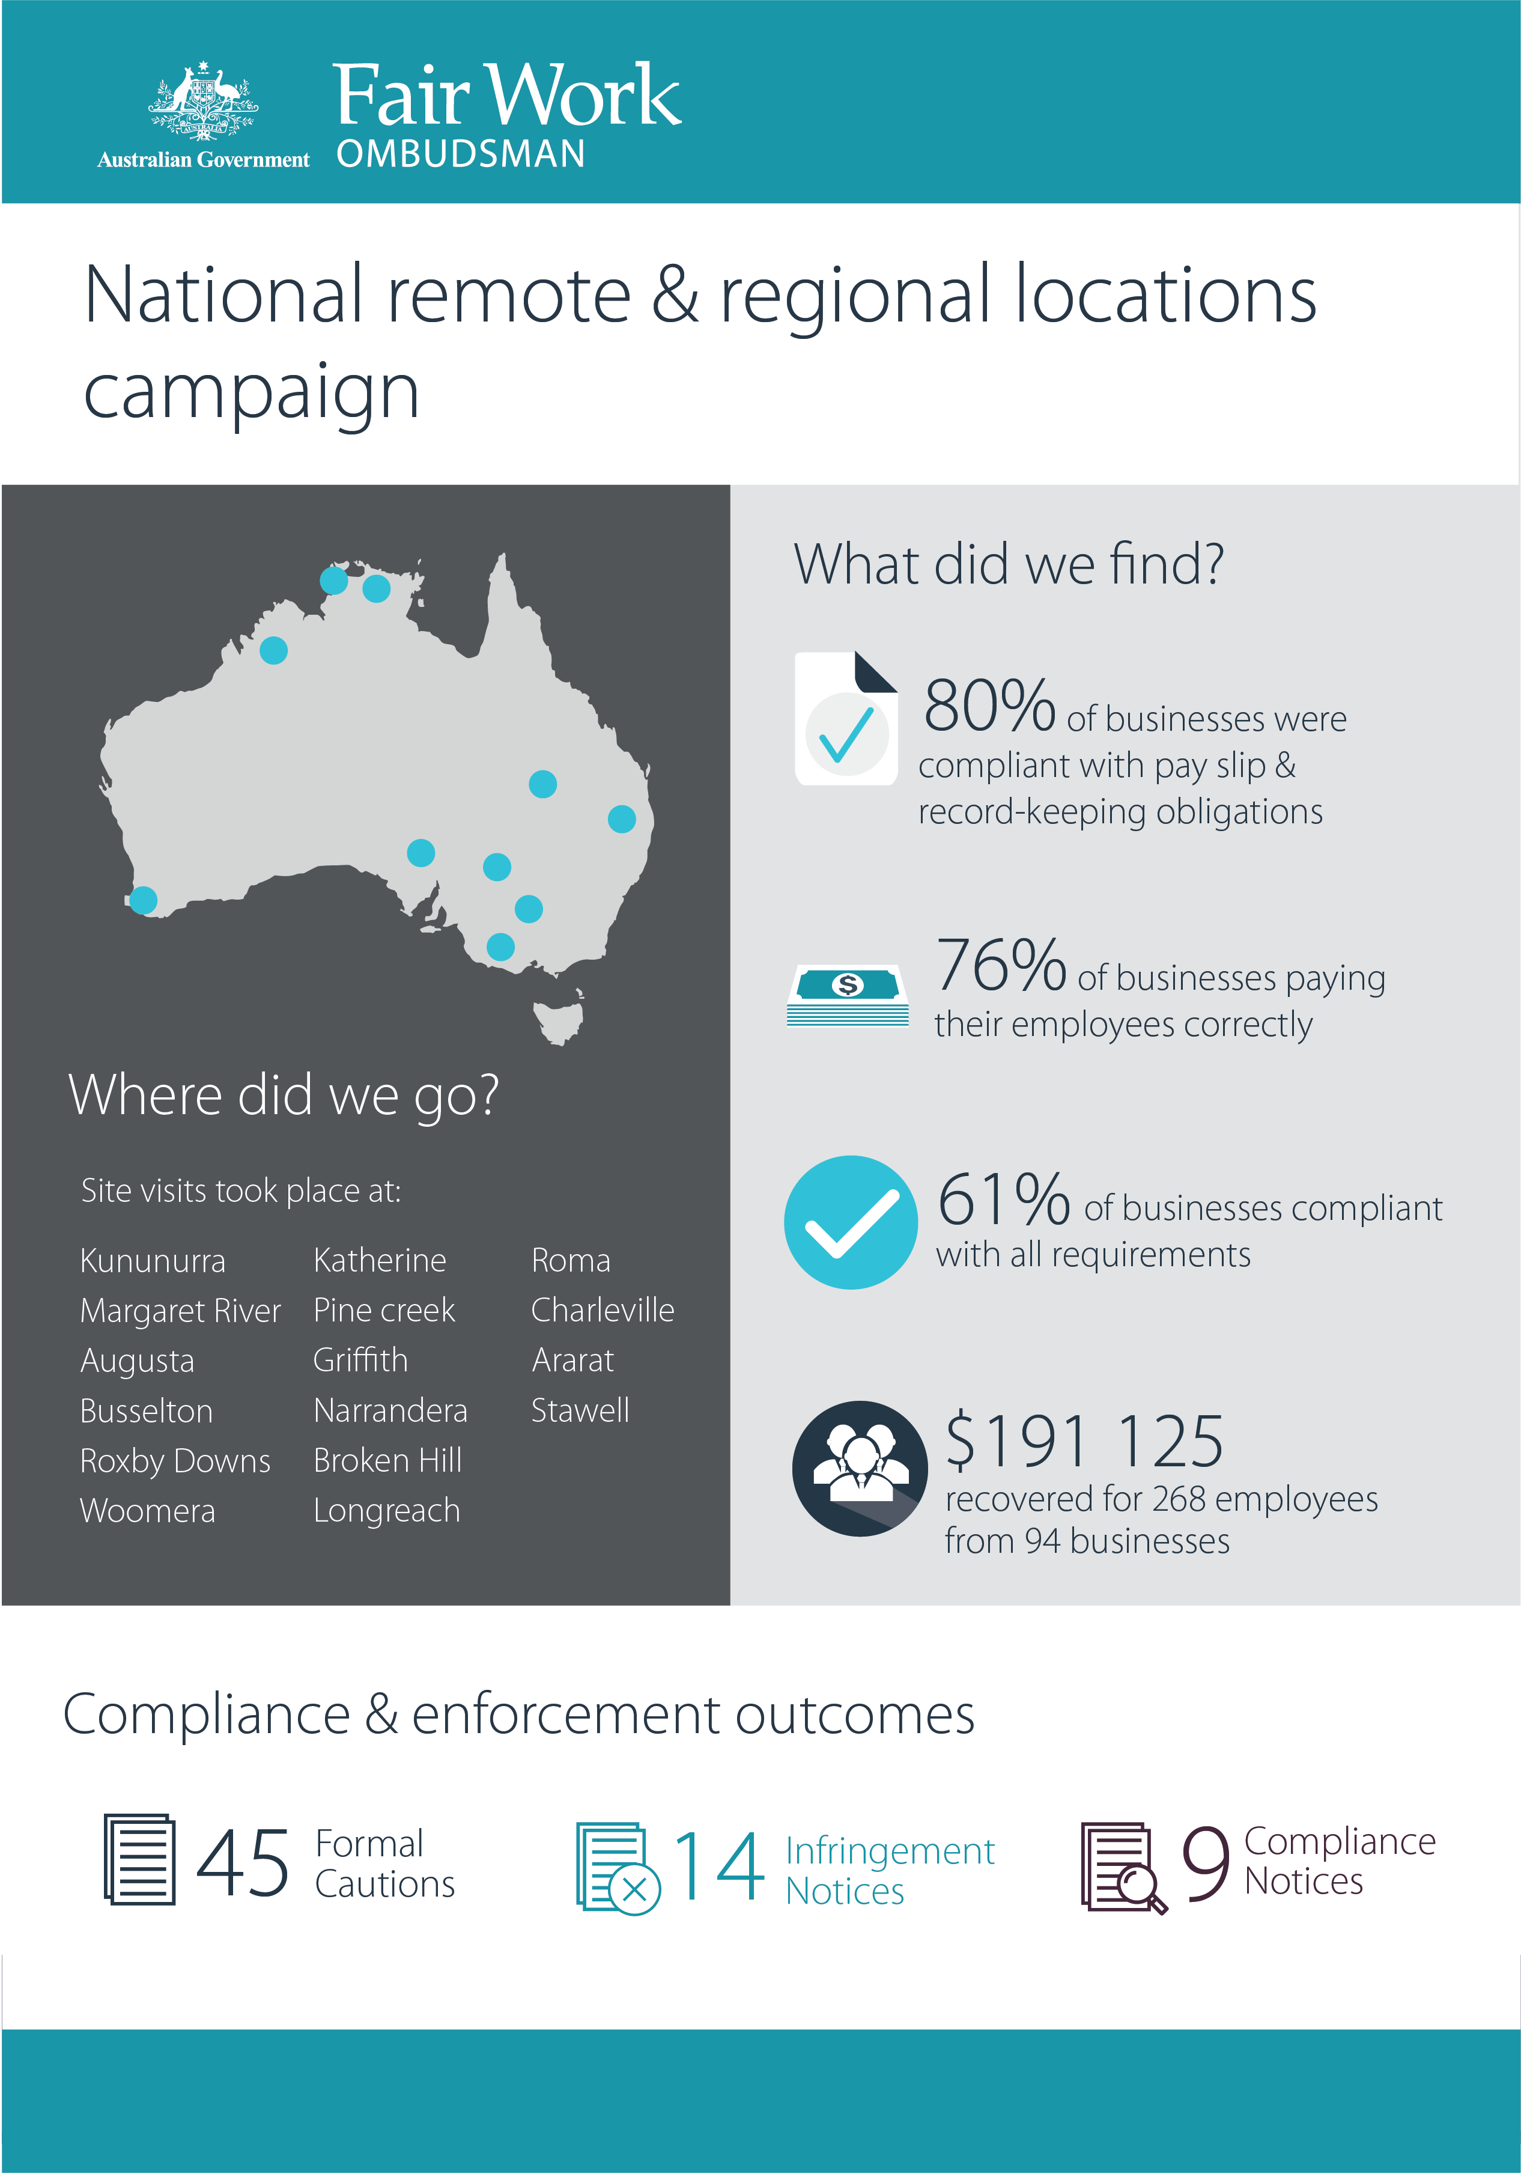

# Table of contents

Executive summary 4

Background 6

Objectives 7

Methodology 8

Key findings 11

National outcomes 11

Outcomes by area 12

Comparison of findings 13

Compliance and enforcement results 15

Conclusion 16

About the Fair Work Ombudsman 17

Appendix A – Stakeholder engagement 18

Appendix B – Social media coverage 22

# Executive summary

The Fair Work Ombudsman (FWO) undertook an education and compliance campaign in regional and remote areas of Australia.

There are a number of specific barriers to compliance in these areas, including:

* limited access to services and training
* limited employment options
* reduced job security in seasonal industries.

During this campaign the FWO used a combination of the following to promote compliance:

* stakeholder engagement, education and awareness raising activities
* direct assistance to employers
* compliance and enforcement tools.

Fair Work Inspectors conducted a total of 600 audits of businesses comprising a range of industry sectors.

The FWO found that 61% of employers (363) were compliant and meeting all of their workplace relations obligations.

The FWO also identified that a total of 237 businesses (39%) were non-compliant with workplace laws. Of these:

* 116 (19%) were in breach of their monetary obligations (not paying employees correctly)
* 91 (15%) were compliant with monetary requirements but in breach of pay slip or record-keeping obligations
* 30 (5%) were in breach of both their monetary and non-monetary obligations.

To make sure these businesses took corrective action and achieved compliance, Fair Work Inspectors issued:

* 45 Formal Cautions
* 14 Infringement Notices
* nine Compliance Notices.

As a result of the campaign, the FWO recovered $191 125 for 268 employees from 94 businesses.

This report explains why the FWO commenced the campaign, how it was conducted, its outcomes, and how we will continue to assist employers and their workers in remote and regional Australia.

# Background

Around ten percent (10.3%) of the Australian population lives in an outer regional or remote area.[1]

### Figure 1: Australian population location breakdown

The FWO’s experience discloses the existence of additional barriers to compliance with Australian workplace laws in remote and regional areas, including:

* limited access to education and training opportunities
* reduced access to services and transport
* limited employment options.

Employment options and job security can be further impacted by:

* environmental factors like flood, drought and crop destruction
* seasonality of jobs in tourism, agriculture and farming
* industry decline.

Case study: Downturn in Charleville

Prior to auditing businesses in the Charleville region, there had been a downturn in agriculture and horticulture due to the ongoing effects of drought. This meant many casual and seasonal workers that would ordinarily be drawn to the area for the harvest season were not required. The flow on effect was felt in other industries such as transport, accommodation, retail and hospitality. One of the town’s two remaining pubs was forced to close after sitting largely empty for some time.[2] Local employers reported to Fair Work Inspectors that young people were relocating to bigger regional centres to seek employment, which was putting further pressure on local businesses.

Previous compliance work in remote and regional areas has shown that workers can be less likely to raise concerns about employment conditions due to fear of losing their job and having limited alternative employment options. Sensitivities about ‘rocking the boat’ are also heightened in relatively small, isolated and close-knit communities.

These factors were instrumental in the decision for the FWO to conduct a campaign in remote and regional areas.

## Objectives

The campaign aims were to:

* engage stakeholders to gain assistance in promoting the importance of workplace relations compliance in remote and regional communities
* increase awareness among remote and regional employers about FWO tools and assistance, including those available via fairwork.gov.au
* assist employers to resolve compliance issues by providing education and support
* use appropriate enforcement and compliance outcomes to address non-compliance and divert non-compliant behaviours.

## Methodology

### Communications - raising awareness

The campaign included a public awareness phase prior to the commencement of audits. This aimed to promote awareness of rights and responsibilities among workplace participants in the selected areas. Activities included:

* social media messaging through the FWO Facebook page (see example posts in Appendix B)
* contacting local print and radio outlets prior to the activities in an area[3]
* interviews with local radio stations
* print advertising in local papers to coincide with Fair Work Inspectors’ visits and associated coverage in local media
* press releases sent out and published on fairwork.gov.au.[4]

### Stakeholder engagement

The FWO engaged with an extensive network of key stakeholders during the early stages of the campaign to:

* notify them of our planned activities
* gain contextual understanding about the challenges faced by businesses and employees in the areas targeted
* seek assistance in promoting the objectives of the campaign.

The FWO wrote to federal regulatory agencies; peak bodies such as the Australian Industry Group (AIG) and Council of Small Business Australia (COSBOA); unions and other key industry stakeholders, and; important national bodies such as the Indigenous Chamber of Commerce and Outback Business Networks.

Given the broad and remote geographical reach of the campaign, the FWO also engaged with many smaller, local organisations including: local councils; chambers of commerce; job network providers; and, indigenous community organisations.

A full list of stakeholders contacted about the campaign is found in Appendix A.

### Audits

Internal and external data was analysed to determine which remote and regional areas to focus on, including:

* requests for assistance received from employees
* geographical analysis of FWO compliance and enforcement activities
* ABS Census employment, economic and demographic data.

The following major regions were identified as suitable for inclusion in the campaign:

* Kimberley, Augusta/Margaret River/Busselton/Manjimup (WA)
* Mid-north and Outback – north and east (SA)
* Katherine/Daly/Tiwi/West Arnhem (NT)
* Lower Murray/Broken Hill and far west (NSW)
* Darling Downs/Maranoa/Outback – south (Qld).
* The Grampians and Maryborough-Pyrenees (VIC).

A total of 600 audits were completed. The map below plots the locations where audits were conducted.

#### Figure 2. Map of audits

The key provides a description of the symbols used to plot desk based audits and field visits undertaken during this campaign. 
Locations where desk based audits were undertaken are plotted with a purple triangle
Locations where field visits were undertaken are plotted with a blue circle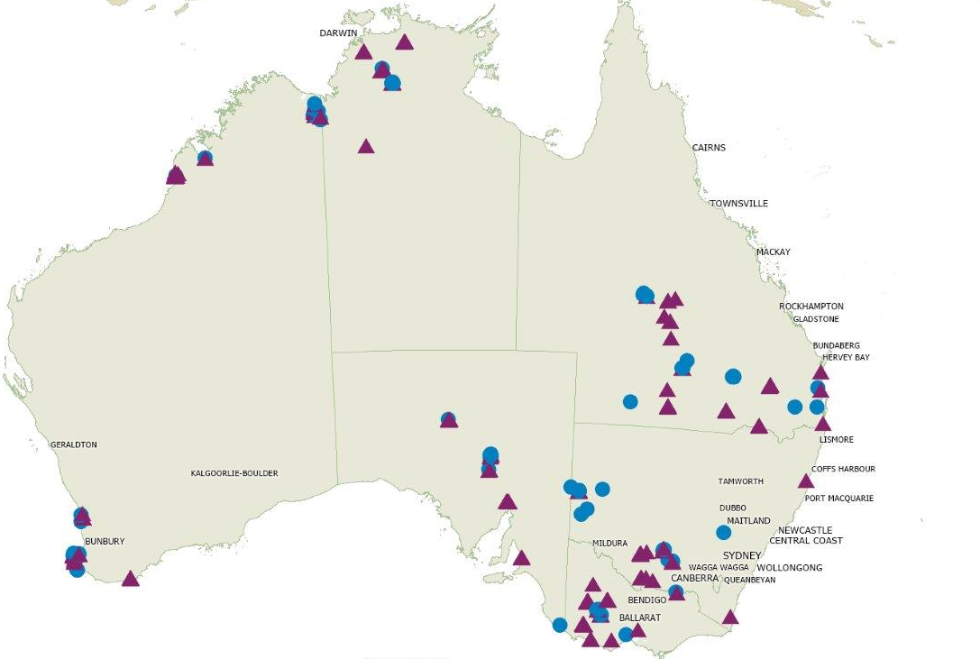

While some businesses were contacted prior to a site visit, other audits were unannounced.

During site visits, Inspectors showed employers tools and resources on fairwork.gov.au and assessed time and wages records.

Case study: Direct engagement with business owners

During their visit to Katherine in the Northern Territory, Fair Work Inspectors gave a presentation to a small group of employer representatives at the local public library.[5] Topics included FWO online tools and resources, the National Employment Standards and specific compliance issues identified during site visits to businesses in the area. In discussion with employers, Inspectors were able to provide practical advice to assist with specific issues

# Key findings

During the Campaign, many employers stated that finding and keeping staff was the key challenge they faced, and they paid above award minimum rates to attract and retain employees. In both Kununurra and Katherine, for example, employers explained that they were competing with the mining industry for staff, and needed to pay well above the industry standard to keep skilled or qualified employees. This trend had a positive effect on the monetary compliance rates in these areas.

In other locations, businesses struggled with the impact of a declining local populace. For example, in Stawell and Ararat, employers operating retail and hospitality businesses noted that the demand for products and services had dropped off along with the population. In turn, they explained, compliance with monetary obligations was more challenging.

Inspectors found that while most employers were familiar with the FWO website, many were unaware of the full suite of tools and resources on offer.

## National outcomes

Fair Work Inspectors completed 600 audits of businesses across Australia during the campaign. Of these, 363 (61%) were compliant with all requirements and 237 (39%) were non-compliant.

The breakdown of non-compliance was as follows:

* 116 (19% of all businesses as audited) had monetary breaches
* 91 (15%) were non-compliant with pay slip and/or record-keeping obligations
* 30 (5%) were found to have both monetary and non-monetary breaches.

Fair Work Inspectors recovered $191 125 from 94 businesses for 268 employees.

The most common breaches identified by Fair Work Inspectors were:

* failure to pay the correct hourly rate (36% of all breaches)
* failure to provide pay slips in the prescribed form (35%)
* failure to pay correct penalty rates (12%).

## Outcomes by area

### A small icon map of New South Wales to the right of the explanatory text. New South Wales – Broken Hill, Far West, Griffith-Murrumbidgee and Lower Murray

* 123 audits completed
* 83 (68%) businesses were compliant with record-keeping and pay slip requirements for their staff
* 86 (70%) businesses were paying their staff correctly
* 58 (47%) businesses were compliant with all requirements
* $24 616 was recovered on behalf of 33 employees from 20 businesses
* 7 Formal Cautions, one Compliance Notice and one Infringement Notice were issued.

### A small icon map of the Northern Territory to the right of the explanatory text. Northern Territory – Daly-Tiwi-West Arnhem and Katherine

* 54 audits completed
* 47 (87%) businesses were compliant with record-keeping and pay slip requirements for their staff
* 42 (78%) businesses were paying their staff correctly
* 36 (67%) businesses were compliant with all requirements
* $21 593 was recovered on behalf of 23 employees from 5 businesses
* one Formal Caution and two Compliance Notices were issued.

### A small icon map of Queensland to the right of the explanatory text. Queensland – Outback South and Darling Downs-Maranoa

* 102 audits completed
* 84 (82%) businesses were compliant with record-keeping and pay slip requirements for their staff
* 76 (75%) businesses were paying their staff correctly
* 62 (61%) businesses were compliant with all requirements
* $32 975 was recovered on behalf of 65 employees from 21 businesses
* 9 Formal Cautions, one Compliance Notice and one Infringement Notice were issued.

### A small icon map of South Australia to the right of the explanatory text. South Australia – Mid-North and Outback North and East

* 54 audits completed
* 42 (78%) businesses were compliant with record-keeping and pay slip requirements for their staff
* 35 (65%) businesses were paying their staff correctly
* 28 (52%) businesses were compliant with all requirements
* $20 390 was recovered on behalf of 38 employees from 15 businesses
* 8 Formal Cautions and 6 Infringement Notices were issued.

Victoria – The Grampians and Maryborough-Pyrenees

* 137 audits completed
* 106 (78%) businesses were compliant with record-keeping and pay slip requirements for their staff
* 107 (78%) businesses were paying their staff correctly
* 82 (60%) businesses were compliant with all requirements
* $52 779 was recovered on behalf of 51 employees from 19 businesses
* 10 Formal Cautions, one Compliance Notice and four Infringement Notices were issued.

### A small icon map of Western Australia to the right of the explanatory text. Western Australia – Kimberly, Augusta-Margaret River-Busselton and Manjimup

* 130 audits completed
* 117 (90%) businesses were compliant with record-keeping and pay slip requirements for their staff
* 108 (83%) businesses were paying their staff correctly
* 97 (75%) businesses were compliant with all requirements
* $38 772 was recovered on behalf of 58 employees from 14 businesses
* 10 Formal Cautions, four Compliance Notices and two Infringement Notices were issued.

## Comparison of Findings

The FWO has identified that 61% of businesses audited in this campaign were compliant with all aspects of their workplace relations obligations. This is higher than the average compliance rate for businesses audited in all other campaigns conducted during the corresponding period (53%).[6] The table below shows that the same observation can be made when comparing compliance with either monetary or non-monetary obligations.

#### Figure 3: A comparison of the average compliance rates of all FWO campaigns in the corresponding period with those of Remote and Regional Locations Campaign.

| Workplace Relations Obligations | All Campaigns | Remote and Regional Locations Campaign |
| --- | --- | --- |
| Monetary | 71% | 76% |
| Non-monetary | 75% | 80% |

The FWO has found that in most industries, the compliance rates identified during this campaign were generally higher than the average for all campaigns conducted during the corresponding period. This trend may reflect the necessity for many remotely located businesses to offer sufficiently attractive wages and conditions to retain workers. In a majority of industries however, over a third of businesses were non-compliant with their workplace relations obligations.

#### Figure 4: Compliance rates by industry[7] – Remote and Regional Campaign v all-campaign average in corresponding period[8]

| **Industry** | **Remote and regional campaign** | **All-campaign**  **average** |
| --- | --- | --- |
| Retail Trade | 57% | 53% |
| Accommodation and Food Services | 51% | 43% |
| Other Services | 57% | 55% |
| Construction | 68% | 56% |
| Manufacturing | 62% | 55% |
| Professional Scientific and Technical Services | 73% | 58% |
| Wholesale Trade | 48% | 57% |
| Transport Postal and Warehousing | 65% | 52% |
| Rental Hiring and Real Estate Services | 72% | 62% |
| Financial and Insurance Services | 47% | 57% |
| Health Care and Social Assistance | 59% | 63% |

## Compliance and enforcement results

The impact of non-compliance in regional and remote areas can have a significant impact on small, isolated communities. This is particularly the case where there is one dominant industry or a limited number of major employers.

To ensure that non-compliant employers took corrective action and understood the importance of achieving sustained compliance with their workplace relations obligations, Fair Work Inspectors issued:

* 45 Formal Cautions
* 14 Infringement Notices, amounting to $2520 in penalties
* nine Compliance Notices, compelling employers to back pay a total of $47 521 to 49 employees.

# Conclusion

Most industries audited in this campaign achieved higher than average compliance rates. This may reflect the fact that many businesses operating in remote areas offer above-award rates of pay to attract and retain labour.

Notwithstanding, in a majority of industries, over a third of businesses were non-compliant with their workplace relations obligations. The impacts of non-compliance in smaller, more isolated remote and regional communities with fewer employers can be significant. Factors that contribute to non-compliance in these areas include:

* limited access to education and training opportunities
* reduced access to services and transport
* limited employment options
* reduced job security in times of flood, drought and crop destruction or due to industry seasonality and decline
* lower likelihood of workers complaining (in light of the above) for fear of it being known within small communities and not finding alternative employment
* relatively large proportion of small businesses without access to workplace relations support.

The FWO will continue to promote workplace relations compliance in remote and regional Australia by:

* supporting third-party intermediaries located outside capital cities and major regional areas, such as accountants, HR specialists and business chambers, to assist their clients achieve compliance with workplace relations obligations
* continuing a program of proactive compliance campaigns in regional areas
* developing and promoting tools and resources designed to help small businesses, such as [Small Business Showcase](https://www.fairwork.gov.au/small-business-showcase/help-for-small-business)[9] (a portal to the full suite of FWO tools, templates, online courses and other tailored resources), and our [Workplace Basics Quiz](https://www.fairwork.gov.au/how-we-will-help/online-training/workplace-basics)[10]
* monitoring businesses identified as non-compliant through our ongoing National Compliance Monitoring program.[11]

# About the Fair Work Ombudsman

The Fair Work Ombudsman is an independent agency created by the *Fair Work Act 2009* on 1 July 2009. Our main role is to promote harmonious, productive and cooperative workplace relations.

The Fair Work Ombudsman regularly undertakes proactive campaigns to assist employers and employees understand their rights and obligations under Australian workplace relations laws.

These campaigns can focus on particular industries, regions and/or labour market issues and are conducted nationally or in specific regions.

This report covers the background, method and findings of the Remote and Regional Campaign. For further information and media enquiries please contact the media team at [media@fwo.gov.au](mailto:media@fwo.gov.au)

If you would like further information about the Fair Work Ombudsman’s campaigns please contact Steven Ronson, Executive Director - Proactive Compliance at [Steven.Ronson@fwo.gov.au](mailto:Steven.Ronson@fwo.gov.au).

# Appendix A – Stakeholder engagement

### Industry/employer groups

* Australian Industry Group (AIG)
* Australian Retailers Association (ARA)
* National Road Transport Association (NRTA)
* Australian Chamber of Commerce and Industry (ACCI)
* Council of Small Business Australia (COSBOA)
* Outback Business Networks
* Indigenous Chamber of Commerce
* Family Business Australia

### Employee representatives

* Australian Workers Union (AWU)
* The Construction, Forestry, Mining and Energy Union (CFMEU)
* The National Union of Workers (NUW)
* United Voice (UV)

### Kimberley Region

* Kununurra Chamber of Commerce
* Derby Chamber of Commerce
* Broome Chamber of Commerce
* Shire of Broome
* Shire of Wyndham East Kimberley
* Shire of Derby/West Kimberley Council
* Department of Training & Workforce Development – indigeWorkforce Development Centre (Broome Office)
* Yawuru – Native title holders of the Western Australian town of Broome
* Wunan Employment Services – Kununurra office
* Winun Ngari Aboriginal Corporation (WNAC) – Derby Office

### Outback North and East South Australian Region

* Bungala Aboriginal Corporation
* Port Augusta City Council
* Roxy Downs Municipal Council
* Career Employment Group (Roxby Downs)
* District Council of Coober Pedy
* Woomera Aboriginal Council

### The Outback - South Qld

* Murweh Shire Council
* Longreach Regional Council
* Barcaldine Regional Council
* Paroo Shire Council
* Tambo Regional Council
* Central Queensland Indigenous Development
* Charleville Chamber of Commerce

### Broken Hill and Far West NSW region

* Broken Hill Regional Council
* Broken Hill Chamber of Commerce
* Maari Ma Health
* Central Darling Shire Council

### Katherine NT region

* Katherine Town Council
* NT Chamber of Commerce
* Victoria River Daly Shire Council
* Roper Gulf Regional Council

### Daly-Tiwi West Arnhem NT Region

* West Daly Regional Council
* NT Chamber of Commerce
* Tiwi Land Council (specifically the Tiwi Islands Training and Employment Board).
* Tiwi Islands Regional Council
* West Arnhem Regional Council

### Grampians VIC Region

* North Grampians Shire Council
* Horsham Rural City Council
* Ararat Rural City Council
* Yarriambiak Shire Council

### Darling Downs – Maranoa Region

* Goondiwindi Chamber of Commerce
* Chinchilla Chamber of Commerce
* St George Chamber of Commerce
* Maranoa Regional Council
* Balonne Shire Council
* SkillCentred Indigenous Services - Roma
* Goondiwindi Regional Council

### Augusta – Margaret River – Busselton WA region

* Augusta – Margaret River Shire
* Margaret River Chamber of Commerce
* Busselton City Council
* JSW Training and Community Services (Busselton and Margaret River)

### Griffith – Murrumbidgee NSW Region

* Griffith City Council
* Griffith Chamber of Commerce
* Murrumbidgee Shire Council

# Appendix B – Social media coverage

Examples of Facebook and Twitter Posts from the communication and awareness phase of this campaign
Pictures of locations across regional Australia were posted along with the words: "Need advice on a workplace issue? No matter where you are, we can help."

Twitter posts advise the reader about upcoming field visits. The first Twitter post states: "From Broken Hill to Pine Creek. We're making our way to regional and remote areas with workplace advice". The second post states: "We're visiting remote and regional Australia, talking rights and obligations with employers."


1. ABS 3218.0 Regional Population Growth, Australia, as at 30th June 2017, released Aug 2018
2. https://www.couriermail.com.au/news/queensland/queensland-drought-country-pubs-closing-doors-as-businesses-fold/news-story/a1124679d5a4811adb58aca95a9d205a
3. Print coverage included Northern Territory News, Halls Creek Herald (WA) and The Kimberley Echo (WA)
4. The FWO published three media releases, for our release on activities for WA see: <https://www.fairwork.gov.au/about-us/news-and-media-releases/2016-media-releases/april-2016/20160413-lms-kimberly>
5. Organised with the assistance of the Northern Territory Chamber of Commerce
6. The 2016/17 financial year
7. Only industries where the FWO conducted fifteen or more audits are included in the table
8. The 2016/17 financial year
9. <https://www.fairwork.gov.au/small-business-showcase/help-for-small-business>
10. <https://www.fairwork.gov.au/how-we-will-help/online-training/workplace-basics>
11. National Compliance Monitoring: https://www.fairwork.gov.au/how-we-will-help/helping-the-community/campaigns/national-campaigns/compliance-monitoring-campaign