FWO Regional campaigns

A report on a series of proactive compliance and education activities in regional Queensland, New South Wales and Victoria

May 2019

© Commonwealth of Australia, 2019

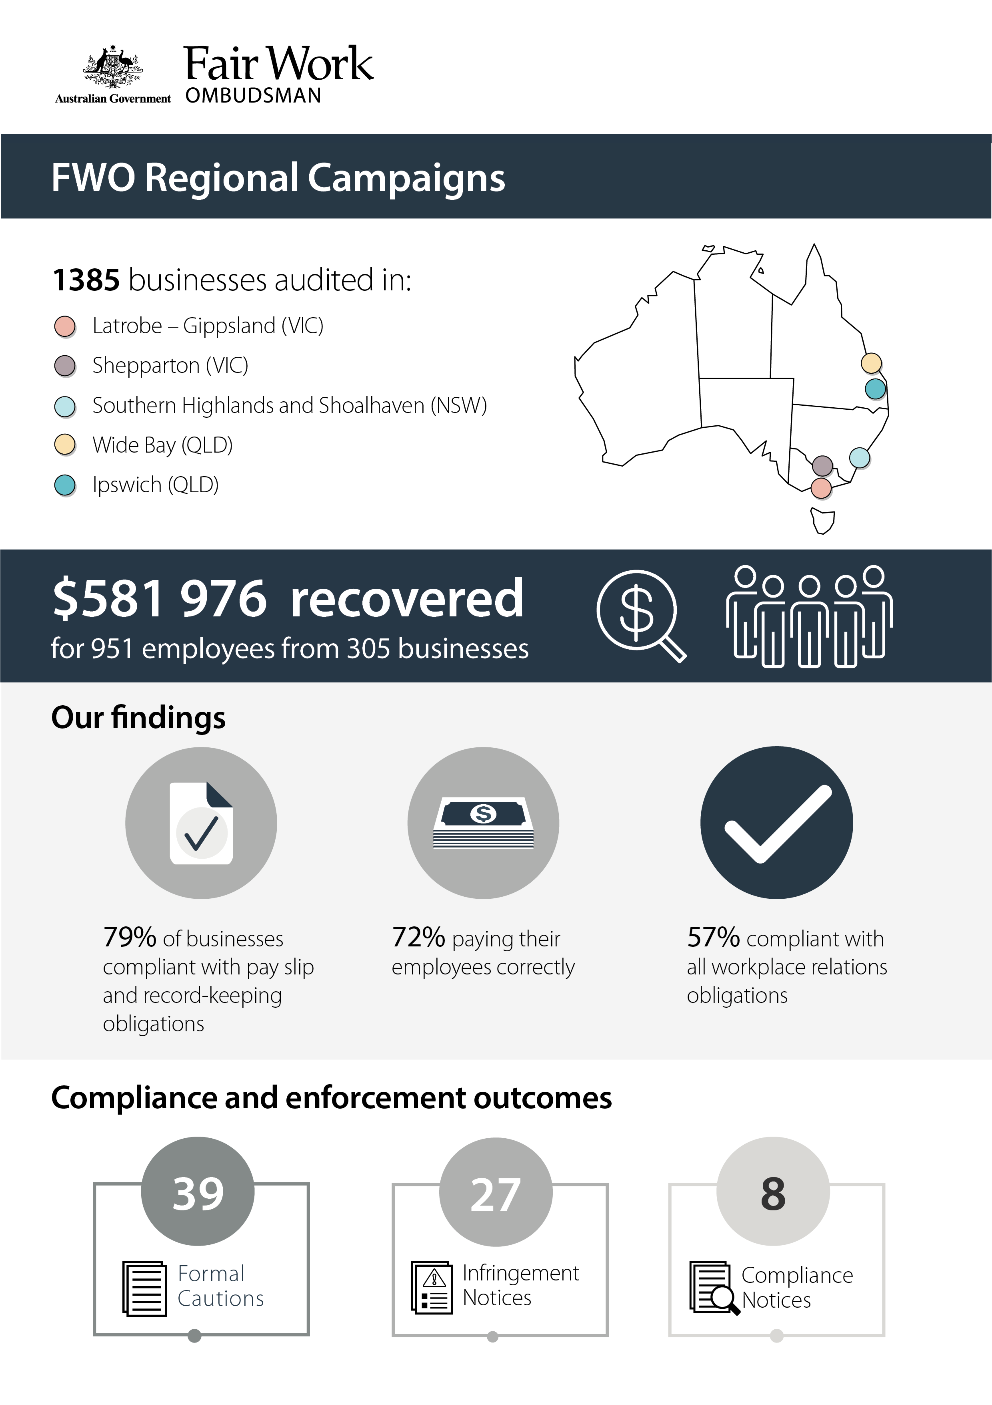

Table of contents

Executive summary 4

Background 5

Objectives 5

Stakeholder and communication activities 5

Methodology 5

Results 7

Compliance and enforcement outcomes 9

Conclusion 11

About the Fair Work Ombudsman 12

# Executive summary

This report details the background, methodology and outcomes of the FWO’s proactive compliance and education activities in the following regions:

* Latrobe-Gippsland (Vic)
* Shepparton (Vic)
* Southern Highlands and Shoalhaven (NSW)
* Wide Bay (Qld)
* Ipswich (Qld).

The FWO conducted audits in each of these locations to:

* check compliance with workplace relations laws
* recover outstanding employee entitlements
* educate employers about their workplace relations obligations.

Fair Work Inspectors audited 1385 businesses and found:

* 788 (57%) were compliant with all aspects of their workplace relations obligations
* 1089 (79%) were compliant with pay slip and record-keeping requirements (non-monetary obligations)
* 995 (72%) were paying their employees correctly (monetary obligations).

Where Fair Work Inspectors identified non-compliance, they examined the reasons why employers failed to follow the law and determined that a lack of awareness of workplace laws was the key driver. Employers were educated about a range of free FWO tools and resources available online for keeping up to date with their obligations.

The FWO took compliance and enforcement action to address and deter non-compliant behaviours, issuing:

* 39 Formal Cautions
* 27 Infringement Notices
* eight Compliance Notices.

Across all locations, a total of $581 976 was recovered for 951 employees from 305 businesses involved in monetary breaches.

# Background

The FWO targeted the regions covered in this activity based on evidence suggesting that businesses in these areas were at risk of non-compliance. These risk factors included:

* the proportion of vulnerable employees engaged by regionally based businesses, for example young workers and/or migrant workers
* the number and type of Requests for Assistance received by the FWO from local workers
* regional unemployment rates.

Businesses from a cross-section of local industries were selected, with the Accommodation and Food Services (Hospitality) and Retail sectors a particular focus. The FWO has found that these industries present a high risk of non-compliance compared with most other industriesand attract a greater number of young and/or migrant workers.

## Objectives

The objectives of these activities were to:

* assess compliance with workplace relations laws
* educate employers about their workplace relations obligations and FWO tools and resources
* use compliance and enforcement tools where required to address and deter non-compliance
* recover outstanding entitlements for workers.

## Stakeholder and communication activities

The FWO wrote to local and industry stakeholders notifying them about the activities and to seek their assistance and support to raise awareness in the community about the importance of compliance with workplace relations laws.

Media releases were issued at the commencement of each activity, generating extensive local media interest. Media coverage included local radio interviews with FWO officers and WIN TV covered the Latrobe-Gippsland campaign.

## Methodology

Fair Work Inspectors audited 1385 businesses. This included:

* 364 audits in the Latrobe-Gippsland region (Vic)
* 262 in the Shepparton region (Vic)
* 338 in the Southern Highlands and Shoalhaven regions (NSW)
* 209 in the Wide Bay region (Qld)
* 212 in the Ipswich region (Qld).

Inspectors assessed time and wages records against the *Fair Work Act 2009* (the Act), the *Fair Work Regulations 2009* (the Regulations) and the applicable award/agreement. Common awards applying to local businesses were:

* General Retail Industry Award 2010
* Hospitality Industry (General) Award 2010
* Restaurant Industry Award 2010
* Fast Food Industry Award 2010
* Manufacturing and Associated Industries Award 2010
* Building and Construction General On-Site Award 2010.

Fair Work Inspectors required employers to rectify any breaches and to provide evidence of corrective action taken, for example proof of payment of outstanding employee entitlements. They gave employers tailored information and advice based on the reasons for non-compliance. Small business employers were shown the FWO’s free online tools and resources designed specifically for them.[1]

# Results

Of the 1385 businesses audited, Fair Work Inspectors found:

* 788 (57%) were compliant with all workplace relations laws
* 597 (43%) were in breach of their obligations.

Compliance rates were similar across the regions:

* 52% in Shepparton
* 59% in Latrobe-Gippsland
* 55% in Southern Highlands & Shoalhaven
* 57% in Ipswich
* 63% in Wide Bay.[2]

The hospitality sector was the least compliant of all industries audited by the FWO (with a compliance rate of 45%). This is consistent with the FWO’s findings from across other campaign activities.

Of the 597 non-compliant businesses:

* 301 (22% of all audited business) failed to pay their employees correctly, but complied with pay slip and record-keeping obligations (non-monetary obligations)
* 207 (15%) were in breach of non-monetary obligations, but complied with monetary requirements
* 89 (6%) were in breach of both their monetary and non-monetary obligations.

The most common breaches Fair Work Inspectors identified were:

* underpayment of the minimum hourly rate (41% of all breaches)
* failure to provide pay slips in the form prescribed by the Regulations (30%)
* penalty rates (10%)
* overtime (7%)
* record-keeping (6%).

The reasons for non-compliance were found to be:

* lack of awareness of workplace relations obligations (48% of non-compliant businesses)
* misinterpretation of award requirements (20%)
* business decisions leading to non-compliance e.g. paying flat hourly rates in lieu of weekend penalties (12%)
* missing the July annual wage increase (9%)
* other reasons, such as payroll software issues (7%)
* incorrect advice from a third party, such as an accountant or another employer (4%).

Case study—missing the annual minimum wage increase

Fair Work Inspectors audited a furniture retail business in Ipswich. They identified that the employer had missed the annual minimum wage increase on 1 July. As a result, the employer underpaid four casual workers a total of $821.

The employer reimbursed the affected workers, explaining they had relied on their accountant to keep them up to date with changes to workplace relations laws including annual pay rate increases.

To assist the employer take greater control of their workplace relations obligations in future, Fair Work Inspectors helped them sign up to the FWO’s My Account service and employer newsletter. This means that in addition their accountant’s services, they now receive automatic updates on any changes to workplace relations laws—including annual minimum wages increases.

# Compliance and enforcement outcomes

Fair Work Inspectors used compliance and enforcement tools to ensure breaches were rectified and to deter non-compliant behaviours. They issued:

* 39 Formal Cautions, putting employers on notice about the consequences of continued non-compliance
* 27 Infringement Notices for breaches of pay slip and/or record-keeping requirements
* eight Compliance Notices, through which $49 749 was recovered for 59 workers.

In total, $581 976 was recovered for 951 employees from 305 business.

### Formal Caution

Fair Work Inspectors issue Formal Cautions to put businesses on notice (in writing) that further non-compliance could result in the FWO seeking financial penalties in court.

Case study—Formal Caution

Fair Work Inspectors audited a food retail business in Ipswich.

The employer didn’t know the correct award and paid employees a flat rate for all hours worked, including Saturdays.

Inspectors advised that the *General Retail Industry Award 2010* applied and identified that as the flat rate being paid by the employer fell beneath the award’s minimum ordinary hourly rate, four employees (all migrant workers) were underpaid nearly $4000.

The employer adopted the correct rates of pay and reimbursed all affected staff.

Inspectors issued a Formal Caution, warning the employer about the potential consequences of further non-compliance.

### Infringement Notice

An Infringement Notice is a fine for non-compliance with the record-keeping or pay slip requirements of the Act and Regulations.

Case study—Infringement Notice

Fair Work Inspectors audited a construction business in the Shepparton region.

The employer was issuing pay slips to staff that left out details required by the Act and Regulations, such as the business ABN, employee surnames, pay period, hourly rates and superannuation details.

Fair Work Inspectors issued the employer with an Infringement Notice to deter further non-compliance.

### Compliance Notice

A Compliance Notice is a written notice legally requiring a business to rectify breaches of the Act. Failure to comply with the notice can result in the FWO commencing legal proceedings.

**Case study—Compliance Notice**

Fair Work Inspectors audited a takeaway food business in the Southern Highlands-Shoalhaven region.

The employer was confused about award coverage and the applicable hourly rates of pay. As a result, they were paying seven casual employees less than the ordinary hourly rates of pay set out by the Fast Food Industry Award 2010. Three employees were also underpaid weekend penalty rates.

Underpayments ranged from just over one dollar to nearly five dollars per hour, and amounted to nearly $12 000. Four of the affected workers were juniors.

Inspectors issued a Compliance Notice requiring the employer to take corrective action and reimburse all employees.

# Conclusion

The FWO found 597 or 43% of businesses visited in these regions failed to comply with their workplace relations obligations. The hospitality sector was again shown to be an industry of concern with lowest rate of compliance overall (45%), validating our continued focus on this sector as a strategic priority.

Around half (48%) of non-compliant employers were unaware of applicable workplace relations laws. This highlights the importance of continuing to audit and educate regional employers. Audits provide an opportunity to promote free FWO tools and resources that support compliance, including:

* PACT- calculates employee entitlements including award pay rates, leave entitlements and termination pay[3]
* MyAccount - interactive service where employers receive tailored information and updates[4]
* Online learning centre - award-winning videos on key subjects like hiring employees, managing performance and record-keeping and pay slip obligations[5]
* Small Business Showcase - tools and resources specifically designed to assist small businesses with their workplace relations obligations.[6]

The FWO expects employers to use the education and advice provided through audit activities to be compliant with workplace relations obligations. Non-compliant employers will be revisited as part of the FWO’s ongoing national proactive compliance monitoring programs. Appropriate compliance and enforcement action will be used against employers who continue to not comply with workplace laws.

In all instances, where serious and/or wilful non-compliance is found, the FWO may commence legal proceedings and ask the court to impose penalties.[7]

# About the Fair Work Ombudsman

The Fair Work Ombudsman is an independent agency created by the *Fair Work Act 2009* on 1 July 2009. The FWO’s role is to promote harmonious, productive and cooperative Australian workplaces, and to monitor and enforce compliance with Australian workplace laws.

The FWO regularly conducts proactive campaigns targeting at-risk employers as part of its compliance monitoring function.

For media enquiries please contact the media team at [media@fwo.gov.au](mailto:media@fwo.gov.au)

If you would like further information about the Fair Work Ombudsman’s campaigns please contact Steven Ronson, Executive Director-Proactive Compliance at: [steven.ronson@fwo.gov.au](mailto:steven.ronson@fwo.gov.au)

1. www.fairwork.gov.au/find-help-for/small-business
2. Caution should be used when comparing results between regions due to limitations arising from sample profile and size.
3. https://calculate.fairwork.gov.au/
4. https://www.fairwork.gov.au/my-account/registerpage.aspx
5. https://www.fairwork.gov.au/how-we-will-help/online-training/online-learning-centre
6. https://www.fairwork.gov.au/small-business-showcase
7. Courts may impose penalties up to $12 600 per breach for an individual, and $63 000 per breach for companies. Where non-compliance is proven to be deliberate or systemic, penalties can amount to $126 000 per breach for individuals and $630 000 per for companies.