


Designed to Fit

Insights and outcomes from the Fair Work Ombudsman’s education phase of the National Textile, Clothing and Footwear Campaign 2015

Background

The National Textile, Clothing and Footwear Campaign is being conducted in two distinct phases; an educative campaign in the first instance, followed by a compliance campaign. The educative campaign was carried out by the Fair Work Ombudsman (FWO) throughout 2015. This report discusses the activities and outcomes of the first phase of this work, as well as its impact upon the next (compliance) phase of the campaign.
Summary of Outcomes

The education phase consisted of a range of activities as outlined in this report. Outcomes included:
- Community engagement material distributed to Migrant Resource and Working Women’s Centres Australia wide;
- Education material reached over 30 local councils in Victoria and NSW;
- Co-hosting a family day with the Sydney organisation, Asian Women at Work;
- Facebook page views from more than 400 000 people;
- Radio and print advertising circulations totalling over 155 500;
- Online media reaching an audience of nearly 120 000 people;
- Contact with 412 industry participants;
- Direct engagement with 295 textile, clothing and footwear manufacturers; and
- 38 businesses identified as utilising 80 outworkers.

Campaign Objectives
The primary objective of the campaign was to increase awareness of workplace laws at all levels of supply chains (including outworkers and businesses that engage outworkers) within the textile, clothing and footwear Industry.
The FWO also wanted to promote the free tools and resources the FWO has available to help those in the industry understand their rights and obligations.
The campaign focussed on the Clothing and Footwear Manufacturing and the Cut and Sewn Textile Product Manufacturing sub-industries.
These sub industries were identified as representing 78% of businesses operating in the industry. The campaign placed particular emphasis on the engagement of outworkers by employers operating within these industries.
In recognition of the influence participants at all levels of the supply chain have on compliance within the industry, retailers, merchant distributors and wholesalers that stock and distribute such goods were included within the scope of the campaign.
The campaign was run with an initial education phase executed first, to reflect the distinct characteristics of the industry and gain a greater understanding of any specific industry issues that could affect compliance.

Industry Snapshot
Education and assistance tailored specifically to the industry was considered necessary due to the following particular features of the industry:
- The industry has reduced in size and production. There has been a significant shift within the Australian Textile, Clothing and Footwear industry in the past few decades. The effect of globalization and access to overseas competition for consumers has changed the landscape for local producers. There is pressure on the price of local production which has rendered those at the lower levels of the varied and fragmented supply chains particularly vulnerable;
- 87% of businesses in the industry are categorised as small businesses. Small businesses are less likely to have dedicated or in-house support for human resource and payroll matters;
- The industry has relatively high levels of female workers including those from culturally and linguistically diverse (CALD) backgrounds. Cultural barriers including language difficulties, fear of discrimination and a perceived lack of alternate employment opportunities can lead to workers not being aware of their rights and entitlements; and
- FWO data surrounding requests for assistance from workers in the industry in the 2012 calendar year reveals a high contravention rate (39.56%) which may reflect difficulties in navigating supply chain arrangements. Supply chains in this industry are both varied and fragmented, with many ‘layers’ stretching from the sourcing of the product right through to the end supply to the customer.

Educating the Industry
The FWO delivered the first phase of the campaign through several activities including stakeholder engagement, a communications campaign, direct engagement with the community and educating employers in person and via telephone.

February 2015 - Stakeholder Engagement

The FWO commenced engagement with key industry stakeholders in February 2015. Engagement was undertaken prior to the design, development and delivery of the campaign, to allow any direct input and insights gleaned regarding industry specific issues to shape operational activities.
Insights included the importance of in-language resources and the effective use of in-language media. This information was used to develop the Communications Campaign (detailed below).
Engagement also provided the chance to explore future opportunities to work collaboratively to assist the industry such as the Asian Women at Work Family day held in May 2015 (discussed in further detail below).
The FWO engaged with stakeholders including:
- Textile Clothing and Footwear Union of Australia;
- Ethical Clothing Australia;
- Australian Retailers Association;
- Asian Women at Work.

A full list of stakeholders the FWO engaged with is available in Appendix A.
March 2015 to April 2015 - Communications Campaign

The FWO ran a communications campaign during March and April 2015. It was designed with a view to reaching participants in the industry, at all levels of the supply chain, and to provide them with information on their rights and obligations.
Industry specific collateral was created for the campaign, including a fairwork.gov.au campaign page, a DL flyer, in-language ads, search engine ads and social media assets. All collateral was designed to make it easily shared and was available in English, Traditional Chinese and Vietnamese, with existing FWO downloadable resources were also translated into Traditional Chinese and Vietnamese.
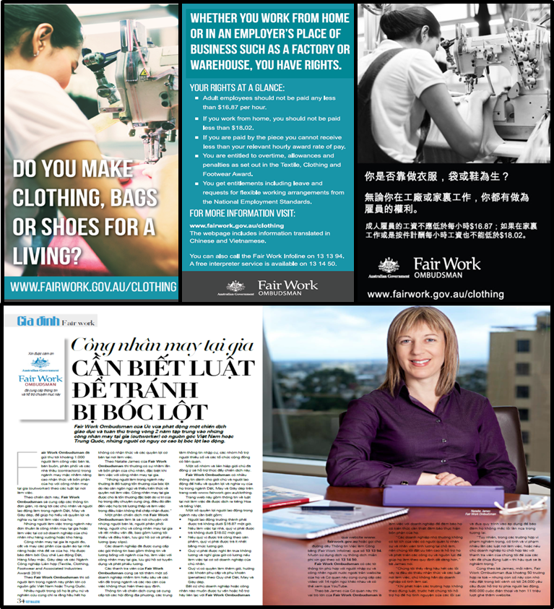
Above: a sample of creative collateral created for the campaign.
The campaign utilised a number of channels to have the best chance to reach the target audience. These included:
Social Media
The FWO utilised social media to engage with industry participants including employers, employees and outworkers, and intermediaries such as accountants, tax professionals and lawyers.
Key messages were developed to appeal to employees and outworkers in the industry and drive traffic to the campaign webpage. Messages included information covering minimum wages, piece rates, outworker rights and where to go for assistance.
Of all channels utilised by the campaign, Facebook received the most engagement, with:
- Page views from more than 400,000 people;
- 23,725 clicks which led to a click-through rate (CTR) of 2.89% which exceeds the industry average of 1.0%; and
- Promoted posts targeting Chinese speaking people showing the highest engagement (6997 clicks on our posts, Facebook page or images with 1258 direct to fairwork.gov.au and 737 likes). This equated to a CTR of 3.28%.
Content on Twitter included a mix of employee/outworker focused information as well as to employers and those at the top levels of the supply chain. This reflects the greater engagement that we have with accountants, tax professionals and lawyers through Twitter which helps us reach employers and small business operators.
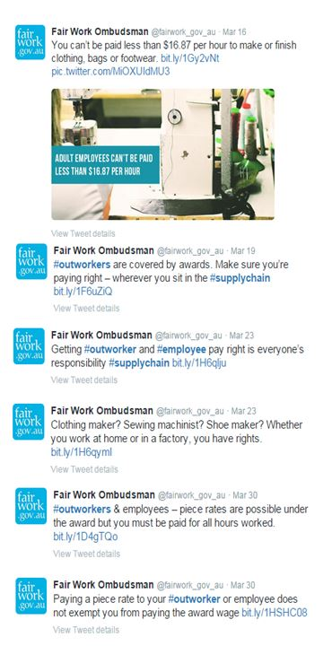
The 6 tweets tweeted as part of the campaign were collectively viewed by over 7,000 people
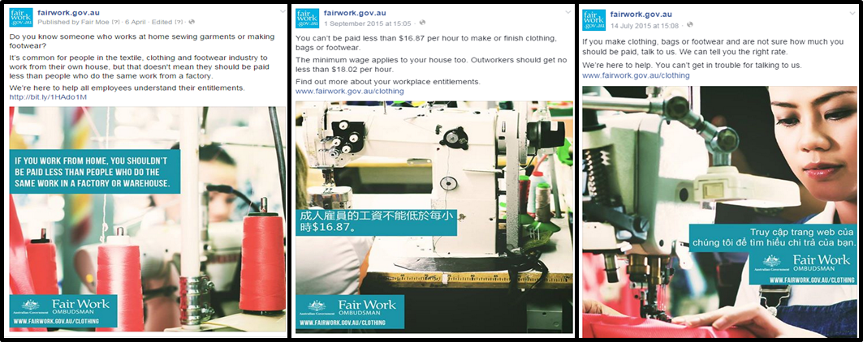
A sample of the Facebook posts that attracted 6997 clicks.
Google Search
Hundreds of key words (such as “factory jobs”, “minimum wage”, “work rights”, “pay for making clothes”, “working from home”, “outworkers” and “textiles”) were employed to deliver sponsored search results in Google when people search for these, or similar terms.
This was run in English, Chinese and Vietnamese and linked users to the dedicated campaigns page at fairwork.gov.au. Over the 4 week campaign the ads made 128,254 impressions and received 1,348 clicks.
Media
- A media release highlighting the activities FWO would be undertaking during the campaign, and directing people to the dedicated campaigns page at fairwork.gov.au, was distributed; and
- The campaign generated 37 items across print, radio and online, with an audience of nearly 120,000 people.
Radio and print advertising
A radio and print advertising campaign was run across NSW and Victoria in Vietnamese and Chinese media outlets. In-language media was identified as an important communications channel with Chinese and Vietnamese speakers. Publications and locations were selected based on ABS geographical data of our target audience and included Chinese Community News, Asian Multimedia, The Australian Chinese Age, Ti Vi Victoria and Chieu Duong – Sunrise Daily.
The circulation numbers for the papers that advertisements were placed within totals over 155,500. In addition to the audiences reached by radio and newspaper, fairwork.gov.au analytics also indicate 4,276 visits to the campaign page during the campaign period with a further 323 visits to the employer specific page and 2,392 to the employee/outworker specific page. Radio and print advertising would have been a strong factor in these pages reaching this many people.

May 2015 – Community Engagement

Engagement with community stakeholders was integral to the FWO’s ability to connect with employees and outworkers in the industry. Connecting with established networks within the community and fostering existing relationships with stakeholders was vital in reaching out to workers, providing education and building trust within those communities with the FWO.
Community Engagement Packs
Community engagement packs were developed for stakeholders to help spread the message to employees and outworkers on a local level. Stakeholders included Migrant Resource Centres and over 30 local City Councils across NSW and Victoria, and Working Women’s Centres Australia wide.
The FWO provided templates and images, a newsletter article and media release. Stakeholders were asked to tailor the information and distribute it across their networks with the aim of increasing worker confidence, connecting employees and outworkers to available resources and alerting some to the fact there may be an issue.
Asian Women at Work Family Day
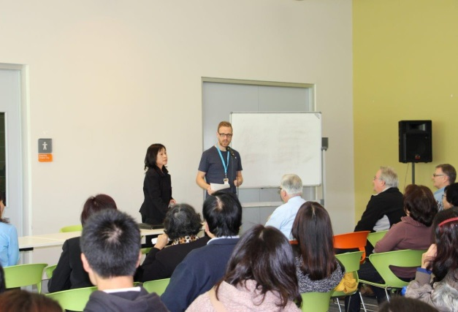
On Saturday 23 May 2015, the FWO co-hosted a family day with a Sydney based organisation Asian Women at Work (AWAW).
Scheduling the event on the weekend allowed over 60 women of Vietnamese background working in the industry to attend, and provided a chance to ask questions about their rights at work, and to confidentially talk with the FWO about potentially non-compliant businesses in an informal setting.
Above: Robert Hortle, Director of Small Business Strategy and Campaigns addressing attendees at the AWAW family day.
Joining with Asian Women at Work for the event gave the FWO the opportunity to reach out to the often closed outworker group and build a relationship with the community in order to overcome any perceived mistrust of government.
During the course of the day, a number of the participants took the opportunity to share their insights and experience as outworkers with the FWO staff at the event. These insights included useful information that was used to inform the compliance phase of the campaign including:
- The conditions and issues faced by outworkers;
- The difficulties outworkers face in making a complaint about their conditions;
- Suggestions for how to engage with outworkers; and
- Suggestions for how to conduct visits to outworkers and workers in the industry in factory settings.

March 2015 to May 2015 – Educating Employers

The FWO sent educational resources to over 800 businesses that were identified as potential industry participants. This included information about their workplace rights and responsibilities. These businesses represented the spectrum of the supply chain.
Fair Work Inspectors (FWI’s) subsequently directly contacted 412 industry participants to:
Provide further information about the tools, resources and assistance available from FWO and other relevant bodies;
Answer any questions that participants may have had about their workplace rights or responsibilities; and
Gather information about the industry, including employment arrangements, employee and outworker characteristics, supply chain information and intelligence on issues in the industry to inform the second, compliance phase of the campaign. This detail is discussed in greater detail at the industry Intelligence section below.
While not a specific focus of this stage of the campaign, in addition to providing tailored education and advice, FWI’s assisted industry participants where obvious errors were raised, and worked with them to rectify these issues.


Building upon the foundations
Industry Intelligence
Information gathered by FWI’s during the education phase of the campaign is discussed below. This information will be used to test the FWO’s assumptions about the industry and to inform the second, compliance phase of the campaign.
Demographics
Of the 412 industry participants contacted by FWI’s, 295 directly manufactured TCF goods in Australia. Of this subset:
- 252 had employees who were engaged in production;
- 8 engaged contractors;
- 38 business were found to be utilising 80 outworkers;
- Over half the businesses engaged with (55%) were a small business (5-19 employees) or a micro business (1-4 employees); and
- The most common employee and outworker nationalities identified were Australian, Vietnamese, and Chinese, followed by Greek and Italian.
Prevalent Issues
Conversations with industry participants revealed key areas of confusion or concern including:
- Limited understanding of obligations relating to the registration of outworkers to the board of reference (an industry specific board administered through the Fair Work Commission which exists to monitor the engagement and workflow of outworkers);
- Limited understanding or observation of minimum rates of pay for outworkers; and
- Confusion about how compliance and regulation interacts with different levels of the supply chain.

Conclusion

Several conclusions can be drawn from the insights and outcomes of the first, educative phase of the campaign. However, in recognising the small sample size and scope of this phase, the findings of the second (compliance) phase of the campaign should be used to test and either confirm or reject these conclusions. These conclusions will shape the future interaction the FWO has within this industry in its efforts to promote conscious compliance and detect and deter unlawful workplace practices. Insights and outcomes included:
- Chinese and Vietnamese digital content was extremely successful in reaching and engaging the target audience as demonstrated by the above industry average CTR. Where appropriate, translated content should be utilised to reach industry participants in other, similarly multicultural industries;
- This phase of the campaign has identified around 365 businesses that are operating in the industry and within scope of the campaign. These businesses are suitable for inclusion in the second, compliance phase of the campaign;
- The ability to identify and engage directly with outworkers in the community is difficult. The very nature of these arrangements and the way in which supply chains operate means outworkers and outworker arrangements are not readily visible; and
- There is willingness within the community to communicate with and approach government, in the right setting.
Next Steps

- The next phase of the campaign will involve greater, more in-depth contact with businesses engaging employees and outworkers. The FWO will seek to establish industry compliance through this phase of the campaign;
- Businesses found to be non-compliant during the second phase will be subject to greater scrutiny and potential enforcement action;
- The FWO will re-engage with stakeholders to develop further strategies to assist employers and workers within the Industry; and
- The results of this phase of the campaign will be shared with industry stakeholders, and more broadly via media channels.
About the Fair Work Ombudsman

The Fair Work Ombudsman is an independent agency created by the Fair Work Act 2009 on 1 July 2009. Our main role is to promote harmonious, productive and cooperative workplace relations.
Each year the Fair Work Ombudsman (FWO) runs proactive campaigns to assist employers and employees understand their rights and obligations under Commonwealth workplace relations laws.
These campaigns can focus on particular industries, regions and/or labour market issues and are conducted on a national and state level.
This report covers the first, educative phase of the National Textile, Clothing & Footwear Industry Campaign 2015. For further information please contact the media team at media@fwo.gov.au
If you would like further information about the Fair Work Ombudsman’s campaigns please contact Lynda McAlary-Smith, Executive Director – Proactive Compliance and Education at Lynda.McAlary-Smith@fwo.gov.au

Appendix A
Stakeholders

Australian Industry Group (AIG)  Australian Council of Trade Unions  Migrant Resource Centres  Working Women’s Centre SA / NT/QLD  Community Legal Centres  FairWear  Australian Chamber of Commerce and Industry (ACCI)  Australian Retailers Association | NSW Business Chamber  Brotherhood of St Laurence  Asian Women At Work  Immigrant Women’s Speak out  Oxfam  Asian Business Associations  Council of Textile and Fashion Industries Australia (TFIA)  Textile, Clothing and Footwear Union Australia (TCFUA)

Appendix B
TCF Collateral – Facebook Posts
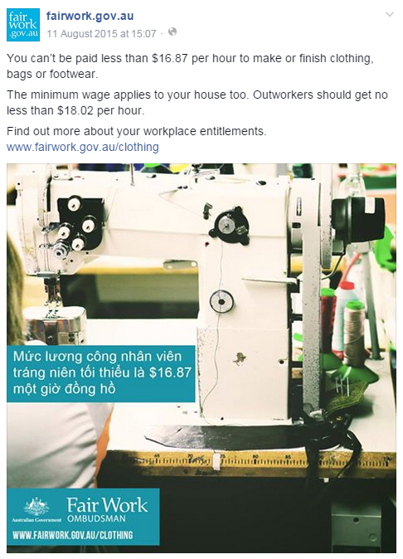
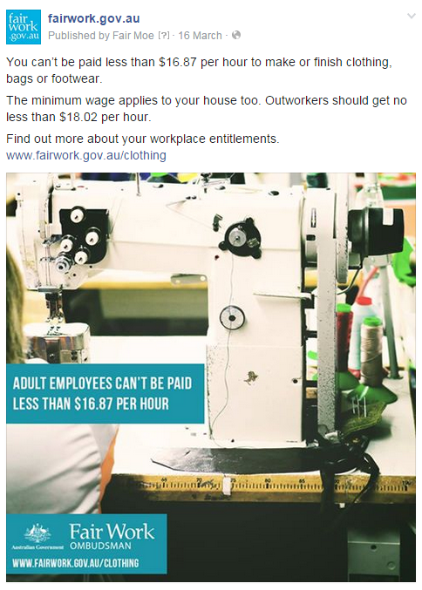
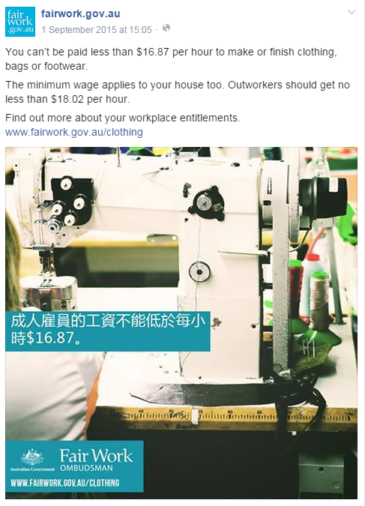
Week One

Week Two
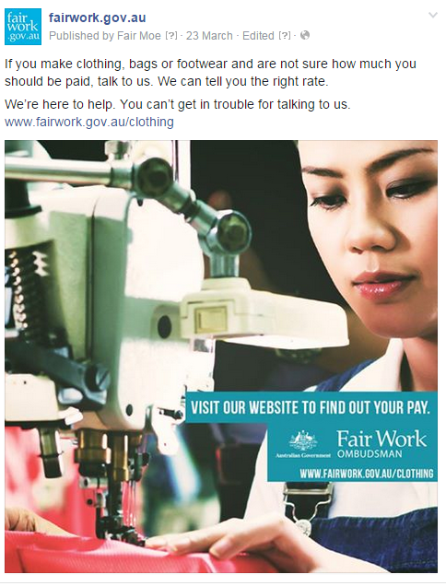
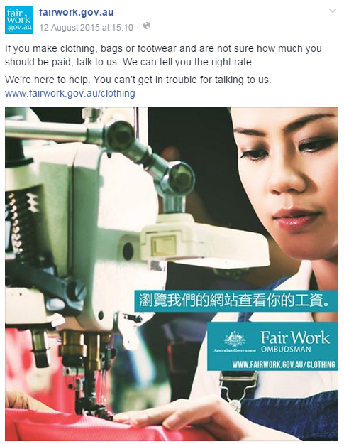
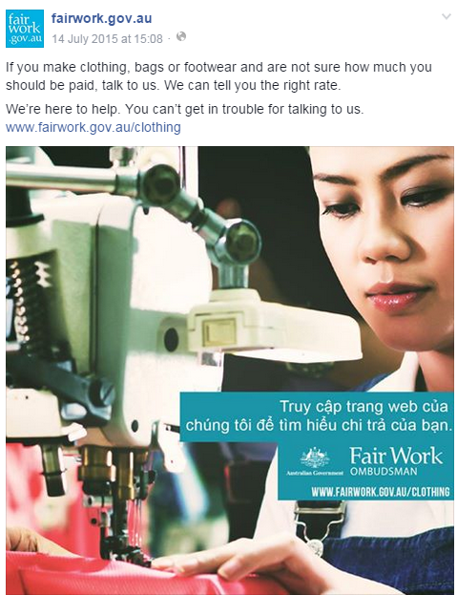

Week Three
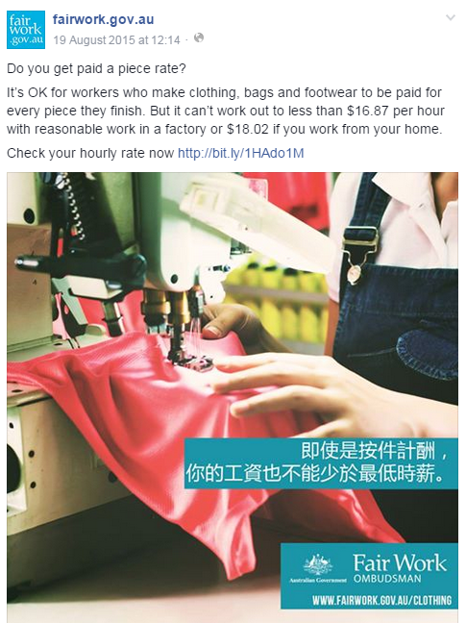
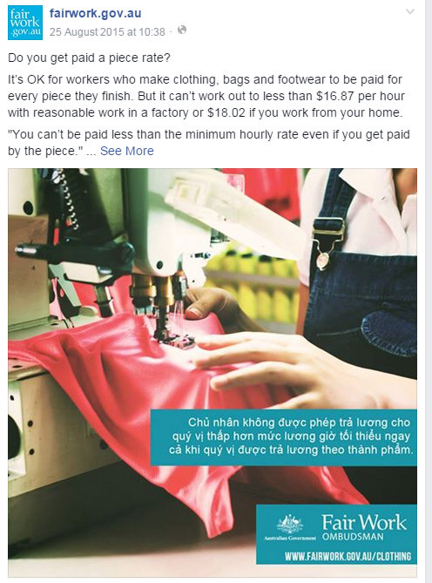
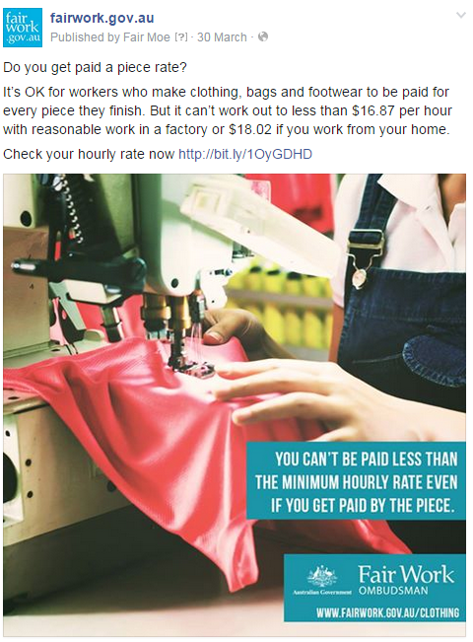

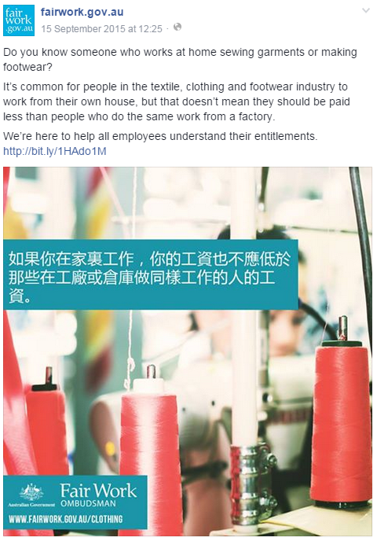
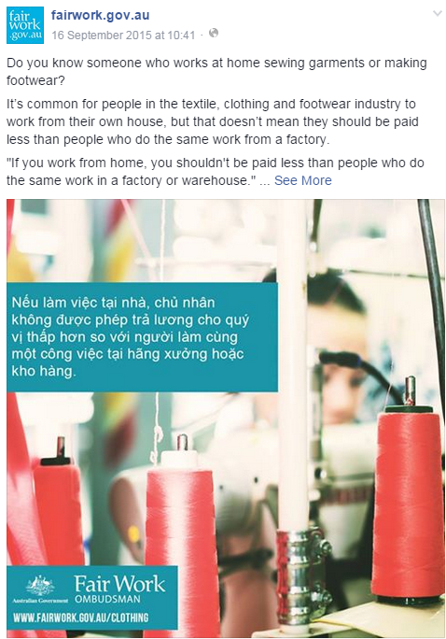
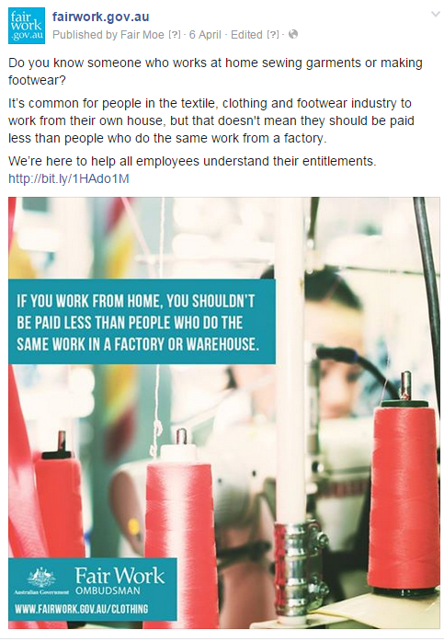
Week Four

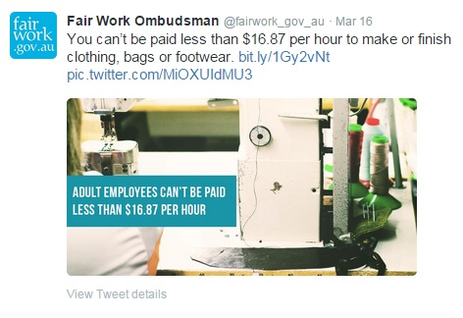
TCF Collateral – Twitter Posts

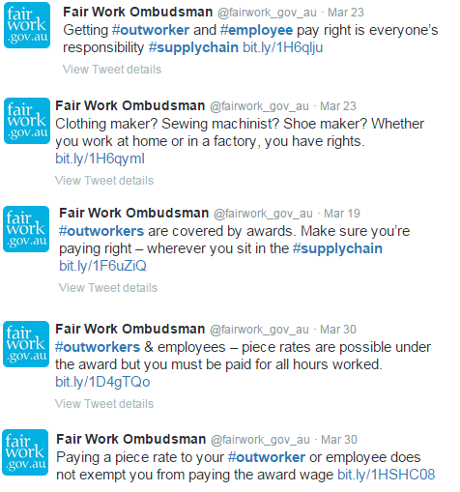

TCF Collateral – In-language Advertisement

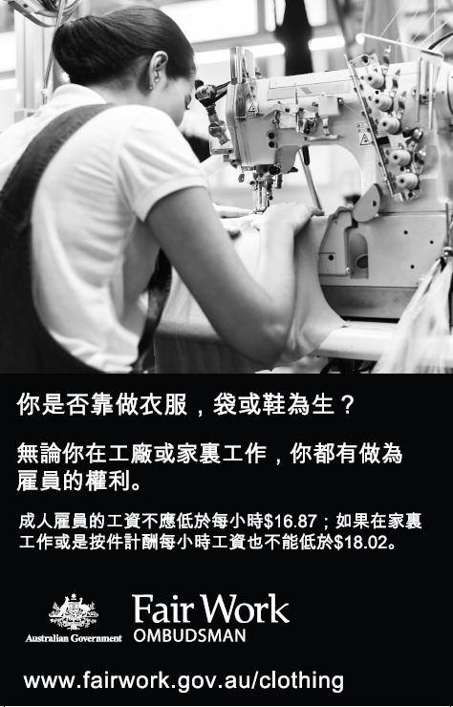
TCF Collateral – DL Flyer
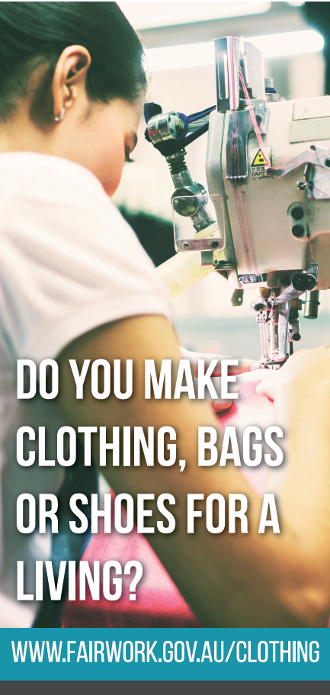
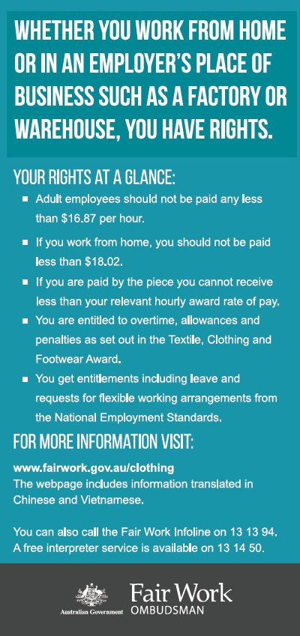

Ethical Clothing Australia
Tailoring and Clothing Accessories Manufacturing Market Research Report | ANZSIC C1351d

