Fourth Annual Report

Final report - Enforceable Undertaking between the Fair Work Ombudsman and Coles Supermarkets Australia Pty Ltd

© Commonwealth of Australia, 2019

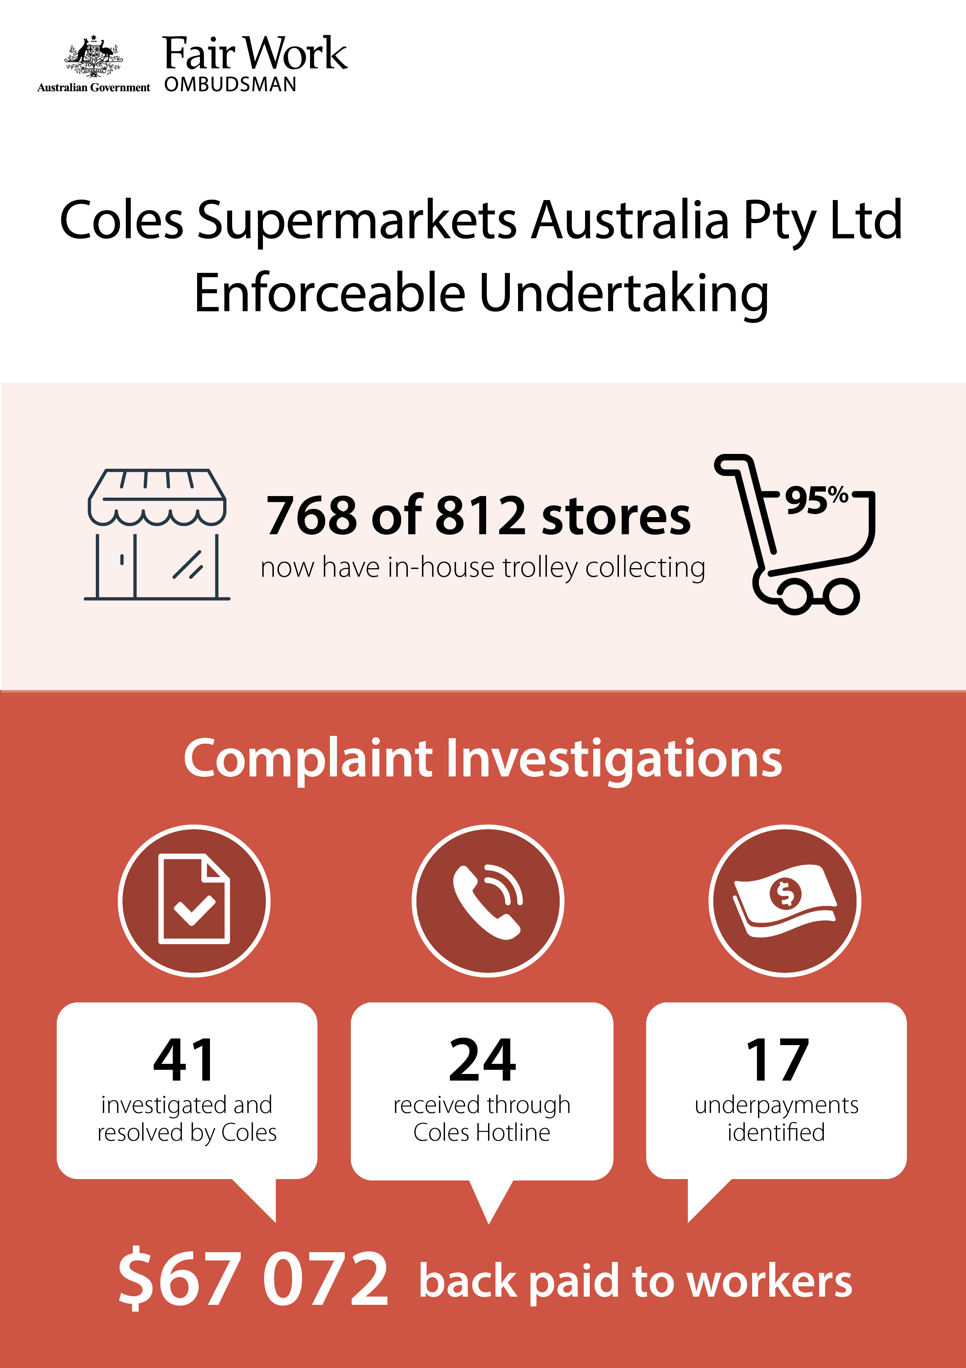

# Annual Report

This is the fourth and final annual report regarding the Enforceable Undertaking [EU][1] between the Fair Work Ombudsman (FWO) and Coles Supermarkets Australia Pty Ltd (Coles) [ACN 004 189 708].[2]

# Background

In 2012, the FWO commenced legal proceedings against two sub-contractors providing trolley collecting services at several Coles sites, alleging they had underpaid 10 trolley collectors over $200 000. However, the sub-contracting companies went into liquidation during the proceedings and the amounts owing to the employees remained unpaid.

In 2014, in response to the proceedings, Coles entered into an EU with the FWO, publicly declaring its “ethical and moral responsibility” to join with the FWO in stamping out the exploitation of vulnerable trolley collectors.

One of Coles’ commitments was to rectify the outstanding amounts owed to the 10 trolley collectors, which it did on an *ex-gratia* basis. Other key obligations in the EU included:

* communicating the existence of the EU to all employees and to Coles’ trolley collection service provider, United Trolley Collections (UTC)
* maintaining and advertising a wage underpayment hotline (the Hotline)
* investigating trolley collecting wage complaints within 28 days of their receipt
* extending its in-house trolley collection model so that collection is undertaken by direct employees at all stores
* establishing a $500 000 “Guarantee” reserve fund, to be distributed to trolley collectors employed by UTC or its subcontractors if their trolley collectors are found to be underpaid
* annual audits of at least 20% of UTC sub-contractors in each year of the EU, to be independently reviewed and certified by a Certified Practicing Accountant (CPA)
* designing and implementing a workplace relations training program for staff managing and/or procuring trolley collection services
* reporting annually to the FWO on its investigation into complaints received from trolley collectors.

# Review of Coles’ Progress

## In-house trolley collection

During the period of the EU, Coles has committed to positively influencing the settings that determine whether unlawful conduct occurs within its labour supply chain.

As part its EU commitments, Coles has continued to bring car park trolley collection in-house. This process was already underway at the commencement of the EU (2014), starting at locations where converting to the in-house model was less of a logistical challenge.

Coles continued to report annually to FWO on the progress of car park trolley collection insourcing. Prior to the commencement of the EU, around 400 stores used the in-house model. Over the duration of the EU, as the table below demonstrates, the company has made consistent progress towards insourcing all car park trolley collection operations.

**Table 1: Coles’ conversion of car park trolley collection to in-house operations**

| **Annual report** | **Stores with in-house collection** | **Total stores** | **Percentage of stores with in-house collection** |
| --- | --- | --- | --- |
| 2015 | 558 | 776 | 71.9% |
| 2016 | 655 | 790 | 82.9% |
| 2017 | 730 | 800 | 91.2% |
| 2018 | 768 | 812 | 94.6% |

As at 2 November 2018, around only 5% of stores outsourced car park trolley collection. The majority of these locations use a mix of Coles’ staff and UTC contractors; the function remains fully outsourced in only 1% of stores. Coles and UTC monitor any remaining contract arrangements closely.[3]

Coles advised the FWO on the reasons for the delay in expanding its insourced collection model to all stores. These were:

* the waiting period involved in taking delivery of specially modified trolley collecting vehicles
* the need to navigate local arrangements at larger sites where a number of retailers provide trolleys for their customers
* the need to factor in sites where street trolley collections are still outsourced to UTC.

Coles has advised the FWO that it expects to convert all car park trolley collections to its in-house model by October 2019.

## Investigation of complaints

Coles’ most recent report to the FWO[4] describes the steps it has taken to comply with its obligations over the last 12 months. It includes the following results:

* five complaints regarding trolley collection wage underpayments (three were received via the Hotline[5])
* an average time to investigate these complaints of 20 days
* $6791.31 in back pay to seven employees.

The results again confirm the positive impact of Coles’ commitment to compliance. Table 2 (below) shows that during the period of the EU there has been an overall decline in both the number of complaints referred to Coles through the dedicated Hotline, and the quantum of underpayments identified. The average time taken to conclude underpayment investigations has remained low.

At the same time, the year-on-year results disclose the need for robust and effective self-monitoring arrangements.

**Table 2: Year-on-year results from Coles’ Hotline investigations**

| **Year** | **Number referred to Coles through the Hotline [6]** | **Average time to conclude investigation** | **Underpayments determined** | | **Total Underpayment amount** | **Number of employees back-paid** |
| --- | --- | --- | --- | --- | --- | --- |
| 2015 | 12 | 19 | 6 | $40 440.60 | | 6 |
| 2016 | 6 | 27 | 5 | $17 169.71 | | 5 |
| 2017 | 3 | 12 | 1 | $2671.01 | | 1 |
| 2018 | 3 | 20 | 5 | $6791.31 | | 7 |
| Total | *24* | *78* | *17* | *$67 072.61* | | *19* |

## Workplace relations training

Coles has also reported to the FWO on the ongoing workplace relations training program it committed to designing and implementing as per the EU. Coles advised FWO that it provided training to nine team members in 2018, meaning that 125 Coles employees have received training since the commencement of the EU.

## Annual audit of UTC and subcontractors

To satisfy the auditing requirements of the EU, Coles engaged external firm Price Waterhouse Coopers (PWC) to conduct the 2018 annual independent audit of trolley subcontractors engaged by UTC. The audit focused on subcontractors where compliance issues had previously been identified. As part of the audit:

* seven (22%) UTC subcontractors were audited, including contractors in various states and territories
* wages paid to employees were assessed against the minimum entitlements set out by the *Cleaning Services Award 2010*
* three pay cycles (or six weeks) were sampled (greater than the one month specified in the EU)
* 37 employees were found to have been underpaid a total of $7099.60
* it was identified that during the corresponding period, 122 employees were paid above their minimum award entitlements, with these above-award minimum payments totalling $69 592.93.

All underpayments were rectified, and no action was taken to recover above-award minimum payments.

The audit did not reveal any systemic issues leading to the underpayments. However, the FWO notes that Coles is still evaluating the audit results to determine if any additional actions are required of UTC subcontractors.

Audit results have improved significantly over the life of the EU, as shown in Table 3, below. Importantly, they reveal a reduction in both the quantum of underpayments (from $112 000 in 2015 down to $7099.60 in 2018) and the average underpayment per employee (from $457 in 2015 to $192 in 2018).

**Table 3: Year-on-year results from independent annual audits of UTC and subcontractors**

| **Year** | **Subcontractors audited** | **Total underpayment[7]** | **Employees**  **underpaid** |
| --- | --- | --- | --- |
| 2015 | 15 | $112 000 | 245 |
| 2016 | 16 | $18 385 | 121 |
| 2017 | 13 | $8834.69 | 53 |
| 2018 | 7 | $7099.60 | 37 |
| Total | *51* | *$146 319.29* | *456* |

# Conclusion

The EU between Coles Supermarkets Australia Pty Ltd (Coles) and the FWO expired on 31 December 2018.

The FWO is satisfied with the progress Coles has made in satisfying its EU obligations. In particular, the FWO notes the significant reduction in trolley collector underpayments by subcontractors identified through succussive independent audits.

The result indicates that Coles has been successful in improving its overall compliance with the FW Act, including the compliance of subcontractors engaged in its labour supply chain. It also demonstrates the positive impact on compliance that lead businesses have when taking on an active role in supply chain governance.

# About the Fair Work Ombudsman

The Fair Work Ombudsman is an independent agency created by the Fair Work Act 2009 on 1 July 2009. The Fair Work Ombudsman’s role is to promote harmonious, productive and inclusive Australian workplaces as well as ensure compliance with Commonwealth workplace laws.

The FWO employs a number of tools and strategies to achieve compliance with national workplace laws, including Enforceable Undertakings.

When we reasonably believe that someone has breached the FW Act, the breach is serious and the person acknowledges this, accepts responsibility and agrees to fix the harm, we can accept a written undertaking from the person.

Enforceable Undertakings typically operate for a period of between two to five years and often include terms about fixing loss or damage caused (e.g. by paying compensation or back pay to employees). They are also ‘forward looking’ and deal with future compliance and what the person will do in the future to prevent more breaches, such as workplace law training sessions for senior managers. Enforceable Undertakings require people to report to FWO on their compliance at specific times as well as when a particular action is undertaken.

The FWO may offer a person the option to enter into an Enforceable Undertaking as an alternative to legal proceedings to secure a superior compliance outcome. The FWO also considers offering Enforceable Undertakings to persons who have approached us with admissions that they have breached the law and are committed to ‘righting the wrongs’ of the past.

To ensure transparency and accountability, the FWO publishes Enforceable Undertakings on its website. If the terms of an Enforceable Undertaking are not complied with, the FWO can take legal action in a court to enforce them, as well as seek other orders the court considers appropriate.

For further information and media enquiries, please contact FWO media (media@fwo.gov.au*)*

If you would like further information about Enforceable Undertakings please contact Steven Ronson, Executive Director – Proactive Compliance at: [steven.ronson@fwo.gov.au](mailto:steven.ronson@fwo.gov.au)

1. Coles Supermarkets Australia Pty Ltd and Fair Work Ombudsman enforceable undertaking is available on the FWO website: <https://www.fairwork.gov.au/ArticleDocuments/837/enforceable-undertaking-coles-supermarkets-australia.pdf.aspx>
2. Previous reports on the progress of the Coles EU are available on the FWO website:

   <https://www.fairwork.gov.au/ArticleDocuments/884/coles-report-eu.pdf.aspx>(2015)

   <https://www.fairwork.gov.au/reports/coles-eu-report/summary>(2016)

   <https://www.fairwork.gov.au/ArticleDocuments/837/2017-coles-annual-report.pdf.aspx >(2017)
3. [UTC entered into a three-year compliance partnership with the FWO](http://www.fairwork.gov.au/about-us/news-and-media-releases/2014-media-releases/august-2014/20140829-trolley-collectors) in May 2014 to promote and ensure compliance within its own network of sub-contractors. The proactive compliance deed is available on the FWO website: <https://www.fairwork.gov.au/ArticleDocuments/544/utc-pcd-final-report.docx.aspx>
4. <https://www.fairwork.gov.au/ArticleDocuments/837/coles-supermarkets-pty-ltd-enforceable-undertaking-annual-report-2018.pdf.aspx>
5. Two of the complaints were from Coles’ employees - the company was therefore not required to include these in its report to FWO.
6. Only complaints received through the hotline are tabled here. As identified in the covering infographic, Coles investigated 41 complaints over the life of the EU. Total investigation numbers (including Hotline compliant investigations) for each year of the EU are as follows: 21 Complaints (2015), 11 complaints (2016), four complaints (2017) and five complaints (2018).
7. ‘Total underpayment’ does not take into account that in each year, independent audits also revealed payments above award minimum entitlements. Audits for 2016, 2017 and 2018 identified that the quantum of above award minimum payments was greater than that of the underpayments identified.