Baiada Group Compliance Partnership

Final report

December 2018

© Commonwealth of Australia, 2018

# Table of contents

Table of contents 2

Summary 3

Background 4

FWO Inquiry into Baiada’s labour procurement 6

Workplace relations settings 7

Outcomes 8

Communication 8

Systems and processes 9

Self-audits 12

Resolving disputes and rectifying underpayments 15

Conclusion 16

About the Fair Work Ombudsman 17

Appendix A - Notice published in the Weekend Australian on 14 November 2015 18

Appendix B – Second Audit Report, Addendum report and key assumptions and limitations 19

Appendix C – Third Audit Report – key assumptions and limitations 21

# Summary

Baiada Poultry Pty Limited [ACN 002 925 948] (Baiada) is one of Australia’s largest producers of poultry meat.

Baiada entered into a compliance partnership with the Fair Work Ombudsman (FWO) in October 2015. Underpinned by a Proactive Compliance Deed (PCD)[1], the overarching objective of the compliance partnership was to drive ongoing and sustainable compliance across Baiada’s labour supply chain.

Because of the compliance partnership, Baiada now has greater capability to prevent, detect and respond to non-compliance at all of its poultry processing facilities.

The compliance partnership outcomes included:

* rectification of over $340,000 to 296 workers (most of which occurred in the first 12 months of the PCD’s operation[2])
* $450 000 paid to charitable organisations
* implementation of best practice supply chain governance measures, including a centralised payroll system that contractors must now use
* termination of non-compliant contractors
* significant rise in overall compliance as identified through three independent audits by Deloitte Touche Tomatsu; the second and third of which identified no underpayments.

The majority of the obligations prescribed by the PCD were satisfied in the first 12 months of its operation. These outcomes are contained in the FWO’s Interim Report on the compliance partnership with Baiada published on 26 November 2016 (Interim PCD Report).[3]

Concluding in June 2018, this report outlines the background to the FWO’s compliance partnership with Baiada and describes the key outcomes.

# Background

Baiada Poultry Pty Limited [ACN 002 925 948] (Baiada) is an Australian-owned private company that operates a vertically integrated poultry growing, processing and supply operation.[4] Headquartered in Pendle Hill in Sydney, the company employs over 4000 staff across its operations.[5]

Baiada is one of Australia’s largest poultry processing companies, producing the Steggles and Lilydale free-range chicken brands with a combined market share of 24.4%, and generating over $1.5 billion in revenue in the 2017-18 financial year.[6]

While poultry processing market share is dominated by two lead firms (Baiada and Inghams, who together account for over 50% of industry revenue), there is high competition in the sector.

Poultry is the most consumed meat in Australia. In 2017/18, poultry processing was a $6.4 billion industry. Chicken meat accounts for over 90% of industry revenue, with other poultry varieties including duck, goose, turkey and game birds.[7] The major buyers of processed poultry meat are supermarkets (38.4%), food-service establishments (29.8%) and wholesalers (13.1%).[8] Fast-food outlets are also a major market for chicken products.[9]

Consumer preferences are changing with rising health consciousness driving greater demand for organic and free-range poultry meat. Time-poor consumers are also demanding ‘value-added’ products such as pre-cooked, marinated, seasoned and stuffed poultry products. At the same time, the rising number of vegetarians and vegans in Australia has negatively affected demand for poultry over the past five years.[10]

In November 2013, the FWO commenced an Inquiry into the labour procurement arrangements of the Baiada Group at its three New South Wales poultry processing facilities located in Beresfield, Tamworth and Hanwood (Baiada Inquiry).[11]

The Inquiry findings led Baiada to enter into a compliance partnership with the FWO in October 2015.

The objectives of the partnership were to:

* address significant non-compliance identified in the Baiada Inquiry, by contractors supplying services to Baiada’s poultry processing facilities[12]
* transform its systems and practices to eradicate exploitation and ensure compliance with workplace laws by all businesses operating on Baiada sites.

The terms and undertakings contained in the proactive compliance deed [PCD] that underpin the compliance partnership relate to Baiada’s governance and oversight of workers provided by contractors. It does not cover the majority of Baiada’s workforce who are directly engaged as employees of Baiada.[13]

The PCD also only relates to Baiada’s poultry processing activities. Baiada operates six poultry processing plants in the following locations:

* Beresfield, Tamworth and Hanwood in New South Wales
* Mareeba in Queensland
* Osborne Park in Western Australia
* Wingfield in South Australia.[14]

The PCD committed Baiada to a comprehensive suite of measures, including:

* publicly declaring its ethical and moral responsibility to ensure compliance in its labour supply chain
* committing to make ex-gratia payments where contractors failed to rectify underpayments
* setting aside $500 000 to reimburse workers underpaid by contractors in the 10-month period prior to the commencement of the PCD
* establishing and promoting a dedicated, multi-language hotline for enquiries and complaints
* maintaining a dedicated HR specialist to manage responses to inquiries and investigate complaints
* engaging workplace relations specialists to design and implement workplace relations training for workers and managers
* supply chain accountability measures such as formalised contractor arrangements and regular reporting to the FWO
* implementing systems and processes to track hours worked by contract workers
* ensuring contractors maintain accurate and complete time and wages records and requiring weekly payment of wages in a manner verifiable by an independent third party
* commissioning independent annual audits of labour hire contractors
* terminating contractors for serious breaches.

## FWO Inquiry into Baiada’s labour procurement

The FWO conducted the Baiada Inquiry following allegations raised on the ABC's Lateline program in October 2013 concerning the employment practices of contractors operating at Baiada’s Beresfield site. The allegations were consistent with information the FWO had received from plant workers, the Australian Meat Industry Employees’ Union (AMIEU) and members of the local communities of Griffith and Tamworth.

On 18 June 2015, the FWO published a report on the findings of the Baiada Inquiry.[15] The Inquiry found:

* non-compliance with a range of Australian workplace laws by contractors in Baiada’s labour supply chain
* limited governance arrangements by Baiada of its labour supply chains
* exploitation by contractors of workers, comprised predominantly of overseas workers in Australia on sub-class 417 working holiday visas, involving:
* significant underpayments
* extremely long hours of work
* high rents for overcrowded and unsafe worker accommodation
* discrimination
* misclassification of employees as contractors.[16]

The FWO recommended that Baiada enter into a compliance partnership to publicly acknowledge and demonstrate its moral and ethical responsibility to eliminate exploitation of vulnerable workers at its processing sites.

On 23 October 2015, FWO and Baiada entered into a compliance partnership underpinned by a [Proactive Compliance Deed (PCD)](https://www.fairwork.gov.au/ArticleDocuments/762/baiada-proactive-compliance-deed.pdf.aspx).[17]

## Workplace relations settings

The *Poultry Processing Award 2010* (Award) applies to the majority of contract workers servicing Baiada, unless the relevant contractor has an enterprise agreement in place. The minimum base rates in the Award and the National Employment Standards (NES) underpin all enterprise agreements.

The Award covers employees in the poultry processing industry, which is defined as the killing, processing, preparation, packing, wholesaling and distribution of uncooked poultry, poultry products and poultry by-products and associated cooked poultry, poultry products and poultry by-products.

As of 1 July 2018, under the Award, the rates of pay for a permanent part-time or full-time adult employees range from $19.56 per hour (Level 1) to $21.49 per hour (Level 6).

Junior pay rates vary for different ages. For example:

* 70% of the adult rate of pay for a 16 year old
* 80% of the adult rate of pay for a 17 year old.

Penalty rates also apply:

* 25% loading on top of the base rate for casual employees
* 50% Saturday and 75% Sunday penalty loading
* 150% public holiday loading
* overtime rates depending on the time and number of hours worked
* special provisions for shift workers, with additional loadings ranging from 10% to 25% depending on when shifts are worked.

# 

# Outcomes

The outcomes of the compliance partnership are reported below, including a summary of the obligations satisfied and reported in the Interim Report (published November 2016)[18] and the ongoing obligations of the PCD up to the conclusion of the partnership in June 2018.[19]

## Communication

A key requirement of the compliance partnership was for Baiada to publically declare its moral and ethical responsibility to ensure full compliance with Australia workplace laws by individuals and entities involved in its business.

Within 28 days of the execution of the PCD, Baiada posted statements:

* to its public website
* on noticeboards at all of its processing sites, in the languages most commonly spoken at its sites (English, Chinese, Vietnamese and Korean)
* in The Weekend Australian newspaper (14 November 2015).[20]

### Baiada hotline

Baiada engaged a third party (Stopline) to administer a hotline for current and former workers, and members of the public, to make enquiries, lodge complaints or report potential non-compliance with Australian workplace laws (as per Clause 6 of the PCD).

Baiada promoted the hotline on its website and on noticeboards at its processing sites.

The FWO supported the public promotion of the hotline by issuing a media release[21] and with various messages through FWO social media channels during December 2015.[22] [23]

During the operation of the compliance partnership, a total of 18 calls and emails related to Baiada sites were received by the hotline.

### Meetings

The FWO and Baiada agreed it was important to hold regular formal meetings to discuss and settle the implementation of the obligations under the PCD.

A higher than average number of meetings occurred in the first year of the compliance partnership, as that was the period when the majority of the obligations under the PCD were required and fulfilled.[24]

Between the time of publication of the Interim PCD Report in November 2016 and the conclusion of the PCD in April 2018, a further three meetings have occurred. These meetings have proven to be a successful forum for discussing progress and sharing feedback on the requirements of, and activities associated with, implementing the terms of the PCD.

In addition to these formal meetings, FWO and Baiada representatives responsible for ensuring compliance with the PCD, have held regular and frequent informal discussions regarding issues as they arose. These discussions have been productive with a view of honouring the terms of the PCD and the ‘spirit of the partnership’.

## Systems and processes

### Identifying employees and maintaining records

Baiada was required to improve its system and governance arrangements under the PCD, with the introduction of:

* identification cards for all workers at its processing sites (including full name, employing entity and employing entity’s Australian Business Number)
* an electronic timekeeping system (KRONOS) to monitor and maintain accurate records of hours worked.

The KRONOS system was upgraded in the second half of the compliance partnership to use biometrics to track shift start and end times.

Baiada also instituted additional processes to ensure labour hire contractors were compliant, including the Titan security gate access system. Under this system, Baiada’s supervisors now meet contract workers at all sites before the shift starting time at the site entry gate, to check their photo ID card. The Baiada supervisor then swipes the Kronos card matched to that individual’s photo ID card to allow entry to the site. The workers then proceed to the change/wash area at the appointed shift start time where a Baiada supervisor again swipes on each worker at Kronos point(s) adjacent to the designated work area. The reverse occurs at the end of each shift.

### Engagement of contractors

Baiada has taken the necessary steps to ensure all labour hire contractors:

* enter into a written contract regarding the engagement of contract workers at Baiada’s processing sites
* provide written certification signed by a director that their directors, officers and managers understand their obligations to comply with Australian workplace laws
* provide details of the terms and conditions for all workers, including hours of work and pay rates (on a six monthly basis).

Baiada provided copies of all the contracts and notification of any changes, to the FWO.

The number of labour hire contractors in operation at Baiada sites reduced from seven at the commencement of the PCD in October 2015, to six in October 2016, and four by the conclusion of the PCD in April 2018.

The following contractors were terminated:

* B&E Poultry Holdings Pty Ltd
* NTD Poultry Pty Ltd
* Evergreenlee Pty Ltd
* HP Foods Pty Ltd
* VNJ Holdings Pty Ltd.
* AMAI Enterprises Pty Ltd

The four contractors in operation at Baiada sites at the conclusion of the PCD were:

* J & T Trade Pty Ltd (engaged at Beresfield NSW and Adelaide SA)
* GGPB Power Pty Ltd (engaged at Hanwood NSW and Tamworth NSW)
* Springtime Poultry Pty Ltd (engaged at Mareeba QLD)
* Calacash Inwa Enterprises Pty Limited (engaged at Osborne Park WA).

The multiple layers of sub-contracting that previously characterised Baiada’s labour supply chain have been removed. This means that Baiada is in a better position to know what is happening in its supply chain, and to prevent, detect and respond to non-compliance by labour hire contractors.

### Enhanced payroll system

Baiada implemented a centralised payroll system, via a Payroll Services Agreement, that requires its labour hire contractors to use Eatmore Holdings Pty Ltd (a Baiada Group entity) to provide payroll services. This ensures contract workers are paid correctly according to the Award.

Another aspect of the arrangement that wasn’t required under the PCD, is that Baiada holds a $50 000 bond from each contractor to cover underpayments should they be identified.

### Workplace relations training

A key obligation under the terms of the PCD is the provision of workplace relations training.

Baiada engaged Australian Federation of Employers and Industries Legal to design and implement a workplace relations and human resources training program for its directors, supervisors and managers, including contracting and subcontracting staff. The training covered:

* the NES and the Fair Work Act 2009 (the Act)
* modern awards and enterprise agreements
* pay and record-keeping requirements
* work health and safety
* migration laws
* supply chain obligations.

Workplace relations training for workers was also a requirement of the compliance partnership. Baiada incorporated this training in the in-person induction sessions for new workers. Refresher training was provided to existing staff also, covering:

* workplace health and safety
* workplace bullying
* animal welfare
* disciplinary guidelines
* the Award and enterprise agreements
* the NES and the Act.

## Self-audits

The Baiada Inquiry found a lack of governance and monitoring of the labour supply chain contributed to serious worker exploitation by contractors.

In addition to governance systems and process reforms, clause 3 of the PCD required a robust independent auditing regime. Baiada was required to forward the audit results to the FWO.

Baiada engaged Deloitte Touche Tohmatsu (Deloitte) to conduct annual audits of all contractors supplying workers to Baiada processing sites.

Contractors were required to provide Baiada and Deloitte all necessary documents such as timesheets, invoices and pay slips for checking against KRONOS and Australian workplace laws. Deloitte provided a signed statement certifying the outcome of each audit.

The first audit in 2016 resulted in a back payment to three workers for the net amounts of $8, $46 and $1,615.05 respectively.[25] The second and third audits in 2017 and 2018 disclosed no underpayments.

This indicates significant improvements in compliance with workplace laws on Baiada’s sites. The maintenance of processes established to prevent, identify and rectify underpayments will be critical in ensuring a firmly embedded ‘culture of compliance’ in Baiada’s workforce going forward.

The FWO also observe that the size of the contractor worker workforce has steadily decreased since the commencement of the compliance partnership (as evidenced by the reduced size of the 20% sample audited in each report, namely 168 in 2016, 149 in 2017 and 131 in 2018). This would appear to indicate that Baiada is reducing its overall reliance on contract workers.[26] This observation was confirmed at a meeting between representatives of Baiada and FWO in February 2017.

### First self-audit (2016)

Baiada provided Deloitte’s first audit report on 23 June 2016.

A 20% sample of Baiada contract workers over the period 14 March to 10 April 2016 were reviewed. No systemic risk of underpayments was identified; however a number of limited exceptions were investigated by Baiada resulting in repayments to three workers of $8, $46 and $1,615 respectively.

More detail about the first self-audit can be found in the Interim PCD Report.

### Second self-audit (2017)

Baiada provided Deloitte’s second completed audit report on 2 June 2017.

At the time of this audit, six contractors undertook operations at Baiada facilities. These were: Calacash Inwa Enterprises Pty Ltd, GGPB Power Pty Ltd, J&T Trade Pty Ltd, PHV Poultry Pty Ltd, Springtime Poultry Pty Ltd, and Amai Enterprise Pty Ltd.

The self-audit reviewed a 20% sample of workers employed by each contractor (149 workers in total) who worked over the four-week period from 20 February 2017 to 19 March 2017 inclusive.

All workers were employed as casuals. In conducting the audit, Deloitte analysed records for 2617 work events (or work shifts).

The Deloitte report did not identify any systemic risk of underpayments. However, some exceptions that appeared to be limited and isolated in nature were identified[27], which indicated a small number of workers might have been underpaid. Baiada investigated these exceptions and advised that they were satisfied there were no actual underpayment.

Deloitte’s signed statement dated 1 June 2017 is at Appendix B.

At a meeting between representatives of the FWO and Baiada on 9 August 2017, the FWO asked Baiada further questions in respect of the detail contained in the audit report. These questions sought further information as to Baiada’s assessment[28] of classification levels for workers. Clarification was also sought regarding how one contractor’s use of a supplementary piece rate payment system was reconciled against minimum wages required under the Award. Baiada provided written responses to the FWO on 17 August 2017 that satisfied the FWO’s queries.

At the meeting on 9 August 2017, the FWO also asked Baiada to re-engage Deloitte and instruct the firm to expand the scope of its earlier audit to address the matters contained in clauses 3.2(c) (checking of sample records compared to invoices) and 3.2(d) (leave and termination entitlements) of the PCD.

Baiada then re-engaged Deloitte who subsequently provided an addendum report dated 24 August 2017. In respect of checking the sample records compared to invoices, no exceptions were found. No exceptions were found either in respect of leave and termination entitlements, as no leave or termination entitlements were applicable to the workers (who were all employed as casuals) during the audit period.

Deloitte’s Addendum statement dated 24 August 2017 is at Appendix B.

### Third self-audit (2018)

Baiada provided Deloitte’s third completed audit report on 18 May 2018.[29]

At the time of this audit, five contractors undertook operations at Baiada facilities. These were Calacash Inwa Enterprises Pty Ltd, GGPB Power Pty Ltd, J&T Trade Pty Ltd, Springtime Poultry Pty Ltd, and Amai Enterprise Pty Ltd.

The self-audit reviewed a 20% sample of workers employed by each contractor (131 workers in total) who worked over the four-week period from 22 January 2018 to 18 February 2018 inclusive. The contractors employed all workers as casual employees.

In conducting the audit, Deloitte analysed records for 2038 work events (or work shifts).

It is worth noting that at the time of this audit, Baiada’s electronic time recording system, KRONOS, had been enhanced to operate using only biometrics. This enhancement further increased confidence in the accuracy of the time records. It is noted however that this development did not change the comprehensive procedures used by Deloitte to audit the time records.

The Deloitte report did not identify any systemic risk of underpayments to workers. However, again, the report did identify some exceptions that appeared to be limited and isolated in nature, which indicated a small number of workers might have been underpaid.

Baiada investigated these exceptions and advised they were satisfied that there had been no actual underpayment.

Deloitte’s signed statement date 18 May 2018 is at Appendix C.

## Resolving disputes and rectifying underpayments

Throughout the duration of the partnership, Baiada assumed responsibility for rectifying underpayments to contractor workers, even though they were not the worker’s direct employer.

Baiada also established a dedicated hotline managed by qualified internal human resources specialists for workers to lodge enquiries and complaints.

The same human resources specialists investigated, resolved and reported on all requests for assistance relating to underpayment of wages that were referred by the FWO.

Over $340, 000 in underpayments involving 296 workers were identified and repaid through claims and self-audit processes. The FWO’s Interim PCD Report covers most of these recoveries in more detail.

There were no requests for assistance received by the FWO involving Baiada contract workers between the time of publication of the Interim Compliance Partnership Report and the conclusion of the partnership in June 2018. However, the following occurred during this period:

* two anonymous allegations made via the FWO’s Anonymous reporting tool[30] were referred to Baiada to investigate
* one anonymous allegation was made directly to Baiada through a suggestion box in a worker lunchroom
* one allegation of poor conduct against a contractor supervisor at the Tamworth processing plant led to termination of their employment with the contractor
* underpayments by three contractors relating to unpaid rest break entitlements and misclassifications of staff were self-identified by Baiada through its internal audit and review processes, resulting in a total of $115 688.46 in back-paid wages
* two claims made by former contractor workers relating to the period before the PCD commenced were lodged after the PCD deadline. Baiada successfully secured settlement payments for the claimants (totalling $4,000).

Baiada conducted investigations and reported to the FWO in detail on each of the above matters.

None of the three anonymous allegations were sustained.

# Conclusion

The FWO considers that by significantly transforming its governance of its contract labour supply chain, Baiada has developed a demonstrably more effective capability to prevent, detect and respond to non-compliance at all of its poultry processing facilities.

This compliance partnership demonstrates that embedding and sustaining a culture of compliance in a supply chain requires commitment and action from the lead firm at the top of the chain.

While significant progress has occurred, Baiada must continue to remain vigilant to ensure that non-compliant behaviour by contractors does not return to Baiada sites.[31]

The FWO will continue to monitor compliance at the Baiada sites.

# About the Fair Work Ombudsman

The FWO is an independent agency created by the *Fair Work Act 2009* on 1 July 2009. Our main role is to promote harmonious, productive and cooperative workplace relations.

The FWO employs a number of strategies to achieve compliance with national workplace laws. This includes entering into compliance partnerships with employers. A compliance partnership is an opportunity for lead businesses to work with the FWO in a positive and constructive manner and achieve sustainable monitoring arrangements.

Lead businesses may seek to enter into a Compliance Partnership with the FWO for a variety of reasons. Some of these reasons include:

* ensuring its obligations under the Act are being met
* a method of identifying and minimising business risks with respect to its employees and those working in its supply chain or service network
* to demonstrate that it is a fair Australian workplace and potentially an employer of choice
* to address potential areas of non-compliance with the Act.

A range of activities can be utilised to assist lead firms meet the intended outcomes of the partnership, for example, self-auditing of wages and record keeping, initiatives to engage with employees to improve compliance, and mutually beneficial improvements to employment and business outcomes by focussing on supply chain, brand and franchise relationships.

A business that enters into a partnership with the FWO is assigned a dedicated Fair Work Officer who provides support and assistance to the business to ensure they are able to meet the outcomes of the partnership.

A publicly available report is published at the conclusion of each partnership.

For further information and media enquiries please contact FWO media (media@fwo.gov.au).

If you would like further information about compliance partnerships please contact Steve Ronson, Executive Director – Proactive Compliance ([steven.ronson@fwo.gov.au](mailto:steven.ronson@fwo.gov.au)).

# Appendix A - Notice published in the Weekend Australian on 14 November 2015

Extract from: <https://www.fairwork.gov.au/reports/baiada-group-interim-report/appendices>

# Appendix B – Second Audit Report, Addendum - report and key assumptions and limitations

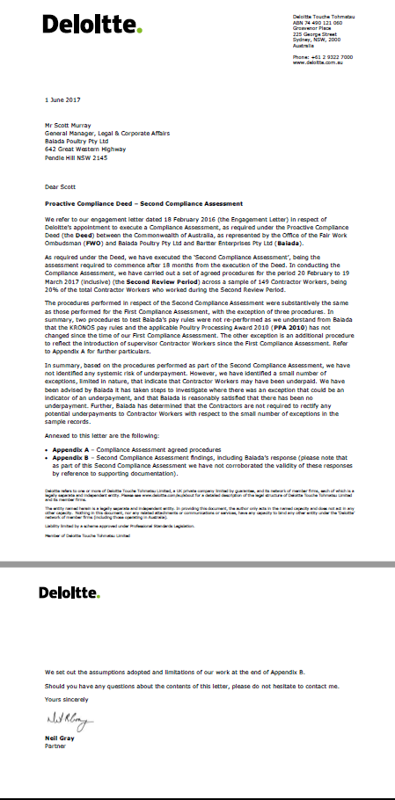

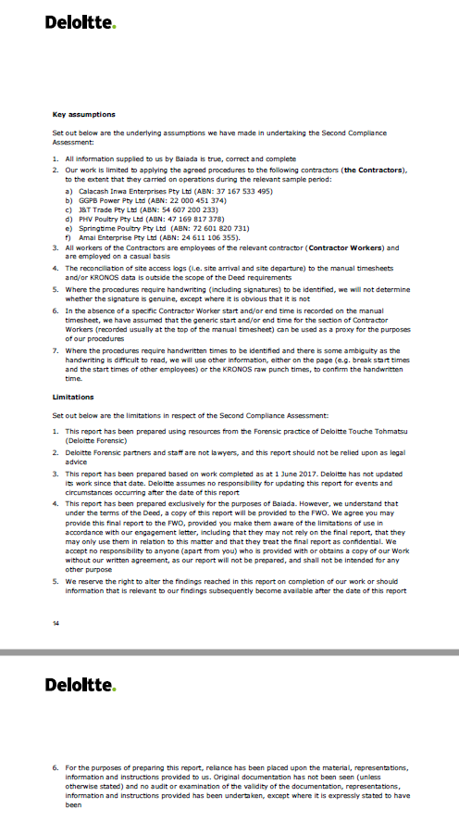

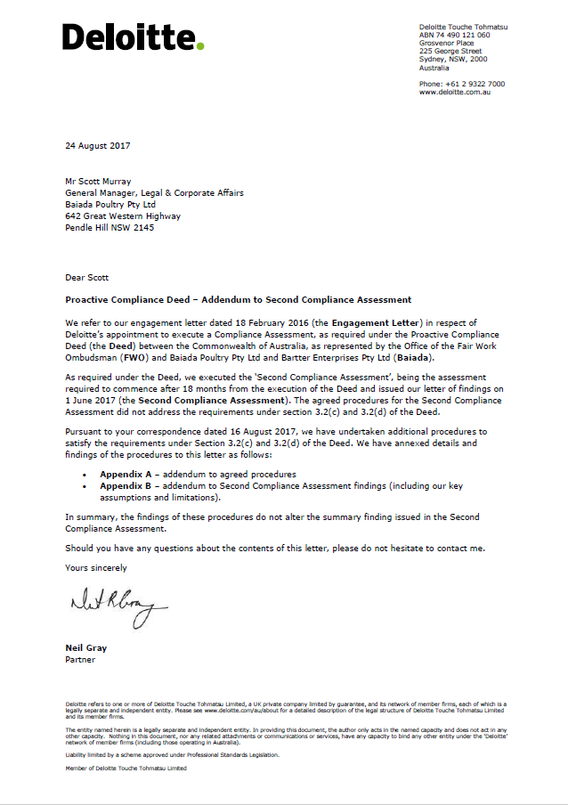

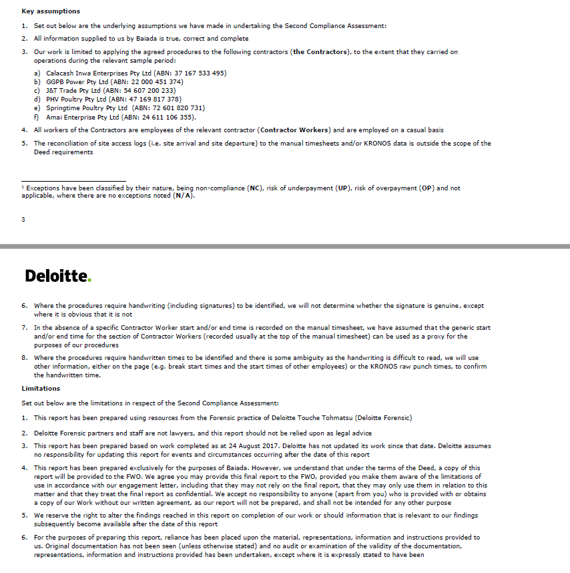

# Appendix C – Third Audit Report – key assumptions and limitations

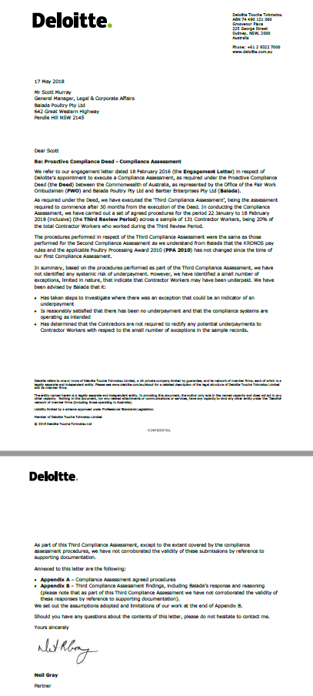

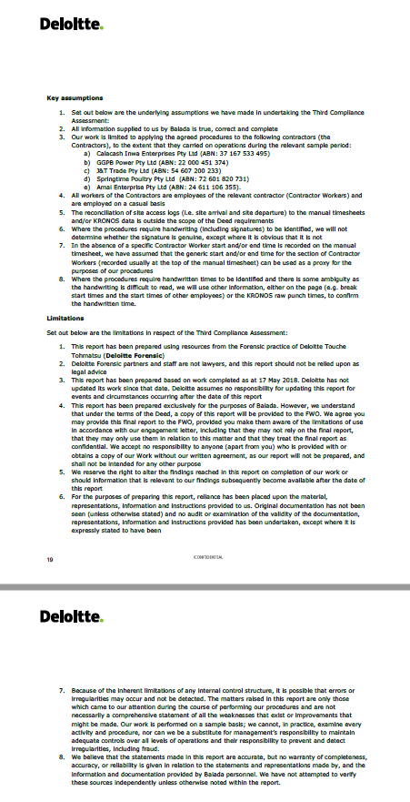

1. A copy of the PCD can be accessed at: <https://www.fairwork.gov.au/ArticleDocuments/762/baiada-proactive-compliance-deed.pdf.aspx>
2. See the FWO’s Interim Report on our partnership with Baiada published on 26 November 2016: https://www.fairwork.gov.au/about-us/news-and-media-releases/2016-media-releases/november-2016/20161128-baiada-media-release
3. FWO media release: https://www.fairwork.gov.au/about-us/news-and-media-releases/2016-media-releases/november-2016/20161128-baiada-media-release
4. <https://www.baiada.com.au/our-expertise/poultry/operations>
5. Cloutman, Nathan, IBISWorld Industry Report C1112 - Poultry Processing in Australia, IBISWorld Pty Ltd, February 2018
6. Ibid
7. Ibid
8. Ibid
9. Ibid
10. Ibid
11. FWO Inquiry into the labour procurement arrangements of the Baiada Group in New South Wales, 2015: <https://www.fairwork.gov.au/about-us/access-accountability-and-reporting/inquiry-reports>
12. FWO media release: https://www.fairwork.gov.au/about-us/news-and-media-releases/2015-media-releases/june-2015/20150618-baiada-group-statement-of-findings
13. See Recital D of the PCD
14. Ibid
15. FWO Inquiry into the labour procurement arrangements of the Baiada Group in New South Wales, 2015: <https://www.fairwork.gov.au/about-us/access-accountability-and-reporting/inquiry-reports>
16. Ibid., p.3
17. FWO media release: <https://www.fairwork.gov.au/about-us/news-and-media-releases/2015-media-releases/october-2015/20151026-baiada-media-release>
18. FWO media release: <https://www.fairwork.gov.au/about-us/news-and-media-releases/2016-media-releases/november-2016/20161128-baiada-media-release>
19. The PCD applied for 30 months from 23 October 2015 to 23 April 2018 [clause 15], however a built-in facilitative provision [clause

    20 1(b)] extended this period to enable the final audit process under clause 3 (which commenced at 30 months after the execution of the PCD) to be completed – the partnership therefore ending in June 2018
20. See Appendix A - Notice published in the Weekend Australian on 14 November 2015
21. FWO media release: <https://www.fairwork.gov.au/about-us/news-and-media-releases/2015-media-releases/december->

    2015/20151204-baiada-hotline
22. FWO tweet: <https://mobile.twitter.com/fairwork_gov_au/status/672544595297767424>
23. FWO tweet: https://twitter.com/natjamescitz/status/672553613927944194
24. For further details, please refer to the [Interim PCD Report](https://www.fairwork.gov.au/about-us/news-and-media-releases/2016-media-releases/november-2016/20161128-baiada-media-release)
25. For full details, please refer to the [Interim PCD Report](https://www.fairwork.gov.au/about-us/news-and-media-releases/2016-media-releases/november-2016/20161128-baiada-media-release)
26. Although we acknowledge that the number of Contractors and the size of Contractor workforce was also affected by Baiada’s decisions to close some processing plants (e.g. at Laverton in Victoria in 2016 and Ipswich in Queensland in early 2018) due to difficult market conditions
27. As an example, in less than 5% of the significant number of work shifts analysed, the KRONOS start time was recorded after the manual timesheet time. However, for 99% of these exceptions, the difference was no more than 10 minutes. No underpayments were found to have occurred as a result.
28. Noting that one of Baiada’s reforms to its systems and processes was establishing a specific entity that manages the payroll for all Baiada labour contractors and directly pays employees electronically into their bank accounts. For full details, please refer to the [Interim PCD Report](https://www.fairwork.gov.au/about-us/news-and-media-releases/2016-media-releases/november-2016/20161128-baiada-media-release)
29. The PCD applied for 30 months from 23 October 2015 to 23 April 2018 [clause 15], however a built-in facilitative provision [clause

    20 1(b)] extended this period to allow the final audit process under clause 3 (which commenced at 30 months after the execution of the PCD) to be completed
30. See: <https://www.fairwork.gov.au/how-we-will-help/how-we-help-you/anonymous-tipoff>
31. See: [Baiada cleaning up act after wages scandal](https://www.afr.com/business/agriculture/baiada-cleaning-up-act-after-wages-scandal-20161127-gsydyq), Adele Ferguson, *Australian Financial Review* 28/11/16