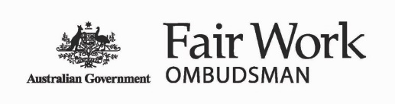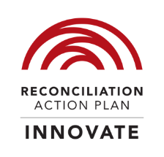

Fair Work Ombudsman and Registered Organisations Commission Entity

## Reconciliation Action Plan

## July 2020 – July 2022

## About the artist and artwork

The artwork by Jordan Lovegrove, a Ngarrindjeri man, of Dreamtime Creative, shows the journey of the Fair Work Ombudsman and Registered Organisations Commission Entity (the Entity) towards reconciliation. The large combined meeting place in the middle represents the Entity, and the large pathway going through the artwork represents our reconciliation journey. The pathway increases in width to represent growth. The smaller meeting places represent different Aboriginal and Torres Strait Islander communities and people, while the pathways leading out to them show the Entity building stronger connections. The patterned areas represent the different Aboriginal and Torres Strait Islander regions and places around Australia that the Entity is reaching.

The Artwork

The artwork by Jordan Lovegrove, a Ngarrindjeri man, of Dreamtime Creative, shows the journey of the Fair Work Ombudsman and Registered Organisations Commission Entity (the Entity) towards reconciliation.

## Acknowledgement of Country and Traditional Custodians

The Fair Work Ombudsman and Registered Organisations Commission Entity acknowledges the Traditional Custodians of Country throughout Australia and their continuing connection to land, waters and community. We pay our respect to them and their cultures, and Elders, past, present and future.

Please note: Aboriginal and Torres Strait Islander readers are warned that this document may contain images and names of deceased persons.

# Sandra Parker

# Foreword from Sandra Parker PSM, Fair Work Ombudsman

As the accountable authority for the Fair Work Ombudsman and Registered Organisations Commission Entity (the Entity), I acknowledge that we operate on the traditional lands of Aboriginal and Torres Strait Islander peoples.

I am proud to present the Fair Work Ombudsman and Registered Organisations Commission Entity Reconciliation Action Plan (RAP) July 2020 – July 2022.

This RAP builds upon the strong foundation of previous years and demonstrates our ongoing commitment to direct engagement with Aboriginal and Torres Strait Islander peoples and their communities.

We will work to further strengthen the relationships, respect and opportunities for Aboriginal and Torres Strait Islander peoples and strive to ensure our workforce and the services we provide to the community are inclusive and diverse and promote participation for all.

I encourage all employees and their managers to continue to reflect on the role we play both as individuals and as an Entity in supporting and contributing to a workplace that values and promotes diversity, equity and inclusion, and how we can continue to enhance our contribution to reconciliation through the various commitments outlined in the RAP.

I encourage you to consider what you can personally do, at work and in your personal lives, to better advance reconciliation.

Sandra Parker PSM  
  
Fair Work Ombudsman

# Karen Mundine

# Message from Reconciliation Australia

On behalf of Reconciliation Australia, I am delighted to see the Fair Work Ombudsman and Registered Organisations Commission Entity (the Entity) continue its reconciliation journey and to formally endorse its Innovate RAP.

Through the development of an Innovate RAP the Entity continues to play an important part in a community of over 1,000 dedicated corporate, government, and not-for-profit organisations that have formally committed to reconciliation through the RAP program since its inception in 2006. RAP organisations across Australia are turning good intentions into positive actions, helping to build higher trust, lower prejudice, and pride in Aboriginal and Torres Strait Islander cultures.

Reconciliation is no one single issue or agenda. Based on international research and benchmarking, Reconciliation Australia defines and measures reconciliation through five critical dimensions: race relations; equality and equity; institutional integrity; unity; and historical acceptance. All sections of the community—governments, civil society, the private sector, and Aboriginal and Strait Islander communities—have a role to play to progress these dimensions.

By committing to this Innovate RAP, the Entity will strengthen structures to guide reconciliation initiatives and continue promoting lifelong cultural learning journeys amongst all employees. The Entity will deepen its understanding of its sphere of influence and the unique contribution it can make to lead progress across the five dimensions of reconciliation.

We wish the Entity well as it embeds and expands its own unique approach to reconciliation. We encourage the Entity to embrace this journey with open hearts and minds, to grow from the challenges, and to build on its successes. As the Council for Aboriginal Reconciliation reminded the nation in its final report:

“Reconciliation is hard work—it’s a long, winding and corrugated road, not a broad, paved highway. Determination and effort at all levels of government and in all sections of the community will be essential to make reconciliation a reality.”

On behalf of Reconciliation Australia, I commend the Entity on its Innovate RAP, and look forward to following its ongoing reconciliation journey.

Karen Mundine   
  
Chief Executive Officer   
  
Reconciliation Australia

# Naomi Bleeser

# Message from our Aboriginal and Torres Strait Islander Peoples Senior Executive Service Sponsor

# Naomi Bleeser

## Our commitment to reconciliation

I’m pleased to join Sandra Parker, the Fair Work Ombudsman, in presenting our RAP. We have a RAP because we are committed to continuing to cultivate relationships and build respect, acceptance, understanding, growth, trust and equal opportunities between Aboriginal and Torres Strait Islander peoples and the wider Australian community.

Our commitment is to work collaboratively with Aboriginal and Torres Strait Islander peoples to promote harmonious, productive, cooperative and compliant workplace relations by ensuring that Aboriginal and Torres Strait Islander organisations, employers and employees have access to accurate and accessible information on workplace rights and responsibilities. We will do this by building networks, both internally and externally, to increase our understanding of Aboriginal and Torres Strait Islander peoples’ cultures whilst supporting our Aboriginal and Torres Strait Islander employees.

We continue to articulate our strategy through the three key pillars of our RAP – building relationships, respect and opportunities for Aboriginal and Torres Strait Islander peoples. We intend to take this forward to improve our work with each iteration of our RAP.

At this stage of our journey we are working towards achieving our unique vision for reconciliation. In doing so, we are seeking to gain a deeper understanding of our sphere of influence, and establish the best approach to advancing reconciliation. We will continue to develop and strengthen relationships with Aboriginal and Torres Strait Islander peoples, engage employees and stakeholders in reconciliation, and develop and pilot innovative strategies to empower Aboriginal and Torres Strait Islander peoples.

Thank you to those people who have been instrumental in shaping the future of our approach to reconciliation. We continue a successful partnership with Reconciliation Australia while also undertaking consultation with our employees through the hard work of our RAP Working Group (RWG) and Aboriginal and Torres Strait Islander Peoples Employee Network.

# RAP July 2020 – July 2022

## Our vision for reconciliation

Our vision for reconciliation is for a fair, diverse and socially inclusive workplace where we build understanding and respect amongst our employees for the histories and living cultures of Aboriginal and Torres Strait Islander peoples and their contribution to the social, economic and cultural life of Australia.

This understanding and respect will be reflected in our services.

## Our business

The Entity comprises two independent government bodies:

* the Fair Work Ombudsman (FWO), created by the Fair Work Act 2009 (FW Act)
* the Registered Organisations Commission (ROC), established under the Fair Work (Registered Organisations) Amendment Act 2016.

The FWO is Australia’s workplace regulator, and our purpose is to promote harmonious, productive, cooperative and compliant workplace relations. We regulate around 12 million workers and 2 million workplaces around Australia. The community expects the FWO, as the national workplace regulator, to uphold Australian workplace standards and protect the most vulnerable workers in our community. We are here to help all Australians understand their rights and responsibilities at work.

We have a workforce of over 800 employees nationally, with offices located in all capital cities and 14 regional locations. At the time of developing the RAP, we had eight employees who identified as Aboriginal and/or Torres Strait Islander employees.

Our functions outline the responsibilities we have as set by the FW Act to achieve our purpose:

* Provide education, assistance, advice and guidance to employers, employees, outworkers, outworker entities and organisations.
* Promote and monitor compliance with workplace laws.
* Inquire into and investigate breaches of the FW Act.
* Take appropriate enforcement action.
* Perform our statutory functions efficiently, effectively, economically and ethically.

The ROC is the independent regulator of all federally registered employer and employee organisations. The ROC’s functions include promoting the efficient management of organisations, and high standards of accountability of organisations and their office holders, as set out in the Fair Work (Registered Organisations) Act 2009 (RO Act).

The ROC seeks to encourage behaviours in registered organisations that see them consistently focussed on acting in the best interests of their members, ensuring members’ money is spent in a way that is transparent, properly authorised and which complies with their obligations under the RO Act, and their rules.

The ROC is committed to adding value to organisations and fostering good governance and financial transparency, as well as compliance with the RO Act.

# Our RAP

Our RAP has been developed in consultation with our employees and the RWG. The RWG is made up of Aboriginal and Torres Strait Islander employee representatives and non-Aboriginal and Torres Strait Islander employees from across the Entity. The RAP Champion, Naomi Bleeser, Executive Director, People and the People Branch assist in the administration of the actions of the RWG. At the time of the development of the RAP, the members of the RWG were:

* Naomi Bleeser, Aboriginal and Torres Strait Islander Peoples Senior Executive Service Sponsor and RAP Champion
* Andrew Alexander, Enforcement
* Carey Trundle, Engagement
* Corinna Coleman, Customer Services
* Jane Bayas, Customer Services
* Lisa Smith, Enforcement
* Lucy Olsen, Engagement
* Jess Berenyi, Communication
* Monique Tudman, Corporate Services.

We have had RAPs in place since 2009 and continue to advance reconciliation. Our previous RAPs were endorsed through Reconciliation Australia’s RAP Framework which provides organisations with a structured approach to advancing reconciliation. The RAP Framework includes four types of RAPs that an organisation can develop: Reflect, Innovate, Stretch and Elevate with each type of RAP being designed to suit an organisation at different stages of their reconciliation journey.[1] Our most recent RAP was an Innovate.

This RAP builds on previous RAPs and learnings from other organisations, including that:

* reconciliation is everyone’s business, therefore action items should reflect both an internal and an external focus
* an effective RAP should be tied to our purpose
* engagement and collaboration with other Australian Public Service agencies is critical to the success of our reconciliation efforts
* personal experiences and insights of our Aboriginal and Torres Strait Islander employees are invaluable in improving our services.

*RWG members*

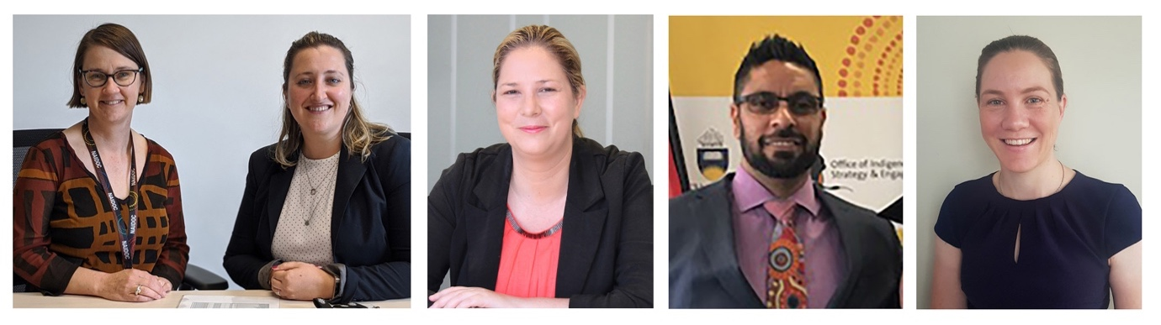

In our 2017 – 2019 RAP we:

* introduced online cultural awareness training which is available for all employees and attended face to face Cross Cultural Workshops
* entered into a Memorandum of Understanding (MOU) with the Australian Public Service Commission (APSC) for the provision of Indigenous Employment programs including employee Yarn sessions, Indigenous Liaison Officer meetings, mentoring programs for supervisors and employees and capability development programs
* participated in a ‘Discovery workshop’ facilitated by the APSC’s Indigenous Capability team to identify ways to focus our efforts in the key areas of Recruitment, Retention and Cultural Capability
* developed information and education resources for Aboriginal and Torres Strait Islander employees and employers
* purchased and held unveiling events in our Melbourne and Sydney offices for artworks created by Aboriginal and Torres Strait Islander artists
* participated in Reconciliation Australia’s RAP Learning Circles events in Sydney and Brisbane
* held and/or participated in Australian Public Service (APS) events for National Reconciliation Week and NAIDOC Week each year
* awarded six contracts in 2017-18 and eight contracts in 2018-19 financial years to Aboriginal and Torres Strait Islander suppliers
* continued our participation in the Jawun secondment program.

The Aboriginal and Torres Strait Islander Peoples Senior Executive Service Sponsor/RAP Champion and the RWG will work together to raise internal awareness about our commitment to reconciliation by promoting the RAP to employees and providing opportunities to engage in reconciliation activities. Our Aboriginal and Torres Strait Islander Peoples Employee Network also plays a key role in the implementation of the RAP and the completion of its deliverables, as well as supporting and promoting our agency strategies and initiatives for Aboriginal and Torres Strait Islander employment.

The goals of this RAP are to:

* demonstrate through our organisational behaviours, activities and relationships that we respect Aboriginal and Torres Strait Islander peoples and cultures
* assist agency employees in gaining a deeper understanding of Aboriginal and Torres Strait Islander peoples and cultures
* make our workplace a more inclusive working environment for Aboriginal and Torres Strait Islander employees
* ensure that all of our employees are equipped to provide the best possible service to Aboriginal and Torres Strait Islander customers
* promote our education resources to engage with Aboriginal and Torres Strait Islander communities.

# Employee profiles:

## Lisa Smith

## Lisa Smith Fair Work Inspector – Enforcement

### Tell us about who you are?

I identify myself as Me, Lisa, like a coat of many colours my heritage is full of many. My mother and grandmother were both Stolen Gen and I recently met my father who is Serbian, I acknowledge that my Indigenous heritage is part of me but not all of me.

### Where are you from?

I was born in Alice Springs and raised in the Northern Territory.

### How does your cultural heritage benefit the work you do at the FWO?

My cultural heritage helps me to understand the issues and barriers all people face from their backgrounds, I have hundreds of relatives from all walks of life and I have had to understand each of them individually to communicate with them.

### What does reconciliation mean to you in 2020?

Reconciliation for me means moving forward together as one and accepting each other.

### What are your hopes and dreams for the future of reconciliation within Australia?

Accepting and moving forward, acknowledging the past and looking to a future where we accept each other.

## Carey Trundle

## Carey Trundle Director – Engagement

### Tell us about who you are?

My name is Carey Trundle, I have worked at the FWO (and its predecessors) for thirteen and a half years, including a six-month break while I took up a position with the Northern Territory Government.

I am a migrant to Australia and arrived 31 years ago.

I am the Director of International Labour Strategy, in the Engagement Branch of FWO. I started at the FWO as a Fair Work Inspector and spent twelve years of my career in Operations.

I am based in the Northern Territory (NT), Darwin FWO office and feel privileged to call Darwin my home. The NT has the highest proportion of Aboriginal and Torres Strait Islander peoples in Australia (NSW is home to the highest number). I work and live on Larrakia land[2] and have made some great friendships with Larrakia people, Elders and Traditional Owners.

“You have come by way of the Larrakia Land. You will hear the voice of Larrakia ancestors. When you leave, the Larrakia message will stay with you.”

The late Reverend Walter Fejo

### Tell us about ways you have been able to support reconciliation

Through the APSC I have joined the Indigenous Mentoring Program[3] which has provided me an opportunity to learn more about my new home, Aboriginal and Torres Strait Islander peoples’ cultures and to contribute my workplace skills and knowledge to Aboriginal and Torres Strait Islander APS employees.

The flexibility of FWO as a workplace enabled me to spend six months working for the NT Government in their Territory Families Department.[4] My role was to monitor and report on progress of the implementation of recommendations from the Royal Commission into the Protection and Detention of Children in the Northern Territory[5] and the Royal Commission into Institutional Responses to Child Sexual Abuse.[6] This work enabled me to better understand the NT, the history of Aboriginal and Torres Strait Islander peoples in the NT and the historical and contemporary issues facing Aboriginal and Torres Strait Islander peoples in the NT. While expanding my knowledge, learnings and friendships here I was able to make a contribution through this engagement and reporting work.

One of my outside interests is softball, not as a player but as a board member. Softball NT has a significant impact and makes an important contribution across the NT in local communities and is a highly popular and participatory sport within the Aboriginal and Torres Strait Islander communities.

### What does reconciliation mean to you in 2020?

I think my view of reconciliation has changed, developed and expanded since living in Darwin. In my 31 years’ experience as a migrant Aussie, I feel Aboriginal and Torres Strait Islander culture is much more ‘present’ here in the NT and being here you cannot help but develop and expand your understanding of culture and what reconciliation looks and could look like. While my thoughts are subjective and come from a non-Aboriginal and Torres Strait Islander peoples background and understanding, reconciliation to me here in the NT means empowerment and local decision-making. It means understanding history, its impact and looking for ways to be part of and contribute to a positive future. As a non-Aboriginal and Torres Strait Islander person living in Darwin, I am reminded every day of the need for and the power of what reconciliation can bring to peoples’ lives.

I like to reflect on the wise words of a friend of mine, Dr Christine Fejo-King, Larrakia Elder & Traditional Owner:

“Reconciliation is a journey as well as a destination. On that journey, you are asked to see, hear, listen to and critically reflect on the impact of the invasion of Australia on the First Australians. The invasion of our lands, culture and ways of knowing, being and doing, did not end when the big ships stopped coming, it has continued through time by those who have come more recently on ships, boats and planes. If you are challenged by what I have said here, good! This is an excellent point for you to begin your critical reflection and ask yourself what the impact of your footprints on our lands leaves in your wake. Take time to camp along your journey, to talk to Aboriginal and Torres Strait Islander People, to listen to our stories and experiences and to share food, laughter and friendship with us on your journey toward reconciliation. Reconciliation is about people understanding people and coming together. There is no other way to achieve this goal”.

# Working with community

The FWO’s educational guides and fact sheets have proven popular in helping employees and employers understand their workplace rights and obligations. As part of our 2017 - 2019 RAP, we committed to developing education resources to engage with Aboriginal and Torres Strait Islander communities. We commissioned research to identify opportunities to increase our educative reach and influence in Aboriginal and Torres Strait Islander communities. The research supported the development of Aboriginal and Torres Strait Islander specific resources.

Following this research, we partnered with Aboriginal and Torres Strait Islander designers and communications professionals, and members of our Aboriginal and Torres Strait Islander Peoples Employee Network to create a dedicated suite of resources. These resources provide help on important workplace issues relevant to Aboriginal and Torres Strait Islander peoples.

## Tailored resources

Our dedicated resources include:

* videos to help employees understand workplace basics, and foster the skills and confidence to talk to their boss about taking leave for sorry business
* a suite of fact sheets and postcards exploring cultural issues relevant to Aboriginal and Torres Strait Islander employees and employers
* tailored guides about common workplace entitlements or issues, such as hiring employees, starting a new job and resolving workplace issues.

The resources were then tested with Aboriginal and Torres Strait Islander employees and employers from Perth, Alice Springs and Wujal in remote Queensland, and at the 2017 National Indigenous Youth Parliament Marketplace.

By engaging with Aboriginal and Torres Strait Islander stakeholders at every stage of the project, we ensured we understood the educative needs of Aboriginal and Torres Strait Islander peoples. This enabled us to create culturally relevant materials that are meaningful and identifiable to a wide range of Aboriginal and Torres Strait Islander audiences.

## Resource promotion

We raised awareness of, and promoted, our resources through a number of targeted communications campaigns throughout NAIDOC Week and other times to help reach our audience including:

* Facebook interest-based targeting
* promoting content through Aboriginal and Torres Strait Islander community radio stations
* publishing content in the Koori Mail, a fortnightly national Aboriginal and Torres Strait Islander newspaper
* emailing Aboriginal and Torres Strait Islander support units at Australian universities
* featuring the new videos on Indigitube, a multimedia platform run by the Indigenous Remote Communications Association.

People from across the FWO share and use our resources when communicating with customers, including with community organisations. This has led to co-branding the materials with several organisations to expand our reach. The resources have resonated, with campaign messaging on Facebook being seen more than 2.4 million times throughout 2017-2019 and resulting in more than 25,000 click throughs to the Aboriginal and Torres Strait Islander resources on our website.

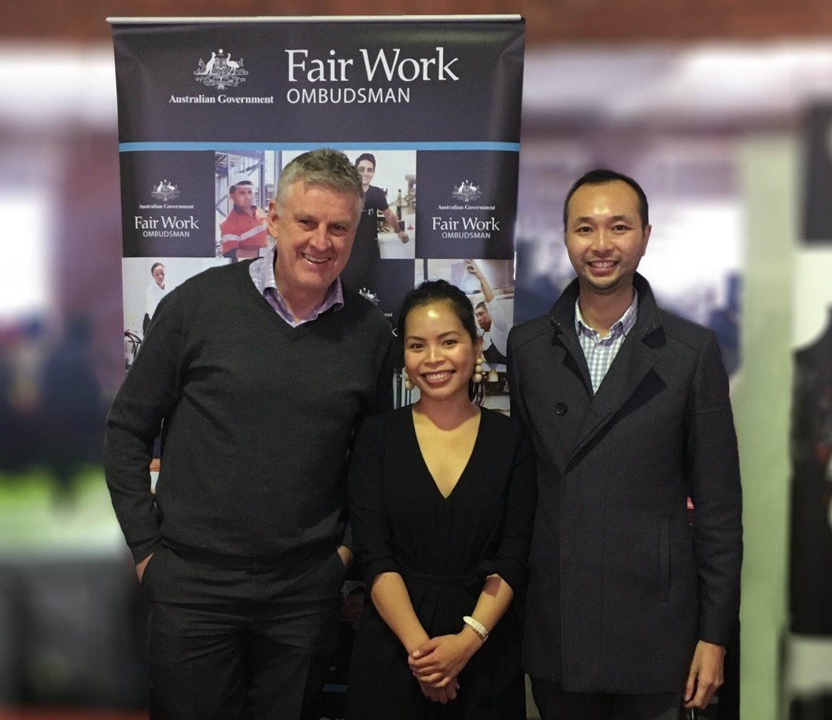

*FWO employees promoting our education resources at a NAIDOC week event*

# Relationships

We will foster positive, respectful and consultative relationships with Aboriginal and Torres Strait Islander peoples and communities to enhance our understanding and appreciation of Aboriginal and Torres Strait Islander customs and traditions. This will ensure our approach to delivering workplace relations services and advice for Aboriginal and Torres Strait Islander organisations, registered organisations, employers and employees will be culturally relevant, respectful and inclusive.

| Action | Deliverable | Timeline | Responsibility |
| --- | --- | --- | --- |
| 1. Establish and maintain mutually beneficial relationships with Aboriginal and Torres Strait Islander stakeholders and organisations. | Meet with Aboriginal and Torres Strait Islander stakeholders and organisations to explore how best to engage with Aboriginal and Torres Strait Islander workplace participants in order to develop guiding principles for future engagement that establish sustainable, long term connections to ensure ongoing relationships and engagement. | Complete by March 2021 | Executive Director, Engagement |
|  | Develop and implement an engagement plan to work with Aboriginal and Torres Strait Islander stakeholders and organisations including Australian Public Service diversity networks. | Implement from November 2021 | Executive Director, Engagement |
|  | Engage with Aboriginal and Torres Strait Islander stakeholders and organisations, working together to support Aboriginal and Torres Strait Islander workplace participants and generate positive outcomes. | Implement from November 2021 | Executive Director, Engagement |
| 1. Build relationships through celebrating National Reconciliation Week (NRW). | Circulate Reconciliation Australia’s NRW resources and reconciliation materials to our employees. | 27 May – 3 June 2021, 2022 | Aboriginal and Torres Strait Islander Peoples Senior Executive Service Sponsor |
|  | RWG members to participate in an external NRW event. | 27 May – 3 June 2021, 2022 | RWG Chair |
|  | Encourage and support employees and senior leaders to participate in at least one external event to recognise and celebrate NRW. | 27 May – 3 June 2021, 2022 | Aboriginal and Torres Strait Islander Peoples Senior Executive Service Sponsor |
|  | Organise at least one NRW event each year. | 27 May – 3 June 2021, 2022 | Aboriginal and Torres Strait Islander Peoples Senior Executive Service Sponsor |
|  | Register our NRW events on Reconciliation Australia’s [NRW website](https://www.reconciliation.org.au/national-reconciliation-week/). | 27 May – 3 June 2021, 2022 | Aboriginal and Torres Strait Islander Peoples Senior Executive Service Sponsor |
| 1. Promote reconciliation through our sphere of influence. | Implement strategies to engage our employees in reconciliation through intranet articles, our employee network sharespace and promoting internal and external events. | May, July and September 2020, 2021 and 2022 | Aboriginal and Torres Strait Islander Peoples Senior Executive Service Sponsor |
|  | Communicate our commitment to reconciliation publicly. | From July 2020 | Executive Director Communication |
|  | Explore opportunities to positively influence our external stakeholders to drive reconciliation outcomes. | Implement from December 2020 | Executive Director, Engagement |
|  | Collaborate with organisations with a RAP and other like-minded organisations to develop ways to advance reconciliation. | Complete by December 2020 | Aboriginal and Torres Strait Islander Peoples Senior Executive Service Sponsor |
| 1. Promote positive race relations through anti-discrimination strategies. | Review, implement and communicate our Managing and Reporting Unacceptable Behaviour Policy.  Consult with members of our Aboriginal and Torres Strait Islander Peoples Employee Network in this process. | Complete by December 2020 | Executive Director People |
|  | Continue educating senior leaders on the effects of unconscious bias and racism. | Implement from July 2020 | Executive Director People |
| 1. Develop and maintain mutually beneficial relationships with APS diversity networks to support FWO’s reconciliation journey. | Continue participating in APS diversity and Aboriginal and Torres Strait Islander peoples networks including the RAP Champions, Human Resources (HR) inclusion forum, Indigenous liaison officers and employee Yarn sessions. | Implement from July 2020 | Executive Director People |
|  | Investigate new opportunities to engage with APS diversity networks. | Complete by December 2020 | Executive Director People |

# Respect

We acknowledge and value the Traditional Owners of the lands on which we operate. We are committed to fostering a supportive, respectful and inclusive workplace environment where all employees have an opportunity to gain an understanding of and celebrate the heritage, values and beliefs of Aboriginal and Torres Strait Islander peoples. In doing this, we have the opportunity to improve our service delivery and to contribute to the reconciliation objectives of the broader APS.

| Action | Deliverable | Timeline | Responsibility |
| --- | --- | --- | --- |
| 1. Increase understanding, value and recognition of Aboriginal and Torres Strait Islander cultures, histories, knowledge and rights through cultural learning. | Finalise the review of FWO’s cultural capability development needs. | Complete by August 2020 | Executive Director, People |
|  | Consult local Traditional Owners and/or Aboriginal and Torres Strait Islander advisers on the development and implementation of a cultural learning strategy. | Complete by February 2022 | Executive Director, People |
|  | Develop, implement and communicate a future cultural learning strategy for our employees. | Complete by February 2022 | Executive Director, People |
|  | Provide opportunities for RWG members, HR employees, managers and other key leadership employees to participate in formal and structured cultural learning as well as other forms of learning. | From July 2020 | Executive Director, People |
|  | Encourage employees to identify and participate in local cultural immersion opportunities. | Implement from July 2020 | Executive Director, People |
|  | Encourage participation in the Jawun secondment program including the provision of any cultural learning requirements needed for participation in this program. | Annually from November 2020 | Executive Director, People |
| 1. Demonstrate respect to Aboriginal and Torres Strait Islander peoples by observing cultural protocols. | Increase employee understanding of the purpose and significance behind cultural protocols, including Acknowledgement of Country and Welcome to Country Protocol Guidelines on the Diversity intranet page and through intranet articles. | Implement from July 2020 | Executive Director, People |
|  | Review and communicate current Welcome to Country and Acknowledgement of Country Protocol Guidelines. | Review February 2021, 2022 | Executive Director, People |
|  | Invite a local Traditional Owner or Custodian to provide a Welcome to Country or other appropriate cultural protocol at significant events each year. | Annually from July 2020 | Executive Director, People |
|  | Include an Acknowledgement of Country or other appropriate protocols at the commencement of important meetings. | Implement from July 2020 | Executive Director, People |
|  | Include an Acknowledgement of Country on the FWO and ROC websites. | Implement from July 2020 | Executive Director, Communication and Executive Director, ROC |
| 1. Build respect for Aboriginal and Torres Strait Islander cultures and histories by celebrating NAIDOC Week. | Create opportunities for RWG members to participate in external NAIDOC Week events. | First week in July 2020 & 2021 | Aboriginal and Torres Strait Islander Peoples Senior Executive Service Sponsor |
|  | Maintain HR policies and procedures to maximise opportunities for employees to participate in NAIDOC Week. | Implement from July 2020 | Executive Director, People |
|  | Promote and encourage participation in external NAIDOC events to all employees. | First week in July 2020 & 2021 | Aboriginal and Torres Strait Islander Peoples Senior Executive Service Sponsor |
| 1. Seek opportunities to reflect Aboriginal and Torres Strait Islander peoples’ cultures within our offices. | Investigate undertaking a cultural safety audit of our offices. | Complete by November 2021 | Aboriginal and Torres Strait Islander Peoples Senior Executive Service Sponsor |
|  | Investigate options to visibly demonstrate our commitment to reconciliation within all of our offices. For example naming meeting rooms, displaying language maps or Acknowlegement plaques. Consult with local community groups, Elders and family members on protocols around naming meeting rooms as appropriate. | Complete by November 2021 | Aboriginal and Torres Strait Islander Peoples Senior Executive Service Sponsor |
|  | Investigate the option of sourcing a bespoke Aboriginal and Torres Strait Islander artwork to display in our offices and that can also be used to create a visual identity for use in future RAPs and other related documents/items. | Complete by November 2021 | Aboriginal and Torres Strait Islander Peoples Senior Executive Service Sponsor |
|  | Publish the details of any purchased Aboriginal and Torres Strait Islander artwork on the FWO intranet including the artist and meaning/story. | Complete by November 2021 | Aboriginal and Torres Strait Islander Peoples Senior Executive Service Sponsor |

# Opportunities

Creating opportunities to recruit, retain and support the development of Aboriginal and Torres Strait Islander employees enables us to build a culturally diverse workforce and enhance employee capability. We will also create opportunities to improve outcomes for Aboriginal and Torres Strait Islander businesses through our procurement processes and seek opportunities to increase awareness of the services we provide to redress adverse employment outcomes experienced by Aboriginal and Torres Strait Islander employees.

| Action | Deliverable | Timeline | Responsibility |
| --- | --- | --- | --- |
| 1. Improve employment outcomes by increasing Aboriginal and Torres Strait Islander recruitment, retention and professional development. | Build understanding of current Aboriginal and Torres Strait Islander staffing to inform future employment and professional development opportunities. | Implement from July 2020 | Executive Director, People |
|  | Engage with Aboriginal and Torres Strait Islander employees and job seekers to consult on our Aboriginal and Torres Strait Islander Employment Strategy about recruitment, retention and professional development. | Complete by December 2020 | Executive Director, People |
|  | Develop and implement an Aboriginal and Torres Strait Islander Employment Strategy addressing recruitment, retention and professional development. | Complete by December 2020 | Executive Director, People |
|  | Advertise job vacancies to effectively reach prospective Aboriginal and Torres Strait Islander candidates including investigating advertising in Aboriginal and Torres Strait Islander networks and media, | Ongoing from July 2020 | Executive Director, People |
|  | Review HR and recruitment procedures and policies to remove barriers to Aboriginal and Torres Strait Islander participation in our workplace. | Complete by December 2020 | Executive Director, People |
|  | Explore options to use Affirmative measures and Identified recruitment at all levels of the FWO. | Implement from July 2020 | Executive Director, People |
|  | Increase the percentage of Aboriginal and Torres Strait Islander employees employed in our workforce. | July 2022 | Executive Director, People |
|  | Actively promote opportunities to participate in development programs available through the APSC. | Implement from July 2020 | Executive Director, People |
| 1. Increase Aboriginal and Torres Strait Islander supplier diversity to support improved economic and social outcomes. | Implement the Commonwealth Indigenous Procurement Policy 2015. | Continue implementing from July 2020 | Executive Director, Corporate Services |
|  | Communicate opportunities for procurement of goods and services from Aboriginal and Torres Strait Islander businesses to our employees. | July 2020, July 2021 | Executive Director, Corporate Services |
|  | Review and update procurement practices to remove barriers to procuring goods and services from Aboriginal and Torres Strait Islander businesses. | Complete by December 2020 | Executive Director, Corporate Services |
|  | Develop at least five commercial relationships with Aboriginal and/or Torres Strait Islander businesses subject to the requirements as set out in the Commonwealth Indigenous Procurement Policy 2015, Commonwealth Procurement Rules and the Public Governance, Performance and Accountability Act 2013. | Implement from July 2020 | Executive Director, Corporate Services |
|  | Investigate Supply Nation membership. | Complete by March 2022 | Executive Director, Corporate Services |
| 1. Redress adverse employment outcomes experienced by Aboriginal and Torres Strait Islander employees. | Develop and implement a communications strategy to raise awareness about FWO’s functions and services for Aboriginal and Torres Strait Islander employers and employees, including promotion of FWO’s suite of Aboriginal and Torres Strait Islander education resources and exploring opportunities to share these resources with other organisations. | From July 2020 ongoing | Executive Director, Communication |

# Governance

| Action | Deliverable | Timeline | Responsibility |
| --- | --- | --- | --- |
| 1. Establish and maintain an effective RWG to drive governance of the RAP. | Appoint and maintain an internal RAP Champion from senior management. | July 2020 onwards | Executive Director, People |
|  | Maintain Aboriginal and Torres Strait Islander representation on the RWG. | July 2020 onwards | Aboriginal and Torres Strait Islander Peoples Senior Executive Service Sponsor |
|  | Review and apply RWG Terms of Reference. | Complete by May 2022 | Aboriginal and Torres Strait Islander Peoples Senior Executive Service Sponsor |
|  | Meet quarterly to drive and monitor RAP implementation. | August 2020, November 2020, February 2021, May 2021, August 2021, November 2021, February 2022, May 2022 | Aboriginal and Torres Strait Islander Peoples Senior Executive Service Sponsor |
| 1. Provide appropriate support for effective implementation of RAP commitments. | Define resource needs for RAP implementation. | July 2020 onwards | RAP Champion |
|  | Engage our senior leaders and other employees in the delivery of RAP commitments. | July 2020 onwards | RAP Champion |
|  | Define and maintain appropriate systems to track, measure and report on RAP commitments. | July 2020 onwards | RAP Champion |
| 1. Build accountability and transparency through reporting RAP achievements, challenges and learnings both internally and externally. | Complete and submit the annual RAP Impact Measurement Questionnaire to Reconciliation Australia. | Complete by 30 September 2020 & 2021 | Executive Director, People |
|  | Report RAP progress to all employees and senior leaders twice per year. | September 2020, March 2021, September 2021, March 2022 | Executive Director, People |
|  | Report our RAP achievements, challenges and learnings in FWO’s annual report. | June 2020 & 2021 | Executive Director, People |
|  | Investigate participating in Reconciliation Australia’s biennial Workplace RAP Barometer. | March 2022 | RAP Champion |
| 1. Continue our reconciliation journey by developing our next RAP. | Register via Reconciliation Australia’s [website](https://www.reconciliation.org.au/reconciliation-action-plans/submit-your-rap/) to begin developing our next RAP. | January 2022 | Executive Director, People |

## Contact details

For more information, please contact the FWO People Branch at [hr@fwo.gov.au](mailto:hr@fwo.gov.au)

1. [Reconciliation Australia RAP Framework](https://www.reconciliation.org.au/reconciliation-action-plans/#ra-rap-actions)
2. [www.larrakia.com](http://larrakia.com/)
3. [www.apsc.gov.au/join-indigenous-mentoring-program](https://www.apsc.gov.au/join-indigenous-mentoring-program)
4. [www.rmo.nt.gov.au](https://rmo.nt.gov.au/)
5. [www.royalcommission.gov.au/royal-commission-detention-and-protection-children-northern-territory](https://www.royalcommission.gov.au/royal-commission-detention-and-protection-children-northern-territory)
6. [www.childabuseroyalcommission.gov.au/](https://www.childabuseroyalcommission.gov.au/)