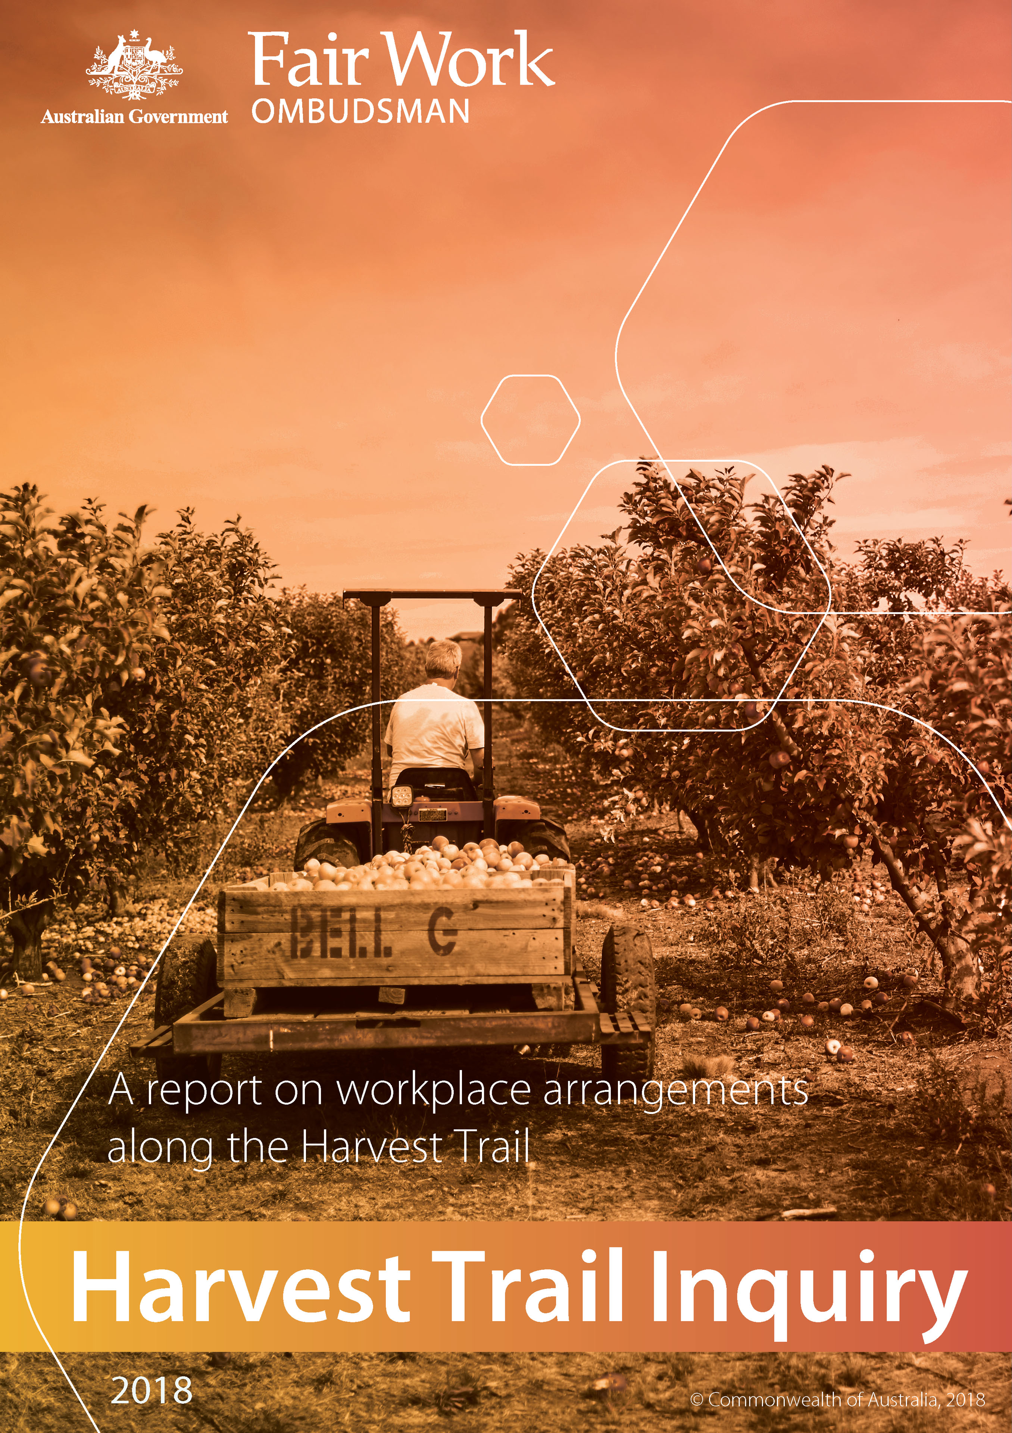

# Infographic detailing Harvest Trail Inquiry highlights

# Table of contents

Executive summary 4

The Inquiry 6

The industry 16

Finding 1 – Widespread non-compliance amongst investigated employers 26

Finding 2 – Misuse of piecework arrangements 29

Finding 3 – Significant reliance by growers on overseas workers 30

Finding 4 – Negative impact where labour hire arrangements are used 34

Finding 5 – Consumers can play a role in addressing exploitation 46

Next steps 48

Conclusions 50

Appendix A – Stakeholder list 51

Appendix B – Consumer Research 55

# Executive summary

The ‘Harvest Trail’ comprises thousands of horticulture and viticulture enterprises throughout every state and territory in Australia. The Harvest Trail is a pathway in regional Australia that follows the seasonal harvesting of fresh fruit, vegetables and wine grapes. Workers follow seasonal jobs around the country using a number of sources, including the *National Harvest Guide*.[1]

The horticulture and viticulture industries include the Australian and New Zealand Standard Industrial Classification (ANZSIC) groups: Fruit and Tree Nut Growing, Mushroom and Vegetable Growing and Nursery and Floriculture Production. According to the Australian Bureau of Statistics (ABS) there are 8023 employing entities in these industry groups and 14 510 non-employing entities.[2] A report by the then Department of Employment put the number of people employed in horticulture at 73 000.[3]

The Fair Work Ombudsman (FWO) commenced an Inquiry into workplace arrangements on the Harvest Trail in August 2013, in response to employee and community concerns about non-compliance with Australian workplace laws.

Seeking to identify the drivers of non-compliance, the FWO Harvest Trail Inquiry (the Inquiry) focused on areas and crop sectors that are heavily reliant on manual harvesting, preparation, maintenance and processing.

During the Inquiry, the FWO engaged with growers, workers, labour hire contractors, industry bodies, community groups and consumers to complete 1295 discrete education and compliance activities.

The majority of employers involved in the Inquiry were selected randomly. A smaller number of employers were selected on the basis of intelligence gathered from industry stakeholders, other government agencies and departments, media, community members and workplace participants. The FWO revisited non-compliant employers in subsequent seasons to assess compliance.

Fair Work Inspectors completed 836 investigations, involving 444 growers and 194 labour hire contractors across all states in Australia and the Northern Territory.[4]

As a result of these activities, the FWO recovered $1 022 698 for 2503 employees. As Fair Work Inspectors were unable to assess and determine the full extent of underpayments in many cases due to issues such as poor record-keeping, cash payments and a transient workforce, the FWO believes the full extent of worker underpayments is significantly higher than this.

As part of the Inquiry, the FWO commissioned market research to examine consumer attitudes and preferences when buying fresh fruit and vegetables. While price, taste and convenience are key considerations, the research found that some consumers are prepared to pay more for produce they know has been handled by a workforce that has been treated fairly and paid properly.

The Inquiry identified five key findings relating to workplace arrangements along the Harvest Trail:

* widespread non-compliance among the employers investigated
* misuse of piece rates
* significant reliance by growers on overseas workers
* a negative impact where labour hire arrangements were illegally used
* consumers can play a role in addressing exploitation.

The ability to detect, quantify and recover underpayments was impeded by a number of issues, including:

* record-keeping deficiencies
* invalid or absent piecework agreements
* reluctance or unwillingness to share information with the FWO
* transient workers and labour hire contractors.

The Inquiry resulted in a number of compliance and enforcement outcomes, including:

* 150 Formal Cautions
* 132 Infringement Notices
* 13 Compliance Notices
* seven (7) Enforceable Undertakings
* commencement of eight (8) legal proceedings.[5]

This report outlines the background to the Inquiry, its methodology, Harvest Trail working conditions and market dynamics. In detailing the Inquiry’s key findings, the report contains a number of recommendations designed to secure future industry-wide compliance.

# The Inquiry

To address concerns highlighted through intelligence from various sources, in August 2013 the FWO commenced an in-depth Inquiry into workplace arrangements along the Harvest Trail. This strategic intervention aimed to:

* better understand employment conditions and market characteristics on the Harvest Trail
* identify drivers of non-compliance, including within associated industry subsectors
* educate growers, labour hire contractors and workers about workplace rights and obligations
* ensure, where possible, that workers were receiving correct minimum employment entitlements
* address non-compliance by taking effective compliance and enforcement action
* encourage ongoing sustainable self-monitoring arrangements within Harvest Trail supply chains.

The Inquiry was multifaceted, involving:

* extensive stakeholder engagement
* targeted awareness-raising and education communications
* consumer research
* compliance and enforcement activities.

### Stakeholder engagement

During the course of the Inquiry, the FWO engaged with a number of key stakeholders, including:

* industry associations
* community groups
* unions
* commonwealth and state government departments
* members of parliament
* local councils.[6]

Through these interactions, Fair Work Inspectors developed a better understanding of Harvest Trail operations and the drivers of non-compliance. Fair Work Inspectors continued to leverage these relationships as the Inquiry progressed to realise its objectives.

For example, the FWO took part in the **Horticulture Worker Interagency Group (HWIG)**,which comprised members from a number of Queensland and Australian Government departments and authorities and focused on issues of concern in areas such as Bundaberg, the Lockyer Valley and Bowen.

The FWO also worked closely with the **Recruitment and Consulting Services Association (RCSA)**. The RCSA’s relationship with the FWO was formalised in a Memorandum of Understanding (MoU) executed in August 2016.[7] The MoU established an information-sharing pathway for the RCSA and its members to inform the FWO about labour hire providers alleged to be acting unlawfully.

The FWO formed a relationship with the **Local Council in the Lockyer Valley** horticultural region of Queensland to address the plight of backpackers in the area. Fair Work Inspectors participated in Council-run sessions and provided educational resources to backpackers to help them understand what to expect as employees in Australia.

The FWO also worked with bilingual **Community Liaison Officers of the Queensland Police Service** who assisted the Inquiry in its interactions with Mandarin, Cantonese and Korean speaking overseas workers. Officers accompanied Fair Work Inspectors to pop-up education posts, encouraging employees to engage with the Inquiry, and yielding useful intelligence.

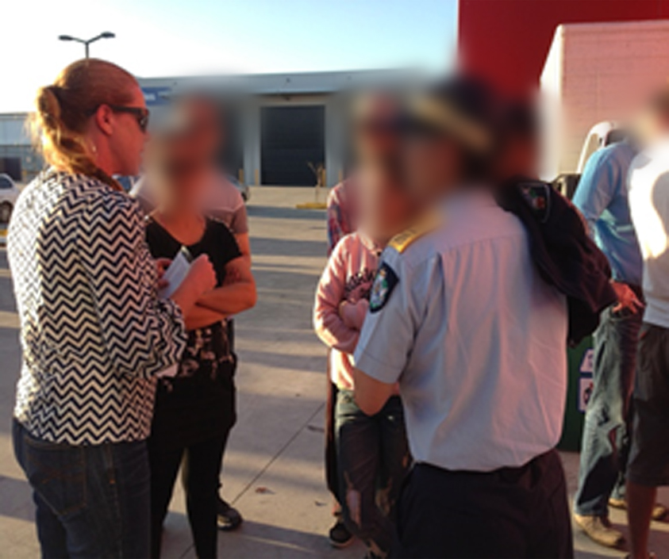

*Photo: Fair Work Inspectors talking with overseas workers in Caboolture, assisted by Queensland Police Community Liaison Officers.*

In 2016, the FWO also presented at a number of information sessions for prospective employees in the strawberry industry, as part of the ‘**The Sweetest Job Campaign’**. The campaign was funded by Regional Development Australia, the Sunshine Coast and Moreton Bay Councils and widely supported by industry stakeholders.[8] The Campaign, which has continued into 2018[9], focusses on developing local workforces to improve regional employment opportunities, and to meet the seasonal demand for horticultural workers along the Harvest trail.

In January 2017, the FWO announced it had partnered with Growcom in support of their **Fair Farms Initiative**. [10] The Initiative was launched in May 2017, with funding assistance over four years provided by the FWO through its Community Engagement Grants Program.[11] The Initiative supports growers with tools and information to implement employment practices that comply with workplace laws and industry standards, and to demonstrate this to customers and the wider community. As part of this initiative, growers access training and certification that supports them to achieve compliance with their workplace obligations and helps ensure ethical supply chain practices. Growcom launched the Fair Farms Training and Certification Pilot Program in October 2018, with the full program rollout planned for 2019.[12] On 5 November 2018, the Australian Government announced further funding of $1.5 million in support of the initiative.[13]

Since the completion of the Inquiry, the FWO has maintained and enhanced its industry stakeholder network through regular meetings and information sharing. Ongoing information sharing also occurs with:

* Department of Jobs and Small Business (in relation to the Seasonal Worker Programme[14])
* Department of Home Affairs (in relation to activities conducted under Taskforce Cadena, the Visa Assurance Protocol[15] and the FWO’s monitoring of certain 457 and 482 subclass visa arrangements).

### Awareness-raising and educational communications

Over the course of the Inquiry, the FWO issued 37 dedicated media statements covering education offerings, field activities, information-sharing opportunities, and compliance and enforcement outcomes.

In addition, social media was used to communicate Inquiry messages. The first social media campaign occurred early in the Inquiry and included Facebook posts on key issues facing working holiday makers and a live ‘Question and Answer’ session. These Facebook posts were seen by over 410 000 individuals.

Digital display advertising was also used on English and in-language websites to spread campaign messages and promote resources translated into Chinese, Korean and Vietnamese. Websites where individuals were known to post Harvest Trail jobs (such as Gumtree) were preferenced in the digital display advertising. In total display ads were seen 622 000 times.

In August 2015, the FWO ran an advertising campaign at regional airports in Mildura, Rockhampton, Mackay, Ballina, Bundaberg and Cairns targeting backpackers following the Harvest Trail. This advertising was potentially seen by up to 530 000 individuals during the four-week campaign period.

The airport advertising ran in conjunction with a second, four-week social media campaign through Facebook and Twitter. Campaign content was viewed approximately 218 000 times on social media. The impact was notable, with visits to the [fairwork.gov.au/harvesttrail page](https://www.fairwork.gov.au/how-we-will-help/helping-the-community/campaigns/national-campaigns/harvest-trail-campaign) increasing by 573% during the campaign period (1147 visits).

Examples of social media communications used by the FWO to support the Inquiry are provided below.

#### Figure 1: FWO Facebook post example – promoting educational resources

#### FWO Facebook post – promoting educational resources, August 4 2014 Figure 2: FWO Facebook post example – highlighting airport advertising

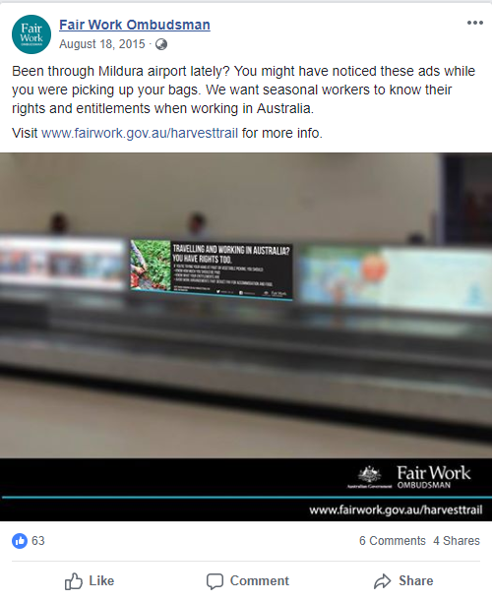

#### Figure 3. FWO Twitter post examples

### Three FWO tweets targeting backpackers, fruitpickers and seasonal workers, encouarging them to see our top tips and know their rights

### Compliance and enforcement activities

Over the course of the Inquiry, Fair Work Inspectors visited produce farms across Australia. They interviewed workplace participants, investigated employers and, where appropriate, took compliance and enforcement action to address and deter unlawful workplace practices.

In the first two years of the Inquiry in particular, Fair Work Inspectors devoted considerable time onsite at Harvest Trail businesses. Fair Work Inspectors used these interactions to educate employers on issues such as award coverage, and to promote FWO tools to help achieve compliance.

There were 1295 discrete education and compliance interactions with Harvest Trail participants, and 836 completed investigations.

Many visits were made in response to intelligence the FWO received, including requests for assistance and anonymous tip-offs. The first visits were to strawberry farms in Caboolture, Queensland, in August 2013. The Inquiry then progressed to different regions and crops throughout the Harvest Trail. If non-compliance was identified in a region, it would be revisited again the following year. The map below shows where visits took place.

#### Map of Australia showing where workplace visits were made and in what concentrationsFigure 4. Map illustrating number of FWO Harvest Trail visits[16]

The table below shows the regions visited over the course of the Inquiry and the type of produce grown.

#### Table 1. Regions visited during the Harvest Trail Inquiry

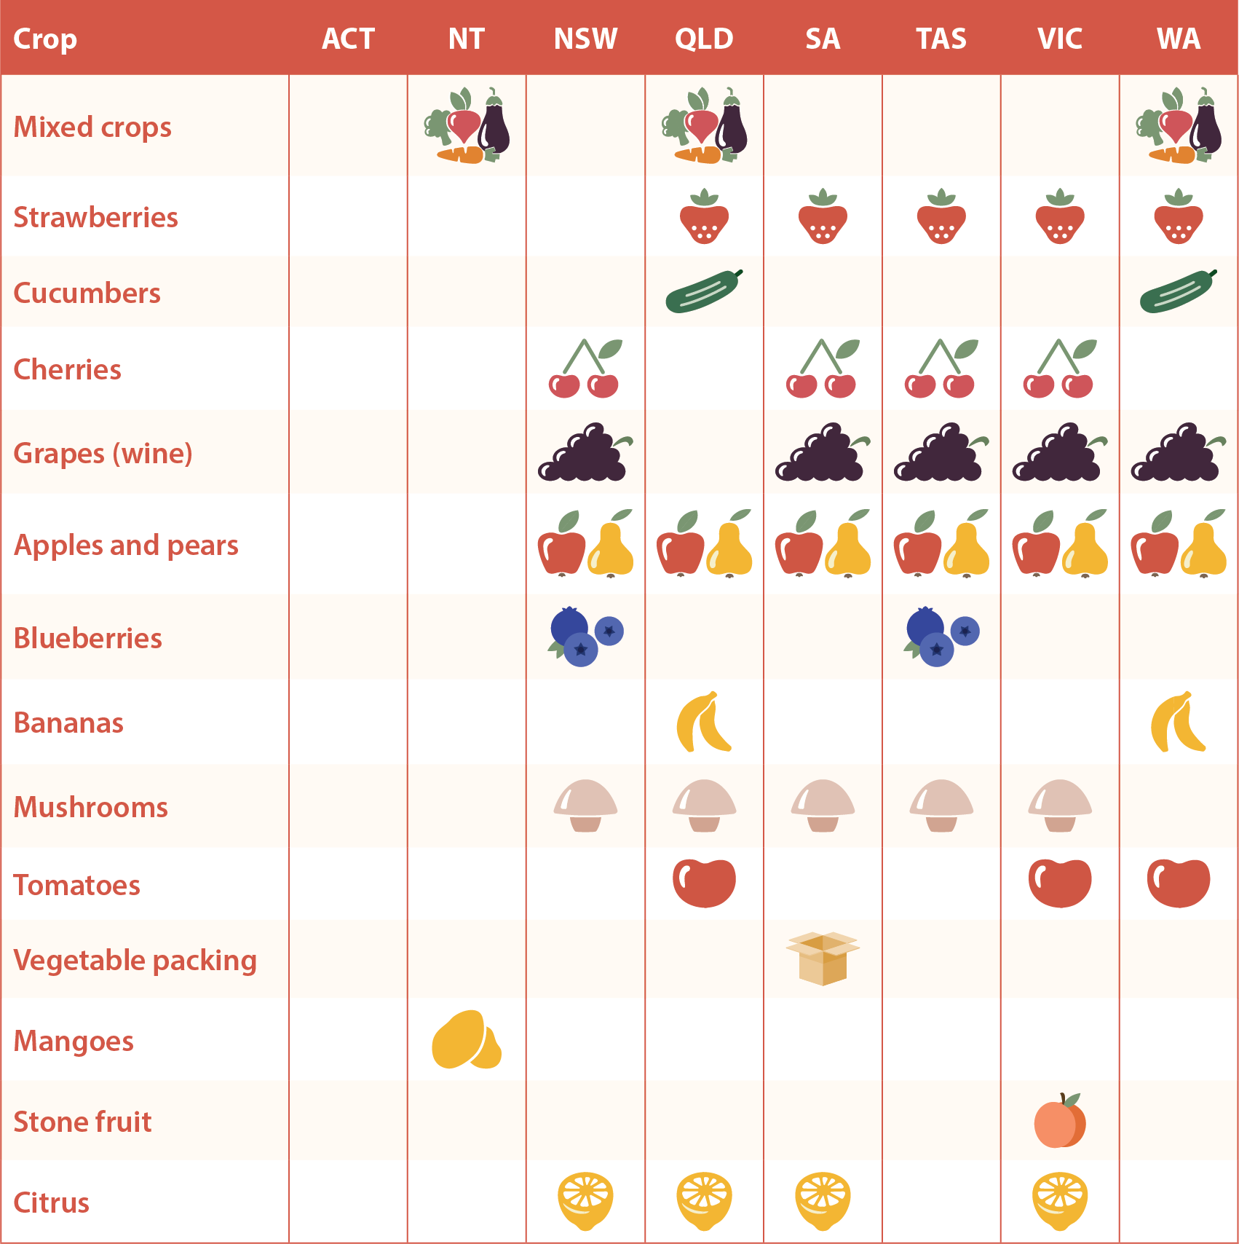

Where minor non-compliance was identified as a result of an error, Fair Work Inspectors provided employers with an opportunity to voluntarily rectify underpayments and correct record-keeping or pay slip breaches.

Where serious breaches were identified, Fair Work Inspectors issued Formal Cautions and Infringement Notices in accordance with the FWO’s [Compliance and Enforcement Policy](https://www.fairwork.gov.au/about-us/our-vision/compliance-and-enforcement-policy).[17] As the Inquiry progressed, Fair Work Inspectors revisited non-compliant businesses to assess compliance. Where subsequent breaches were identified, the FWO escalated its compliance and enforcement response to drive behavioural change and deter any future unlawful conduct.

A number of instances of significant non-compliance resulted in the FWO initiating Enforceable Undertakings and legal proceedings. By entering into an Enforceable Undertaking with the FWO, businesses acknowledged breaches of the law, accepted responsibility and agreed to remedy the harm. Enforceable Undertakings are made in a legally binding document, which is published on the FWO website. If the terms of an Enforceable Undertaking are not complied with, the FWO can take legal action in a court to enforce them, as well as seek other orders the court considers appropriate.

Legal proceedings were commenced in those cases where it was considered warranted to penalise employers and send a message of deterrence to the wider business community about the consequences of significant non-compliance.

### Constraints

The ability to detect, quantify and recover underpayments was impeded by:

* record-keeping deficiencies
* invalid or absent piecework agreements
* reluctance or unwillingness to share information by workplace participants
* transient workers and labour hire contractors.

Record-keeping deficiencies in particular, prevented Fair Work Inspectors from being able to fully establish outstanding entitlements in a number of investigations. This issue was noted by the court in the FWO’s case against labour hire contractor, Seasonal Farm Services Pty Ltd. [18]

Case study: Seasonal Farm Services Pty Ltd

Seasonal Farm Services Pty Ltd was a labour hire contractor based in the Lockyer Valley, Queensland.

In October 2015, the FWO received a Request for Assistance from an employee in relation to underpayment of wages.

A FWO audit of the business considered a 12-month period. Records and information gathered by Fair Work Inspectors showed 214 employees were engaged by the company. However, record-keeping breaches meant the assessment was required to be limited to 144 employees. A total of $60 780.30 was identified as having been underpaid to 144 employees.

The FWO commenced legal proceedings in the Federal Circuit Court, which resulted in pecuniary penalties of $85 000 and $17 000 being imposed on the company and a director respectively.

The court noted that the absence of records of hours worked made the FWO investigation “extremely difficult” and that there was no way of ascertaining if the breaches “were even more blatant than what the investigation discovered”.[19]

The FWO found that in a number of instances, employers were not paying the piecework rates prescribed by the *Horticulture Award 2010* (Horticulture Award) or had failed to document the arrangements as required in a written piecework agreement.

Currently, employers are not required to record hours worked by pieceworkers under the Horticulture Award and the *Wine Industry Award 2010* (Wine Industry Award). Fair Work Inspectors also found workers rarely recorded their hours. This presented a further barrier to making accurate assessments of outstanding employee entitlements where piecework arrangements were found to be invalid and where Fair Work Inspectors believed that underpayments had occurred.

The Harvest Trail is characterised by itinerant workplace participants, which again compounded difficulties in establishing the extent of underpayments. Fair Work Inspectors were at times unable to locate and speak with itinerant labour hire contractors operating across state and territory boundaries. Workers too, had often moved on to other locations or left Australia altogether.

The FWO encountered workers and growers reluctant to provide information. For instance, growers who did not want to reveal the identity of certain contractors whom they considered less reputable, or workers who were fearful of government officials, loss of employment, or not having their second visa issued.

The FWO used the full range of compliance and enforcement tools that were available at the time of the Inquiry, including litigation. However, it should be noted that the Inquiry did not benefit from the *reverse onus* provisions now contained in the FW Act.[20] These provisions require employers who fail to meet record-keeping or pay slip obligations, without a reasonable excuse, to disprove wage claim allegations made in court, meaning the employer bears the onus of proof.

### Consumer research

To complete the Inquiry and improve our understanding of market dynamics, the FWO commissioned research on consumer and retailer attitudes.

The research found that some consumers are willing to pay more for produce if they know it is picked and packed by a workforce treated fairly.[21] The research report is provided at Appendix B.

# The industry

Australians spend $18 billion annually on fresh fruit and vegetables[22] and just under $3 billion a year on wine.[23]

According to the ABS, in the financial year ending 30 June 2017, the overall value of Australian agricultural commodities produced was worth approximately $60.8 billion. Of this amount, approximately $9.6 billion was the combined value for the production of fruit, nuts, grapes and vegetables.[24]

Horticulture Innovation Australia values exports of Australian horticultural products for the financial year ending 30 June 2017 at $2.23 billion (not including grapes). For the same period the value of horticultural imports (not including grapes) into Australia was $2.79 billion.[25]

Wine Australia reports that there was $2.3 billion in export wine sales in 2016-17 and $3.3 billion in domestic sales.[26]

The significant majority of fruit and vegetables grown and sold in Australia is through supermarket chains and wholesale markets. A recent Roy Morgan report shows that Australia’s two largest supermarket retailers - Woolworths and Coles - captured a larger share of Australia’s $18 billion fresh fruit and vegetable market than all the other retail outlets combined (including supermarket IGA, greengrocers, markets, other supermarkets and other non-supermarkets), with more than 51%. Greengrocers account for just under 16% of the market.[27]

The Australian Bureau of Agricultural and Resource Economics and Sciences (ABARES) has conducted annual surveys of Australian vegetable growers since 2007. Hired labour costs are consistently the largest component of cash costs to vegetable growers.[28]

Harvest Trail growers that the FWO interacted with were a mixture of:

* small, family run businesses with small acreage farms
* larger-scale family-run farms operating across a number of states
* large companies with significant market share.

A wide spectrum of sophistication was identified in terms of the systems used for managing compliance with Australian workplace laws - from unsophisticated through to operations with dedicated human resources functions overseeing the employment practices of the company.

Harvest Trail growers supplement their labour pool during peak periods with overseas workers, mostly working holiday makers (subclass 417 visa holders). The FWO considers temporary visa holders as vulnerable workers due to a higher incidence of cultural and language barriers, low awareness of workplace rights and barriers to accessing assistance.[29]

The Inquiry found a significant percentage of growers utilise the services of labour hire contractors to source labour to pick and pack crops during the short harvest season. Labour hire contractors that the FWO engaged with during the Inquiry varied in terms of size and sophistication: from large, very well organised and managed, through to much smaller, individual operators with limited infrastructure or business and administrative capability.

The use of labour hire contractors creates a labour supply chain. This report uses the term ‘labour supply chain’ to describe multi-level subcontracting, namely, where one business contracts another business to provide workers or services and then responsibility for contracting labour is further subcontracted out, creating a labour supply chain or contracting network.[30]

Since 2015, the FWO has conducted several inquiries into labour supply chain arrangements, including the contracting of trolley collection, cleaning and poultry processing services.[31] These inquiries have generally found that ineffective supply chain governance contributes to a culture of non-compliance by contractors throughout the labour supply chain.

### Working conditions

People are often attracted to work on the Harvest Trail for the opportunity to combine work and travel around Australia, visiting scenic parts of the country and meeting other travellers along the way.

Piece rates are a common feature of work on the Harvest Trail. This incentive-based payment system is further discussed later in this section. From a worker’s perspective, piece rates can provide suitable reward to an efficient and productive day of work.

However, working conditions can be challenging. Harvest Trail jobs are physically demanding. It is not uncommon for workers to work long hours for short and defined periods (e.g. four weeks) to ensure a crop is picked, packed and dispatched for the market ‘just in time’. Harvest Trail workers can find themselves working in a range of temperature extremes. For example, in the summer months in Mildura (regional Victoria), temperatures exceed 40 degrees Celsius for protracted periods.[32] Combined with humidity, these working conditions can be dangerous. Extreme cold can also be an issue, particularly when working to prepare sites for the next harvest period.

Working on the Harvest Trail may also involve risk of injury or even death. In the crop, fruit, vegetable and flower growing industries there were 82 fatalities in the ten years to 2016.[33]

Individuals often work in isolated areas where quality accommodation may be scarce and/or of sub-standard condition.

### Terms and conditions of employment

With the exception of sole traders and partnerships in Western Australia, employers involved in the Harvest Trail are ‘national system employers’ under the *Fair Work Act 2009* (the Act)**.**

The majority of the employers in the Inquiry were covered by the Horticulture Award or the Wine Industry Award. Less frequently, the Inquiry also encountered businesses covered by the *Storage Services and Wholesale Award 2010*.

A smaller percentage of employers involved in the Inquiry had enterprise agreements in place, including some made under the *Workplace Relations Act 1996* that had passed their nominal expiry date.

Enterprise agreements are made by an employer and the majority of their employees, and must be approved by the Fair Work Commission. Where an enterprise agreement is operating, employee entitlements are informed by the agreement. The ordinary hourly base rate of pay cannot be less than any applicable modern award rate and the National Employment Standards apply, although all other terms and conditions come from the relevant enterprise agreement.

Apart from some specific requirements[34], workers engaged under the Seasonal Worker Programme (SWP) are covered by the same terms and conditions of employment as other workers in the industry, be that the Horticulture Award, or a relevant enterprise agreement.

The SWP started on 1 July 2012 and is administered by the Department of Jobs and Small Business as the lead agency, in partnership with the Departments of Foreign Affairs and Trade and Home Affairs and the FWO. [35] Building on a three and a half year pilot scheme it is an aid initiative with two key objectives:

* To contribute to the economic development of nine Pacific Island countries (Fiji, Kiribati, Nauru, Papua New Guinea, Samoa, Solomon Islands, Tonga, Tuvalu and Vanuatu) and Timor Leste.
* To assist Australian employers to meet seasonal labour needs in the agriculture sector, accommodation sector (in selected locations) and tourism sector (the Northern Australia tourism pilot), subject to local labour market testing.

In addition to the SWP, the Pacific Labour Scheme (PLS) program commenced on 1 July 2018 with the aim of helping to deliver more workers to fill shortages in rural and regional Australia. The PLS program allows people from Pacific Island countries to work in low and semi-skilled jobs in rural and regional Australia for up to three years. The FWO supports the PLS by informing participants of their workplace rights and obligations, and monitoring compliance with workplace laws by PLS employers.[36]

### Horticulture Award 2010 [MA000028]

Clause 4.2 of the Horticulture Award defines the ‘horticulture industry’ as:

1. *the sowing, planting, raising, cultivation, harvesting, picking, washing, packing, storing, grading, forwarding or treating of horticultural crops in connection with a horticultural enterprise; or*
2. *clearing, fencing, trenching, draining or otherwise preparing or treating land or property in connection with the activities listed at 4.2 (a).*

Exclusions to this definition at clause 4.3 include the wine industry, silviculture and afforestation, sugar farming or sugar cane growing, sugar milling, sugar refining, sugar distilleries, and/or sugar terminals, any work in or in connection with cotton growing or harvesting, cotton ginneries and associated depots, cotton oil mills and the extraction of oil from seed, or plant nurseries.

Clause 4.7 of the Horticulture Award specifies coverage for employers supplying labour on an on-hire basis.

### Wine Industry Award 2010 [MA000090]

Clause 3.1 of the Wine Industry Award defines the ‘wine industry’ as:

*…the industry of growing and processing wine grapes and includes:*

1. *the preparation of land for the planting of wine grape vines, the planting of wine grape vines, the pruning of wine grape vines, the care, growing, treating, picking, harvesting and forwarding of wine grapes and other activities associated with a wine grape vineyard; and/or*
2. *processing wine grapes, producing wine juice or grape spirit, the bottling, packaging, storage or dispatch of wine, brandy or other potable spirit, liqueurs, vinegar or grape juice and other activities associated with a winery or wine distillery including but not limited to cellar door sales, laboratory activities and making or repairing barrels, vats, casks and like articles; and/or*
3. *packaging, storing and dispatching of wine or grape spirit from a warehouse facility or other place of storage associated with a winery or wine distillery.*

Key conditions applying to Harvest Trail employees in these Awards (as at the date of publication) are included in the table below.

#### Table 2. Key provisions of Harvest Trail Awards

| **Provisions** | **Horticulture Industry Award 2010[37]** | **Wine Industry Award 2010[38]** |
| --- | --- | --- |
| **Casual employees** | *Clause 10.4 (b): Casual employment*  *For each hour worked, a casual employee will be paid no less than 1/38th of the minimum weekly rate of pay for an employee in that classification in clause 14—*[*Minimum wages*](https://www.fwc.gov.au/documents/documents/modern_awards/award/ma000028/ma000028-18.htm#P291_27893)*, plus a casual loading of 25%.* | *Clause 13.2: Casual employment*  *A casual employee for working ordinary time must be paid an hourly rate calculated on the basis of 1/38th of the minimum weekly wage prescribed in clause 16—Classifications and adult minimum wages for the work being performed plus a casual loading of 25%.* |
| **Hours of work** | *Clause 22.1: Types of employment*  *22.1 The ordinary hours of work for all full-time and part-time employees other than shift workers will not exceed 152 hours over a four week period provided that:*  *(a) The ordinary hours will be worked between Monday and Friday inclusive except by arrangement between the employer and the majority of employees in the section/s concerned that the ordinary hours will be worked between Monday and Saturday inclusive.*  *(b) The ordinary hours will be worked between 6.00 am and 6.00 pm except if varied by arrangement between the employer and the majority of the employees in the section/s concerned.*  *(c) The ordinary hours will not exceed eight hours per day except by arrangement between the employer and the majority of employees in the section/s concerned in which case ordinary hours should not exceed 12 hours on any day.*  *(d) All time worked by full-time and part-time employees in excess of the ordinary hours will be deemed overtime.* | *Clause 28.2: Ordinary hours of work—day workers*  *(a) Subject to clause 28.4, the ordinary hours of work for a day worker are an average of 38 per week.*  *(b) Subject to clauses 28.2(c) and 28.2(d), the ordinary hours of work are to be worked continuously, except for meal breaks, between the hours of 6.00 am and 6.00 pm, Monday to Friday.*  *(c) The ordinary hours of work for an employee rostered to perform work in the cellar door are to be worked continuously, except for meal breaks, between the hours of 6.00 am and 6.00 pm, Monday to Friday, and 8.00 am and 6.00 pm Saturday to Sunday.* |
| **Overtime** | *Clause 24.2: Payment of overtime*  *(a) The rate of pay for overtime will be 150%, except for overtime worked on a Sunday.*  *(b) The rate of pay for overtime worked on a Sunday, except during harvest period, will be 200%.*  *(c) Should employees be required to work on a Saturday and the majority of such employees elect not to work on the Saturday but rather on the Sunday then such work performed on that Sunday will be paid for at the rate prescribed for Saturday work.*  *(d) During harvest period, the first eight hours of overtime in a week may include five hours work on a Sunday at the rate of 150% but all Sunday work in excess of the eighth overtime hour worked in the week, or in excess of five hours on a Sunday, will be paid at the rate of 200%.*  *(e) All employees required to work on a Sunday will be paid for a minimum of three hours.* | *Clause 30.1: Payment for working overtime*  *Except as provided in clauses 30.2, 30.3 and 30.6, all time worked outside ordinary hours on any day or shift must be paid for at the rate of 150% for the first two hours on any day or shift and 200% thereafter until the completion of the overtime work.* |
| **Public holidays** | *Clause 28.3 Public holiday rates of pay*  *All work performed on public holidays will be paid for at the rate of 200% of the ordinary rate.* | *Clause 30.3: Public holiday work*  *An employee required to work overtime on a public holiday must be paid for a minimum of four hours work at the rate of 250% until the completion of the overtime.* |
| **Level 1 classification** | *Schedule B – Classification Structure and Definitions*  *B.1 Level 1*  *B.1.1 Level 1 employee means an employee classified in accordance with the following criteria:*  *B.1.2 General description*  *An employee at this level:*  *undertakes induction training which may include information on the enterprise, conditions of employment, introduction to supervisors and fellow workers, training and career opportunities, plant layout, work and documentation procedures, occupational health and safety, equal employment opportunity and quality control/assurance;*  *performs routine duties essentially of a manual nature and to the level of their training;*  *exercises minimal judgment;*  *works under direct supervision;*  *is responsible for the quality of their own work;*  *is a new employee; or is an existing employee performing work within this grade who is undertaking training so as to enable advancement to Level 2.* | *B.5.2 Grade 2—Vineyard stream*  *(a) Point of entry*  *(i) A Grade 1 employee who has passed an accredited assessment for progression from Grade 1 to Grade 2 with successful completion of training and assessment in all of the following modules:*  *pruning*  *vine training*  *basic machinery training*  *irrigation*  *harvesting*  *safety and safety regulations (on-going)*  *chemicals handling*  *grafting; or*  *(ii) A Grade 1 employee who has passed an accredited assessment for progression from Grade 1 to Grade 2 with training in more than one stream and successful training and assessment in general viticulture (internal or external) and two modules essential to one or two other streams such as:*  *forklift driving (certificate required)*  *heavy vehicle driving*  *basic machinery maintenance; or*  *Wine Industry Award 2010 MA000090*  *(iii) A person deemed by the employer to have the necessary skills and competence to satisfactorily perform duties at this level.* |

### Piece rates

The Horticulture Award and Wine Industry Award are distinct from most other modern awards in that they contain provisions allowing employees to be paid piece rates, without a minimum hourly payment. The provisions prescribe how an employer enters into such an arrangement and what sort of documentation is required.

Designed as an incentive-based payment system, a key issue relating to piece rates is how an ‘average competent employee’ or ‘employee of average capacity’ is interpreted.

The Horticulture Award (clause 15.2) states:

*The piecework rate fixed by agreement between the employer and the employee must enable the average competent employee to earn at least 15% more per hour than the minimum hourly rate prescribed in this award for the type of employment and the classification level of the employee. The piecework rate agreed is to be paid for all work performed in accordance with the piecework agreement.*

The Horticulture Award (clause 15.7) further requires that a piecework agreement must be in writing and signed by the employer and the employee.

The Wine Industry Award (clause 23.2) states:

*The piecework rate fixed by agreement between the employer and the employee must enable an employee of average capacity to earn at least 20% more per hour than the minimum hourly wage for ordinary hours of work which is prescribed in this award for the type of employment and the classification level of the employee. The piecework rate agreed is to be paid for all work performed in accordance with the piecework agreement.*

The Wine Industry Award (clause 23.6) prescribes a number of piecework agreement requirements, including setting out which clauses of the Award do not apply, such as meal allowance, overtime and penalty rates. Clause 23.6 of the Wine Industry Award states that piecework agreements must:

1. *be in writing, name the parties to the agreement and be signed by the employer and the individual employee and, if the employee is under 18 years of age, the employee’s parent or guardian;*
2. *detail the piecework rate;*
3. *set out that the piecework rate will be paid instead of the minimum wages specified in clause* [*16*](http://kms.hosts.application.enet/KO/ma000090.htm#P300_30098)*—*[*Classifications and adult minimum wages*](http://kms.hosts.application.enet/KO/ma000090.htm#P300_30098) *of the Wine Industry Award 2010;*
4. *set out that the following clauses of the Wine Industry Award 2010 do not apply to the employee as the employee is on a piecework rate:*
   1. *clause* [*24.3*](http://kms.hosts.application.enet/KO/ma000090.htm#P446_42927)*—*[*Meal allowance*](http://kms.hosts.application.enet/KO/ma000090.htm#P446_42927)*; and*
   2. *clause* [*28*](http://kms.hosts.application.enet/KO/ma000090.htm#P568_53905)*—*[*Ordinary hours of work and rostering*](http://kms.hosts.application.enet/KO/ma000090.htm#P568_53905)*; and*
   3. *clause* [*30*](http://kms.hosts.application.enet/KO/ma000090.htm#P625_61892)*—*[*Overtime and penalty rates*](http://kms.hosts.application.enet/KO/ma000090.htm#P625_61892)*; and*
5. *state the date the agreement commences to operate.*

### Total cost of an employee

During the Inquiry, employers told Fair Work Inspectors that labour costs are one of their highest operating costs. There is therefore, a risk that some employers experiencing market and cost pressures may seek to improve financial viability by cutting labour costs. The FWO’s experience suggests that labour costs can be more susceptible to cost-cutting than fixed costs such as fuel, electricity, mortgages and supplier contract prices.

The Inquiry considered the total cost of an employee as comprising both direct and indirect costs to an employer. Direct costs may include:

* minimum ordinary hourly rates
* overtime and public holiday rates
* piece rates
* weekend penalties
* casual loadings
* allowances
* leave payments e.g. personal leave or annual leave
* annual leave loading.

There are two categories of potential indirect costs to an employer:

* items that provide a benefit to the individual employee
* items that are a part of running a business and a consequence of having employees.

Indirect costs may include benefits such as insurance, health insurance payments, transport or accommodation.

Superannuation contributions are considered an indirect cost because they are paid to a fund rather than directly to the employee. Superannuation contributions are compulsory, and if they are not paid, an employer must pay the Superannuation Guarantee Levy. Other common indirect costs to an employer may include workers’ compensation premiums and payroll tax. Workers compensation premiums vary according to the industry and type of employment, as well as the employer’s past history.

Industry has advised the FWO that the competing pressures identified above can be difficult for employers to manage and can become drivers for non-compliance with workplace laws.

There are also specific costs borne by both approved employers[39] and employees participating in the SWP.[40] For example, approved employers are required to provide pastoral care, accommodation and transport for employees, as well as pay the cost of workers’ return airfares up-front. Approved employers can incrementally recoup some costs from workers, through deductions, during their period of employment in Australia.

# Finding 1 – Widespread non-compliance amongst investigated employers

Fair Work Inspectors investigated 638 employers as part of the Inquiry. This included 444 growers and 194 labour hire contractors. In total, these 638 employers were subject to 836 investigations.[41]

In more than half (465 or 55.6%) of these investigations, the FWO determined that there had been a failure to comply with Australian workplace laws. These breaches were as follows:

* 236 (or 28.2% of all investigations) monetary breaches – mainly in relation to underpayment of the hourly rate and not being paid for time worked
* 120 (or 14.4% of all investigations) non-monetary breaches – mainly a failure to keep records and payslips
* 109 (or 13.0% of all investigations) both monetary and non-monetary breaches.

### Figure 5. Overall compliance rates

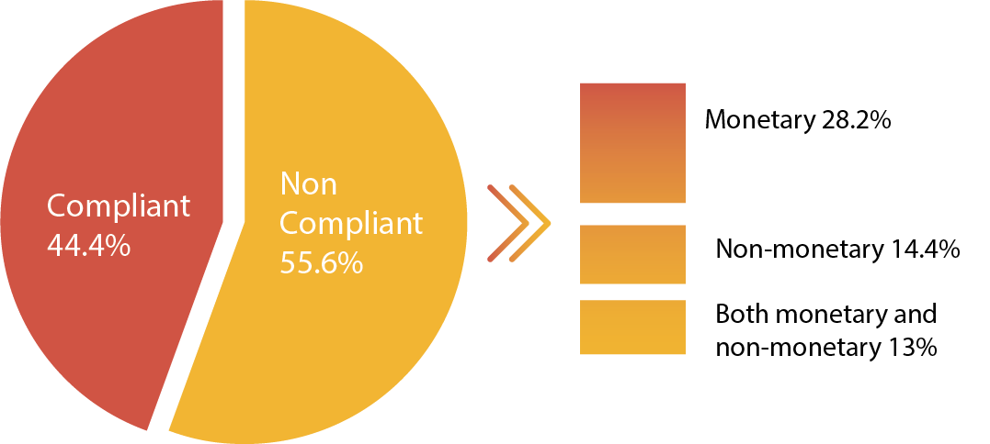

In the 465 investigations in which non-compliance was found, the FWO identified a total of 693 individual breaches. Underpayment or non-payment of wages (44% of breaches) and failure to meet pay slip and record-keeping obligations (41%) were the most common types of breaches identified, with the balance comprising casual loading, penalty rate, leave and leave loading, overtime and other technical breaches.

### Money recovered

A total of $1 022 698 was recovered for 2503 employees. The average monetary recovery per employee was approximately $409. The smallest recovery was approximately $21 and the largest recovery arising from a single investigation was $125 053 for 15 employees.

### Compliance and enforcement outcomes

Fair Work Inspectors issued:

* 150 Formal Cautions
* 132 Infringement Notices, totalling $155 390 in fines for record-keeping and pay slip breaches
* 13 Compliance Notices, of which 11 were complied with, recovering back pay of $87 649.62 for 32 employees.[42]

The FWO entered into Enforceable Undertakings with seven businesses, through which a total of   
$233 569.04 was recovered for 584 employees:

* Jasbinder Singh Benning, Tarlochen Singh Benning, Balbir Kaur Benning, Amrarjit Kaur Benning trading as K S Benning & Sons - $46 082.31 recovered for 137 employees.[43]
* TDS International Investment Group Pty Ltd - $51 974.08 recovered for 52 employees. Note: The total underpayments were $92 381.92 of which $40 407.84 was recovered from Gromor Enterprises Pty Ltd as an accessory (below).[44]
* Gromor Enterprises Pty Ltd - $40 407.84 recovered for 52 employees.[45] Note: This figure was the proportion of the overall $92 381.92 in underpayments attributed to Gromor Enterprises Pty Ltd after it admitted it was an accessory to the contraventions of TDS International Pty Ltd (above).
* Lai Yoong Ching & Swee Cheng Khong trading as Team Search Harvesting - $15 892.33 recovered for 255 employees.[46]
* Seasonal Labour Solutions Pty Ltd - $14 720.38 recovered for 26 employees.[47]
* Boonah Packing Pty Ltd - $16 710.77 recovered for 110 employees.[48]
* Letusgrow Hydroponics Pty Ltd - recovered $37 781.33 for four (4) employees.[49]

The FWO also commenced legal proceedings in the Federal Circuit Court of Australia (FCCA) or Federal Court of Australia (FCA) against eight businesses, and to date has obtained penalties against six of those businesses:

* Gurmakh Singh Dosanjh - $13 005 penalty against Mr Dosanjh.[50]
* Maroochy Sunshine Pty Ltd and Mr Emmanuel Bani - $186 000 penalty against the company and   
  $41 300 against sole director Mr Bani[51]
* I Luv Pty Ltd, Mr Hour Him and Ms Tay-Duc Nguyen - $56 000 penalty for the company, $6 400 for Mr Him and $6 400 for Ms Nguyen.[52]
* Vinai Chaipom - $25 412 penalty against Mr Chaipom.[53]
* Seasonal Farm Services Pty Ltd and Mr Ram Kumar - $85 000 penalty for the company and $17 000 penalty for director Mr Ram Kumar.[54]
* HTA Farmings Pty Ltd and Mr Tuan Le - $70 550 penalty against the company and $14 110 against director Mr Le.[55]
* Hu Tao, Marland Mushrooms Qld Pty Ltd and Mr Troy Marland.[56]
* Zucco Farming Pty Ltd and Mr Chris Zucco - awaiting a decision on penalty.[57]

# 

# Finding 2 – Misuse of piecework arrangements

Both the Horticulture and Wine Industry Awards provide for piecework arrangements.

The availability of labour and quick harvesting of crops is critically important for growers of produce with short shelf lives. In many cases, this drives the use of incentive-based systems such as piece rates.

The FWO found that more than a third of employers were paying piece rates or a combination of piece and hourly rates, which is acceptable under the Awards. However, over 100 of those employers were not engaging pieceworkers correctly by having no written piecework agreement or having an invalid piecework agreement.

Fair Work Inspectors observed some growers and labour hire contractors applying group rates for pieceworker employees. This practice involves a group of employees working together to fill a unit of measurement (for example filling a bin of mangoes) for which they are paid an equal share. This method of arranging work does not take into consideration the actual contribution of each employee and can lead to situations where more productive employees are financially disadvantaged.

The FWO treats these arrangements as inconsistent with the piecework arrangements contemplated under the Horticulture and Wine Industry Awards because piecework arrangements are between an individual employee and their employer. The amounts payable to the employee are contingent on their individual productivity, which cannot be accurately quantified in this type of group arrangement.

The FWO’s position is that an employer must be able to demonstrate that the piece rate offered will allow an average competent employee to earn at least 15% more per hour than the minimum hourly rate prescribed by the Horticulture Award, and at least 20% of the rate prescribed by the Wine Industry Award (see clause 15.2 of the Horticulture Industry Award and clause 23.2 of the Wine Industry Award).[58]

Industry guides may assist employers in determining relevant factors and employee characteristics to take into consideration in the calculation of appropriate piecework rates.

**Case study: Good practice**

Fruit Growers Victoria (FGV) publishes a piece rate guide for its members each season. To set these rates, FGV meets with key growers and analyses the bins picked, taking into consideration the length of time it takes to pick bins of fruit and environmental conditions. The price per bin that it publishes is a guide and growers are encouraged to keep productivity records to allow them to show how their rates have been calculated.

# Finding 3 – Significant reliance by growers on overseas workers

The Inquiry found Harvest Trail growers rely heavily on overseas labour. Of the 626 employers[59] FWO interacted with who were employing staff at the time, 67% (420) were employing overseas workers.

The 420 growers employing overseas workers is broken down by state/territory in the graph below.

### Figure 6. State/territory breakdown of employers hiring overseas workers

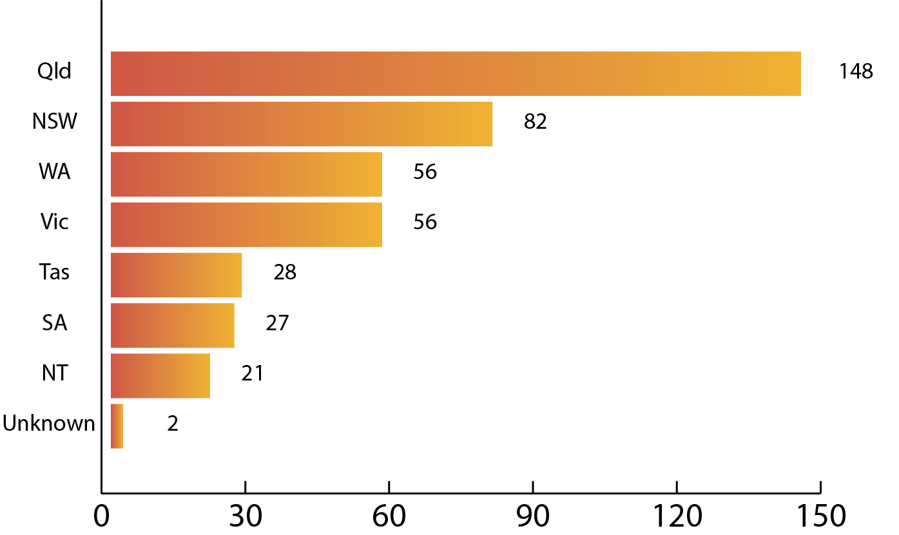

73% (305) of 420 growers who advised they were employing overseas workers identified Working Holiday visa subclass 417 as the most commonly held visa type. There were also employers who did not provide this information to the FWO.

#### Figure 7. Visa breakdown

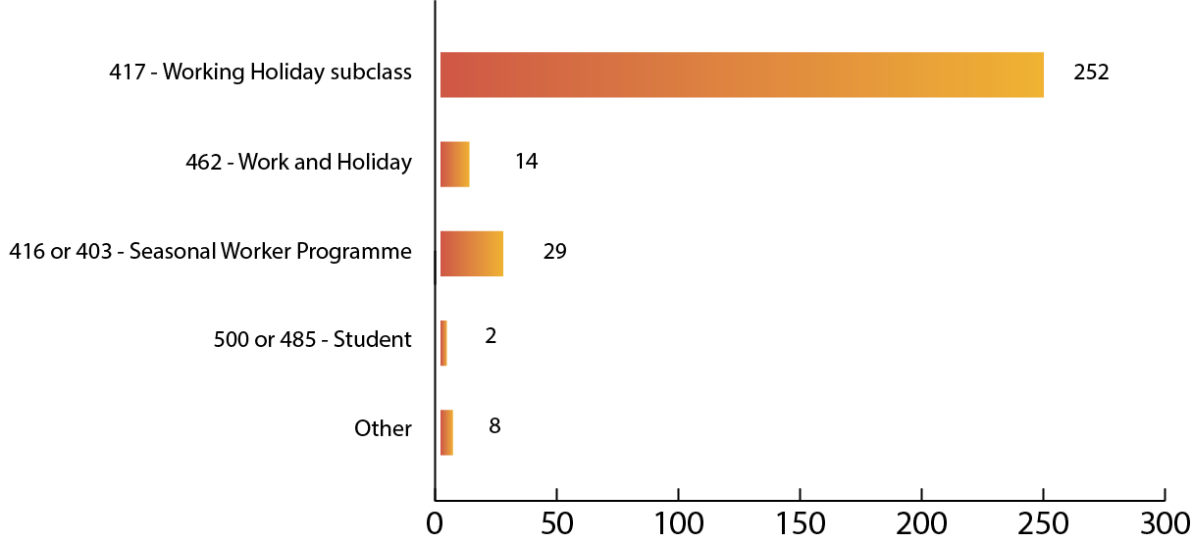

### Working Holiday visa subclass 417

With a subclass 417 visa, 18 to 30 year olds from 17 eligible nations and regions, and 18 to 35 year olds from Canada and the Republic of Ireland, can holiday and work in Australia for one year. They have the option to apply for a visa for a second year if they undertake three months (88 calendar days) of ‘specified work’ in plant and animal cultivation, fishing and pearling, tree farming and felling, mining and construction in regional Australia.[60]

In 2017-18, 185 450 subclass 417 Working Holiday visas were granted, including 152 622 first and 32 828 second Working Holiday visas. As at 30 June 2018, there were 118 524 working holiday makers in Australia (on first and second visas).[61]

As detailed in the FWO’s Inquiry into the working conditions of 417 Visa Holders[62], positive outcomes of the program include:

* workers are drawn to regional areas that would otherwise struggle to attract an adequate workforce from the local community
* growers are able to increase and decrease the size of their workforce throughout the season
* for many crops, 88 days suits the seasonal requirements for harvesting labour.

### Inherent vulnerabilities of overseas workers

The FWO’s experience indicates Harvest Trail workers from overseas are often young adults who have limited English language skills, face cultural barriers and commonly do not have a good understanding of workplace rights and entitlements - or where to get help when needed. When these factors are coupled with a strong desire to stay in Australia, overseas workers are more vulnerable to exploitation than Australian-born workers.

The FWO’s Inquiry into wages and conditions of people working under the 417 Working Holiday Maker program[63] confirmed that visa holders engaged as employees in Australia are a vulnerable group, due to:

* cultural and language barriers
* suspicion of government
* little or no knowledge about Australian workplace rights and obligations
* lack of understanding about how to ensure their workplace rights are provided or where to find assistance.

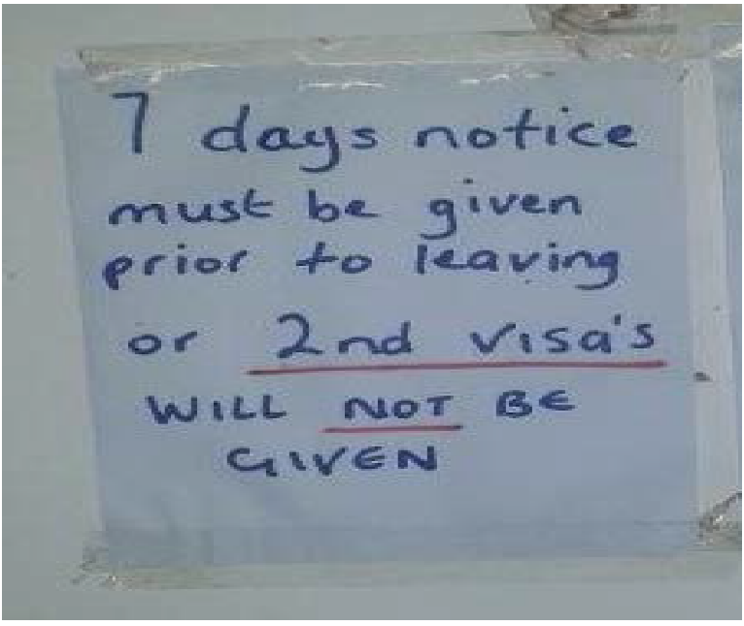Working Holiday visa holders have the same rights and protections under Australian workplace laws as any other employee. However, the FWO’s experience shows that overseas workers, particularly those on 417 visas, are more vulnerable to exploitation. The incentive to obtain a second visa through completing three months (88 calendar days) of specified work means workers may be willing to accept substandard pay and conditions, and/or be unwilling to seek assistance from the FWO. Unscrupulous employers can use this as leverage to pay less, give notice periods that are outside award conditions and withhold pay.[64]

*Photo: Sign posted for Caboolture-based workers indicating employer will not sign-off on days worked if 7 days’ notice not provided before they leave.*

Given these risks, the FWO has been concerned that while some workers request the FWO’s assistance once their employment has ceased and the 88-days have been signed-off, it is likely that many instances of exploitation are never reported.

To address these issues, the FWO launched an online anonymous reporting tool in 2016 (with an in-language version in 2017).[65] In 2017, the FWO also announced an arrangement with the Department of Home Affairs offering protections for workers to come forward and report issues without fear of visa cancellation.[66]

During the Harvest Trail Inquiry, Fair Work Inspectors had mixed results engaging with visa workers. Some interactions elicited information Fair Work Inspectors could test in the course of investigations. At other times, workers were reluctant to engage with Fair Work Inspectors, given their status as government officials. The quality of the information provided by workers about potentially unlawful work practices sometimes was not sufficient to advance an investigation.

From 1 December 2015, changes made by the Australian Government to the subclass 417 visa require that work undertaken to obtain a second year extension must be paid work. Visa holders must provide pay slips to the Department of Home Affairs as evidence.[67]

During the Inquiry, Fair Work Inspectors also met with a smaller cohort of 417 Working Holiday visa holders who were participating in a volunteering scheme known as Willing Workers On Organic Farms (WWOOF).[68] ‘WWOOFing’ involves volunteer work of between 4-6 hours a day in exchange for meals and accommodation. The work is carried out on registered organic farms and properties. This report notes that WWOOFing work is no longer eligible to be counted towards the 88 days’ work requirement for a second year extension of the working holiday visa.

# Finding 4 – Negative impact where labour hire arrangements are used

A critical element of a grower’s enterprise is the availability of labour to pick, pack and dispatch produce in a tight ‘harvest window’. A lack of workers can mean fruit and vegetables remain unpicked, unpacked and then spoil.

To secure a workforce at the times required, growers on the Harvest Trail source labour directly and indirectly, with labour hire contractors playing a significant role.

The Inquiry examined the labour procurement methods used by 638 growers. The FWO found that in around half of the 366 cases where it was able to establish the procurement arrangements in place, growers used labour hire contractors. The FWO identified that:

* 49% (180) of growers directly employed all their labour
* 39% (144) used a combination of direct employment and labour hire contractors
* 12% (42) sourced all labour via labour hire contractors.

A number of growers informed the Inquiry that there were challenges in sourcing labour due to a decline in ‘professional picker gangs’ over the past decade. Such ‘gangs’ were typically well-established workforce groups which would ‘service’ the same crop areas at the same times each year. The chief advantages of the ‘gangs’ were the growers knew the group organiser, the workers knew each other, and the workers knew the farm and the crop. The FWO concluded this may be one of the reasons some employers elect to source labour through the SWP.

The significance of the ‘decline’ in the availability of these ‘professional’ groups is supported in a recent report by Adelaide and Sydney Universities which suggested the issues at play on the Harvest Trail are not so much a ‘labour shortage’ but a ‘recruitment difficulty’.[69] The Inquiry found a number of issues relating to the practices of labour hire contractors on the Harvest Trail which illustrate recruitment ‘difficulties’, as discussed below.[70]

### Overseas nationals and visa holders running labour hire contracting businesses

Regulators such as the FWO can find it difficult to commence legal proceedings against companies that have majority overseas-based directors and just one domestic resident with little assets.

Under the *Corporations Act 2001*, at least one director of a proprietary company established in Australia must ordinarily be an Australian resident.[71] The same requirement applies if the company appoints a company secretary.[72] In this respect, the Inquiry found some labour hire contractor companies that may have been operating in breach of the *Corporations Act 2001*.

Fair Work Inspectors interacted with 237 incorporated labour hire contractors and identified that 271 individuals had been appointed as directors of these entities. Of this number, 92 of the directors were visa holders, including the following visa subclasses:

* 22% (working holiday visa)
* 18% (student visa)
* 15% (returning resident visa)
* 13% (New Zealand citizens but not born in NZ).

**Case study: Listed company director not involved in the business**

Ten Caboolture strawberry farm workers visited the FWO Brisbane office to request assistance for recovering unpaid wages.

The grower in this matter had engaged a labour hire contractor to source workers. The labour hire contractor (now deregistered) had registered a company in Melbourne. The director was born overseas and living in Melbourne. He told Fair Work Inspectors that he had been approached by another member of the community about registering and co-running a labour hire contractor business, sourcing workers mostly from their country of origin. He had no experience running a company but agreed to the proposal.

Upon commencement of the business, the member of the community relocated to Queensland to run the business ‘on the ground’. He did not communicate with the director in Melbourne and did not engage with the FWO during its investigations. At the end of the season he left Caboolture without paying 34 employees approximately $96 000 in wages. In the meantime, the Melbourne-based director disassociated himself from the company.

The grower in this matter agreed to pay the employees’ unpaid wages, despite not having been the employer of the workers and being able to produce evidence of previous payment to the labour hire contractor in question.

### Governance of labour supply chain contracts

The FWO’s interest in the use of labour hire as an employment option extends as far as establishing whether a particular arrangement is lawful, and to its impact on compliance with workplace laws in the labour supply chain.

The FWO’s experience is that multiple levels of subcontracting increases the risk of non-compliance. As additional subcontractors enter the labour contracting chain, the increasing pressure of multiple players taking their profit can result in the legal employer of workers having insufficient funds to cover their full entitlements.

The FWO’s inquiries into labour supply chain contracts confirm the importance of lead firms having strong contract management and governance systems in place to help ensure that workers receive their lawful entitlements. By improving their visibility of supply chain arrangements, lead firms can also protect themselves from reputational damage that can arise from the potentially unlawful conduct of a labour supply contractor on whom they may rely.

**Case study: Lack of clarity in the supply-chain**

A joint operation between the FWO and the Department of Home Affairs[73] involved an established company that supplied fresh produce to major supermarkets and resulted in the detention of unlawful workers and a FWO investigation.

It was alleged workers were being paid $13 per hour. When interviewed, workers were unable to identify who employed them or, at best, appeared only to know the employer’s first name.

The FWO investigation found multi-level contracting arrangements and a complex web of financial transactions (see Figure 8 below). Fair Work Inspectors identified at least three sub-contractors, although it was unclear whether other individuals in the supply chain were employees, subcontractors, or performing both functions, and to whom payments were being made beyond these points.

FWO found that the company lacked processes to track who was working on its farms or if workers were being paid correctly. As a result of the investigation, and with a view to mitigating reputational damage, the company sought to improve labour force governance by:

▪ implementing a process to assess labour hire service providers

▪ amending labour procurement agreements to ensure they provided for clear operating expectations, including restraints on the use of sub-contractors, scope of work, agreed pay rates and right-to-work compliance

▪ regular auditing of its contractors.

#### Figure 8: Example of supply chain identified during a FWO investigation into a major produce grower

The arrows in the graph refer to the payment arrangements between various individuals in the contractor’s network. Question marks denote the uncertain destination of payments. 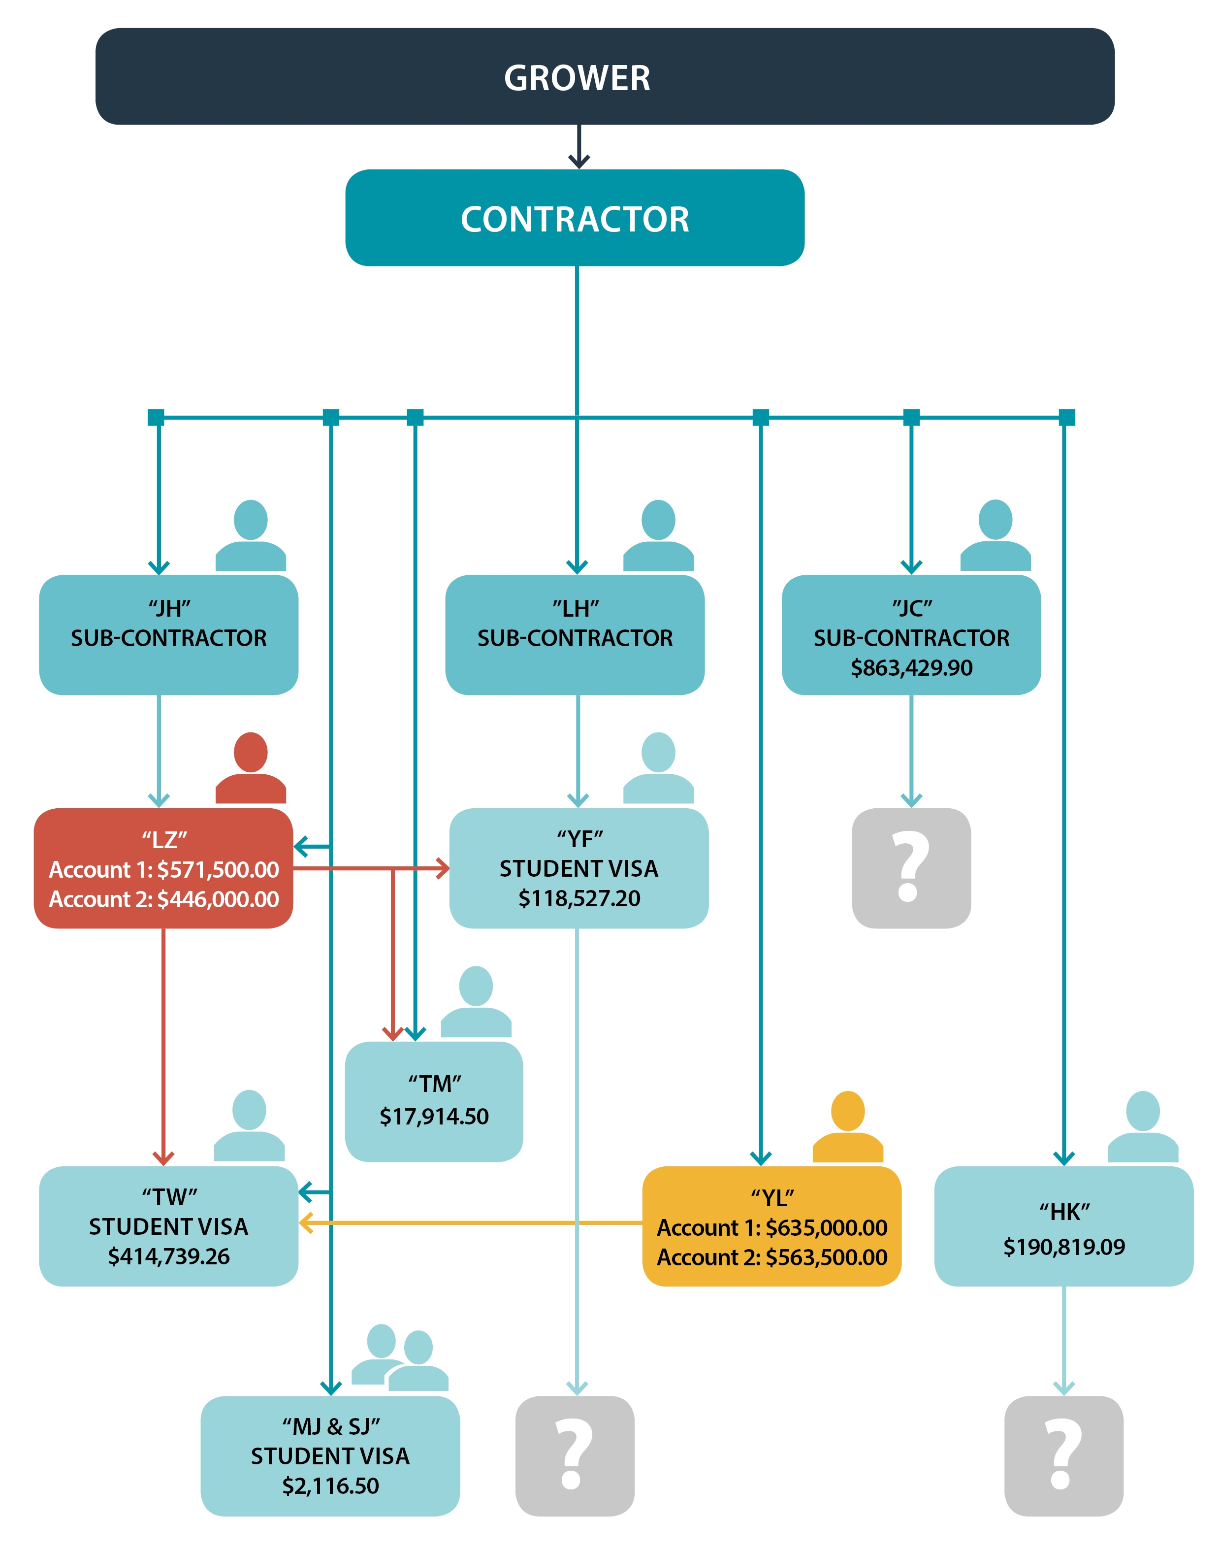

### Itinerant labour hire contractors

The Inquiry found a number of labour hire contractors regularly moved across state/territory borders, following the Harvest Trail as a season finished.

Labour hire contractors would approach growers at a time when they needed ‘to get the crop off’. The Inquiry heard of growers who, faced with tight timeframes, accepted quotes from labour hire contractors that were ‘too good to be true’. These were typically smaller growers.

The case study below illustrates how labour hire contractors operate across geographical areas and crop types as well as how locating and engaging with key personnel was challenging for Fair Work Inspectors.

**Case study: Itinerant labour hire contractor**

Fair Work Inspectors found one labour hire contractor director who repeatedly left crop areas shortly before the end of harvesting without paying employees who had been provided to growers at low cost. They sought to evade responsibility through a combination of measures:

▪ deregistration of the business

▪ constant changing of domiciles

▪ providing Fair Work Inspectors with a false address for the receipt of Compliance Notices and requests for production of documents.

### Grower compliance

The Harvest Trail Inquiry and media attention on the issue of underpayments in the sector had a positive impact on culture in at least some parts of the industry.

The Inquiry heard from growers who had responded to ‘negative media’ about employment practices on the Harvest Trail by changing from using labour hire contractors to direct employment practices. These growers informed the Inquiry they were keen to employ capable staff and retain a ‘good name’ in the sector.

Others who continued to hire indirectly conveyed how they were careful to use recognised labour hire contractors with a reputation for ‘doing the right thing’, and conducted thorough ‘checks’ to ensure workers on their property had Australian work rights.

**Case study: Switching to direct employment**

During visits to apple and pear growers in the Goulburn Valley, one small grower informed Fair Work Inspectors that it was their first year employing labour directly because they had received too many complaints from pickers about not receiving payment from a labour hire contractor.

Advertising on Gumtree, the grower sourced seven-eight pickers directly and provided accommodation to the ‘backpackers’ on the property ($10/night to pitch a tent, with bathroom and laundry facilities provided, rate discounted to $5/night when there was no fruit to pick).

**Case study: Best practice**

A medium-sized grower in Victoria had previously used labour hire contractors to employ backpackers in their packing shed. Given they had been unable to confirm the workers’ wages were being properly paid, the grower started employing directly in 2013.

As a major supplier to Coles and Woolworths, the business wanted to ensure it was compliant with all laws. They also stated that they had utilised the services of MADEC to conduct Visa Entitlement Verification Online (VEVO) checks, provide workers with a ‘work entitlements card’ (likened to a plastic membership card, issued by non-government organisations) and conduct an induction tailored for their business. MADEC provided these services for free.[74]

The business also stated that it had been using Ironbark Software and a ‘Bundy Clock’ which employs a fingerprinting system for employees to clock on and off. These steps prevented unauthorised people from working on the farm.

### Labour hire contractors and the Seasonal Worker Programme (SWP)

Under the SWP, seasonal workers benefit from the opportunity to earn Australian wages and gain valuable on-the-job learning opportunities. Many use the money earned in Australia to pay for their children’s education, start a small business or build a house.[75]

To participate in the SWP, an employer must apply to the Department of Jobs and Small Business to become an approved employer and must obtain the approval of the Department of Home Affairs to become an approved Temporary Activities sponsor.

During the Inquiry, 17 investigations were completed that involved SWP employees who were employed by approved employers. Of these, 11 investigations detected that the employer was non-compliant with Australian workplace laws. Four investigations involved monetary breaches only, two detected non-monetary breaches only and five investigations found that the employer had breached both their monetary and non-monetary obligations.

A total of $150 356 was recovered for 96 employees as a result of investigations involving employees in Australia under the SWP.

The FWO issued:

* four (4) Formal Cautions
* six (6) Infringement Notices (penalties of $12 850)
* one (1) Compliance Notice.

An Enforceable Undertaking was entered into with Seasonal Labour Hire Solutions Pty Ltd ($14 720.38 in underpayments was recovered for 26 employees).[76]

One instance of deliberate exploitation of seasonal workers under the SWP resulted in the FWO commencing legal proceedings as detailed in the below case study.

**Case study: Maroochy Sunshine Pty Ltd**

Following a referral from the Department of Jobs and Small Business, Fair Work Inspectors investigated the alleged underpayment of 22 workers from Vanuatu employed to pick fruit and vegetables by a labour hire contractor operating at sites in the Lockyer Valley, Sunshine Coast and Bundaberg.

In proceedings commenced by the FWO in the Federal Circuit Court, the Court found that the company and its director Mr Emmanuel Bani had breached the Act by failing to pay minimum wages and leave entitlements.

Some workers gave evidence that they had been subjected to very poor conditions during their employment, including:

▪ inadequate accommodation

▪ a lack of food and water

▪ the withholding of passports and personal belongings

▪ threats of deportation or police reports if they complained.

The Court imposed a total of $227 300 in penalties on the company and Mr Bani and stated, “It is difficult to imagine more egregious conduct than that exhibited by Maroochy Sunshine and Mr Bani in this matter.”

During the FWO’s court case, the Department of Jobs and Small Business suspended Maroochy Sunshine Pty Ltd, meaning they were not able to recruit under the program. On 30 June 2016, the deed between the Department of Jobs and Small Business and Maroochy Sunshine Pty Ltd ended and accordingly the company was removed from the list of approved employers.

### The role of accommodation, transport and job service providers

As well as underpayments, the FWO witnessed other exploitation including substandard accommodation, transport and extra charges.

Accommodation options and other service providers are limited in many of the crop areas of the Harvest Trail. The Inquiry found that labour hire contractors and ancillary service providers had entered into arrangements that were to their advantage but which disadvantaged workers, including:

* charging job finding/placement bonds
* restricting accommodation options to the use of specific labour hire contractors, which at times meant visa holders were without work while accruing accommodation debts
* offering over-crowded, sub-standard accommodation at above market rates
* requiring workers to use specific transport providers between accommodation and the work site.

One hostel in Gatton, Queensland was prohibited from providing accommodation as a consequence of legal action by the Queensland Fire and Emergency Services (QFES).[77] QFES Commissioner Katarina Carroll said:

*"The threat to life at these premises was so serious that QFES officers decided to take action in the Supreme Court as a matter of urgency, to ensure the building owners did not continue to provide accommodation to any person ... If a fire started at this building, our officers were concerned the people inside would have had absolutely no chance of escape … We're confident that the court action will prevent a serious tragedy and protect at risk persons like transient workers and international tourists working in the horticulture industry from serious risks such as injury or death."*

The Inquiry found a number of accommodation providers charging visa holders a bond to find them work. Examples of these arrangements included a backpacker hostel in Bundaberg where the hostel charged backpackers a $100 bond to find them work:

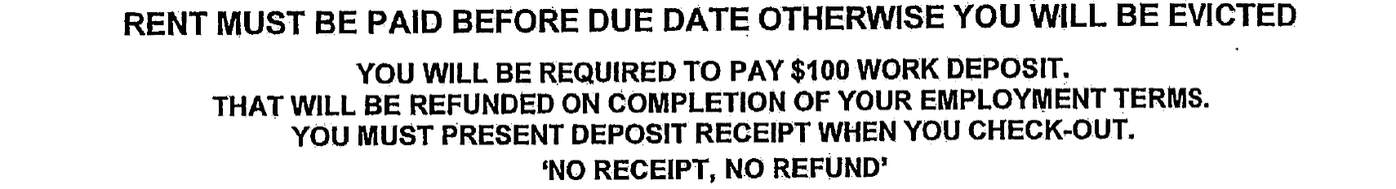

*Image: Part of a notice posted on wall of hostel in Bundaberg*

Similarly, an accommodation provider in regional Queensland charged backpackers a $100 recruitment fee. The provider also had a small strawberry farm where visa holders were advised the following:

*“Please bring $150 for your rent to be paid in advance, please bring cash. There is a $200 bond and $150 of this will be returned when the accommodation is clean and tidy and your bedding clean and when you have stayed until the planting has finished, which can be the end of April or sometimes the beginning of May. Please be sure you want to stay for this time.*

*You are required to stay in accommodation that I provide in the area. The rent is $150 a week per person. The bond is $200. The partial bond of $100 is returned to you at the end of the planting season. When you are on my team when the last plant is planted (and the accommodation you live in is clean and undamaged) I will return your bond. If you do not have a car then there will be a small fee for transport about $5 a day. You are required to have this in cash when I meet you and place you in accommodation. I can meet you at [the] Train Station.*

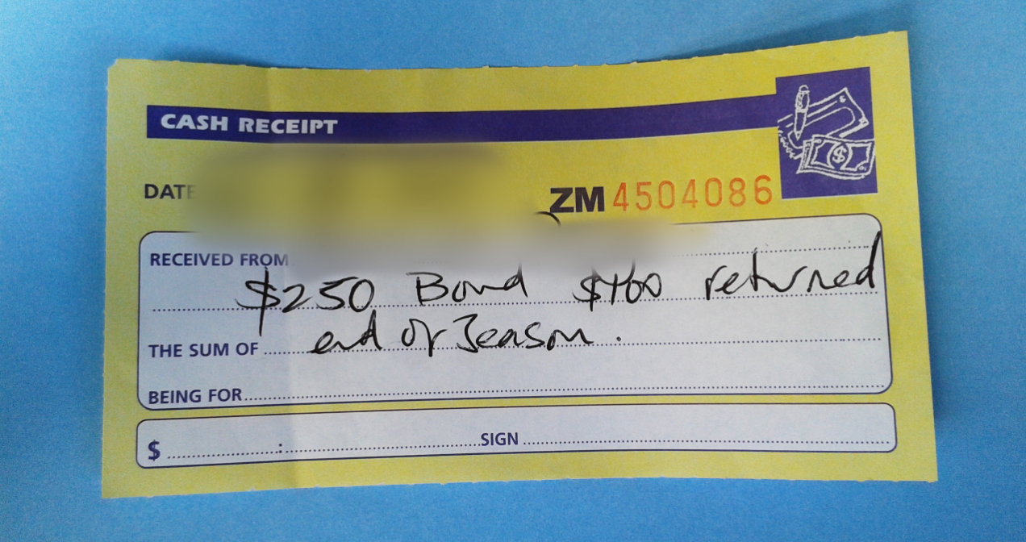*I do not want to keep your accommodation bond, but I will if you leave my team. It is very hard for me to recruit and train people when we are in the middle of planting. Also if you leave I will not sign your days that you have worked towards your second visa. I prefer people who need a 2nd visa.”*

*Image: Receipt for a cash bond provided by a regional Queensland strawberry worker*

One farm in Queensland charged a 417 visa holder a $300 job bond that would not be refunded if the worker was ‘sacked’ or if they failed to complete a minimum of two months’ work.

The Inquiry noted that Queensland is currently the only state that has legislation that makes it unlawful for a third party to seek the payment of monies by a prospective employee in exchange for finding that person a job.[78] The Inquiry referred six instances of ‘job bonds’ being paid by potential employees to the Queensland Office of Industrial Relations for action.

**Case study: Employment finder**

The FWO received information from backpackers who had responded to advertisements for farm work through Facebook, Gumtree and other social media channels posted by an individual operating in regional Victoria. The FWO’s investigation made a number of findings, including that he collected workers from bus and train stations and took them straight to bank teller machines to withdraw money to cover job finding fees and accommodation deposits to be paid to him up front. He then took them to substandard, over-crowded accommodation.

The operator was alleged to have organised jobs at local farms, transported them to the farms to work, but then failed to pay them monies that he had collected from growers. If the backpackers complained and requested to leave, he told them that the job finding fee and deposit were not refundable.

The FWO was unable to definitively confirm an employment relationship with the individual because the backpackers had been asked to sign contracts stating that he was not their employer. They were also unable to advise the FWO what farms they had worked on, which prevented Fair Work Inspectors from gathering evidence from growers.

### Social media as a deterrent to exploitation

The Inquiry found strong social networks within the backpacking community, particularly among groups of workers from the same country and those working in remote areas.

The Inquiry observed a number of posts on social media containing accounts of work experiences with particular employers and/or regions. These posts regarding conditions of employment or accommodation were often negative and on some occasions would name growers/farms, even if they were not the employer. Posts would also feature commentary on accommodation providers linked to particular industries.

Acknowledging that posts on social media channels are generally unregulated, these posts can pose ongoing reputational risk to employers in the industry, proximate communities, regions and, in some cases, Australia.

Examples of social media posts describing negative experiences and offering warnings to others about pay, conditions, accommodation and potential discrimination are provided below.

#### Figure 9. Post describing negative experience on social media

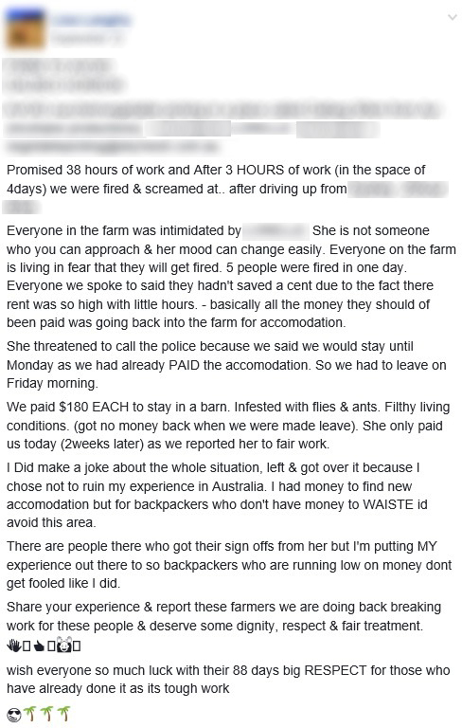

#### Figure 10. Posts describing negative experience on horticulture jobs website

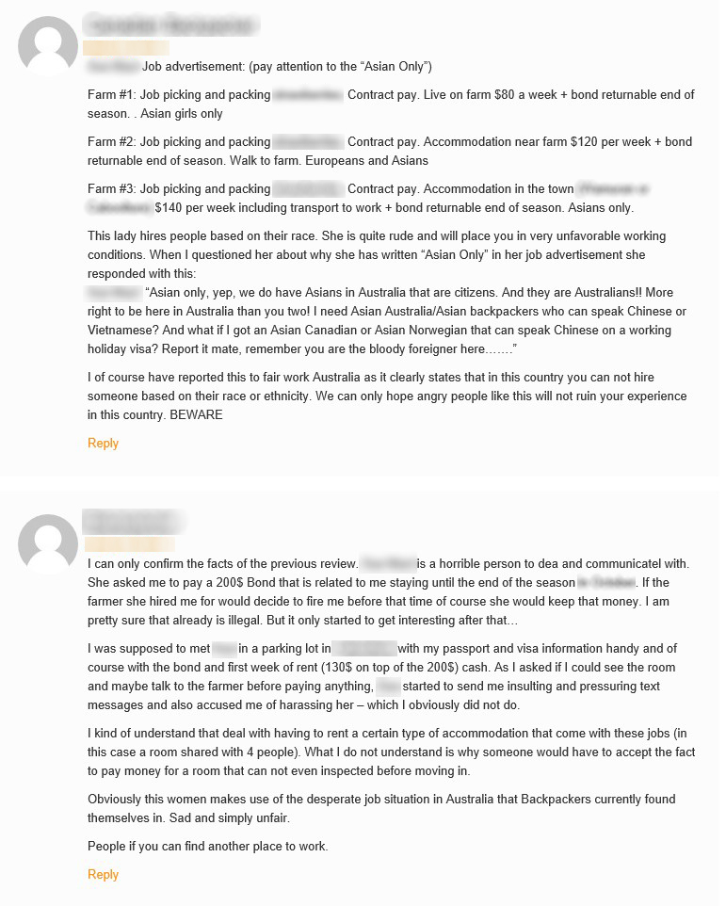

# 

# Finding 5 – Consumers can play a role in addressing exploitation

As the Harvest Trail Inquiry progressed and the underpayment of workers became apparent, the FWO considered it important to commission research regarding consumer behaviours and awareness. The objective of the research was to assess whether consumer behaviour had any role in the Harvest Trail’s non-compliance rates.

Drawing upon interactions with Harvest Trail participants, the research study investigated:

* fresh produce buying behaviours and motivations of consumers
* the extent to which ethical considerations affect consumer willingness to pay more for a product
* whether knowledge about worker conditions and treatment might impact shopping decisions.

Consumers and fresh produce vendors (supermarkets, independent grocery stores, green grocers and farmers’ market sellers) were included in the research study.

The project used a mixed methodology comprising:

* an environmental scan and review of secondary data
* 20 in-depth interviews with vendors, including large supermarkets, independent grocery stores, green grocers, wholesalers and farmers participating at farmers’ markets
* 280 intercept interviews of shoppers at large shopping centres in five different locations
* a 10-minute national online survey and choice model experiment (sample of 1000 consumers)
* an online discussion forum with 12 consumers over seven days.

A number of key findings from the research are highlighted below. Of particular note, is the propensity of a segment of consumers to pay more for ‘domestic fair trade’ produce.

* 91% of consumers sampled buy some fresh produce at supermarkets, and 75% buy most of their fresh produce at supermarkets.
* Most consumers (85%) believe prices for fresh produce have increased in the last 5-10 years.
* A majority of consumers believe the government should ensure farm workers are paid correctly (72%) and many (63%) expect supermarkets to take responsibility for ensuring this too.
* Most consumers believe that workers do receive fair conditions (72%) and that they are paid the minimum wage (60%).
* 40% of the 1025 consumers surveyed were concerned that farm workers might not be paid correctly or have fair working conditions. Of these, a large majority (81%) said they would avoid buying produce if they knew workers had not been paid fairly or given fair work conditions. Over a third (36%) of those who were unconcerned, did not believe farm workers would be unfairly treated.
* Three-quarters of consumers say they would choose produce marked as being produced fairly, including 11% who would even pay more for ‘domestic fair trade’ produce, 25% who’d pay more for produce of the same quality and 49% who would choose the ethically produce product if the price was the same.
* Many consumers are prepared to pay up to $0.50 per kilo more and some would pay up to $1 more for ‘fairly produced’ fruit and vegetables. This was assessed on a sliding scale with 9% stating they were prepared to pay $0.05 per kilo more, through to 12% who would pay $0.90-$1 extra per kilo.
* Choice modelling reveals the top five drivers to choose ethically sourced produce would be: information and education about conditions for farm workers (22%); advertising messages supporting the need to buy fairly produced products (18%); location of the shop (17%); perceived quality (13%); and, locally grown signage (8%).

The research recommendations for increasing engagement in ethical consumption of fresh produce were to:

* educate the public through an information campaign about the Harvest Trail and how prices are set, including the role of supermarkets
* provide a vocabulary e.g. ethical sourcing, ‘domestic fair trade’
* present ethical sourcing as a marketing opportunity to producers and vendors
* build trust through a verification system.

The research findings revealed a lack of consumer awareness about the treatment of workers on the Harvest Trail. The full report containing the research methodology and the complete findings and recommendations is available at fairwork.gov.au.[79]

# Next steps

During the Inquiry, Fair Work Inspectors engaged extensively with key Harvest Trail stakeholders and conducted numerous workplace interviews. These interactions enhanced the FWO’s understanding of both the nature and market dynamics of the Harvest Trail.

Informed by this knowledge as well as the detailed research undertaken during the Inquiry, the FWO has formulated the following action plan in order to address the key findings of this report:

1. Establish a Harvest Trail Working Group

The FWO will establish a Harvest Trail Working Group within the FWO, to coordinate and prioritise the next phase of education, engagement and compliance activities for the Harvest Trail.

The Harvest Trail Working Group will consult with stakeholders as appropriate to inform its work. This will include the referral of this report and the consumer research report to the Migrant Workers’ Taskforce.

2. Enhance compliance through information, education, and support

The Harvest Trail Working Group will help growers achieve enduring compliance with workplace laws by partnering with key intermediaries including horticulture industry bodies, such as Growcom[80], and community organisations. They will work with these groups to educate growers and their employees on their workplace rights and obligations, including the rules around contracting labour, record-keeping and pay slips and piecework arrangements. This will involve working with the sector regarding the drivers of non-compliance and co-designing solutions that drive behavioural change.

The Harvest Trail Working Group will also take forward the findings of the consumer research, by working with key government and non-government partners to develop a coordinated and sustainable communications campaign, informing consumers of how they can play a role in addressing exploitation in the horticulture sector through greater awareness of the ‘true cost’ of fruit and vegetables.

3. Enhance the regulatory framework

The Harvest Trail Working Group will work closely with government departments and agencies[81] to enhance the regulatory framework that governs the rights and obligations of all Harvest Trail workplace participants, by collaborating on a range of initiatives, including:

* Operationalising recommendations of the Commonwealth Government’s Migrant Workers’ Taskforce relating to the employment of labour on the Harvest Trail.
* Operationalising recommendations of the Black Economy Taskforce as they relate to record-keeping and pay slip provisions on the Harvest Trail. This includes establishing communication channels to exchange information with AUSTRAC on suspicious money transfers and persons of interest.
* Subject to the passage of the legislation, monitoring the impact of the Commonwealth Parliament’s *Modern Slavery Bill 2018* as it relates to major fruit and vegetable retailers.[82]

4. Build a culture of compliance on the Harvest Trail

The Harvest Trail Working Group will prioritise operational activities on the Harvest Trail and collaborate with a range of key stakeholders to reach as many industry participants and consumers as possible. [83] Specifically, the FWO will seek to:

* include the Harvest Trail in the FWO’s priority areas for proactive compliance and enforcement activities, ensuring that results are well publicised
* leverage the record-keeping provisions detailed in the ‘Protecting Vulnerable Workers’ legislation to target seriously non-compliant businesses
* ensure clarity around the understanding and application of various labour hire licensing schemes
* explore the opportunity for compliance partnerships with leading horticulture sector businesses
* leverage recommendations and outcomes from the Migrant Worker Taskforce as they relate to the Harvest Trail.

5. Report to government and stakeholders

The FWO will provide this report to:

* the Commonwealth Minister for Jobs and Industrial Relations
* Professor Alan Fels, Chair - Migrant Workers Taskforce
* key stakeholders associated with the Harvest Trail.

# Conclusions

The Inquiry undertaken by the FWO uncovered widespread and concerning non-compliance with workplace laws in the horticulture industry.

The FWO will continue to maintain a key focus on this sector due to:

* the high proportion of vulnerable workers employed, including seasonal and young workers
* ongoing uncertainty concerning certain matters at law regarding the application of provisions within industrial instruments, for example, the application of piece rates
* ongoing issues relating to Harvest Trail labour supply and demand that can drive non-compliance, such as the availability and standard of accommodation and transport services
* the need to empower consumers with more information about pay and work conditions for workers involved in picking, packing and processing fresh food produce.

The Inquiry findings detailed in this report only include instances of non-compliance that could be supported by evidence.

The Inquiry found a combination of factors that contribute to an environment where breaches of workplace laws are more likely.

The Inquiry highlights the need to build a culture of compliance and accountability amongst beneficiaries of labour, in particular, those at the top of the labour supply chain. The research indicates consumers require confidence in businesses that supply food and the recommendations in this report will build confidence.

The five key findings of this Inquiry, in part reflect the difficulties the FWO encounters when seeking to enforce workplace laws on the Harvest Trail. For instance, the geographical isolation and remoteness of several parts of the Harvest Trail makes it difficult for the FWO to maintain a constant and visible presence for each harvest season, even during an extended Inquiry.

The FWO cannot be present in all locations along the Harvest Trail at all times. However, the passage of the *Fair Work Amendment (Protecting Vulnerable Workers) Bill 2017*enables the FWO to address the most serious and deliberate cases of non-compliance through targeted interventions and strategic litigations.

Employers who provide Fair Work Inspectors with false and misleading information, or who choose not to keep employment records now face significant penalties, and employers will hold responsibility to demonstrate their compliance. These provisions will significantly affect cash-based businesses.

The FWO will work with key stakeholders and workforce participants in implementing the recommendations contained in the report.

# Appendix A – Stakeholder list

### Community groups

Queensland Police Service Ethnic Advisory Group

Taiwan Cultural Office

Sunraysia Mallee Ethnic Communities Council

Swan Hill Community Issues Group

Uniting Church of Australia

### Local government

Southern Downs Regional Council

Bundaberg Regional Council

Gascoyne Development Commission

Gascoyne Small Business Centre

Mildura Rural City Council

Loxton Waikerie Council

### Members of Parliament

Leanne Donaldson MP (ALP-Bundaberg)

Peter Crisp MP (NAT-Mildura)

Andrew Broad MP (NAT-Mallee)

Sharman Stone MP (Liberal - Murray)

Darren Chester MP (NAT-Gippsland)

Keith Pitt MP (Liberal - Hinkler)

Senator Barry O'Sullivan (Liberal - Qld)

Craig Laundy MP (Liberal-Reid)

Senator Michaelia Cash (Liberal-WA)

### Unions

National Union of Workers (NUW)

Australian Worker Union (AWU)

### Government

Anti-discrimination Commission Queensland

Workcover Queensland

Department of Agriculture, Forestry & Fisheries (Qld)

Bundaberg & District Chamber of Commerce

Department of State Development, Infrastructure & Planning (Qld)

Horticulture Workers Interagency Group (HWIG)

Queensland Office of Industrial Relations

Queensland Police

Queensland Fire and Emergency Services (QFES)

Australian Border Force (ABF)

Department of Jobs and Small Business - Seasonal Worker Programme

Mildura Police

WorkSafe Victoria

Department of Agriculture, Fisheries and Forestry (DAFF)

NSW Department of Primary Industries

Western Australia Department of Agriculture & Food

### Industry associations

National Farmers’ Federation

Growcom

Ausveg

Voice of Horticulture

Horticulture Innovation Australia Limited (HIA Ltd) (previously Horticulture Australia Limited - HAL)

Fruit Growers Victoria Ltd

Vegetables Western Australia (Potato Growers Association of WA Inc)

Western Australia Fruit Growers Association (Fruit West Co-operative Limited)

AusVeg VIC (Vegetables Victoria)

Victorian Farmers Federation (VFFIA)

Fruit Growers Tasmania

Tasmanian Farmers and Graziers Association

Primary Employers Tasmania

Wine Industry Tasmania Inc

Raspberries and Blackberries Australia Inc

Hunter Valley Wine and Tourism Association (previously Hunter Valley Wine Industry Association)

Batlow Fruit Co-Operative Ltd

Chestnuts Australia Inc

Apple and Pear Australia Ltd (APAL)

Cherry Growers Australia Inc.

New South Wales Cherry Growers

Lockyer Valley Growers Association

Bundaberg Fruit and Vegetable Growers Association

Victorian Strawberry Industry Development Committee

Queensland Strawberry Growers Association

Nursery & Garden Industry Queensland

Wines of Western Australia

Margaret River Wine Industry Association

Great Southern Wine Producers Industry Association

Swan Valley and Regional Winemakers Association

Donnybrook Orchard Improvement Group

Strawberry Growers Association of Western Australia

Sweeter Bananas Cooperative

Carnarvon Growers Association

Wine Victoria

Yarra Valley Wine Growers Association Inc

South Australian Wine Industry Association

Wine Geelong

Onions Australia

Wine Victoria

Wines of Eastern Gippsland

Australian Asparagus Council

Coonawarra Grape and Wine Incorporated

Apple and Pear Growers Association of South Australia

Cherry Growers Association of South Australia

Berry Growers of South Australia

Oz Group Co-Op Pty Ltd

Australian Blueberry Growers Association Inc

Australian Mushrooms Growers Association Inc (AMGA)

Heathcote Wine Growers Association

Stanthorpe Growers Association

Citrus Australia

New South Wales Farmers Association

### Other - Industry

Costa Group

Coles Group Limited

Woolworths Group

# Appendix B – Consumer Research

Download [Instinct and Reason – Harvest Trail Consumer Behaviour Research Report September 2017](https://www.fairwork.gov.au/ArticleDocuments/1461/instinct-and-reason-harvest-trail-consumer-behaviour-research-report.pdf.aspx)

1. National Harvest Guide https://jobsearch.gov.au/documents/harvest%20guide%2020150225.pdf, <https://jobsearch.gov.au/harvest/towns-and-crops>
2. ABS Counts of Australian Businesses report (8165.0) February, 2018
3. Department of Employment, Interactive data file, Employment levels and change with projections by industry sector, May 2017, viewed 4 September 2018, <http://lmip.gov.au/default.aspx?LMIP/Downloads/InteractiveDataFiles>
4. Some businesses were subject to repeat investigations over the course of the Inquiry. It is difficult to assess the labour hire representation of this sample size without accurate data on the number of labour hire contractors and the number of workers they supply to the industry
5. At the time of publication, the courts have decided in favour of the FWO in six matters and handed down penalties of over $521 777 ($435 967 against companies and $85 210 against five individuals as accessories under section 550 of the Fair Work Act 2009)
6. A detailed list of stakeholders is at Appendix A
7. RCSA Memorandum of Understanding: <https://www.fairwork.gov.au/ArticleDocuments/725/recruitment-and-consulting-services-association-memorandum-of-understanding.pdf.aspx>
8. <http://mysunshinecoast.com.au/news/news-display/6000-sweet-jobs-are-ripe-for-the-picking,43495>
9. At the time of this report the Campaign is focussing on mango picking in the Northern Territory: https://www.thesweetestjob.com.au/participants/
10. https://www.fairwork.gov.au/about-us/news-and-media-releases/2017-media-releases/january-2017/20170105-cegp-media-release
11. <https://www.growcom.com.au/fairfarmsinitiative/#!form/FairFarms>
12. Fair Farms Initiative fact sheet: https://www.growcom.com.au/fairfarmsinitiative/#!form/FairFarms
13. https://www.northqueenslandregister.com.au/story/5739645/farmers-back-fair-farms-funding-visa-reforms/?cs=4752
14. See page 16
15. <https://www.fairwork.gov.au/find-help-for/visa-holders-and-migrants>
16. Green indicates fewer visits, red indicates more visits
17. FWO Compliance and Enforcement Policy: <https://www.fairwork.gov.au/about-us/our-vision/compliance-and-enforcement-policy>
18. FWO media release: <https://www.fairwork.gov.au/about-us/news-and-media-releases/2017-media-releases/june-2017/20170602-seasonal-farm-services-penalty>
19. <http://www.austlii.edu.au/cgi-bin/viewdoc/au/cases/cth/FCCA/2017/1020.html?context=0;query=%22seasonal%20farm%20services%22>
20. The provisions came into operation through the passage of the *Fair Work Amendment (Protecting Vulnerable Workers) Act 2017*, which came into effect on 15 September 2017
21. Research report – See Appendix B
22. Roy Morgan, Supermarket and Fresh Food Currency Report, March 2018
23. Wine Australia, Australian Wine: Production, Sales and Inventory Report 2016-17
24. ABS 7503.0 Value of Agriculture Commodities Produced, 2016-17
25. Horticulture Innovation Australia, Australian Horticulture Statistics Handbook, 2016-17
26. Wine Australia, Australian Wine: Production, Sales and Inventory Report 2016-17
27. Roy Morgan, Supermarket and Fresh Food Currency Report, March 2018
28. ABARES Australian vegetable-growing farms survey 2018 <http://www.agriculture.gov.au/SiteCollectionImages/abares/veg-fig-16-large.png>
29. FWO’s Inquiry into the wages and conditions of people working under the 417 Working Holiday Maker Program https://www.fairwork.gov.au/ArticleDocuments/763/417-visa-inquiry-report.docx.aspx
30. FWO guidance on contracting labour and supply chains <https://www.fairwork.gov.au/find-help-for/contracting-labour-and-supply-chains>
31. [https://www.fairwork.gov.au/about-us/access-accountability-and-reporting/Inquiry-reports](https://www.fairwork.gov.au/about-us/access-accountability-and-reporting/inquiry-reports)
32. Bureau of Meteorology, Average annual & monthly maximum, minimum, & mean temperature, <http://www.bom.gov.au/jsp/ncc/climate_averages/temperature/index.jsp?maptype=1&period=sum>
33. Safe Work Australia, Work-related Traumatic Injury Fatalities, 2016
34. Seasonal Worker Programme fact sheet: <https://docs.jobs.gov.au/system/files/doc/other/seasonal_worker_programme_approved_employer_factsheet_updated_0.pdf>
35. <https://www.jobs.gov.au/seasonal-worker-programme>
36. https://www.fairwork.gov.au/how-we-will-help/helping-the-community/pacific-labour-scheme
37. <https://www.fwc.gov.au/documents/documents/modern_awards/award/ma000028/default.htm>
38. <https://www.fwc.gov.au/documents/documents/modern_awards/pdf/ma000090.pdf>
39. An ‘approved’ employer enters into agreement with the Department of Jobs and Small Business. They must also obtain the approval of the Department of Home Affairs to become a Temporary Activities (TA) sponsor
40. <https://www.jobs.gov.au/seasonal-worker-programme>
41. The total number of investigations is greater than the number of employers investigated. This is because the FWO investigated some employers on more than one occasion to examine their compliance over a sustained period of time
42. One of the outstanding Compliance Notices involved a business that went into liquidation, the other was taken to court - Vinai Chaipom, trading as The Mango Shop
43. <https://www.fairwork.gov.au/ArticleDocuments/884/enforceable-undertaking-ks-benning-and-sons-redacted.docx.aspx>
44. <https://www.fairwork.gov.au/ArticleDocuments/884/enforceable-undertaking-tds-international-investment-group-pty-ltd-redacted.docx.aspx>
45. <https://www.fairwork.gov.au/ArticleDocuments/884/enforceable-undertaking-gromor-enterprises-pty-ltd-redacted.docx.aspx>
46. <https://www.fairwork.gov.au/ArticleDocuments/884/enforceable-undertaking-team-search-harvesting-redacted.docx.aspx>
47. <https://www.fairwork.gov.au/ArticleDocuments/971/seasonal-labour-solutions-eu-redacted.docx.aspx>
48. <https://www.fairwork.gov.au/ArticleDocuments/971/enforceable-undertaking-boonah-packing-pty-ltd-redacted.docx.aspx>
49. <https://www.fairwork.gov.au/ArticleDocuments/1179/letusgrow-hydroponics-enforceable-undertaking-redacted.pdf.aspx>
50. *FWO v Dosanjh* (2016) FCCA 923. FWO media release: <https://www.fairwork.gov.au/about-us/news-and-media-releases/2016-media-releases/may-2016/20160518-dosanjh-penalty>. Decision: <http://www.austlii.edu.au/cgi-bin/viewdoc/au/cases/cth/FCCA/2016/923.html?context=1;query=dosanjh;mask_path=au/cases/cth/FCCA+au/cases/cth/FMCA+au/cases/cth/FMCAfam>
51. *FWO v Maroochy Sunshine Pty Ltd & Anor* (2017) FCCA 559. Decision: <http://www.austlii.edu.au/cgi-bin/viewdoc/au/cases/cth/FCCA/2017/559.html?context=1;query=%5b2017%5d%20FCCA%20559>

    Note: employees have not yet received payment of outstanding entitlements
52. *FWO v I Luv Pty Ltd & Anor* (2016) FCCA 2569. FWO media release: <https://www.fairwork.gov.au/about-us/our-role/enforcing-the-legislation/litigation/litigation-outcomes-2016-2017> (decision not available)
53. *FWO v Chaipom & Anor* (2017) FCCA 3211, Decision: <https://www.austlii.edu.au/cgi-bin/viewdoc/au/cases/cth/FCCA/2017/3211.html?context=1;query=Fair%20Work%20Ombudsman%20v%20Chaipom;mask_path>=
54. *FWO v Seasonal Farm Services & Anor* (2017) FCCA 1020. Decision: <http://www.austlii.edu.au/cgi-bin/viewdoc/au/cases/cth/FCCA/2017/1020.html?context=0;query=%22seasonal%20farm%20services%22>
55. *FWO v HTA Farmings Pty Ltd & Anor* (2017) FCCA 1847. Decision: <http://www.austlii.edu.au/cgi-bin/viewdoc/au/cases/cth/FCCA/2017/1847.html?context=1;query=%5b2017%5d%20FCCA%201847>
56. *Fair Work Ombudsman v Hu* (No 2) (2018) FCA 1034. Decision: <http://www.austlii.edu.au/cgi-bin/viewdoc/au/cases/cth/FCA/2018/1034.html> Note: aspects of the decision are being appealed by the FWO
57. FWO media release: <https://www.fairwork.gov.au/about-us/news-and-media-releases/2017-media-releases/july-2017/20170705-zucco-farming-litigation>
58. The meaning of clause 15.2 was considered by the Federal Court in the matter of *FWO v Hu* (No.2) (2018) FCA 1034 (Justice Rangiah, 12 July 2018). On 3 August 2018, the FWO filed an appeal of the decision of the Federal Court which will be heard before the Full Bench of the Federal Court
59. Some employers were investigated more than once, hence the difference between the number of employers and the number of investigations overall
60. https://immi.homeaffairs.gov.au/visas/getting-a-visa/visa-listing/work-holiday-417
61. Home Affairs Working Holiday Maker Report 2018 https://www.homeaffairs.gov.au/research-and-stats/files/working-holiday-report-jun18.pdf
62. FWO’s Inquiry into the wages and conditions of people working under the 417 Working Holiday Maker Program <https://www.fairwork.gov.au/ArticleDocuments/763/417-visa-inquiry-report.docx.aspx>
63. FWO Inquiry into the wages and conditions of people working under the 417 Working Holiday Maker Program <https://www.fairwork.gov.au/ArticleDocuments/763/417-visa-inquiry-report.docx.aspx>
64. *Ibid*
65. <https://www.fairwork.gov.au/how-we-will-help/how-we-help-you/report-a-workplace-issue-in-your-language>
66. https://www.fairwork.gov.au/find-help-for/visa-holders-and-migrants
67. <https://parlinfo.aph.gov.au/parlInfo/search/display/display.w3p;query=Id:%22media/pressrel/3804276%22>
68. <https://www.fairwork.gov.au/about-us/our-role/enforcing-the-legislation/enforceable-undertakings/2017-2018-enforceable-undertakings>
69. ‘Sustainable Solutions: The Future of Labour Supply in the Australian vegetable industry’ – Joanna Howe, Alexander Reilly, Diane van den Broek & Chris F Wright, February 2017 <https://blogs.adelaide.edu.au/law/tag/sustainable-solutions-the-future-of-labour-supply-in-the-australian-vegetable-industry/>
70. At the time of publishing, the Queensland Parliament, Victorian Parliament, and South Australian Parliament had passed legislation regulating the operation of labour hire contractors. The Queensland Labour Hire Licensing Act 2017 commenced operation on 16 April 2018 and the South Australian Labour Hire Licensing Act 2017 commenced operation from 1 March 2018. The Victorian Parliament passed the Labour Hire Licensing Act 2018 on 26 June 2018, with the licensing scheme expected to commence in the first half of 2019. The South Australian Government have subsequently announced their intention to introduce legislation to repeal their Act. Repeal legislation expected to be introduced into the SA Parliament by the end of 2018. The Commonwealth Government, through its Migrant Worker Taskforce, is also considering forms of regulating labour hire contractors
71. *Corporations Act 2001,* section 201A (1) and Part 1.5 Small business guide, section 1.5.5 <http://www5.austlii.edu.au/au/legis/cth/num_act/ca2001172/s1.5.5.html>. Separate requirements apply for public companies.
72. *Ibid*
73. The operation was conducted by *Operation Cloudburst* - a joint agency initiative between the FWO and the Department of Home Affairs led by its operational arm, the Australian Border Force (ABF). The Australian Government subsequently established Taskforce Cadena in June 2015 to target and disrupt criminals organising visa fraud, illegal work and the exploitation of foreign workers: <https://www.homeaffairs.gov.au/australian-border-force-abf/taskforce-cadena>
74. The MADEC ‘work entitlements card’ is understood to be similar to a membership card (issued by non-government organisations) and includes a photo of the passport holder, personal details and VEVO details (downloaded from the VEVO system)
75. Fact sheet: The horticulture industry and the Seasonal Worker programme: https://docs.jobs.gov.au/system/files/doc/other/seasonal_worker_programme_horticulture_factsheet_updated_0.pdf
76. https://www.fairwork.gov.au/ArticleDocuments/971/seasonal-labour-solutions-eu-redacted.docx.aspx
77. Brisbane Times coverage: https://www.brisbanetimes.com.au/national/queensland/fire-chief-shuts-down-lockyer-valley-fire-trap-20150708-gi7qfu.html
78. Private Employment Agents Act 2005 (Qld) – statute is administered by the Queensland Office of Industrial Relations
79. Research report – see Appendix B
80. Peak representative body for Queensland horticulture and organisation responsible for the Fair Farms Initiative: https://www.growcom.com.au/category/media/
81. Stakeholders include the Department of Jobs, Department of Home Affairs, Australian Taxation Office, Migrant Workers Taskforce AUSTRAC, Australian Securities and Investments Commission, Australian Consumer and Competition Commission, Department of Foreign Affairs and Trade, other key state and local government workplace regulators
82. <http://parlinfo.aph.gov.au/parlInfo/search/display/display.w3p;query=Id%3A%22legislation%2Fbills%2Fr6148_first-reps%2F0000%22;rec=0>
83. Stakeholders including Recruitment, Consulting and Staffing Association Australia and New Zealand, National Union of Workers, State and Local government workplace regulators responsible for Labour Hire Licensing, , major retailers, including Coles, Woolworths, IGA and Aldi, Australian Workers Union, Horticulture Workers Interagency Group (Queensland), Horticulture Innovation Australia, Mildura Council , Lockyer Valley Regional Council Southern Downs Regional Council, Bundaberg Regional Council