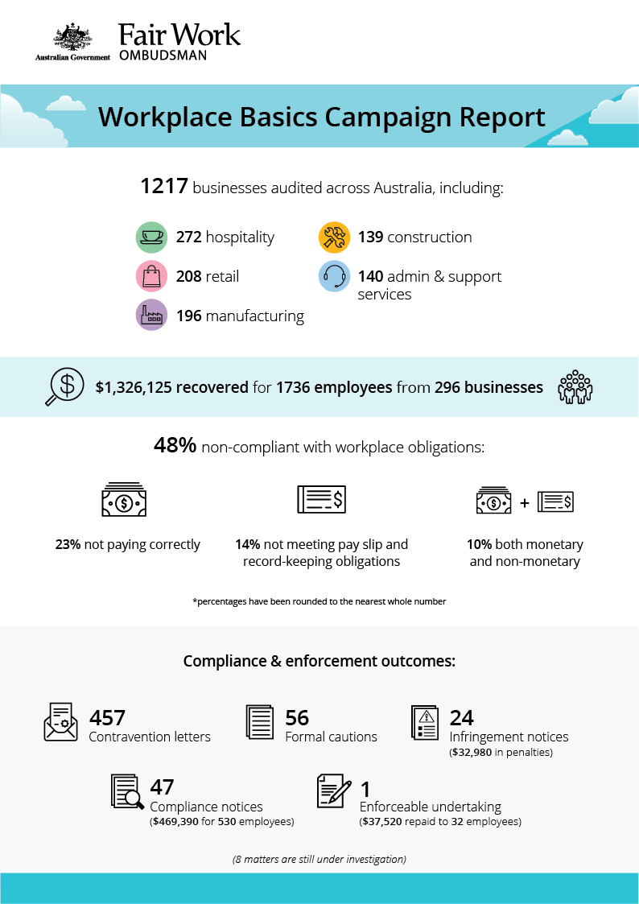

# Workplace Basics Campaign Report

## What we did and why

The Fair Work Ombudsman (FWO) audited over 1200 businesses across Australia as part of the Workplace Basics campaign, which is a rolling campaign that tests compliance with the ‘basics’, such as pay, record-keeping and pay slips.[1]

The campaign commenced in April 2018.[2] We targeted common breaches of ‘basic’ workplace relations obligations:

* base hourly rates
* penalty rates
* overtime
* record-keeping requirements
* pay slip requirements.

Businesses in key industries and locations that engage casual, student and/or migrant workers were targeted.

Fair Work Inspectors assessed records against the *Fair Work Act 2009* (the Act), the *Fair Work Regulations 2009* (the Regulations) and applicable modern awards and enterprise agreements. Employers were made aware of their obligations and the consequences of non-compliance, including increased penalties under the *Protecting Vulnerable Workers Act 2017*.[3]

## Our findings

Fair Work Inspectors audited 1217 businesses and found 583 (48%) were in breach of workplace laws:

* 284 (23%) weren’t paying employees correctly.
* 175 (14%) were non-compliant with pay slip and record-keeping requirements.
* 124 (10%) breached both their monetary and non-monetary obligations.[4]

The most common breaches were:

* underpayment of the minimum hourly rate (28%)
* non-compliance with pay slip obligations as set out by the Act and Regulations (23%)
* non-payment of weekend penalty rates (8%).

Reasons for non-compliance given by employers included:

* being unaware of applicable workplace relations obligations (74%)
* misinterpreting award requirements (8%)
* making a business decision that led to non-compliance, such as paying flat hourly rates in lieu of weekend penalties (5%)
* missing the July annual wage increase (4%).

Hospitality was the least compliant industry (61% non-compliant). This is consistent with other audit findings, and supports our focus on the Fast Food, Restaurant and Cafés (FRAC) sector.[5]

## Table 1: Compliance results by sector[6]

|  |  |  |
| --- | --- | --- |
| **Industry** | **Businesses audited** | **Non-compliance rate** |
| Accommodation and Food Services | 272 | 61% |
| Retail Trade | 208 | 47% |
| Administration and Support Services | 140 | 47% |
| Manufacturing | 196 | 39% |
| Public Administration and Safety | 78 | 36% |
| Domestic construction | 139 | 33% |

## Action taken and next steps

A total of $1,326,125 was recovered from 296 businesses for 1736 employees.

Employers were required to rectify any non-compliance identified, and to provide evidence of the action taken, such as proof of payment of outstanding employee entitlements.

Inspectors issued:

* 457 contravention letters
* 56 formal cautions
* 24 infringement notices ($32,980 in penalties)
* 47 compliance notices ($469,390 for 530 employees).

The FWO also entered into an Enforceable Undertaking (EU) with Super Max Coffee Pty Ltd (trading as Mitte Café). The employer is required to back pay $37,520 to 32 employees and engage an external professional to conduct audits of employee entitlements.[7]

Eight employers remain under investigation for serious non-compliance. The FWO is considering appropriate compliance and enforcement responses in these matters, which may see us commence legal proceedings seeking the imposition of significant penalties on the businesses and individuals involved.

The FWO expects employers to comply with all basic workplace relations obligations and utilise our free tools and resources, including:

* PACT - calculates employee entitlements, including award pay rates, leave entitlements and termination pay.[8]
* My account - interactive service where employers receive tailored information and updates.[9]
* Online learning centre - award-winning videos on key subjects like hiring employees, managing performance and record-keeping and pay slip obligations.[10]
* Templates and guides - tools and resources specifically designed to assist businesses with their payslips and record keeping obligations.[11]

The FWO considers employers who don’t take advantage of these free tools and resources to be negligent. A lack of awareness of obligations under the *Fair Work Act 2009* is not a valid reason for non-compliance in the workplace.

1. <https://www.fairwork.gov.au/how-we-will-help/helping-the-community/campaigns/national-campaigns/workplace-basics-campaign>
2. FWO media release: <https://www.fairwork.gov.au/about-us/news-and-media-releases/2018-media-releases/april-2018/20180411-workplace-basics-campaign-mr>
3. <https://www.fairwork.gov.au/about-us/legislation/the-fair-work-system/protecting-vulnerable-workers-reform>
4. Percentages have been rounded to the nearest whole number
5. <https://www.fairwork.gov.au/about-us/our-purpose/our-priorities>
6. Industries with more than 50 businesses audited are included in the table. Other businesses not categorised by these industries were audited and included in overall compliance data.
7. https://www.fairwork.gov.au/about-us/news-and-media-releases/2019-media-releases/may-2019/20190522-super-max-coffee-eu-media-release
8. <https://calculate.fairwork.gov.au/>
9. <https://www.fairwork.gov.au/my-account/registerpage.aspx>
10. <https://www.fairwork.gov.au/how-we-will-help/online-training/online-learning-centre>
11. https://www.fairwork.gov.au/how-we-will-help/templates-and-guides