Findings of compliance activity involving sushi enterprises

October 2018

© Commonwealth of Australia, 2018

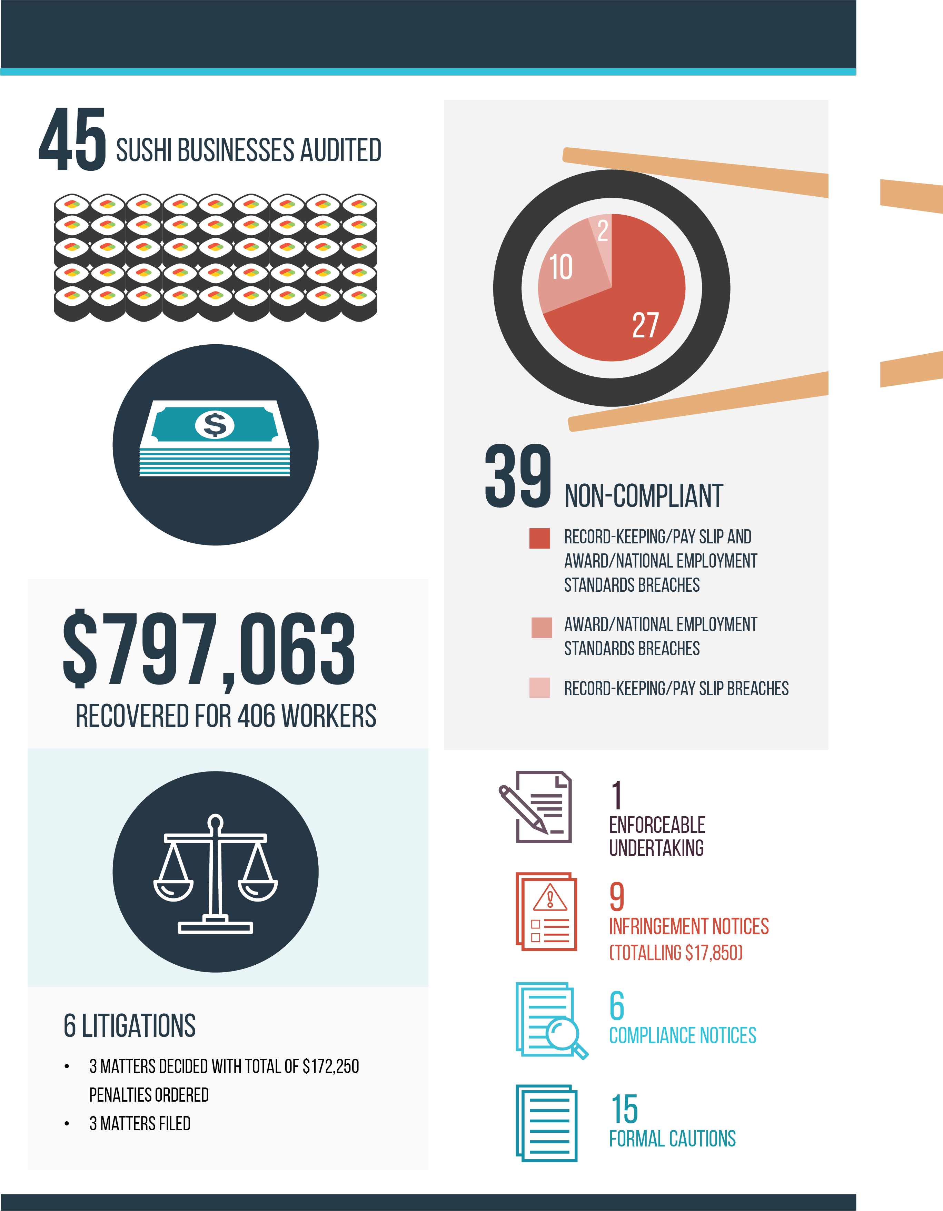

# Table of contents

Summary 4

Background 5

Methodology 6

Key findings 7

Record-keeping 7

Award entitlements and the NES 7

Cash economy 7

Compliance and enforcement outcomes 9

Litigation 9

Enforceable undertakings 10

Other compliance and enforcement outcomes 11

Conclusion 12

About the Fair Work Ombudsman 13

Appendix A – Litigations 14

# Summary

Due to the high number of requests for assistance from vulnerable workers in regional sushi eateries, the Fair Work Ombudsman [FWO] commenced a compliance activity examining 45 sushi businesses in the following regions:

* Newcastle (NSW)
* Hunter / Central Coast (NSW)
* Coffs Harbour (NSW)
* North Coast (NSW)
* Canberra (ACT)
* Gold Coast (QLD).

Fair Work Inspectors found an 87% non-compliance rate and recovered $797 063 for 406 employees. The activity identified the following items of concern:

* widespread use of false records
* non-issue of pay slips
* excessive unpaid or underpaid hours
* a reliance on vulnerable workers (young, migrant, non-English speaking background).

The activity resulted in the following compliance and enforcement outcomes:

* six legal proceedings (with 3 additional litigations likely)
* one Enforceable Undertaking
* six Compliance Notices
* nine Infringement Notices
* fifteen Formal Cautions.

To date, three of the six legal matters have been finalised, resulting in court ordered penalties of $172 250.

# Background

The popularity of sushi in the Australian fast food market has grown considerably in recent years, as reflected by the sector’s strong profit growth[1] and consumer taste research.[2]

From July 2013 to June 2017, the FWO resolved 11,826 disputes involving businesses in the Food and Beverage Services sector. These workplace disputes accounted for 14% of all those resolved by FWO in the period, making it the highest industry sector of FWO completed disputes.

From July 2013 to June 2017, 54% of dispute lodgements from sushi eateries involved a visa holder and 39% involved a young worker.

Since the launch of the FWO anonymous report tool in 2016 the number of sushi-related reports has increased from 15 in 2016, to 60 in 2017 and 169 in 2018.

The FWO commenced a compliance activity to assess compliance at a sample of sushi businesses in six regions.

# Methodology

The compliance activity focussed on assessing compliance in six locations with the following provisions of the *Fair Work Act 2009* (the Act):

* Section 44 – Contravening the National Employment Standards (NES)
* Section 45 – Contravening a Modern Award
* Section 535 – Employer obligations in relation to employee records
* Section 536 – Employer obligations in relation to pay slips.

Fair Work Inspectors visited sushi businesses in Canberra (7), the Hunter / Central Coast regions in NSW (20), the Coffs Harbour and North Coast region in NSW (13) and South East Queensland (5).[3]

The majority of the businesses were selected randomly, with approximately 15% targeted due to either requests for assistance or intelligence held by the FWO alleging non-compliance.

The locations selected covered both regional and metropolitan businesses.

During the site visits, Inspectors spoke with employees about their employment experiences, including hours of work, rates of pay, availability of leave and their employer’s practices of recording hours of work and providing pay slips.

Inspectors also spoke with employers and (where relevant) employer representatives about their obligations under the Act and were required to make time and wage records available for inspection.

Following the visits Inspectors assessed the information and found non-compliance at 39 of the 45 businesses visited.

# Key findings

#### Figure 1: Non-compliant businesses and monies recovered

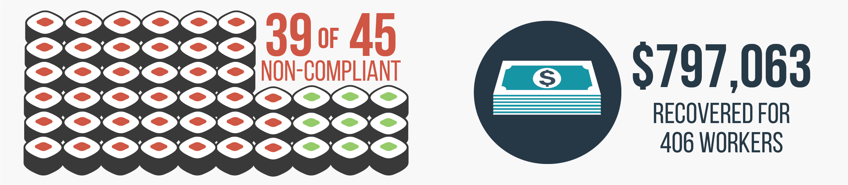

Thirty-nine of the 45 businesses audited were non-compliant with workplace relations legal obligations. The non-compliance primarily related to breaches of the record-keeping, award and NES provisions.

## Record-keeping

Of the 39 non-compliant businesses, 29 (64%) had contravened the record-keeping and / or pay slip provisions of the Act and the *Fair Work Regulations 2009* (the Regulations).

Nine businesses knowingly provided false or misleading employee records to Inspectors, with four doing so on multiple occasions.

## Award entitlements and the NES

Inspectors determined that 37 businesses had breached the applicable modern award[4] and/or the NES.[5]

The FWO recovered $797 063 owed to 406 employees from 31 businesses. The underpayments were predominantly for underpayments of minimum hourly rates, casual loading, penalty rates and overtime.

## Cash economy

In the case of five businesses, cash wage payments, coupled with serious record-keeping breaches meant that the Inspectors were unable to determine the full extent of employees’ entitlements.

As the audits occurred prior to the introduction of the *Fair Work Amendment (Protecting Vulnerable Workers) Act 2017* the reverse onus of proof provisions were not available. However, should Inspectors identify that these practices continue in future, the employers may be required to provide proof that they did not underpay their workers and they could face significantly higher penalties for serious record-keeping breaches.

# Compliance and enforcement outcomes

To date, the FWO has taken the following enforcement actions.

#### Figure 2: Enforcement outcomes

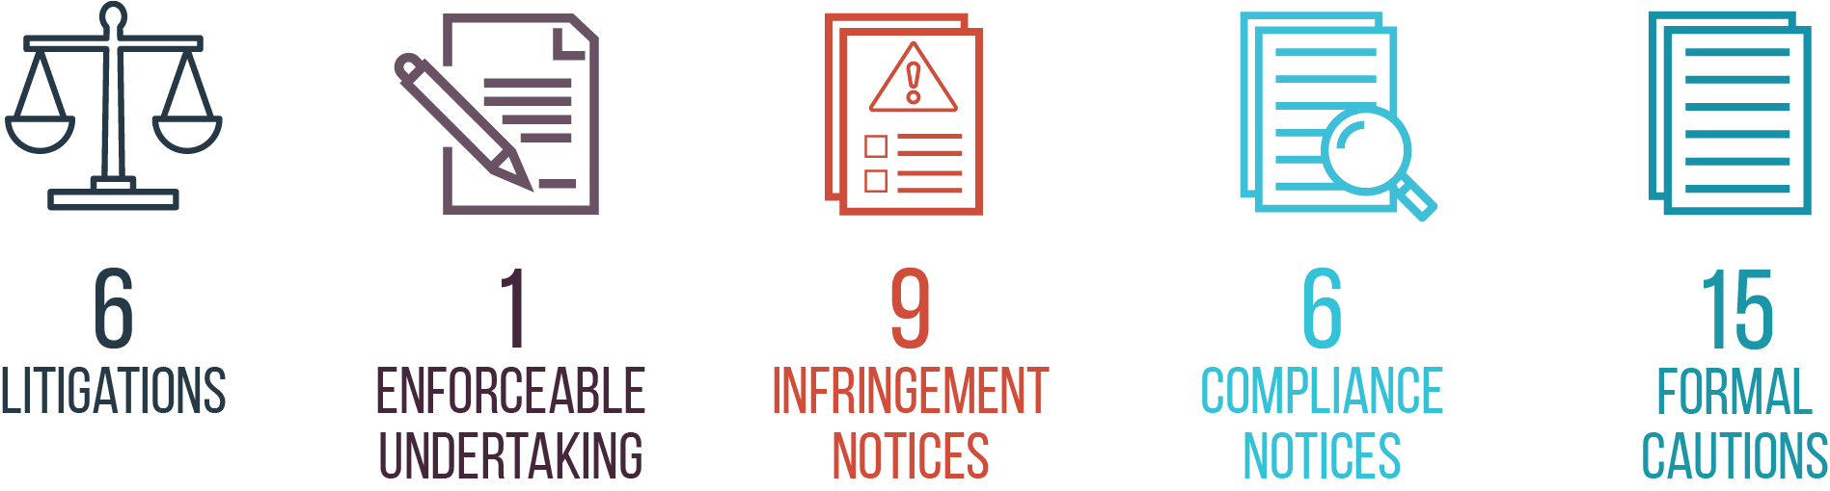

## Litigation

Legal proceedings have commenced against six employers and the FWO is considering commencing proceedings against another three. To date three of the six matters have been finalised, resulting in court ordered penalties of $172 250.

Information about the six litigation matters the FWO has commenced is contained in Appendix A.

**Case study: Sushi Kuni, Ballina NSW**

Fair Work Inspectors attended Ballina One (trading as Sushi Kuni in Ballina, New South Wales) and spoke to the operator Mr Dai Il Kang about his business’s award obligations as well as requesting time and wage records. Mr Kang told Inspectors that the records were not on the premises and asked them to call back the next day to collect them. The Inspectors agreed to return the next day and cautioned Mr Kang not to create or falsify records overnight.

Following an audit of the records, the FWO had concerns that the documents provided by Mr Kang were false and that the recorded number of hours worked by employees had reduced in order to make it appear their hourly rates of pay were higher than they were. The FWO was also aware of allegations that Mr Kang had required employees to sign false records indicating lawful rates of pay.

Several months after Inspectors commenced the investigation of Ballina One, two requests for assistance were received from employees of EJ Group working at Sushi Kuni in Redcliffe, Queensland. Mr Kang was the sole Director and shareholder of both Ballina One and EJ Group.

Although Inspectors had given Mr Kang information about minimum pay rates as part of the audit of Ballina One, employees of EJ Group, the FWO found evidence that they were paid unlawfully low flat rates of pay between $120 and $160 for 10 to 12 hour shifts.

Given the nature of the breaches, the vulnerability of employees and the provision of false records, the FWO commenced legal proceedings against both Ballina One and EJ Group. Ballina One entered into liquidation prior to litigation commencing. As a result, proceedings were commenced against Mr Kang personally for his involvement in the Ballina One breaches and EJ Group and Mr Kang for the Redcliffe breaches.

The Court ordered Mr Kang pay a penalty of $20 000 for his involvement in the breaches at Ballina and for him to pay $8 328 to employees for underpayments.

The EJ Group investigation was the subject of separate proceedings where the court ordered over $116 000 in penalties.

Further information about the matter is contained on the FWO’s website.[6]

## Enforceable undertakings

The FWO can provide an employer with the option to enter into an Enforceable Undertaking as an alternative to the commencement of legal proceedings.

In exercising this option, the FWO considers a number of factors, including whether the undertakings sought through an Enforceable Undertaking would result in a superior outcome compared to litigation.[7]

If the employer does not comply with the terms of an Enforceable Undertaking, the FWO can take legal action to enforce them, as well as seek other orders the court considers appropriate.

Generally, the FWO enters into Enforceable Undertakings with employers where:

* the breaches have been admitted
* rectification of harm is assured
* contrition is evidenced.

Enforceable Undertakings are formalised in agreements provided for by the Act and published on the FWO website.

The FWO entered into an Enforceable Undertaking with Shinobu Sushi Bar Pty Ltd [ABN 53 164 665 730].[8] The Undertaking was entered into after Inspectors identified the employer had failed to make and keep accurate employee records. Under the terms of the Enforceable Undertaking, the employer participated in workplace relations training and engaged in an external compliance audit for a full financial year. The audit did not detect further underpayment of employee wages.

## Other compliance and enforcement outcomes

Six Compliance Notices were issued, resulting in $72 612 being paid to 20 employees.

Nine Infringement Notices (totalling $17 850) were issued to four businesses for a range of record making and record-keeping breaches, including:

* failure to issue pay slips
* pay slips not being provided in the prescribed form
* failure to record employees’ start and finish times
* failure to make and or keep records.

Fifteen Formal Cautions were issued to businesses for a range of breaches of workplace laws. These letters placed the businesses on notice that any future breaches may result in the commencement of legal proceedings by the FWO.

# Conclusion

The FWO considers the fast food, restaurant and café subsectors to be a compliance priority and the non-compliant businesses identified during the activity will be subject to follow up compliance checks.

The findings of this Activity will inform the design and development of FWO’s future activities in the hospitality sector.

Individuals with compliance concerns about a sushi eatery are encouraged to report the matter to the FWO, including via the anonymous tip-off form available at [www.fairwork.gov.au/tipoff](http://www.fairwork.gov.au/tipoff).

# About the Fair Work Ombudsman

The FWO is an independent agency created by the Fair Work Act 2009 on 1 July 2009.

Our main role is to promote harmonious, productive and cooperative workplace relations.

The FWO supports compliance with Australian workplace laws by:

* offering a single point of contact for reliable and timely information about Australia's workplace relations system
* educating people working in Australia about fair work practices, rights and obligations
* assessing complaints or suspected breaches of workplace laws, awards and registered agreements and some Fair Work Commission orders
* litigating in some circumstances to enforce workplace laws and deter people from doing wrong in the community
* building strong and effective relationships with industry, unions and other stakeholders.

The FWO has a range of resources and publications for employers and employees on our website at [www.fairwork.gov.au](http://www.fairwork.gov.au/), including our [Strategic Intent](https://www.fairwork.gov.au/About-us/Our-vision/strategic-intent) and [Compliance and Enforcement Policy](https://www.fairwork.gov.au/about-us/our-vision/compliance-and-enforcement-policy) that explains how we approach fulfilling our role.

For more information about this report or our current compliance and enforcement activities, please contact Lynda McAlary-Smith, Executive Director Compliance and Enforcement, at

[lynda.mcalary-smith@fwo.gov.au](mailto:lynda.mcalary-smith@fwo.gov.au).

# Appendix A – Litigations

### Fair Work Ombudsman v Kang [2017] FCCA 1010 (finalised)

As a result of these proceedings, the Court ordered Mr Da Il Kang sole Director and shareholder of Ballina One Sushi Pty Ltd (in liquidation) pay a penalty of $20 000 due to a range of workplace relations breaches:

* Section 44 of the Act for contravention of the National Employment Standards:
  + Section 90 of the Act for failure to pay annual leave on termination
* Section 45 of the Act for contraventions of a Modern Award:
  + Clause 20 of the *Restaurant Industry Award* *2010* (Restaurant Award) for failure to pay minimum wage entitlements
  + Clause 33.2 of the Restaurant Award for failure to pay minimum entitlements for overtime worked
  + Clause 34.1 of the Restaurant Award for failure to pay minimum entitlements for work on Saturdays and Sundays
  + Clause 35.2 of the Restaurant Award for failure to pay the required annual leave loading
* Section 535 of the Act for failure to make and keep employee records
* Regulation 3.44(1) of the Regulationsfor failing to ensure that employee records were not false or misleading to his knowledge
* Regulation 3.44(6) for making use of entries in employee records knowing those records were false or misleading.

Additional information about the matter in our media release.[9]

### Fair Work Ombudsman v EJ Group International Pty Ltd & Anor [2017] FCCA 997 (finalised)

As a result of these proceedings, the Court ordered EJ Group International Pty Ltd pay a penalty of $100 000 and Mr Da Il Kang Director of EJ Group International Pty Ltd pay a penalty of $16 250 due to the following breaches:

* Section 45 of the Act for contraventions of a Modern Award:
  + Clause 13.1 of the Restaurant Award for failure to pay casual loading
  + Clause 20 of the Restaurant Award for failure to pay minimum wage entitlements
  + Clause 33.2 of the Restaurant Award for failure to pay minimum entitlements for overtime worked
  + Clause 34.1 of the Restaurant Award for failure to pay minimum entitlements for work on Saturdays and Sundays
  + Clause 35.2 of the Restaurant Award for failure to pay the required annual leave loading
* Section 535 of the Act for failure to make and keep employee records
* Section 536 of the Act for failure to issue pay slips
* Regulation 3.44(1) of the Regulationsfor failing to ensure that employee records were not false or misleading to his knowledge
* Regulation 3.44(6) for making use of entries in employee records knowing those records were false or misleading.

Additional information about the matter is available in our media release.[10]

### The Fair Work Ombudsman v Lydia Chang (finalised)

As a result of these proceedings, the Court ordered Ms Lydia Chang sole Director, Secretary and shareholder of Sushi Revolution Pty Ltd (in liquidation) (Sushi Revolution)pay a penalty of $36,000 due to being involved in the following breaches by Sushi Revolution:

* Section 44 of the Act for contraventions of the NES:
  + Section 90 of the Act for failure to pay annual leave on termination
* Section 45 the Act for contraventions of a Modern Award:
  + Clauses 17 and 18 of the *Fast Food Industry Award 2010* (Fast Food Award) and Clause 30 of the Restaurant Award for failure to pay minimum wage entitlements for adult and junior employees
  + Clause 19.2 of the Fast Food Award for failure to pay a special clothing allowance
  + Clause 21.2 of the Fast Food Award and Clause 30.2 of the R Award for failure to pay superannuation
  + Clause 25.5 of the Fast Food Award and Clause 34.1 of the R Award for failure to pay minimum entitlements for work on Saturdays and Sundays
  + Clause 26 of the Fast Food Award and Clause 33.1 of the R Award for failure to pay minimum overtime rates
  + Clause 30.3 of the Fast Food Award and Clause 34.1 of the R Award for failure to pay minimum entitlements for work on Public Holidays
* Section 323 of the Act for failure to pay some employees in full
* Section 535 of the Act for failure to make and keep employee records
* Section 536 of the Act for failure to provide pay slips with the content prescribed by the Regulations
* Regulation 3.44(1) of the Regulationsfor failing to ensure that employee records were not false or misleading to his knowledge
* Regulation 3.44(6) of the Regulations for making use of entries in employee records knowing those records were false or misleading.

Additional information about the matter is available in our media release.[11]

### The Fair Work Ombudsman v Hasegawa & Ye International Pty Ltd & Anor (current)

In these proceedings, the FWO is alleging the following breaches:

* Section 45 of the Act – contraventions of a Modern Award as follows:
  + Clause 13.2 of the Fast Food Award for failure to pay casual loading
  + Clauses 17 and 18 of the Fast Food Award for failure to pay minimum wage entitlements to adult and junior employees
  + Clause 21.2 of the Fast Food Award for failure to make superannuation contributions
  + Clauses 25.5(b) and 25.5(c)(ii) of the Fast Food Award for failure to pay minimum entitlements for work on Saturdays and Sundays
  + Clause 30.3 of the Fast Food Award for failure to pay minimum entitlements for work on Public Holidays
* Section 535 of the Act – failure to make and keep employee records.

Hasegawa & Ye International Pty Ltd and Kiyoshi Hasegawa, Director, Secretary and Shareholder, have admitted the allegations in full. The Court conducted a penalty hearing on 16 May 2018, and heard the matter together with *Fair Work Ombudsman v Heiwa International Pty Ltd & Anor*. The parties are awaiting the Court’s decision on penalties.

Additional information about the matter is available in our media release.[12]

### The Fair Work Ombudsman v Heiwa International Pty Ltd & Anor (current)

In these proceedings, the FWO is alleging the following breaches:

* Section 45 of the Act – contraventions of a Modern Award:
  + Clause 13.2 of the Fast Food Award for failure to pay casual loading
  + Clause 13.4 of the Fast Food Award for failure to roster employees for prescribed minimum daily engagements
  + Clauses 17 and 18 of the Fast Food Award for failure to pay minimum wage entitlements for adult and junior employees
  + Clause 21.2 of the Fast Food Award for failure to make superannuation contributions
  + Clauses 25.5(b) and 25.5(c)(ii) of the Fast Food Award for failure to pay minimum entitlements for work on Saturdays and Sundays
  + Clause 30.3 of the Fast Food Award for failure to pay minimum entitlements for work on Public Holidays
* Section 535 of the Act for failure to make and keep employee records.

Heiwa International Pty Ltd and Kiyoshi Hasegawa, former shareholder and the controlling mind of the company, have admitted the allegations in full. The Court conducted a penalty hearing on 16 May 2018, and heard the matter together with *Fair Work Ombudsman v Hasegawa & Ye International Pty Ltd & Anor*. The parties are awaiting the Court’s decision on penalties.

Additional information about the matter is available in our media release.[13]

### The Fair Work Ombudsman v Sushi Bay ACT Pty Ltd & Anor (current)

In these proceedings, the FWO is alleging the following breaches:

* Section 44 of the Act for contraventions of the NES:
  + Section 90 of the Act for failure to pay annual leave entitlements on termination
  + Section 96 of the Act for failure to accrue and pay personal leave entitlements
* Section 45 of the Act for contraventions of a Modern Award as follows:
  + Clause 12.3 of the Restaurant Award for failure to make part-time agreements with part-time employees
  + Clause 13.1 of the Restaurant Award for failure to pay casual loading
  + Clauses 20.1 and 20.3 of the Restaurant Award for failure to pay minimum wage entitlements for adult and junior employees
  + Clause 34.1 of the Restaurant Award for failure to pay Saturday, Sunday and public holiday penalty rates
* Section 535 of the Act for failure to make and keep employee records

Sushi Bay ACT Pty Ltd and Ms Rebecca Yi Jeoung Shin, the sole director and shareholder of Sushi Bay ACT Pty Ltd, have admitted the contraventions in full. Ms Shin admitted her involvement in all of the contraventions. The Court conducted a penalty hearing on 31 May 2018. The parties are awaiting the Court’s decision on penalties.

Additional information about the matter is available in our media release.[14]

1. IBIS World – H4512 Fast Food and Takeaway services in Australia Industry Report – December 2017
2. Roy Morgan Research (2014) Land of the Rising Sushi – [Land of the rising sushi (and the falling spring roll)](http://www.roymorgan.com/findings/5877-land-of-rising-sushi-falling-spring-roll-201410212259) 
3. One of the Hunter / Central Coast matters and two of the Gold Coast matters were initiated because of requests for assistance received from four employees during the compliance activity.
4. 14 businesses were covered by the *Restaurant Industry Award 2010,* 30 were covered by the *Fast Food Award 2010* and one business was covered by both awards*.*
5. NES breaches with a monetary value were in relation to non-payment of annual leave entitlements.
6. FWO Media release: [Sushi operator penalised for “deliberate and calculated” exploitation of Korean workers](https://www.fairwork.gov.au/about-us/news-and-media-releases/2017-media-releases/may-2017/20170529-kang-penalties-mr), 29 May 2017
7. These considerations are documented in the FWO’s [Compliance and Enforcement Policy](https://www.fairwork.gov.au/about-us/our-vision/compliance-and-enforcement-policy)
8. [2016-2017 Enforceable Undertakings](https://www.fairwork.gov.au/about-us/our-role/enforcing-the-legislation/enforceable-undertakings/2016-2017-enforceable-undertakings)
9. [FWO media release: Sushi operator penalised for “deliberate and calculated” exploitation of Korean workers](https://www.fairwork.gov.au/about-us/news-and-media-releases/2017-media-releases/may-2017/20170529-kang-penalties-mr), 29 May 2017
10. [FWO media release: Sushi operator allegedly exploited young overseas workers](https://www.fairwork.gov.au/about-us/news-and-media-releases/2017-media-releases/february-2017/20170216-kang-litigations-mr), 16 February 2017
11. [FWO media release: Sushi operator faces Court for allegedly underpaying overseas workers in Newcastle](https://www.fairwork.gov.au/about-us/news-and-media-releases/2018-media-releases/may-2018/20180503-chang-litigation), 3 May 2018
12. [FWO media release: Sushi operator allegedly underpaid vulnerable workers in regional NSW](https://www.fairwork.gov.au/about-us/news-and-media-releases/2017-media-releases/august-2017/20170801-tokyo-sushi-litigations), 1 August 2017
13. [FWO media release: Sushi operator allegedly underpaid vulnerable workers in regional NSW](https://www.fairwork.gov.au/about-us/news-and-media-releases/2017-media-releases/august-2017/20170801-tokyo-sushi-litigations), 1 August 2017
14. [FWO media release: Sushi operator faces Court for allegedly underpaying overseas workers in Newcastle](https://www.fairwork.gov.au/about-us/news-and-media-releases/2018-media-releases/may-2018/20180503-chang-litigation), 3 May 2018