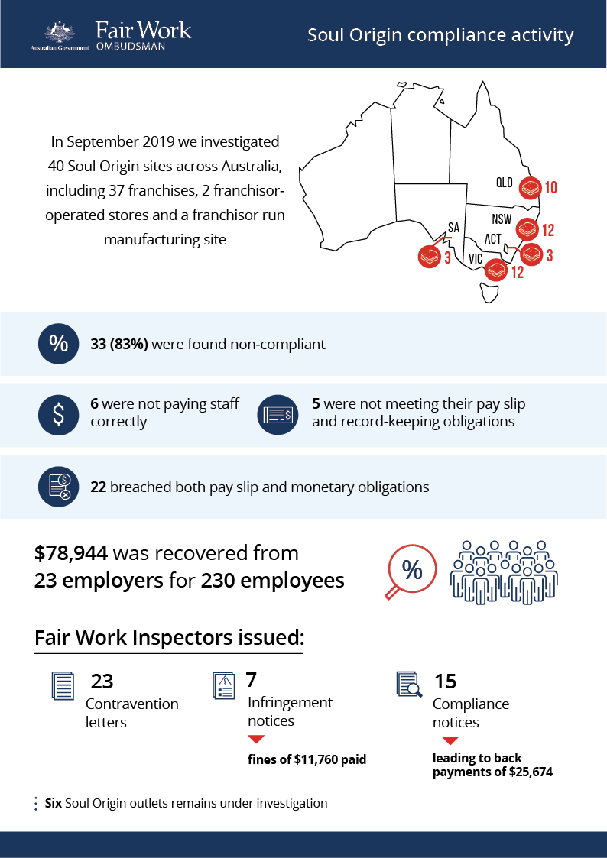

# Soul Origin

## What we did and why

Soul Origin has around 100 stores across all Australian states and territories except Tasmania, selling a range of salads, sandwiches and coffee.

The Fair Work Ombudsman (FWO) investigated 40 Soul Origin sites across Australia in September 2019, including:

* 37 franchisee-operated stores
* 2 franchisor-operated stores
* the franchisors’ manufacturing site.

Our investigation was in response to intelligence including enquiries and anonymous reports, alleging non-compliance with Australian workplace laws. We were also keen to ensure Soul Origin was fully aware of its responsibilities as the head of a relatively new and rapidly expanding franchise network.

Fair Work Inspectors assessed employment records for a 4-week period against the:

* *Fair Work Act 2009*
* *Fair Work Regulations 2009*
* *Fast Food Industry Award 2010* (the Fast Food Award)
* *Food, Beverage and Tobacco Manufacturing Award 2010* (the Food Manufacturing Award).

## Our findings

33 sites (83%) were found to be non-compliant:

* 6 were not paying employees correctly (breaching their monetary obligations)
* 5 were not meeting pay slip and/or record-keeping requirements (breaching non-monetary obligations)
* 22 had breached both their monetary and non-monetary obligations.

We discovered issues concerning the engagement of part-time employees at 24 stores (including the 2 franchisor stores) and the one manufacturing site.

Template employment agreements used to engage part-time employees didn’t fully comply with clause 12.2 of the Fast Food Award. The template failed to specify start and finish times, hours of work or the days of the week the employee was being hired to work. This meant that employee entitlements to overtime rates for hours in excess of ‘agreed hours’ couldn’t be determined. Some franchisees didn’t use part-time agreements at all.

## Action taken and next steps

We recovered a total of $78,944from 23 employers for 230 employees working in 26 stores and one manufacturing site. Some employers operated multiple stores.

### Table.1 Breakdown of back payments

|  |  |  |  |
| --- | --- | --- | --- |
|  | Back payments | Employers | Employees |
| Franchisor | $25,613 | 2 | 9 (Fast Food Award)  17 (Food Manufacturing Award) |
| Franchisees | $53,331 | 21 | 204 (Fast Food Award) |
| Total | $78,944 | 23 | 230 |

Fair Work Inspectors issued:

* 23 contravention letters (for 26 stores and one manufacturing site)
* 7 infringement notices (fines of $11,760.00 paid)
* 15 compliance notices (back payments of $25,674)[1].

6 Soul Origin stores remain under investigation.

The FWO wrote to the franchisor in August 2020:

* detailing our investigation findings (contraventions per store and total underpayments)
* updating them about our ongoing investigations
* providing education about their responsibilities as franchisor to promote compliance in their network[2]
* putting them on notice regarding future non-compliance and recommending it reviews information and guidance provided to franchisees on engagement of part-time employees, to address widespread contraventions in this area.

1. Represents monies recovered in investigations where a CN was issued
2. FWO website: <https://www.fairwork.gov.au/find-help-for/franchises/franchisors>