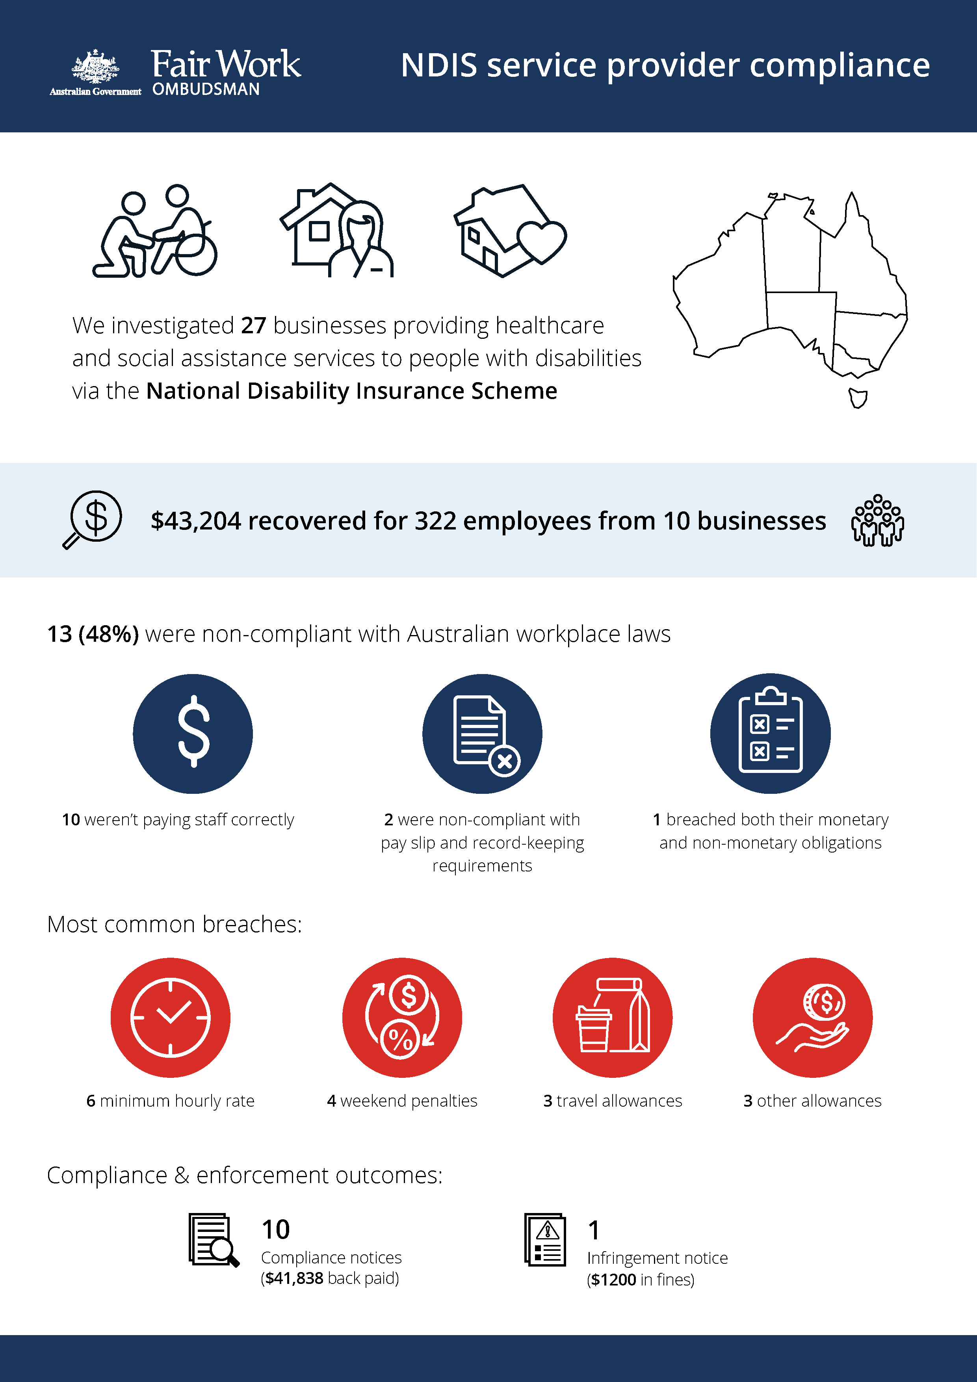

# National Disability Insurance Scheme

## What we did & why

The healthcare and social assistance sector is the largest employing industry in Australia, engaging over 1.3 million workers and accounting for 13% of Australia’s workforce. It’s also one of the fastest growing industries in the country. The National Disability Insurance Scheme (NDIS) funds people with disabilities to access services in the sector.

The Fair Work Ombudsman (FWO) is concerned about the potential for non-compliance with Australian workplace laws among NDIS service providers due to rapid growth and increased competition from new, relatively inexperienced entrants to the sector.

The FWO investigated 27 businesses between September 2019 and July 2020 -- 8 operating in Inner-East Melbourne, 9 in Western Sydney and 10 businesses across the Central and Mid-North Coast of NSW. These areas were selected based on NDIS rollout dates, numbers of registered providers and levels of socioeconomic disadvantage. Socioeconomically disadvantaged workers can be vulnerable to exploitation, due to a lack of awareness or understanding of their entitlements, and an unwillingness to raise concerns with their employer or the FWO.

We used intelligence to select businesses for audit, including requests for assistance, anonymous tip offs and any history of previous non-compliance.

Fair Work Inspectors assessed employment records that spanned a 32-week period (April 2018 to October 2019) against the *Fair Work Act 2009*, *Fair Work Regulations 2009*, *Social, Community, Home Care and Disability Services* *Award* *2010*, *Supported Employment Services Award* and relevant enterprise agreements.

## Our findings

13 (48%) of the 27 businesses investigated were non-compliant with Australian workplace laws. Of those:

* 10 were not paying staff correctly
* 2 were non-compliant with pay slip and record-keeping requirements
* 1 had breached both their monetary and non-monetary obligations.

The most common breaches were:

* underpayment of the minimum hourly rate of pay (6 businesses)
* underpayment of weekend penalties (4)
* failure to pay travel allowances (3)
* failure to pay other allowances (3).

## Actions taken and next steps

We recovered $43,204 for 322 employees from 10 businesses. Recoveries from individual businesses ranged from $23 to $21,549.

Fair Work Inspectors issued:

* 10 compliance notices, recovering $41,838 for 315 employees
* 1 infringement notice, resulting in $1200 paid in fines.

The FWO continues to monitor workplace law compliance in the industry and encourages all businesses in the healthcare and social assistance sector to take meaningful steps to ensure they are compliant with workplace laws. Employees and employers with questions or concerns about workplace law compliance should contact the FWO.