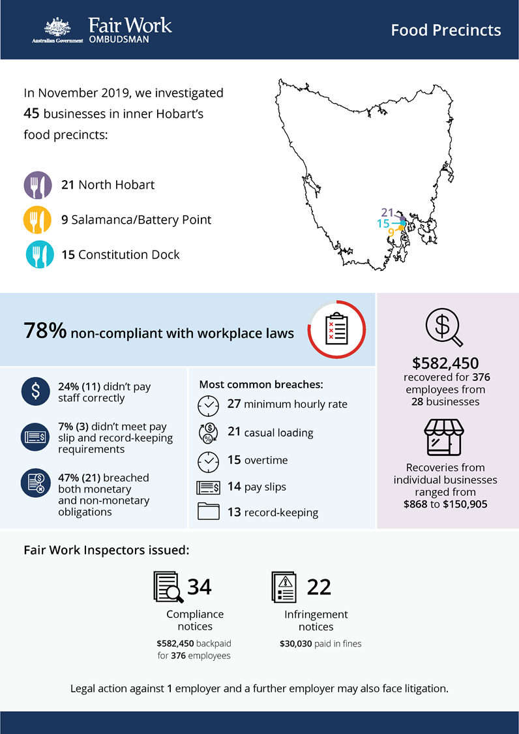[infographic]

# Hobart food precincts

## What we did & why

In November 2019, the Fair Work Ombudsman (FWO) investigated 45 businesses in inner Hobart’s food precincts:

* 21 in North Hobart
* 9 in Salamanca/Battery Point
* 15 in Constitution Dock.

This activity formed part of a rolling program examining non-compliance in popular ‘cheap eats’ food precincts that commenced in 2016.[1][2][3] Fast food, Restaurants and Cafés (FRAC) sector businesses within these precincts typically employ a high proportion of young workers and temporary visa holders. These workers can be vulnerable to exploitation, due to a lack of awareness or understanding of their entitlements, and an unwillingness to raise concerns with their employer or the FWO.

Fair Work Inspectors conducted site visits over two days. They:

* requested employment and payroll records
* interviewed employers, managers and workers
* observed work practices
* noted staff numbers to validate business records.

Pay slips and record-keeping practises were assessed against the requirements of the *Fair Work Act 2009*, the *Fair Work Regulations 2009*, and applicable awards or registered agreements. Most businesses were covered by the *Restaurant Industry Award 2010* or *Fast Food Industry Award 2010*.

## Our findings

35 (78%) of the 45 businesses investigated had breached workplace laws. Of those:

* 11 (24%) were not paying staff correctly
* 3 (7%) were non-compliant with pay slip and record-keeping requirements
* 21 (47%) breached both their monetary and non-monetary obligations.

The most common breaches were:

* underpayment of the minimum hourly pay rate (27 businesses)
* failure to pay casual loading (21)
* failure to pay overtime in excess of ordinary hours (15)
* failure to provide a pay slip in the correct format (14)
* failure to make and keep employee records (13).

## Actions taken & next steps

We recovered $582,450 for 376 employees from 28 businesses. Recoveries from individual businesses ranged from $868 to $150,905.

Fair Work Inspectors issued:

* 34 compliance notices (to 32 businesses), recovering $582,450 for 376 employees
* 22 infringement notices, resulting in $30,030 paid in fines.

We commenced legal action against 1 employer, Welvin & Kevin Pty Ltd, and a further employer may also face litigation. Both failed to comply with a compliance notice.

1. FWO media release: <https://www.fairwork.gov.au/about-us/news-and-media-releases/2020-media-releases/september-2020/20200904-food-precincts-melbourne-brisbane-and-food-retail-report-media-release>
2. FWO media release: <https://www.fairwork.gov.au/about-us/news-and-media-releases/2019-media-releases/december-2019/20191206-over-300-000-returned-to-fast-food-restaurant-and-cafe-workers>
3. FWO report: <https://www.fairwork.gov.au/reports/food-precincts-activities-report>