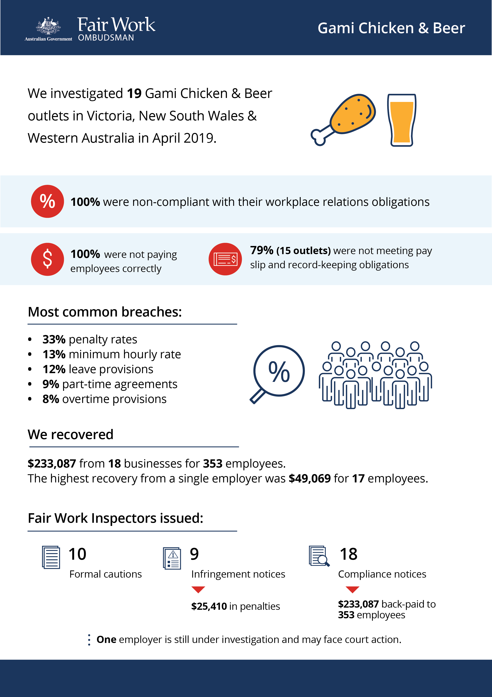

[infographic]

# Gami Chicken & Beer

## What we did and why

Gami Chicken & Beer is a chain of fried chicken outlets that was established in Australia in 2006. There are currently 26 outlets across Australia, mostly in Victoria (Vic), New South Wales (NSW) and Western Australia (WA). The majority of stores are franchises (six of the 19 stores audited were found to be operated by the franchisor).

The Fair Work Ombudsman (FWO) began investigating the Gami Chicken & Beer franchise network in April 2019 after a large number of enquiries, anonymous reports and requests for assistance. Many were from young and/or migrant workers who we know are particularly vulnerable to exploitation. This can be because they often lack awareness or understanding about their entitlements or are unwilling to raise concerns with their employer or the FWO.

Common allegations included:

* underpayment of the base hourly rate of pay under the *Restaurant Industry Award 2010* (the Award)
* non-payment of weekend penalty rates
* non-payment of overtime
* non-payment for ordinary hours worked.

Gami Chicken & Beer expanded rapidly in 2018-19 and media reports suggested the network was planning to significantly increase outlet numbers by 2020. The FWO was concerned that this could lead to an increased risk of non-compliance with workplace laws.

On 11-12 April 2019, teams of Fair Work Inspectors made unannounced visits to 19 Gami Chicken & Beer outlets in Vic, NSW and WA. They:

* spoke to employees, managers and owners
* checked employment records available onsite
* questioned employers about interactions with the franchisor, including the training or direction provided on workplace relations laws and regulations
* assessed employment records against the *Fair Work Act 2009* (the Act), the *Fair Work Regulations 2009* and the Award
* provided educational resources to assist with compliance.

## Our findings

All 19 businesses investigated had breached workplace laws:

* 100% of businesses were not paying staff correctly.
* 15 (79%) businesses had also breached their non-monetary obligations.[1]

The most common breaches related to:

* under/non-payment of penalty rates (33%)
* underpayment of the minimum hourly rate (13%)
* under/non-payment of leave provisions (12%)
* non-provision of part-time agreements (9%)
* under/non-payment of overtime provisions (8%).

Reasons for non-compliance given by employers included:

* lack of awareness of all workplace relations obligations (68%)
* misinterpretation of award requirements (16%)
* making a business decision to not comply with obligations (11%).

## Action taken and next steps

Employers were required to fix non-compliance and provide evidence of action taken, for example proof of payment of outstanding employee entitlements.

We recovered $233,087 from 18 businesses for 353 employees. For individual businesses, recoveries ranged from $1,129 for 8 employees to $49,069 for 17 employees.

Fair Work Inspectors issued:

* 10 formal cautions
* 9 infringement notices, totalling $25,410 in penalties for pay slip and record-keeping breaches
* 18 compliance notices, with back payments totalling $233,087 for 353 employees.

One employer remains under investigation and may face court action.

The high rates of non-compliance across the Gami Chicken & Beer network identified are consistent with the results of previous FWO activities involving franchises in the fast food, restaurants and café (FRAC) sector.[2]

We support compliance amongst franchises via dedicated online information and resources,[3] and education at Franchising and Business Opportunity Expos around Australia. We continue to focus our compliance monitoring and enforcement activities on franchises in the FRAC sector. Through our FRAC strategy we:

* work with business owners and stakeholder networks to educate and drive behavioural change
* may take enforcement action to deal with contraventions of the Act, such as issuing compliance notices if a Fair Work Inspector forms a belief that there has been a breach of an award, enterprise agreement or another instrument or the National Employment Standards
* use our powers under the Act to hold franchisors and other accessories to account
* provide an online portal of information and resources specific to the industry.[4]

We expect employers to comply with all workplace relations obligations. To assist them to comply, they can utilise our free tools and resources, including:

* PACT - calculates employee entitlements, including award pay rates, leave entitlements and termination pay[5]
* My account - interactive service where employers receive tailored information and updates[6]
* Online Learning Centre - award-winning videos on key subjects like hiring employees, managing performance and record-keeping and pay slip obligations[7]
* Templates and guides - tools and resources specifically designed to assist businesses with their payslips and record keeping obligations.[8]

The FWO does not accept that a lack of awareness of obligations under the Act is a valid reason for non-compliance with workplace laws.

1. Percentages have been rounded to the nearest whole number
2. For example: <https://www.fairwork.gov.au/about-us/news-and-media-releases/2019-media-releases/december-2019/20191218-emerging-franchises-compliance-activity>
3. <https://www.fairwork.gov.au/find-help-for/franchises>
4. <https://www.fairwork.gov.au/find-help-for/fast-food-restaurants-cafes>
5. <https://calculate.fairwork.gov.au/>
6. <https://www.fairwork.gov.au/my-account/registerpage.aspx>
7. <https://www.fairwork.gov.au/how-we-will-help/online-training/online-learning-centre>
8. <https://www.fairwork.gov.au/how-we-will-help/templates-and-guides>