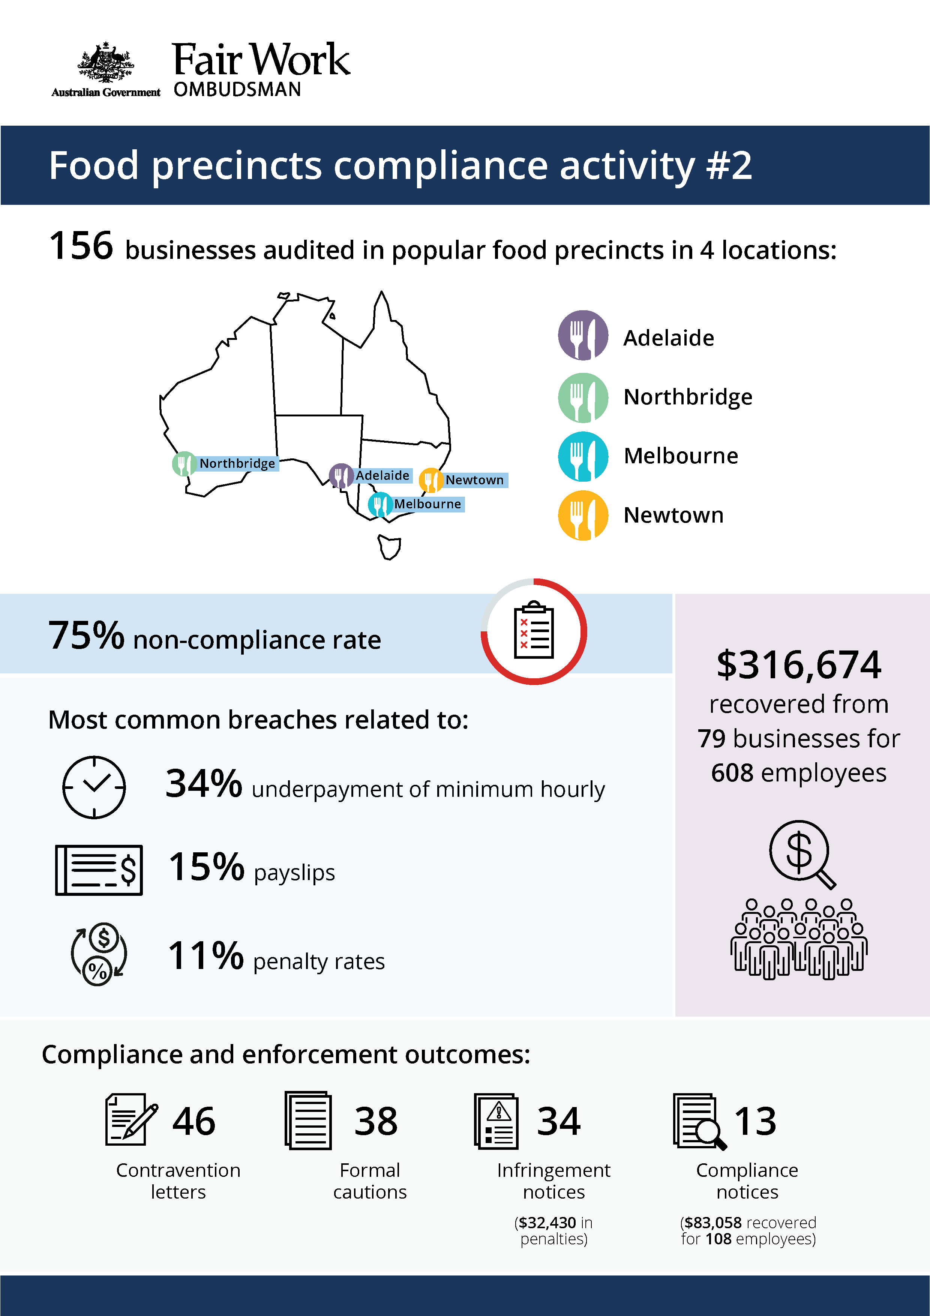


Food Precincts Compliance Activity #2

What we did and why
The hospitality industry accounts for around 7% of Australia’s total workforce, but it is disproportionately represented in Fair Work Ombudsman (FWO) compliance data. In 2017-2018, hospitality accounted for:
- 18% of all workplace disputes received
- 19% of all monetary recoveries ($4.8 million)
- 37% of all anonymous reports received
- around a third of all compliance and enforcement outcomes, including litigations.
With low barriers to entry, hospitality offers accessible employment for young workers, students and migrants entering the Australian labour market. These groups can be vulnerable to exploitation, due to a lack of awareness or understanding of their entitlements, and an unwillingness to raise concerns with their employer or the FWO.
High non-compliance rates, coupled with the vulnerability of the workforce in the fast food, restaurant and café (FRAC) sector, make it a key priority for the FWO.
This compliance activity was the second in a series targeting food precincts (‘cheap-eat’ and entertainment strips). In the first activity, we found 81% of businesses in Victoria St, Melbourne (Vic) were non-compliant, which signalled the need for further targeted audits.
These food precincts are characterised by:
- low entry barriers for new businesses
- low (or no) union coverage and limited employee organisation
- exploitation of vulnerable workers (young / migrants / from non-English speaking backgrounds)
- long trading hours, over the seven days of the week (often without payment of penalty rates for early, late, weekend and public holiday shifts)
- high turnover of labour (suggesting a ready supply of workers willing to work for below minimum award rates and conditions)
- routine skill requirements
- strong competition and tight profit margins.
It is in the FWO’s experience that employers in these highly competitive, price-driven markets attempt to save costs by failing to pay the lawful employee entitlements.
In this second activity, we used intelligence data including anonymous tip offs, requests for assistance and stakeholder referrals, to target priority sites within 4 popular ‘cheap-eat’ food precincts:
- Adelaide (SA) – Rundle St, Gouger St, Grote St and The Parade
- Northbridge (WA) – James St and Francis St
- Melbourne (VIC) – Swanston St, Lygon St, Sydney Rd and St Georges Rd
- Newtown (NSW) – King St.
Fair Work Inspectors audited 156 businesses across the 4 locations. Site visits were co-ordinated to minimise the potential for tip-offs. Fair Work Inspectors requested employment and payroll records, interviewed employers, managers and workers, observed work practices, and noted staff numbers to validate business records.
Pay slips and record-keeping practises were assessed against the requirements of the Fair Work Act 2009 (the Act), the Fair Work Regulations 2009 (the Regulations), and applicable awards or registered agreements. The majority of businesses were covered by the Restaurant Industry Award 2010 or Fast Food Industry Award 2010.

Our findings
We found 117 (75%) businesses in breach of workplace laws. Of these:
- 60 breached their monetary obligations (didn’t pay workers correctly)
- 25 breached their non-monetary obligations (pay slip and/or record-keeping requirements)
- 32 breached both their monetary and non-monetary obligations.
The most common breaches related to:
- underpayment of the minimum hourly rate (34%)
- failure to provide pay slips in the prescribed form (15%)
- underpayment or non-payment of weekend penalty rates (11%).
The findings confirm the absence of an even playing field in these food precincts. We are concerned about the flow-on effect to the wider FRAC sector with three-quarters (75%) of businesses are adopting non-compliant practises.
Compliance results in each of the precincts targeted are shown in the table below.

Table 1: Compliance results by precinct location
Location | Total audits | Non-compliant | Contravention letters | Formal cautions | Infringement notices | Compliance notices | Monies recovered
Melbourne | 40 | 85% | 11 | 12 | 14 | 1 | $77,116  (91 employees / 18 businesses)
Adelaide & Northbridge | 62 | 69% | 16 | 14 | 11 | 8 | $159,364  (231 employees / 36 businesses)
Newtown | 54 | 74% | 19 | 12 | 9 | 4 | $80,194  (286 employees / 25 businesses)

Supporting compliance

We recovered a total of $316,674 from 79 businesses for 608 employees.
Fair Work Inspectors issued:
- 46 contravention letters
- 38 formal cautions
- 34 infringement notices ($32,430 in penalties for pay slip and record-keeping breaches)
- 13 compliance notices (requiring $83,058 to be reimbursed to 108 employees).
The FWO supports compliance in the FRAC sector through dedicated online information and resources, and a continued focus on compliance monitoring and enforcement activities, including:
- working with key businesses and stakeholder networks to educate and drive behaviour change
- targeting communications to increase employer and employee awareness of and engagement with workplace laws
- developing FRAC-specific online tools and resources to make compliance easier for employers, such as our interactive Fast Food Industry 2010 and Restaurant Industry Award 2010 tools
- targeting at-risk employers and monitoring compliance within the sector through proactive audit campaigns
- issuing infringement notices and compliance notices to address underpayments and breaches
- commencing legal proceedings in matters involving serious non-compliance.

https://www.fairwork.gov.au/about-us/our-purpose/our-priorities
https://www.fairwork.gov.au/reports/food-precincts-activities-report
Visits to businesses in Adelaide and Northbridge were conducted as one activity
https://www.fairwork.gov.au/find-help-for/fast-food-restaurants-cafes

