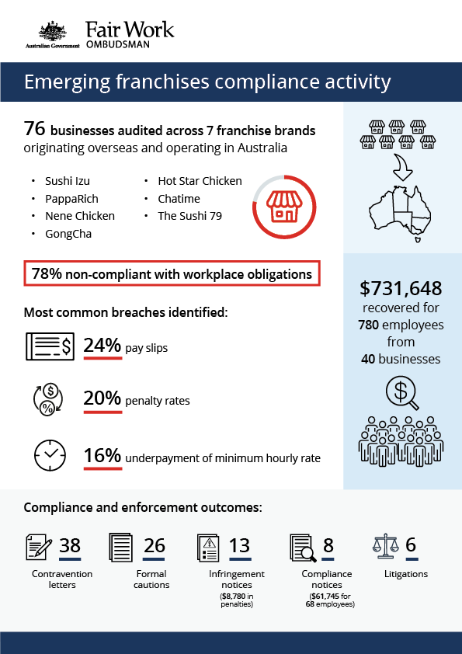

# Emerging Franchises Compliance Activity Report

## What we did and why

Compliance within franchise networks is a strategic priority for the FWO.[1] The franchise sector in Australia engages approximately 472,000 employees across 79,000 individual businesses representing 1160 brands. Around 19% of franchises are in the Accommodation and Food Services industry.[2]

In recent years, franchise brands from overseas have begun operating in Australia. There is a risk that these businesses lack the requisite knowledge of Australia’s workplace relations laws. Typically comprising of both migrant employers and migrant workers, our experience is that franchises receive limited centralised support from the franchisor on regulatory requirements. There is also little evidence of engagement with, or membership of, employer groups such as the Franchise Council of Australia for regulatory support and information.

In order to test the levels of knowledge with Australian workplace laws, we investigated 7 emerging franchises in the fast food, restaurant and café (FRAC) sector:

* Sushi Izu – USA sushi retailer that started operating in Australia in 2011
* PappaRich – Malaysian restaurant chain that started operating in Australia in 2012
* Nene Chicken – South Korean fried chicken chain that started operating in Australia in 2015
* GongCha – Taiwanese beverage takeaway chain that started operating in Australia in 2012
* Hot Star Chicken – Taiwanese fried chicken outlets that started operating in Australia in 2013
* Chatime – Taiwanese bubble tea outlets that starting operating in Australia in 2009
* The Sushi 79 – Australian sushi restaurant chain established in 2015.

These franchises were selected based on FWO intelligence data, including anonymous tip offs, requests for assistance and stakeholder referrals. The FRAC sector is also a key strategic priority industry for the FWO, with consistently high levels of non-compliance with workplace laws.

Priority sites within the brands were identified across capital cities around Australia, and visits to businesses by Fair Work Inspectors were co-ordinated to minimise the opportunity of internal tip-offs within the franchise networks.

Fair Work Inspectors audited 76 individual businesses across the 7 brands, to:

* check compliance with workplace relations laws
* assess records against the Fair Work Act 2009 (the Act), the Fair Work Regulations 2009 (the Regulations) and the applicable awards (Restaurant Industry Award 2010 and Fast Food Industry Award 2010)
* recover outstanding employee entitlements, if identified
* educate employers about their obligations and employees about their rights
* examine the control and influence franchisors have over franchisees.

Employers were questioned about their interactions with franchisors, including the training or direction provided on workplace relations laws and regulations. We also explored franchisor-imposed operating models that could put pressure on profit margins (e.g. setting fixed menu prices, preferred suppliers, franchising fees and royalty payments) given it’s not uncommon for employers of vulnerable workers to seek to recover costs by paying ‘below award’ rates.

While the franchisee employer is ultimately responsible for compliance, a franchisor can be held responsible for breaches of the Act in particular circumstances. A franchisor may not be liable for breaches under responsible franchisor provisions if they have taken reasonable steps to prevent franchisees from contravening their obligations under the Act.[3]

## Our findings

17 (22%) businesses were compliant with all aspects of their workplace relations obligations.

59 (78%) were in breach of at least one of their workplace obligations.

* 15 (20%) weren’t paying employees correctly, but complied with pay slip and record-keeping obligations (non-monetary obligations).
* 17 (23%) were in breach of non-monetary obligations, but complied with monetary requirements.
* 27 (35%) were in breach of both their monetary and non-monetary obligations.

The most common breaches related to:

* pay slip obligations contained in the Act and the Regulations(24%)
* penalty rates (20%)
* minimum hourly rates of pay (16%)
* record-keeping requirements (11%).

These results indicate significantly higher non-compliance amongst emerging franchises (78%) than employers generally (55% non-compliance rate across all audits conducted in 2018-19[4]).

Articulated reasons by employers for their non-compliance included:

* lack of awareness of workplace relations obligations (81%)
* payment of flat hourly rates (8%)
* misinterpretation of award requirements (3%).

Franchisees reported that franchisors provided little guidance on regulatory matters, especially workplace laws and that direction was more focused on outlet setup, branding, menu and staff training.

Some non-compliant franchisees told Fair Work Inspectors that they faced financial pressures due to franchisor controls. For example, through a requirement to use in-house suppliers at higher costs than available locally.

The specific results from each activity are available at Appendix A.

## Actions taken and next steps

Employers were required to fix non-compliance and provide evidence of action taken, for example proof of payment of outstanding employee entitlements.

We recovered a total of $731,648 for 780 employees from 40 businesses.[5]

Fair Work Inspectors issued:

* 38 contravention letters
* 26 formal cautions
* 13 infringement notices ($8780 in penalties for pay slip and record-keeping breaches)
* 8 compliance notices (requiring reimbursement of $61,745 for 68 employees).

We took legal action against 6 businesses for serious non-compliance, including:

* The director of 3 Sydney-based PappaRich restaurants who admitted to the underpayment of 154 employees, owing more than $76,000. Staff were paid flat rates as low as $13 per hour for all hours worked. The court imposed penalties of $141,751 and $131,626 on PPR Ryde (NSW) Pty Ltd and Gateharvest Pty Ltd, respectively, for their involvement in the underpayments. The director was also penalised $34,425.[6]
* A Sydney-based Chatime outlet that allegedly underpaid 17 workers more than $46,000. Staff were paid flat rates as little as $13 per hour.[7]
* The directors of two The Sushi 79 outlets in Brisbane, who admitted underpaying 9 workers over $19,467.24 gross over a three-month period. The FWO was prepared to use reverse onus of proof laws from the *Fair Work Amendment (Protecting Vulnerable Workers) Act 2017* had the directors not admitted liability. Underpayments related to the use of flat rates of pay. Quantification of underpayments was also hindered by the company’s failure to keep time and wage records. The court imposed penalties of $108,000 on A & K Property Services Pty Ltd and $17,700 on the directors.[8]
* The Australian franchisor of Chatime (Chatime Australia Pty Ltd, formerly known as Infinite Plus Pty Ltd), who allegedly underpaid $169,320 to 152 employees in company owned stores, over a 5-month period in 2016.[9]

A further $195,270 was recovered from Chatime employers through FWO-guided self-assessment.

The FWO is supporting compliance in the franchise sector via dedicated online information and resources[10], and education at Franchising and Business Opportunity Expos around Australia.

We continue to focus compliance monitoring and enforcement activities on franchises in the fast food, restaurants and café (FRAC) sub-sector of hospitality.

Through our FRAC strategy we are:

* working with key business owners and stakeholder networks to educate and drive behaviour change
* issuing compliance notices to address underpayments and breaches of awards and the National Employment Standards
* using our new powers to hold franchisors and other accessories to account.

## Conclusion

The overall compliance rate of 22% across seven overseas-based emerging franchises confirmed the intelligence received by the FWO.

While the majority of non-compliant businesses (81%) asserted they were unaware of their obligations, some non-compliant franchisees informed Fair Work Inspectors on a confidential basis of the financial pressures they faced due to the franchisor’s control over financial decisions, including the requirement to use in-house suppliers at higher costs for products that could be obtained cheaper locally.

We found that while master franchisors were directive on aspects of the business such as outlet aesthetic and design, menu and staff training, there was limited guidance and engagement on regulatory matters, especially workplace laws.

To provide support to the franchise sector, the FWO has a dedicated portal for information and resources on its website[11] to ensure that employers in the sector are able to easily access the information they need.

The portal includes free FWO tools and resources that support compliance, including:

* PACT - calculates employee entitlements including award pay rates, leave entitlements and termination pay[12]
* My account - interactive service where employers receive tailored information and updates[13]
* Online learning centre - award-winning videos on key subjects like hiring employees, managing performance and record-keeping and pay slip obligations[14]
* Small Business Showcase - tools and resources specifically designed to assist small businesses with their workplace relations obligations.[15]

The FWO has also attended the Franchising and Business Opportunity Expos around Australia, providing educational support to potential and existing franchisees and franchisors.

The FWO expects employers to use the education and advice provided through audit activities to be compliant with workplace relations obligations. Non-compliant employers will be revisited as part of the FWO’s ongoing national proactive compliance monitoring programs. Appropriate and proportionate compliance and enforcement action will be escalated against employers who continue to not comply with workplace laws.

# Appendix A

### Table: Compliance results by franchise brand

|  |  |  |  |  |  |  |  |
| --- | --- | --- | --- | --- | --- | --- | --- |
| Franchise | Outlets audited | Compliant | Non-compliant | Monetary breaches | Non-monetary breaches | Both monetary & non-monetary | Monies recovered |
| Sushi Izu | 14 | 4 (29%) | 10 (71%) | 2 | 7 | 1 | $1408 (3 employees from 3 businesses) |
| PappaRich | 12 | 1 (8%) | 11 (92%) | 3 | 1 | 7 | $237,177 (247 employees from 10 businesses) |
| Nene Chicken | 6 | 1 (17%) | 5 (83%) | 0 | 0 | 5 | $14,532 (18 employees from 5 businesses) |
| Chatime | 19 | 8 (42%) | 11 (58%) | 5 | 3 | 3 | $410,962 (379 employees from 7 businesses)[16] |
| Gongcha | 11 | 2 (18%) | 9 (82%) | 3 | 3 | 3 | $36,903 (84 employees from 6 businesses) |
| Hot Star Chicken | 6 | 1 (17%) | 5 (83%) | 0 | 2 | 3 | $1708 (26 employees from 3 businesses) |
| The Sushi 79 | 8 | 0 (0%) | 8 (100%) | 2 | 1 | 5 | $28,958 (23 employees from 6 businesses |

1. <https://www.fairwork.gov.au/about-us/our-purpose/our-priorities>
2. <https://www.franchise-ed.org.au/franchising/2016-survey-shows-franchising-on-the-rise-in-australia/>

   Within this sector, the FWO has designated ‘fast food, restaurants and cafés’ an agency priority due to the high non-compliance levels and vulnerable workforce (young and migrant).
3. <https://www.fairwork.gov.au/about-us/our-role/enforcing-the-legislation/litigation/accessorial-franchisor-and-holding-company-liability#franchisor>
4. <https://www.transparency.gov.au/annual-reports/fair-work-ombudsman-and-registered-organisations-commission-entity/reporting-year>
5. This figure may rise. Legal proceedings currently before the courts involve monies not yet recovered for workers.
6. <https://www.fairwork.gov.au/about-us/news-and-media-releases/2019-media-releases/november-2019/20191121-papparich-franchisee-penalty-media-release>
7. <https://www.fairwork.gov.au/about-us/news-and-media-releases/2019-media-releases/april-2019/20190403-chatime-franchisee-litigation-media-release>
8. <https://www.fairwork.gov.au/about-us/news-and-media-releases/2019-media-releases/august-2019/20190821-sushi-79-penalty-media-release>
9. <https://www.fairwork.gov.au/about-us/news-and-media-releases/2019-media-releases/december-2019/20191218-chatime-franchisor-litigation-media-release>
10. <https://www.fairwork.gov.au/find-help-for/franchises>
11. <https://www.fairwork.gov.au/find-help-for/franchises>
12. <https://calculate.fairwork.gov.au/>
13. <https://www.fairwork.gov.au/my-account/registerpage.aspx>
14. <https://www.fairwork.gov.au/how-we-will-help/online-training/online-learning-centre>
15. <https://www.fairwork.gov.au/small-business-showcase>
16. $146, 372 is subject to legal action: <https://www.fairwork.gov.au/about-us/news-and-media-releases/2019-media-releases/april-2019/20190403-chatime-franchisee-litigation-media-release>; $169,320 is subject to legal action: <https://www.fairwork.gov.au/about-us/news-and-media-releases/2019-media-releases/december-2019/20191218-chatime-franchisor-litigation-media-release>