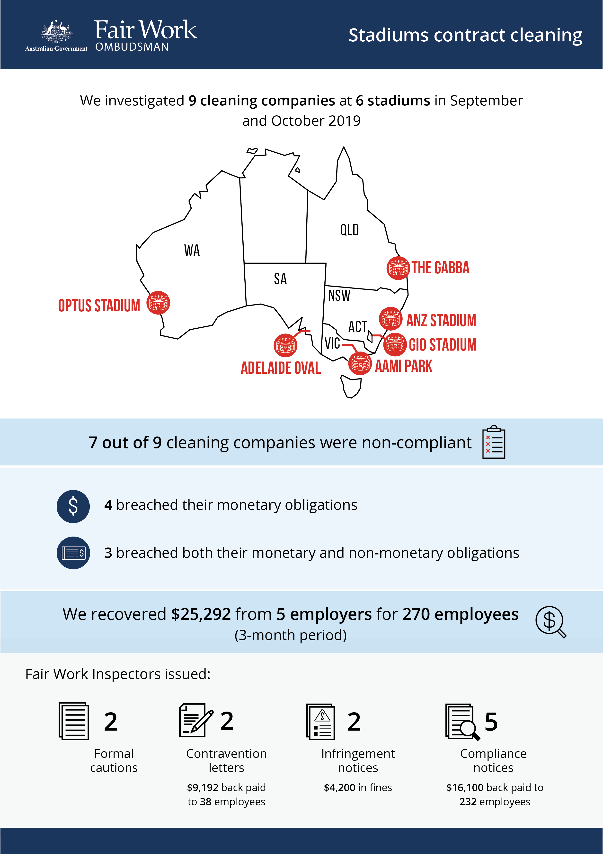

Stadiums contract cleaning

What we did and why
Between September and October 2019, the Fair Work Ombudsman (FWO) investigated the contract cleaning labour supply chains at 6 stadiums across Australia (AAMI Park in Melbourne, Adelaide Oval, ANZ Stadium in Sydney, GIO Stadium in Canberra, the Gabba in Brisbane and Optus Stadium in Perth). This was in response to general intelligence that cleaning companies in the stadiums sector may not have been compliant with workplace laws, including concerns about possible sham contracting.
9 cleaning companies operated at the 6 stadiums. Layers of subcontracting within the labour supply chains meant that a total of 15 businesses were investigated.
We conducted unannounced and after-hours site visits and assessed records for a 3-month period.

Our findings
7 of the 9 cleaning companies investigated were non-compliant with Australian workplace laws:
- 4 were underpaying workers (breaching their monetary obligations)
- 3 were underpaying workers and not meeting pay slip and record-keeping requirements set out in the Fair Work Act 2009 and Fair Work Regulations 2009 (breaching both their monetary and non-monetary obligations).
Underpayments of minimum entitlements set out in the Cleaning Services Award 2010 were found to include failure to pay:
- penalty rates (weekend, public holiday)
- allowances (industry, broken shift)
- overtime
- minimum hourly rates of pay
- casual loading
- minimum engagement for casuals.
No evidence of sham contracting or misclassification of employment was found.
Our investigations uncovered breaches by contractors and subcontractors operating at 5 of the 6 stadiums – Adelaide Oval, ANZ Stadium, GIO Stadium, the Gabba and Optus Stadium. The stadium operators were not found to be involved in breaches of workplace laws.

Action taken and next steps
A total of $25,292 was recovered from 5 employers for 270 employees, for a 3-month period of employment.
Fair Work Inspectors issued:
- 2 formal cautions
- 2 contraventions letters ($9,192 back paid to 38 workers)
- 2 infringement notices for pay slip infringements (totalling $4,200 in fines)
- 5 compliance notices ($16,100 back paid to 232 employers).
We engaged with the stadiums by:
- notifying them about our findings
- directing them to our free educational tools and resources
- recommending improved governance arrangements, including the regular review of contracts to ensure all levels of their supply chains are compliant with workplace laws.
The FWO continues to monitor compliance in the stadiums cleaning sector. Late last year, following a separate audit activity, we commenced legal action against the principal cleaning contractor, a sub-contractor and two individual directors of sub-contractors who provided cleaning services at the then Etihad Stadium (now Marvel Stadium), alleging multiple breaches of workplace laws. This matter is currently before the Court.
The FWO encourages all public and private businesses to review their cleaning contracts and apply for certification of employment sites through the Cleaning Accountability Framework. This industry-led initiative promotes the adoption of best practice throughout cleaning supply chains to improve labour and cleaning standards across Australia.

FWO media releases: http://www.fairwork.gov.au/about-us/news-and-media-releases/2019-media-releases/september-2019/20190909-stadiums-sica-media-release, http://www.fairwork.gov.au/about-us/news-and-media-releases/2019-media-releases/september-2019/20190923-fwo-audits-cleaning-operations-at-optus-stadium, http://www.fairwork.gov.au/about-us/news-and-media-releases/2019-media-releases/october-2019/20191031-stadium-cleaners-adelaide-oval-and-gabba-activity-media-release
https://www.fairwork.gov.au/about-us/news-and-media-releases/2020-media-releases/january-2020/20200113-marvel-stadium-cleaners-litigation-media-release

