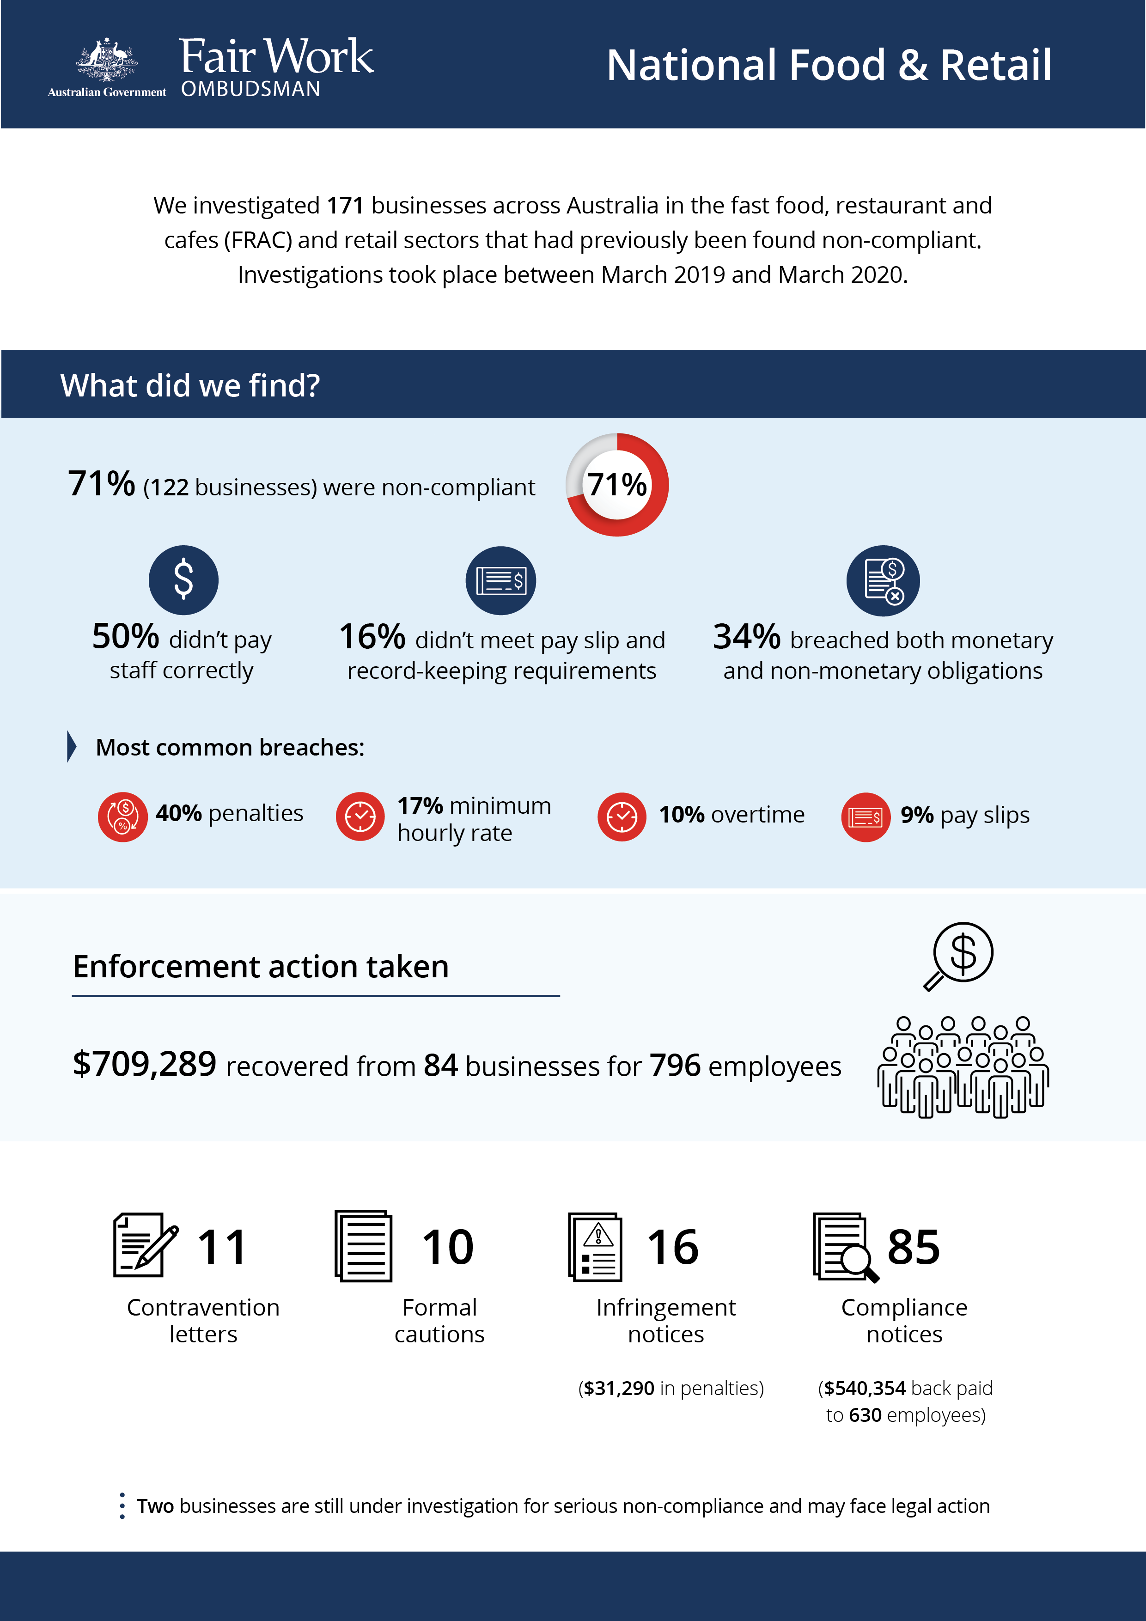

# National Food and Retail Revisit

## What we did and why

The Fair Work Ombudsman (FWO) investigated 171 businesses in the fast food, restaurant and cafes (FRAC) and retail sectors across Australia that had previously breached workplace laws. The investigations took place between March 2019 and March 2020.

Fair Work Inspectors assessed records against the *Fair Work Act 2009* (the Act), the *Fair Work Regulations 2009* (the Regulations) and applicable modern awards (e.g. *Restaurant Industry Award 2010, Fast Food Industry Award 2010* and the *General Retail Industry Award 2010*) and enterprise agreements. Education resources were provided to employers to assist with compliance.

## Our findings

122 businesses (71%) were found to non-compliant with workplace laws:

* 61 (50%) were not paying staff correctly
* 19 (16%) were non-compliant with pay slip and record-keeping requirements
* 42 (34%) breached both their monetary and non-monetary obligations.[1]

The most common breaches related to:

* under / non-payment of penalty rates (40%)
* underpayment of the minimum hourly rate (17%)
* under / non-payment of overtime provisions (10%).
* failure to provide pay slips as per requirements of the Act and Regulations (9%)

The reasons given for non-compliance included:

* lack of awareness of obligations (51%)
* misinterpreting award requirements (17%)
* payment of a flat hourly rate insufficient to compensate for award-based penalties (6%).

## Action taken and next steps

We recovered $709,289 from 84 businesses for 796 employees.

Fair Work Inspectors issued:

* 11 contravention letters
* 10 formal cautions
* 16 infringement notices ($31,290 in penalties for pay slip and record-keeping breaches)
* 83 compliance notices ($540,354 back paid to 630 employees)

Two businesses are still under investigation for non-compliance and may face legal proceedings.

We expect employers to comply with all workplace relations obligations. To assist them to comply, they can utilise our free tools and resources, including:

* PACT - calculates employee entitlements, including award pay rates, leave entitlements and termination pay[2]
* My account - interactive service where employers receive tailored information and updates[3]
* Online Learning Centre - award-winning videos on key subjects like hiring employees, managing performance and record-keeping and pay slip obligations[4]
* Templates and guides - tools and resources specifically designed to assist businesses with their payslips and record keeping obligations.[5]

The FWO does not accept that a lack of awareness of obligations under the Act is a valid reason for non-compliance with workplace laws.

1. Percentages have been rounded to the nearest whole number
2. <https://calculate.fairwork.gov.au/>
3. <https://www.fairwork.gov.au/my-account/registerpage.aspx>
4. <https://www.fairwork.gov.au/how-we-will-help/online-training/online-learning-centre>
5. <https://www.fairwork.gov.au/how-we-will-help/templates-and-guides>