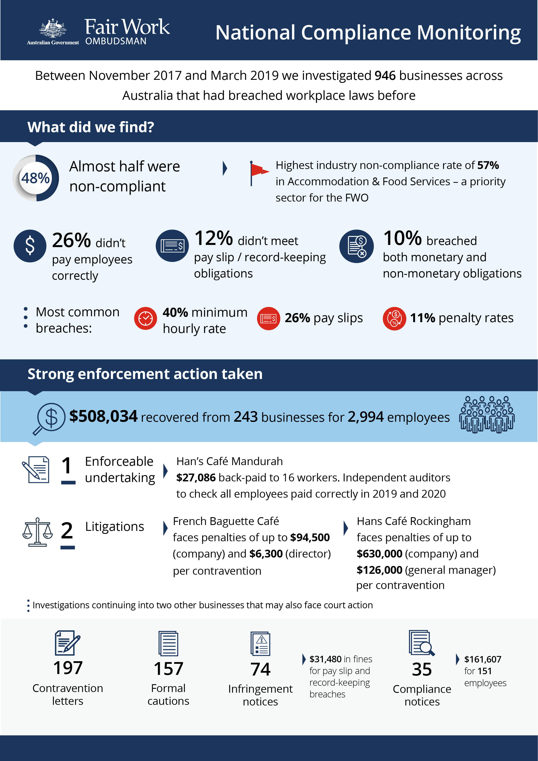

# National Compliance Monitoring

## What we did and why

Between November 2017 and March 2019, the FWO investigated 946 businesses across Australia that we had found to have previously breached Australian workplace laws.

## Our findings

Almost half of the businesses (452 businesses, or 48%) were non-compliant with workplace laws:

* 243 (26%) were not paying employees correctly (monetary obligations not met)
* 116 (12%) did not meet pay slip and record-keeping requirements (non-monetary obligations not met)
* 93 (10%) breached both their monetary and non-monetary obligations.

Looking at all the individual breaches of workplace laws made by the 452 employers, the most common breaches identified were:

* underpayment of the minimum hourly rate (40%)
* pay slips not provided as per the *Fair Work Act* and *Fair Work Regulations* (26%)
* failure to pay penalty rates (11%).

Accommodation and food services businesses had the highest rate of non-compliance (57%).

## Action taken and next steps

We recovered $508,034 from 243 businesses for 2,994 employees.

Fair Work Inspectors issued:

* 197 contravention letters
* 157 formal cautions
* 74 infringement notices, totalling $31,480 in fines for pay slip and record-keeping breaches
* 35 compliance notices, with back payments totalling $161,607 for 151 employees.

An enforceable undertaking was entered into with T J D Sayoco Pty Ltd, trading as Han’s Café Mandurah. Under the terms of the enforceable undertaking, the company was required to back-pay $27,086 to 16 employees, and to engage independent external auditors to check that all employees received their correct entitlements in 2019 and 2020.[1]

Legal action has been taken against two businesses for alleged non-compliance with Australian workplace laws:

* Saveway Store Pty Ltd, which operates 2 French Baguette Cafés (the company faces penalties of up to $94,500 per contravention, and the director faces penalties of up to $6,300 per contravention)[2]
* Tac Pham Pty Ltd, trading as Hans Café Rockingham (the company faces penalties of up to $630,000 per contravention and the director faces penalties of up to $126,000 per contravention.[3]

Investigations into alleged non-compliance with Australian workplace laws by 2 further employers is ongoing and the FWO is considering litigation.

1. <https://www.fairwork.gov.au/about-us/news-and-media-releases/2019-media-releases/august-2019/20190815-hans-cafe-mandurah-eu-media-release>
2. <https://www.fairwork.gov.au/about-us/news-and-media-releases/2020-media-releases/january-2020/20200108-saveway-litigation-media-release>
3. <https://www.fairwork.gov.au/about-us/news-and-media-releases/2020-media-releases/january-2020/20200107-tac-pham-hans-cafe-litigation-media-release>