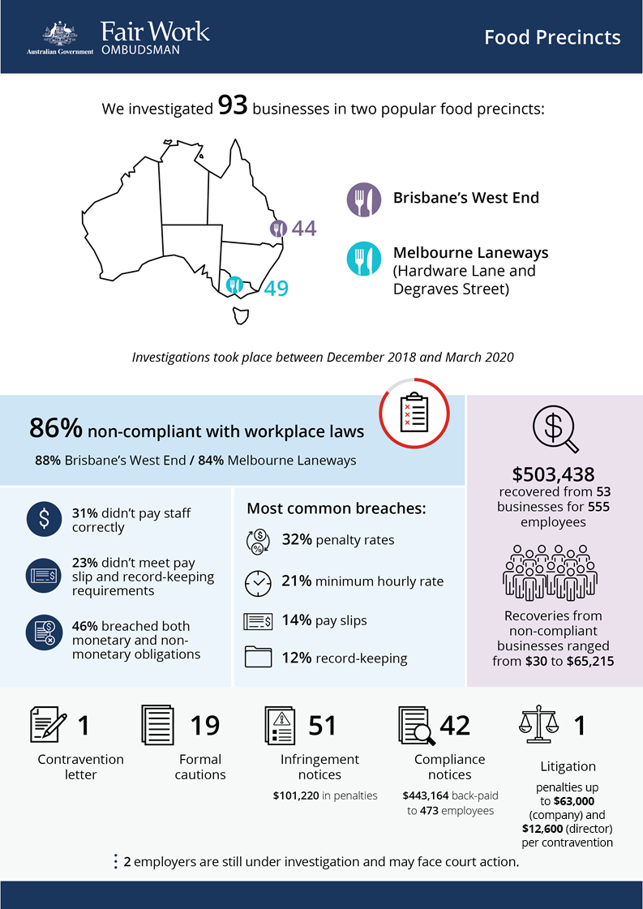

[infographic]

# Food Precincts Investigations: Melbourne Laneways and Brisbane’s West End

## What we did and why

The Fair Work Ombudsman (FWO) investigated 93 fast food, restaurants and café (FRAC) businesses in:

* Hardware Lane and Degraves Street (two of Melbourne’s popular CBD laneway dining strips)
* Brisbane’s West End.

This is the third in a series of activities examining non-compliance in popular ‘cheap eats’ food precincts. These precincts are high-density and highly competitive, with businesses competing on price to attract customers. Open long hours and seven days a week, businesses may be required to pay penalty rates and overtime. However, as profit margins narrow, employee wages are often impacted in the drive to reduce costs.

Workers are typically young, students and migrants, often entering the Australian labour market for the first time. They can be vulnerable to exploitation, due to a lack of awareness or understanding of their entitlements, and an unwillingness to raise concerns with their employer or the FWO.

Hardware Lane and Degraves Street are well established dining strips in Melbourne’s CBD that exemplify Melbourne’s famous ‘laneway culture’, attracting large numbers of tourists and locals. Audits in the laneways were carried out between December 2018 and March 2020.

Brisbane’s West End attracts students and young professionals to its growing and vibrant food, music and art scene. With more restaurants and bars opening and many domestic and international students living in the area, it was targeted between July 2019 and February 2020.

Fair Work Inspectors assessed employment records against the *Fair Work Act 2009* (the Act), the *Fair Work Regulations 2009* (the Regulations) and applicable awards (e.g. *Fast Food Industry Award 2010* and *Restaurant Industry Award 2010)* and enterprise agreements. Educational resources were given to employers to assist with compliance.

## Our findings

80 (86%) of the 93 businesses investigated had breached Australian workplace laws:

* 25 (31%) were not paying staff correctly
* 18 (23%) were non-compliant with pay slip and record-keeping requirements
* 37 (46%) breached both their monetary and non-monetary obligations.[1]

The most common breaches related to:

* under / non-payment of penalty rates (32%)
* underpayment of minimum hourly rates (21%)
* failure to provide pay slips as per the Act and Regulations (14%)
* failure to comply with record-keeping requirements in the Act and Regulations (12%).

Reasons for non-compliance given by employers included:

* lack of awareness of all workplace relations obligations (64%)
* paying flat hourly rates to save on administration costs but failing to adequately compensate employees for their full entitlements to weekend penalty rates (11%)
* misinterpreting award requirements (10%)
* ‘other’ reasons e.g. payroll system / software issues (7%)
* missing the annual July wage increase (5%).

Compliance results in each precinct are tabled below.

### Table 1: Compliance results by precinct location

| **Location** | **Total businesses** | **Non-compliant** | **Contravention letters** | **Formal cautions** | **Infringement notices** | **Compliance notices** | **Monies recovered** |
| --- | --- | --- | --- | --- | --- | --- | --- |
| **Melbourne Laneways** | 49 | 84% | 0 | 19 | 29 | 10 | $194,365  (186 employees / 25 businesses) |
| **Brisbane West End** | 44 | 88% | 1 | 0 | 22 | 32 | $309,073  (369 employees / 28 businesses) |

For background, compliance results in precincts audited previously are included below.

### Table 2: Compliance results in previous food precinct activities

| **Location** | **Total businesses** | **Non-compliant** | **Contravention letters** | **Formal cautions** | **Infringement notices** | **Compliance notices** | **Monies recovered** |
| --- | --- | --- | --- | --- | --- | --- | --- |
| **Melbourne Streets (VIC)** | 40 | 85% | 11 | 12 | 14 | 1 | $77,116  (91 employees / 18 businesses) |
| **Adelaide & Northbridge[2] (SA & WA)** | 62 | 69% | 16 | 14 | 11 | 8 | $159,364  (231 employees / 36 businesses) |
| **Newtown (NSW)[3]** | 54 | 74% | 19 | 12 | 9 | 4 | $80,194  (286 employees / 25 businesses) |
| **Fortitude Valley (QLD)** | 73 | 60% | N/A | 7 | 21 | 1 | $64,941  (180 employees / 25 businesses) |
| **Glebe Point Road (NSW)** | 67 | 70% | N/A | 18 | 20 | 2 | $188,125  (176 employees / 29 businesses) |
| **Victoria Street, Richmond (VIC)[4]** | 103 | 81% | N/A | 38 | 30 | 4 | $218,838  (260 employees / 48 businesses) |

## Action taken and next steps

Employers were required to fix non-compliance and provide evidence of action taken, for example proof of payment of outstanding employee entitlements.

We recovered $503,438 from 53 businesses for 555 employees. Recoveries from individual businesses ranged from $30 for 1 employee, to $62,215 for 47 employees.

Fair Work Inspectors issued:

* 1 contravention letter
* 19 formal cautions, advising of contraventions and putting the employer on notice about consequences of continued non-compliance
* 51 infringement notices, totalling $101,220 in penalties for pay slip and record-keeping breaches
* 42 compliance notices, with back payments totalling $443,164 for 473 employees.

One litigation has commenced against Shri Krishna Pty Ltd, which operates three Little Cupcakes retail stores in Melbourne, including one on Degraves Street. The FWO alleges 35 employees (including 10 juniors aged under 21 years) were underpaid a total of $57,179.69. The company faces penalties of up to $63,000 per contravention, and director Shreyansh Dharmesh Shah faces penalties of up to $12,600 per contravention.[5]

Legal action is being considered against two employers for failing to comply with a compliance notice.

We are in discussions with another 4 employers who were issued compliance notices, that are claiming severe financial hardship due to the COVID-19 pandemic. Further enforcement action will depend on factors including each business’s response and commitment to remedying the non-compliance. The FWO continues to enforce workplace laws in a proportionate manner during the pandemic; holding employers to account in order to protect employees.

We support compliance in the FRAC sector through:

* business and stakeholder engagement to educate and drive behaviour change
* targeted communications to increase awareness of and engagement with workplace laws
* dedicated online information and resources to make compliance easier for employers, such as our interactive *Fast Food Industry 2010* and *Restaurant Industry Award 2010* tools[6]
* a continued focus on compliance monitoring and enforcement activities in high-risk sectors.

We expect employers to comply with all workplace relations obligations. To assist them to comply, they can utilise our free tools and resources, including:

* PACT - calculates employee entitlements, including award pay rates, leave entitlements and termination pay[7]
* My account - interactive service where employers receive tailored information and updates[8]
* Online Learning Centre - award-winning videos on key subjects like hiring employees, managing performance and record-keeping and pay slip obligations[9]
* Templates and guides - tools and resources specifically designed to assist businesses with their payslips and record keeping obligations.[10]

The FWO does not accept that a lack of awareness of obligations under the Act is a valid reason for non-compliance with workplace laws.

1. Percentages have been rounded to the nearest whole number
2. Visits to businesses in Adelaide and Northbridge were conducted as one activity
3. https://www.fairwork.gov.au/ArticleDocuments/1151/food-precincts-activity-sica-report-2.pdf.aspx
4. https://www.fairwork.gov.au/ArticleDocuments/1386/fwo-food-precincts-report.pdf.aspx
5. FWO media release: http://www.fairwork.gov.au/about-us/news-and-media-releases/2020-media-releases/july-2020/20200717-shri-krishna-guru-litigation-media-release
6. <https://www.fairwork.gov.au/find-help-for/fast-food-restaurants-cafes>
7. <https://calculate.fairwork.gov.au/>
8. <https://www.fairwork.gov.au/my-account/registerpage.aspx>
9. <https://www.fairwork.gov.au/how-we-will-help/online-training/online-learning-centre>
10. <https://www.fairwork.gov.au/how-we-will-help/templates-and-guides>