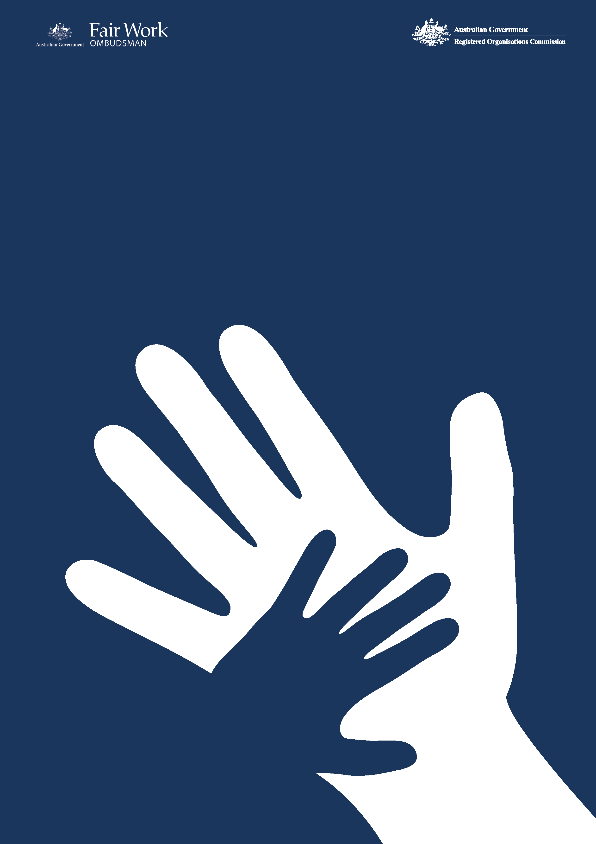

Commonwealth Child Safe Framework

Fair Work Ombudsman

Annual Statement of Compliance

2025-26 Financial Year
f
- FWO’s commitment to child safety

The Office of the Fair Work Ombudsman (FWO) is committed to ensuring the safety and wellbeing of children and young people in connection with our work and with our employees. FWO seeks to create and maintain behaviours, practices and an organisational culture that acknowledges the importance of child safety and wellbeing. FWO is committed to:
- Implementing strategies and taking action to promote child wellbeing and prevent harm to children.
- Creating an environment where children’s safety and wellbeing is acknowledged during interactions with children and young people.
- Genuine engagement with and valuing of children.
- Creating conditions that reduce the likelihood of harm to children.
- Creating conditions that increase the likelihood of identifying any harm.
- Reporting/responding to any concerns, disclosures, allegations, or suspicions of harm.
- Making sure staff and volunteers have the skills, confidence and knowledge to keep children safe.

- FWO’s interaction with children as part of its operations

The FWO’s jurisdiction is set out in the Fair Work Act 2009, our main role is to promote harmonious, productive, cooperative and compliant workplace relations in Australia through advice and education; and take appropriate enforcement action.

The majority of FWO staff members do not interact directly with children on a regular basis in the performance of their duties. Though, in some instances, staff members may interact with children in the course of their duties - whether it be face-to-face, over the telephone, by way of electronic communication or by accessing a record pertaining to that person. These staff members may engage with children in the following instances:
- Customer services
- Compliance and enforcement activities
- Litigation proceedings
- Education activities

- Child safety risk assessment

In accordance with the requirements of the Framework, an annual risk assessment was undertaken by FWO . Six key risks were identified (five rated low and one rated medium) which resulted in an overarching risk rating of low for the FWO. This overall rating is consistent with the previous year’s risk assessment.

- Compliance with the Framework

The FWO is compliant with the four requirements of the Framework as set out below.

Table 1. Summary table compliance with the Framework
Requirement 1  Undertake risk assessments annually in relation to activities of the entity to identify the level of responsibility for and contact with children, evaluate risks to child safety and put in place appropriate strategies to manage identified risks. | Requirement 2  Establish and maintain a system of training and compliance to make staff aware of and compliant with the Framework and relevant legislation including Working with Children Checks / Working with Vulnerable People Checks and mandatory reporting requirements. | Requirement 3  Adopt and implement the National Principles for Child Safe Organisations. | Requirement 4  Publish an Annual Statement of Compliance with the Framework including an overview of the entity’s child safety risk assessment (conducted under Requirement 1).
Compliant | Compliant | Compliant | Compliant

4.1 Child safety initiatives undertaken for 2025-26 financial year

The child safety initiatives set out in Table 2 below, have been undertaken within or following the end of the 2025-26 financial year.

Table 2. Child safe initiatives undertaken within or following the end of the 2025-26 financial year
Initiative | Period | Description

As committed to in the FWO Annual Statement of Compliance for the 2024-25 reporting period
Privacy Impact Assessment | In progress | As an additional commitment to enhance our processes, a review is currently underway of the FWO’s reporting processes for suspected child safety breaches, this includes a Privacy Impact Assessment for the collection of related information. The outcomes of this review will support better reporting and agency wide training and feed into the Annual Compliance Statement for 2026-27.
Updated Child Safety and Wellbeing Policy | In progress | The internal Child Safety and Wellbeing Policy is currently under review and will be updated when the Privacy Impact Assessment has been finalised.
Annual risk assessment | Conducted for the 2026-27 FY | The FWO operating environment has been reviewed as part of the annual risk assessment for the year ahead (2026-27 financial year) with appropriate controls in place – see section 3.
Child Safe Framework training modules | In progress | The Child Safe Framework online training module for new starters and refresher training module for all staff are each reviewed every second year. The 2025-26 review is still in progress and will be completed when other associated activities have been finalised.
Formalisation of compliance regime | Conducted following the end of 2025-26 FY | Following the end of the 2025-26 financial year, the following activities were undertaken to monitor compliance with the Framework and will be undertaken on an annual basis:  - FWO business areas review position requirements prior to advertising job vacancies to determine FWO positions that may require Working with Children Checks (WWCCs) or Working with Vulnerable People Checks (WWVPs) - currently no FWO positions require WWCCs or WWVPs.  - Review to confirm that all staff who commenced with the FWO within the financial year completed the Child Safe Framework training module. All staff who are identified as not having completed the training are sent monthly reminders of their mandatory obligations.  - Review to confirm that all staff completed the Child Safe Framework mandatory refresher training module as per requirements. This module is required to be completed as part of the FWO corporate mandatory refresher training that is undertaken every two years (based on the employment commencement date). Training completion rates are tracked and monitored and all staff who have not completed the training as per requirements are sent monthly reminders of their obligations.  - Review of the adequacy and inclusion of child safety requirements and clauses in contracts with third party suppliers that involve the provision of services directly to children, or where activities will, or may, involve contact with children that is a usual and more than incidental part of the services.

4.2 Measures to improve compliance

In the course of the 2026-27 financial year, the FWO’s compliance with the Framework will continue to be monitored, reviewed and assessed, and subject to formal reporting for the period.

The risk assessment was reviewed in September 2026 following the end of the financial year, to assist with the assessment of FWO’s compliance with the Framework for the 2026-27 reporting period and ensure risks and controls were contemporary for the year ahead.

