Aged Care Services Sector Investigation Report
Proactive investigation into direct care employees in the aged care services sector
  - August 2026
© Commonwealth of Australia

The Fair Work Ombudsman acknowledges the Traditional Custodians of Country throughout Australia and their continuing connection to land, waters, skies, and community.

We pay our respect to them, their Cultures, and Elders past and present, and extend that respect to all Aboriginal and Torres Strait Islander people today.

Our artwork: Stepping forward
Stepping forward represents taking the next step on the journey towards reconciliation and the potential possible when everyone is included.
Connecting with diverse peoples; meeting, listening and sharing together, can build respect and trust. Working in concert for a common purpose and united in the mission to make meaningful change.
It serves as a reminder of the dynamism and vibrancy of First Nations peoples and the lands from which they come, making the emergence of new ideas and ways of being possible that enables the envisioning of a brighter future.

Artist: Timothy Buckley

Contents
Summary 3
Background 4
Aged care proactive investigation overview 5
Investigation description 5
Investigation findings 5
Contraventions identified by service type 6
Proactive investigation enforcement results by service type 6
Residential aged care 6
Home care 7
Recovery observations 7
Case study 7
Learnings for employers 8
Ensure correct instrument interpretation 8
Strengthen payroll and rostering systems 8
Invest in targeted training 8
Undertake proactive audits 8
Act quickly on non-compliance 8
Consider compliance with broader obligations 8
Working collaboratively 8
Resources 9

Summary
From February 2025 to May 2026, the Fair Work Ombudsman (FWO) investigated 22 businesses operating in the aged care services sector (ACSS) employing direct care workers.
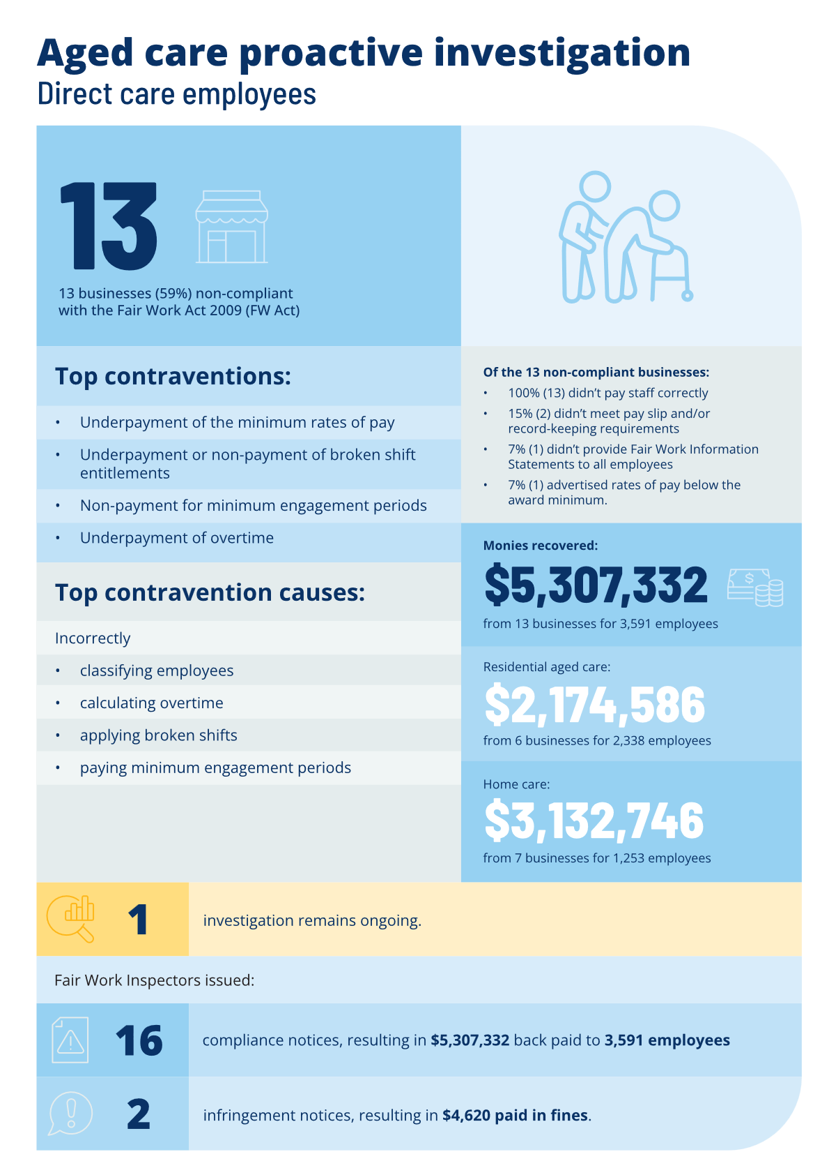

Background
The ACSS is made up of approximately 2,000 registered providers delivering aged care support to people who need help in their own home or who can no longer live at home. It is comprised of not-for-profits, private, and government organisations who provide care, accommodation, and support services.
The ACSS has a large employee footprint, and is a key element of the Australian economy, particularly as the population ages. It supports over 1 million older Australians annually, providing crucial social infrastructure that supports workforce participation and contributes to direct and indirect economic activity. The sector has two predominant service types, residential care and home care. Home care providers provide home care services that are also provided through digital platforms that facilitate connections between care workers and aged care clients.
The demographics of aged care workers have consistently been proportionately high levels of female, casual, young and migrant workers. This is replicated in digital platform work, combined with reports that many platform workers are new to care and support work.
In 2024, we established ACSS as a priority sector following data and environmental analysis, as well as internal and external stakeholder consultation. The reasons for prioritising the ACSS included:
- a large employee footprint
- the sector’s projected expansion and public commentary detailing allegations of low pay, unpaid work, high workloads
- undertraining as well as understaffing as identified through the Aged Care Royal Commission.
Our priority areas provide a framework for us to make decisions about our resource allocation, areas or behaviours. Our strategic enforcement initiatives are designed to have a sector or system-wide impact in a priority area.
In consultation with stakeholders and informed by data and intelligence, our activities may include:
- education and communication
- tailored material and resources
- influencing sector-wide compliance and governance
- targeted compliance and enforcement activities.

Aged care proactive investigation overview

Investigation description
With the objective to understand the drivers of non-compliance and create sector wide impacts, we commenced a proactive investigation in early 2025.
We undertook a nation-wide proactive investigation testing the compliance of 22 aged care employers with direct care employees engaged to perform work in:
- residential care
- home care services
- home care services – digital platforms.
For the purposes of the investigation, ‘direct care employees’ are employees who are engaged to perform roles including personal care workers, assistants in nursing, enrolled nurses and registered nurses.
Organisations were selected based on factors including any history of non-compliance with the FW Act, requests for assistance, enquiries and anonymous reports from staff members received by the FWO, a cross section of metropolitan and regional locations, entities that were not the subject of a current investigation and/or their employment of visa holders, among other intelligence.
The investigation sought information from employers for a representative sample of direct care employees for a 3-month assessment period between 1 October 2024 to 31 December 2024, and included:
- announced and unannounced inspections at 27 locations
- interviews with workers and management
- use of statutory information gathering powers including notices to produce
- identification of non-compliance and reporting of causes and drivers of non-compliance
- consultation with reference group members (see below) and relevant co-regulators.

Investigation findings
- 22 businesses were investigated
- 59% (13) were non-compliant with Commonwealth workplace laws in one or more respects
- 36% (8) were compliant with their obligations
- 1 business remains the subject of an ongoing investigation.

We issued:
- 16 compliance notices to 13 businesses:
- 8 to residential aged care businesses
- 8 to home care businesses
- 2 infringement notices to 2 businesses in residential aged care.
We recovered $5,307,332 for 3,591 employees, and 2 businesses paid $4,620 in fines.

Contraventions identified by service type
Contraventions | Instruments contravened | Causes of non-compliance
Residential aged care
- Base rates  - Weekend penalties  - Overtime  - Shift allowances  - Broken shift allowances  - Public holiday rates  - Annual leave and leave loading  - Personal leave  - Pay slip content  - Record-keeping - time records  - Failure to provide the Fair Work Information Statement. | - One or multiple applicable enterprise agreements  - Aged Care Award 2010 [MA000018]  - Nurses Award 2020 [MA000034]  - National Employment Standards. | - Incorrectly classifying employees  - Failing to ensure the base rate of pay under an applicable enterprise agreement was at least the base rate of the underlying award  - Incorrectly calculating overtime  - Payroll configuration  - Failing to keep adequate records of actual hours worked.
Home care
- Base rates  - Weekend penalties  - Shift penalties  - Overtime  - Travel time and km’s  - Broken shift allowances  - Minimum engagement  - Public holiday rates  - Annual leave  - Personal leave  - Advertising rates of pay that would contravene a Fair Work instrument. | - Social, Community, Home Care and Disability Services (SCHADS) Industry Award 2010 [MA000100]  - Nurses Award 2020 [MA000034]  - National Employment Standards  - An applicable enterprise agreement. | - Incorrectly classifying employees – SCHADS stream  - Incorrectly classifying employees – qualification  - Incorrectly applying broken shifts  - Incorrectly paying minimum engagement periods.

Proactive investigation enforcement results by service type

Residential aged care
Outcome type | Number issued | Total recoveries ($) | Total penalties ($) | Employees back paid
Compliance notices | 8 | $2,174,586 | 0 | 2,338
Infringement notices | 2 | 0 | $4,620

Home care
Outcome type | Number issued | Total recoveries ($) | Total penalties ($) | Employees back paid
Compliance notices | 8 | $3,132,746 | 0 | 1,253
Infringement notices | 0 | 0 | 0

Recovery observations
During the investigation, employers were highly cooperative, responsive and proactive, often rectifying underpayments swiftly, including across large employee cohorts and for extended historical periods beyond statutory requirements. These behaviours indicated most employers were committed to undertaking internal reviews and implementing assurance measures to strengthen their practices.
The monetary recoveries through our proactive investigation can be attributed to the (large) size of the workforce as well as the responsiveness of employers to rectify issues quickly for employees outside of the sample employees and periods exceeding the rectification period.
Recoveries for employees have improved through direct engagement with employers where we detailed our investigation findings, sought to understand the causes of non-compliance and encouraged employers to consider the broader impacts of the issues found - highlighting where the FWO had identified non-compliance in a sample of employees, others may also be impacted.

Case study
During our proactive investigation we examined an aged care provider delivering home care services and tested their compliance with workplace laws for a representative sample of employees and sample period of 3 months.
We found that casual home care employees were underpaid due to failures to correctly apply broken shift allowances and minimum engagement periods required under the SCHADS Award. We communicated our findings and required the provider to rectify the non-compliance for sample employees and the sample period, detailing further that that other employees were possibly also similarly impacted.
The provider quickly responded, seeking their own advice to clarify broken shift and minimum engagement application, calculating and rectifying the issue for all impacted employees, conducting a full workforce audit and back-paying over $2 million to more than 600 employees back to 2023 (when the error began).
The non-compliance was attributed to a misinterpretation of award provisions and historical industrial relations advice and was compounded due to the number of employees impacted and the time that had elapsed since the error arose.
The provider commenced their own audit to identify and remediate affected employees, took corrective actions including implementing system improvements, updating its payroll system and designed and delivered targeted and ongoing training to HR and payroll teams to prevent recurrence.

Learnings for employers

Ensure correct instrument interpretation
Misunderstanding provisions can lead to large underpayments, even where the error is small in isolation. This is especially the case where employers engage large numbers of workers or misapplication of provision goes untested for prolonged periods —seek advice early and validate it.

Strengthen payroll and rostering systems
Systems need to be configured correctly and tested to verify correct application at regular intervals to ensure ongoing compliance.

Invest in targeted training
Payroll, rostering, and management staff may benefit from regular practical training on industrial instrument obligations and updates.

Undertake proactive audits
Regular internal audits can surface issues early and reduce the incidence of non-compliance and scale of remediation.

Act quickly on non-compliance
Prompt remediation, workforce reviews, and transparent engagement with regulators, unions and employees can reduce compliance risks and support a culture of compliance.

Consider compliance with broader obligations
Aged care providers operate within a regulated environment and must comply with a range of workforce, financial and prudential obligations under the Aged Care Act 2024. Workforce compliance issues may indicate broader risks to an aged care provider's ability to meet its obligations.
The Aged Care Quality and Safety Commission monitors these risks including through intelligence sharing with agencies like FWO to review and investigate potential non-compliance.

Working collaboratively
Since determining aged care services as a priority area, we have been working closely with members of our Aged Care Services Reference Group, a tripartite initiative to enhance compliance with workplace laws.
This reference group consists of senior FWO leaders, the peak employer body Ageing Australia, and unions representing care workers: the Health Services Union, the Australian Nursing and Midwifery Federation, and the United Workers Union.
We meet regularly and consult frequently with members of the reference group, learning from their unique knowledge and understanding of the ACSS. We seek their advice, feedback and partnership to promote a culture of compliance through educational and compliance initiatives.
We are an impartial and independent regulator, committed to acting as a model litigant, accordingly the reference group is consultative only and not a decision-making body of FWO.
We also work closely with co-regulators such as the Aged Care Quality and Safety Commission and Australian Border Force to share intelligence, coordinate compliance activities and strengthen deterrence. In the aged care services proactive investigation, engagement with these co-regulators supported parallel regulation and coordinated responses.

Resources
- Working in the aged care industry - Fair Work Ombudsman
- Understanding the Social, Community, Home Care and Disability Services Award - Fair Work Ombudsman
- Pay slips and record-keeping - Fair Work Ombudsman
- P.A.C.T Home
- Payroll remediation program guide

Provider Register | Aged Care Quality and Safety Commission
People using aged care - AIHW Gen
Care and support economy – state of play | PM&C
2023 ACPWS Summary Report (gen-agedcaredata.gov.au)
Aged Care Royal Commission Final Report: Summary
Some businesses received more than 1 compliance notice, and/or a combination of compliance notices and infringement notices, as part of the FWO’s investigations.

