



Know your workplace rights in the Australian maritime industry
Workers on certain Australian owned or operated vessels have rights and protections under Australian workplace laws.

Did you know…
If any of your personal belongings are damaged or lost while working, depending on the circumstances your employer may need to help pay for the loss or damage.
Workers on a vessel with a foreign flag may also have rights and protections under Australian workplace laws. Those laws, including minimum pay rates, can apply when the vessel is undertaking a voyage authorised by a temporary licence and has commenced at least 2 voyages authorised by a temporary licence within 12 months before commencing that 3rd voyage.
These rights and protections may come from:
- The Fair Work Act – Australia’s main set of workplace laws
- An award or enterprise agreement – legal documents with rules about work

Seagoing Industry Award
If you are covered by Australian workplace laws and you work on a cargo vessel, passenger vessel or research vessel that goes to sea, your entitlements may come from the Seagoing Industry Award. The Seagoing Industry Award includes rules that set out:
- Minimum pay rates and extra pay for overtime work
- How much leave you are entitled to
- How many hours you can work at a time and how much rest time you need between shifts.
Some workers in the maritime industry might get their entitlements from another award. If you are unsure which award applies, the Fair Work Ombudsman can help. You can call us on 13 13 94 or visit our website at fairwork.gov.au/findmyaward



For more information on your workplace rights visit our maritime industry webpage at fairwork.gov.au/maritime
For help in your language visit fairwork.gov.au/language-help

Who can help if I have an issue?
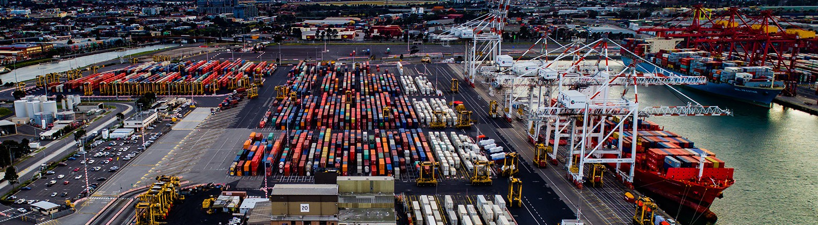

The Fair Work Ombudsman
We are the Fair Work Ombudsman. We provide free information to people about their rights at work. This includes information about bullying, sexual harassment or discrimination. We also help people if they have a problem with their pay and rights at work. If you have a problem at work or if you aren’t being paid properly you can contact us by:
- Emailing us at maritime@fwo.gov.au
- Calling us on 13 13 94

Contact us anonymously
Do you want to report a problem without telling us who you are?
Make an anonymous report at
fairwork.gov.au/anonymous-report

Do you need an interpreter to contact the Fair Work Ombudsman?
Contact the free Translating and Interpreting Service on 13 14 50. Tell the operator which language you speak. Then, give them our number, 13 13 94. They will call us for you and translate.

Where to find help
Working in the maritime industry can be challenging. To find different organisations that can help support the health and wellbeing of seafarers visit amsa.gov.au/seafarer-support

Australian Maritime Officers Union
Can help professional, administrative, supervisory and technical employees in the maritime industry
- Phone: +61 2 9264 2388
- Website: amou.com.au
International Transport Worker’s Federation
Represents transport workers globally and can provide assistance if you have a problem
- Phone: +61 2 9265 8453
- Website: itfseafarers.org
Australian Maritime Safety Authority
Is a government agency that provides safety and environment protection services to the Australian maritime industry
- Phone: +61 2 6279 5000
- Website: amsa.gov.au
Maritime Union of Australia
Can help members with workplace issues
- Phone: +61 9267 9134
- Website: mua.org.au

