

2026-2029

2026-2029

2026-2029

2026-2029

2026-2029

2026-2029

2026-2029

2026-2029

2026-2029

2026-2029

2026-2029

2026-2029

2026-2029

2026-2029

2026-2029

2026-2029
Multicultural Access and Equity Action Plan

Multicultural Access and Equity Action Plan

Multicultural Access and Equity Action Plan

Multicultural Access and Equity Action Plan

Multicultural Access and Equity Action Plan

Multicultural Access and Equity Action Plan

Multicultural Access and Equity Action Plan

Multicultural Access and Equity Action Plan

Multicultural Access and Equity Action Plan

Multicultural Access and Equity Action Plan

Multicultural Access and Equity Action Plan

Multicultural Access and Equity Action Plan

Multicultural Access and Equity Action Plan

Multicultural Access and Equity Action Plan

Multicultural Access and Equity Action Plan

Multicultural Access and Equity Action Plan



Acknowledgment of Country
In the spirit of reconciliation, the Office of the Fair Work Ombudsman (FWO) acknowledges the Traditional Custodians of Country throughout Australia and their continuing connection to land, waters and community. We pay our respect to them and their Cultures, and their Elders, past and present and extend that respect to all Aboriginal and Torres Strait Islander peoples today.

About our artwork: Stepping forward
Stepping forward represents taking the next step on the journey towards reconciliation and the potential possible when everyone is included. Connecting with diverse peoples - meeting, listening and sharing together - can build respect and trust. Working in concert for a common purpose and united in the mission to make meaningful change. It serves as a reminder of the dynamism and vibrancy of First Nations peoples and the lands from which they come, making possible the emergence of new ideas and ways of being that enables the envisioning of a brighter future.
Artist: Timothy Buckley

Other acknowledgements
This Multicultural Access and Equity Action Plan is presented with appreciation for the contributions of employees across the Office of the Fair Work Ombudsman. In particular, we acknowledge the insights, lived experiences and leadership of our culturally and linguistically diverse colleagues, whose perspectives continue to shape a more inclusive and responsive workplace.

Contents
Foreword by Anna Booth, Fair Work Ombudsman 2
Message from our Executive Champion for Cultural and Linguistic Diversity, Dimitar Dimitrovski 3
Cultural Diversity: A snapshot 4
Our vision 5
Our role 5
Overview 5
Our Journey 6
What we will deliver 7
Leadership 8
Engagement 9
Responsiveness 11
Performance 12
Capability 13
Openness 14
Last updated: January 2026
© Copyright Fair Work Ombudsman


Foreword by Anna Booth, Fair Work Ombudsman

I am delighted to present the Office of the Fair Work Ombudsman’s (FWO) Multicultural Access and Equity Action Plan 2026-2029 (the Plan). Our vision of working for fairer workplaces starts with enabling equal access to information, advice and assistance, and this Plan publicly reaffirms our ongoing commitment to improving this access and to achieving equal outcomes for multicultural communities.
Although we have a longstanding commitment to ensuring our policies, programs and services are accessible to all workplace participants, regardless of their cultural and linguistic background, we can and should always strive to do better. I want the FWO to lead by example in the way that we embrace diversity, and this Plan sets out the actions we will take as we continuously improve the way we both support workplace community participants and celebrate cultural and linguistic diversity within our agency.
Many of Australia’s 14.6 million workers and their employers come from culturally and linguistically diverse (CALD) backgrounds, including newly arrived migrants and refugees and some on temporary visas. Diversity of individual experience brings a richness and strength to our workplaces that should be celebrated. Unfortunately, we know that workers from CALD backgrounds are more likely to experience harm or ill-treatment, have less ability to advocate for themselves in their workplace or may experience barriers when seeking assistance. Addressing the obstacles faced by CALD workers requires a proactive and coordinated approach from all areas of the FWO, and this Plan will ensure that we are effectively reaching vulnerable or at-risk members of our community.
I am personally committed to fostering a workplace culture where everyone feels respected, valued, and empowered to contribute their lived experience to our work. We are conscious that our own workplace, like any other, is not immune to obstacles that our CALD staff might face at work, and have ensured that we make cultural awareness initiatives, staff networks and ongoing training available for all staff. Cultivating a workforce that reflects the diversity of the community that we serve is crucial to leading by example.
The Plan sets out the tangible steps that we will take as an agency as we continue on our journey to enhancing multicultural access and equity for all workplace participants. I look forward to working together with our staff and the workplace community to achieve these goals to serve the rich diversity of our nation.

Anna Booth
Fair Work Ombudsman

Message from our Executive Champion for Cultural and Linguistic Diversity, Dimitar Dimitrovski

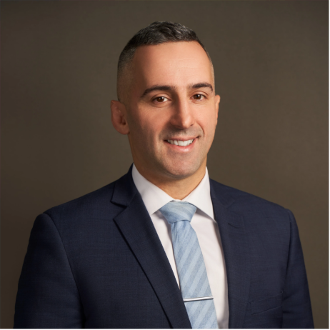As Executive Champion for Cultural and Linguistic Diversity, it is my privilege to join Anna in presenting our Multicultural Access and Equity Action Plan 2026-29.
My passion and advocacy for greater multicultural access and equity across the FWO’s work comes from a deeply personal place. Having moved to Australia as a teenager, I know first-hand how challenging it is to be suddenly immersed in a new culture with limited English. Making sure diverse voices are heard is crucial but it’s only the first step. Ensuring our rich multicultural experiences and perspectives are actively incorporated and reflected in the workplace is what’s really powerful and is why the actionable steps in the Plan are so important.
It's also why I’m especially proud to lead the FWO’s Culturally and Linguistically Diverse Employee Network. The group supports peer connections, celebrates cultural identities, enhances cultural capability, and promotes the representation of culturally and linguistically diverse staff across the FWO. Cultivating meaningful discussions and creating space for diverse voices to be heard not only ensures everyone can contribute and thrive within our workplace, but helps strengthen and spark new ideas that improve our work with Australia’s multicultural workplace community.
I’d like to extend my sincere thanks to everyone who contributed to the development of this Plan. Your insights have been instrumental in ensuring our agency has the capability to respond to and engage with diversity in all the work that we do, now and into the future.

Dimitar Dimitrovski
Executive Champion for Cultural and Linguistic Diversity

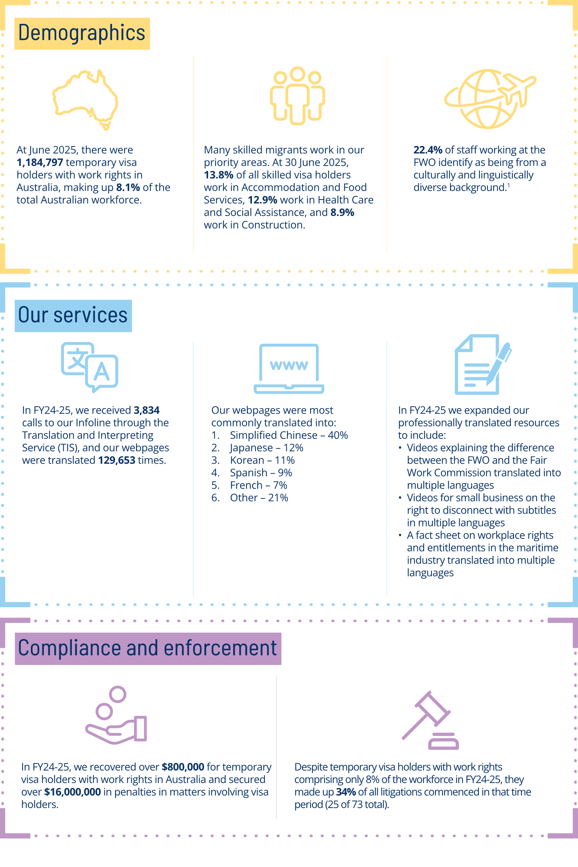
Cultural Diversity: A snapshot

Our vision
Our vision is for a fair and inclusive workplace relations system in Australia – one in which all participants, including those from culturally and linguistically diverse backgrounds, can confidently understand and engage with their workplace rights and responsibilities.
To achieve our vision, we strive to ensure that our services are accessible, inclusive and trusted by the rich diversity of identities and backgrounds that are represented in Australian workplaces.


Our role
The Fair Work Ombudsman (FWO) is the national workplace regulator established by the Fair Work Act 2009 (Cth) (FW Act). Our purpose is to promote harmonious, productive, cooperative and compliant workplace relations in Australia.
We regulate a workplace community of around 1 million workplaces and 14.6 million workers through a range of functions including education, advice, compliance and enforcement. The community is incredibly diverse. In addition to the more than 1 million temporary visa holders with work rights in Australia, nearly half of all Australians were either born overseas or have a parent who was. Australians born overseas come from across the globe – with more than 230 countries of origin represented.
All workers in Australia, regardless of their background or visa status, have the same rights at work under the FW Act. We are here to help everyone understand their rights and responsibilities at work, and to uphold workplace standards for all participants in the Australian workplace relations system.
Our purpose and functions are further outlined in our Corporate Plan.

Overview
This Plan outlines the practical steps we’ll take to improve access and equity for culturally and linguistically diverse workplace participants. It reflects our ongoing commitment to making our services easier to access, more inclusive and better suited to the needs of culturally and linguistically diverse communities.

This Plan aligns with the Australian Government’s Multicultural Access and Equity Policy, and complements our Diversity and Inclusion Strategy 2024-2027, which sets out our commitment to fostering a respectful, inclusive and diverse workplace for our staff.
Throughout this Plan the term ‘culturally and linguistically diverse’ (CALD) is used to describe individuals and communities of Australia’s cultural groups who are not from an English-speaking, Anglo-Celtic background.
‘CALD’ is a broad term that reflects that people may have different life experiences depending on their cultural background or identity, visa status, English language skills, how long they’ve been in Australia, or how familiar they are with working in Australia. People may also identify with more than one cultural identity, ethnicity or cultural background.
We acknowledge that people from CALD backgrounds can experience difficulties accessing services that are compounded by other aspects of their identity, including gender, sexuality, disability and age. We strive to ensure that our activities consider issues of intersectionality, and that no one is left behind in our efforts to enhance multicultural access and equity.
To avoid duplication, this Plan does not cover First Nations people. We recognise and respect Aboriginal and Torres Strait Islander peoples’ unique position as First Nations Peoples. Our Innovate Reconciliation Action Plan September 2024 – September 2026 sets out our commitment to ensuring that First Nations people have equitable access to our policies, programs and services.

Our journey
We are proud of our achievements towards multicultural access and equity. We ensure access to our services through our enduring commitment to provide education and assistance to vulnerable workers, including migrant workers, and CALD small business employers and employees. Our regulatory activities strive to deliver outcomes for CALD workplace participants on par with those for all other workplace participants.
To support and encourage access to our services, we do not require people to disclose their cultural background when engaging with us. As a result, our data likely under-reports the proportion of CALD workplace participants who access our services. Throughout our journey to date, we know that CALD workplace participants are less likely to access our services and may be hesitant to ask for our help, for reasons including language barriers, lack of awareness about the Australian workplace relations system, and concerns about visa status.
We direct our resources toward our priority areas, which are those where there is significant risk or a history of systemic non-compliance. When setting our priorities, we consider factors including data, intelligence and our experience relating to vulnerable cohorts. Our priority areas include agriculture, building and construction, aged care and disability support services, and the fast food, restaurant and cafe sector, which all employ a high proportion of visa holders and migrants.
Our primary education and advice channel is our website, which hosts a suite of professionally translated resources and webpages, available in over 30 languages. Since 2018, professionally translated content has been complemented by an automatic translator tool, which enhances accessibility of our information by allowing CALD workplace participants to view webpages in their own language, in real time. The FWO manages a professionally translated custom dictionary within the automatic translator that allows us to upload definitions for terms that have specific meanings under Australian workplace laws. Migrant communities and their intermediaries have embraced this initiative.
CALD customers can also contact our Fair Work Infoline and our Small Business Helpline for free advice about workplace rights and obligations. Free interpreter access is available through the Translating and Interpreting Service (TIS). CALD workplace participants also have the option to discreetly notify us about suspected breaches of workplace laws by making an anonymous report. Anonymous reports can be made in 16 languages other than English, empowering CALD workplace participants to report issues safely and in their preferred language.
We regularly develop new professionally translated education resources and content to help the community understand their workplace rights and obligations as well as changes to workplace laws. We also continually review and update our existing materials to ensure we meet the needs of priority cohorts and sectors, including CALD workplace participants. Our offerings include:
- support for migrant workers with dedicated information on our website, available in English and in-language (automatic translator tool), including tailored information for migrant workers in the agriculture and horticulture sectors on our Horticulture Showcase
- support for workers and employers participating in the Pacific Australia Labour Mobility (PALM) scheme through the development of tailored resources, available in English and in-language
- support for small business employers on our Small Business Showcase - a central point for small business employers to quickly and easily access tailored workplace information in English and in-language (automatic translator tool)
- support for CALD small business through in-language videos on pay, entitlements and agreement making, which we developed in partnership with the Fair Work Commission as well as videos to help employers understand and apply the new ‘right to disconnect’ laws.
If it is not feasible to create an in-language version of an education resource, we include information in the English version of that resource about how employers and employees can get help in their language if they need it, for example by calling the TIS or visiting the ‘Language help’ section of our website.
Under Australian workplace laws all workers, including migrants and visa holders, are entitled to the same workplace rights, protections and entitlements as other Australian workers. Our Compliance and Enforcement Policy sets out the factors we consider when using our compliance and enforcement powers, including whether a person affected by alleged contraventions of workplace laws is from a CALD background. A significant proportion of litigations we commence involve migrant workers and this is one of the ways we seek to deliver equitable outcomes for them.
Working with other regulators through joint compliance operations is another key part of our strategic enforcement approach. We carry out proactive, intelligence-led activities to disrupt employers who exploit vulnerable workers, including CALD workplace participants, and our joint investigations, information sharing and coordinated actions broaden our reach and impact. We work closely with agencies such as the Australian Border Force and the Department of Home Affairs (Home Affairs) to assist migrant workers and their employers understand that migrant workers have the same workplace rights as all other workers under the FW Act.
We also work closely with intermediaries, such as community organisations, cross-government networks, and legal centres, to extend our reach to vulnerable communities, including migrant workers. These trusted groups play an important role in helping individuals understand their workplace rights and connect with our services. We recognise the importance of ongoing engagement with intermediaries and will continue to share resources and facilitate referrals to ensure vulnerable workers are better supported to seek assistance and resolve workplace issues.
As part of the Australian Public Service, we want to reflect the community we serve, which deepens our understanding of our customers to further improve our services and achieve equal outcomes for all workplace participants. Dedicated initiatives attract and support our workforce of people from diverse backgrounds. We equip our leaders to drive inclusivity, celebrate significant events, provide access to cultural leave, and pay a community language allowance to those who are required to regularly use their ability to communicate in a language other than English in the course of their work. We have also recently established the CALD Employee Network, which supports peer connection and cultural inclusion, and have appointed an Executive Champion for Cultural and Linguistic Diversity.


What we will deliver
Over the next 4 years, we will take actions to build upon and continue our journey towards accessible information, advice and assistance and equal outcomes for multicultural workplace participants. These actions reflect our commitment to continuously improving the way we support CALD workers and employers, and to ensuring our services are inclusive, responsive and trusted.
Our deliverables are grouped under the 6 commitments that are essential to multicultural access and equity across Australian Government programs and services:
Leadership | Responsiveness | Capability
Australian Government agencies will demonstrate a commitment to multicultural access and equity and take responsibility for its implementation | Australian Government agencies will have strategies in place to ensure that policies, programs, community interactions and service delivery are responsive to culturally and linguistically diverse Australians | Australian Government agencies will understand, and have the capacity to respond to, the cultural and linguistic diversity of Australia’s population
Engagement | Performance | Openness
Australian Government agencies will identify and strategically engage with culturally and linguistically diverse clients, stakeholders and communities | Australian Government agencies will have strong and clear mechanisms in place to measure their multicultural access and equity performance | Australian Government agencies will be transparent in their implementation of multicultural access and equity

1. Leadership
We commit to multicultural access and equity and take responsibility for its implementation.
Senior leaders have accountability and oversight of our journey towards multicultural access and equity via our established governance structures. The FWO’s strategic boards and committees ensure that we achieve our objectives, manage risk and meet our statutory obligations. The Accountability Sub-Committee is a standing committee of the Corporate Board and has responsibility for endorsing this Plan and maintaining oversight of its implementation. Progress reports will be provided annually to the Accountability Sub-Committee.
Our Executive Champion for Cultural and Linguistic Diversity advocates for multicultural access and equity, with a particular focus on the FWO’s internal culture. This includes promoting inclusion and allyship, and ensuring that CALD voices are heard, valued, and represented in decision-making. Leadership on multicultural access and equity issues isn’t limited to the senior executive – we have established active member roles within our CALD Employee Network. Active members are allocated paid time away from their regular duties to consider issues and perform tasks related to the activities of the network. By resourcing our networks, we ensure they remain responsive, representative, and impactful, while safeguarding their ongoing sustainability.
 | Deliverable |  | Timeline / Target
 |  | The Executive Champion for Cultural and Linguistic Diversity is responsible for fostering an inclusive culture across the FWO and representing the needs of CALD staff and customers. | Ongoing
 |  | Active member roles are established and embedded within the FWO’s CALD Employee Network. | Ongoing
 |  | A senior leader has responsibility and oversight of deliverables under the Plan. | Ongoing
 |  | Appropriate governance oversight is maintained via regular reporting on the FWO’s progress towards achieving the deliverables set out in the Plan. | Annually

2. Engagement
We identify and strategically engage with culturally and linguistically diverse workplace participants, stakeholders and communities.
Our Statement of Intent highlights our strong commitment to meaningful engagement with a wide range of stakeholders including our Advisory Group and Reference Groups, community organisations, government entities and others. Our approach to stakeholder engagement is also guided by our public facing Stakeholder Engagement Strategy. By working together, we ensure our advice and education services meet the needs of diverse vulnerable communities, including CALD groups.
To effectively reach CALD communities, the FWO actively engages through a range of tailored initiatives. We host and participate in expos, workshops, webinars and presentations specifically designed for migrant workers and international students, ensuring our messages resonate with their experiences. Key messages from our communications campaigns are delivered in languages other than English, and we publish translated media releases to make information accessible to all. Educational resources such as in-language fact sheets and videos supporting PALM scheme participants are widely distributed, helping workers with low literacy understand their rights and obligations. Additionally, we extend our reach to regional and remote areas through dedicated outreach and partnerships with local stakeholders.
 | Deliverable | Timeline / Target
 | Publish and maintain inclusive website content and education resources in multiple languages that support multicultural workplace participants. This includes:  - professionally translated online information and resources including animated storyboards, and in-language videos  - an automatic translator tool on www.fairwork.gov.au, www.horticulture.fairwork.gov.au, and www.smallbusiness.fairwork.gov.au  - Easy Read resources that provide inclusive and accessible content for those who need it  - providing pathways to language help in education resources when it is not feasible to create in-language versions. | Updates to our online resources will be made as required, including in response to legislative changes and from behavioural insights and learnings when user testing is conducted.  As set out in our Corporate Plan 2025-26, the FWO will undertake quarterly surveys to determine the effectiveness of our digital tools in helping users to understand their workplace rights and obligations.
 | Pitch media releases, including in-language, to CALD media to enhance awareness of the FWO and what we do and maximise the deterrence effect of significant litigations, particularly where relevant to multicultural workplace participants. | An average of 1 media release will be professionally translated into languages other than English per month.
 | Promote key FWO messages via external communications activities that are designed to meet the information needs of multicultural workplace participants. | Two (or more) targeted activities per year that focus on marketing information / resources to multicultural workplace participants, including consideration of in-language content.
 | Develop and deliver an annual program of webinars to assist workplace participants to understand their rights and responsibilities under Australian workplace laws:  - the FWO will have regard to the information needs of multicultural workplace participants in the promotion, development and delivery of the program  - audience reach will be enhanced for multicultural workplace participants by hosting select webinars relevant to CALD audiences on YouTube for a minimum of 6 months. | More than 10 webinars will be delivered annually.  Webinar recordings will be hosted on YouTube to enhance accessibility.
 | Identify and harness the best mechanisms to engage with and seek feedback from CALD communities about our multicultural access and equity performance, including engagement with CALD employers and their representatives. | Continue to engage with multicultural stakeholders, further develop stakeholder relationships, and collaborate with service providers and other government agencies engaging with multicultural communities.
 | Promote key FWO messages and external communication activities via stakeholder meetings and events with the aim to meet the information needs of multicultural workplace participants. | Deliver tailored workplace relations information to CALD communities through stakeholder meetings, relationship building, and participation in community events.

3. Responsiveness
We have strategies in place to ensure that our policies, programs, community interactions and service delivery (whether in-house or outsourced) are responsive to culturally and linguistically diverse Australians and deliver equal outcomes.
Being responsive to the needs of CALD workplace participants is necessary to effectively discharge our statutory obligations as the Australian workplace relations regulator. We recognise that CALD workplace participants may be hesitant to ask for our help and strive to support people from CALD backgrounds to approach us, understand their rights, meet their obligations, and receive equal outcomes under the Australian workplace relations system through our services.
 | Deliverable | Timeline / Target
 | Assess and triage reports received via our anonymous reporting tool that relate to the alleged exploitation of multicultural workplace participants, including in-language reports. | Ongoing
 | Maintain an internal translation strategy and translation policy to guide decision-making about the services and material we offer the CALD community. | Decisions about the information and services we offer the CALD community are made in accordance with the principles set out in the translation strategy and translation policy.  The translation strategy and translation policy are reviewed regularly to ensure guidance remains appropriate.
 | Review the FWO’s suite of professionally translated education resources to ensure resources prioritise the information needs of multicultural workplace participants. | Ongoing
 | Support workers participating in the Pacific Australia Labour Mobility (PALM) scheme to understand their workplace entitlements and protections, and the FWO’s role and services. | PALM scheme workers receive tailored information at arrival presentations delivered by the FWO, in accordance with our supporting activities under the Australian Government’s PALM scheme on an ongoing basis.
 | Explore ways to ensure procurement incorporates costs of language and translation services or other services to remove barriers to multicultural customers. | Ongoing
 | Act on data and intelligence to initiate investigations to address non-compliance involving migrant workers and visa holders in our priority sectors and to deliver outcomes for CALD workplace participants which are on par with those for other workplace participants. | Ongoing

4. Performance
Clear mechanisms are in place to measure our multicultural access and equity performance.
Through our Technology Strategy and Data Strategy 2025-2027 we are focussed on best practice data collection, and investing in technology systems to support customer experience when seeking information and support.
Analysis of internal and external data informs how we measure our effectiveness in reaching multicultural communities, and this is shared across business areas to inform future activities and identify opportunities for improvement. This includes resource downloads, the use of interpreters, reach from our communications campaigns, and compliance and enforcement outcomes.
We also seek feedback from multicultural communities and stakeholders through user research and testing, surveys and polls which inform the design of resources and educational content. It’s important that we receive and respond to feedback from CALD communities, and tailor our services so that they meet the diverse needs within those communities. When suitable, we also utilise our standing tripartite Advisory Group comprising of peak employer and worker representatives, Reference Groups and Community Legal Centre Employment Law Services Forum to gather feedback so that our current and future programs and services are fit for purpose.
 | Deliverable |  | Timeline / Target
4.1 |  | Respond to feedback from our customers and stakeholders about our website content and education resources and, where appropriate, implement changes to ensure accessibility and cultural appropriateness. | Ongoing
4.2 |  | Explore opportunities to improve capture and use of data related to multicultural workplace participants, in alignment with the principles set out in our Data Strategy 2025-2027. | Ongoing

5. Capability
We understand, and have capacity to respond to, the cultural and linguistic diversity of Australia’s population.
Internal initiatives that build knowledge, skills and capability to support Australia’s multicultural population enhance our recruitment and retention of CALD staff. Our agency is committed to providing a safe and inclusive workplace and we recognise the value that colleagues from CALD backgrounds add to our work through their skills, experiences and perspectives.
 | Deliverable | Timeline / Target
 | Develop an agency CALD Employment Strategy in alignment with our Diversity and Inclusion Strategy 2024-2027. | Development to commence in 2026.
 | Recognise events, occasions and staff stories that celebrate cultural diversity and community through our internal communications platforms (including intranet-based staff spaces). | Ongoing
 | Maintain the Linguistically Diverse Employee Register as a voluntary internal resource to support culturally responsive service delivery. | Ongoing
 | Manage the assessment and provision of the FWO’s Community Language Allowance to provide incentive for the retention of CALD employees. | Ongoing
 | Identify and promote training opportunities for FWO staff that enhance cultural awareness and cultural sensitivity. | 30 June 2026
 | Explore opportunities to deliver training for frontline staff on ‘tips and tricks’ for the effective use of interpreters. | Ongoing
 | Implement learnings about cultural appropriateness from international engagement activities undertaken as part of the FWO’s International Engagement Strategy. | Development to commence in 2026.

6. Openness
We are transparent in our implementation of multicultural access and equity initiatives.
This Plan is published on our website alongside our Diversity and Inclusion Strategy 2024–2027, Gender Equality Action Plan 2024–2027, and Innovate Reconciliation Action Plan September 2024 – September 2026. These documents outline our broader commitments to inclusion and equitable access for all communities.
We will also report on our progress by contributing to whole-of-government reporting on multicultural access and equity, and on our activities through our annual reports.
 | Deliverable |  | Timeline / Target
 |  | This Plan is published on our website. | The Plan is published on www.fairwork.gov.au in the first quarter of 2026 and updates are made as required.
 |  | We will report on our multicultural access and equity performance to Home Affairs. | Annually, or as requested by Home Affairs.
 |  | The FWO’s commitment and progress towards achieving multicultural access and equity (including tracking progress of the deliverables outlined in this Plan) will be promoted internally via intranet articles. | At least once per year.
Contact us  Fair Work online: fairwork.gov.au  Fair Work Infoline: 13 13 94  Need language help?  Contact the Translating and Interpreting Service (TIS) on  13 14 50 | Help for people who are deaf or have hearing or speech difficulties  You can contact us through the National Relay Service (NRS).  Select your preferred access option and give our phone number: 13 13 94

As at 30 June 2025
Australian Bureau of Statistics (ABS), Counts of Australian Businesses, including Entries and Exits, July 2021 - June 2025 | Australian Bureau of Statistics
ABS, Labour Force, Australia, October 2025 | Australian Bureau of Statistics
ABS, 2021 Census: Nearly half of Australians have a parent born overseas | Australian Bureau of Statistics
Australian Government Centre for Population, Changes in Australia’s overseas born population since Federation | Centre for Population

