

Fair Work Ombudsman   
Data Strategy 2025–2027

# Contents

Message from the Fair Work Ombudsman 2

Message from the Chief Data Officer 3

Vision 4

Purpose 4

Our data principles 5

Our operating environment 5

Future state 6

Our data priorities 8

Our data initiatives 8

Appendix – Roadmap 11

# Message from the Fair Work Ombudsman

I am delighted to present the Fair Work Ombudsman Data Strategy 2025–2027.

This is our first data strategy and an important step for the Fair Work Ombudsman (FWO) in our approach to risk-based, data informed and strategic compliance and enforcement.

This initial strategy focuses on building a strong foundation by establishing effective data governance, building a positive data culture and capability throughout the agency, and improving our use of data analytics.

This data strategy is a milestone for the FWO and is significant in our journey as we strive to be innovative in the way we provide services to the Australian community.

We are committed to working with other agencies and stakeholders as we develop our analytical capability with a view to sharing our data.

Data is key to future regulation as we embrace innovation and technology to detect non-compliance and advance our strategic and risk-based approach to compliance.

I am committed to leading the necessary cultural change and building the capability of our workforce that we need to unlock the potential of the data strategy. I am confident that it will enable us to be a modern regulator and maximise our public value.



**Anna Booth**

**Fair Work Ombudsman**

**June 2025**

# Message from the Chief Data Officer

In a rapidly evolving digital landscape, data is essential in driving innovation and strategic decision-making. A well-developed data strategy, co-designed with key internal stakeholders, is essential in transforming our data holdings into valuable insights, driving decision-making, and improving operational efficiency. It also ensures compliance with regulatory requirements, safeguarding data integrity and security.

## Importance of a data strategy

A data strategy is critical for several reasons:

* **Informed decision-making:** reliable data enables informed decisions, reducing uncertainty and enhancing strategic planning.
* **Operational efficiency:** streamlining data management processes supports increased efficiency, cost savings and productivity.
* **Compliance and security:** a robust data strategy ensures that data is managed in compliance with regulatory requirements, safeguarding it against breaches and misuse.

## Why we need a data strategy

The absence of a robust data strategy can lead to inconsistent data quality and missed opportunities. By implementing a comprehensive data strategy, we aim to:

* **Enhance data quality:** embed standards and practices to maintain high data quality and reliability.
* **Cultivate innovation:** enable data-driven innovation by providing the tools necessary for advanced analytics.
* **Empower staff:** equip staff with the insights they need to drive decision-making, efficiency and resilience in an ever-changing landscape.

A data strategy is not just a technical guide to data, but a strategic imperative that underpins our ability to promote harmonious, productive, cooperative, and compliant workplace relations in Australia.



**Naomi Bleeser**

**Chief Data Officer**

**June 2025**

# Vision

The vision underpinning our data strategy is as follows:

The Fair Work Ombudsman (FWO) is a modern, adaptive regulator that leverages data to fulfil our statutory functions, while minimising regulatory burden and maximising public value.

# Purpose

The purpose of this data strategy is to highlight data as a key agency asset, and drive our work as a data-driven and evidence led organisation.

This data strategy will guide us as we embed and leverage a culture that better understands, trusts, and uses data to support positive interventions and outcomes in Australian workplaces.

## Scope and definitions

For the purposes of this data strategy, we define data as:

Any information in a form capable of being communicated, analysed, or processed (whether by an individual or by computer or other automated means).[1]

All of the FWO’s data is within scope.

Our data strategy applies to information and platforms including:

* internal business systems
* open source and third-party data sources
* customer-facing platforms.

Public sector data is data that is lawfully collected, created, or held by – or on behalf of – a Commonwealth body. This includes, but is not limited to:

* program and service delivery data
* data collected through regulatory functions
* all third-party data
* data types that are structured (databases), semi-structured, and unstructured.

# Our data principles

The below graphic summarises the principles guiding our data strategy:

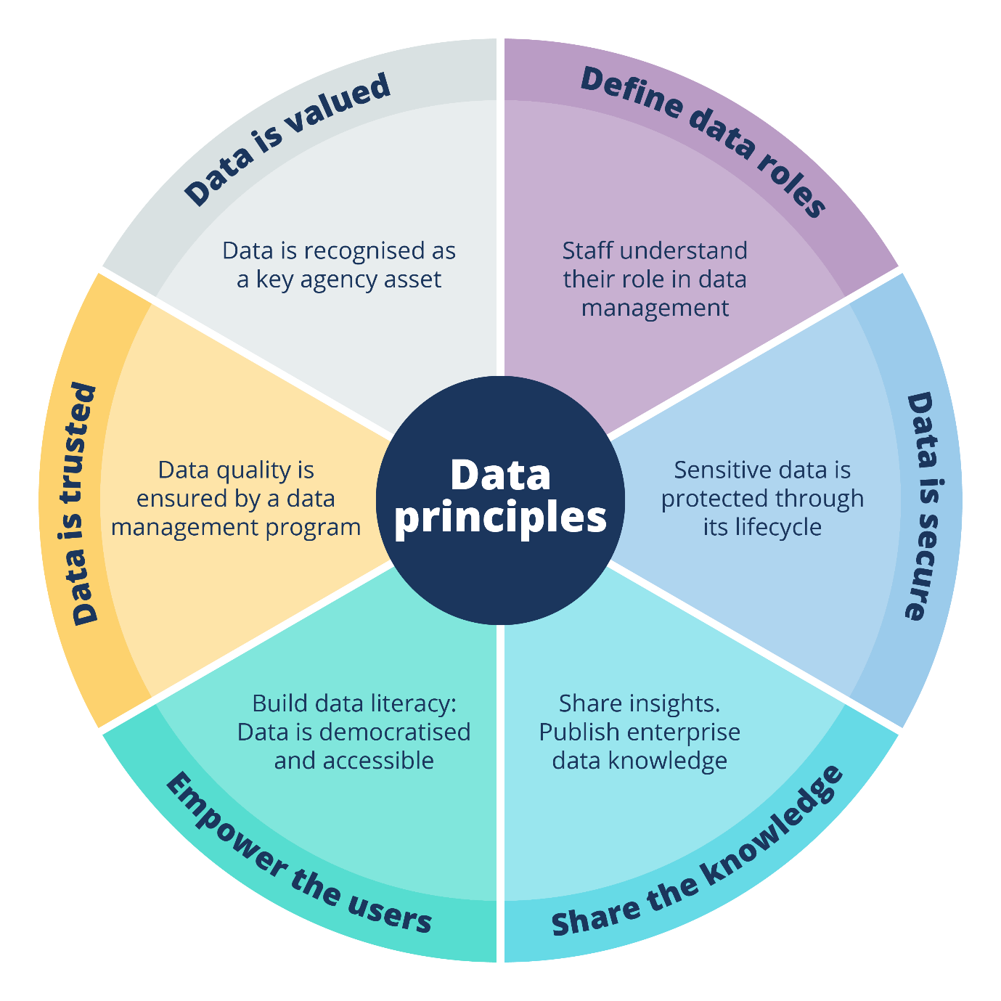

# Our operating environment

The FWO promotes harmonious, productive, cooperative, and compliant workplace relations in Australia. We do this through the following functions:

* provide education, assistance, advice and guidance to employers, employees, outworkers, outworker entities, organisations and other duty holders
* promote and monitor compliance with workplace laws
* inquire into and investigate breaches of the Fair Work Act 2009
* take appropriate enforcement action
* perform our statutory functions efficiently, effectively, economically, and ethically.

Regulatory agencies face an increasingly complex landscape where data is a strategic asset that:

* transforms regulatory intelligence into actionable insights, informing decisions
* anticipates emerging risks
* measures regulatory effectiveness
* maximises public value through improved services.

Within this landscape the FWO will enhance the way we record, use and understand our data so we can leverage insights to improve regulatory outcomes.

The key drivers for this data strategy are:

**Internal**

Supporting our strategic enforcement model, set out in our [Compliance and Enforcement Policy](https://www.fairwork.gov.au/about-us/compliance-and-enforcement)

Enabling risk-based and data-driven compliance and enforcement activities

Supporting evidence led strategy and decision-making and evaluation throughout the agency

Our strategic objectives (as set out in the [Corporate Plan](https://www.fairwork.gov.au/about-us/our-role-and-purpose/our-priorities/corporate-plan)), and alignment with policies, guides and plans including our Technology Strategy 2024–2027 and our approach to building capability.

**External**

Meeting community expectations of a modern, digitally proficient Australian Public Service (APS)

Maintaining public trust in the way we use and share data

Improving data sharing across the APS, including via the [*Data Availability and Transparency Act 2022* (Cth)](https://www.austlii.edu.au/cgi-bin/viewdb/au/legis/cth/consol_act/daata2022312/) (and the [DATA Scheme](https://www.datacommissioner.gov.au/the-data-scheme))

Meeting our obligations under whole-of-government policies and legislation, including the [Australian Data and Digital Government Strategy](https://www.dataanddigital.gov.au/), [Regulatory Policy, Practice & Performance Framework](https://www.regulatoryreform.gov.au/sites/default/files/Regulatory-Policy-Practice-and-Performance-Framework.pdf), [*Privacy Act 1988*](https://www.legislation.gov.au/Details/C2014C00076) (Cth), [*Archives Act 1983*](https://www.legislation.gov.au/Details/C2016C00772) (Cth), [*Public Governance, Performance and Accountability Act 2013*](https://www.legislation.gov.au/Details/C2014C00076) (Cth), and Protective Security Policy Framework.

# Future state

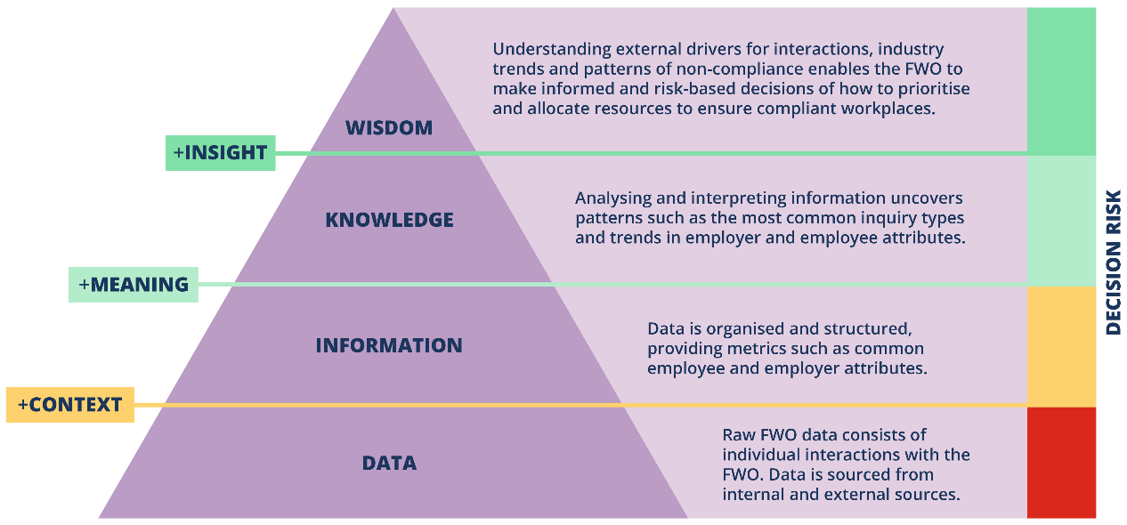The pyramid below outlines the progression of data from its raw form through to actionable insights. By adding context, meaning and insight to data, its utility is improved, providing greater value to the FWO, our staff, and the community that we serve.

Our target future state is decision-making that’s underpinned by the right data at the right time. Our data will be accessible, reliable, relevant, and easy to use.​

Our future state will be characterised by:

* strong data governance
* best practice analytics
* a positive data culture and capable workforce.

## Strong data governance

In our future:

* data is managed with transparent accountability and oversight
* a data governance framework guides data decisions and processes
* robust documentation of data flows and sources provides a shared operational understanding of data and points of risk
* the data lifecycle is managed from creation to deletion, ensuring compliance with record-keeping obligations, and security and privacy policies and legislation
* internal systems are designed with consideration of the user experience, data needs, and best practice data collection from the beginning.

## Best practice analytics

Our future state will see:

* our data needs are understood and met efficiently, maximising staff capacity
* us undertake more high impact or large-scale interventions, based on high quality data and insights
* decisions around agency priorities, proactive activities, and non-compliance risk identification and assessment are enhanced
* our staff access reliable, relevant reporting and business intelligence – meaning business decisions are informed by accurate insights.

## Positive data culture and a capable workforce

We are working to achieve a state where:

* our staff are confident collecting, finding, using, managing, interpreting, and analysing data relevant to their work
* current data and data resources are accessible through a ‘Data Hub’
* we can demonstrate an established data-driven culture, increased technical capabilities, and that domain knowledge is shared and connected
* data roles and responsibilities are defined and data career pathways and opportunities in a data professions stream are established
* all FWO staff are confident and capable to handle and engage with data in an ethical manner – with awareness of legislation and policies surrounding its access, use, retention and privacy.

# Our data priorities

We have identified our 3 key data priorities taking account of our current data maturity.

## Build strong data governance

Data governance is the foundation on which other data management functions are established. Improving the way data flows through an organisation enhances its value through:

* increased timeliness
* improved quality
* greater trust.

This data strategy will implement and improve practices and tools used across the FWO to manage and control data assets.

## Leverage best practice analytics

Analytics allow us to transform data into actionable insight, which is critical for developing and delivering effective regulatory interventions.

This data strategy will improve the extent to which analytics are used to inform decision-making at the FWO.

## Elevate data culture and capability

Elevating the data capability of all FWO employees is critical to developing a data-driven culture.

Through this strategy we will increase data literacy across the FWO.

# Our data initiatives

We have identified the following initiatives to advance our maturity in each priority area.

## Priority 1: Strong data governance

### Transparent oversight and accountability

* Develop a data governance framework.
* Re-establish a data governance decision-making body with published terms of reference.

### Data program management

* Publish a ‘Data Hub’ site on the FWO intranet.
* Establish data roles and responsibilities – identify, appoint and educate:
  + data owners
  + data custodians
  + data stewards.
* Develop and publish a ‘Data Asset Register’ on the ‘Data Hub’.
* Define and publish business processes for storing, accessing, and using data.

### Data quality standards

We will establish rules and practices to ensure data is accurate, consistent, and reliable – including:

* tracking and resolution of data issues
* monitoring and maintaining data quality and lineage
* collecting, storing and destroying data appropriately.

### Metadata management

Data asset management activities will include:

* establishing and documenting an enterprise data model
* curating enterprise data tables to deliver a ‘single source of truth’
* publishing data dictionaries on the ‘Data Hub’.

### Data security and privacy

* Publish data policies on ‘Data Hub’.
* Assess data activities against data security and privacy policies.

### Measurement of success

* Develop, publish, and make accessible to all staff the resources that are outlined in this data strategy.
* Improve our data maturity rating relating to data strategy and governance in the next APS Data Maturity Assessment.
* Data governance decision-making body meeting regularly with published terms of reference.
* Publishing a ‘Data Hub’ on the intranet.
* Publishing a Data Asset Register, with roles and responsibilities defined for each data asset.

## Priority 2: Best practice analytics

### Articulate information and data needs​

* Embed data requirements in business process changes and system design.
* Develop and implement a use-case framework to understand and prioritise data and information needs.

### Data analytics practice management

* Define and implement best practice guidelines for data analytics​ and products.
* Define and publish data architecture and standards, in accordance with our technology standards.
* Define the data product lifecycle and implement a management process for data products.

### Analytics innovation​

* Pilot quick wins using analytics with external datasets and domains.
* Prototype descriptive, diagnostic, predictive, and prescriptive analytics.

### Measurement of success

* Improve our data maturity rating relating to data analytics in the next APS Data Maturity Assessment.
* Publish data architecture and standards.
* Develop and publish best practice guidelines and frameworks for data analytics.

## Priority 3: Data-driven culture and capability

### Enhance data literacy​

* Assess existing data capabilities and determine desired capability level
* Develop a plan to elevate data capabilities to the desired level.​
* Include the essential learning clusters of the [APS Data Literacy Foundational Pathway](https://www.apsc.gov.au/initiatives-and-programs/aps-professional-streams/aps-data-profession/data-literacy) in core training in performance plans.

### Knowledge sharing and culture building

* Develop a communications plan that sets out activities to encourage staff to understand their role in our data ecosystem and enhance their data capabilities, and celebrate outcomes or activities that showcase good data culture. ​
* Promote active participation in the APS Data Professional Stream and Community of Practice to build knowledge and cultivate a culture of ethical data use.

### Measurement of success

* Majority of staff (greater than 80%) complete the essential learning clusters of the [APS Data Literacy Foundational Pathway](https://www.apsc.gov.au/initiatives-and-programs/aps-professional-streams/aps-data-profession/data-literacy) by 2026. All new starters to complete within 6 months.
* Response to APS Census question ‘My SES manager routinely promotes the use of data and evidence to deliver outcomes’ increases from 71% (2024) to 80% (by 2027).

# Appendix – Roadmap

1. Defined in the *Data Availability and Transparency Act 2022* (Cth).