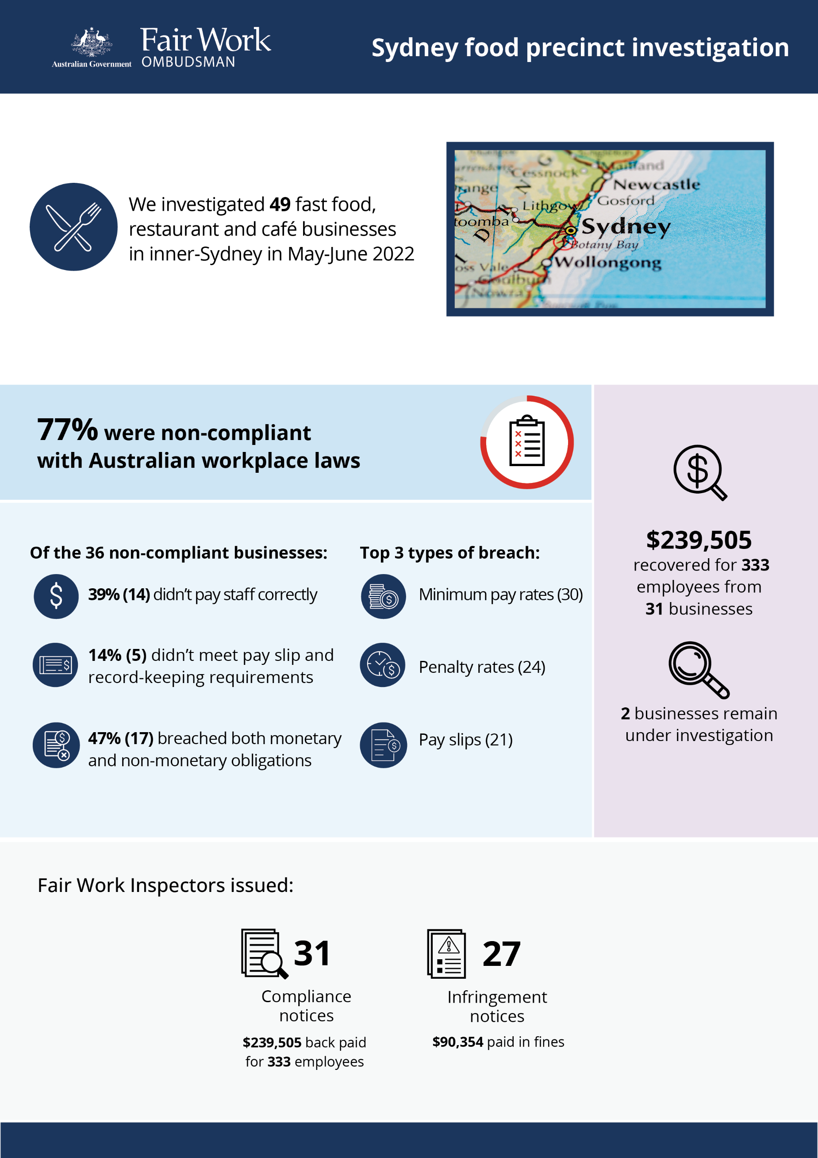

# Sydney food precinct investigation

## What we did and why

In May-June 2022, the Fair Work Ombudsman (FWO) commenced investigations of 49 businesses in inner-Sydney (Haymarket, Chinatown, Darling Harbour, Barangaroo, Surry Hills and Darlinghurst precincts). This proactive investigation was part of a program examining non-compliance in popular ‘cheap eats’ food precincts that commenced in 2016.[1][2][3][4][5][6]

Fast food, Restaurants and Cafés (FRAC) sector businesses within these precincts typically employ a high proportion of young and migrant (temporary visa holder) workers. These workers can be vulnerable to exploitation, due to a lack of awareness or understanding of their entitlements, or an unwillingness to raise concerns with their employer or the FWO.

We targeted businesses deemed to be at risk of non-compliance, based on a history of non-compliance with the FWO and/or anonymous tip offs or customer enquiries received about the business.

Fair Work Inspectors conducted unannounced site visits,[7] and:

* requested employment and payroll records
* interviewed employers, managers, and workers
* observed work practices
* noted staff numbers to validate business records.

Pay slips and record-keeping practises were assessed against the requirements of the *Fair Work Act 2009*, the *Fair Work Regulations 2009*, and applicable awards or registered agreements. Most businesses were covered by the *Restaurant Industry Award 2010* or *Fast Food Industry Award 2010*.

## Our findings

36 (77%) of 47 businesses were found to have breached workplace laws. Of those:

* 14 (39%) were not paying staff correctly
* 5 (14%) were non-compliant with pay slip and record-keeping requirements
* 17 (47%) breached both their monetary and non-monetary obligations.

2 businesses remain under investigation for alleged non-compliance.

The most common breaches were:

* underpayment of the minimum hourly rate – 30 businesses
* failure to pay penalty rates – 24 businesses
* pay slips not containing the required information – 21 businesses
* failure to pay correct overtime allowances – 10 businesses
* failure to keep proper records – 10 businesses.

## Action taken and next steps

We recovered $239,505 for 333 employees from 31 businesses. The largest recovery from a single business was $52,081.

Fair Work Inspectors issued:

* 31 compliance notices, recovering $239,505 for 333 employees
* 27 infringement notices, with $90,354 paid in fines.

2 businesses are still under investigation for alleged non-compliance with workplace laws.

1. [Over-1.2-million-recovered-for-food-and-retail-workers– Media releases – Fair Work Ombudsman](https://www.fairwork.gov.au/about-us/news-and-media-releases/2020-media-releases/september-2020/20200904-food-precincts-melbourne-brisbane-and-food-retail-report-media-release)
2. [Over $300 000 returned to fast food, restaurant and café workers - Media releases - Fair Work Ombudsman](https://www.fairwork.gov.au/about-us/news-and-media-releases/2019-media-releases/december-2019/20191206-over-300-000-returned-to-fast-food-restaurant-and-cafe-workers)
3. [Over $580,000 recovered for Hobart workers - Fair Work Ombudsman](https://www.fairwork.gov.au/newsroom/media-releases/2021-media-releases/april-2021/210401-hobart-food-precincts-audits-media-release)
4. [More than $200,000 recovered for Gold Coast workers - Fair Work Ombudsman](https://www.fairwork.gov.au/newsroom/media-releases/2021-media-releases/september-2021/20210907-gold-coast-food-precincts-report-media-release)
5. [Darwin workers back-paid nearly $400,000 - Fair Work Ombudsman](https://www.fairwork.gov.au/newsroom/media-releases/2022-media-releases/september-2022/20220912-darwin-food-precincts-report-media-release)
6. [Launceston workers back-paid more than $120,000 - Fair Work Ombudsman](https://www.fairwork.gov.au/newsroom/media-releases/2022-media-releases/october-2022/20221013-launceston-food-precincts-report-media-release)
7. [Sydney eateries face pay investigations - Fair Work Ombudsman](https://www.fairwork.gov.au/newsroom/media-releases/2022-media-releases/june-2022/20220603-sydney-food-precincts-investigations-media-release)