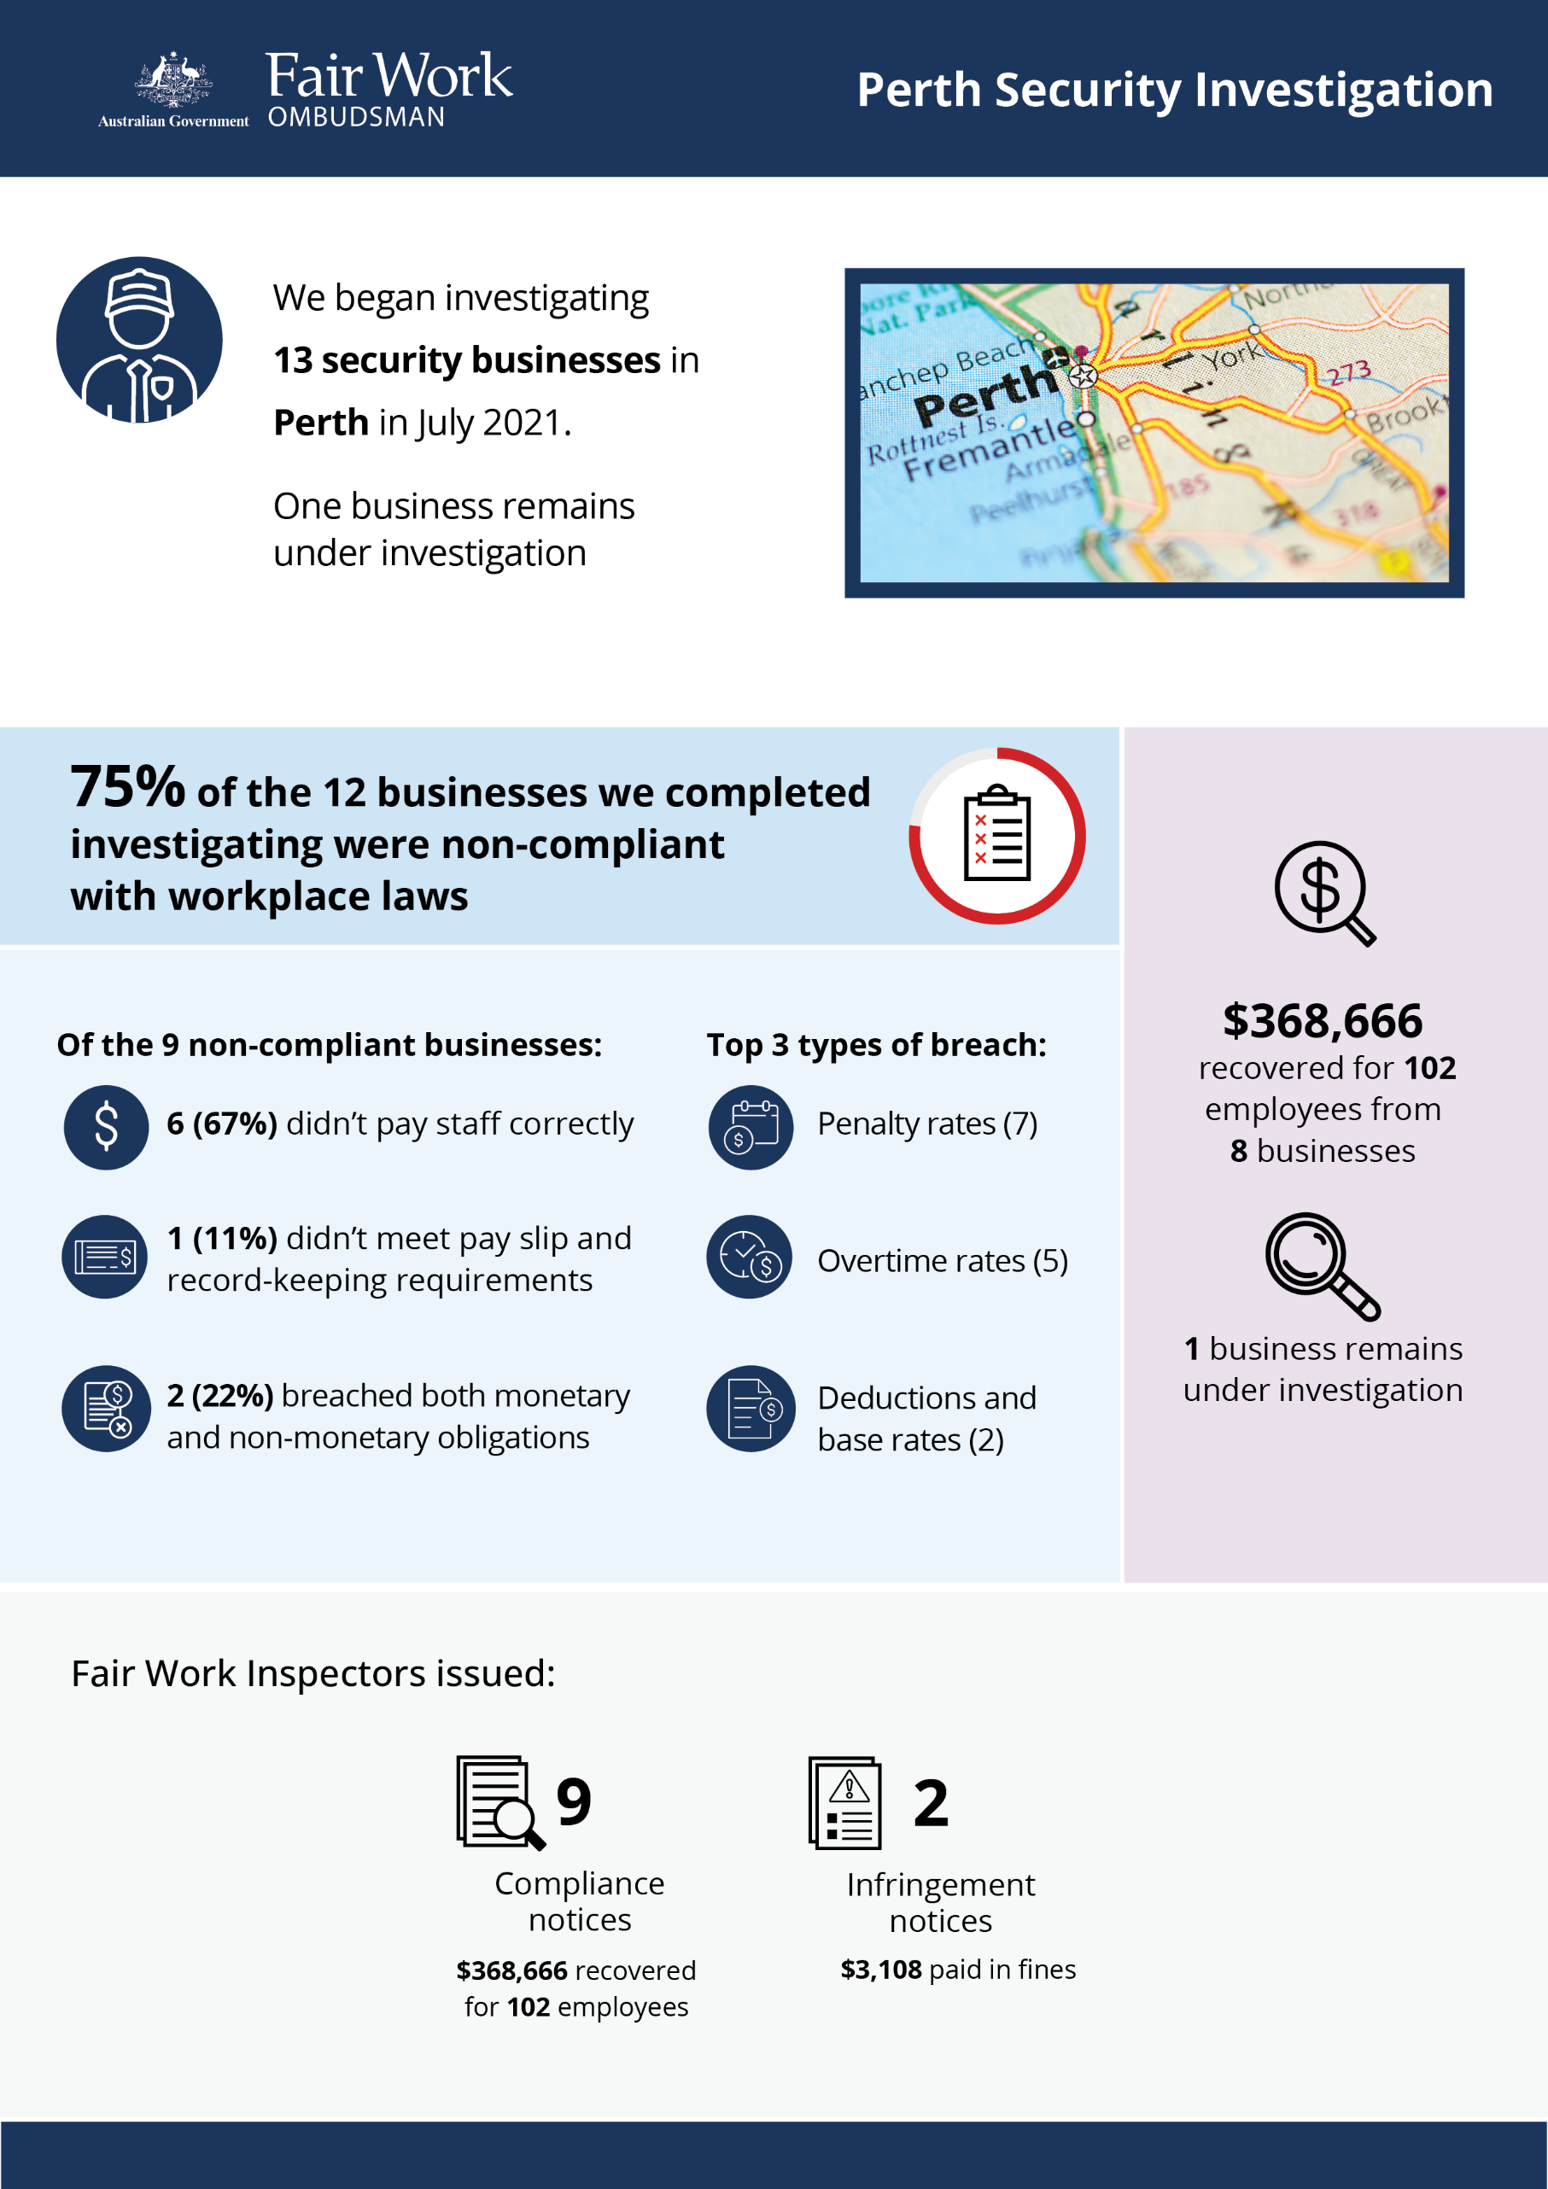

# 

# Perth Security investigation

## What we did and why

In July 2021, we began investigating 13 security businesses in the Perth region. The proactive investigation examined compliance with workplace laws and was initiated following anonymous tip-offs and other intelligence reports of non-compliance. We have concluded our investigations of 12 businesses, and 1 business remains under investigation.

The Fair Work Ombudsman (FWO) is concerned about ongoing compliance issues in the security industry, including exploitation of vulnerable workers. Factors driving high non-compliance include strong price competition and tight profit margins, low barriers to entry, large numbers of small business operators, multi-level labour supply chains, low rates of pay, and a relatively low or unskilled skilled workforce.

This activity followed other FWO proactive investigations in the security sector, including in Queensland where nearly $390,000 was recovered,[1] and separately in Melbourne and Sydney where more than $300,000 was recovered for workers providing security services at COVID-19 quarantine hotels.[2]

## Our findings

75% of the 12 businesses where investigations have been concluded (9) were found to have breached workplace laws. Of those:

* 6 (67%) were not paying staff correctly.
* 1 (11%) was non-compliant with pay slip and record-keeping requirements.
* 2 (22%) breached both their monetary and non-monetary obligations.

The most common breaches were:

* failure to pay penalty rates – including weekends, shift loadings, public holidays, casual loadings, evening/night/early morning penalties, part-time loading (7 businesses)
* failure to pay overtime rates (5)
* unauthorised deductions and underpayments of base rates (2)
* failure to pay annual and personal leave (1).

## Action taken and next steps

We recovered a total of $368,666 for 102 employees from 8 businesses.

Fair Work Inspectors issued:

* 9 compliance notices to 8 businesses, recovering $368,666 for 102 employees
* 2 infringement notices, with $3,108 paid in fines.

1 business is still under investigation.

1. [Nearly $390,000 recovered for security guards - Fair Work Ombudsman](https://www.fairwork.gov.au/newsroom/media-releases/2021-media-releases/march-2021/20210305-queensland-security-report-media-release)
2. [More than $300,000 recovered for security staff - Fair Work Ombudsman](https://www.fairwork.gov.au/newsroom/media-releases/2021-media-releases/october-2021/20211001-covid-19-hotel-quarantine-security-media-release)