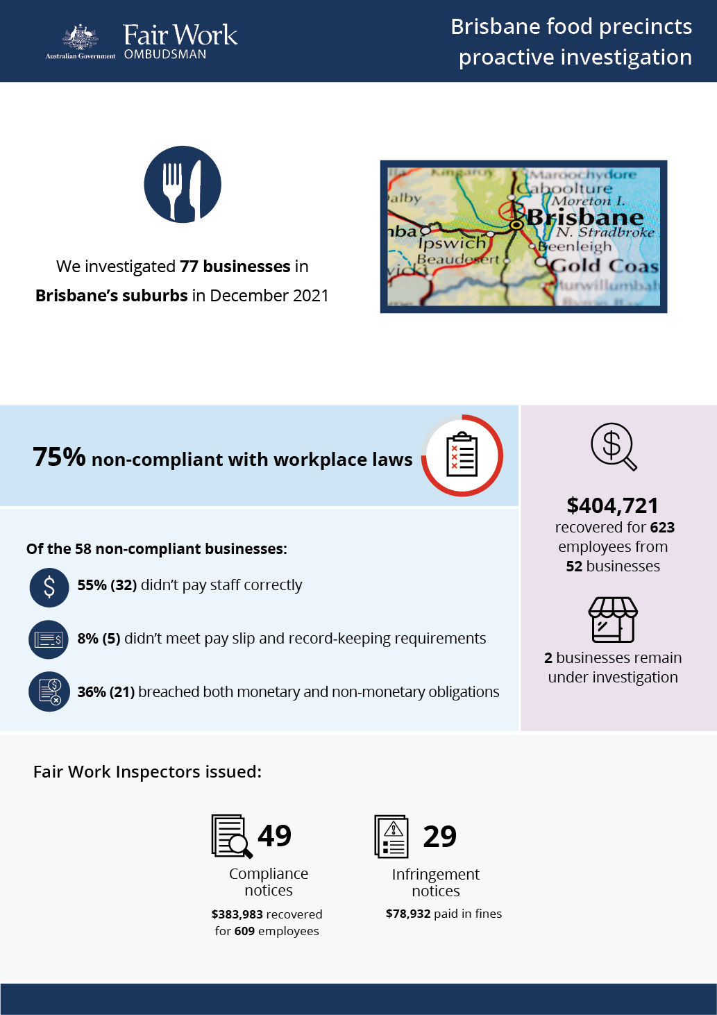

## What we did and why

In December 2021, we investigated 77 businesses in Brisbane suburbs. This proactive investigation was part of a program examining non-compliance in popular food precincts that commenced in 2016.[1][2][3][4][5][6]

Businesses in the Fast Food, Restaurants and Cafés (FRAC) sector within the areas typically employ a high proportion of young and migrant (temporary visa holder) workers. These workers can be vulnerable to exploitation, due to a lack of awareness or understanding of their entitlements, and an unwillingness to raise concerns with their employer or the Fair Work Ombudsman.

Brisbane has a diverse mix of businesses, employers and employees. Anonymous tip offs from workers suggested non-compliance in restaurants and fast food outlets in the areas.

We targeted businesses deemed to be at risk of non-compliance, based on one or more of the following characteristics:

* a history of non-compliance with the FWO
* anonymous tip offs and/or customer enquiries received about the business
* employing vulnerable migrant workers (confirmed using Home Affairs data).

Fair Work Inspectors conducted unannounced site visits at 77 businesses over 4 days. They:

* requested employment and payroll records
* interviewed employers, managers and workers
* observed work practices
* noted staff numbers to validate business records.

Pay slips and record-keeping practises were assessed against the requirements of the *Fair Work Act 2009*, the *Fair Work Regulations 2009*, and applicable awards or registered agreements. Most businesses were covered by the *Restaurant Industry Award 2020* or *Fast Food Industry Award 2010*.

## Our findings

58 (75%) of the 77 businesses investigated had breached workplace laws. Of those:

* 32 (55%) were not paying staff correctly
* 5 (8%) were non-compliant with pay slip and record-keeping requirements
* 21 (36%) breached both their monetary and non-monetary obligations.

The most common breaches were:

* failure to pay penalty rates or casual loadings – 40 businesses (69%)
* underpayment of the minimum hourly rate – 37 businesses (64%)
* failure to pay correct overtime allowances – 10 businesses (17%)
* payslip breaches – 19 businesses (33%)
* record-keeping breaches– 13 businesses (22%).

More than a quarter (29%) of the 77 businesses investigated employed young workers, and 6% were found to employ visa holders.

## Action taken and next steps

We recovered $404,721 for 623 employees from 52 businesses.[7] The largest recovery from a single business was $80,258 for 68 employees.

Fair Work Inspectors issued:

* 49 compliance notices (to 49 businesses), recovering $383,983 for 609 employees
* 29 infringement notices, with $78,932 paid in fines.

2 businesses are still under investigation for alleged non-compliance with workplace laws.

1. [Over-1.2-million-recovered-for-food-and-retail-workers](https://www.fairwork.gov.au/about-us/news-and-media-releases/2020-media-releases/september-2020/20200904-food-precincts-melbourne-brisbane-and-food-retail-report-media-release)
2. [Over $300 000 returned to fast food, restaurant and café workers](https://www.fairwork.gov.au/about-us/news-and-media-releases/2019-media-releases/december-2019/20191206-over-300-000-returned-to-fast-food-restaurant-and-cafe-workers) 
3. [Over $580,000 recovered for Hobart workers](https://www.fairwork.gov.au/newsroom/media-releases/2021-media-releases/april-2021/210401-hobart-food-precincts-audits-media-release)
4. [More than $200,000 recovered for Gold Coast workers](https://www.fairwork.gov.au/newsroom/media-releases/2021-media-releases/september-2021/20210907-gold-coast-food-precincts-report-media-release)
5. [Darwin workers back-paid nearly $400,000](https://www.fairwork.gov.au/newsroom/media-releases/2022-media-releases/september-2022/20220912-darwin-food-precincts-report-media-release)
6. [Launceston workers back-paid more than $120,000](https://www.fairwork.gov.au/newsroom/media-releases/2022-media-releases/october-2022/20221013-launceston-food-precincts-report-media-release)
7. 4 businesses rectified underpayments of $20,737 for 14 employees at the time of our site visits, without Fair Work Inspectors needing to investigate further.