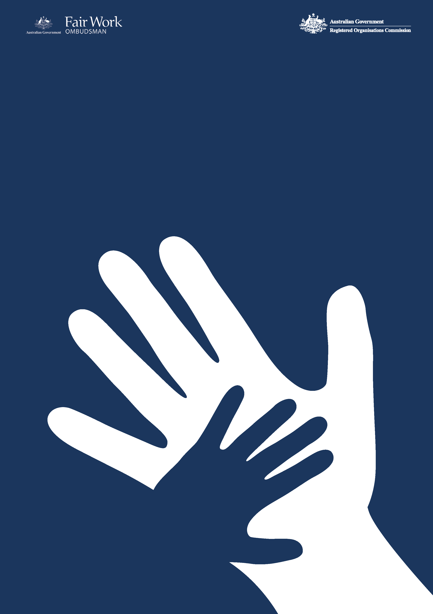­­

Commonwealth Child Safe Framework

**FWOROCE**

**Annual Statement of Compliance**

**2021-22** Financial Year

The Commonwealth Child Safe Framework (the Framework) is a whole-of-government policy that sets minimum standards for Australian Government entities to create and maintain behaviours and practices that are safe for children[1]. Under [Requirement 4](https://childsafety.pmc.gov.au/what-we-do/commonwealth-child-safe-framework/requirement-4) of the Framework, Commonwealth entities are required to publish an annual statement of compliance with the Framework including an overview of the entity’s child safety risk assessment. The Annual Statement of Compliance for the 2021-22 financial year for the Fair Work Ombudsman and Registered Organisations Commission Entity (FWOROCE) is set out below.

1. **FWOROCE’s commitment to child safety**

The FWOROCE is committed to ensuring the safety and wellbeing of children and young people in connection with our work and with our employees. FWOROCE seeks to create and maintain behaviours, practices and an organisational culture that acknowledges the importance of child safety and wellbeing. FWOROCE is committed to:

* Implementing strategies and taking action to promote child wellbeing and prevent harm to children.
* Creating an environment where children’s safety and wellbeing is acknowledged during the course of interactions with children and young people.
* Genuine engagement with and valuing of children.
* Creating conditions that reduce the likelihood of harm to children.
* Creating conditions that increase the likelihood of identifying any harm.
* Reporting/responding to any concerns, disclosures, allegations, or suspicions of harm.
* Making sure staff and volunteers have the skills, confidence and knowledge to keep children safe.

1. **FWOROCE’s interaction with children as part of its operations**

The FWOROCE is comprised of the following combination of independent bodies:

* The Office of the Fair Work Ombudsman (FWO)
* The Registered Organisations Commission (ROC)

The FWO’s jurisdiction is set out in the *Fair Work Act 2009*, its main role is to promote harmonious, productive and cooperative workplace relations through advice and education; and ensure and enforce compliance with Australian workplace laws. The ROC is responsible for improving the governance and financial accountability of unions and employer associations by ensuring compliance with the *Fair Work (Registered Organisations) Act 2009* through education, monitoring and where appropriate, enforcement. The ROC has no direct contact or interaction in the course of its operations, and the FWO has minimal direct contact or interaction with children as part of carrying out FWO operations.

The majority of FWO staff members do not interact directly with children in the performance of their duties. Although in some instances staff members may interact with children in the course of their duties - whether it be face-to-face, over the telephone, by way of electronic communication or by accessing a record pertaining to that person. These staff members may engage with children in the following instances:

* Customer services

Fair Work Advisers answer telephone calls from members of the public regarding a range of employment related matters. As part of their duties an Adviser may from time to time answer a telephone enquiry from a young worker[2]. Please note the age of a customer is not always disclosed during the course of an enquiry.

* Compliance and enforcement activities

Assessment Officers and Fair Work Inspectors (FWIs) promote and monitor compliance with Commonwealth workplace laws. Their roles include assessing and triaging requests for assistance involving a workplace dispute, conducting compliance audits, investigating workplace complaints and suspected breaches, and taking steps to enforce relevant Commonwealth workplace laws. In performing these functions, an Assessment Officer or FWI may speak to or interview a young worker and access a record relating to the employment of a young worker.

* Litigation proceedings

When undertaking litigation to remedy breaches of Commonwealth workplace laws, FWO lawyers may take evidence or otherwise deal with a young worker in the course of a litigation.

* Education activities

The FWO’s Community Engagement Officers may have contact with children in the context of attending expos held by universities, other education providers or stakeholders (for example having a stall/stand or delivering a presentation).

The FWO administers a Community Engagement Grants Program (CEG Program) which commenced on 1 January 2017. The CEG Program involves funding to third party providers who may in turn deliver services to children. The CEG program provides funding to not-for-profit organisations to undertake a range of activities involving the provision of professional advice, information or assistance to people within the Commonwealth workplace relations system about the operation of Commonwealth workplace laws, particularly the *Fair Work Act 2009* and may include:

* Legal advice sessions
* Community education
* Telephone or face to face advisory services
* Case work services.

In the latest round of grants, the FWO awarded a total of $7.2 million to five not-for-profit organisations. The CEG Program will see grants of between $1 million and $1.8 million provided to the organisations over four years to support people including young workers understand and exercise their rights under the Commonwealth workplace relations system. Funding will be provided from 1 January 2021 to 31 December 2024. One grant has been awarded to Youth Law Australia who will provide information, advice and education about Commonwealth workplace laws to young workers in NSW, the Northern Territory and the ACT.

1. **Child safety risk assessment**

In accordance with the requirements of the Framework an annual risk assessment was undertaken by FWOROCE[3]. Five key risks were identified (four rated low and one rated medium) which resulted in an overarching risk rating of low for the FWOROCE. A summary of the five identified risks is set out below in Table 1, along with controls in place to address these risks.

***Table 1. Child safety risk assessment July 2022***

|  |  |  |
| --- | --- | --- |
| No. | Description | Control |
| RISK 1 - Reporting Risks  Rating: MEDIUM | * Child (under 18) suffers from physical, sexual, emotional or psychological abuse or is neglected and the FWO fails to act promptly or appropriately by meeting the relevant state or territory mandatory reporting requirements in response to either:   + information received through FWO channels   + information disclosed by a child during discussions with a FWO employee   + visual observations by the FWO employee   + a request through the National Redress Scheme. | 1. Accessible guidance materials that assist staff to understand mandatory reporting where there are concerns, suspicions or beliefs that a child or young person is or has been abused and or neglected 2. Established centralised procedure for the report of potential child abuse or neglect to the Agency Security Advisor for assessment and action 3. Procurement guidelines include guidance in relation to imposing requirements that reflect those of the Framework on third party suppliers 4. Applicable clauses imposing requirements that reflect those of the Framework on grant recipients included in the Community Engagement Grants Program Agreements. |
| RISK 2 –  On-site and Off-site Child Safety Risks  Rating: LOW | Child (under 18) suffers physical, sexual, emotional or psychological abuse on or external of FWOROCE premises:   * accompanying their parent who is a FWOROCE employee * participating in a work experience or other employment program sponsored by FWOROCE * being interviewed by Fair Work Inspectors (FWIs) * attending the FWO front counter * being a contractor or employee of a contractor to the FWOROCE. * due to FWI participating in a site inspection * due to FWO employee attending external conference or other forum * in the course of interactions with FWOROCE online. | 1. Child Safety and Wellbeing Policy 2. Children and Young People in the Workplace Policy 3. Mandatory Commonwealth Child Safe Framework eLearning module 4. WHS Policies and Procedures 5. Criminal record check prior to commencing employment and baseline security clearances required for all staff 6. Working with Children Checks or equivalent held by staff if required 7. APS Code of Conduct and values and Child Safe Code of Conduct 8. Conducting Investigative Interviews Guide (protocols in place if the person interviewed is under 18 years of age 9. Site Inspections Risk Assessment Guide and Safety Prompt fact sheet 10. Security processes and procedures 11. Complaints management processes 12. FWO’s Social Media Policy. |
| RISK 3 –  Privacy Risks  Rating: LOW | Child suffers physical, sexual, emotional or psychological abuse by someone other than a FWO employee due to:   * FWO employee inappropriately or inadvertently disclosing private information (such as phone number or address) of a child to someone other than custodial parent or guardian * external party inappropriately accessing private information stored on FWO databases. | 1. Managing information access requests Non-Government and Individuals Policy 2. Managing information access requests Government Entities Policy 3. Information Security Policy 4. Privacy Policy 5. Information Governance Framework 6. Information and Records Management Policy 7. Audit trails and logs for accessing information 8. IT Security policies 9. Principles and Customer Service Reference including Proof of Identity 10. Customer Privacy at the FWO. |
| RISK 4 –  Third Party Suppliers  Rating: LOW | Child suffers physical, sexual, emotional or psychological abuse by a third-party supplier. | 1. Procurement guidance to all staff that (where appropriate) child safety requirements consistent with the Framework are imposed on any individuals or organisations funded to provide services directly to children or for activities that involve contact with children, that is a usual part of and more than incidental to the funded activity 2. Applicable clauses imposing requirements that reflect those of the Framework on grant recipients including mandatory reporting are included in the Community Engagement Grants Program Agreements and signed off by recipients. |
| RISK 5 – Framework Implementation  Rating: LOW | FWOROCE fails to implement and maintain the requirements outlined in the Framework. | 1. Annual review of compliance in accordance with Requirement 4 of the Framework to publish an Annual Statement of Compliance. The annual review will consider any necessary updates to guidance and training materials, and policies 2. Annual review of the Framework Risk Register in accordance with Requirement 1 of the Framework to ensure risks are contemporary and that the identified controls and treatment remain effective 3. Centralised coordination and oversight of the implementation of the Framework and monitoring of compliance including an annual compliance check. |

1. **Compliance with the Framework**

The FWOROCE is compliant with the four requirements of the Framework as set out below.

***Table 2. Summary table compliance with the Framework***

|  |  |  |  |
| --- | --- | --- | --- |
| Requirement 1  Undertake risk assessments annually in relation to activities of the entity to identify the level of responsibility for and contact with children, evaluate risks to child safety and put in place appropriate strategies to manage identified risks. | Requirement 2  Establish and maintain a system of training and compliance to make staff aware of and compliant with the Framework and relevant legislation including Working with Children Checks / Working with Vulnerable People Checks and mandatory reporting requirements. | Requirement 3  Adopt and implement the National Principles for Child Safe Organisations. | Requirement 4  Publish an Annual Statement of Compliance with the Framework including an overview of the entity’s child safety risk assessment (conducted under Requirement 1). |
| Compliant | **Compliant** | **Compliant** | **Compliant** |

**4.1 Child safety initiatives undertaken for 2021-22 financial year**

The child safety initiatives set out in Table 3 below, have been undertaken within or following the end of the 2021-22 financial year.

***Table 3. Child safe initiatives undertaken within or following the end of the 2021-22 financial year***

| Initiative | Period | Description |
| --- | --- | --- |
| As committed to in the FWOROCE [Annual Statement of Compliance](https://www.fairwork.gov.au/sites/default/files/2021-10/commonwealth-child-safe-framework-fworoce-annual-statement-of-compliance-2020-2021.pdf) for the 2020-21 reporting period | | |
| Development of a Child Safety and Wellbeing Policy | 2021-22 | Development of an internal Child Safety and Wellbeing Policy that:   * references the FWOROCE’s child safe governance arrangements including relevant policies and procedures (including information sharing, record keeping policies, accessibility, anti-discrimination, cultural safety, diversity and inclusion and online interaction policies) * includes Information regarding mandatory reporting obligations, Working with Children Checks (WWCC) / Working with Vulnerable People (WWVP) checks * details how the FWOROCE implements the National Principles for Child Safe Organisations. |
| Feedback and Complaints Policy reviewed | 2021-22 | Feedback and Complaints Policy has been reviewed to ensure it is accessible, child-friendly and culturally safe regarding complaints processes for children and young people. In addition, the complaints management process in relation to children has been addressed within the Child Safety and Wellbeing Policy. |
| Development of a Child Safe Code of Conduct | 2021-22 | Development of a Child Safe Code of Conduct which has been included within Child Safety and Wellbeing Policy. |
| Online risk assessment | Conducted following the end of the 2021-22 FY | Online environment has been reviewed as part of annual risk assessment for the year ahead (2022-23 financial year) with appropriate controls in place – see section 3. |
| Child Safe Framework training module | Conducted following the end of the 2021-22 | The Child Safe Framework online training module has been updated to ensure it is contemporary and includes reference to the Child Safety and Wellbeing Policy. |
| Formalisation of compliance regime | Conducted following the end of the 2021-22 FY | Following the end of the 2021-22 financial year the following activities were undertaken to monitor compliance with the Framework and will be undertaken on an annual basis:   * review of position requirements to determine which staff may require WWCCs or WWVPs - currently no staff require WWCCs or WWVPs * confirmation that all staff who commenced with the FWOROCE within the financial year have completed the Child Safe Framework training module – Staff who have not completed will be re enrolled. * Review of all reports made by staff in relation to potential child abuse or neglect to ensure appropriate action taken (including meeting reporting requirements) – due to the FWOROCE’s limited interaction with children, no instances of potential child abuse or neglect were raised by staff during the financial year * Review of the inclusion of child safety clauses in contracts with third party suppliers / grant recipients * review and update of child safety related policies and procedures. |
| Other Initiatives | | |
| Mandatory training | 2021-22 | Throughout the course of the 2021-22 financial year all new staff members have been required to complete a mandatory Commonwealth Child Safe framework online training module. |
| Dedicated Child safe Intranet Page | 2021-22 | The Development of a dedicated Commonwealth Child Safe Framework intranet page to provide guidance to staff on the key elements of the Framework including links to Child Safety and Wellbeing Policy and useful resources and guidance materials. |

**4.2 Measures to improve compliance**

In the course of the 2022-23 financial year the FWOROCE’s compliance with the Framework will be the subject of an Internal Audit. Any weaknesses or improvements identified to the implementation the Framework within the FWOROCE will be reported within the 2022-23 Annual Statement of Compliance.

1. As defined by the Framework a child or young person is a person under 18 years of age or a person apparently less than 18 years of age if the person’s age cannot be proven.
2. For the purposes of the statement a young worker is defined as a person under the age of 18.
3. The risk assessment was undertaken in July 2022 following the end of the financial year in order to assist with the assessment of FWOROCE compliance with the framework for the 2021-22 reporting period and ensure risks and controls were contemporary for the year ahead.