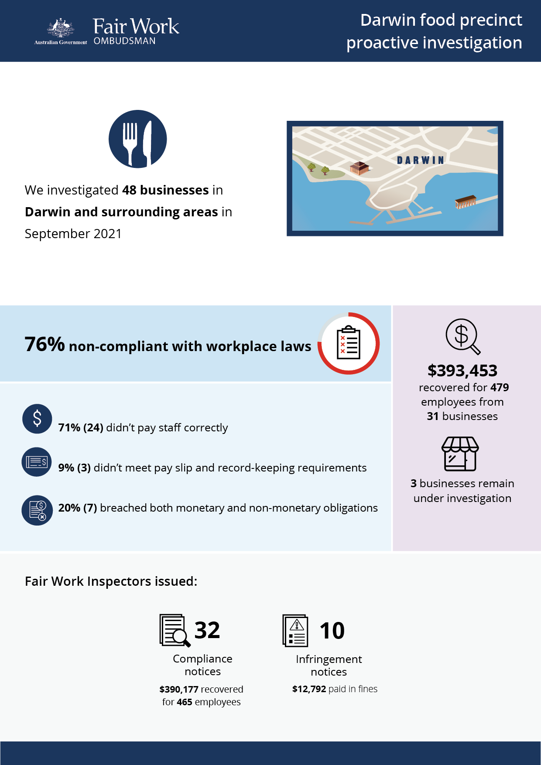

# Darwin food precincts investigation

## What we did and why

In September 2021, we investigated 48 businesses in Darwin and surrounding areas. This proactive investigation was part of a program examining non-compliance in popular food precincts that commenced in 2016.[1][2][3][4]

Fast food, Restaurants and Cafés (FRAC) sector businesses within these precincts typically employ a high proportion of young and migrant (temporary visa holder) workers. These workers can be vulnerable to exploitation, due to a lack of awareness or understanding of their entitlements, and an unwillingness to raise concerns with their employer or the FWO.

Darwin has a diverse mix of businesses, employers and employees. Anonymous tip offs from workers suggested non-compliance in restaurants and fast food outlets in the area.

We targeted businesses deemed to be at risk of non-compliance, based on one or more of the following characteristics:

* a history of non-compliance with the FWO
* anonymous tip offs and/or customer enquiries received about the business
* employing vulnerable migrant workers (confirmed using Home Affairs data).

Fair Work Inspectors conducted unannounced site visits at 48 businesses over 3 days. They:

* requested employment and payroll records
* interviewed employers, managers and workers
* observed work practices
* noted staff numbers to validate business records.

Pay slips and record-keeping practises were assessed against the requirements of the *Fair Work Act 2009*, the *Fair Work Regulations 2009*, and applicable awards or registered agreements. Most businesses were covered by the *Restaurant Industry Award 2020* or *Fast Food Industry Award 2010*.

## Our findings

34 (76%) of the 45 businesses with finalised investigations had breached workplace laws. Of those:

* 24 (71%) were not paying staff correctly.
* 3 (9%) were non-compliant with pay slip and record-keeping requirements.
* 7 (20%) breached both their monetary and non-monetary obligations.

The most common breaches were:

* failure to pay penalty rates or casual loadings – 28 businesses (82%)
* underpayment of the minimum hourly rate – 13 businesses (38%)
* failure to pay correct overtime allowances – 13 businesses (38%)
* payslip breaches – 7 businesses (21%)
* record-keeping breaches– 4 businesses (12%).

Around two-thirds (63%) of the 48 businesses investigated employed visa holders, and around three-quarters (77%) were found to employ young workers.

## Action taken and next steps

We recovered $393,453 for 479 employees from 31 businesses[5]. The largest recovery from a single business was $94,687.

Fair Work Inspectors issued:

* 32 compliance notices (to 32 businesses), recovering $390,177 for 465 employees
* 10 infringement notices, with $12,792 paid in fines.

3 businesses are still under investigation for alleged non-compliance with workplace laws.

1. [Over-1.2-million-recovered-for-food-and-retail-workers– Media releases – Fair Work Ombudsman](https://www.fairwork.gov.au/about-us/news-and-media-releases/2020-media-releases/september-2020/20200904-food-precincts-melbourne-brisbane-and-food-retail-report-media-release)
2. [Over $300 000 returned to fast food, restaurant and café workers - Media releases - Fair Work Ombudsman](https://www.fairwork.gov.au/about-us/news-and-media-releases/2019-media-releases/december-2019/20191206-over-300-000-returned-to-fast-food-restaurant-and-cafe-workers)
3. [Over $580,000 recovered for Hobart workers - Fair Work Ombudsman](https://www.fairwork.gov.au/newsroom/media-releases/2021-media-releases/april-2021/210401-hobart-food-precincts-audits-media-release)
4. [More than $200,000 recovered for Gold Coast workers - Fair Work Ombudsman](https://www.fairwork.gov.au/newsroom/media-releases/2021-media-releases/september-2021/20210907-gold-coast-food-precincts-report-media-release)
5. One business rectified underpayments of $3,276 to 14 employees at the time of our site visits, without Fair Work inspectors needing to investigate further.